APPENDIX A

2003 Final Negative Declaration Chapter 1.0 Project Description

CHAPTER 1

PROJECT DESCRIPTION

Introduction
Agency Authority
Project Location
Overview of Current Operations
Proposed Description

1.1 INTRODUCTION

Chevron Products Company (Chevron) is proposing to build a new Hydrogen Plant at the existing Chevron El Segundo Refinery (see Figures 1 and 2). The Hydrogen Plant will produce gaseous hydrogen and steam for use in Refinery process units. Chevron’s proposed project has been developed to comply with the South Coast Air Quality Management (SCAQMD) District’s Rule 1189 which regulates emissions from hydrogen plants. Hydrogen is used in various aspects of petroleum refining.

SCAQMD Rule 1189 (c)(3) states that after January 1, 2003, the total VOC emissions from all process vents of the hydrogen Steam Methane Reformer (SMR) plant combined, are to be less than 2.5 pounds of volatile organic compounds (VOC) per million standard cubic feet of hydrogen. The compliance date can be extended to July 1, 2003, with a written statement to the SCAQMD’s Executive Officer by January 1, 2003 indicating that a retrofit is required to comply. After review of various options available to achieve compliance with Rule 1189, Chevron determined that the most efficient and effective way to comply was to build a new Hydrogen Plant and demolish the existing Steam Methane Reformer hydrogen plant. Another existing hydrogen plant at the Chevron Refinery referred to as the Steam Naphtha Reformer is expected to be in compliance with Rule 1189 by July 1, 2003. Operation of the new Hydrogen Plant offers substantial environmental benefits, including: reduced VOC emissions from process vents and reduced emissions of other criteria pollutants (e.g., example, nitrogen oxides (NOx) and sulfur oxides (SOx)). Under Rule 1189 (d)(2), the total VOC emissions from all process vents of a new or reconstructed hydrogen plant combined must be less than 0.5 pound of VOC per million standard cubic feet of hydrogen produced.

Chevron and the SCAQMD entered into an Order for Abatement in June 2002 to reduce emissions at the Refinery. The Order of Abatement included the demolition of the existing Steam Methane Reformer hydrogen plant and construction of a new Hydrogen Plant, which is expected to be completed by December 31, 2004. During the period from July 1, 2003, until the completion of the construction of the Hydrogen Plant (i.e., December 2004), excess emissions of VOCs are expected since Chevron will not be in compliance with SCAQMD Rule 1189. In order to offset excess VOC emissions during the period of non-compliance, Chevron has been ordered to surrender an equivalent amount of VOC emission reduction credits. Chevron also agreed to several other VOC emission reduction measures at the Refinery, including installation of a flare gas recovery system. The flare gas system has already been installed.

The new Hydrogen Plant is being developed by Air Liquide America, LP for Chevron. Chevron will be the operator of the Hydrogen Plant with Air Liquide as the legal owner. The new Hydrogen Plant will come under the Refinery’s existing Title V and RECLAIM permits. Although legally owned by Air Liquide, the new Hydrogen Plant as a support facility will fall under Rule 1302(p) and Rule 2000(c)(37) definition of facility: “any

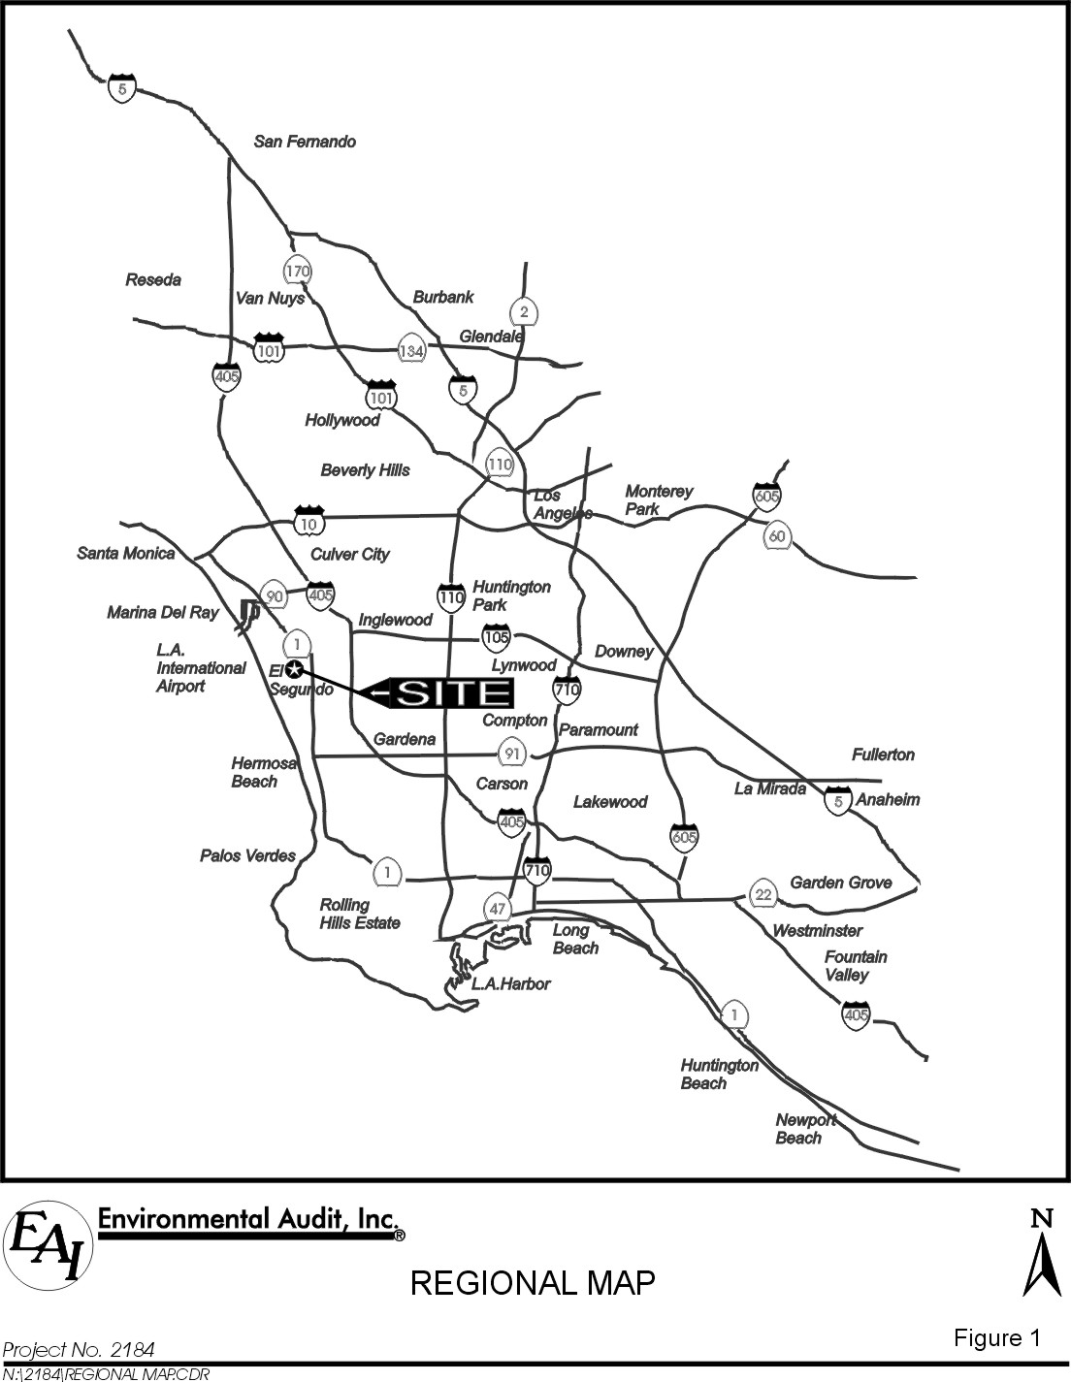

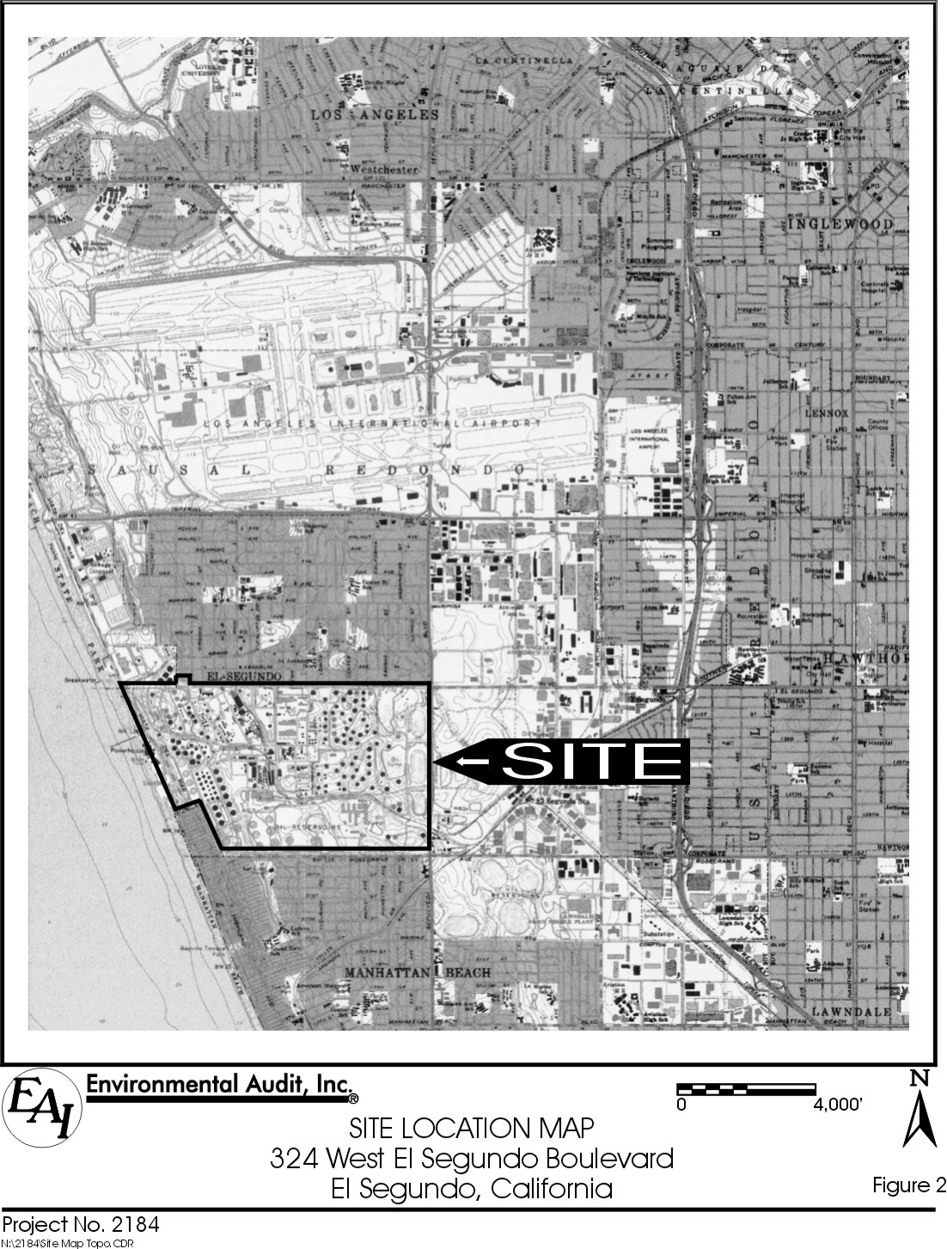
source or grouping of sources or other air contaminant-emitting activities which are located on one or more contiguous properties within the Basin in actual physical contact, or separated solely by a public roadway or other public right-of-way, and are owned or operated by the same person (or by persons under common control).”

AGENCY AUTHORITY

The California Environmental Quality Act (CEQA), Public Resources Code Section 21000 et seq., requires that the environmental impacts of proposed “projects” be evaluated and that feasible methods to reduce, avoid or eliminate significant adverse impacts of these projects be identified and implemented. The proposed modifications constitute a “project” as defined by CEQA. To fulfill the purpose and intent of CEQA, the SCAQMD is the “lead agency” for this project and has prepared this Negative Declaration to address the potential environmental impacts associated with the proposed construction of a new Hydrogen Plant at the Chevron Refinery.

The lead agency is the public agency that has the principal responsibility for carrying out or approving a project that may have a significant adverse effect upon the environment (Public Resources Code §21067). Since the proposed project requires discretionary approval from the SCAQMD and the SCAQMD has the greatest responsibility for supervising or approving the project as a whole, it was determined that the SCAQMD would be the most appropriate public agency to act as lead agency (CEQA Guidelines §15051(b)).

To fulfill the purpose and intent of CEQA, the SCAQMD has prepared this Negative Declaration to address the potential adverse environmental impacts associated with the proposed project. A Negative Declaration for a project subject to CEQA is prepared when an analysis of the project identifies potentially significant effects; but revisions in the project plans or proposals made by, or agreed to by, and the developed mitigation measures, would avoid the significant effects or mitigate the effects to a point where clearly no significant effects would occur (CEQA Guidelines §15070(b)).

  - PROJECT LOCATION

The Chevron Refinery (Refinery) is located at 324 West El Segundo Boulevard in the City of El Segundo, California. The Refinery occupies a rectangular-shaped parcel of land totaling approximately 1,000 acres south of the Los Angeles International Airport and west of the San Diego Freeway (I-405) on the shore of Santa Monica Bay. The Refinery is bordered on all four sides by roads: El Segundo Boulevard to the north, Sepulveda Boulevard to the east, Rosecrans Avenue to the south, and Vista Del Mar to the west. The proposed new Hydrogen Plant will be constructed within the boundaries of the existing Refinery. The location of the proposed new Hydrogen Plant is shown in Figure 3.

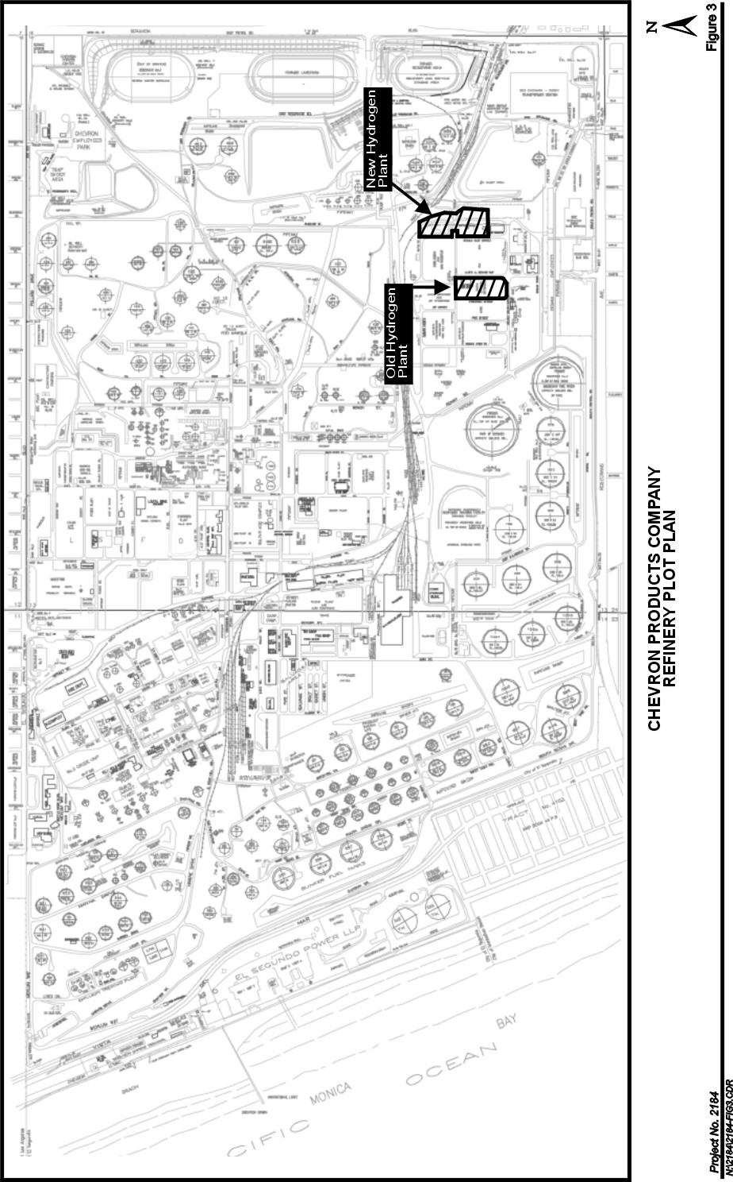
Regional access to the Refinery is provided by Interstate 405, which runs north-south approximately 0.5 mile east of the Refinery. The terminus of Interstate 105 with Interstate 405 is located about 0.75 mile north of the Refinery. The main entrance to the administrative offices at the Refinery is on El Segundo Boulevard.

  - OVERVIEW OF CURRENT OPERATIONS

Crude oil is a mixture of hydrocarbon compounds and relatively small amounts of other materials, such as oxygen, nitrogen, sulfur, salt, and water. Petroleum refining is a coordinated arrangement of manufacturing processes designed to produce physical and chemical changes in the crude oil to remove most of the non-hydrocarbon substances, break the crude oil into its various components, and blend them into various useful products. The overall refining process uses four kinds of techniques: (1) separation, including distilling hydrocarbon liquids into gases, gasoline, diesel fuel, fuel oil, and heavier residual materials; (2) cracking or breaking large hydrocarbon molecules into smaller ones by thermal or catalytic processes; (3) reforming using heat and catalysts to rearrange the chemical structure of a particular oil stream to improve its quality; and (4) combining by chemically combining two or more hydrocarbons to produce high-grade gasoline.

Hydrogen is an important gas currently produced at the Refinery and used in refinery process units. Hydrogen is added to various refinery streams and processes to reduce sulfur, nitrogen, benzene and olefin content of finished products, including gasoline. All hydrogen currently produced at the Refinery is used by Chevron and no hydrogen is sold to third parties or transported off-site.

The Chevron Refinery produces a variety of products including gasoline, jet fuel, diesel fuel, petroleum gases, petroleum coke, residual fuel, sulfur and various unfinished intermediate feedstocks.

1.5 PROJECT DESCRIPTION

The proposed Hydrogen Plant will supply hydrogen and steam to the Chevron Refinery. The facility may also sell a portion of its hydrogen production to other customers in the Los Angeles area. A portion of the steam will be used in the hydrogen production process, but most will be transported by pipeline to other units within the Refinery.

- The proposed Hydrogen Plant has the capacity to produce 90 million standard cubic feet per day (MMscfd) of hydrogen and 227,000 pounds per hour of steam. The design basis for the Hydrogen Plant is steam reforming of the following four types of feedstock – refinery fuel gas, pentane, natural gas and anhydrous ammonia. A simplified process flow diagram is shown in Figure 4. Generally, the process passes feed gas and steam over a catalyst to produce hydrogen. Medium pressure steam,

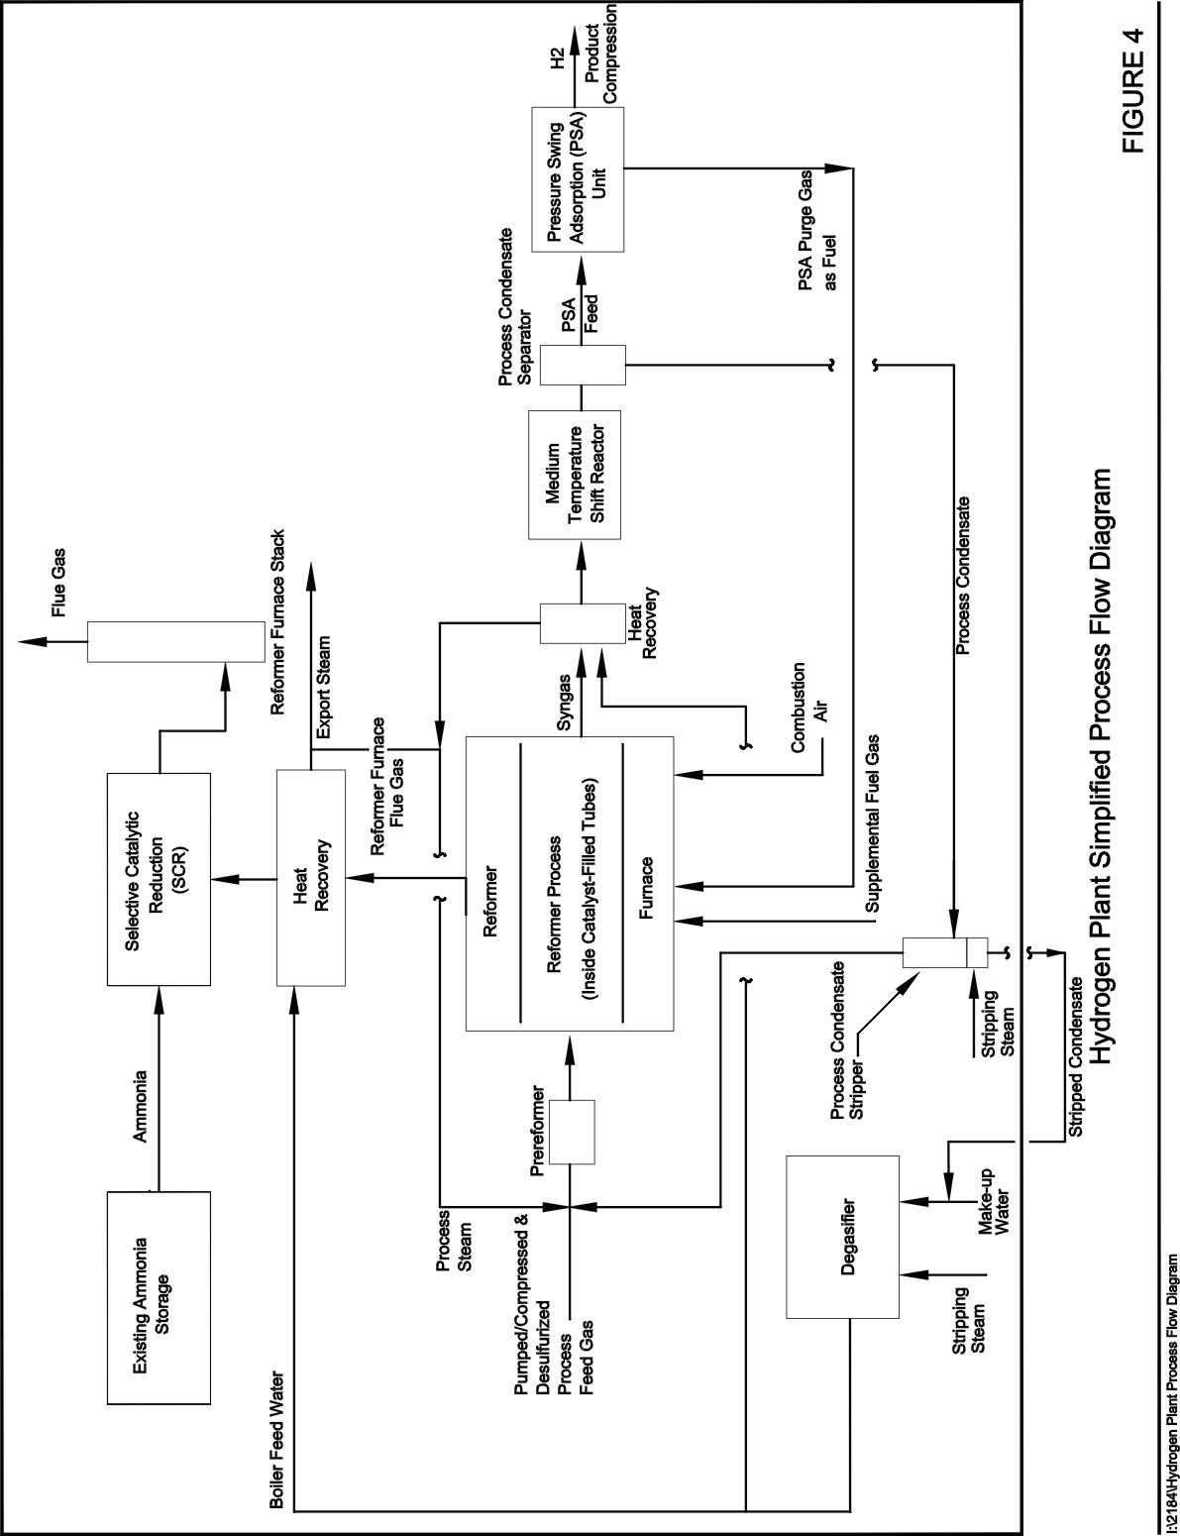
produced by heat recovery in the Hydrogen Plant, will be generated and distributed to other units and used within the Hydrogen Plant. A preliminary plot plan for the proposed Hydrogen Plant is shown in Figure 5.

The seven processing steps for the hydrogen and steam systems can be categorized as follows. More detailed descriptions of each of these processes are provided below.

- Feed stock compression/pumping and pretreatment;
- Pre-reforming;
- Steam methane reforming (SMR) and heat recovery;
- Medium temperature shift conversion;
- Purification of the process gas by Pressure Swing Adsorption (PSA);
- Product compression; and
- Waste heat recovery/steam generation.

Feed Stock Compression and Pumping

Feed stocks to the reformer can include refinery fuel gas, natural gas, pentane and ammonia. Compressors will be used to compress the feed gases (refinery fuel gas, and natural gas) to the reformer and the facility's hydrogen product. Process pumps will be used to elevate the feed pressure of the liquid feed stocks (pentane and ammonia). The compressors will be multi-stage and oil lubricated. For the feed compression service, the compressors elevate the feed gas pressure to the process requirement, prior to the preheating and purification steps.

Feed Purification

The feed gas from the feed compressors will be heated in a feed preheater using steam generated by the heat recovery section of the Hydrogen Plant. The feed gas will then be sent to the feed hydrogenation reactor, where organic sulfur will be hydrogenated to hydrogen sulfide over the cobalt/molybdenum catalyst. The hydrogenation reactor will be followed by two feed sulfur absorbers in series to remove the hydrogen sulfide from the feed gas, using a zinc oxide catalyst.

When anhydrous ammonia is used as a feed stock it will be desulfurized in a separate train. The sulfur will be absorbed on a separate catalyst to remove hydrogen sulfide as well as organic sulfur compounds.

Steam Methane Reforming and Heat Recovery

After purification, the feed gas will be mixed with process steam before going to the reformer. A prereformer feed preheater will also be incorporated in the process design to optimize the facility’s overall performance. The prereformer vessel will be filled with a prereforming catalyst. Mixed feed gas that has been preheated will pass through the

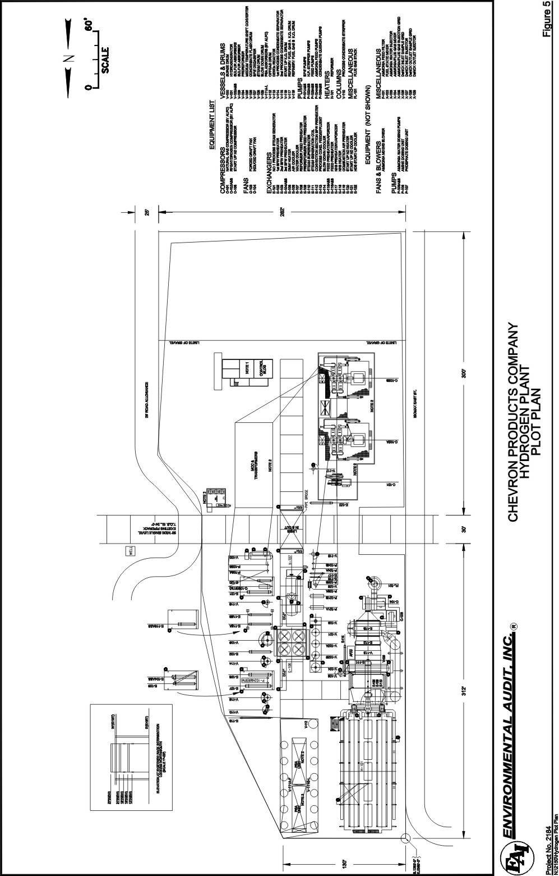
prereformer to initiate the reforming process prior to the gas going to the main reformer tubes.

Desulfurized ammonia will be mixed with the prereformer outlet stream and sent to the main reformer tubes.

The prereformer contains tubes that are filled with a nickel-based reforming catalyst. The feed gas will be converted to a mixture of hydrogen, methane and carbon oxides over this catalyst. The process gas flows downward with the gas entering the top of the vertically mounted tubes. The reformer product exits through the bottom of the catalyst tubes. Flue gas flow is upward with an outlet near the top of the radiant chamber.

The heat of reaction will be supplied by burners, arranged in rows on each side of the furnace, to provide control of a uniform temperature profile along the length of the catalyst tubes. An on-line oxygen analyzer in the flue gas ductwork will be used to control excess combustion air. Fans will provide the required draft to evacuate the combustion flue gases and to provide combustion air to the burners.

The majority of the heat requirement will be satisfied by combustion of off gas from the PSA unit. The balance of the heat requirement for the reformer will be made up by firing refinery fuel gas or natural gas as trim fuels.

The flue gas collector passes the flue gas from the radiant chamber to the waste heat recovery section where the heat of the flue gas is used to: (1) preheat pre-reformer and reformer feed gases; (2) superheat steam; (3) heat the waste heat boiler coil; (4) preheat boiler feed water; and (5) preheat combustion air. Maximum heat recovery will be achieved from both the reformer process gas and the reformer flue gas.

The reformer process gas will be cooled by generating steam in the waste heat boiler, producing saturated steam. The incoming boiler feed water is also preheated by the reformer process gas.

The reformer flue gas will be routed to a Selective Catalyst Reduction (SCR) Unit, which is an air pollution control device. The SCR Unit reduces NOx emissions in the flue gas by injecting ammonia, which reacts with NOx. Aqueous ammonia will be vaporized and mixed with air, preheated, and injected into the reformer flue gas, directly upstream of the SCR catalyst. In the presence of the SCR catalyst, the NOx reacts with the ammonia to form nitrogen and water. The appropriate amount of ammonia will be added to reduce the NOx to the desired concentration.

Aqueous ammonia from an existing on-site storage tank will be fed to an ammonia feed pump and through a filter, prior to being combined with recycled flue gas. Air and heated air are introduced into the system from the instrument air header and ammonia injection blower, respectively. The ammonia/air mixture exiting the ammonia mixer passes through a static mixer and will then be sprayed into the flue gas stream through the ammonia injection grid.

Medium Temperature Shift Conversion

Carbon monoxide in the reformer process gas will be converted in the presence of steam (water) to carbon dioxide and additional hydrogen in the medium temperature shift reactor. Adjustment of the medium temperature shift reactor inlet temperature will be necessary because the shift reaction equilibrium is favored by low temperature, while catalyst activity will be increased by higher temperature. Thus, an optimum temperature will be selected. As the shift catalyst ages, the inlet temperature will be raised to maintain activity. The medium temperature shift reactor effluent will be cooled, waste heat recovered, and boiler feed water preheated in a series of steps before it is fed to the PSA unit.

Purification of the Process Gas by Pressure Swing Adsorption (PSA) Unit

After the process gas exiting the medium temperature shift reactor has been cooled, the remaining hydrogen-rich process gas will be sent to the multi-bed PSA Unit for hydrogen purification. The hydrogen produced by the PSA unit will have a minimum purity of 99 mole percent. The PSA unit consists of: vertical adsorber vessels which will contain adsorbent; vertical PSA off gas surge tank; and valve skids which will include manual valves, switch valves, control valves, instrumentation, relief valves, silencers, and interconnecting piping.

Each adsorption vessel in the PSA unit follows a cycle of adsorption, stepwise depressuring, purging, and stepwise re-pressuring. The system maximizes hydrogen recovery by effectively utilizing the residual hydrogen in an adsorber vessel at the end of its cycle to re-pressure the other vessels and provide hydrogen for purging. Product hydrogen from the PSA unit will be compressed in a hydrogen compressor.

The purge gas (offgas) from the purging (regeneration) process will be collected. This PSA off gas will be composed of the hydrogen purge and desorbed impurities (i.e., carbon dioxide, methane, carbon monoxide, nitrogen, and water vapor). From the surge tank, the off gas will be sent to the reformer furnace burners as fuel.

Product Compression

A compressor will be used to compress the hydrogen product for delivery to the various Refinery units. Two compressors will be installed, but only one will be in operation at a time.

Waste Heat Recovery/Steam Generation

The reformed process gas will be cooled by generating saturated steam in the process boiler. The gas will then enter the medium temperature shift converter where the gas temperature is raised. The gas then passes through a series of preheaters, and process condensate separators where additional hydrogen will be recovered.

Boiler feed water from the degasifier is pumped, preheated, and routed to the steam drum. The treated water from the steam drums will be used for the production of steam in two boilers.

Process condensate will be routed from two process condensate separators to a separate process condensate stripper where dissolved gases, methanol and ammonia, will be removed. Stripped condensate is cooled and sent to the degasifier. The gas leaving the final process condensate separator (with a hydrogen content of about 70 mole percent) is routed to the PSA unit for purification. The stripper overhead is recycled back to the process gas upstream of the reformer.

All new and modified process components are required to comply with the SCAQMD’s Regulation XIII requirement to install Best Available Control Technology (BACT) in conformance with the BACT Guidelines. BACT will be required to control stationary source emissions for all criteria pollutants (nitrogen oxides, sulfur oxides, carbon monoxide, particulate matter and VOC emissions).

Miscellaneous Project Issues

The proposed project is expected to require nine additional permanent workers at the Refinery. No increase in truck traffic is expected on a routine basis. The Refinery and all related equipment will continue to operate up to 24 hours per day for 365 days per year.

Construction Activities

Construction of the Hydrogen Plant will use construction equipment including forklifts, cranes, dozers, air compressors, welding machines, etc. Process equipment will be brought to the site and installed. Most system equipment will be built off-site and transported on-site for assembly into the final facility arrangement.

Construction is scheduled to begin when all permits and approvals are obtained (estimated to be third quarter of 2003). Construction activities are expected to last about 12 months. Current plans are to work five days per week, Monday through Friday from 7:00 a.m. to 5:00 p.m., with possible overtime or work on weekends, as the construction schedule may require and local ordinances will allow. The maximum number of daily workers used during the construction of the facility is estimated to be 213. Parking will be provided for construction workers at several locations within the existing Chevron Refinery.

Other Permits and Approvals

The proposed Hydrogen Plant will require building permits (including grading, fire, electrical and mechanical permits) from the City of El Segundo.

