south coast air quality management district

Final Negative Declaration for the Installation of an Additional Production Line at Cytec Fiberite Inc., Anaheim, California

May 31, 2000
SCAG Clearinghouse: I20000053

Executive Officer
Barry R. Wallerstein, D. Env.
Deputy Executive Officer
Planning, Rule Development and Area Sources
Jack P. Broadbent
Assistant Deputy Executive Officer
Planning, Rule Development and Area Sources
Elaine Chang, DrPH
Planning and Rules Manager
CEQA, Socioeconomic Analysis, PM/AQMP Control Strategy
Alene Taber, AICP

Prepared By: ENSR Corporation

Reviewed by: Michael A. Krause Air Quality Specialist
Steve Smith, Ph.D. Program Supervisor
Jeri Voge Senior Deputy District Counsel
South coast air quality management district

governing board

Chairman: WILLIAM A. BURKE, Ed.D.
Speaker of the Assembly Appointee

Vice Chairman: NORMA J. GLOVER
Councilmember, City of Newport Beach
Cities Representative, Orange County

MEMBERS:

MICHAEL D. ANTONOVICH
Supervisor, Fifth District
Los Angeles County Representative

HAL BERNSON
Councilmember, City of Los Angeles
Cities Representative, Los Angeles County, Western Region

JANE CARNEY
Senate Rules Committee Appointee

BEATRICE J.S. LAPISTO-KIRTLEY
Councilmember, City of Bradbury
Cities Representative, Los Angeles County, Eastern Region

RONALD O. LOVERIDGE
Mayor, City of Riverside
Cities Representative, Riverside County

JON D. MIKELS
Supervisor, Second District
San Bernardino County Representative

LEONARD PAULITZ
Councilmember, City of Montclair
Cities Representative, San Bernardino County

CYNTHIA P. COAD, Ed.D.
Supervisor, Fourth District
Orange County Representative

CYNTHIA VERDUGO-PERALTA
Governor's Appointee

S. ROY WILSON, Ed.D.
Supervisor, Fourth District
Riverside County Representative

EXECUTIVE OFFICER:

BARRY R. WALLERSTEIN, D.Env.
Table of Contents
Chapter 1 - Project Description

Information 1-1
Project Description and Location 1-1
Chapter 2 - Environmental Checklist Form

Introduction 2-1
Environmental Checklist Form 2-1
Potentially Significant Impact Areas 2-1
Determination 2-2
Environmental Checklist and Discussion 2-3

Figure 1
Regional Location Map 1-2
Figure 2
Site Location Map 1-3

appendix a
Evaluation of the Potential for Significant Hazard Impacts A-1
appendix b
Evaluation of the Potential Construction Emissions B-1
appendix c
Comment Letter and Responses to the Comments C-1

Preface

This document constitutes the Final Negative Declaration (ND) for the Installation of an Additional Production Line at Cytec Fiberite Inc., Anaheim, California. The Draft ND was released for a 30-day public review and comment period from February 16, 2000 to March 16, 2000. One comment letter was received from the public. Minor modifications have been made to the Draft such that it is now a Final ND. Deletions and additions to the text of the ND are denoted using strikethrough and underlined, respectively.

C H A P T E R 1

P R O J E C T D E S C R I P T I O N

Introduction
Project Description and Location

Introduction

Cytec Fiberite Inc. (Cytec) manufactures advanced composite materials and structural adhesives for use in commercial and military aircraft, and other products. This manufacturing, which has been performed at two locations in Southern California (City of Anaheim and Culver City), will be consolidated at the current Anaheim location. The Culver City site will be decommissioned and the items of value recovered.

The addition of the process line and associated equipment to the Anaheim facility will require South Coast Air Quality Management District (SCAQMD) Operating Permits. The project applicant also completed a California Environmental Quality Act (CEQA) applicability form (Form 400-CEQA). Based upon the results of Form 400-CEQA, it was determined that the proposed project had the potential to generate significant hazard impacts. As a result, the SCAQMD, as lead agency, has prepared this negative declaration. The results of the analysis for the proposed Cytec project indicated that the project would not generate significant adverse impacts to any environmental area identified in the environmental checklist form in Chapter 2. The CEQA evaluation process and this compliance document are prerequisite to the SCAQMD’s evaluation and decision on the air permit application.

Pursuant to CEQA Guidelines § 15051(b), the SCAQMD is the appropriate lead agency for this project because it is the public agency with the greatest responsibility for supervising or approving the project as a whole.

Project Description and location

Cytec currently operates a line that manufactures advanced composite materials and structural adhesives for use in commercial and military aircraft at its Anaheim location (see Figures 1 and 2). The Anaheim facility is located at 1440 North Kraemer Boulevard, Anaheim, CA 92806. The proposed project consists of relocating, installing, and operating a similar process line to the existing Cytec manufacturing location in the City of Anaheim. The line to be relocated was formerly located at a site in Culver City. The proposed project would increase the throughput and the output of product currently manufactured at the site. The material processed in the new production line will be the same or similar to that which is currently manufactured at the Anaheim site.

The processing line consists of a vertical oven, attached ductwork for exhaust to a Regenerative Thermal Oxidizer, web handling equipment for raw material unwinding, tension and accumulator controls, dip path impregnation stations, let-off stations, and associated controls and control consoles. The installed equipment will include Best Available Control Technology such as low NO_{X} burners for the oven and an oxidizer for emissions control.

The equipment will be installed in an existing building on the current Anaheim site. There will be no subsurface construction, and only minor modifications above ground. The above ground structure modification will consist of reinforcing the foundation and raising a portion of the roof of the process line building to the approximate elevation of an existing onsite enclosure. The
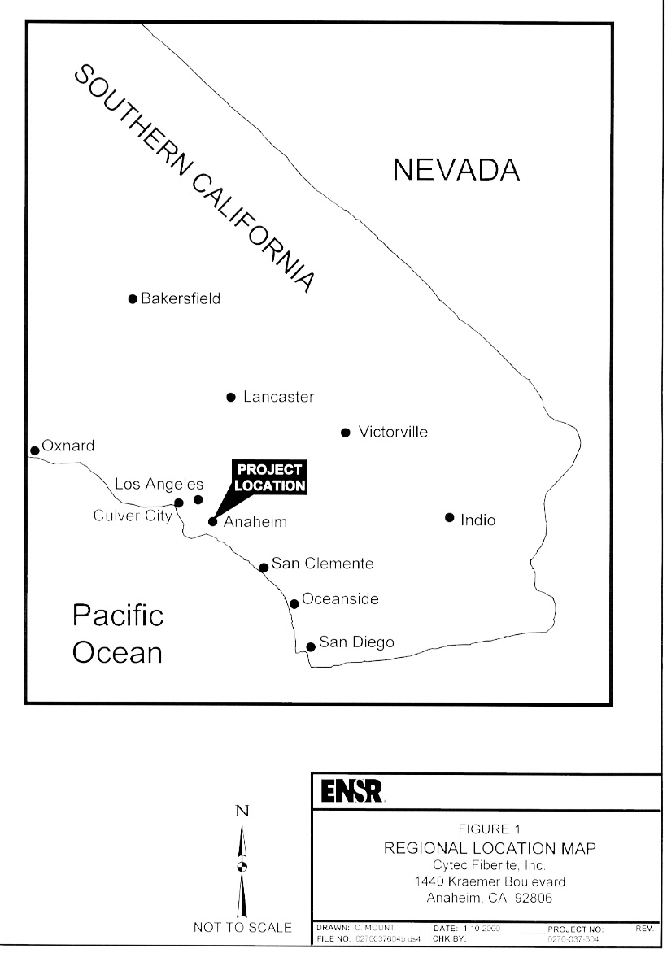

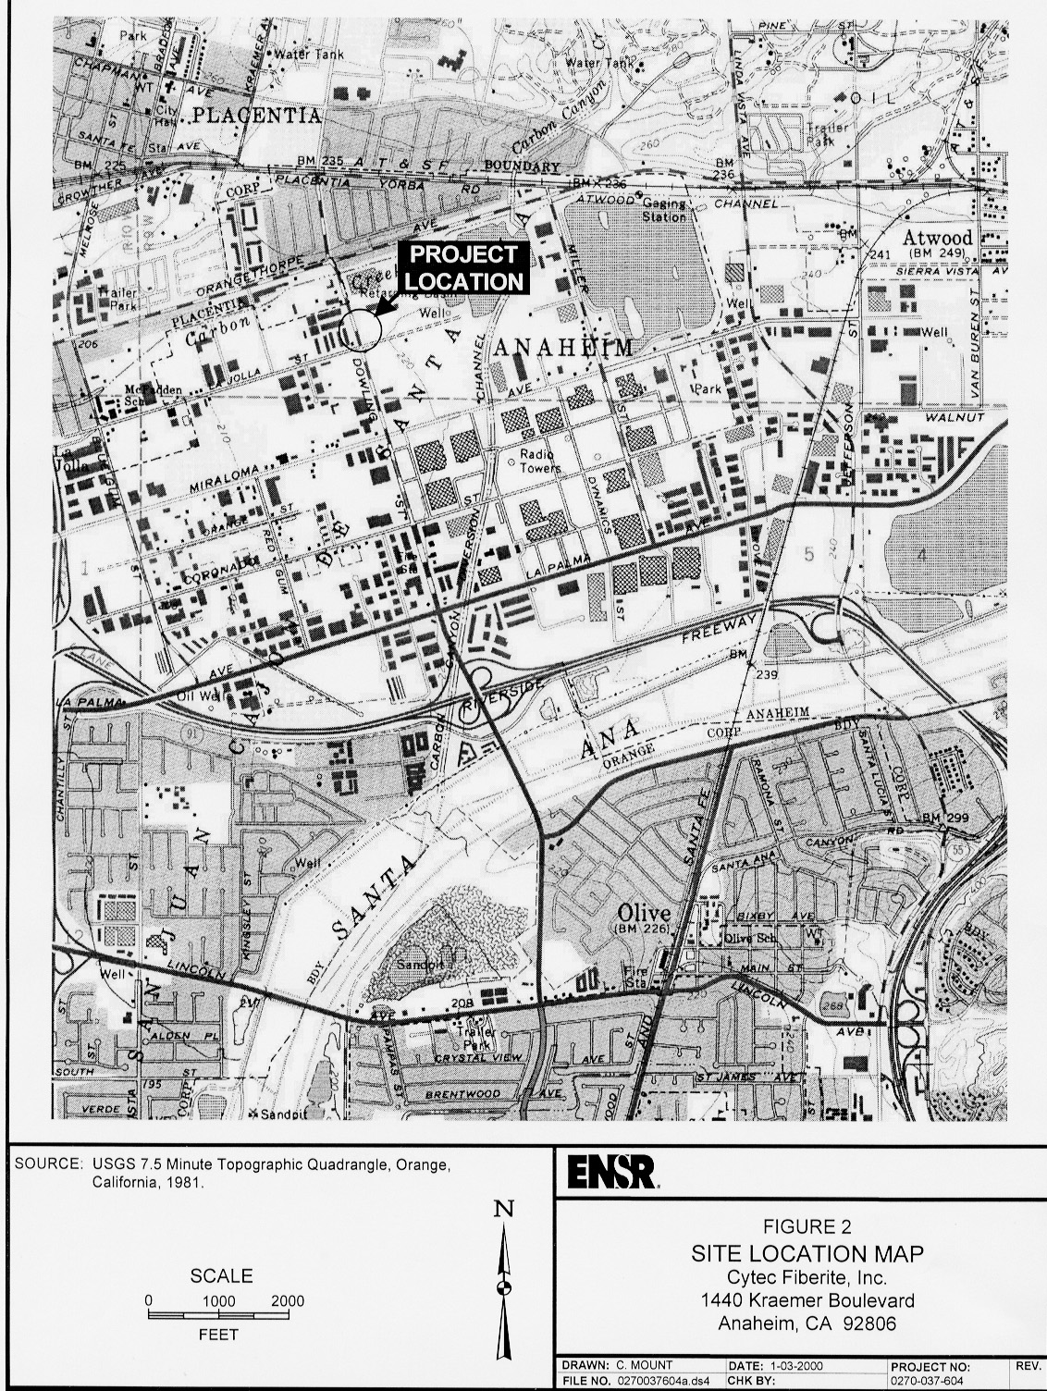
schedule, contingent on approval of the air permit application, is to complete the project and start up the process line by August 2000.

Electricity drives fans, blowers and lights for the facility. The ovens and the thermal oxidizer (air pollution control device) are operated by natural gas. The energy requirements for the Anaheim location due to the proposed project will increase by 1,525 kilowatts per day of electrical power and 2,000 to 3,000 therms per day of natural gas.

Water is needed for maintenance and sanitation (sink and toilet usage from new employees). No additional water is needed for the process application. The facility currently discharges to the sewer an average of 16,000 gallons per production day (gppd). The proposed project will add about 10 percent or 1,600 gppd. The proposed project will increase solid waste generation by about 15 percent (660 pounds per day). Solid waste is generated from non-hazardous packaging for additional personal protective equipment. Additional hazardous waste is generated from used cleaning materials, solvents and contaminated packaging. The hazardous wastes generation will increase by about 20 percent (320 pounds per day). The solid and hazardous waste constituents will be about the same as for current operations.

The feedstock materials, which contain 6 to 10 percent formaldehyde and 5 to 10 percent phenol, will be delivered to the site via an additional 1-2 truck trips per day. The project will add six to ten new employees to the site.

C H A P T E R 2

E N V I R O N M E N T A L C H E C K L I S T

Introduction
Environmental Checklist Form
Potentially Significant Impact Areas
Determination
Environmental Checklist and Discussion

Introduction

The environmental checklist provides a standard evaluation tool to identify a project's adverse environmental impacts. This checklist identifies and evaluates potential adverse environmental impacts that may be created by the proposed project.

environmental checklist form

Project Proponent: Cytec Fiberite Inc. (Cytec)

Proponent Address: 1440 North Kraemer Blvd., Anaheim, CA 92806 (See Figure 1, Regional Location Map and Figure 2, Site Location Map)

Lead Agency: South Coast Air Quality Management District

Contact Person: Michael Krause

Name of Project: Installation of an Additional Production Line at Cytec Fiberite Inc., Anaheim, California

Potentially Significant Impact Areas

The following environmental impact areas have been assessed to determine their potential to be affected by the proposed project. As indicated by the checklist on the following pages, environmental topics marked with an "x" may be adversely affected by the proposed project. An explanation relative to the determination of impacts can be found following the checklist for each environmental topic.

Land Use and Planning Population/Housing Geophysical
Water Air Quality Transportation
Biological Resources Energy x Hazards
Noise Public Services Solid/Hazardous Waste
Mineral Resources Aesthetics/Recreation Cultural Resources
x Mandatory Findings of Significance

Determination

On the basis of this initial evaluation:

x I find the proposed project, in accordance with those findings made pursuant to CEQA Guidelines Section 15074(b), could NOT have a significant effect on the environment, and that a NEGATIVE DECLARATION will be prepared.

I find that, although the proposed project could have a significant effect on the environment, there will NOT be significant effects in this case because the mitigation measures described in the following pages have been added to the project. A MITIGATED NEGATIVE DECLARATION will be prepared.

I find that the project MAY have a significant effect(s) on the environment, and an ENVIRONMENTAL IMPACT REPORT will be prepared.

Date: 2/15/00 Signature:
Steve Smith, Ph.D.
CEQA Program Supervisor
Planning, Rule Development, Area Sources
Environmental Checklist and Discussion

I. LAND USE AND PLANNING. Would the proposal: | Potentially Significant Impact | Less Than Significant Impact | No Impact
a) Conflict with general plan designation or zoning? |  |  | X
b) Conflict with applicable environmental plans or policies adopted by agencies with jurisdiction over the project? |  |  | X
c) Affect agricultural resources or operations (e.g., impacts to soils or farmlands, or impacts from incompatible land uses)? |  |  | X
d) Disrupt or divide the physical arrangements of an established community (including a low-income or minority community)? |  |  | X
The project will be completed wholly within the confines of a currently operating, permitted facility. The proposed project would not result in a change of either the present or planned use of the project site. The facility’s operations are consistent with the local zoning ordinances of the area and relevant regional plans. The facility does not have a Conditional Use Permit (CUP) and according to Mr. Ted White, Planner with the City of Anaheim Planning Department, a CUP is not required for the facility (February 11, 2000). The proposed project is compatible with surrounding land uses and would not result in a change in intensity of development. No agricultural resources or established communities will be affected.

II. POPULATION AND HOUSING. Would the proposal: | Potentially Significant Impact | Less Than Significant Impact | No Impact
a) Cumulatively exceed official regional or local population projections? |  |  | X
b) Induce substantial growth in an area either directly or indirectly (e.g., through projects in an undeveloped area or extension of major infrastructure)? |  |  | X
c) Displace existing housing, especially affordable housing? |  |  | X
The project will add from six to ten new employees to an existing work force of approximately 180 individuals. It is anticipated that these new employees will be available from the existing employment pool in the local area. As a result, the proposed project will not generate a need for new housing in the immediate vicinity of the proposed project or in the local area in general. The proposed project would not alter the location, distribution, density, or growth rate of the human population or housing in the area. The addition of six to ten new employees will have no significant adverse impact to local populations or affect housing availability.

III. GEOPHYSICAL. Would the proposal result in or expose people to potential impacts involving: | Potentially Significant Impact | Less Than Significant Impact | No Impact
a) Seismicity: fault rupture, ground shaking, or tsunami? |  |  | X
b) Landslides or mudslides? |  |  | X
c) Erosion, changes in topography or unstable soil conditions from excavation, grading, or fill? |  |  | X
d) Subsidence of the land? |  |  | X
e) Unique geologic or physical features? |  |  | X
The proposed project consists entirely of installation of additional equipment at an existing industrial facility. As a result, development of a new site is not necessary and, therefore, will not require any grading or site preparation that could generate changes in geologic substructures, soils, topography, or ground surface relief features or include destruction of any unique geologic or physical features. The project will be constructed in conformance with local seismic codes, therefore there will be no impacts from seismicity. Because the new equipment will be assembled entirely within an existing industrial facility, the proposed project will not increase soil erosion or deposition due to wind or water.

IV. WATER. Would the proposal result in: | Potentially Significant Impact | Less Than Significant Impact | No Impact
a) Changes in absorption rates, drainage patterns, or the rate and amount of surface runoff? |  |  | X
b) Exposure of people or property to water-related hazards such as flooding? |  |  | X
c) Discharge into surface waters or other alteration of surface water quality (e.g., temperature or dissolved oxygen)? |  |  | X
d) Changes in the amount of surface water in any water body? |  |  | X
e) Changes in currents, or the course or direction of water movements? |  |  | X
f) Change in the quantity of groundwaters, either through direct additions or withdrawals, or through interception of an aquifer by cuts or excavations? |  |  | X
g) Altered direction or rate of flow of groundwater? |  |  | X
h) Impacts to groundwater quality? |  |  | X

i) A need for new or substantial alteration to existing sewer or septic tanks, local or regional water treatment or distribution facilities, or storm water drainage systems? |  |  | X
The proposed relocated process line will be assembled entirely within the existing Anaheim manufacturing facility. Because the site is fully developed and runoff from the site is controlled there will be no change in absorption rates or runoff to any body of water. The process line that will be relocated duplicates an existing line, which does not use water during the manufacturing process. Consequently, no additional water is needed for the manufacturing process. However, some additional water supplies will be needed for maintenance and sanitation (sink and toilet usage from new employees). Water demand impacts associated with the installation of the process line are anticipated to create a negligible incremental water demand impact and will be far below the SCAQMD’s significance threshold of 5,000,000 gallons per day.
The project will use a closed loop cooling system and therefore, there will be no increase in process wastewater as a result of the project. Total wastewater discharges from the facility as a whole, which are discharged to the local municipal sewer system, currently average 16,000 gallons per production day (gppd). New wastewater from the additional sink and toilet usage by the additional employees will be increased by approximately 10 percent or 1,600 gppd. According to the Sewer Design Manual for the City of Anaheim, the peak flow is 2.0 times the average daily flow (http://www.anaheim.net/anaheim/depts_servc/pub_works/dev_svc/sewermanual.htm). Therefore the pre-project and post project peak flows would be 32,000 gppd and 35,200 gppd respectively. According to the Northeast Industrial Area Sewer Deficiency Study (ASL Consulting Engineers, May 1998), the design capacity at peak flow is 400,860 gpd for Basin 204, the area of the proposed project. At peak flow, the Cytec discharge is currently about 8% of the sewer capacity and would be 8.8% of capacity with the proposed modification. An increase of less than 1% of the available capacity at peak flow should not necessitate sewer system modifications.
The Orange County Sanitation District wastewater-treatment facility that receives Cytec’s wastewater has ample capacity to receive this small increase in wastewater discharge.
Water will not be drawn from surface or groundwater supplies and it will not be discharged to surface or groundwater. Therefore, there will be no potential for new adverse impacts to surface or groundwater.

V. AIR QUALITY. Would the proposal: | Potentially Significant Impact | Less Than Significant Impact | No Impact
a) Violate any air quality standard, contribute to an existing or projected air quality violation, or substantially increase pollutant emissions, including hazardous air pollutants? |  |  | X
b) Expose sensitive receptors to pollutants, including hazardous air pollutants? |  |  | X
c) Alter air movement, moisture, or temperature, or cause any change in climate? |  |  | X
d) Create objectionable odors? |  |  | X
e) Result in the need for new or substantially greater AQMD resources? |  |  | X
Construction activity involves the reinforcement of the foundation, extension of the roof and the reinstallation of the relocated process line within an existing building. An additional two to five trucks per day and up to 10 commuting vehicles per day will be needed during the construction phase. The construction emissions and indirect emissions from construction worker commuting and truck deliveries are provided in Appendix B. Construction related emissions will be negligible, will take place over a temporary period of time and will not exceed the SCAQMD’s significance threshold limits for air quality impacts established for construction-related emissions.
The combined operation-related emissions and indirect emissions from new employee commuting and additional truck deliveries will not exceed the SCAQMD’s significance threshold limits established for project operations except for VOC. However, the maximum VOC emissions will be the same at the new location as the existing location. VOC is a precursor to ozone, which is a regional pollutant. Because the relocation will occur within the same air basin and zone in the SCAQMD, no significant adverse air quality impacts will result.
Cytec will be required to comply with SCAQMD’s permitting requirements, which will preclude the release of constituents that would violate air quality standards or pose a significant risk to sensitive receptors. Cytec will operate the equipment in compliance with the SCAQMD’s applicable rules and regulations. According to CEQA Guidelines Section 15064(h)(1)(A), “a change in the environment is not a significant effect if the change complies with a standard…” A standard is a quantitative requirement found in a rule or regulation, according to Guidelines §15064 (h)(3). Therefore, no significant adverse air quality impacts would result from the project. The air quality analysis of this project is appended to the permit applications for the equipment.
Since the proposed project consists of relatively small emission sources located in an existing industrial facility, it is not expected to alter air movements, moisture, or temperature nor would it create objectionable odors.

VI. TRANSPORTATION/CIRCULATION. Would the proposal result in: | Potentially Significant Impact | Less Than Significant Impact | No Impact
a) Increased vehicle trips or traffic congestion? |  |  | X
b) Hazards to safety from design features (e.g., sharp curves or dangerous intersections) or incompatible uses (e.g., farm equipment)? |  |  | X
c) Inadequate emergency access or access to nearby uses? |  |  | X
d) Insufficient parking capacity onsite or offsite? |  |  | X
e) Hazards or barriers for pedestrians or bicyclists? |  |  | X
f) Conflicts with adopted policies supporting alternative transportation (e.g., bus turnouts, bicycle racks)? |  |  | X
g) Rail, waterborne, or air traffic impacts? |  |  | X
h) The need for new or altered (including increased maintenance) public facilities related to transportation, including roads? |  |  | X
The proposed project would generate trips to the project location in the form of the construction workers’ vehicles and construction equipment. A total of 15 vehicle trips per day will be added to the surrounding roadways as a result of the project during construction. Information provided by the City of Anaheim Public Works Department, Traffic and Engineering Division, indicates that vehicle to capacity (v/c) ratio at the intersection of West Orangethorpe Avenue and North Kraemer Boulevard is 0.64 (Level of Service (LOS) B) during AM peak periods and 0.71 (LOS C) during PM peak periods. The v/c ratio at the intersection of Miraloma Avenue and North Kraemer Boulevard is 0.53 (LOS A) during AM peaks and 0.60 (LOS A) during PM peaks. The v/c ration at the intersection of East La Palma Avenue and North Kraemer Boulevard is 0.67 (LOS B) during AM peaks and 0.85 (LOS D) during PM peaks. None of the relevant intersections are currently at capacity. Additionally, Mr. Taher Jalai of the City of Anaheim Traffic Engineering Division indicated that the City’s significance level is an increase of 100 vehicle trips during the PM peak period (February 11, 2000). Because the project construction is expected to add only 15 vehicle trips per day, the traffic impacts are considered to be not significant.
Trucks will be used to deliver raw materials and ship out finished products. Currently, about five to ten trucks visit the facility daily. With the new process line, an additional one to two truck trips would be expected daily. The facility is situated on a corner with a traffic control light. This signalized intersection facilitates entering and leaving the site.
The project would result in the addition of approximately three people per shift. This small number of additional workers would not be noticed either in terms of traffic entering or leaving the facility or in terms of parking. The facility was designed to accommodate 350 - 400 employees yet it currently has only about 180 employees with no plans for substantial expansion. Because the project will be conducted all on-site there will be no offsite impacts to pedestrians, bicyclists, or other forms of transportation. The proposed project would not affect parking, the transportation system, circulation patterns, waterborne, rail or air traffic.

VII. BIOLOGICAL RESOURCES. Would the proposal result in impacts to: | Potentially Significant Impact | Less Than Significant Impact | No Impact
a) Endangered, threatened, or rare species or their habitats (including but not limited to plants, fish, insects, mammals, and/or birds)? |  |  | X
b) Locally designated species and/or natural communities (e.g., heritage trees, oak forest, coastal habitat, etc.)? |  |  | X
c) Wetland habitat (e.g., marsh, riparian, and vernal pool)? |  |  | X
d) Wildlife dispersal or migration corridors? |  |  | X
The proposed project would not result in significant physical changes to critical habitats identified by the California Department of Fish and Game or U.S. Fish and Wildlife Service for candidate, sensitive or special status species. The project is not anticipated to cause any widespread adverse change that would adversely alter the overall character or distribution of plant life in the area. The project will be completed entirely on the fully developed site. Also, the proposed project is not expected to adversely affect animal species or animal population for the same reason. Therefore, no significant adverse impacts to biological resources are anticipated from the project.

VIII. ENERGY. Would the proposal: | Potentially Significant Impact | Less Than Significant Impact | No Impact
a) Conflict with adopted energy conservation plans? |  |  | X
b) Use non-renewable resources in a wasteful and inefficient manner? |  |  | X
c) Result in the need for new or substantial alterations to energy utilities (e.g., power or natural gas)? |  |  | X
Electricity drives fans, blowers and the lighting of the facility. The ovens and the thermal oxidizer (air pollution control device) are operated by natural gas. The project will result in the use of roughly an additional 1,525 kilowatts of electricity per day and 2,000 to 3,000 therms per day (or 0.19 – 0.29 mmscf/day = 2,000-3,000 therms x 100,000 BTU/therm x scf/1050 BTU) of natural gas. Current electricity and natural gas use at the facility is approximately 41,550 kilowatts per day and 1,115 therms per day respectively. The annual 1998 energy demand in the district was 110 billion kilowatts or 303 million kilowatts per day. With a daily usage of 1,525 kW per day, the total electricity impact from the proposed project would be 0.0005 percent of the total energy demand in the basin. The utilities have been able to meet the demand needs of the users in the basin and this small additional demand from the proposed project is negligible relative to the existing demand.

VIII. ENERGY. Would the proposal: | Potentially Significant Impact | Less Than Significant Impact | No Impact
The projected natural gas demand for the year 2000 is 1,382,334 mmscf/year and the supply is 1,646,150 mmscf/year. The total natural gas usage from the project (0.19-0.29 mmscf/day or 70-106 mmscf/year) is 0.03 – 0.04 percent of the available capacity of 263,816 mmscf/year.
The local providers of electricity and natural gas are the City of Anaheim and Enron (via Southern California Gas Company) respectively. These electricity and gas utility providers have generating/distribution systems that can readily handle this small incremental increase in energy use. The small amount of additional fuel that may be used to generate electricity would be negligible compared to existing supplies, and thus, would not substantially deplete existing energy resources. Because wasteful energy practices are expensive for Cytec, they will ensure that the equipment is operating at optimal efficiency.

IX. HAZARDS. Would the proposal involve: | Potentially Significant Impact | Less Than Significant Impact | No Impact
a) A risk of accidental explosion or release of hazardous substances including, but not limited to: oil, pesticides, chemicals, or radiation? |  | X
b) Possible interference with an emergency response plan or emergency evacuation plan? |  |  | X
c) The creation of any health hazards or potential health hazards? |  |  | X
d) Exposure of people to existing sources of potential health hazards? |  |  | X
e) Increased fire hazard in areas with flammable brush, grass, or trees? |  |  | X
Feedstock materials for the production lines are delivered to the site via commercial trucks. The project involves the addition of a process line, currently at the Culver City facility, to the facility at the Anaheim site. At present, raw materials for this process are delivered to both sites. With the implementation of this project, deliveries will all occur at the Anaheim site. There will be no change in the amount of this material transported in the Los Angeles Basin.

Cytec uses a variety of resins that contain formaldehyde and phenol. Formaldehyde is regulated under the EPA Risk Management Program (RMP) and the California Accidental Release Program (CalARP). Each of these programs has defined a threshold quantity (TQ) for each chemical regulated by the program. The RMP TQ is 15,000 pounds and the CalARP TQ is 500 pounds for formaldehyde. Phenol is regulated under the CalARP program but not the EPA RMP program. The TQ for phenol in solution is 500 pounds.
The maximum concentration of formaldehyde in the resins used by Cytec is about 10 percent by weight. The maximum amount of phenol in the resins used by Cytec is about 10 percent by weight and can be as high as 16 percent by weight in one of the existing raw materials used. The resins are generally shipped and stored in 55 gallon drums. Approximately 150 drums may be in storage at any time. The formaldehyde component of the drum storage is approximately 6750 pounds. The phenol component may be as high as 10,800 pounds but it is unlikely that all drums present would contain
the 16 percent by weight material. In the production area, the volume of the single largest vessel (a reactor) is 350 gallons. The formaldehyde component in the 350 gallons of resin utilized in this process would be less than 300 pounds and the phenol would be less than about 450 pounds in the worst cases. The cumulative amount of formaldehyde and phenol on-site would exceed the California TQs but not the federal RMP limits.
For estimating the worst case and alternate case releases for CalARP, various scenarios can be considered. One would be that the 350 gallon largest vessel would rupture and release its contents and have a toxic impact. Another possibility would be that 150 drums in storage would rupture simultaneously with complete release of their contents (extremely unlikely even in a major earthquake). More realistic scenarios would involve fewer drums. The reactivity of the resins is low and it is unlikely that a chain reaction of the drums would be initiated by one or more drums rupturing.
To further evaluate the potential for significant adverse environmental impacts due to an accidental release of formaldehyde, various scenarios were evaluated that could occur during the transportation of this material. While there have been no known releases from trucks delivering these materials to the plant to date, the potential for impacts from such an event has been evaluated in further detail. The “worst case” scenario, the accident probability and the drum performance standards are discussed and analyzed in the Appendix A.
Extensive analyses were conducted to evaluate the impact of various release scenarios due to transportation accidents. The resin that contains formaldehyde is shipped in 55 gallon drums. The formaldehyde constituent of the resin is approximately 10 percent of the contents. The largest single truck-load delivery to the facility is 80 drums. The total amount of formaldehyde contained in 80 drums is about 3,600 pounds. In the extremely unlikely event that all 80 drums ruptured and released all their contents in an accident, the distance to the RMP endpoint for formaldehyde would be 0.2 miles. The RMP endpoint for formaldehyde is 10 ppm and is the Emergency Response Planning Guidelines (ERPG) Level 2. ERPG-2 is defined to be the maximum airborne concentration below which it is believed that nearly all individuals could be exposed for up to one hour without experiencing or developing irreversible or other serious health effects of symptoms which could impair an individuals ability to take protective action. If 20 percent of the drums were ruptured, still a highly unlikely scenario, the distance to ERPG-2 would be less than 0.1 mile. The probability of a chemical truck accident with a major chemical release is less than one per 100,000 years. Based on the improbability of the accident and its potential severity if it did occur, it has been determined that there is no potential for significant impacts due to accidental explosion or release of chemical substances from the new processing line; however the potential exists for a less than significant impact. An RMP for formaldehyde and phenol will be prepared in accordance with the CalARP program.
Since the project will involve the same activities now occurring at the existing facility, current emergency plans will not be impacted. Since additional operations will use, for the most part, the same materials as are currently at the site, and the facility must comply with OSHA and CalOSHA regulations, no additional health hazards will be created, nor should there be additional exposure to existing health hazards. The entire site is developed and there is no increased fire hazard from brush, grass, or trees.

X. NOISE. Would the proposal result in: | Potentially Significant Impact | Less Than Significant Impact | No Impact
a) Increases in existing noise levels? |  |  | X
b) Exposure of people to severe noise levels? |  |  | X
The facility is located within an industrial area and adjacent to a major street. The proposed project would generate noise during the construction of the roof extension. However, the noise is not expected to exceed local ordinances and will only be temporary. The project will also require the addition of a few pieces of machinery similar to that currently at the facility. The equipment will be located within an existing structure. While noise levels will increase somewhat, the incremental increase over background is expected to be minimal and imperceptible to an observer at the street, the nearest location that a sensitive receptor is likely to occur.
During operation of the equipment, the facility is subject to local noise ordinances and Occupational Safety and Health Administration (OSHA) worker safety regulations which are expected to ensure that potential noise impacts are not significant.

XI. PUBLIC SERVICES. Would the proposal have an effect upon, or result in a need for new or altered government services in any of the following areas: | Potentially Significant Impact | Less Than Significant Impact | No Impact
a) Fire protection? |  |  | X
b) Police protection? |  |  | X
c) Schools? |  |  | X
d) Local government (e.g., city or county) services, including maintenance of public facilities? |  |  | X
e) Other governmental services? |  |  | X
The facility is currently operating with nominal demands on fire and police protection and other government services. Also, because this project does not affect the population density, distribution or growth, there would be no need for new or altered government services. The small change in the facility’s process capacity will not affect those requirements.

XII. SOLID/HAZARDOUS WASTE. Would the proposal result in a need for new systems, or substantial alterations to the following: | Potentially Significant Impact | Less Than Significant Impact | No Impact
a) Substantially increase the amount or volume of solid or hazardous waste generated? |  |  | X
b) Result in a need for new systems, or substantial alterations to existing solid or hazardous waste disposal facilities? |  |  | X
Solid waste is generated from non-hazardous packaging for additional personal protective equipment. Additional hazardous waste is generated from used cleaning materials, solvents, and contaminated packaging.
Non-hazardous solid waste generation at the facility is currently 4,400 pounds per day, with an expected increase of 700 pounds per day due to the project. Solid waste generated by the project will be disposed of at the Brea Linda landfill in Yorba Linda, California. The maximum daily capacity of the Brea Linda Class III landfill is 7,000 tons per day. The daily operating capacity is 6,111 tons per day. With an increased daily disposal of 0.33 tons per day from the project, the solid waste impact from the project is less than 0.0001 percent of the daily operating capacity. This is below the maximum daily capacity of the landfill. Therefore, the solid waste impact is not considered significant.
Hazardous waste generation at the facility is approximately 1,600 pounds per day, with a potential increase of 320 pounds per day. Hazardous waste from the project will be disposed of at the Butterfield Class I landfill in Arizona. Currently, the Butterfield landfill does not have a maximum daily volume capacity, but does have a traffic load limitation. The landfill is currently at 10 percent of the traffic load capacity. An additional 320 pounds of hazardous waste per day (less than one truck trip per day) from the project is not considered significant based on the available traffic capacity at the landfill.
Because the project involves the relocation of a process line from one location to another and materials used and hazardous wastes generated will generally be the same as for the existing production activities and the slight increases are negligible to the existing landfill capacity, no new solid or hazardous waste disposal facilities or modifications to existing facilities will be required.

XIII. MINERAL RESOURCES. Would the proposal: | Potentially Significant Impact | Less Than Significant Impact | No Impact
a) Use non-renewable mineral resources in a wasteful and inefficient manner? |  |  | X
b) Substantially deplete any non-renewable mineral resource? |  |  | X
The construction of the facility will not require the use of or substantially deplete non-renewable mineral resources. Since the proposed project would not have any resource-dependent operations, the project would not affect the rate of use of natural resources. Those mineral resources that might be required such as concrete or aggregate will be minimized as part of a standard cost control program at Cytec.

XIV. AESTHETICS/RECREATION. Would the proposal: | Potentially Significant Impact | Less Than Significant Impact | No Impact
a) Adversely affect aesthetically valuable components of the environment (e.g., a scenic vista or scenic highway)? |  |  | X
b) Create light or glare that is dangerous or a nuisance? |  |  | X
c) Increase the demand for neighborhood or regional parks or other recreational facilities? |  |  | X
d) Adversely affect existing recreational opportunities? |  |  | X
The facility is a currently operating manufacturing plant. Modifications to the one process building will raise the roof of a portion of the building to the approximate elevation of other portions of the building. Therefore, the building where the new equipment will be located will be approximately the same height as the other buildings at the complex and in the adjacent facilities. The installation of new equipment and the roof expansion will occur at a commercial facility and would not obstruct any scenic vista or view or create an aesthetically offensive site open to public view. There will be no impacts to aesthetics from the building modifications.
There will be no additional exterior lights installed for this project or additional demand for lighting or reflective materials beyond existing conditions that could result in dangerous or nuisance glare.
The project will not adversely affect recreational facilities since all expansion will occur on the existing industrial site.

XV. CULTURAL RESOURCES. Would the proposal: | Potentially Significant Impact | Less Than Significant Impact | No Impact
a) Disturb paleontological, archaeological, or historical resources? |  |  | X
b) Have the potential to adversely affect unique ethnic cultural or religious values or sites? |  |  | X
No subsurface construction activities will occur as a result of the proposed project and, therefore, the proposed project would not require physical changes to the environment that may disturb paleontological or archaeological resources. There are several existing laws currently in place that are designed to protect and mitigate potential adverse impacts to cultural resources. The site is fully developed but less than 25 years old. It has no potential for historic importance. The project will have no impact on unique ethnic, cultural, or religious resources.

XVI. MANDATORY FINDINGS OF SIGNIFICANCE. | Potentially Significant Impact | Less Than Significant Impact | No Impact
a) Does the project have the potential to degrade the quality of the environment, substantially reduce the habitat of a fish or wildlife species, cause a fish or wildlife population to drop below self-sustaining levels, threaten to eliminate a plant or animal community, reduce the number or restrict the range of a rare or endangered plant or animal or eliminate important examples of the major periods of California history or prehistory? |  |  | X
b) Does the project have the potential to achieve short-term, to the disadvantage of long-term, environmental goals? |  |  | X
c) Does the project have impacts that are individually limited, but cumulatively considerable? ("Cumulatively considerable" means that the incremental effects of a project are considerable when viewed in connection with the effects of past projects, the effects of other current projects, and the effects of probable future projects). |  |  | X
d) Does the project have environmental effects which will cause substantial adverse effects on human beings, either directly or indirectly? |  |  | X
The proposed project involves the relocation of manufacturing equipment from a location in Southern California to an existing similar facility in Anaheim that is currently performing the same type of manufacturing operations with generally the same materials and equipment. The manufacturing equipment and site modifications must comply with SCAQMD, OSHA, Fire Department, and other regulatory agency requirements, and any potential effects would be very localized and minor in nature as described in the previous responses. Since the project is consistent with local land uses, requires minimal resources, and will be consistent with environmental regulatory requirements, there is no potential for the proposed project to achieve short-term, to the disadvantage of long-term, environmental goals.
The proposed project will occur at an existing site. The relocated operations will be consistent with the SCAQMD permits, when and if issued, that ensures there will be no cumulative impact.
Based on the relatively small scope of this project of up to 15 construction employees and up to 10 operations employees there will not be an opportunity for significant cumulative impacts. Additionally, a City of Anaheim representative (Ted White, Planner, 2-11-2000) stated that he was unaware of large scale manufacturing projects planned for the area.
The only potentially significant impact identified, an accident during the transport of feedstock materials, has been analyzed and determined not to reasonably pose a risk of substantial adverse effects on human beings, either directly or indirectly.

A P P E N D I X A

E V A L U A T I O N O F P O T E N T I A L
S I G N I F I C A N T H A Z A R D I M P A C T S

Evaluation of the Potential for Significant Hazard Impacts due to the transportation of the Cytec Fiberite feedstock material containing formaldehyde

The new processing line operations would involve the periodic truck delivery of feedstock material transported in drums containing five to ten percent formaldehyde in a proprietary mixture. Individual deliveries may entail up to 80 drums, 55 gallons each. Because this maximum quantity of formaldehyde exceeds the SCAQMD CEQA Checklist threshold, the potential for environmental impacts due to an accidental release of material resulting from a traffic accident has been evaluated in further detail herein.

“Worst Case” Scenario

If all the resin were delivered in 55-gallon drums and the facility operates seven days a week, approximately 133 drums of resin would be delivered per week (approximately 60,000 pounds per week). The largest delivery truck holds eighty 55-gallon drums. Each drum weighs approximately 450 pounds and contains from five to ten percent formaldehyde. For the “worst case” analysis a ten percent (by weight) concentration of formaldehyde was assumed. The formaldehyde is in a solution of resin, water and solvents. For 80 drums, the total weight of solution is about 36,000 pounds. For analysis the amount of the formaldehyde was assumed to be 3,600 pounds.

For the “worst case” scenario, it has been assumed that all eighty drums would be ruptured and that the material from all of the drums would be released to the environment. This is a highly conservative and unlikely scenario. For this scenario, 36,000 pounds of ten percent formaldehyde solution would be released. The formaldehyde component of the spill is 3,600 pounds. The EPA*RMP Comp program (which is at “FORMALDEHYDE”, EPA OAQPS Unified Air Toxics Website, http://www.EPA.gov/ttnuatw1/hlthef/formalde.html) was used to approximate the impact of formaldehyde, the chemical with the highest CalARP risk. The RMP*Comp program can only calculate 37 percent solutions of formaldehyde in water. To approximate the same amount of formaldehyde (3,600 pounds) for the ten percent solution, 9,730 pounds of 37 percent solution was assumed to be released. This calculates to be 3,600 pounds of formaldehyde (9,730 x 0.37 = 3,600). The emission rate for a 37 percent solution will be higher than for an equivalent ten percent solution, so the assumption is conservative.

For short-term inhalation exposure, formaldehyde can result in eye, nose, and throat irritation and respiratory symptoms. According to the California RMP and EPA guidelines, the toxic endpoint for formaldehyde to be used for modeling is 0.012 mg/l which is approximately 10 ppm [California Code of Regulation, Appendix A, Title 19, Division 2, Chapter 4.5, Subchapter 1, Table of Toxic Endpoints; and 40CFR Part 68, Appendix A, Table of Toxic Endpoints]. For the “worst case” release of 9,730 pounds of 37 percent formaldehyde solution, and for the 10 ppm acute threshold level for human discomfort, the distance to the RMP endpoint is estimated to be 0.2 miles.

Accident Probability

Approximately 133 drums of resin would be delivered per week. This would require two truck deliveries of approximately 70 drums each. (The largest shipments are usually about 80 drums). To estimate the risk of a delivery accident, assume that the drums are shipped 25 miles to the facility twice a week. Truck accident rates are approximately one per 8.7 million miles (Risk of Upset Evaluation, Unocal San Francisco Refinery, ENSR 1994). Assuming 104 deliveries of 25 miles per year, the expected number of accidents would be one per 3,346 years. The likelihood of any release in an accident is one in ten and of a major release, one in forty (ENSR 1994, above).

The expected major release frequency is one per 133,800 years. In the unlikely situation that all the drums are ruptured, the endpoint distance was conservatively estimated to be 0.2 miles. For a very conservative but more feasible scenario of the rupture of 20 percent of the drums (16 drums), the endpoint distance was determined to be 0.1 miles using the RMPComp chemical release simulation program. Refer to the Drum Performance Standards below for discussion of drum rupture potential.

In summary, the probability of the occurrence of any accident involving a major release is one per 133,800 years. For the reasonably feasible scenario, the endpoint distance was conservatively estimated to be 0.1 miles. The release of formaldehyde does not appear to be a controlling risk from the risk management standpoint.

Drum Performance Standards

The transportation of hazardous materials is strictly regulated under federal laws. Transportation of most hazardous materials is regulated under the Hazardous Materials Transportation Authorization Act of 1994 (HMTA) as amended. Most aspects of the 1994 HMTA are administered by the US Department of Transportation (DOT).

DOT regulations specify rigorous performance standards for packages that will hold hazardous materials during transport (49 CFR parts 173, 178, 180). These regulations provide general guidance and performance standards corresponding to the hazardous characteristics of the materials being packaged. The Cytec Fiberite feedstock mixture is transported in "lAl" steel drums, as required by DOT regulations (49 CFR 172 and 173). Standards for steel drums are defined in 49 CFR 178.504.

Specifications for the steel used to construct the drums are outlined in Appendix A of 49 CFR 178. Nominal and minimum thickness of steel drums are defined in Appendix C of 49 CFR 178. For a 55-gallon drum, the nominal thickness is 1.0 millimeter and the minimum thickness is 0.92 millimeters.

Performance testing requirements for packaging are defined in 49 CFR 178.600. A drop test must be conducted for the qualification of all packaging design types and must be performed periodically. Where more than one orientation is possible for a given drop test, the orientation most likely to result in failure of the packaging must be used. The number of drops required for steel drums is six. Drop height for this material is about two to three feet, measured as the vertical distance from the target to the lowest point on the package. A package containing liquid is considered to successfully pass the drop tests if, for each sample tested, the packaging does not leak when equilibrium has been reached between the internal and external pressures. For a drum specifically, the package passes the test if any discharge from a closure is slight and ceases immediately after impact with no further leakage.
A P P E N D I X B

E V A L U A T I O N O F P O T E N T I A L
C O N S T R U C T I O N E M I S S I O N S

EVALUATION OF THE POTENTIAL CONSTRUCTION EMISSIONS DUE TO
INSTALLATION OF AN ADDITIONAL PRODUCTION LINE AT
CYTEC FIBERITE, ANAHEIM, CA
Phase 1
Onsite Construction Equipment Use and Emissions (premitigation)
 |  |  | Load Factor* | Max. | Max. Daily | CO | VOC | NOx | SOx | PM10
Equipment | Fuel | Horsepower | (percent) | Hrs/Day | HP-Hr | lb/day | lb/day | lb/day | lb/day | lb/day
Concrete Saw | Gasoline | 30 | 78 | 8 | 187 | 1 | 8 | 1 | 0 | 0
Backhoe | Diesel | 290 | 46.5 | 8 | 1,079 | 16 | 3 | 24 | 2 | 1
Forklift | Diesel | 185 | 30 | 8 | 444 | 6 | 1 | 14 | 1 | 1
Total |  |  |  |  |  | 23 | 13 | 38 | 3 | 2
Phase 2
Onsite Construction Equipment Use and Emissions (premitigation)
 |  |  | Load Factor* | Max. | Max. Daily | CO | VOC | NOx | SOx | PM10
Equipment | Fuel | Horsepower | (percent) | Hrs/Day | HP-Hr | lb/day | lb/day | lb/day | lb/day | lb/day
Concrete Pump | Diesel | 300 | 62 | 8 | 1,488 | 30 | 4 | 36 | 3 | 2
Concrete Truck | Diesel | 300 | 62 | 8 | 1,488 | 30 | 4 | 36 | 3 | 2
Forklift | Diesel | 185 | 30 | 8 | 444 | 6 | 1 | 14 | 1 | 1
Total |  |  |  |  |  | 65 | 10 | 85 | 7 | 5
Phase 3
Onsite Construction Equipment Use and Emissions (premitigation)
 |  |  | Load Factor* | Max. | Max. Daily | CO | VOC | NOx | SOx | PM10
Equipment | Fuel | Horsepower | (percent) | Hrs/Day | HP-Hr | lb/day | lb/day | lb/day | lb/day | lb/day
Crane | Diesel | 350 | 43 | 8 | 1,204 | 11 | 4 | 28 | 2 | 2
Forklift | Diesel | 185 | 30 | 8 | 444 | 6 | 1 | 14 | 1 | 1
Total |  |  |  |  |  | 17 | 5 | 41 | 3 | 2
Phase 4
Onsite Construction Equipment Use and Emissions (premitigation)
 |  |  | Load Factor* | Max. | Max. Daily | CO | VOC | NOx | SOx | PM10
Equipment | Fuel | Horsepower | (percent) | Hrs/Day | HP-Hr | lb/day | lb/day | lb/day | lb/day | lb/day
Welding Machine | Diesel | 65 | 45 | 8 | 234 | 3 | 0 | 4 | 0 | 0
Welding Machine | Diesel | 65 | 45 | 8 | 234 | 3 | 0 | 4 | 0 | 0
Welding Machine | Gasoline | 30 | 51 | 8 | 122 | 1 | 0 | 2 | 0 | 0
Crane | Diesel | 350 | 43 | 8 | 1,204 | 11 | 4 | 28 | 2 | 2
Crane | Diesel | 300 | 43 | 8 | 1,032 | 9 | 3 | 24 | 2 | 2
Forklift | Diesel | 185 | 30 | 8 | 444 | 6 | 1 | 14 | 1 | 1
Forklift | Diesel | 185 | 30 | 8 | 444 | 6 | 1 | 14 | 1 | 1
Total |  |  |  |  |  | 38 | 11 | 90 | 7 | 5
*Source: CEQA Air Quality Handbook, South Coast Air Quality Management District, Table A9-8-D
Construction Equipment Emission Factors
 |  | CO | VOC | NOx | SOx | PM10
Equipment | Fuel | lb/bhp-hr | lb/bhp-hr | lb/bhp-hr | lb/bhp-hr | lb/bhp-hr
Concrete Pump | Diesel | 0.02 | 0.003 | 0.024 | 0.002 | 0.0015
Concrete Saw | Gasoline | 0.003 | 0.043 | 0.004 | 0.0005 | 0.00025
Concrete Truck | Diesel | 0.02 | 0.003 | 0.024 | 0.002 | 0.0015
Backhoe | Diesel | 0.015 | 0.003 | 0.022 | 0.002 | 0.001
Welding Machine | Diesel | 0.011 | 0.002 | 0.018 | 0.002 | 0.001
Welding Machine | Gasoline | 1.479 | 0.054 | 0.002 | 0.0006 | 0.00025
Crane | Diesel | 0.009 | 0.003 | 0.023 | 0.002 | 0.0015
Forklift | Diesel | 0.013 | 0.003 | 0.031 | 0.002 | 0.0015
Source: CEQA Air Quality Handbook, South Coast Air Quality Management District, Table A9-8-B
On-Road Mobile Source Running Emission Factors
 |  |  |  | Combustion | Tire Wear | Brake Wear
Vehicle Type | CO | VOC* | NOx | PM10 | PM10 | PM10
 | g/mile | g/mile | g/mile | g/mile | g/mile | g/mile
Light-Duty Trucks - Cat | 4.02 | 0.39 | 0.78 | 0.00 | 0.01 | 0.01
Heavy Heavy Duty Diesel Trk. | 7.20 | 1.22 | 9.20 | 0.67 | 0.04 | 0.01
Source: CARB's MVEIG Program, 2000 (summer), non-enhanced I/M, 35 mph
* Includes exhaust and evaporative running losses
On-Road Mobile Source Start-Up, Hot Soak and Diurnal Emission Factors
 | Start-Up | Start-Up | Hot Soak | Diurnal | Start-Up
Vehicle | CO* | VOC* | VOC | VOC** | NOx*
 | g/start | g/start | g/trip | g/day | g/start
Light-Duty Trucks - Cat | 45.70 | 4.08 | 0.62 | 18.96 | 2.42
Heavy Heavy Duty Diesel Trk. | 0.00 | 0.00 | 0.00 | 0.00 | 0.00
Source: CARB's MVEIG Program, 2000 (summer), non-enhanced I/M
* After 720 minutes
* Includes diurnal and resting losses
Worker Commuting Emissions (personal vehicles and delivery trucks)
 |  |  |  |  |  |  |  |  |  | Exhaust | Tire Wear | Brake Wear | Total
 | Number | RT VMT | VMT | Starts | Trips | Vehicle-Days | CO | VOC | NOx | PM10 | PM10 | PM10 | PM10
Vehicle | per Day | mi/veh | mi/day | no./day | no./day | no./day | lb/day | lb/day | lb/day | lb/day | lb/day | lb/day
Light-Duty Trucks - Cat | 10 | 50 | 500 | 20 | 20 | 10 | 6 | 1 | 1 | 0 | 0 | 0 | 0
Heavy Heavy Duty Diesel Trk. | 5 | 70 | 350 | 10 | 10 | 5 | 6 | 1 | 7 | 1 | 0 | 0 | 1
Total Off-Site |  |  |  |  |  |  | 12 | 2 | 8 | 1 | 0 | 0 | 1
Total Construction Emissions
 | CO | VOC | NOx | SOx | PM10
 | lb/day | lb/day | lb/day | lb/day | lb/day
Onsite | 65 | 13 | 90 | 7 | 5
Off-Site | 12 | 2 | 8 | 1 | 0
Total | 77 | 15 | 98 | 8 | 5
CEQA Significance Level | 550 | 75 | 100 | 150 | 150
Significant? (Yes/No) | No | No | No | No | No

A P P E N D I X C

C O M M E N T L E T T E R A N D
R E S P O N S E S T O T H E CO M M E N T S

City of Anaheim, California

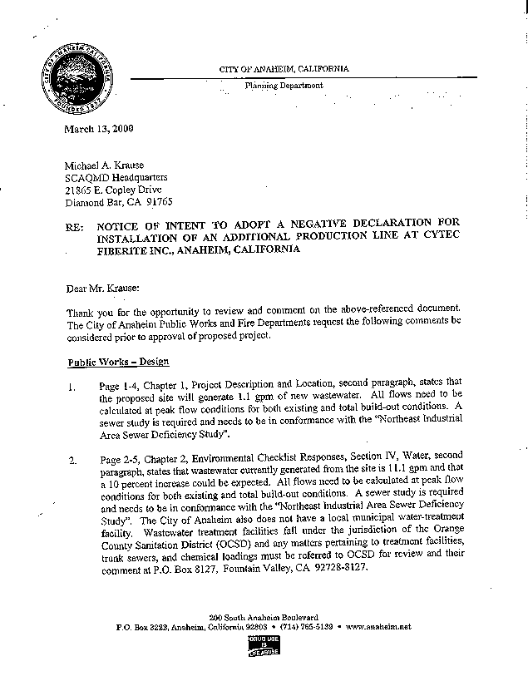
1-1
1-2
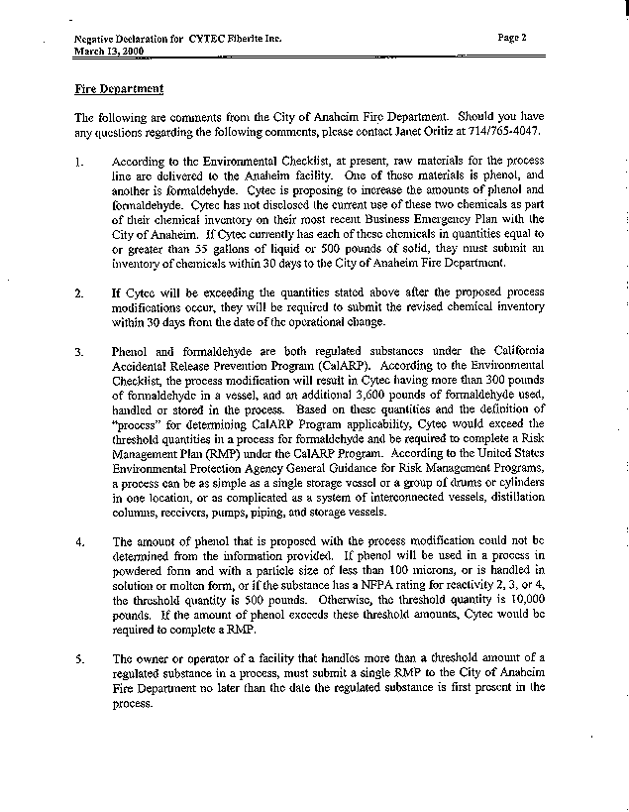
1-3
1-4
1-5
1-6
1-7
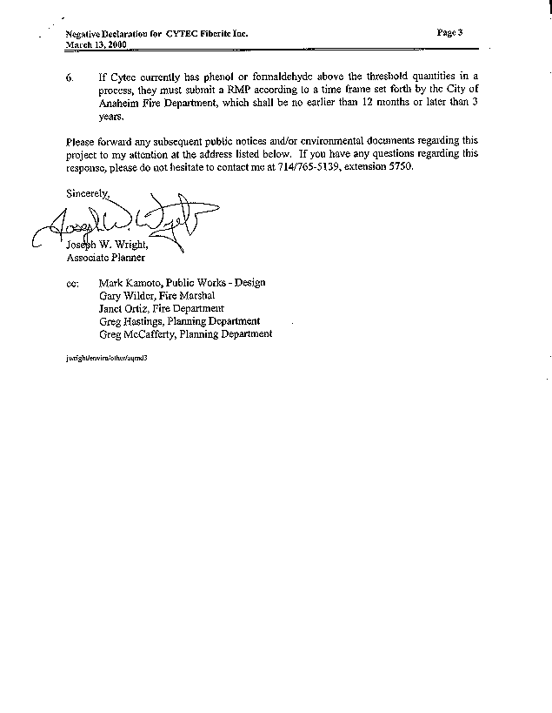
1-8

COMMENT LETTER #1
CITY OF ANAHEIM, CALIFORNIA
(MARCH 13, 2000)

1-1 The total wastewater flow for the (current) entire facility is 16,000 gallons per production day (gppd). The post-project average flow will increase by 10% to 17,600 gppd due to an increase in the number of employees at the facility. Accordingly to the City of Anaheim, Public Works Engineering Department, Sewer Design Manual, the peak flow rate is 32,000 gppd, and the post-project peak flow rate would be 35,3000 gppd.

The project site is located in Basin 204 of the Northeast Industrial Area Sewer System. The design capacity for the Basin 204 collector system is 400,860 gpd. If the maximum potential peak flow were to occur, the requirement for additional capacity due to the proposed project would be less than 1% of the design capacity.

The Negative Declaration has been revised to reflect the pre and post-project peak flow rates for wastewater. The peak flows and potential impact to the sewer system are addressed in Section IV WATER.

1-2 Wastewater generation is addressed in the Negative Declaration Section IV WATER. See response to comment 1-1. Also, the document has been revised to reflect that the wastewater from the Cytec Fiberite facility is treated at the Orange County Sanitation District facilities.

1-3 A revised Business Emergency Plan chemical inventory that includes phenol and formaldehyde containing materials has been submitted to the City of Anaheim Fire Department. If the quantities stored onsite change after the proposed project, the Business Emergency Plan chemical inventory will be updated and submitted to the City of Anaheim Fire Department within thirty days of the date of the operational change.

1-4 The Business Emergency Plan has been revised. See response to comment 1-3.

1-5 Although the Cytec Fiberite facility does not now, nor would it with the proposed project, have any single process or storage vessel that exceeds the threshold quantities for phenol and formaldehyde, the cumulative storage of materials in drums would exceed the CalARP threshold quantity. Cytec Fiberite will prepare a Risk Management Plan (RMP) under the CalARP Program. The RMP will be submitted, to the City of Anaheim Fire Department, which is also the CUPA. In accordance with recent guidance from the City of Anaheim Fire Department (April 7, 2000), the RMP will be submitted no later than April 2001. Section IX HAZARDS has been revised accordingly.

1-6 See response to comment 1-5.

1-7 See response to comment 1-5.

1-8 See response to comment 1-5.

