SOUTH COAST AIR QUALITY MANAGEMENT DISTRICT

Final Environmental Assessment for

Proposed Rule 410 – Odors from Transfer Stations and Material Recovery Facilities

September 2006
SCAQMD No. 060706JK

Executive Officer
Barry R. Wallerstein, D. Env.
Deputy Executive Officer
Planning, Rule Development, and Area Sources
Elaine Chang, DrPH
Assistant Deputy Executive Officer
Planning, Rule Development, and Area Sources
Laki Tisopulos, Ph.D., P.E.
Planning and Rules Manager
CEQA and Socioeconomic Analysis
Susan Nakamura

Author: James Koizumi, Air Quality Specialist

Technical Robert Gottschalk, Air Quality Specialist
Assistance:

Reviewed By: Steve Smith, Ph.D. – Program Supervisor
Andrew Lee – Program Supervisor
John Olvera – Senior Deputy District Counsel
South coast air quality management district
governing board

CHAIRMAN: WILLIAM A. BURKE, Ed.D.
Speaker of the Assembly Appointee

VICE CHAIRMAN: S. ROY WILSON, Ed.D.
Supervisor, Fourth District
Riverside County Representative
MEMBERS:

MICHAEL D. ANTONOVICH
Supervisor, Fifth District
Los Angeles County Representative

JANE W. CARNEY
Senate Rules Committee Appointee

Ronald O. Loveridge
Mayor, City of Riverside
Cities Representative, Riverside County

GARY OVITT
Supervisor, Fourth District
San Bernardino County Representative

JAN PERRY
Councilmember, Ninth District
Cities Representative, Los Angeles County, Western Region

MIGUEL A. PULIDO
Mayor, City of Santa Ana
Cities Representative, Orange County

Tonia Reyes Uranga
Councilmember, City of Long Beach
Cities Representative, Los Angeles County, Eastern Region

JAMES SILVA
Supervisor, Second District
Orange County Representative

CYNTHIA VERDUGO-PERALTA
Governor's Appointee

DENNIS YATES
Mayor, City of Chino
Cities Representative, San Bernardino County

EXECUTIVE OFFICER:

BARRY R. WALLERSTEIN, D.Env.
PREFACE
This document constitutes the Final Environmental Assessment (EA) for Proposed Rule (PR) 410 – Odors from Transfer Stations and Material Recovery Facilities. The Draft EA was released for a 30-day public review and comment period from July 21, 2006, to August 22, 2006. Four comment letters were received from the public. To facilitate identifying modifications to the document, modifications to the document are included as underlined text and text removed from the document is indicated by strikethrough.
The Draft EA contained the July 19, 2006 version of PR 410. Modifications have been made to the proposed Draft EA in accordance with changes to the Staff Report and Proposed Rule for clarity and continuity.
None of the modifications alter any conclusions reached in the Draft EA, nor provide new information of substantial importance relative to environmental impacts in the draft document that would require recirculation of the Draft EA pursuant to California Environmental Quality Act (CEQA) Guidelines §15073.5.

Table of contents
CHAPTER 1 - PROJECT DESCRIPTION

Introduction 1-1
Legislative Authority 1-1
California Environmental Quality Act 1-1
Project Objective 1-2
Project Location 1-2
Regulatory Background 1-3
Project Description 1-5
Transfer Station and Material Recovery Facility Operations 1-9
Affected Facilities 1-10
Odor Background 1-11
Available Control Technologies 1-12

CHAPTER 2 - ENVIRONMENTAL CHECKLIST

Introduction 2-1
General Information 2-1
Environmental Factors Potentially Affected 2-1
Determination 2-2
General Effects of the Proposed Project 2-3
Environmental Checklist and Discussion 2-5

FIGURES
Figure 1-1 – South Coast Air Quality Management District 1-3
Figure 1-2 – Total Odor Complaints for Five-Year Period 1-11
Figure 1-3 - Distribution of Facilities and Verified Odor Complaints 1-12
Tables
Table 1-1 – Permitted Throughput Range of Facilities Subject to
PR 410 1-18
Table 2-1 – Air Quality Significance Thresholds 2-9
Table 2-2 – Construction Impacts from Installation of Two Tilt-up
Walls and Three Wind Barriers 2-10
Table 2-3 – Operational Emission Summary 2-12
Table 2-4 – City of Los Angeles Noise Requirements 2-32
Table 2-5 – Typical Construction Noise Sources 2-32

APPENDICES

APPENDIX A – ABBREVIATIONS AND ACROYNMS
APPENDIX B – PROPOSED RULE 410
APPENDIX C – ASSUMPTIONS AND CALCULATIONS
APPENDIX D – COMMENT LETTERS ON THE DRAFT ENIVRONMENTAL ASSESSMENT AND RESPONSES TO COMMENTS

C H A P T E R 1 - P R O J E C T D E S C R I P T I O N

Introduction
Legislative Authority
California Environmental Quality Act
Project Objective
Project Location
Regulatory Background
Project Description
Transfer Station and Material Recovery Operations
Affected Facilities
Odor Background
Available Control Technologies

introduction
In accordance with the California Environmental Quality Act (CEQA), the South Coast Air Quality Management District (SCAQMD), as the Lead Agency, has prepared this draft Final Environmental Assessment for Proposed Rule (PR) 410 – Odors from Transfer Stations and Material Recovery Facilities. PR 410 is designed to reduce odors from facilities conducting transfer and sorting operations. Transfer stations are where municipal solid waste, greenwaste, and construction and demolition materials are transferred from small vehicles such as refuse trucks to large transfer trucks for transport to landfills, recycling centers, and other disposal sites. Material recovery facilities (MRFs) sort and separate recyclable materials from solid waste.

PR 410 is a direct result of an odor control strategy for solid waste facilities proposed in the Cumulative Impacts White Paper, which was approved by the Governing Board in September 2003. The proposed odor rule was developed as a result of reviewing SCAQMD records, which showed a number of nuisance odor complaints from transfer stations and MRFs.

Throughout this document, references to the proposed project or PR 410 are used interchangeably.

LEGISLATIVE AUTHORITY
The California Legislature created the SCAQMD in 1977 as the agency responsible for developing and enforcing air pollution control rules and regulations in the South Coast Air Basin (Basin) and in portions of the Salton Sea Air Basin and Mojave Desert Air Basin. The SCAQMDs Air Quality Management Plan (AQMP) does not contain any control measures to reduce odors from transfer stations or MRFs. PR 410 is a direct result of a strategy proposed in the White Paper on Potential Control Strategies to Address Cumulative Impacts from Air Pollution (Cumulative Impacts White Paper). In September 2003, the Governing Board approved the Cumulative Impacts White Paper, including Control Strategy #10, recommending development of a Pilot Odor Abatement Program in order to prevent exposure to odors. Due to a number of nuisance odor complaints from transfer stations and processing facilities, this industry was selected for development of the pilot odor rule.

california environmental quality act (ceqa)
PR 410 is a “project” as defined by CEQA Guidelines §15378 and California Public Resources Code §21065. SCAQMD is the lead agency for this project and has prepared this draft Final EA with no significant adverse environmental impacts pursuant to its certified regulatory program. California Public Resources Code §21080.5 allows public agencies with certified regulatory programs to prepare a plan or other written document in lieu of an environmental impact report or negative declaration once the Secretary of the Resources Agency has certified its regulatory program. The SCAQMD’s regulatory program was certified on March 1, 1989, and is codified as SCAQMD Rule 110.

An environmental impact is defined as an impact to the physical conditions that exist within the area which would be affected by a proposed project, including land, air, water, minerals, flora, fauna, noise, or objects of historic significance. CEQA and Rule 110 both require that potential significant adverse environmental impacts of proposed projects be evaluated, and that feasible methods to reduce or avoid these significant adverse environmental impacts be implemented. To fulfill the purpose and intent of CEQA, the SCAQMD has prepared this draft Final EA to address the potential significant adverse environmental impacts associated with implementing PR 410. The draft Final EA is a public disclosure document intended to: (a) provide the lead agency, responsible agencies, decision makers and the general public with information on the environmental effects of the proposed project; and (b) be used as a tool by decision makers to facilitate decision making on the proposed project.

SCAQMD's review of the proposed project shows that the project would not have significant adverse effects on the environment. Therefore, no alternatives or mitigation measures are required to be included in this draft Final EA to avoid or reduce any significant effects on the environment (CEQA Guidelines §15252(b)(2)). The environmental checklist and discussion in Chapter 2 supports the conclusion of no significant adverse environmental impacts.

All comments received during the public comment period on the analysis presented in this draft EA will be responded to and included in the Final EA. The Draft EA was released for a 30-day public review and comment period from July 21, 2006, to August 22, 2006. Four comment letters were received from the public on the Draft EA during the public review and comment period. The comment letters and responses to those comments are included as Appendix D of this Final EA. Prior to making a decision on the proposed project, the SCAQMD Governing Board must review and certify the Final EA as providing adequate information on the potential adverse environmental impacts of PR 410.

PROJECT OBJECTIVE
The objective of PR 410 – Odors from Transfer Stations and Material Recovery Facilities, is to reduce odors from transfer station and MRF operations to reduce public exposure to nuisance odors.

project location
The SCAQMD has jurisdiction over an area of 10,473 square miles (referred to hereafter as the district), consisting of the four-county South Coast Air Basin (Basin) (Orange County and the nondesert portions of Los Angeles, Riverside, and San Bernardino counties) and the Riverside County portions of the Salton Sea Air Basin (SSAB) and the Mojave Desert Air Basin (MDAB). The Basin, which is a subregion of the SCAQMD’s jurisdiction, is bounded by the Pacific Ocean to the west and the San Gabriel, San Bernardino, and San Jacinto Mountains to the north and east. The Los Angeles County portion of the MDAB (known as North County or Antelope Valley) is bounded by the San Gabriel Mountains to the south and west, the Los Angeles/Kern County border to the north, and the Los Angeles/San Bernardino County border to the east. The Riverside County portion of the SSAB is bounded by the San Jacinto Mountains to the west and spans eastward up to the Palo Verde Valley. The federal nonattainment area (known as the Coachella Valley Planning Area) is a subregion of Riverside County and the SSAB that is bounded by the San Jacinto Mountains to the west and the eastern boundary of the Coachella Valley to the east (Figure 1-1).
Figure 1-1
South Coast Air Quality Management District

REGULATORY BACKGROUND
PR 410 is a direct result of a strategy proposed in the Cumulative Impacts White Paper. In September 2003, the Governing Board approved the Cumulative Impacts White Paper, including Control Strategy #10, recommending development of a Pilot Odor Abatement Program in order to prevent exposure to odors. Due the high number of nuisance odor complaints from transfer stations and processing facilities, this industry was selected for rule development of the pilot odor rule. The following subsections briefly describe the SCAQMD’s existing rule that addresses odors and explains why there has been a proliferation of transfer stations and MRFs.

Rule 402 - Nuisance
Rule 402 prohibits the discharge of air contaminants or other material form from any type of operations which can cause nuisance or annoyance to any considerable number of people or to the public or which endanger the comfort or repose of any such persons, or the public. Historically, some transfer stations and MRFs that cause a public emit nuisance because of odors have been cited for violation of Rule 402.

Under Rule 402, a Notice of Violation (NOV) for public nuisance can only be issued after the AQMD receives public complaints. Generally, a certain number of public complaints must be received to constitute a “public nuisance.” There are limitations, however, with the implementation of Rule 402 to address complaints from odors from transfer stations and MRFs. Rule 402 is a reactive approach to public complaints, since AQMD staff must wait for public complaints prior to taking enforcement action. Often, there is a lag in time between the complaint and inspector verification of an odor, making it difficult to address specific odor issues. In addition, Rule 402 does not establish minimum standards to minimize or reduce odors.

Rule 1131.1 - Chipping and Grinding Activities
Rule 1133.1 establishes holding or processing (i.e., chipping and grinding or on-site applications) time requirements for greenwaste and foodwaste chipping and grinding activities in order to prevent inadvertent decomposition associated with stockpiling greenwaste or foodwaste for extended periods of time. The holding/processing times established for foodwaste and various types of greenwaste (curbside, non-curbside, mixed) are primarily in-line with normal practice of chipping and grinding operations and do not interfere with AB 939 diversion goals (waste diversion from landfills). Rule 1133.1 does not address odors from handling and transfer of greenwaste that is not used in a chipping and grinding operation.

AB 939
In 1989, Assembly Bill 939, (Integrated Waste Management Act), was adopted due to a statewide increase in the waste stream and decrease in landfill capacity. AB 939 mandates a reduction of waste being disposed. Diversion goals were set at 25 percent by 1995 and 50 percent by 2000. The diversion rate is the percentage of the total amount of waste that is diverted from disposal at a landfill through reduction, reuse, recycling, composting or energy from waste programs.

As a result of AB 939, the California Integrated Waste Management Board (CIWMB) was established. Regulations developed to implement AB 939 are codified under Title 14 and Title 27 of the California Code of Regulations. Regulations specific to transfer stations and MRFs are contained in Title 14, Chapter 3, Article 6. This article contains operating standards and other regulatory requirements for the following facilities and operations:
- Sealed container transfer operations;
- Limited volume transfer operations;
- Direct transfer facilities;
- Emergency transfer/processing operations;
- Medium volume transfer/processing facilities; and
- Large volume transfer/processing facilities.

Solid waste transfer stations are facilities where municipal solid waste, green waste, and construction and demolition materials are transferred from smaller vehicles such as refuse trucks to larger transfer trucks for transport to landfills, recycling centers, and other disposal sites. Transfer trucks can generally hold 100 cubic yards representing three to five loads from refuse trucks. MRFs sort and separate recyclable materials from solid waste. Recyclable materials are transported to recyclers and the remaining non-recyclable solid waste is transported to landfills or other disposal sites.

To minimize the distances that refuse trucks travel between residents and commercial establishments, some transfer stations are located near residential communities. As a result, odors often emanate off-site causing a nuisance to residences and businesses. The SCAQMD’s Rule 402 – Nuisance, prohibits public nuisances such as odors. Some transfer stations and MRFs have been issued Notices of Violations under Rule 402 due to odor complaints.

PROJECT DESCRIPTION
Proposed Rule 410 is designed to complement Rule 402. Proposed Rule 410 establishes minimum requirements for transfer stations and MRFs and offers a proactive approach to minimizing odors. Odors from transfer stations and MRFs are very site-specific, and depend upon a number of different factors, including the type of waste (municipal solid waste, greenwaste, construction and demolition materials, etc.), types of odor controls at a facility, among other factors. In addition, facility operators use a variety of operating practices to minimize offsite odors. Under Proposed Rule 410, each facility operator will be required to either submit to the SCAQMD a Rule 410 Odor Management Plan (Rule 410 OMP) or voluntarily submit to the Local Enforcement Agency (LEA) an Alternative Odor Management Plan (AOMP). At a minimum, both the Rule 410 OMP and the AOMP will include the methods or techniques the facility operators would use to minimize odors from their tipping floors. In addition, facilities with permitted throughputs greater than 1000 tons per day (TPD) are required to identify techniques used to minimize odors in transfer tunnels, MRFs, and green waste operations. In addition, the OMPs must specify housekeeping requirements and include a community response protocol to respond to community complaints pertaining to odors.

Proposed Rule 410

(a) Purpose
Proposed Rule 410 will establish odor management practices and requirements to reduce odors from MSW transfer stations and MRFs. The proposed rule will be implemented in addition to existing enforcement of public nuisance under Rule 402.

(b) Applicability
The proposed rule applies to new and existing transfer stations and MRFs located in the district that have a permit issued by a LEA with a permitted throughput of MSW of greater than 100 tons per day or greater. MSW is defined as including food waste, yard trimmings, greenwaste, and other waste. It does not apply to direct transfer facilities, facilities handling only nonhazardous ash, and facilities handling only construction and demolition and inert debris, sealed container transfer operations, and recycling centers.
(c) Definitions
This subdivision lists keywords related to municipal solid waste and related operations and defines them for clarity and to enhance enforceability. Please refer to Appendix B for a copy of PR 410 and its definitions.

(d) Enclosure Requirements for New and Modified Source Facilities
New and modified facilities have two compliance options. The first option is to enclose the tipping, sorting and transfer operations. The second option is to demonstrate an appropriate buffer zone around the facility. New facilities are those that begin operation on and after the date of rule adoption, that have an operating permit issued by a LEA to tip more than 1,000 tons per day, and modified facilities are those with an incremental increase in permitted throughput due to an increase of MSW of more than 1,000 tons per day in an approved permit, issued on or after January 2008 by a LEA; or facilities with a cumulative throughput of more than 3,000 tons per day after modification. Construction and demolition (C&D) debris does not have significant odor-generating potential. Therefore, in cases where a separate limit is given for C&D debris, permitted throughput will be taken as total throughput in tons/day, minus C&D debris in tons/day. For facilities that choose to enclose the tipping sorting and transfer operations, they must meet design criteria for inward face velocity and percentage of enclosure opening.

(e) Odor Management Plan (Rule 410 OMP) Compliance Dates
The owner or operator of a facility subject to this rule shall comply by having an approved OMP or Alternative OMP by:
(A) On or before January 1, 2008, for existing facilities, or upon date of issuance of a revised solid waste facility operating permit that will incorporate the requirements of an Alternative OMP provided the owner or operator submits an application to the LEA for a permit revision at least 180 days prior to January 1, 2008, or other date approved by the Executive Officer, but not later than January 1, 2008; or
(B) Before increasing permitted throughput for any facility for which permitted throughput is increased after January 1, 2008; or
(C) Before commencing operations or by January 1, 2008, whichever is later, for a new facility

(f) Rule 410 Odor Management Plan (OMP)
All existing, new and modified facilities subject to this rule are required to submit a Rule 410 Odor Management Plan (OMP) or an Alternative OMP. The two submittal options are: (1) submit a Rule 410 OMP directly to the SCAQMD or; (2) voluntarily submit an AOMP to the SCAQMD that has been approved by the facility’s LEA and is incorporated in a solid waste facility operating permit, Transfer/Processing Report (T\PR) or Report of Facility Information (RFI) or other enforceable document issued by the LEA. Both OMPs must address: odor control from the tipping floor; waste transfer tunnels; MRF; housekeeping activities for the tipping floor, transfer tunnel and facility perimeter; and community response (installation of a contact sign, identification of a Community Coordinator, and odor complaint protocol).

The owner or operator of a facility complying with a submittal of a Rule 410 OMP, shall submit to the Executive Officer the necessary information on or before:
(A) (180 days after date of adoption) for existing facilities; or
(B) July 1, 2007, for new facilities that begin operations prior to January 1, 2008; or
(C) 180 days prior to commencing operations, for new facilities that begin operations after January 1, 2008; or
(D) 180 days prior to increasing permitted throughput, for any facility for which permitted throughput is increased after January 1, 2008; or
(E) 180 days from the date of occupancy of any residence, building or school for an existing facility subject to this rule that was previously exempt from submitting an OMP under paragraph (i)(2) because there was no residence, building or school within 2000 feet of the facility.

The owner or operator of an affected facility who submits a Rule 410 OMP would be required to provide all information under the “Required Elements” if permitted throughput is greater than 100 tons per day, but only those greater than 250 tons per day are to report greenwaste information. If the permitted throughput exceeds 250 tons per day and is less than or equal to 1,000 tons per day, information under the “Required Elements” and “Level 1 Control Strategies” must be provided. If the permitted throughput exceeds 1,000 tons per day, information under the “Required Elements” and “Level 2 Control Strategies” must be provided.

Facility operators who modify their operations would be required to submit an updated Rule 410 OMP under any of the following conditions; if permitted throughput increases are from below 250 tons per day to greater than or equal to 250 tons per day or permitted throughput increases from less than 1,000 tons per day to greater than or equal to 1,000 tons per day. Alternatively facility operators with permitted increase less than 1,000 tons per day to greater than or equal to 1,000 tons per day may submit a letter to the Executive Officer 180 days prior to increasing throughput explaining that their existing Rule 410 OMP already addresses all information required for facilities with a permitted throughput greater than 1,000 tons per day.

Within 60 days after notification from the Executive Officer that a previously approved Rule 410 OMP does not adequately address odors from any odor generating source at the facility, the owner or operator would be required to revise and resubmit an updated Rule 410 OMP. An approved Rule 410 OMP shall remain in effect until an updated Rule 410 OMP is approved by the Executive Officer.
Within 60 days after making a change to Section 1 or 2 under “Required Elements,” the owner or operator of a facility subject to this rule is required to revise and resubmit a Rule 410 OMP to the Executive Officer.
The Executive Officer will approve or disapprove a Rule 410 OMP within 180 days after submittal. If the OMP is disapproved, the owner or operator must resubmit the OMP within 60 days after notification of disapproval. The resubmitted OMP must include any information necessary to address deficiencies identified in the disapproval letter.

Approved Rule 410 OMP requirements would need to be posted, clearly visible for operators and inspectors, or as approved by the Executive Officer; and made available upon request to SCAQMD personnel. The owner or operator of a facility with an approved Rule 410 OMP will be required to conduct operations in a manner designated in the approved Rule 410 OMP and comply with all conditions in the approved Rule 410 OMP.

(g) Alternative Odor Management Plan (AOMP)
In lieu of filing a Rule 410 OMP, a facility operator may voluntarily submit an AOMP to the appropriate LEA and obtain enforceable permit conditions in a solid waste facility operating permit, Transfer\Processing Report (T\PR) or Report of Facility Information (RFI), or other document issued by the LEA that have enforceable permit conditions in an operating permit issued by the LEA that address all applicable aspects of the Rule 410 OMP. A facility choosing to submit an AOMP to the LEA is required to file a copy of the approved AOMP with SCAQMD, including the operating permit, T/PR or RFI or other enforceable document issued by the LEA, and written documentation from the LEA of the approval date of the AOMP.

Any facility that was exempt from filing an Odor Management Plan because they were located more than 2,000 feet from any residence, building or school, per exemption (i)(2), will have 180 days from the date of occupancy of any residence, building or school within 2,000 feet to submit all the necessary information for an AOMP.

Approved AOMP requirements would need to be posted, clearly visible for operators and inspectors, or as approved by the Executive Officer; and made available upon request to SCAQMD personnel.
(h) Modifications to Alternative Odor Management Plan (OMP)
Under Proposed Rule 410, modifications to an Alternative OMP can occur if the facility increases its permitted throughput, or if the LEA notifies the facility that a modification to an existing Alternative OMP is needed. At least 180 days prior to increasing permitted throughput, the owner or operator of a facility that increases the permitted throughput must either update and submit the Alternative OMP with all required information; or submit a letter to the LEA explaining that the existing Alternative OMP already addresses all required information.
Under Proposed Rule 410, the Rule 410 OMP serves as a backstop for the Alternative OMP. If the LEA finds that the current Alternative OMP is not sufficient to minimize off-site odor, the LEA can require that facility to modify their Alternative OMP. The facility will be required to do the following:
- Within 60 days from notification from the LEA to modify an Alternative OMP, the owner or operator of a facility must submit a modified Alternative OMP to the LEA.
- Within 180 days from notification from the LEA to modify an Alternative OMP, the owner or operator of a facility must submit an approved modified Alternative OMP to the Executive Officer.
- If the owner or operator of a facility does not comply with the 60-day and 180-day Alternative OMP re-submittal requirements, the owner or operator is required to submit a Rule 410 OMP within 240 days after notification from the LEA to modify an Alternative OMP. The approved Alternative OMP will remain in effect until a Rule 410 OMP is approved by the Executive Officer.

(i) Exemptions
The following operations are not subject to the provisions of PR 410:
- composting operations subject to Rule 1133; and
- chipping and grinding operations subject to Rule 1133.1; and
- co-composting operations subject to Rule 1133.2; and
- transfer and handling of construction and demolition debris.

Proposed Rule 410 includes an exemption for facilities that are located in a remote location where there are no residences, buildings or schools within 2,000 feet. Facilities subject to this rule that are located more than 2,000 feet from any residence, building or school are not required to submit an Odor Management Plan (OMP). This is a continuous demonstration. Thus, if a residence, building or school is located within 2,000 feet of the transfer station or MRF, that facility would be required to submit an OMP or AOMP.

(j) Rule 410 OMP and Alternative OMP Plan Fees
Submittal of an OMP or an approved AOMP will constitute a plan for the purposes of fees assessed under Rule 306 - Plan Fees.

Appendix A - Rule 410 Odor Management Plan
This appendix contains “Required Elements”, and Level 1 and Level 2 “Control Strategies” to be included in a Rule 410 OMP. The “Required Elements” are mandated for all facilities subject to this rule with a permitted throughput of 100 tons per day or greater and are pertinent to the facility’s logistics, community response protocol and signage, housekeeping practices, protocol for handling odiferous loads, and logging of complaints. For larger facilities there is a requirement to install a weather monitoring station as well as logging the information.

In order to be approved, an OMP must contain all the following Required Elements:
- Facility information, including name, address, contact person and contact information;
- Permitted throughput for all types of waste processed;
- Identification, description, and odor control strategies for facilities handling and transfering greenwaste;
- Information on buffer zone, including distance to the nearest residence and sensitive receptor;
- Identification, description, and method of controlling odorsfor facilities handling recyclable materials;
- A protocol for handling community complaints, including contact information on a Community Coordinator, and a requirement to conduct an odor survey when the facility receives odor complaints;
- A requirement for a contact sign so that members of the surrounding community can contact the facility directly with odor complaints;
- A requirement to maintain a paper written log of all odor complaints received;
- A protocol for handling odiferous loads;
- Housekeeping activities, including minimum sweeping frequency for the tipping floor, transfer tunnel and facility perimeter;
- A minimum requirement for covering and parking trucks and trailers that are preloaded for transportation to a landfill or other disposal destination on the following day.

The Level 1 and Level 2 “Control Strategies” are menus of control options that can be used to control odors that pertain to specific odor generating areas of the facility such as the tipping floor, transfer tunnel, and MRF operations. Additionally, for those facilities with permitted throughput greater than 1,000 tons per day, a requirement to install, operate and maintain a weather monitoring station.

Level 1 -Control Strategies for Facilities Permitted Throughput Greater Than 250 Tons per Day and Less Than 1,000 Tons per Day

Odor Emission Point | Control Strategy
Tipping Floor | Handheld or overhead misting system; or
Tipping Floor | Wind barriers surrounding two sides of tipping area; or
Tipping Floor | Partial enclosure; or
Tipping Floor | Complete Full enclosure; or
Tipping Floor | Buffer zone; or
Tipping Floor | Permitted throughput less than 500 tpd and buffer zone; or
Tipping Floor | Other equivalent odor control method approved by EO

Level 2: Control Strategies for Facilities with Permitted Throughput Greater Than 1,000 Tons per Day

Odor Emission Point | Control Strategy
 |  | and
Tipping Floor | Partial enclosure; or | Handheld or overhead misting system
Tipping Floor | Full enclosure; or | Handheld or overhead misting system
Tipping Floor | Buffer zone; or
Tipping Floor | Other equivalent odor control method approved by EO
Transfer Tunnel | Physical barriers at entrance or exit to the transfer tunnel; or
Transfer Tunnel | Maximum drop height from the tipping floor into transfer trucks of three feet or less; or
Transfer Tunnel | Misting system at the entrance or exit to the transfer tunnel; or
Transfer Tunnel | Buffer zone; or
Transfer Tunnel | Other equivalent odor control method approved by EO
Material Recovery Facility | Partial enclosure; or
Material Recovery Facility | Full enclosure; or
Material Recovery Facility | Buffer zone; or
Material Recovery Facility | Other equivalent odor control method approved by EO

Transfer Station and Material Recovery Facility Operations

Types of Transfer Stations
There are several common types of transfer stations, including:

- Direct tipping to trailers – Waste collection trucks and other vehicles tip directly into a transfer truck. Transfer trucks typically hold 100 cubic yards and can accommodate three to five loads from waste collection trucks or many pickup loads.
- Tipping on a floor – This is the most typical arrangement for facilities subject to PR 410. Tipping of solid waste from a refuse truck onto a floor allows more efficient loading of transfer trucks than direct tipping to trailers, because the tipping floor provides a larger buffer waste capacity than direct tipping to trailers. The tipping floor also provides a place to extract recyclables, if the waste is not source-separated, and space to inspect for hazardous or other undesirable waste. A front loader is typically used to push waste into transfer trucks.
- Pit tipping – In this arrangement, refuse trucks tip their load into a large pit, allowing several trucks to unload simultaneously. This allows waste to be stored temporarily during peak operating hours. The pit may have either a walking floor in the bottom of the pit or it may have loaders to push the waste around. An advantage to pit dumping is having a tractor in the pit to crush the waste and maximize trailer loads.

These three types of transfer stations are usually configured so that transfer trucks with open-top trailers are loaded at a level below the tipping area. A clamshell or bucket is sometimes used to load transfer trucks to obtain maximum payload, level the load, remove undesirable materials, and to move piles of waste on the tipping floor.

The typical transfer arrangement routes transfer trucks down a one-way tunnel to the loading areas, and loaded trucks emerge on the opposite side of empty trucks.

Most transfer stations subject to PR 410 use open top trailers in a top-loading arrangement. Waste is not compacted in open-top trucks. Transfer trucks are required to be covered en route to the landfill to prevent windblown debris from the trailer during transit, so trailers normally have a tarp or other membrane that is secured over the top of the load prior to transporting the waste.

Some transfer stations may use a compactor. Using a compactor station, waste is loaded into the hopper of a stationary compactor. Trucks back up to the compactor and the waste is pushed into the trailer as a compacted slug. These operations use a rear-loading arrangement. Transfer trucks used with a compactor use reinforced trailers.

Municipal solid waste can only remain on site at a transfer station for a maximum of 48 hours, by CIWMB regulations, and operating permit conditions.

Material Recovery Facilities
A MRF accepts materials, whether source separated or mixed, and separates processes and stores them for later use as raw materials for remanufacturing and reprocessing. After separation, residual waste is disposed offsite. Often, MRFs are located at the same site as transfer stations.

Separation of recyclable materials may be accomplished by mechanical means, including:
- Disc screens – used to separate materials by size.
- Trommels – rotating cylindrical screens inclined at a downward angle, where separation occurs as material travels down the drum.
- Air classification – utilized to separate light materials like aluminum, cartons, and plastics from heavier materials using an air stream.
- Non-ferrous metal separators, such as rotating disc separators, which set up an electrical current in non-ferrous materials causing them to be deflected.
- Detect and route (DAR) systems can be used to separate glass, plastic and cartons. In a DAR system, materials are identified by sensors and are removed from the waste stream when the conveyor passes the appropriate diversion point. Lighter materials can be diverted by air jets aligned along one wall of the conveyor. Heavier objects can be diverted by a ram or tilt plate.

Separation of recyclables may also be accomplished manually. Often a MRF will utilize both mechanical and manual separation.

Greenwaste Transfer and Handling Activities
Greenwaste is any organic waste material generated form gardening, agricultural, or landscaping activities, including, but not limited to, leaves, grass clippings, tree and shrub trimmings and plant remains. Schedules for grinding or removal of greenwaste are addressed in Rule 1133.1 – Chipping and Grinding Activities. Greenwaste transfer activities in the district are typically completed in unenclosed areas. Greenwaste can remain at a transfer station for up to seven days

Affected facilities
There are 141 existing transfer stations and MRFs in the district. Of the 141 existing transfer stations and MRFs, 93 of the facilities have less than 100 tons per day of throughput; therefore, would not be subject to PR 410. Of the existing facilities, 40 have permitted throughput of 250 tons per day or greater for the purpose of storing, handling, or processing the waste prior to transferring the waste to another solid waste operation or facility. Eight of the active transfer stations and MRFs have a permitted throughput of greater than 100 tons per day and less than or equal to 250 tons per day.

The one planned MRF already complies with the PR 410 requirements for new facilities odor requirements; therefore, would not require any construction or operational changes because of PR 410. SCAQMD staff as not identified any other planned transfer stations or MRF at this time that would be required to comply with PR 410 requirements.

Existing facilities were analyzed for the numbers of nuisance odor complaints and Notices of Violation (NOVs) they have received over a five year period. As explained in the following subsection, adoption of PR 410 included evaluating NOVs and odor complaints received by affected facilities as well as interviews of SCAQMD compliance staff who visited the affected facilities.

Data Resources
During this rule development process, SCAQMD staff visited over 15 facilities to review the operating practices and equipment used for odor control. The throughput of the facilities visited ranged from 400 tons per day to 6,000 tons per day. SCAQMD compliance personnel are familiar with many of the other facilities subject to PR 410 from prior visits and were interviewed about the operating configurations, odor control equipment and operating practices of facilities they visited. In addition, SCAQMD staff worked with the LEA to obtain additional data on facilities affected by PR 410.

For each facility information was collected on throughput, enclosure configuration, use of misting systems at the tipping floor, and greenwaste handling operations, among other data. Numerous site visits provided insight into the typical housekeeping activities, including sweeping schedules, storage of recycled products, and other information leading to potential odors at offsite locations, such as residential neighborhoods.

The range of permitted throughput, for existing facilities is given in Table 1-1 Permitted throughput is the throughput allowed in tons per day in a facility’s operating permit, issued by the LEA. The permit may or may not specify a throughput limit for the individual components of the waste stream that are allowed by the permit. For example, a permit issued to a transfer station may allow greenwaste, construction and demolition materials, or other types of waste in addition to municipal solid waste. However, permit limits are often given only for the total throughput.

Table 1-1
Permitted* Throughput Range of Facilities Subject to PR 410

Throughput Tonnage (tons/day) | Number of Facilities
100 - 250 | 8
251 - 500 | 8
501 - 1,000 | 5
1001 - 2,000 | 16
2001 - 5,000 | 9
>5,000 | 2
Total | 48
*Permitted throughput is the throughput a facility is allowed in the operating permit issued by the LEA.

ODOR BACKGROUND

Odor Complaint Data
Transfer stations and MRFs in the district were analyzed for the numbers of nuisance odor complaints and Notices of Violation (NOVs) they received from January 2001 through December 2005. During that five-year period, a total of 2,352 complaints were received, from 13 facilities. Of the 2,352 total complaints, 1,549 were verified by SCAQMD inspectors. In general, a “verified” complaint is characterized by the following:
- An SCAQMD inspector responds to the complaint;
- The inspector smells the odor the complainant described; and
- The inspector traces the odor back to its source.

Once an odor complaint has been verified, additional action may be taken by the inspector, depending on the length and severity of the odor problem, and the number of people that have complained. This may include issuance of a NOV for public nuisance.

In addition to odor complaints, the number of NOVs issued to each facility in the PR 410 universe was also evaluated for the period from January 2001 through December 2005. The number of odor complaints for the five-year period from January 2001 through December 2005, shown in Figure 1-2, averaged 470 per year.

Figure 1-2 – Total Odor Complaints for Five-Year Period

Some complaints can be verified and correlated to a specific facility. However, other complaints cannot be attributed to a specific source, and therefore cannot be verified. Verification is sometimes complicated because there is a lag time between when the complaint is received and when an inspector arrives at the site and the inspector’s ability to trace the odor back to the source. Once an odor complaint has been verified, additional action may be taken by the inspector, depending on the length and severity of the odor problem, and the number of people that have complained. This may include issuance of a Notice of Violation for public nuisance.
The 1,549 verified complaints received over the five year analysis period were attributed to 14 of the 45 facilities. Figure 1-3 below shows the distribution of facilities and verified complaints. As shown in Figure 1-3, the AQMD did not receive complaints for 69 percent (31 facilities) of the 45 facilities. Five of the 45 facilities represented approximately 1,300 verified complaints over the five year analysis period. Thus, 11 percent of the facilities represent approximately 84 percent of the complaints.
Figure 1-3 – Distribution of Facilities and Verified Odor Complaints
(45 Facilities, 1,549 Verified Complaints)
The AQMD’s complaint database does not reflect the complaints received by the facility’s LEA or complaints received directly by the facility. The AQMD staff visited facilities that received complaints and some facilities that received no complaints or very few complaints. Based on site visits, the AQMD staff found that there are facilities with no complaints where odors are migrating off-site into populated areas. In addition, as discussed Chapter 1, there are limitations with implementation of Rule 402, as the AQMD staff must wait for public complaints prior to taking enforcement action. Thus, the AQMD staff has concluded that there is a need for Proposed Rule 410 to establish minimum standards for transfer stations and MRFs and to provide a more proactive approach.
In September 2005, CIWMB provided comments on the relevance of the data presented in the Preliminary Draft Staff Report, based on the AQMD’s raw odor complaint data for a two-year period (2003/2004). Based on the CIWMB’s data analysis of complaints that the SCAQMD staff had received between 2003 and 2004, the CIWMB identified 1,050 complaints. For that dataset, the AQMD staff identified over 1,200 complaints.
The differences between the CIWMB and AQMD analysis can be attributed in part to the nature of the raw data. When the AQMD receives a complaint, the complainant provides as much information about the complaint such as the complainant’s name, address, phone number, and the alleged source’s information such as facility name, address, description of the complaint. Unfortunately, the complainant often does not have specific information. For example a complaint may be received regarding trash odors and the street address is provided, with no facility name. The AQMD staff reviewed over thousands of nuisance complaints comparing addresses to facility information to track the facility associated with the odor nuisance. The AQMD staff believes that this detailed analysis lead to identification of more complaints than identified through the CIWMB’s analysis.
In addition to odor complaints, the number of Notices of Violation (NOV) issued to each facility subject to PR 410 was also evaluated for the period from January 2001 through December 2005. Over the five year period, 57 NOVs were issued to 12 of the 45 facilities. Three facilities represented 67 percent of the 57 NOVs issued between 2001 and 2005.

AVAILABLE CONTROL TECHNOLOGIES
PR 410 would rely on existing technologies and housekeeping practices that are currently available and, in some cases, currently employed by some of the affected facilities. No new technologies or housekeeping practices were identified during the development of PR 410 beyond those identified in the following subsections. PR 410 does allow facility operators to suggest alternative odor control techniques that are not listed in PR 410 Appendix A; however, since no new odor control techniques were identified, these unknown odor control techniques are speculative and can not be analyzed at this time. The following subsections describe the primary odor generating sources regulated by PR 410 and appropriate control technologies and housekeeping practices.

Odor Control – Tipping Floor Operations
Odors from tipping floors at transfer stations and MRFs can be controlled by the following methods:
- Misting systems (portable or overhead)
- Two sided wind barriers (without roof)
- Partial enclosures (two walls and a roof)
- Full enclosure

Odor Control – Transfer Tunnels
Odors from transfer tunnels at transfer stations and MRFs can be controlled by the following
methods at the exit of the tunnel:
- Odor barrier
- Neutralizer

Odor Control – Green Waste Operations
Odors from transfer tunnels at transfer stations and MRFs can be controlled by the following methods:
- Two sided wind barriers (without roof)
- Partial enclosures (two walls and a roof)
- Full enclosure

Odor Control – Housekeeping
- Park pre-loaded trucks out of the sun or in covered parking areas
- Cover trucks within 15 minutes after loading with an odor-impermeable membrane
- Sweeping schedule for tipping floor, transfer tunnel and facility parameter once per operating day
- Store dairy and organic containers in side, partial, or full enclosure

C H A P T E R 2 - E N V I R O N M E N T A L C H E C K L I S T

Introduction
General Information
Environmental Factors Potentially Affected
Determination
Environmental Checklist and Discussion

INTRODUCTION
The environmental checklist provides a standard evaluation tool to identify a project's adverse environmental impacts. This checklist identifies and evaluates potential adverse environmental impacts that may be created by the proposed rule.

GENERAL INFORMATION

Name of Proponent: | South Coast Air Quality Management District
Address of Proponent: | 21865 Copley Drive  Diamond Bar, CA 91765
Lead Agency Name: | South Coast Air Quality Management District
CEQA Contact Person: | James Koizumi (909) 369-3234
Rule Contact Person: | Robert Gottschalk (909) 396-2456
Name of Project : | Proposed Rule 410 – Odors from Transfer Stations and Material Recovery Facilities

Environmental Factors Potentially Affected
The following environmental impact areas have been assessed to determine their potential to be affected by the proposed project. Any checked items represent areas that may be adversely affected by the proposed project. An explanation relative to the determination of impacts can be found following the checklist for each area.

◻ | Aesthetics | ◻ | Geology and Soils | ◻ | Population and Housing
◻ | Agricultural Resources | ◻ | Hazards and Hazardous Materials | ◻ | Public Services
☑ | Air Quality | ☑ | Hydrology and Water Quality | ◻ | Recreation
◻ | Biological Resources | ◻ | Land Use and Planning | ◻ | Solid/Hazardous Waste
◻ | Cultural Resources | ◻ | Mineral Resources | ◻ | Transportation./Traffic
◻ | Energy | ◻ | Noise | ◻ | Mandatory Findings

DETERMINATION

On the basis of this initial evaluation:
☑ | I find the proposed project, in accordance with those findings made pursuant to CEQA Guideline §15252, COULD NOT have a significant effect on the environment, and that an ENVIRONMENTAL ASSESSMENT with no significant impacts will be prepared.
◻ | I find that although the proposed project could have a significant effect on the environment, there will NOT be significant effects in this case because revisions in the project have been made by or agreed to by the project proponent. An ENVIRONMENTAL ASSESSMENT with no significant impacts will be prepared.
◻ | I find that the proposed project MAY have a significant effect(s) on the environment, and an ENVIRONMENTAL ASSESSMENT will be prepared.
◻ | I find that the proposed project MAY have a "potentially significant impact" on the environment, but at least one effect 1) has been adequately analyzed in an earlier document pursuant to applicable legal standards, and 2) has been addressed by mitigation measures based on the earlier analysis as described on attached sheets. An ENVIRONMENTAL ASSESSMENT is required, but it must analyze only the effects that remain to be addressed.
◻ | I find that although the proposed project could have a significant effect on the environment, because all potentially significant effects (a) have been analyzed adequately in an earlier ENVIRONMENTAL ASSESSMENT pursuant to applicable standards, and (b) have been avoided or mitigated pursuant to that earlier ENVIRONMENTAL ASSESSMENT, including revisions or mitigation measures that are imposed upon the proposed project, nothing further is required.

Date: July 19, 2006 Signature:
Steve Smith, Ph.D.
Program Supervisor – CEQA
Planning, Rule Development, and Area Sources
GENERAL EFFECTS OF THE PROPOSED PROJECT
Implementation of PR 410 is expected to reduce odors from transfer station and MRF operations. PR 410 will provide a more proactive approach to managing and reducing odors. PR 410 does not required construction of new transfer stations or MRFs, it imposes odor control requirements on new and existing facilities. the analysis in this chapter focus only on the potential environmental impacts associated with installing odor controls. Proposals to build new transfer stations and MRFs would be subject to CEQA process prior to approval and construction.

Summary of Rule Requirements that May Impact Environmental Areas:
Odors from transfer stations and MRFs are very site-specific, and depend upon a number of different factors, including the type of waste, proximity to neighbors, types of odor controls at a facility, among other factors. In addition, facility operators use a variety of operating practices to minimize offsite odors. Under PR 410, each facility operator will be required to submit either a Rule 410 OMP or an Alternative OMP. The OMP will identify the particular type of equipment or operating practice at each potential area for odor formation. The OMP is then reviewed by the SCAQMD and approved or disapproved. Once the OMP is approved, an approval letter is issued with conditions specific to the content in the OMP. The approval letter is an enforceable document which SCAQMD inspectors can use to ensure compliance.

Proposed Odor Control for Odor Management Plans
SCAQMD staff identified 12 facilities that receive 1,000 tons per day or less of municipal solid waste. Five of the twelve facilities do not have enclosed or partially enclosed tipping floors. It is assumed that these five facilities would install misting systems, and increase housekeeping activities, such as sweeping, to reduce odors in accordance with an approved OMP.

SCAQMD staff identified 27 facilities that receive over 1,000 tons per day of solid waste. Twenty-five of the facilities currently meet the minimum standards for tipping floor odor control (misting systems or partial enclosures). SCAQMD staff assumes that, at the two facilities, operators would add additional walls to existing buildings to control odors from the tipping floor. Staff assumes that 12 facilities would need to install misting systems to reduce odors. All 27 facilities are expected to install weather stations and increase housekeeping activities.

Minimal requirements of odor management plans that may impact environmental areas include:
- Facilities that process more than 250 tons per day of greenwaste are required to conduct all greenwaste tipping, sorting and handling activities within a physical barrier.
- Within 12 hours after recycled containers that contained dairy products or other organic foodstuffs are bailed for shipment, operators are required to store the containers completely covered in a tarp or odor-impermeable membrane, in a partial enclosure or in a full enclosure, or other method approved by the Executive Officer.
- Facilities with permitted throughput greater than 1,000 tons per day are required to install a weather monitoring station or other Executive Officer approved method to monitor and record temperature, humidity, and wind speed and direction.
- Sweeping tipping floors, transfer tunnels and all areas inside and outside the facility where trash accumulates is required at least once per operating day.
- Sweeping of the tipping floor is required once every week during periods when tipping occurs.
- Sweeping or the clearing of a tipping pit, if applicable, not less than once a week.
- Operators are required to cover open-top trucks in a top-loading configuration within 15 minutes after loading. Owners or operators of facilities that pre-load transfer trucks or trailers for transportation to a landfill or other destination on any day after the trucks or trailers are loaded are required to completely cover the truck or trailer with a solid material, 18-oz vinyl tarp, or the equivalent. Tarps made from screen or other open materials do not meet this requirement. and park pre-loaded trucks or trailers in a covered location within 60 minutes of loading.
- Facilities with permitted throughput greater than 1,000 tons per day are required to control emissions from:
  - Tipping floors by full or partial enclosure, in combination with handheld or over- head misting systems, buffer zone, or other Executive Officer approved method.
  - Minimizing drop heights from truck to tipping floor, install a misting system at the entrance or exit of the transfer tunnel based on prevailing winds, buffer zone, or other Executive Officer approved method.
  - Fully or partially enclosing MRFs, or buffer zone, or other Executive Officer approved method.
- Facilities with permitted throughput equal or less than 1,000 tons per day are required to control emissions from:
  - Tipping floors by full or partial enclosure, wind barrier, misting system, or buffer zone, or other Executive Officer approved method.

Other rule requirements that may impact environmental areas include:
- New facilities with a permitted throughput greater than 21,000 tons per day, modified facilities with incremental increases in throughput of more than 1,000 tons per day, or modified facility with a cumulative throughput of more than 3,000 tons per day after modifications are required to conduct tipping, sorting and transfer operations within the confines of an enclosure and or demonstrate that there is no residence or sensitive receptor located within 1,000 feet of an odor generating source.
- Facilities for which a new residence or sensitive receptor is located within 1,000 feet of any odor generating source at a facility would be required to conduct tipping, sorting and transfer operations within the confines of an enclosure.

Estimation or Evaluation of Impacts from Requirements for New or Modified Facilities
New transfer station or MRF operations or modification to any existing facility which would increase solid waste throughput would be required to obtains a new permit or modify and existing solid waste permit and would also be required to obtain any other applicable permits, such as conditional use permits, etc.. These permits are discretionary permits. Any new or modified discretionary permit would require CEQA analysis pursuant to CEQA Guidelines §15000, et seq., unless specifically exempt from the CEQA process. The impacts and evaluation of those impacts will be evaluated in CEQA analysis for those projects.

Since the establishment of any new transfer station or MRF operation or modification of any existing facility that would increase throughput would be a result of a separate “CEQA” project, the impacts from new or modified facilities are not estimated or evaluated in this document. Any impacts from these future projects would be speculative, and are not required to be evaluated under CEQA Guidelines §15145.

Estimation or Evaluation of Impacts from Requirements for Existing Facilities
PR 410 would result in primary and secondary environmental impacts. Primary and secondary impacts and evaluation of impacts from requirements of PR 410 are evaluated in the Environmental Checklist and Discussion below.

ENVIRONMENTAL CHECKLIST AND DISCUSSION

 | Potentially Significant Impact | Less Than Significant Impact | No Impact
I. AESTHETICS. Would the project:
- Have a substantial adverse effect on a scenic vista? | ◻ | ◻ | ☑
- Substantially damage scenic resources, including, but not limited to, trees, rock outcroppings, and historic buildings within a state scenic highway? | ◻ | ◻ | ☑
- Substantially degrade the existing visual character or quality of the site and its surroundings? | ◻ | ◻ | ☑
- Create a new source of substantial light or glare which would adversely affect day or nighttime views in the area? | ◻ | ◻ | ☑

Significance Criteria
The proposed project impacts on aesthetics would be considered significant if:

- The project will block views from a scenic highway or corridor.
- The project will adversely affect the visual continuity of the surrounding area.
- The impacts on light and glare will be considered significant if the project adds lighting which would add glare to residential areas or sensitive receptors.

DISCUSSION
a) through d) PR 410 includes provisions for controlling odors from tipping floors, transfer tunnels, green waste handling areas. Odor control for these areas includes full or partial enclosures, misting systems and barriers. Wind stations would provide temperature, humidity, wind speed and wind direction information to assist operators in controlling odors. Since most of the large facilities (25 of 27 facilities that handle more than 1,000 tons per day of municipal solid waste) already utilize appropriate odor control techniques, and the capital cost difference between full or partial enclosures and the other options (misting systems); SCAQMD staff assumes that no new enclosures would be built. Staff estimates that at the remaining two large facilities with existing partial enclosures, operators may add an additional wall to control odors. Most facility operators are expected to rely on misting systems to control odors.

PR 410 does not required construction of new transfer stations or MRFs, but imposes odor control requirements for new or existing affected facilities. Since the affected facilities are zoned for industrial activities involving solid waste, the visual character of the vicinities of these facilities may already be impacted. The addition of misting systems, weather stations and the addition of walls to existing partial enclosures required by PR 410 is not expected to change or may slightly improve the visual characteristics in the vicinity of the affected facilities.

Implementing the proposed rule may improve the visual character of affected facilities by requiring additional housekeeping operations. PR 410 is not expected to result in shifting operating hours from day to evening hours As a result the proposed project is not anticipated to create or require any new sources of light or glare which would adversely affect day or nighttime views in any scenic areas.

Based on the above discussion, the proposed project is not expected to have a significant adverse impact on aesthetics. Since no significant adverse impacts are anticipated, no mitigation measures are required.

 | Potentially Significant Impact | Less Than Significant Impact | No Impact
II. AGRICULTURE RESOURCES. Would the project:

a) Convert Prime Farmland, Unique Farmland, or Farmland of Statewide Importance (Farmland), as shown on the maps prepared pursuant to the Farmland mapping and Monitoring Program of the California Resources Agency, to non- agricultural use? | ◻ | ◻ | ☑
b) Conflict with existing zoning for agricultural use, or a Williamson Act contract? | ◻ | ◻ | ☑
c) Involve other changes in the existing environment which, due to their location or nature, could result in conversion of Farmland, to non-agricultural use? | ◻ | ◻ | ☑

Significance Criteria
Project-related impacts on agricultural resources would be considered significant if any of the following conditions are met:

- The proposed project conflicts with existing zoning or agricultural use or Williamson Act contracts.
- The proposed project will convert prime farmland, unique farmland or farmland of statewide importance as shown on the maps prepared pursuant to the farmland mapping and monitoring program of the California Resources Agency, to non-agricultural use.
- The proposed project would involve changes in the existing environment, which due to their location or nature, could result in conversion of farmland to non-agricultural uses.

DISCUSSION
a) and c) PR 410 would reduce odors from transfer stations and MRFs. The proposed rule does not, however, require the acquisition of any land for the construction of any building or structure and does not require conversion of farmland to other uses. The proposed amendments would not convert any existing, prime or unique farmland to a non-agricultural use; nor would the proposed rule would cause other changes to the existing environment which would result in the conversion of any existing, prime or unique farmland to a non-agricultural use. Any construction required to reduce odors would occur on-site at existing facilities. Affected new facilities would undergo a project-specific analysis pursuant to CEQA to determine any affects on agricultural resources and is outside the scope of the proposed project.

b) The proposed rule would reduce odors from transfer stations and MRFs operations in the district. The proposed rule has no effect on, and would not conflict with existing zoning or any Williamson Act contracts.

Based on the above discussion, the proposed project is not expected to have a significant adverse impact on agricultural resources. Since no significant adverse impacts are anticipated, no mitigation measures are required.

 | Potentially Significant Impact | Less Than Significant Impact | No Impact
III. AIR QUALITY. Would the project:

a) Conflict with or obstruct implementation of the applicable air quality plan? | ◻ | ◻ | ☑
b) Violate any air quality standard or contribute to an existing or projected air quality violation? | ◻ | ☑ | ◻
c) Result in a cumulatively considerable net increase of any criteria pollutant for which the project region is non-attainment under an applicable federal or state ambient air quality standard (including releasing emissions that exceed quantitative thresholds for ozone precursors)? | ◻ | ☑ | ◻
d) Expose sensitive receptors to substantial pollutant concentrations? | ◻ | ☑ | ◻
e) Create objectionable odors affecting a substantial number of people? | ◻ | ◻ | ☑
f) Diminish an existing air quality rule or future compliance requirement resulting in a significant increase in air pollutant(s)? | ◻ | ◻ | ☑

Significance Criteria
Impacts will be evaluated and compared to the significance criteria in Table 2-1. If impacts equal or exceed any of the following criteria, they will be considered significant.

DISCUSSION
(a) Pursuant to the provisions of both the state and federal CAA, the SCAQMD is required to attain the federal ambient air quality standards for all criteria pollutants. The SCAQMD's planning document which sets forth policies and measures to achieve federal and state air quality standards in the region is the AQMP. The AQMP includes measures which target stationary, mobile and indirect sources. These measures are based on feasible methods of attaining ambient air quality standards. The AQMP does not specifically contain a control measure regulating transfer stations and MRFs.

The SCAQMD Governing Board, however, approved Environmental Justice Initiatives in October of 1997 and enhancements to those initiatives in September of 2002. The Environmental Justice Workplan for 2003-2004 directed SCAQMD staff to prepare a white paper on cumulative impacts. In September 2003, the Governing Board approved the Cumulative Impacts White Paper, including Control Strategy #10, recommending development of a Pilot Odor Abatement Program in order to prevent exposure to odors. PR 410 is a direct result of a strategy proposed in the White Paper on Potential Control Strategies to Address Cumulative Impacts from Air Pollution (Cumulative Impacts White Paper). Due to a high number of nuisance odor complaints from transfer stations and processing facilities, this industry was selected for development of the pilot odor rule. Development of an odor control rule will not conflict or obstruct implementation of the AQMP.

(b), (c) and (f) Potential secondary emission increases might occur from construction and operations of odor controls and increased sweeper usage. Incremental emission increases from these activities are described in the following subsections and detailed in Appendix C. The analyses in the following subsections show that potential adverse air quality impacts from implementing PR 410 do not exceed the applicable CEQA significance thresholds in Table 2-1 and; therefore, are not expected to create significant adverse construction air quality impacts.

Table 2-1
Air Quality Significance Thresholds

Mass Daily Thresholds ª
Pollutant | Construction ^{b} |  | Operation c
NOx | 100 lbs/day |  | 55 lbs/day
VOC | 75 lbs/day |  | 55 lbs/day
PM10 | 150 lbs/day |  | 150 lbs/day
SOx | 150 lbs/day |  | 150 lbs/day
CO | 550 lbs/day |  | 550 lbs/day
Lead | 3 lbs/day |  | 3 lbs/day

Toxic Air Contaminants (TACs) and Odor Thresholds
TACs  (including carcinogens and non-carcinogens) |  | Maximum Incremental Cancer Risk ≥ 10 in 1 million  Hazard Index ≥ 1.0 (project increment)
Odor |  | Project creates an odor nuisance pursuant to SCAQMD Rule 402
Ambient Air Quality for Criteria Pollutants ^{d}
NO2  1-hour average  annual average |  | SCAQMD is in attainment; project is significant if it causes or contributes to an exceedance of the following attainment standards:  0.25 ppm (state)  0.053 ppm (federal)
PM10  24-hour average  annual geometric average  annual arithmetic mean |  | 10.4 μg/m³ (recommended for construction)^{e} & 2.5 μg/m³ (operation)  1.0 μg/m³  20 μg/m³
Sulfate  24-hour average |  | 25 μg/m³
CO  1-hour average  8-hour average |  | SCAQMD is in attainment; project is significant if it causes or contributes to an exceedance of the following attainment standards:  20 ppm (state)  9.0 ppm (state/federal)
ª Source: SCAQMD CEQA Handbook (SCAQMD, 1993)
^{b} Construction thresholds apply to both the South Coast Air Basin and Coachella Valley (Salton Sea and Mojave Desert Air Basins).
^{c} For Coachella Valley, the mass daily thresholds for operation are the same as the construction thresholds.
^{d} Ambient air quality thresholds for criteria pollutants based on SCAQMD Rule 1303, Table A-2 unless otherwise stated.
^{e} Ambient air quality threshold based on SCAQMD Rule 403.

KEY: | lbs/day = pounds per day | ppm = parts per million | μg/m³ = microgram per cubic meter | ≥ greater than or equal to
Construction Activity Impacts
PR 410 may require construction to install misting systems, additional walls for partial enclosures, wind barriers and weather stations. The following subsections describe construction activities that may occur to install odor control equipment. Construction of misting systems and weather stations are not expected to require diesel construction equipment.

Construction of wind barriers would require the installation of a series of posts with wind resistance material placed between the posts. Construction of wind barriers is not expected to require, much if any, construction equipment (forklift and cement mixer). Wind barriers are expected to be built at all eleven facilities with outdoor green waste operations.

Construction of additional walls for existing partial enclosures is expected to require the most construction in terms of numbers of equipment and activity levels of equipment. SCAQMD staff estimates that an additional 200-foot long, 24-foot high wall would need to be built at two facilities. It was assumed that concrete tilt-up walls would be constructed as a worst-case scenario. Concrete tilt-up walls would require at least two phases of construction. The first phase would require the pouring of concrete into forms to create the walls. The second phase would require a crane to tilt the walls into place. It is expected that the walls would be constructed out of light gauge steel sheeting. Light gauge steel sheeting would require fewer emissions, since steel sheeting would not require concrete mixers and may be built without the need of a crane. Peak daily construction emissions to build two tilt-up walls are shown in Table 2-2. Detailed construction assumptions, methodology, and calculations are presented in Appendix C.

Table 2-2
Construction Impacts from Installation of Two Tilt-up Walls and Three Wind Barriers

Sources | CO  lb/day | VOC  lb/day | NOx  lb/day | SOx  lb/day | PM10  lb/day
Two Tilt-up Walls | 23.4 | 4.8 | 48.8 | 2.2 | 2.2
Three Wind Barrier Emissions | 14.8 | 3.0 | 32.7 | 2.0 | 1.5
Maximum Daily Emissions | 38 | 8 | 81 | 4 | 4
Significance Threshold | 550 | 75 | 100 | 150 | 150
Exceed Significance? | No | No | No | No | No

Construction at New Facilities
PR 410 does not require construction of new transfer station or MRF facilities. After adoption of PR 410, any construction of new facilities would occur for reasons unrelated to PR 410. Like any new land used project, a new facility would likely be subject to CEQA by the local land use agency or CIWMB and, therefore, would be required to undergo its own CEQA analysis. Therefore, this analysis does not include impacts from new facilities as this is considered to be outside the scope of PR 410.

PR 410 is also not expected to require facilities to significantly modify their solid waste operations or facilities, such that it would alter discretionary permits other than the addition or modification of odor techniques as described in PR 410. All modifications potentially caused by PR 410 are examined in this draft Final EA. Substantial modifications to solid waste operations that would alter existing discretionary permits would be subject to CEQA by the appropriate local agency and, therefore, would be required to undergo its own CEQA analysis. Therefore, this analysis does not include impacts from modifications to facilities that are not caused by PR 410.

Operational Activity Impacts

Sweeper Trucks
All affected facilities sweep their facilities under state requirements. PR 410 would required that facilities with throughput greater than 100 tons per day would be required to sweep the tipping floor, transfer tunnel and facility parameter once per day as part of their OMPs. Some existing transfer station and MRF operators currently sweep their facilities on a daily basis. To be conservative, it was assumed that an additional mile of travel would be swept per day at all 48 transfer stations or MRFs for a total of 48 miles per day. Estimated emissions from sweeper trucks traveling an additional 48 miles per day are presented in Table 2-3.

Odor Maskants or Neutralizer Delivery Truck Trips
Odor maskants or neutralizers are not required by PR 410; however, facilities that have misting systems typically add odor maskants or neutralizers. Only facilities greater with throughput greater than 250 tons per day are required to implement Level 1 or Level 2 control strategies. Only 40 of the affected facilities have throughput greater than 250 tons per day. It was assumed as a worst-case that each of the 40 facilities with throughput greater than 250 tons per day would use one delivery of odor maskant or neutralizer a week. One delivery per facility per week would be an average of eight trips per day [(40 facilities)/(5 day/week) = 8 deliveries per day]. To be conservative, it was assumed that 16 deliveries per day would occur. It was also assumed that each delivery truck travels 80 miles round trip (40 miles per one way trip). Estimated emissions from truck delivery of odor maskants or neutralizers are presented in Table 2-3.

Odor Maskants or Neutralizer VOC Emissions
Odor maskants and neutralizers may contain VOCs. Deodorants and odor neutralizers are typically use in a ratio of one part odor maskant or neutralizer to 500 parts water and was used for this analysis. Based on a review of odor maskants and neutralizer MSDSs, the worst-case VOC content was estimated to be 10 percent. Misting nozzle parameters used in this analysis were supplied by vendors. Table 2-3 shows that an estimated 17.6 pounds of VOC are emitted per day from the use of odor maskants or odor neutralizers. Detailed assumptions and calculations are presented in Appendix C.

The total operational emissions from complying with PR 410 are presented in Table 2-3, and, as shown in the table, are below the significance thresholds presented in Table 2-1. Therefore, PR 410 is not significant for operational criteria pollutant emissions.
Table 2-3
Operational Emission Summary

Source | CO | VOC | NOx | SOx | PM10
Source | lb/day | lb/day | lb/day | lb/day | lb/day
Sweeper | 0.6 | 0.1 | 1.7 | 0.02 | 0.1
Odor Maskant/Neutralizer Delivery Trucks | 6.3 | 1.7 | 35.5 | 0.5 | 0.8
Odor Maskant/Neutralizer Emissions |  | 17.6
Total Operational Emissions | 6.9 | 19.4 | 37.2 | 0.5 | 0.9
Operational Significance Threshold | 550 | 55 | 55 | 150 | 150
Exceed Significance? | NO | NO | NO | NO | NO

Health Risk Analysis
Diesel particulate exhaust is classified as a carcinogen. Diesel exhaust is emitted both from construction equipment during construction and from sweepers and odor maskant or neutralizer delivery trucks during operation. No other air toxic pollutants were identified from activities associated with the adoption of PR 410.

Carcinogenic health risk is estimated over a 70-year exposure duration for risk management purposes. Since carcinogenic health risk values are developed from long-term studies, it is unclear if these values are valid for short time scales. The shortest exposure duration allowed by OEHHA is nine years. Since construction required by PR10 OMPs would occur over a couple of days, carcinogenic health risk was not estimated from construction equipment diesel exhaust particulate.

The incremental increase in sweeper truck, and odor maskant and/or neutralizer delivery truck deliveries would occur over the life span of the existing transfer station or MRF operations. Since health risk analysis is a localized impact, diesel exhaust particulate emissions from increase use or delivery at an existing facility were estimated using worst-case health risk parameters. Diesel exhaust particulate emissions are presented in detail in Appendix C. Health risk was estimated according to the Tier II procedures presented in the Risk Assessment Procedures for Rules 1401 and 212, Version 7.0, July 1, 2005 with parameters from Attachment L. While these procedures were developed for permitted stationary sources, the methodology is applicable to any stationary source emitting toxic air pollutants over an extended length of time. Since health risk is a localized analysis, the analysis included diesel particulate emissions from truck deliveries and sweeper trips at a single facility. Maximum carcinogenic risk from operational diesel exhaust particulate emissions from a typical affected facility was estimated to be 0.1 in a million. This is less than the carcinogenic health risk significance threshold of 10 in a million. The chronic non-carcinogenic hazard index was estimated to be 0.004 for the respiratory system, which is less than the chronic non-carcinogenic significance threshold of 1.0. An acute non-carcinogenic reference exposure limit has not been established so no acute non-carcinogenic hazard index could be estimated.

SCAQMD staff identified only two facilities of the 48 permitted facilities that are near to each other. The facilities are across the street from each other. Although the Tier II risk assessment procedure was designed to estimate health risk from a single facility, the resulting health risk from two or more facilities could be added together for a conservative estimate. However, the resulting health risk would be conservative since the source receptor distances, release parameters and meteorological data affecting each source are unlikely to result in worst-case impacts at the same receptor. Using this conservative approach the carcinogenic risk from two facilities would be 0.2 in a million (0.1 x 2), which is still less than the carcinogenic health risk significance threshold of 10 in a million. The hazard index would be 0.008 for the respiratory system, which is still less than the chronic non-carcinogenic significance threshold of 1.0.

Although no toxics were found in odor maskants or neutralizer MSDSs compiled and reviewed by SCAQMD staff, as a precaution, PR 410 includes provision that requires odor maskants or neutralizers to be non-toxic and meet all applicable local, state and federal requirements. Therefore, there would be no health risk from the odor maskants or neutralizers.

Therefore, the operational health risk is less than significant for both carcinogenic and non-carcinogenic health risk.

Conclusion
The intent of the proposed rule is to further reduce odors from transfer stations and MRFs in the district. This would be accomplished through implementation of OMPs required by PR 410. Secondary emissions from construction and operational activities may increase criteria and toxic emissions; however, as shown above, the secondary emissions are below all applicable air quality significance thresholds for construction and operation.

As a result of the above analysis, the proposed project is not expected to violate any air quality standards, contribute to an existing or projected air quality violation, result in a cumulatively considerable net increase of any criteria pollutant, or diminish an existing air quality rule or future compliance requirement.

d) Sensitive receptors in the district are currently exposed to daily odors, criteria and toxic pollutants. PR 410 would reduce odors from transfer stations and MRFs. PR 410 would expose sensitive receptors to increased secondary emissions. As shown in the previous discussion, the increased secondary criteria and toxic emissions are below all applicable significance thresholds presented in Table 2-1. Therefore, sensitive receptors would not be exposed to substantial pollutant concentrations.

e) Odors are often associated with diesel emissions. Potential odor impacts from the proposed project are not expected to be significant because the incremental increase in the operation of heavy-duty construction vehicles, sweepers or delivery would last for short periods of time so it is not likely that substantial odors would accumulate at any individual site. PR 410 is designed to reduce odors from transfer station and MRF operations. Therefore, PR 410 would reduce objectionable odors affecting receptors neighboring transfer stations and MRFs.

Based on the above discussion, the proposed project is not expected to cause significant adverse air quality impacts. Since no significant adverse impacts are anticipated, no mitigation measures are required.

 | Potentially Significant Impact | Less Than Significant Impact | No Impact
IV. BIOLOGICAL RESOURCES. Would the project:

a) Have a substantial adverse effect, either directly or through habitat modifications, on any species identified as a candidate, sensitive, or special status species in local or regional plans, policies, or regulations, or by the California Department of Fish and Game or U.S. Fish and Wildlife Service? | ◻ | ◻ | ☑
b) Have a substantial adverse effect on any riparian habitat or other sensitive natural community identified in local or regional plans, policies, or regulations, or by the California Department of Fish and Game or U.S. Fish and Wildlife Service? | ◻ | ◻ | ☑
c) Have a substantial adverse effect on federally protected wetlands as defined by §404 of the Clean Water Act (including, but not limited to, marsh, vernal pool, coastal, etc.) through direct removal, filling, hydrological interruption, or other means? | ◻ | ◻ | ☑
d) Interfere substantially with the movement of any native resident or migratory fish or wildlife species or with established native resident or migratory wildlife corridors, or impede the use of native wildlife nursery sites? | ◻ | ◻ | ☑
e) Conflicting with any local policies or ordinances protecting biological resources, such as a tree preservation policy or ordinance? | ◻ | ◻ | ☑
f) Conflict with the provisions of an adopted Habitat Conservation Plan, Natural Community Conservation Plan, or other approved local, regional, or state habitat conservation plan? | ◻ | ◻ | ☑

Significance Criteria
Impacts on biological resources would be considered significant if any of the following criteria apply:

- The project results in a loss of plant communities or animal habitat considered to be rare, threatened or endangered by federal, state or local agencies.
- The project interferes substantially with the movement of any resident or migratory wildlife species.
- The project adversely affects aquatic communities through construction or operation of the project.

DISCUSSION
(a) and (b) In general, the net effect of PR 410 would be reducing odors from odors from transfer stations and MRFs in the district. Since any construction would occur on-site in existing industrial facilities, and is not expected to involve earthmoving operations; there are no provisions in the proposed rule that require or result in any specific disturbance of undisturbed habitat or have a direct or indirect impact on plant or animal species. No reductions in sensitive plant or animal species are expected to result from implementing the odor control measures outlined in the proposed rule. No riparian habitat or other sensitive natural community would be affected by PR 410.

(c) The proposed rule is expected to incrementally increase existing efforts at existing facilities in the district to control odors. The proposed project does not require any direct removal, filling, hydrological interruption, or other activities in, or near, wetland areas as defined by §404 of the Clean Water Act (CWA). Thus, no adverse effects on these areas are expected.

(d), (e) and (f) Construction to install misting systems and weather stations; addition additional walls to partial enclosures; and install wind barriers is anticipated to occur at existing affected facilities. The proposed rule is expected to incrementally increase existing efforts in the district to control odors. There are no provisions in the proposed rule that conflicts with any local policies or ordinances that protect biological resources, such as Habitat Conservation Plans. The proposed project would not interfere with the movement of any native or migratory animals, affect wildlife corridors, or impede the use of native wildlife nursery sites.

Based on the above discussion, the proposed project is not expected to have a significant adverse impact on biological resources. Since no significant adverse impacts are anticipated, no mitigation measures are required.

 | Potentially Significant Impact | Less Than Significant Impact | No Impact
V. CULTURAL RESOURCES. Would the project:

- Cause a substantial adverse change in the significance of a historical resource as defined in §15064.5? | ◻ | ◻ | ☑
- Cause a substantial adverse change in the significance of an archaeological resource pursuant to §15064.5? | ◻ | ◻ | ☑
- Directly or indirectly destroy a unique paleontological resource or site or unique geologic feature? | ◻ | ◻ | ☑
- Disturb any human remains, including those interred outside formal cemeteries? | ◻ | ◻ | ☑

Significance Criteria
Impacts to cultural resources would be considered significant if:

- The project results in the disturbance of a significant prehistoric or historic archaeological site or a property of historic or cultural significance to a community or ethnic or social group.
- Unique paleontological resources are present that could be disturbed by construction of the proposed project.
- The project would disturb human remains.

DISCUSSION
a) through d) In general, the net effect of the proposed rule would be to reduce odors at existing transfer stations and MRF operations across the district. Any construction would occur at existing transfer stations or MRFs in locations that have been previously disturbed (i.e., roads, storage piles, existing equipment). The proposed rule would require the addition of odor control technology or techniques as a part of OMPs. The proposed rule does not require the demolition of buildings or structures. Construction of additional walls to existing partial enclosures is expected at two affected facilities. Staff expects that constructing new walls would be accomplished by adding tilt-up walls on previously paved areas. The addition of wind screens and misting systems would require minor construction and is not expected to involve heavy construction equipment. Therefore, no earthmoving would be required at affected facilities to comply with PR 410. Since construction would occur on previously disturbed areas in existing industrial facilities, construction activities are not expected to adversely affect cultural resources. No changes to historic, archaeological or paleontological resources or unique geologic features are required upon implementation of the proposed rule. Since all activities associated with PR 410, with the exception of sweeping, would occur on-site; no disturbance of human remains or cemeteries is anticipated as a result of adopting and implementing the proposed project.

Based on the above discussion, the proposed project is not expected to have a significant adverse impact on cultural resources. Since no significant adverse impacts are anticipated, no mitigation measures are required.

 | Potentially Significant Impact | Less Than Significant Impact | No Impact
VI. ENERGY. Would the project:

a) Conflict with adopted energy conservation plans? | ◻ | ◻ | ☑
b) Result in the need for new or substantially altered power or natural gas utility systems? | ◻ | ◻ | ☑
c) Create any significant effects on local or regional energy supplies and on requirements for additional energy? | ◻ | ◻ | ☑
d) Create any significant effects on peak and base period demands for electricity and other forms of energy? | ◻ | ◻ | ☑
e) Comply with existing energy standards? | ◻ | ◻ | ☑

Significance Criteria
The impacts to energy and mineral resources would be considered significant if any of the following criteria are met:

- The project conflicts with adopted energy conservation plans or standards.
- The project results in substantial depletion of existing energy resource supplies.
- An increase in demand for utilities impacts the current capacities of the electric and natural gas utilities.
- The project uses non-renewable resources in a wasteful and/or inefficient manner.

DISCUSSION
a) through e) In general, the net effect of the proposed rule would be to reduce odors from transfer station and MRF operations in the district. There are no provisions within the proposed rule which would conflict with adopted energy conservation plans, result in the need for additional power or natural gas, create impacts on local or regional energy supplies, impact existing energy standards, or affect peak and base demands for electricity or other forms of energy.

Minor increases in diesel fuel use would occur during the constructions of walls at two affected facilities onto existing partial enclosures and from any increased sweeping required by the OMPs. Construction of the walls is expected to take less than three days at each facility using an average of three pieces of construction equipment per day each with a horsepower of 194 or less. Based on these assumptions the amount of diesel fuel used for construction is assumed to be insignificant.

SCAQMD staff estimates that approximately 48 facilities would be affected by PR 410. Assuming that operators sweep on average approximately one mile of road at each facility, approximately 48 miles per day would be swept. EMFAC2002 estimates the diesel fuel economy for a high-duty truck traveling 15 miles per hour to be 4.65 miles per gallon. Therefore, approximately ten gallons of diesel fuel would be used per day by sweepers ((48 facilities x 1 mile)/4.65 miles/gallon = 10 gallons).

Affected facilities with throughput greater than 250 tons per day may also choose to use odor maskants or neutralizers. Assuming that all 40 facilities with throughput greater than 250 tons per day used odor maskants or neutralizers, and that one delivery would be needed per week; the average number of delivery trucks per day would be eight. To be conservative SCAQMD staff doubled the average number of eight truck trips to sixteen truck trips per day. SCAQMD staff assumes an average round trip of 80 miles. Therefore 275 gallons of diesel would be required to complete the delivery of odor maskants and or neutralizers ((16 trips x 80 miles/trip)/4.65 miles/gallon = 275 gallons).

The total amount of diesel that might be used for PR 410 would be about 285 gallons per day. The California Energy Commission estimates that approximately five billion gallons of diesel fuel is used per year in California. An increase of 285 gallons per day would be insignificant and is not considered to be a wasteful use of an energy resource.

If all affected facilities were to prepare PR 410 OMPs, 40 of the facilities would be required to identify and implement Level 1 or Level 2 control strategies. Of the 40 facilities, 18 facilities have existing misting systems. If the remaining operators installed misting systems at the remaining 22 facilities, it is estimated that an additional 1,312 kilowatts per day would be required to power pumps associated with the misting system. According to the Los Angeles Department of Water and Power’s (DWP) Draft 2006 Integrated Resource Plan, 23 million megawatt hours of power were sold in 2005. The 1,312 kilowatts per day would be less than a fraction of a percent of the 23 million megawatts. DWP is only one of the energy suppliers that would supply affected facilities; DWP alone would be able to accommodate the energy usage. Therefore, the 1,312 kilowatts per day would be less than significant and not considered to be wasteful use of an energy resource.

Based on the above discussion, the proposed project is not expected to have a significant adverse impact on energy resources. Since no significant adverse impacts are anticipated, no mitigation measures are required.

 | Potentially Significant Impact | Less Than Significant Impact | No Impact
VII. GEOLOGY AND SOILS. Would the project:

a) Expose people or structures to potential substantial adverse effects, including the risk of loss, injury, or death involving: | ◻ | ◻ | ☑
- Rupture of a known earthquake fault, as delineated on the most recent Alquist-Priolo Earthquake Fault Zoning Map issued by the State Geologist for the area or based on other substantial evidence of a known fault? | ◻ | ◻ | ☑
- Strong seismic ground shaking? | ◻ | ◻ | ☑
- Seismic–related ground failure, including liquefaction? | ◻ | ◻ | ☑
- Landslides? | ◻ | ◻ | ☑
b) Result in substantial soil erosion or the loss of topsoil? | ◻ | ◻ | ☑
c) Be located on a geologic unit or soil that is unstable or that would become unstable as a result of the project, and potentially result in on- or off-site landslide, lateral spreading, subsidence, liquefaction or collapse? | ◻ | ◻ | ☑
d) Be located on expansive soil, as defined in Table 18-1-B of the Uniform Building Code (1994), creating substantial risks to life or property? | ◻ | ◻ | ☑
e) Have soils incapable of adequately supporting the use of septic tanks or alternative waste water disposal systems where sewers are not available for the disposal of waste water? | ◻ | ◻ | ☑

Significance Criteria
Impacts on the geological environment would be considered significant if any of the following criteria apply:

- Topographic alterations would result in significant changes, disruptions, displacement, excavation, and compaction or over covering of large amounts of soil.
- Unique geological resources (paleontological resources or unique outcrops) are present that could be disturbed by the construction of the proposed project.
- Exposure of people or structures to major geologic hazards such as earthquake surface rupture, ground shaking, liquefaction or landslides.
- Secondary seismic effects could occur which could damage facility structures, e.g., liquefaction.
- Other geological hazards exist which could adversely affect the facility, e.g., landslides, mudslides.

DISCUSSION
a), c), & d) The proposed rule is intended to reduce odors from transfer stations and MRF operations. Odor control activities would occur at existing facilities, so any risks associated with ground shaking, etc., are existing risks. Any structure built to comply with PR 410 (wall, misting systems, wind barriers, etc.) would have to comply with relevant requirements of the Uniform Building Code and any other state, county and city building and safety codes which account for seismic activity. The proposed rule does not require the construction of any building or new structures that could be located on an unstable geologic unit or on expansive soil, which could create substantial risks to life or property, but may require additional control to be applied to existing equipment.

b) The proposed rule does not contain any provisions that would require disruption of soils that could result in soil erosion or loss of topsoil, because odor controls are assumed to be built on existing concrete paved areas. Dust control pursuant to Rule 403 would be required for any construction occurring on exposed soils.

c) The installation of add-on controls at existing affected facilities to comply with the proposed project is expected to conform to the Uniform Building Code and all other applicable state and local building codes. As part of the issuance of building permits, local jurisdictions are responsible for assuring that the Uniform Building Code is adhered to and can conduct inspections to ensure compliance. The Uniform Building Code is considered to be a standard safeguard against major structural failures and loss of life. The basic formulas used for the Uniform Building Code seismic design require determination of the seismic zone and site coefficient, which represents the foundation condition at the site. The Uniform Building Code requirements also consider liquefaction potential and establish stringent requirements for building foundations in areas potentially subject to liquefaction. Thus, the proposed project would not alter the exposure of people or property to geological hazards such as earthquakes, landsides, mudslides, ground failure, or other natural hazards.

e) The proposed rule does not include any provisions that require the installation of septic tanks or alternative wastewater systems. Therefore, there is no possibility of installation of water disposal systems in soils incapable of supporting them.

Based on the above discussion, the proposed project is not expected to have an adverse impact on geology or soils. Since no significant adverse impacts are anticipated, no mitigation measures are required.

 | Potentially Significant Impact | Less Than Significant Impact | No Impact
VIII. HAZARDS AND HAZARDOUS MATERIALS. Would the project:

a) Create a significant hazard to the public or the environment through the routine transport, use, and disposal of hazardous materials? | ◻ | ◻ | ☑
- Create a significant hazard to the public or the environment through reasonably foreseeable upset and accident conditions involving the release of hazardous materials into the environment? | ◻ | ◻ | ☑
- Emit hazardous emissions, or handle hazardous or acutely hazardous materials, substances, or waste within one-quarter mile of an existing or proposed school? | ◻ | ◻ | ☑
- Be located on a site which is included on a list of hazardous materials sites compiled pursuant to Government Code §65962.5 and, as a result, would create a significant hazard to the public or the environment? | ◻ | ◻ | ☑
- For a project located within an airport land use plan or, where such a plan has not been adopted, within two miles of a public airport or public use airport, would the project result in a safety hazard for people residing or working in the project area? | ◻ | ◻ | ☑
- For a project within the vicinity of a private airstrip, would the project result in a safety hazard for people residing or working in the project area? | ◻ | ◻ | ☑
- Impair implementation of or physically interfere with an adopted emergency response plan or emergency evacuation plan? | ◻ | ◻ | ☑

 | Potentially Significant Impact | Less Than Significant Impact | No Impact
- Expose people or structures to a significant risk of loss, injury or death involving wildland fires, including where wildlands are adjacent to urbanized areas or where residences are intermixed with wildlands? | ◻ | ◻ | ☑
- Significantly increased fire hazard in areas with flammable materials? | ◻ | ◻ | ☑

Significance Criteria
The impacts associated with hazards would be considered significant if any of the following occur:

- Non-compliance with any applicable design code or regulation.
- Non-conformance to National Fire Protection Association standards.
- Non-conformance to regulations or generally accepted industry practices related to operating policy and procedures concerning the design, construction, security, leak detection, spill containment or fire protection.
- Exposure to hazardous chemicals in concentrations equal to or greater than the Emergency Response Planning Guideline (ERPG) 2 levels.

DISCUSSION
a) through c) In general, the net effect of PR 410 would be to reduce odors from transfer stations and MRF operations in the district. There are no provisions in the proposed rule which would require or result in the routine transport, use, or disposal of hazardous materials; create a significant hazard to the public; emit hazardous emissions, or require the handling of hazardous materials within one-quarter mile of an existing or proposed school.

While there are no PR 410 requirements that necessitate the use of odor maskants or neutralizers, some operators may voluntarily choose to use of odor maskants or neutralizers with misters to control odors. Although no toxics were found in odor maskants or neutralizer MSDSs compiled and reviewed by SCAQMD staff, as a precaution, PR 410 includes provision that requires odor maskants or neutralizers to be non-toxic and meet all applicable local, state and federal requirements. Further, it is the responsibility of the users to ensure that any odor maskants or neutralizers they use is not prohibited for use by the Regional Water Quality Control Boards; the California Air Resources Board; the U.S. EPA; any applicable law, rule or regulation; and should meet any specifications, criteria or test required by the federal, state or local water agency. The primary affect expected as a result of using odor maskants or neutralizers is the potential for groundwater contamination. This effect is discussed in detail under “IX. Hydrology and Water Quality.” Odor maskants and neutralizers are currently widely use by transfer station and MRF operators that use misters. As a result, it is not expected that any incremental increase in the use of odor maskants or neutralizers would expose users or the public to hazardous materials.

d) Government code §65962.5 refers to hazardous waste handling practices at facilities subject to the Resources Conservation and Recovery Act (RCRA). If any affected sites or operations are identified on such a list, compliance with the proposed project is not expected to affect in any way any facility’s hazardous waste handling practices.

e) & f) The proposed project does not involve the use of hazardous materials that could adversely affect air traffic or safety. Therefore, even affected projects located within an airport land use plan, within two miles of a public airport or within the vicinity of a private airstrip are not expected to generate significant adverse hazards or hazardous materials impacts on air traffic or safety.

g) The proposed rule is intended to reduce odors and contains no provisions that could interfere with any adopted emergency response or evacuation plans.

h) & i) Any construction as a result of PR 410 would occur on existing transfer station or MRF operations. The proposed rule does not require the construction of any building, structure or facility in wildlands or any location that could expose people or structures to significant loss, injury, or death involving wildland fires. Similarly, complying with the proposed rule does not require or involve the use of flammable materials that could increase fire hazards in areas with flammable materials.

Based on the above discussion, the proposed project is not expected to create a hazard or hazardous materials impact. Since no significant adverse impacts are anticipated, no mitigation measures are required.

 | Potentially Significant Impact | Less Than Significant Impact | No Impact
IX. HYDROLOGY AND WATER QUALITY. Would the project:

a) Violate any water quality standards or waste discharge requirements? | ◻ | ◻ | ☑
- Substantially deplete groundwater supplies or interfere substantially with groundwater recharge such that there would be a net deficit in aquifer volume or a lowering of the local groundwater table level (e.g. the production rate of pre-existing nearby wells would drop to a level which would not support existing land uses or planned uses for which permits have been granted)? | ◻ | ☑ | ◻

 | Potentially Significant Impact | Less Than Significant Impact | No Impact
c) Substantially alter the existing drainage pattern of the site or area, including through alteration of the course of a stream or river, in a manner that would result in substantial erosion or siltation on- or off-site? | ◻ | ◻ | ☑
d) Substantially alter the existing drainage pattern of the site or area, including through alteration of the course of a stream or river, or substantially increase the rate or amount of surface runoff in a manner that would result in flooding on- or off-site? | ◻ | ◻ | ☑
e) Create or contribute runoff water which would exceed the capacity of existing or planned stormwater drainage systems or provide substantial additional sources of polluted runoff? | ◻ | ◻ | ☑
f) Otherwise substantially degrade water quality? | ◻ | ◻ | ☑
g) Place housing within a 100-year flood hazard area as mapped on a federal Flood Hazard Boundary or Flood Insurance Rate Map or other flood hazard delineation map? | ◻ | ◻ | ☑
h) Place within a 100-year flood hazard area structures which would impede or redirect flood flows? | ◻ | ◻ | ☑
i) Expose people or structures to a significant risk of loss, injury or death involving flooding, including flooding as a result of the failure of a levee or dam? | ◻ | ◻ | ☑
j) Inundation by seiche, tsunami, or mudflow? | ◻ | ◻ | ☑
k) Exceed wastewater treatment requirements of the applicable Regional Water Quality Control Board? | ◻ | ◻ | ☑

 | Potentially Significant Impact | Less Than Significant Impact | No Impact
l) Require or result in the construction of new water or wastewater treatment facilities or expansion of existing facilities, the construction of which could cause significant environmental effects? | ◻ | ◻ | ☑
m) Require or result in the construction of new storm water drainage facilities or expansion of existing facilities, the construction of which could cause significant environmental effects? | ◻ | ◻ | ☑
n) Have sufficient water supplies available to serve the project from existing entitlements and resources, or are new or expanded entitlements needed? | ◻ | ☑ | ◻
o) Require in a determination by the wastewater treatment provider which serves or may serve the project that it has adequate capacity to serve the project's projected demand in addition to the provider's existing commitments? | ◻ | ☑ | ◻

Significance Criteria
Potential impacts on water resources would be considered significant if any of the following criteria apply:

Water Quality:
- The project will cause degradation or depletion of ground water resources substantially affecting current or future uses.
- The project will cause the degradation of surface water substantially affecting current or future uses.
- The project would result in a violation of National Pollutant Discharge Elimination System (NPDES) permit requirements.
- The capacities of existing or proposed wastewater treatment facilities and the sanitary sewer system are not sufficient to meet the needs of the project.
- The project results in substantial increases in the area of impervious surfaces, such that interference with groundwater recharge efforts occurs.
- The project results in alterations to the course or flow of floodwaters.

Water Demand:
- The existing water supply does not have the capacity to meet the increased demands of the project, or the project would use a substantial amount of potable water.
- The project increases demand for water by more than five million gallons per day.

DISCUSSION
There are potential water resource impacts that may be generated by misting systems expected to be used for odor control at transfer station and MRF operations throughout the district. The project-specific impacts are divided into two major impact categories - water quality and water demand.

Potential Water Quality Impacts from Deodorants and Odor Neutralizers
a), f), k), l) & m) The following paragraphs describe the characteristics of odor maskants or neutralizers and their potential to adversely affect groundwater or surface water. (The SCAQMD does not endorse any particular product, but does encourage the use of environmentally safe odor maskants or neutralizers.) It should be noted that although many of these products and control measures required for odor control are used to address Rule 402 – Nuisance, the analyses in this document are based on conservative assumptions, because not all operators may use misting systems, or odor maskants or neutralizers.

While there are no PR 410 requirements that necessitate the use of odor maskants or neutralizers, some operators may voluntarily choose to use of odor maskants or neutralizers with misters to control odors. Although no toxics were found in odor maskants or neutralizer MSDSs compiled and reviewed by SCAQMD staff, as a precaution, PR 410 includes provision that requires odor maskants or neutralizers to be non-toxic and meet all applicable local, state and federal requirements. Odor maskants/neutralizers are often already used for odor control to avoid violating Rule 402 and other nuisance regulations and local programs. In addition, it is the responsibility of the users to ensure that any odor maskants and/or neutralizers they use are not prohibited for use by the Regional Water Quality Control Boards; the California Air Resources Board; the U.S. EPA; any applicable law, rule or regulation; and should meet any specifications, criteria or test required by the federal, state or local water agency. Potential users of odor maskants/neutralizers should contact local RWQCBs to determine whether or not a product is environmentally safe. Users must apply odor maskants and neutralizers in accordance with manufacturers’ and RWQCB recommendations to ensure that water quality is protected. Users are currently required to ensure that any runoff does not migrate to a surface body of water, and PR 410 would affect this requirement. Therefore, any potential adverse impacts would be insignificant.

Municipal solid waste and green waste includes a certain amount of liquid. The addition of water, or odor maskants or neutralizers would increase the amount of liquid in the waste. However, water and odor maskants/neutralizes are typically applied in a fine mist-aerosol (10 micron diameter droplets) from misting systems and typically evaporate from the surface of the waste. The goal of misting systems is to lightly wet the surface of the waste to reduce odors. Operators do not want to saturate the waste, since it increases hauling/disposal cost and fees. Water, odor maskants or neutralizers that drain from the waste would be captured, handled and/or treated like the existing liquid that drains from the waste. If any liquid does drain from the waste, the waste handling areas of transfer facilities and MRFs are designed to capture liquids from waste. It is assumed that misting system would be designed to prevent any additional run-off from the waste.

Since misting systems are not expected to cause run-off, the proposed rule does not have any provisions that affect an existing affected facility or site’s production of wastewater or discharge infrastructure. As a result, the proposed project would not be expected to cause any facility to exceed wastewater treatment requirements of any applicable regional water quality control board. Similarly, since the proposed project has no effect on production of wastewater at any affected site or facility, construction of new, or expansion of existing wastewater treatment plants or storm water drainage facilities is not expected as a result of adopting and implementing the proposed rule. Therefore, the proposed project would not generate significant adverse impacts to water quality.

Potential Water Demand Impacts from Misting Systems
b), n) & o) The proposed rule is intended to reduce odors from transfer stations and MRFs. As noted in previous discussions, implementing the proposed rule could incrementally increase the use of misting systems at these affected facilities throughout the district.

Misting with water, odor maskants or neutralizers is currently being used as one of a number of odor suppression methods for transfer stations and MRFs. State nuisance law (Cal. Health and Safety Code § 41700) restricts odors to levels that do not "... cause injury, detriment, nuisance, or annoyance to any considerable number of persons or to the public..." Eighteen facilities are believed to use misters for the tipping floor. No facilities are assumed to use misters for transfer tunnels.

Implementation of the proposed rule would create an incremental additional demand for water in odor activities. Water could be used by itself for wet suppression, or in conjunction with certain odor control agents. A worst-case scenario was developed based on the assumption that all facilities would use water in misters and that no affected facilities currently use misters. Eighteen facilities currently use misters to control odors. Based on the permitted solid waste levels from the CIWMB's Solid Waste Information System, assumptions of the area required to process the permitted tonnage, and information provided by a misting system vendor an estimated 37,000 gallons of water would be required per day from misters for the remaining 22 facilities that currently do not have misters used according to PR 410 OMPs. This is less than the significance threshold of five million gallons per day. Therefore, the water usage associated with PR 410 is less than significant.

Other Potential Impacts
c), d) & e) The proposed project does not involve altering the course of any stream or river, nor is it expected to alter any existing drainage patters at affected sites that could result in soil erosion or provide additional sources of polluted runoff. The proposed project does involve increasing odor control practices at affected sites or facilities. However, the volume of water anticipated to be used would not substantially increase the rate or amount of surface runoff at any affected facility in the district in a manner that would result in flooding, either on- or offsite, since the rule only requires that operators at affected facilities reduce odor from waste.

g), h), i) & j) The proposed project does not require the construction of any buildings or other structure in a 100-year flood hazard area, which could impede or redirect flood flows. Similarly, the proposed project does not involve construction of structures, levees, or dams that could expose people or structures to a significant risk of loss, injury or death resulting from the failure of a levee or dam. Finally, the proposed project does not require construction of buildings or any other structures in or near areas that could be inundated by seiche, tsunami, or mudflow.

Based on the above discussion, the proposed project is not expected to have an adverse impact on hydrology and water quality. Since no significant adverse impacts are anticipated, no mitigation measures are required.

 | Potentially Significant Impact | Less Than Significant Impact | No Impact
X. LAND USE AND PLANNING. Would the project:

a) Physically divide an established community? | ◻ | ◻ | ☑
b) Conflict with any applicable land use plan, policy, or regulation of an agency with jurisdiction over the project (including, but not limited to the general plan, specific plan, local coastal program or zoning ordinance) adopted for the purpose of avoiding or mitigating an environmental effect? | ◻ | ◻ | ☑
c) Conflict with any applicable habitat conservation or natural community conservation plan? | ◻ | ◻ | ☑

Significance Criteria
- Land use and planning impacts will be considered significant if the project conflicts with the land use and zoning designations established by local jurisdictions.

DISCUSSION
a) through c) The net effect of PR 410 would reduce odors from transfer station and MRF operations in the district. No land use or planning requirements would be altered by the proposed project. The proposed amendments would not physically divide an established community, nor conflict with any land use, habitat conservation or natural community conservation plans.

PAR 410 does not require the construction of new facilities or modify the solid waste throughput at existing facilities. Both the construction of new facilities and the modification of solid waste throughput would require new or modified discretionary permits. Therefore, it is expected that any future new facilities or modification of solid waste throughput at existing facilities would be reviewed under CEQA by the appropriate local public agency. Since future new facilities or modification of solid waste throughput at existing facilities is not tied to this proposed project and cannot be predicted, analysis of potential impacts is considered speculative and therefore cannot be analyzed at this time. Any environmental impacts from future new facilities or modification of solid waste throughput are expected to be analyzed during the CEQA review of that specific project.

Based on the above discussion, the proposed project is not expected to have a significant adverse impact on land use and planning. Since no significant adverse impacts are anticipated, no mitigation measures are required.

 | Potentially Significant Impact | Less Than Significant Impact | No Impact
XI. MINERAL RESOURCES. Would the project:

a) Result in the loss of availability of a known mineral resource that would be of value to the region and the residents of the state? | ◻ | ◻ | ☑
b) Result in the loss of availability of a locally-important mineral resource recovery site delineated on a local general plan, specific plan or other land use plan? | ◻ | ◻ | ☑

Significance Criteria
Project-related impacts on mineral resources would be considered significant if any of the following conditions are met:

- The project would result in the loss of availability of a known mineral resource that would be of value to the region and the residents of the state.
- The proposed project results in the loss of availability of a locally-important mineral resource recovery site delineated on a local general plan, specific plan or other land use plan.

DISCUSSION
a) and b) No provisions of the proposed rule is expected to result in the loss of availability of known mineral resources, such as aggregate, minerals, etc., or the loss of availability of a locally-important mineral resource site. The net effect of the proposed rule would reduce odors from transfer station and MRF operations in the district.

Based on the above, no adverse impacts on mineral resources are expected. Since no significant adverse impacts are anticipated, no mitigation measures are required.

 | Potentially Significant Impact | Less Than Significant Impact | No Impact
XII. NOISE. Would the project result in:

a) Exposure of persons to or generation of noise levels in excess of standards established in the local general plan or noise ordinance, or applicable standards of other agencies? | ◻ | ◻ | ☑
b) Exposure of persons to or generation of excessive groundborne vibration or groundborne noise levels? | ◻ | ◻ | ☑
c) A substantial permanent increase in ambient noise levels in the project vicinity above levels existing without the project? | ◻ | ◻ | ☑
d) A substantial temporary or periodic increase in ambient noise levels in the project vicinity above levels existing without the project? | ◻ | ◻ | ☑
e) For a project located within an airport land use plan or, where such a plan has not been adopted, within two miles of a public airport or public use airport, would the project expose people residing or working in the project area to excessive noise levels? | ◻ | ◻ | ☑
f) For a project within the vicinity of a private airship, would the project expose people residing or working in the project area to excessive noise levels? | ◻ | ◻ | ☑

Significance Criteria
Impacts on noise would be considered significant if:

- Construction noise levels exceed local noise ordinances or, if the noise threshold is currently exceeded, project noise sources increase ambient noise levels by more than three decibels (dBA) at the site boundary. Construction noise levels will be considered significant if they exceed federal Occupational Safety and Health Administration (OSHA) noise standards for workers.
- The proposed project operational noise levels exceed any of the local noise ordinances at the site boundary or, if the noise threshold is currently exceeded, project noise sources increase ambient noise levels by more than three dBA at the site boundary.

DISCUSSION
a), b), c) & d) Noise is usually defined as sound that is undesirable because it interferes with speech communication and hearing, is intense enough to damage hearing, or is otherwise annoying (unwanted noise). Sound levels are measured on a logarithmic scale in decibels (dB). The universal measure for environmental sound is the "A" weighted sound level, dBA, which is the sound pressure level in decibels as measured on a sound level meter using the A-weighted filter network. "A" scale weighting is a set of mathematical factors applied by the measuring instrument to shape the frequency content of the sound in a manner similar to the way the human ear responds to sounds.

The State Department of Aeronautics and the California Commission of Housing and Community Development have adopted the Community Noise Equivalent Level (CNEL). The CNEL is the adjusted noise exposure level for a 24-hour day and accounts for noise source, distance, duration, single event occurrence frequency, and time of day. The CNEL considers a weighted average noise level for the evening hours, from 7:00 p.m. to 10:00 p.m., increased by five dBA, and the late evening and morning hour noise levels from 10:00 p.m. to 7:00 a.m., increase by 10 dBA. The daytime noise levels are combined with these weighted levels and averaged to obtain a CNEL value. The adjustment accounts for the lower tolerance of people to noise during the evening and nighttime periods relative to the daytime period.

Federal, state and local agencies regulate environmental and occupational, as well as, other aspects of noise. Federal and state agencies generally set noise standards for mobile sources, while regulation of stationary sources is left to local agencies. Local regulation of noise involves implementation of General Plan policies and Noise Ordinance standards, which are general principles, intended to guide and influence development plans. Noise Ordinances set forth specific standards and procedures for addressing particular noise sources and activities. The Occupational Safety and Health Administration (OSHA) sets and enforces noise standards for worker safety.

One example of local jurisdiction requirements might be the City of Los Angeles. Existing operational noise generated from transfer station or MRF operations in Los Angeles would be subject to the City of Los Angeles Noise Element of the General Plan and/or the City of Los Angeles Municipal Code. Table 2-4 summarizes these requirements. Other local jurisdictions typically have similar requirements.

Construction-Related Noise
PR 410 may require some construction to comply with requirements in the OMP. Sources which may be expected to generate noise during temporary construction activities might include construction equipment, trucks, work-crew vehicular traffic, compressors and generators. Table 2-5 presents a range of noise levels for various types of equipment that may be used at a typical construction site. Because of the nature of this activity, the types, numbers, periods of operation, loudness of equipment, and distance to the closest sensitive receptor/residence, will vary with each construction phase and the size of the affected facility.
Table 2-4
City of Los Angeles Noise Requirements

Requirement | Construction Limit (dBA) | Operational Limit (exterior dBA except where noted)
Noise Element of the General Plan of the City of Los Angeles | 65 dBA CNEL or less - considered "conditionally acceptable" for residential use.  70-75 dBA CNEL - considered "conditionally acceptable for industrial use". | 65 dBA CNEL or less - considered "conditionally acceptable" for residential use.  70-75 dBA CNEL - considered "conditionally acceptable" for industrial use.
City of Los Angeles Municipal Code Chapter XI, Article 2, §112.05 | Requires that noise levels generated by construction equipment within a residential zone not exceed 75 dBA. | Not applicable.
City of Los Angeles Municipal Code Chapter IV, Article 1, §41.40 | Construction activities prohibited without a special permit between the hours of 10:00 p.m. and 7:00 a.m. | Not applicable.

Table 2-5
Typical Construction Noise Sources

Equipment Type | Typical Range (decibels)
Tractors/Crawlers/Dozers (up to 450 hp) | 78 to 82
Diesel Trucks (100 to 400 hp) | 72 to 81
Backhoe (85 hp) | 76
Forklift (40 hp) | 75
Air Compressor (25 hp or 230 hp) | 75 or 80
Generator (22 hp or 550 hp) | 73 or 85 @ rated hp

Construction activities at affected facilities to comply with PR 410 could result in increased noise levels for a short duration, which will cease once construction of the project is complete. Further, transfer stations and MRF operations are typically located in industrial or commercial areas. Transfer stations and MRF operations include large volumes of heavy-duty trucks and loaders, which currently generate noise that would be similar to the noise generated by the construction equipment required to install the odor controls.

In general, given ambient noise levels near affected facilities, noise attenuation (there is a six dBA drop in noise levels per doubling of distance), and compliance with local noise ordinances, potential construction noise impacts are not expected to be significant.

The proposed project affects primarily existing facilities and would not generate excessive noise levels outside the boundaries of the affected facilities, or expose people residing or working in the project area to excessive noise levels. The proposed project requires no additional equipment to the existing facilities which would cause noise level to exceed ambient levels.

Operation-Related Noise
No provisions of the proposed rule would expose persons to noise levels in excess of standards established in local general plans or ordinances, or standards of other agencies. With the exception of sweepers, none of the odor controls are expected to generate noise (enclosures, barriers, misting systems, weather stations, etc.) The proposed rule does not require the addition of any structure, building or facility that would expose people to groundborne vibration or noise, or increase ambient noise levels during operation (either temporary or permanent). Street sweepers would generate noise, but are expected to generate noise similar to the solid waste trucks and loaders already used on-site. Since all affected facilities sweep their facilities under state requirements, no new sweepers are expected.

In general, given ambient noise levels near affected facilities, noise attenuation (there is a six dBA drop in noise levels per doubling of distance), and compliance with local noise ordinances, potential operational noise impacts are not expected to be significant.

e) & f) No new structures, buildings or facilities are required as part of the proposed project. PR 410 may require additional walls, misting systems, wind barriers, and weather stations; however, noise from these control systems and equipment is not expected to exceed the profiles of existing structures at affected facilities, as a result, the proposed rule is not anticipated to affect in any way airport land use plans or private airstrips. Similarly, construction of odor controls is not expected to affect airport land use plans or private air strips.

Based on the above discussion, no adverse noise impacts are expected as a result of the proposed project. Since no significant adverse impacts are anticipated, no mitigation measures are required.

 | Potentially Significant Impact | Less Than Significant Impact | No Impact
XIII. POPULATION AND HOUSING. Would the project:

a) Induce substantial growth in an area either directly (for example, by proposing new homes and businesses) or indirectly (e.g. through extension of roads or other infrastructure)? | ◻ | ◻ | ☑
b) Displace substantial numbers of existing housing, necessitating the construction of replacement housing elsewhere? | ◻ | ◻ | ☑
c) Displace substantial numbers of people, necessitating the construction of replacement housing elsewhere? | ◻ | ◻ | ☑

Significance Criteria
The impacts of the proposed project on population and housing would be considered significant if the following criteria are exceeded:

- The demand for temporary or permanent housing exceeds the existing supply.
- The proposed project produces additional population, housing or employment inconsistent with adopted plans either in terms of overall amount or location.

DISCUSSION
a) through c) In general, the net effect of the proposed rule would control odors from transfer station and MRF operations in the district. Construction workers are assumed to be taken from the existing local labor pool. None of the odor controls are expected to require the need to hire additional employees. Therefore, no provision of the proposed rule induces growth either directly or indirectly; displaces any housing or substantial numbers of people, or requires the construction of replacement housing.

Based on the above discussion, the proposed project is not expected to have a significant adverse impact on population and housing. Since no significant adverse impacts are anticipated, no mitigation measures are required.

 | Potentially Significant Impact | Less Than Significant Impact | No Impact
XIV. PUBLIC SERVICES. Would the proposal result in substantial adverse physical impacts associated with the provision of new or physically altered governmental facilities, need for new or physically altered government facilities, the construction of which could cause significant environmental impacts, in order to maintain acceptable service ratios, response times or other performance objectives for any of the following public services:

a) Fire protection? | ◻ | ◻ | ☑
b) Police protection? | ◻ | ◻ | ☑
c) Schools? | ◻ | ◻ | ☑
d) Parks? | ◻ | ◻ | ☑
e) Other public facilities? | ◻ | ◻ | ☑

Significance Criteria
- Impacts on public services would be considered significant if the project results in substantial adverse physical impacts associated with the provision of new or physically altered governmental facilities, or the need for new or physically altered government facilities, the construction of which could cause significant environmental impacts, in order to maintain acceptable service ratios, response time or other performance objectives.

DISCUSSION
a) & b) The proposed rule would reduce odors from transfer station and MRF operations in the district. The proposed project does not involve the use of hazardous materials so no impacts to emergency responders, such as local fire or police departments, are anticipated. Similarly, the proposed project would not be expected to affect in any way service ratios, response times or other emergency responder performance objectives.

c), d) & e) No provision of the proposed rule requires the use of public services such as schools, parks or other public facilities. As indicated in the “Population and Housing” discussion, there are no provisions in the proposed rule that would induce population growth, which would require construction of additional schools, parks, or other recreational resources. As a result, it is not expected that the proposed project would cause or require physically altered public facilities. Further, enforcement activities required by PR 410 would be carried out by SCAQMD inspectors as part of their normal duties.

Based on the above discussion, the proposed project is not expected to create a significant adverse impact on public services. Since no significant adverse impacts are anticipated, no mitigation measures are required.

 | Potentially Significant Impact | Less Than Significant Impact | No Impact
XV. RECREATION.

a) Would the project increase the use of existing neighborhood and regional parks or other recreational facilities such that substantial physical deterioration of the facility would occur or be accelerated? | ◻ | ◻ | ☑
b) Does the project include recreational facilities or require the construction or expansion of recreational facilities that might have an adverse physical effect on the environment? | ◻ | ◻ | ☑

Significance Criteria
The impacts to recreation would be considered significant if:

- The project results in an increased demand for neighborhood or regional parks or other recreational facilities.
- The project adversely affects existing recreational opportunities.

DISCUSSION
a) and b) The proposed rule would reduce odors from transfer station and MRF operations in the district. Because the proposed project is not expected to induce or redirect population growth, no provisions of the proposed rule would increase the need for additional parks or other recreational facilities, or cause the deterioration of existing facilities. The proposed rule does not require the development or construction of new recreational facilities or require the expansion of existing recreational facilities, which could have an adverse effect on the environment.

Based on the above discussion, the proposed project is not expected to have a significant adverse impact on recreation. Since no significant adverse impacts are anticipated, no mitigation measures are required.

 | Potentially Significant Impact | Less Than Significant Impact | No Impact
XVI. SOLID/HAZARDOUS WASTE. Would the project:

a) Be served by a landfill with sufficient permitted capacity to accommodate the project’s solid waste disposal needs? | ◻ | ◻ | ☑
b) Comply with federal, state, and local statutes and regulations related to solid and hazardous waste? | ◻ | ◻ | ☑

Significance Criteria
The proposed project impacts on solid/hazardous waste would be considered significant if the following occur:

- The generation and disposal of hazardous and non-hazardous waste exceeds the capacity of designated landfills.

DISCUSSION
a) and b) The proposed rule would reduce odors from transfer station and MRF operations in the district. As stated earlier, no hazardous waste is expected to be generated by provisions of the proposed rule. While the proposed rule would require odor controls as part of OMPs, no provisions of the proposed project would generate new solid waste streams or involve or require new solid waste disposal activities directly. As a result, no impacts on landfill capacity are expected. The odor controls are not expected to interfere with the operations at the transfer station or MRF operations; therefore, implementation of the proposed rule would not impede or hinder in any way compliance with any applicable federal, state or local statutes related to solid or hazardous waste disposal.

Based on the above discussion, the proposed project is not expected to have significant adverse impacts on solid and hazardous waste. Since no significant adverse impacts are anticipated, no mitigation measures are required.

 | Potentially Significant Impact | Less Than Significant Impact | No Impact
XVII. TRANSPORTATION/TRAFFIC. Would the project:

a) Cause an increase in traffic which is substantial in relation to the existing traffic load and capacity of the street system (i.e., result in a substantial increase in either the number of vehicle trips, the volume to capacity ratio on roads, or congestion at intersections)? | ◻ | ◻ | ☑
- Exceed, either individually or cumulatively, a level of service standard established by the county congestion management agency for designated roads or highways? | ◻ | ◻ | ☑
- Result in a change in air traffic patterns, including either an increase in traffic levels or a change in location that results in substantial safety risks? | ◻ | ◻ | ☑
- Substantially increase hazards due to a design feature (e.g. sharp curves or dangerous intersections) or incompatible uses (e.g. farm equipment)? | ◻ | ◻ | ☑
e) Result in inadequate emergency access? | ◻ | ◻ | ☑
f) Result in inadequate parking capacity? | ◻ | ◻ | ☑
g) Conflict with adopted policies, plans, or programs supporting alternative transportation (e.g. bus turnouts, bicycle racks)? | ◻ | ◻ | ☑

Significance Criteria
The impacts on transportation/traffic would be considered significant if any of the following criteria apply:

- Peak period levels on major arterials are disrupted to a point where level of service (LOS) is reduced to D, E or F for more than one month.
- An intersection’s volume to capacity ratio increase by 0.02 (two percent) or more when the LOS is already D, E or F.
- A major roadway is closed to all through traffic, and no alternate route is available.
- There is an increase in traffic (e.g., 350 heavy-duty truck round-trips per day) that is substantial in relation to the existing traffic load and capacity of the street system.
- The demand for parking facilities is substantially increased.
- Water borne, rail car or air traffic is substantially altered.
- Traffic hazards to motor vehicles, bicyclists or pedestrians are substantially increased.

DISCUSSION
(a) & (b) The proposed rule would reduce odors from transfer station and MRF operations in the district. Most impacts would occur during construction from construction worker, haul truck and delivery truck trips to and from each site. The worst-case would require 20 two-way trips (16 construction worker commute trips and four haul truck trips) from construction of odor controls (construction of walls for existing partial enclosures at two affected facilities). Traffic impacts from construction trips would not be significant because only 10 two way trips would occur for each site, the two sites are not near each other and the construction periods would be short in duration. In the air quality section it was determined that during operation one additional delivery truck trip to each of the separate facilities per week would be required for odor neutralizers and street sweeping after each shift would be required. Since there are forty facilities with a throughput of 250 tons per day, forty weekly delivery truck trips would be 16 daily truck trips. Eight additional delivery truck trips throughout the district are below the significance threshold of 350 trucks per day; and therefore, would not significantly adversely impact traffic at any one intersection or roadway segment. Street sweeping is not expected to significantly adversely impact traffic, because it would occur infrequently and for short durations of time and primarily on-site.

c) There are no requirements in the proposed rule which would affect air traffic patterns because the proposed project does not involve transport of any individuals or materials by plane. Further, as noted in the preceding discussion, the proposed rule does not generate an increase in traffic levels or a change in location that results in substantial safety risks to local airports or airstrips.

d) & e) There are no provisions in the proposed rule that require construction of design features (e.g. sharp curves or dangerous intersections) or incompatible uses (e.g. farm equipment) that could create traffic hazards or result in inadequate emergency access, transportation/traffic design features, emergency access, or parking capacity.

f) & g) The proposed rule would not create an inadequate emergency access situation or inadequate parking capacity situation. There are no requirements in the proposed rule which would affect adopted policies, plans, or programs supporting alternative transportation. The proposed rule is intended to reduce odors from transfer station and MRF operations in the district.

Based on the above discussion, the proposed rule is not expected to generate a substantial number of new vehicle trips and therefore would not have a significant adverse impact on the transportation systems within the district. Since no significant adverse impacts are anticipated, no mitigation measures are required.

 | Potentially Significant Impact | Less Than Significant Impact | No Impact
XVIII. MANDATORY FINDINGS OF SIGNIFICANCE.

a) Does the project have the potential to degrade the quality of the environment, substantially reduce the habitat of a fish or wildlife species, cause a fish or wildlife population to drop below self-sustaining levels, threaten to eliminate a plant or animal community, reduce the number or restrict the range of a rare or endangered plant or animal or eliminate important examples of the major periods of California history or prehistory? | ◻ | ◻ | ☑
- Does the project have impacts that are individually limited, but cumulatively considerable? ("Cumulatively considerable" means that the incremental effects of a project are considerable when viewed in connection with the effects of past projects, the effects of other current projects, and the effects of probable future projects) | ◻ | ◻ | ☑
- Does the project have environmental effects that will cause substantial adverse effects on human beings, either directly or indirectly? | ◻ | ☑ | ◻

DISCUSSION
(a) The proposed project may require construction to install two walls, misting systems, and wind barriers. However, as stated in throughout this checklist, the proposed rule is not expected to adversely affect the environment, reduce or eliminate any plant or animal species or destroy prehistoric records of the past. In general, the proposed rule would reduce odors from transfer stations and MRF operations in the district. The proposed rule would enhance the clarity and enforceability of odor reduction requirements from transfer station and MRF operations the district

(b) Based on the preceding analysis of environmental impacts, the proposed project is not expected to generate significant adverse project-specific impacts. As a result, the effects of the proposed rule on the environment are considered to be less than cumulatively considerable. Therefore, the proposed project is not expected to generate significant adverse cumulative environmental impacts when viewed in connection with the effects of past projects, the effects of other current projects, and the effects of probable future projects.

(c) The proposed rule does not have the potential to cause environmental effects that would generate substantial adverse effects on human beings, either directly or indirectly. While there are air quality impacts from both construction and operations, the impacts were determined to be less than significant. The proposed rule is expected to reduce odors from affected sites and operations.

A P P E N D I X A

A B B R E V I A T I O N S A N D A C R O N Y M N S

Abbreviations and Acronyms
Abbreviation/Acronym | Description
μ | Micro
AOMP | Alternative Odor Management Plan
AQMP | Air Quality Management Plan
Basin | South Coast Air Basin
CEQA | California Environmental Quality Act
CIWMB | California Integrated Waste Board
CNEL | Community Noise Equivalent Level
CO | Carbon monoxide
CWA | Clean Water Act
dB | Decibel
dBA | Decibel A-weighted
DOHS | Division of Occupational Health and Safety
EA | Environmental Assessment
EF | Emission factor
ERPG | Emergency Response Planning Guideline
HP | Horsepower
kw | kilowatt
lb | Pound
LEA | Local Enforcement Agency
LOS | Level of Service
M | Meter
MDAB | Mojave Desert Air Basin
MICR | Maximum individual cancer risk
MRF | Material recovery facility
MSW | Municipal solid waste
MWD | Metropolitan Water District
NO2 | Nitrogen dioxide
NOC | Notice of Compliance
NOV | Notice of Violation
NOx | Oxides of nitrogen
NPDES | National Pollutant Discharge Elimination System
NSR | New Source Review
OMP | Odor Management Plan
OIMP | Odor Impact Minimization Plan
OSHA | Occupational Safety and Health Administration
PM10 | Particulate matter less than 10 microns in aerodynamic diameter
PPHM | Parts per hundred million
PPM | Parts per million
PR | Proposed Rule
RCRA | Resources Conservation and Recovery Act
RFI | Report of Facility Information
RWQCB | Regional Water Quality Control Board
S | Surface material silt content
SB | State Bill
SCAQMD | South Coast Air Quality Management District
SIP | State Implementation Plan
SO2 | Sulfur dioxide
SOx | Sulfur oxides
Abbreviations and Acronyms (Continued)
Abbreviation/Acronym | Description
SSAB | Salton Sea Air Basin
TAC | Toxic Air Contaminant
TOC | Total Organic Compounds
T/PR | Transfer/Processing Report
UBC | Uniform Building Code
USEPA | United States Environmental Protection Agency
VMT | Vehicle miles traveled
VOC | Volatile organic compound
W | Mean vehicle weight

A P P E N D I X B

P R O P O S E D R U L E 4 1 0
To save space and avoid repetition, the current version of the rule can be found elsewhere in this Board agenda item. An earlier version of proposed Rule (PR) 410 was circulated with the draft EA, which was made available for a 30-day public review period on July 20, 2006.
Original hard copies of the draft EA for PR 410, which include an earlier version of the proposed rule, can be obtained through the SCAQMD Public Information Center at the Diamond Bar Headquarters or by calling 909.396.2039.

A P P E N D I X C

A S S U M P T I O N S A N D C A L C U L A T I O N S
Methodology and Assumptions Used Estimate Construction Emissions

Construction
- Two facilities would be required to add walls to existing partial enclosures.
  - Existing facilities have concrete tipping floor area; therefore, no earthwork would be required to built additional walls
  - Average wall is 100 feet long x 24 feet high (2,400 ft²)
  - Worst-case – additional wall would be a concrete tilt-up wall.
- The number of existing misting systems was estimated from interviews with SCAQMD inspectors and LEA representatives. If no location was specified for the existing misting system, it was assumed that the existing misting system served the tipping floor.
- Assumed weather stations would not take heavy-duty construction equipment to install; therefore, would not generate emissions.

Operation
- Assumed that each facility already uses a sweeper to satisfy state law.
- Assumed that one additional sweeper trip would be required by PR 410 for each facility. This is conservative, since some facilities already sweep required areas daily.
- Assumed that the average sweeper path is one mile long.
- Assumed that 40 facilities would receive an odor maskant/neutralizer trip weekly. Therefore, dividing 40 facilities by five days would result in eight daily trips.
- Assumed that the average round trip length for delivery trucks is 80 miles.
- Assumed that diesel trucks and sweepers idle 15 minutes per trip.
- Assumed that delivery trucks travel approximately 0.25 miles on affected facility sites.

Table C-1
Additional Enclosure Wall Construction- Phase I – Panel Forms

Construction Activity | Additional Enclosure Wall Construction - Phase I - Panel Forms
Construction Schedule
Equipment Typeª | No. of Equipment | hr/day | Crew Size
Rough Terrain Forklifts | 1 | 7.0 | 8
Cement and Mortar Mixers | 1 | 7.0
Generator Sets | 1 | 7.0
Electric Welders | 2 | 7.0
Construction Equipment Combustion Emission Factors
 | CO | VOC | NOx | SOx | PM10
Equipment Type^{b} | lb/hr | lb/hr | lb/hr | lb/hr | lb/hr
Rough Terrain Forklifts | 0.451 | 0.112 | 0.846 | 0.150 | 0.079
Cement and Mortar Mixers | 0.047 | 0.011 | 0.081 | 0.000 | 0.006
Generator Sets | 0.330 | 0.098 | 0.678 | 0.001 | 0.050
Electric Welders | N/A | N/A | N/A | N/A | N/A
Construction Vehicle (Mobile Source) Emission Factors
 | CO | VOC | NOx | SOx | PM10
 | lb/mile | lb/mile | lb/mile | lb/mile | lb/mile
Passenger Vehicles^{c} | 0.015165 | 0.001626 | 0.001634 | 0.00001 | 0.000079
Heavy-Duty Truck^{d} | 0.006308183 | 0.001402763 | 0.041540914 | 0.000403826 | 0.000774
Construction Worker Number of Trips and Trip Length
Vehicle | No. of One-Way | One WayTrip Length
 | Trips/Day | (miles)
Construction Worker | 8 | 20
Heavy Duty Truckª | 2 | 40
Table C-1 (Continued)
Additional Enclosure Wall Construction- Phase I – Panel Forms

Incremental Increase in Onsite Combustion Emissions from Construction Equipment
Equation: Emission Factor (lb/hr) x No. of Equipment x Work Day (hr/day) = Onsite Construction Emissions (lb/day)
 | CO | VOC | NOx | SOx | PM10
Equipment Type | lb/day | lb/day | lb/day | lb/day | lb/day
Rough Terrain Forklifts | 3.16 | 0.78 | 5.92 | 1.05 | 0.55
Cement and Mortar Mixers | 0.33 | 0.08 | 0.57 | 0.00 | 0.04
Generator Sets | 2.31 | 0.69 | 4.75 | 0.01 | 0.35
Electric Welders | N/A | N/A | N/A | N/A | N/A
Total | 5.80 | 1.55 | 11.24 | 1.06 | 0.94
Incremental Increase in Onsite Combustion Emissions from Onroad Mobile Vehicles
Equation: Emission Factor (lb/mile) x No. of One-Way Trips/Day x 2 x Trip length (mile) = Mobile Emissions (lb/day)
 | CO | VOC | NOx | SOx | PM10
Vehicle | lb/day | lb/day | lb/day | lb/day | lb/day
Passenger Vehicles | 4.85 | 0.52 | 0.52 | 0.00 | 0.025
Flatbed Truck | 1.01 | 0.22 | 6.65 | 0.06 | 0.124
Total | 5.86 | 0.74 | 7.17 | 0.06 | 0.15
Total Incremental Combustion Emissions from Construction Activities
 | CO | VOC | NOx | SOx | PM10
Sources | lb/day | lb/day | lb/day | lb/day | lb/day
Emissions | 11.7 | 2.3 | 18.4 | 1.1 | 1.1
Significance Threshold^{e} | 550 | 75 | 100 | 150 | 150
Exceed Significance? | NO | NO | NO | NO | NO
Table C-1 (Continued)
Additional Enclosure Wall Construction- Phase I – Panel Forms

Notes:
Project specific data may be entered into shaded cells. Changing the values in the shaded cells will not affect the integrity of the worksheets. Verify that units of values entered match units
for cell. Adding lines or entering values with units different than those associated with the shaded cells may alter the integrity of the sheets or produce incorrect results.
a) SCAQMD, staff estimate
b) 2006 SCAB values provided by the ARB, Aug 2004. Assumed equipment is diesel fueled except the welders which are powered by the generator.
c) http://www.aqmd.gov/ceqa/handbook/onroad/onroadEF03_25.xls
d) http://www.aqmd.gov/ceqa/handbook/onroad/onroadHHDT05_25.xls
e) SCAQMD Regional Significance Thresholds

Table C-2
Additional Enclosure Wall Construction- Phase II – Tilt-up Panels

Construction Activity | Additional Enclosure Wall Construction - Phase II - Tilt-up Panels
Construction Schedule
Equipment Typeª | No. of Equipment | hr/day | Crew Size
Cranes | 1 | 5.0 | 6
Generator Sets | 1 | 7.0
Construction Equipment Combustion Emission Factors
 | CO | VOC | NOx | SOx | PM10
Equipment Type^{b} | lb/hr | lb/hr | lb/hr | lb/hr | lb/hr
Cranes | 0.360 | 0.094 | 1.095 | 0.196 | 0.056
Generator Sets | 0.330 | 0.098 | 0.678 | 0.001 | 0.050
Construction Vehicle (Mobile Source) Emission Factors
 | CO | VOC | NOx | SOx | PM10
 | lb/mile | lb/mile | lb/mile | lb/mile | lb/mile
Passenger Vehicles^{c} | 0.015165 | 0.001626 | 0.001634 | 0.00001 | 0.000079
Heavy-Duty Truck^{d} | 0.006308183 | 0.001402763 | 0.041540914 | 0.000403826 | 0.000774
Construction Worker Number of Trips and Trip Length
Vehicle | No. of One-Way | One WayTrip Length
 | Trips/Day | (miles)
Construction Worker | 6 | 20
Flatbed Truckª | 4 | 40
Table C-2 (Continued)
Additional Enclosure Wall Construction- Phase II – Tilt-up Panels

Incremental Increase in Onsite Combustion Emissions from Construction Equipment
Equation: Emission Factor (lb/hr) x No. of Equipment x Work Day (hr/day) = Onsite Construction Emissions (lb/day)
 | CO | VOC | NOx | SOx | PM10
Equipment Type | lb/day | lb/day | lb/day | lb/day | lb/day
Cranes | 1.80 | 0.47 | 5.48 | 0.98 | 0.28
Generator Sets | 2.31 | 0.69 | 4.75 | 0.01 | 0.35
Total | 4.11 | 1.16 | 10.23 | 0.99 | 0.63
Incremental Increase in Onsite Combustion Emissions from Onroad Mobile Vehicles
Equation: Emission Factor (lb/mile) x No. of One-Way Trips/Day x 2 x Trip length (mile) = Mobile Emissions (lb/day)
 | CO | VOC | NOx | SOx | PM10
Vehicle | lb/day | lb/day | lb/day | lb/day | lb/day
Passenger Vehicles | 3.64 | 0.39 | 0.39 | 0.00 | 0.019
Flatbed Truck | 2.02 | 0.45 | 13.29 | 0.13 | 0.248
Total | 5.66 | 0.84 | 13.68 | 0.13 | 0.27
Total Incremental Combustion Emissions from Construction Activities
 | CO | VOC | NOx | SOx | PM10
Sources | lb/day | lb/day | lb/day | lb/day | lb/day
Emissions | 9.8 | 2.0 | 23.9 | 1.1 | 0.9
Significance Threshold^{e} | 550 | 75 | 100 | 150 | 150
Exceed Significance? | NO | NO | NO | NO | NO
Table C-2 (Continued)
Additional Enclosure Wall Construction- Phase II – Tilt-up Panels

Notes:
Project specific data may be entered into shaded cells. Changing the values in the shaded cells will not affect the integrity of the worksheets. Verify that units of values entered match units
for cell. Adding lines or entering values with units different than those associated with the shaded cells may alter the integrity of the sheets or produce incorrect results.
a) SCAQMD, staff estimate
b) 2006 SCAB values provided by the ARB, Aug 2004. Assumed equipment is diesel fueled except the welders which are powered by the generator.
c) http://www.aqmd.gov/ceqa/handbook/onroad/onroadEF03_25.xls
d) http://www.aqmd.gov/ceqa/handbook/onroad/onroadHHDT05_25.xls
e) SCAQMD Regional Significance Thresholds

Table C-3
Wind Barrier Construction

Construction Activity | Wind Barrier Construction
Construction Schedule
Equipment Typeª | No. of Equipment | hr/day | Crew Size
Rough Terrain Forklifts | 1 | 4.0 | 3
Cement and Mortar Mixers | 1 | 7.0
Construction Equipment Combustion Emission Factors
 | CO | VOC | NOx | SOx | PM10
Equipment Type^{b} | lb/hr | lb/hr | lb/hr | lb/hr | lb/hr
Rough Terrain Forklifts | 0.451 | 0.112 | 0.846 | 0.150 | 0.079
Cement and Mortar Mixers | 0.047 | 0.011 | 0.081 | 0.000 | 0.006
Construction Vehicle (Mobile Source) Emission Factors
 | CO | VOC | NOx | SOx | PM10
 | lb/mile | lb/mile | lb/mile | lb/mile | lb/mile
Passenger Vehicles^{c} | 0.013925 | 7.96612E-05 | 0.001489 | 0.000009 | 0.001497
Heavy-Duty Truck^{d} | 0.005932325 | 0.00132058 | 0.038930371 | 0.000405225 | 0.000730
Construction Worker Number of Trips and Trip Length
Vehicle | No. of One-Way | One WayTrip Length
 | Trips/Day | (miles)
Construction Worker | 3 | 20
Heavy Duty Truckª | 2 | 40
Table C-3 (Continued)
Wind Barrier Construction

Incremental Increase in Onsite Combustion Emissions from Construction Equipment
Equation: Emission Factor (lb/hr) x No. of Equipment x Work Day (hr/day) = Onsite Construction Emissions (lb/day)
 | CO | VOC | NOx | SOx | PM10
Equipment Type | lb/day | lb/day | lb/day | lb/day | lb/day
Rough Terrain Forklifts | 1.80 | 0.45 | 3.38 | 0.60 | 0.32
Cement and Mortar Mixers | 0.33 | 0.08 | 0.57 | 0.00 | 0.04
Total | 2.13 | 0.53 | 3.95 | 0.60 | 0.36
Incremental Increase in Onsite Combustion Emissions from Onroad Mobile Vehicles
Equation: Emission Factor (lb/mile) x No. of One-Way Trips/Day x 2 x Trip length (mile) = Mobile Emissions (lb/day)
 | CO | VOC | NOx | SOx | PM10
Vehicle | lb/day | lb/day | lb/day | lb/day | lb/day
Passenger Vehicles | 1.67 | 0.01 | 0.18 | 0.00 | 0.180
Flatbed Truck | 0.95 | 0.21 | 6.23 | 0.06 | 0.117
Total | 2.62 | 0.22 | 6.41 | 0.06 | 0.30
Total Incremental Combustion Emissions from Construction Activities
 | CO | VOC | NOx | SOx | PM10
Sources | lb/day | lb/day | lb/day | lb/day | lb/day
Emissions | 4.8 | 0.8 | 10.4 | 0.7 | 0.7
Significance Threshold^{e} | 550 | 75 | 100 | 150 | 150
Exceed Significance? | NO | NO | NO | NO | NO
Table C-3 (Continued)
Wind Barrier Construction

Notes:
Project specific data may be entered into shaded cells. Changing the values in the shaded cells will not affect the integrity of the worksheets. Verify that units of values entered match units
for cell. Adding lines or entering values with units different than those associated with the shaded cells may alter the integrity of the sheets or produce incorrect results.
a) SCAQMD, staff estimate
b) 2006 SCAB values provided by the ARB, Aug 2004. Assumed equipment is diesel fueled except the welders which are powered by the generator.
c) http://www.aqmd.gov/ceqa/handbook/onroad/onroadEF03_25.xls, 2006 passanger vehicle
d) http://www.aqmd.gov/ceqa/handbook/onroad/onroadHHDT05_25.xls, 2006 heavy duty truck
e) SCAQMD Regional Significance Thresholds

Table C-4
Construction Emissions Summary

Construction of a Tilt-up Wall
Sources | CO  lb/day | VOC  lb/day | NOx  lb/day | SOx  lb/day | PM10  lb/day
Phase I - Concrete Pouring Emissions | 11.7 | 2.3 | 18.4 | 1.1 | 1.1
Phase II - Panel Tilt-up Emissions | 9.8 | 2 | 23.9 | 1.1 | 0.9
Maximum Tilt-up Enclosure Emissions | 11.7 | 2.3 | 23.9 | 1.1 | 1.1

Construction of a Wind Barrier
Sources | CO  lb/day | VOC  lb/day | NOx  lb/day | SOx  lb/day | PM10  lb/day
Maximum Wind Barrier Emissions | 4.8 | 0.8 | 10.4 | 0.7 | 0.7

Maximum Daily Construction Emissions
Sources | CO  lb/day | VOC  lb/day | NOx  lb/day | SOx  lb/day | PM10  lb/day
Two Tilt-up Walls | 23.4 | 4.6 | 47.8 | 2.2 | 2.2
Three Wind Barrier Emissions | 14.3 | 2.3 | 31.1 | 2.0 | 2.0
Maximum Daily Emissions | 38 | 7 | 79 | 4 | 4
Significance Threshold | 550 | 75 | 100 | 150 | 150
Exceed Significance? | No | No | No | No | No

Table C-5
Operational Emissions Summary

Description | Number of Daily Trips | Length of Round Trip, mile/day | Idling Time, min/day | CO | VOC | NOx | SOx | PM10
Travel Emission Factor at 15 mph, g/mile |  |  |  | 5.247 | 1.167 | 16.151 | 0.179 | 0.521
Travel Emission Factor at 35 mph, g/mile |  |  |  | 2.243 | 0.603 | 12.578 | 0.179 | 0.269
Idling Emission Factor, g/hr |  |  |  |  |  |  |  | 1.842
Travel Sweeper Truck Emissions, lb/day | 48 | 1 |  | 0.56 | 0.12 | 1.71 | 0.02 | 0.06
Travel Odor Neutralizer Delivery, lb/day | 16 | 80 |  | 6.33 | 1.70 | 35.49 | 0.51 | 0.76
Idling Sweeper Truck Emissions, lb/day | 48 |  | 15 |  |  |  |  | 0.049
Idling Odor Neutralizer Delivery, lb/day | 16 |  | 15 |  |  |  |  | 0.016
Total Sweeper Truck Emissions, lb/day |  |  |  | 0.56 | 0.12 | 1.71 | 0.02 | 0.10
Total Odor Neutralizer Delivery, lb/day |  |  |  | 6.33 | 1.70 | 35.49 | 0.51 | 0.78
Total Operational Emissions, lb/day |  |  |  | 6.9 | 1.8 | 37.2 | 0.52 | 0.88
Operational Significance Threshold |  |  |  | 550 | 55 | 55 | 150 | 150
Exceed Significance? |  |  |  | No | No | No | No | No
Travel emission factors were developed using EMFAC2002, v 2.2, 2006 fleet year, annual, South Coast Air Basin, 50F, 40% RH
Number of odor neutralizer delivery truck trips was estimated assuming one odor neutralizer delivery truck per facility per week and five days per week (40 facilities/day)/(5 day/week) = 8 trips per day. To be conservative, the eight trips per day was doubled to be 16 trips per day.
Assumed one additional sweeper trip at each of the 40 facilities and an average trip of one mile per trip.
Travel emissions, lb/day = (number of daily trips x length of round trip, mile/trip)/(453.59 g/lb)
Idling emissions, lb/day = (number of daily trips x idling time, min/day)/(453.59 g/lb x 60 min/hr)

Table C-6
Operational Health Risk Analysis Calculations

Emission Estimate
Description | Number of Trips | Length of Round Trip, mile | Idle Time, min | Op Time,  day/yr | Traveling Emission factor, g/mile | Idling Emission Factor, g/hr | Travel Emissions, lb/day | Idling Emissions, lb/day | Total Emissions, lb/day | Total Emissions, ton/yr
Sweeper Truck | 1 | 1 | 15 | 365 | 0.521 | 1.842 | 0.001 | 0.001 | 0.002 | 3.95E-04
Delivery Truck | 1 | 0.25 | 15 | 52 | 0.521 | 1.842 | 0.0003 | 0.001 | 0.001 | 3.39E-05
Total |  |  |  |  |  |  | 0.001 | 0.002 | 0.003 | 4.29E-04
Assumed an additional one mile sweeper truck trip and 0.25 mile delivery truck on-site travel distance.
Assumed 15 min of idling per trip
Travel emissions, lb/day = (number of daily trips x length of round trip, mile/trip x op time, day/year)/(453.59 g/lb)
Idling emissions, lb/day = (number of daily trips x idling time, min/day x op time, day/year)/(453.59 g/lb x 60 min/hr)

Carcinogenic Risk Analysis
Pollutant | Emission Rate,  ton/yr | Cancer Potency  (mg/kg-day)-1 | Daily Breathing Rate,  L/kg-day | X/Q  [(ug/m3)/ (ton/yr)] | MET | EVF | AFann | MP | Carcinogenic Risk
Diesel Exhaust | 4.29E-04 | 1.1 | 302 | 41.45 | 1 | 0.96 | 1 | 1 | 1.37E-07
Cancer potency factor from the Consolidated Table of OEHHA/ARB Approved Risk Assessment Health Values
"Worst-case" daily breathing rate, X/Q, MET, EVF, Afann, and MP were taken from Risk Assessment Procedures for Rules 1401 and 212
Carcinogenic risk = emission rate, ton/yr x CP, (mg/kg-day)-1 x DBR, L/kg-day x X/Q, [(ug/m3)/ (ton/yr)] x MET x EVF x Afann x MP

Table C-6
Operational Health Risk Analysis Calculations (cont.)

Chronic Non-carcinogenic Risk
Pollutant | Emission Rate,  ton/yr | REL  (ug/m3) | X/Q  [(ug/m3)/ (ton/yr)] | MET | MP | Chronic Hazard Index
Diesel Exhaust | 4.29E-04 | 5.0 | 41.45 | 1 | 1 | 0.004
Cancer REL from the Consolidated Table of OEHHA/ARB Approved Risk Assessment Health Values
"Worst-case" daily breathing rate, X/Q, MET, and MP were taken from Risk Assessment Procedures for Rules 1401 and 212
Chronic hazard index = (emission rate, ton/yr x X/Q, [(ug/m3)/ (ton/yr)] x MET x MP)/Chronic REL, ug/m3

Table C-7
Operational Emissions and Water Usage from Misting

Calculation of VOC Emissions From Transfer Stations and MRFs Due to PR 410

Assumptions:
- Average in-use concentration of 500:1 for odor neutralizer
- Worst-case VOC content of 10 percent
- Misting nozzle coverage of 100 ft²
- Misting nozzle flowrate of 0.025 gpm (manufacturer’s specification)
- 10 ft² of tipping floor surface per ton per day of waste processed (conservative assumption)
- Odor neutralizer system utilization factor of 25 percent (odor neutralizers typically used only at perimeter of tipping floor, not used @ misting nozzles inside tipping floor)
- Eight hr/day system utilization (conservative assumption)
- Bulk density of odor neutralizer = 8.34 lb/gal
- Permitted tonnage of facilities not known to have misting systems on tipping floor: 29,295 ton/day for 22 facilities
- Four misting nozzles required for entrance or exit to transfer tunnels

Calculate:
Number of Nozzles Required per Ton/Day of MSW Processed:
(1 nozzle/100 ft²)*(10 ft²/1 ton MSW processed/day)
0.1 nozzles/ton_{MSW}

Water Flowrate (gallons/day) per Ton/Day of MSW Processed:
(0.1 nozzles/ton_{MSW})*(0.025 gal_{H2O}/min)*(60 min/hr)*(8 hr/day) =
1.2 gpd_{H2O}/ton_{MSW}

Total Water Flowrate (gallons/day)
1.2 gpd_{H2O}/ton_{MSW} * (29,295 ton_{MSW}) =
35,154 gpd_{H2O}

Odor Neutralizer Flowrate (gallons/day) per Ton/Day of MSW Processed:
(1.2 gpd_{H2O}/ton_{MSW})*(1 gpd_{ODOR NEUTRALIZER}/500 gpd_{H2O})*(25% utilization factor) =
0.0006 gpd_{ODOR NEUTRALIZER}/ton_{MSW}

Odor Neutralizer Usage (lbs/day) per Ton/Day of MSW Processed:
(0.0006 gpd_{ODOR NEUTRALIZER}/ton_{MSW})*(8.34 lbs/gal) =
0.005 lbs/day_{ODOR NEUTRALIZER}/ton_{MSW}

Max VOC Content (lbs/day) of Odor Neutralizer per Ton/Day of MSW Processed:
(0.005 lbs/day_{ODOR NEUTRALIZER}/ton_{MSW})*(10% VOC) =
0.0005 lbs/day_{VOC}/ton_{MSW}

Max VOC Usage at Tipping Floors
(0.0005 lbs/day_{VOC}/ton_{MSW})*(29,295 ton_{MSW}) =
14.6 lbs_{VOC}/day

Odor Neutralizer Used in Transfer Tunnels

Calculate:
Water Flowrate (gallons/day) per Transfer Tunnel:
(4 nozzles)*(0.025 gal_{H2O}/min)*(60 min/hr)*(8 hr/day) =
48 gpd_{H2O}

Total Water Flowrate (gallons/day)
48 gpd_{H2O} *(38 facilities) =
1,824 gpd_{H2O}

Odor Neutralizer Flowrate (gallons/day) per Transfer Tunnel:
(48 gpd_{H2O})*(1 gpd_{ODOR NEUTRALIZER}/500 gpd_{H2O}) =
0.096 gpd_{ODOR NEUTRALIZER}

Odor Neutralizer Usage (lbs/day) per Transfer Tunnel:
(0.096 gpd_{ODOR NEUTRALIZER})*(8.34 lbs/gal) =
0.8 lbs/day_{ODOR NEUTRALIZER}

Max VOC Content (lbs/day) of Odor Neutralizer per Transfer Tunnel:
(0.8 lbs/day_{ODOR NEUTRALIZER})*(10% VOC) =
0.08 lbs/day_{VOC}

Max VOC Usage at Transfer Tunnels
(0.08 lbs/day_{VOC})*(38 facilities) =
3.0 lbs_{VOC}/day

Maximum Water Usage Expected from Rule 410 Proposal:
Tipping Floors 35,154 gpd_{H2O}
Transfer Tunnels 1,824 gpd_{H2O}
Total 36,978 gpd_{H2O}

Maximum VOC Expected from Rule 410 Proposal:
Tipping Floors 14.6 lbs/day
Transfer Tunnels 3.0 lbs/day
Total 17.6 lbs/day

Table C-8
Summary of Operational Emissions

Source | CO | VOC | NOx | SOx | PM10
Source | lb/day | lb/day | lb/day | lb/day | lb/day
Sweeper | 0.6 | 0.1 | 1.7 | 0.02 | 0.1
Odor Neutralizer Delivery Trucks | 3.2 | 0.9 | 17.7 | 0.3 | 0.4
Odor Neutralizer/Maskant Emissions |  | 17.6
Total Operational Emissions | 3.7 | 18.6 | 19.5 | 0.3 | 0.5
Operational Significance Threshold | 550 | 55 | 55 | 150 | 150
Exceed Significance? | NO | NO | NO | NO | NO

Table C-9
Operational Power Estimate from Misting

Calculation of Power for Misting Systems From
Transfer Stations and MRFs Due to PR 410

There are 22 facilities that are currently permitted at 29,295 tons per day of municipal solid waste that do not have misting systems in place. Based upon the above statement, a total of fifteen horsepower of power for the misting systems would generate enough power to sufficiently provide adequate misting for those facilities, but we will provide a range of power based upon the assumptions below. The low end of the range would estimate all 22 facilities would install a 0.5 hp misting system and the high end would estimate that all 22 facilities would install a 10 hp misting system. The high end of the range would over estimate the power requirement by roughly 15 times.

Assumptions:
- 22 facilities will need to install automatic misting systems on the tipping floor
- All facilities subject to rule currently have misting systems on transfer tunnels
- Eight hr/day system utilization (conservative assumption)
- Power rating of pump motor ranges from 0.5 to 10 hp for flow rate of 0.05 to 13.0 GPM at 1,000 psi for the pump (from misting vendor)

Calculation:

Total Pump Motor Requirement (low end of range):
(0.05 hp)*(22 facilities) =
1.1 hp* (0.746 kw/1 hp) = 0.821 kw

Total Power Requirement per Day
(0.821 kw)*(8 hr/day) = 6.568 kw/day

Total Pump Motor Requirement (high end of range):
(10 hp)*(22 facilities) =
220 hp* (0.746 kw/1 hp) = 164 kw

Total Power Requirement per Day
(164 kw)*(8 hr/day) = 1,312 kw/day

A P P E N D I X D

C O M M E N T L E T T E R O N T H E d r a f t e n v i r o n m e n t a l
a s s e s s m e n t A N D R E S P O N S E T O C O M M E N T

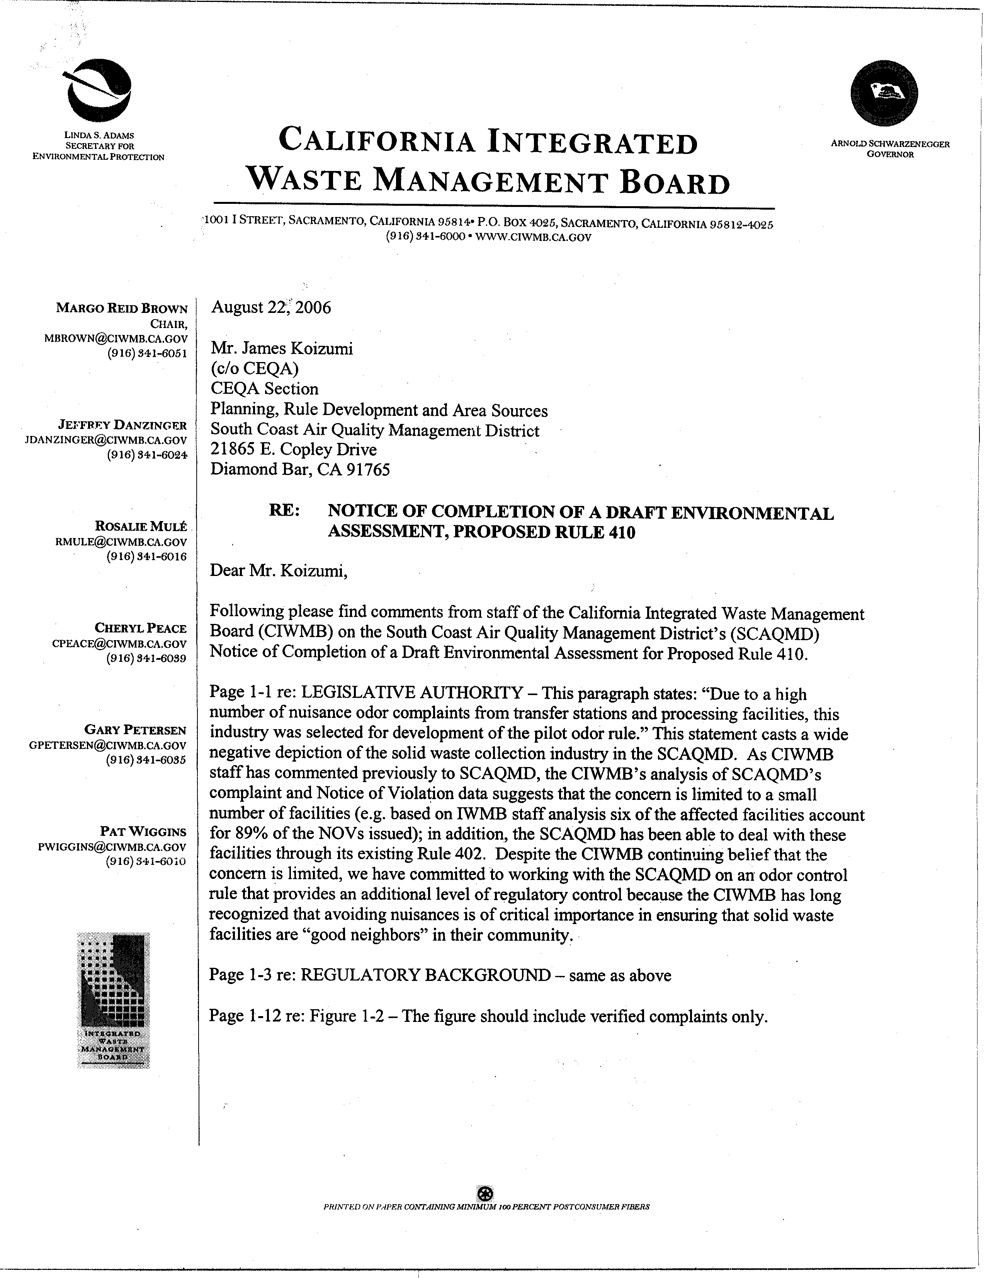
1-1
1-2
1-1
1-2
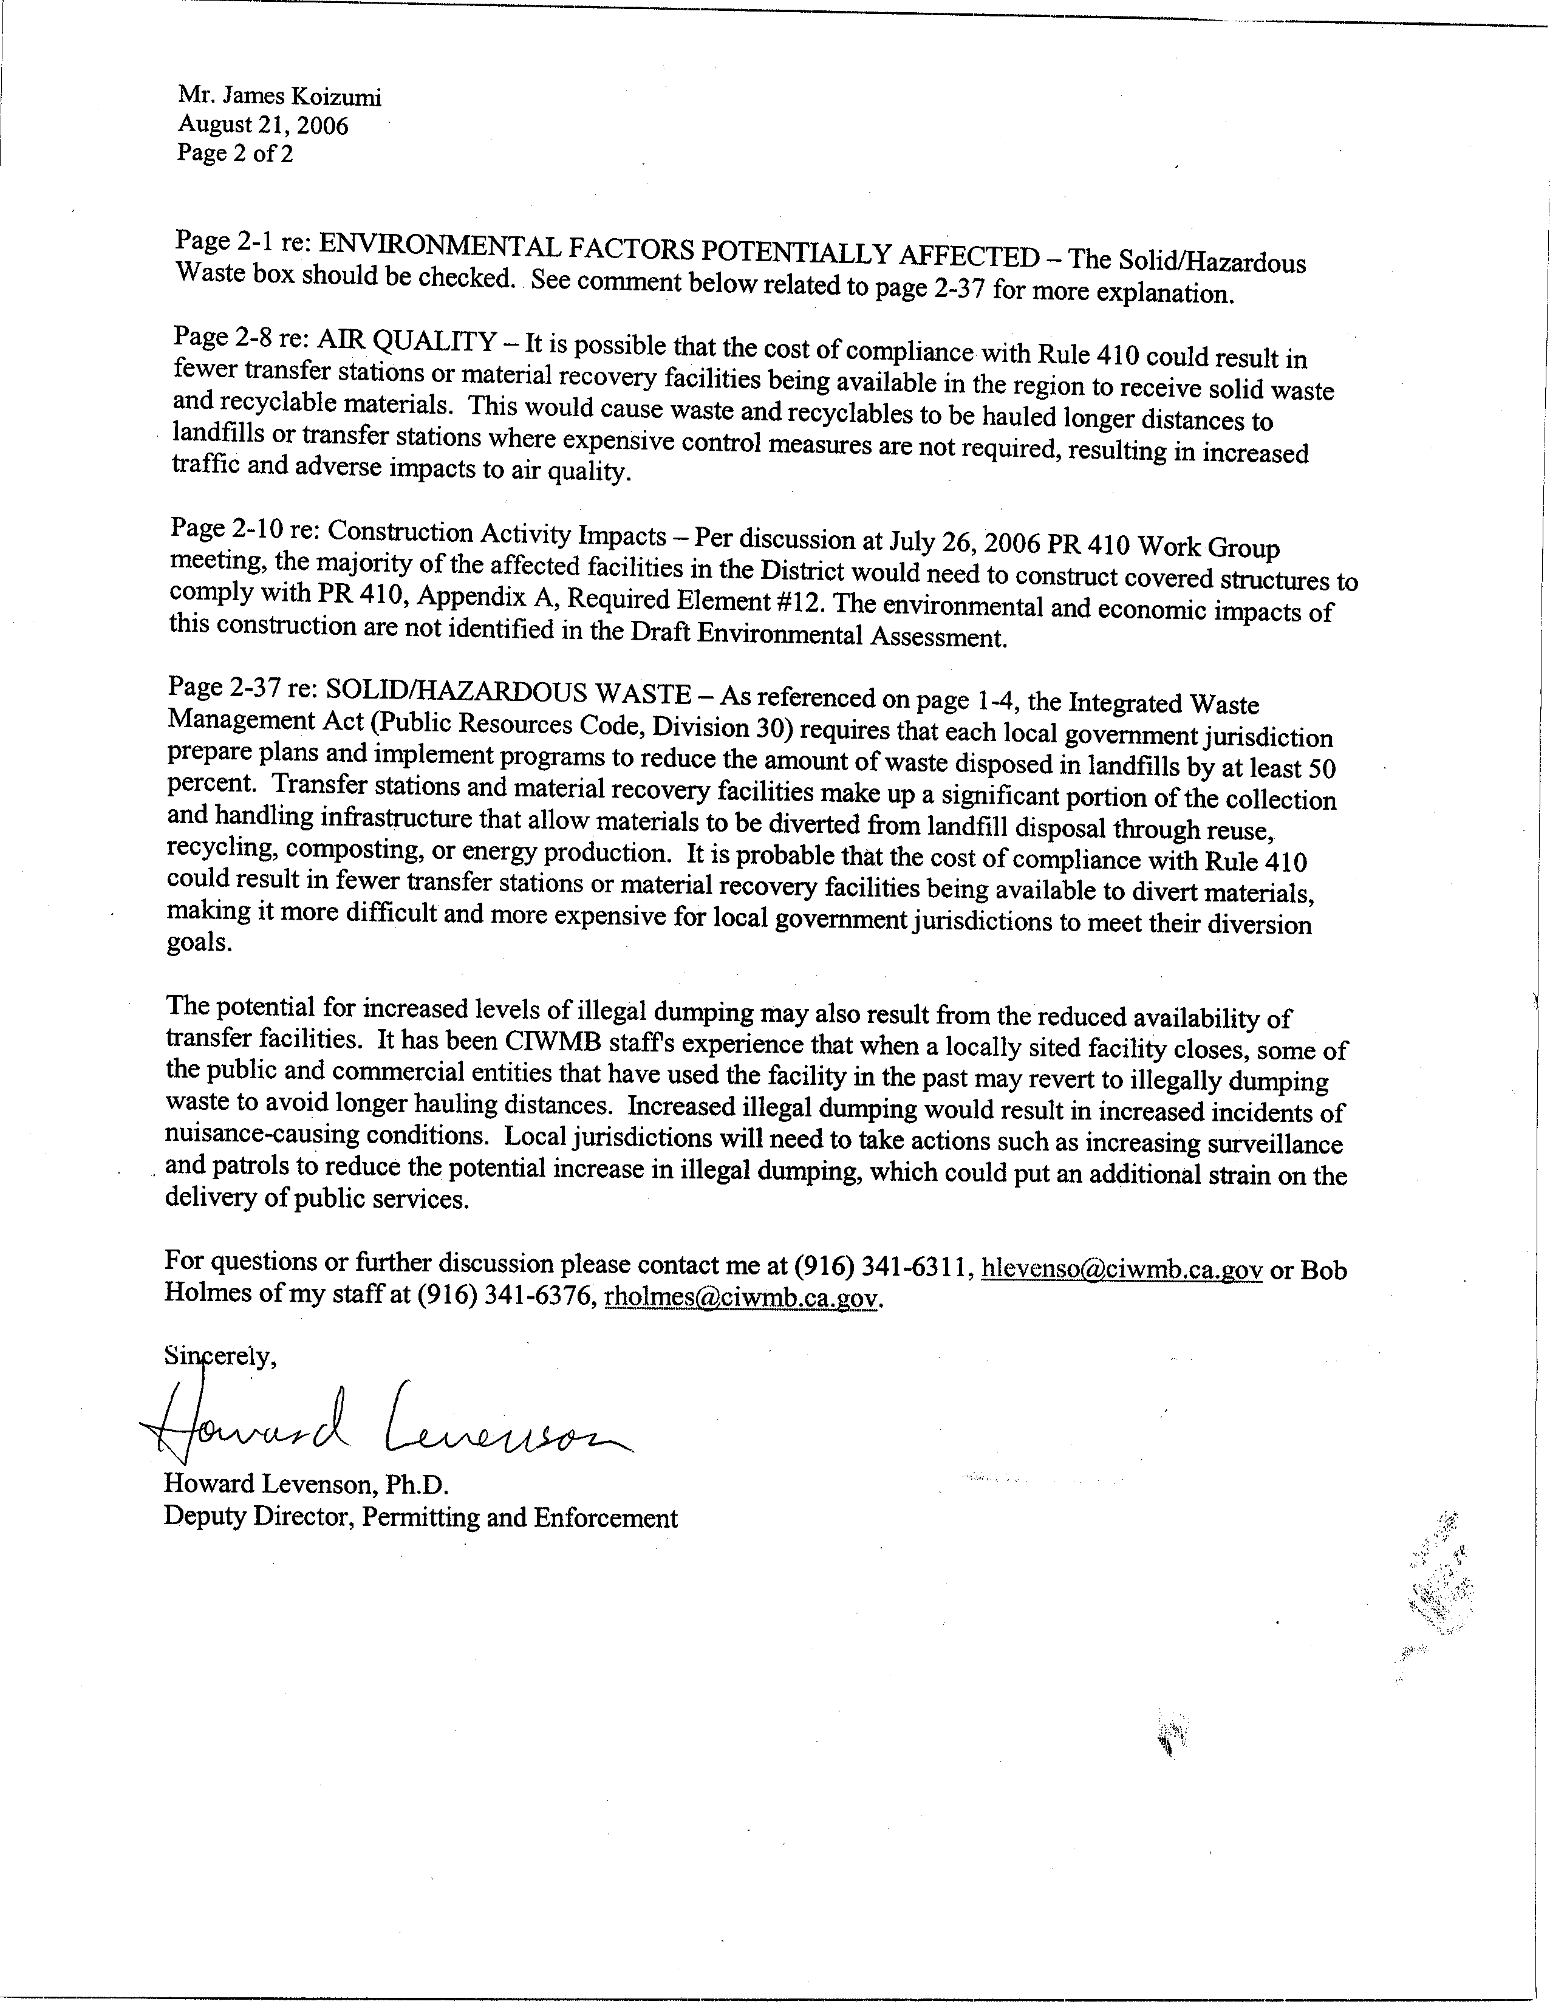
1-3
1-4
1-5
1-6
1-7

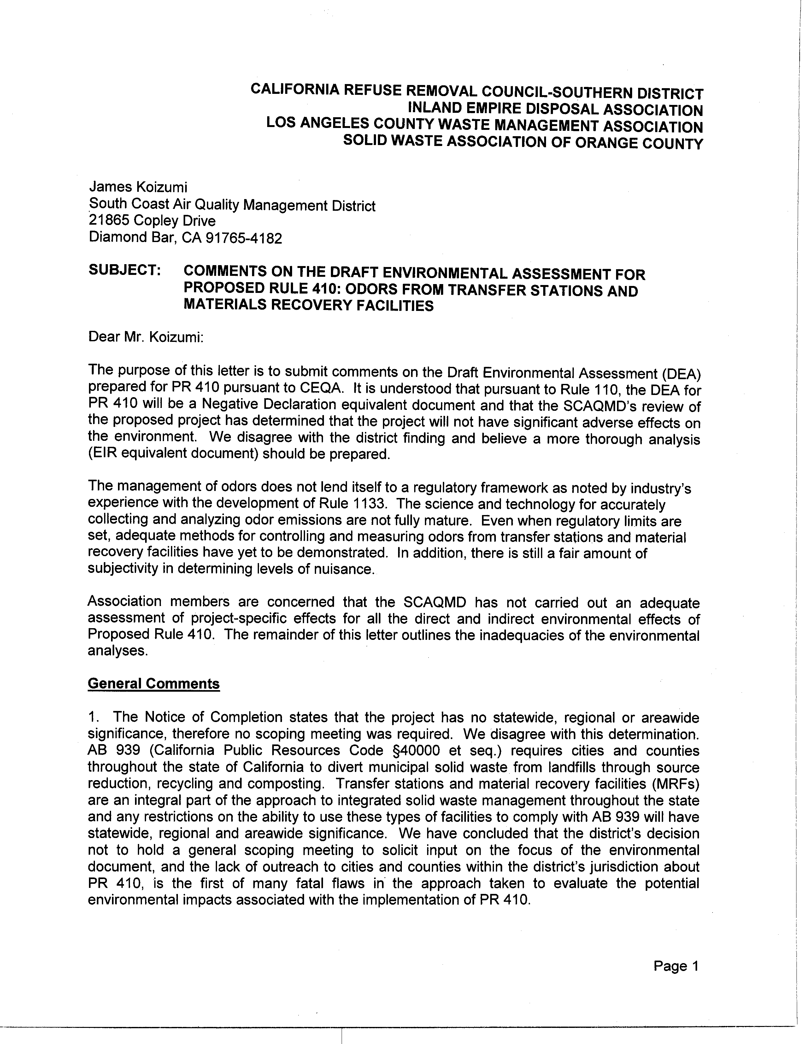
2-1
2-2
1-3
1-4
1-5
1-6
1-7

2-1
2-2
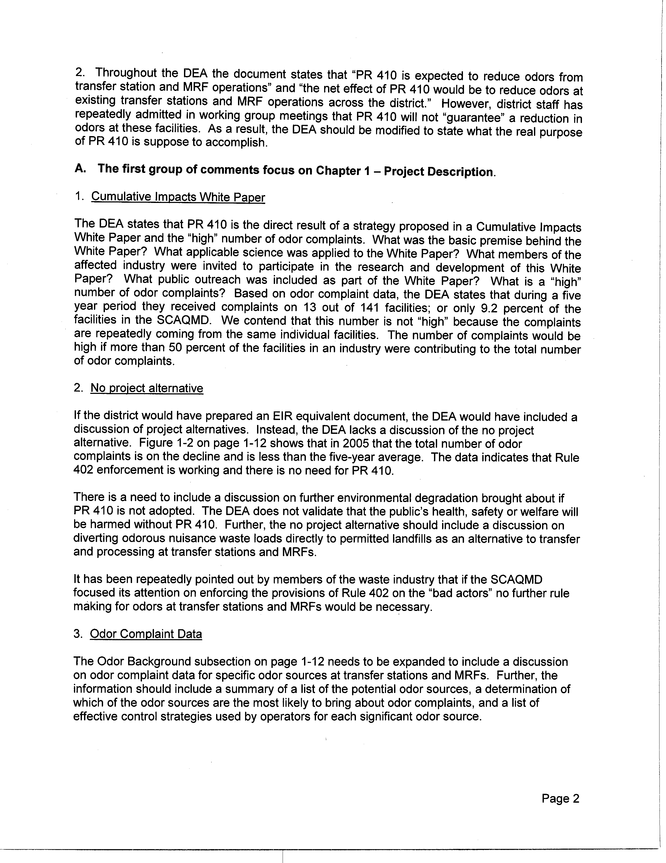
2-3
2-4
2-5
2-6
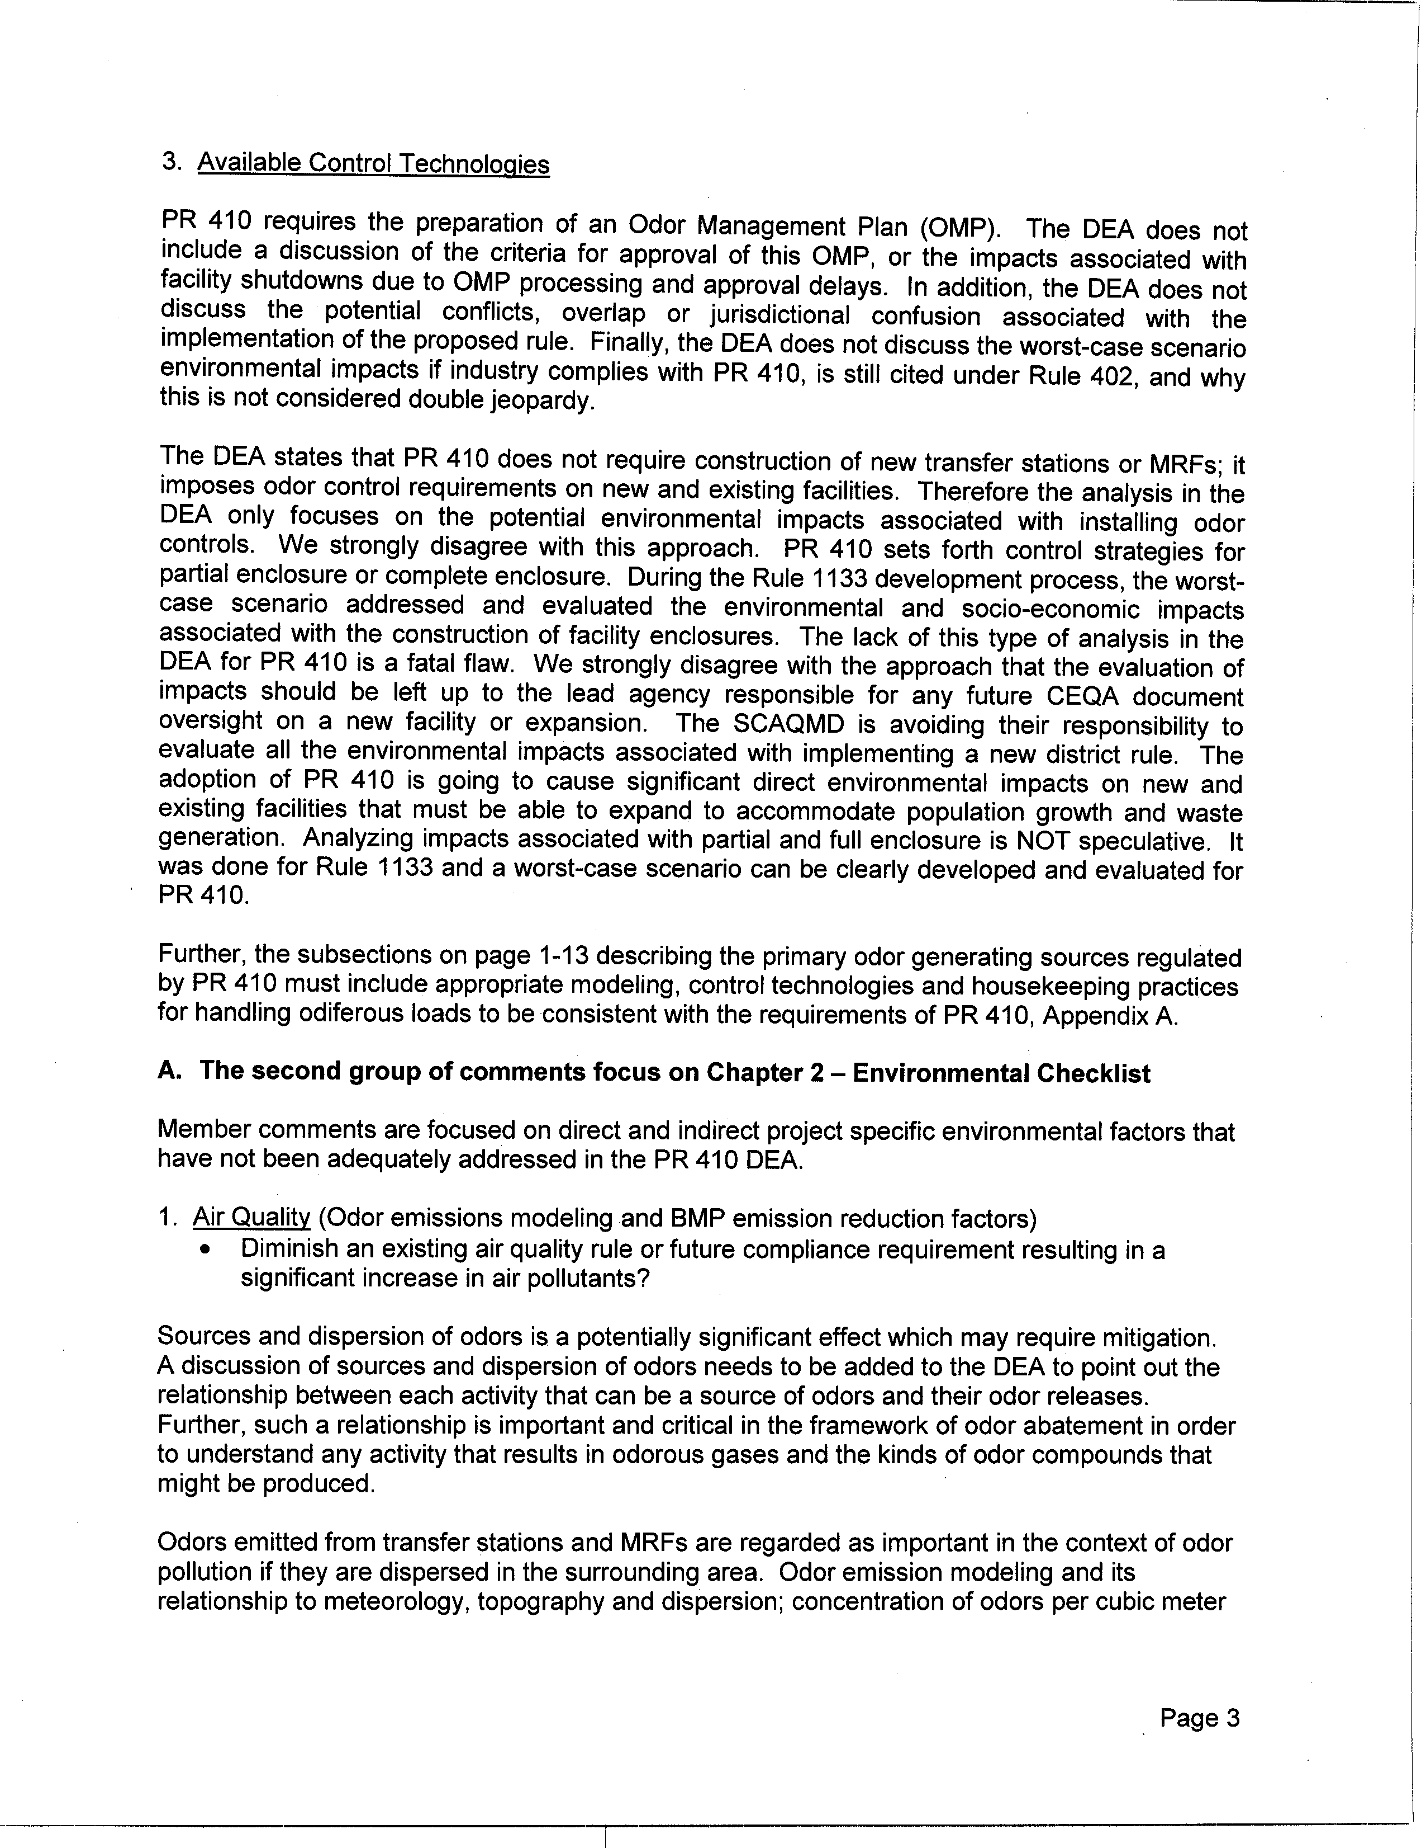
2-7
2-8
2-9
2-10
2-11
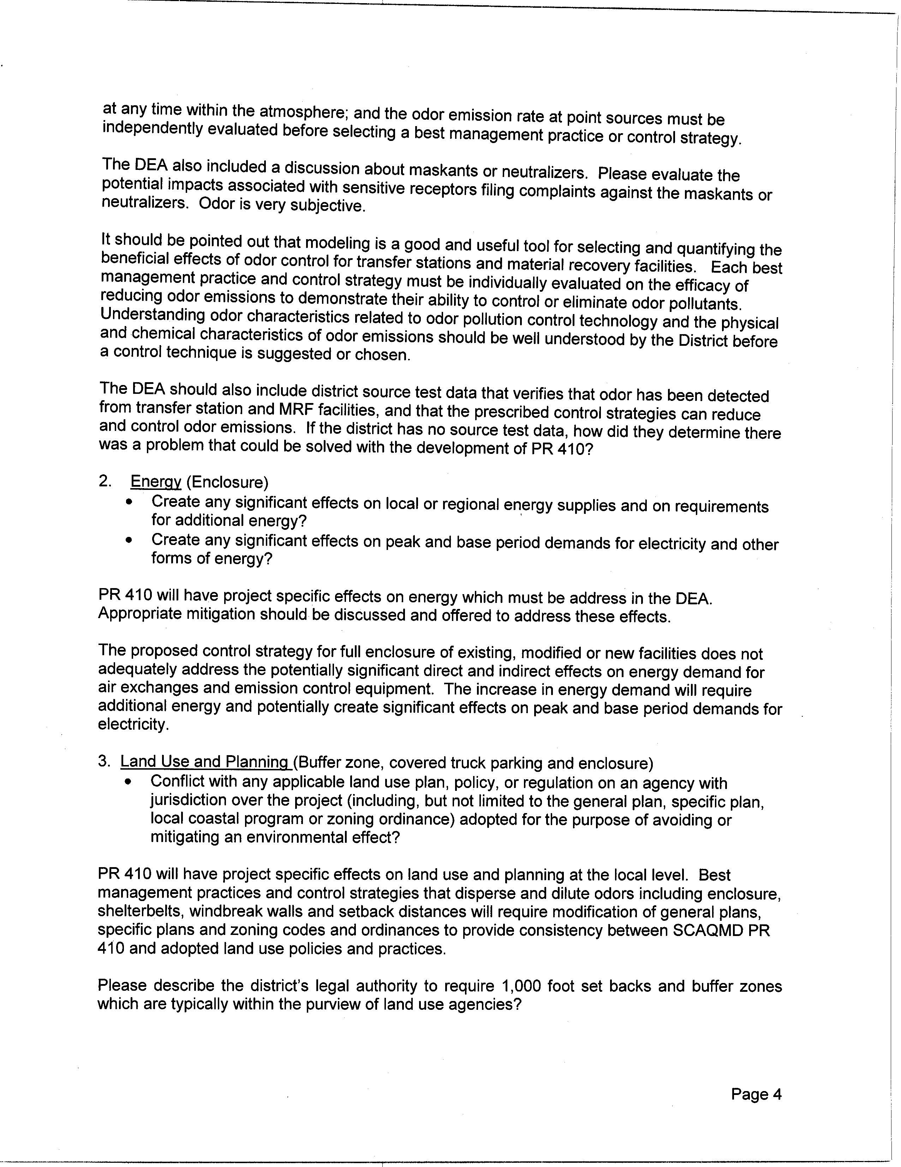
2-11
cont.
2-12
2-13
2-14
2-15
2-16
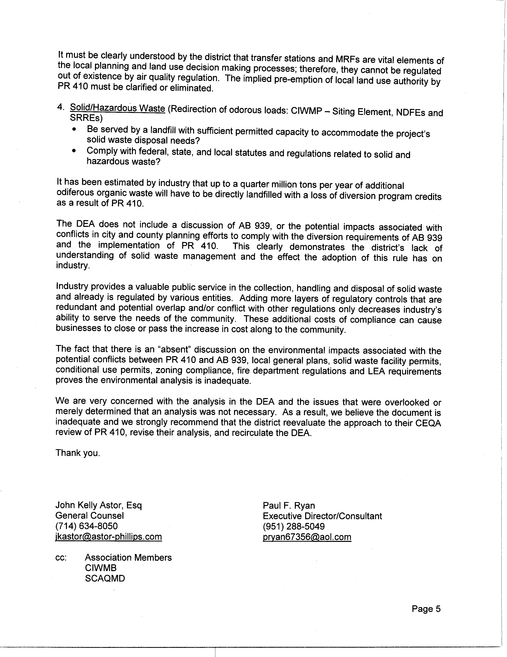
2-16
cont.
2-17
2-18
2-19

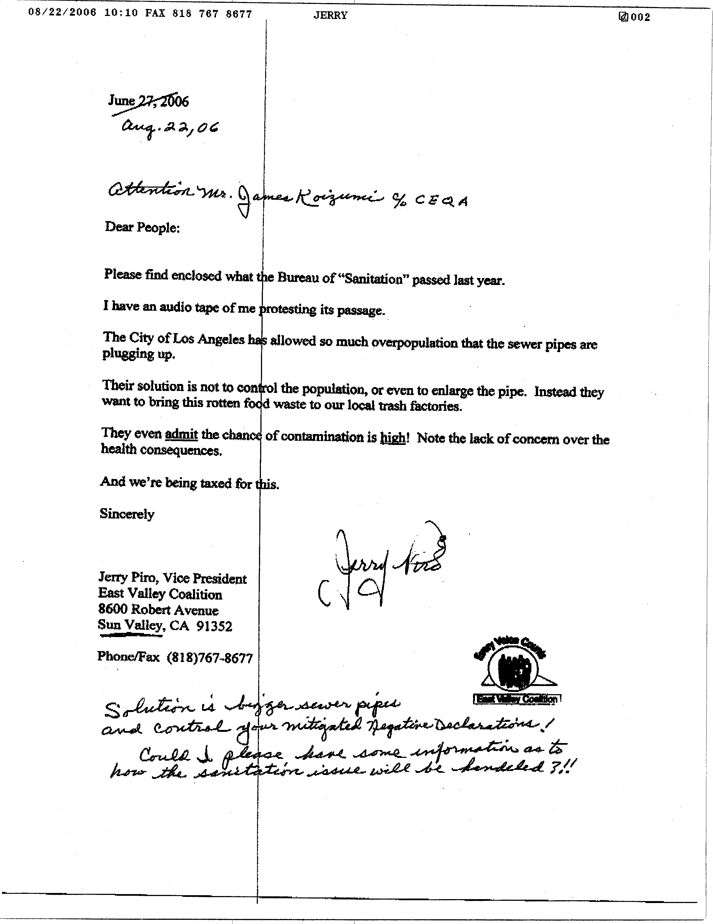
3-1
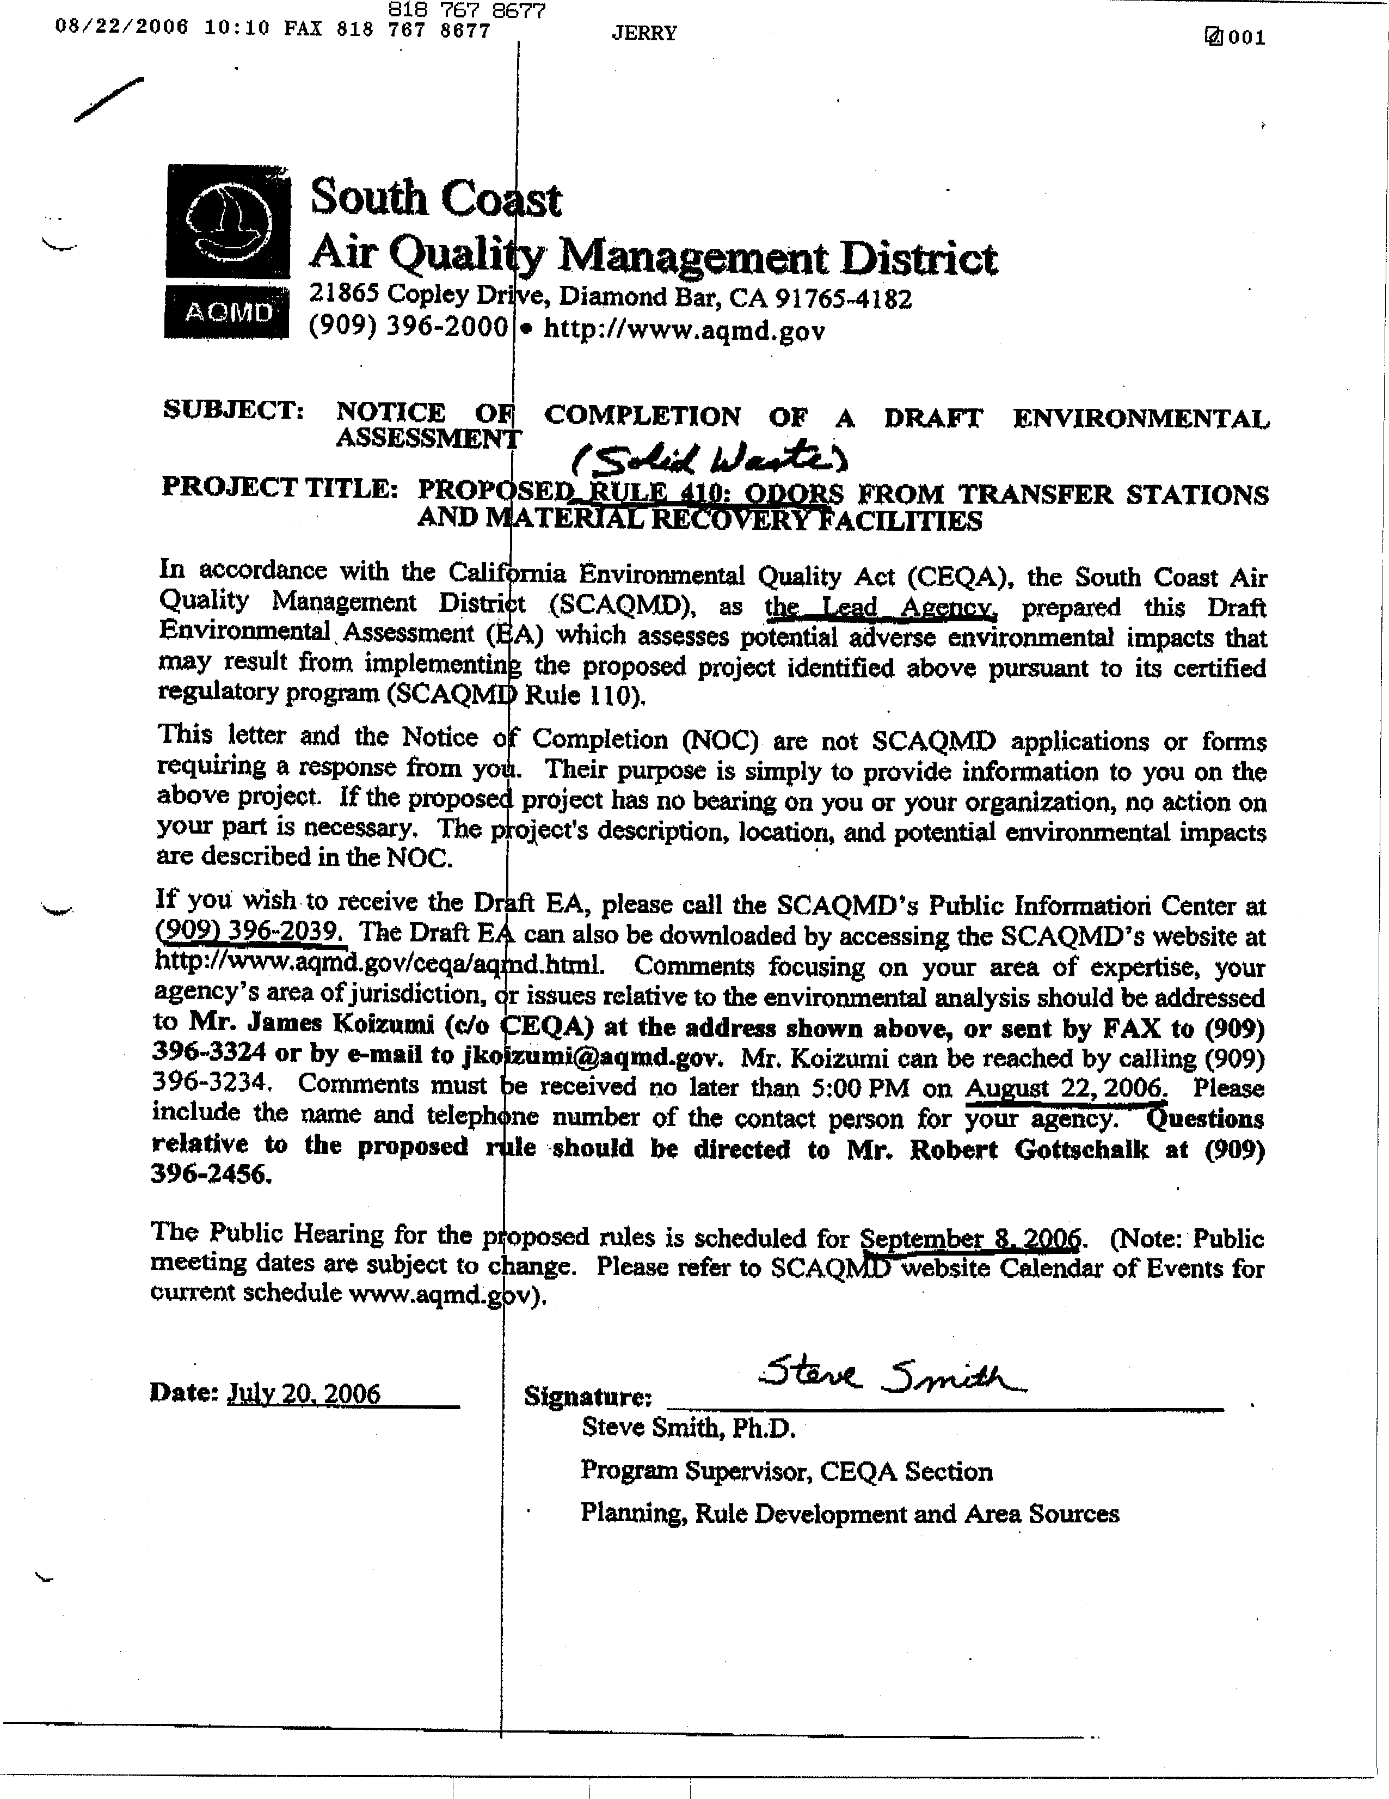
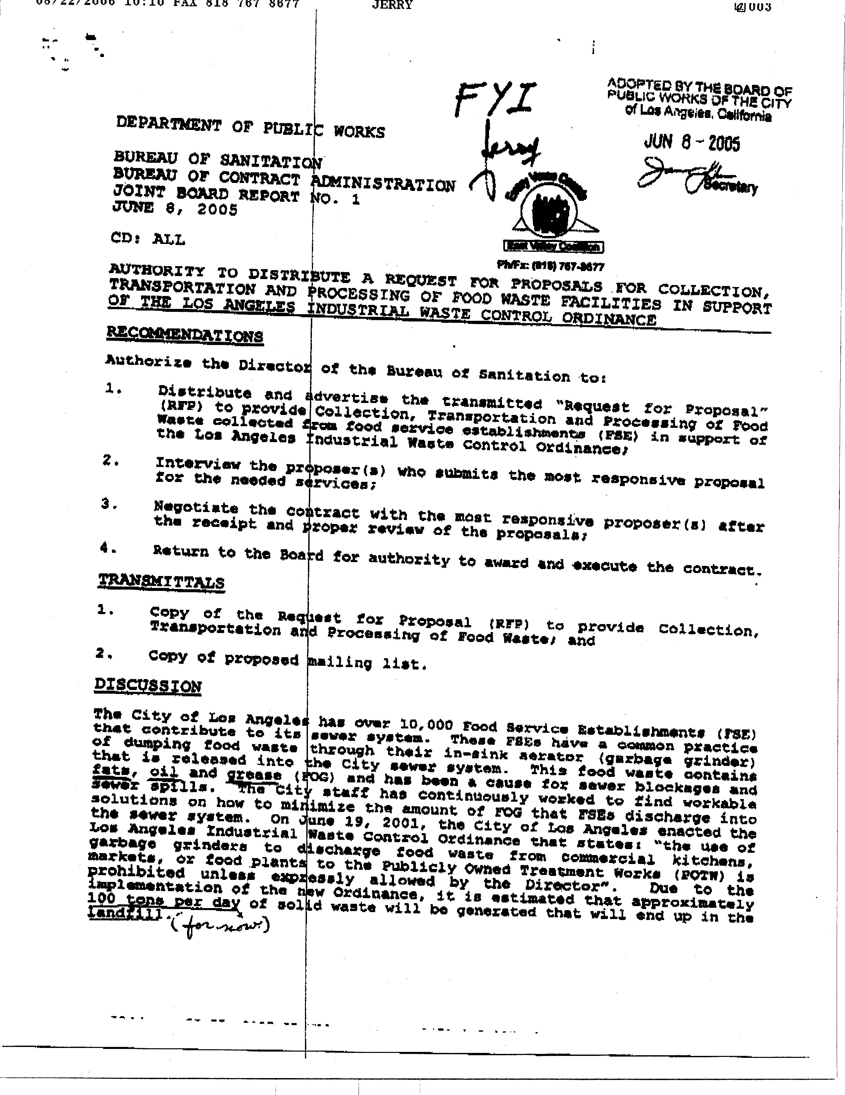
2-3
2-4
2-5
2-6
2-7
2-8
2-9
2-10
2-11
2-11
cont.
2-12
2-13
2-14
2-15
2-16
2-16
cont.
2-17
2-18
2-19
3-1
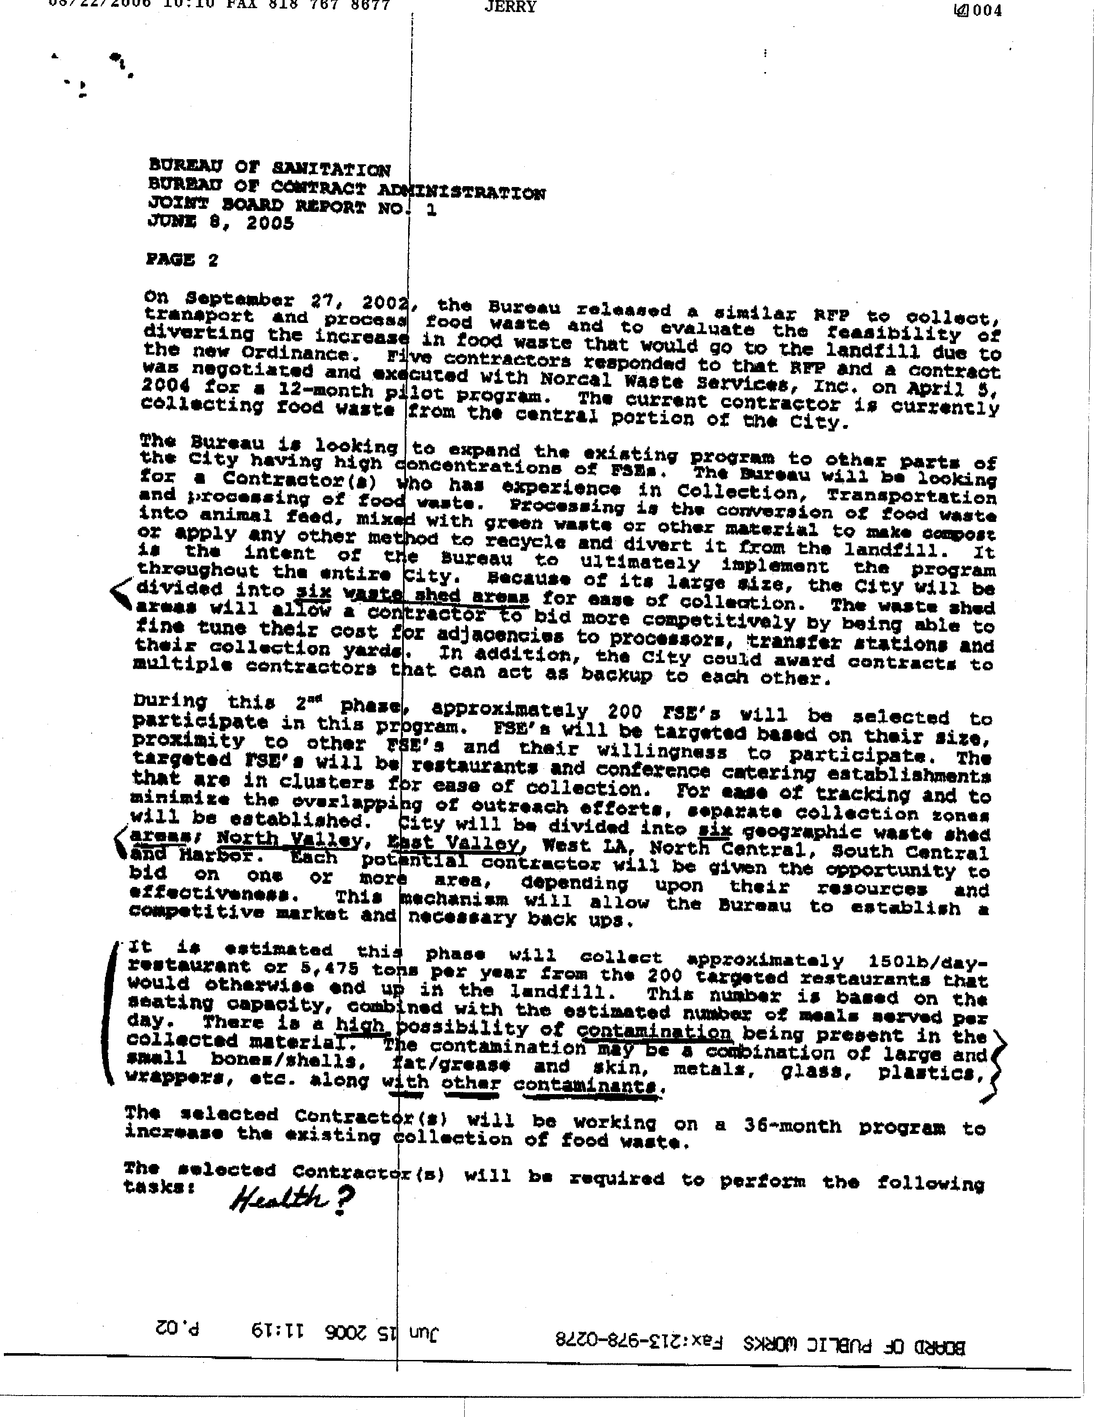
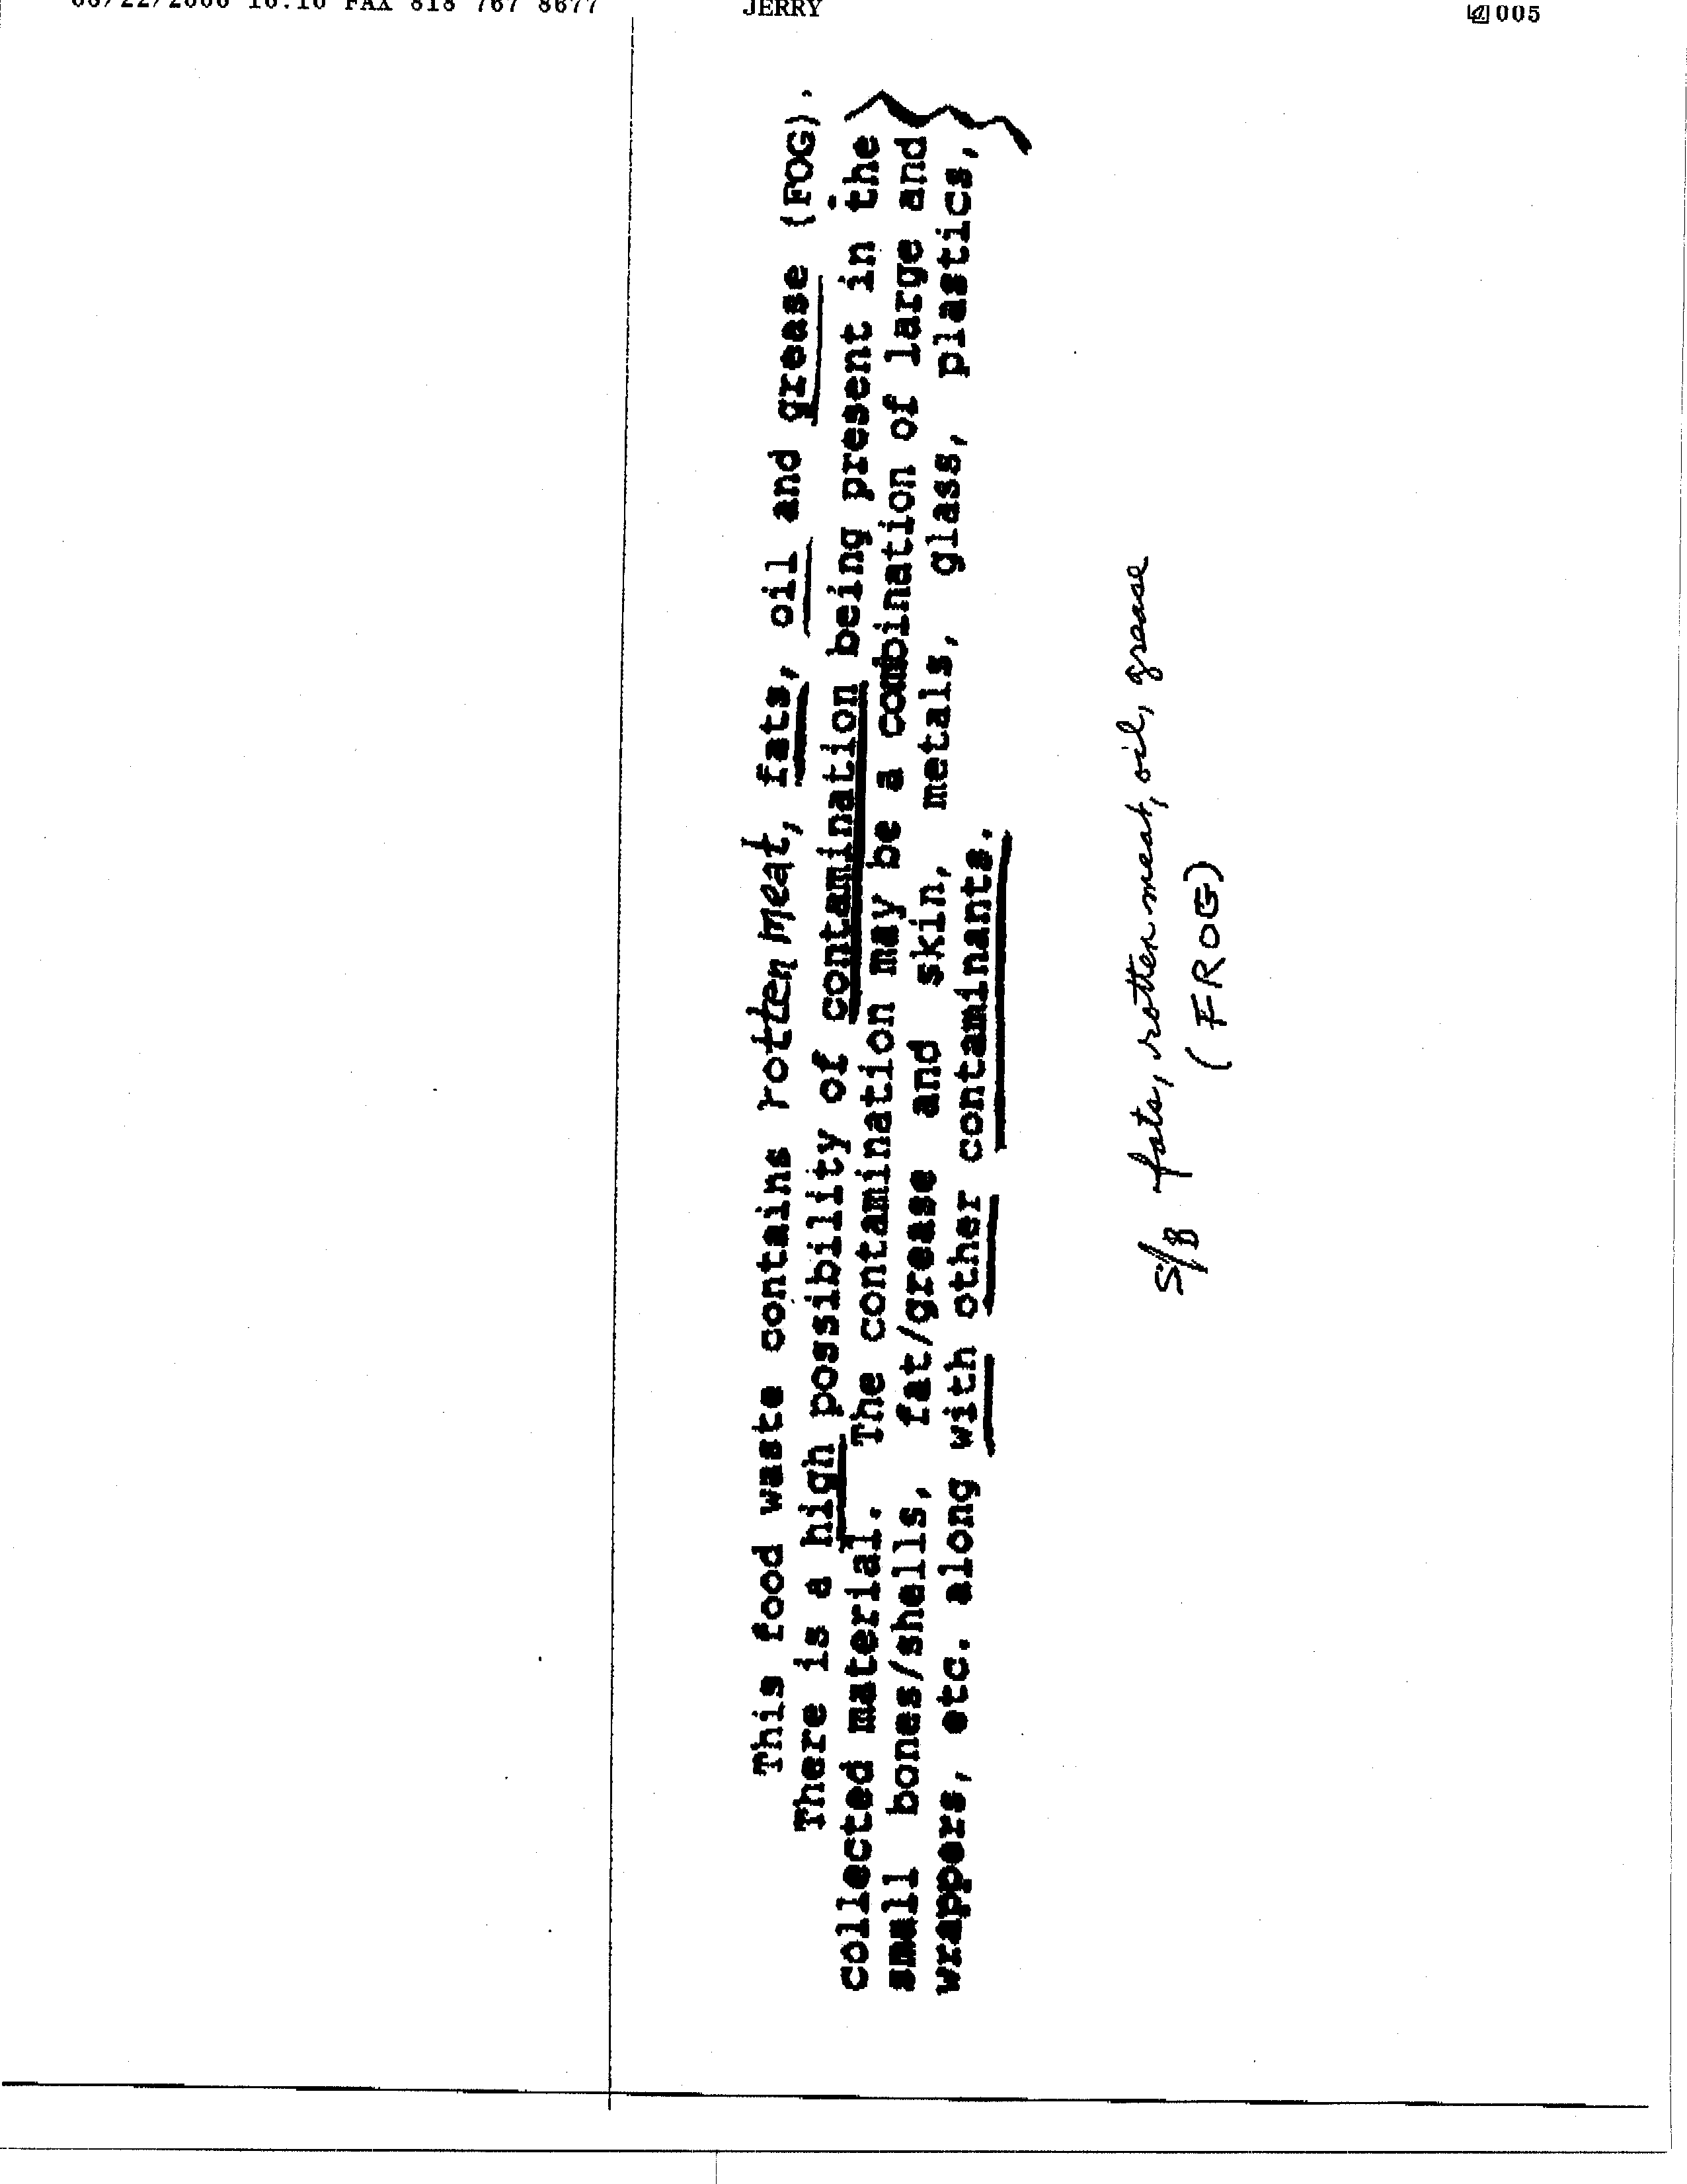
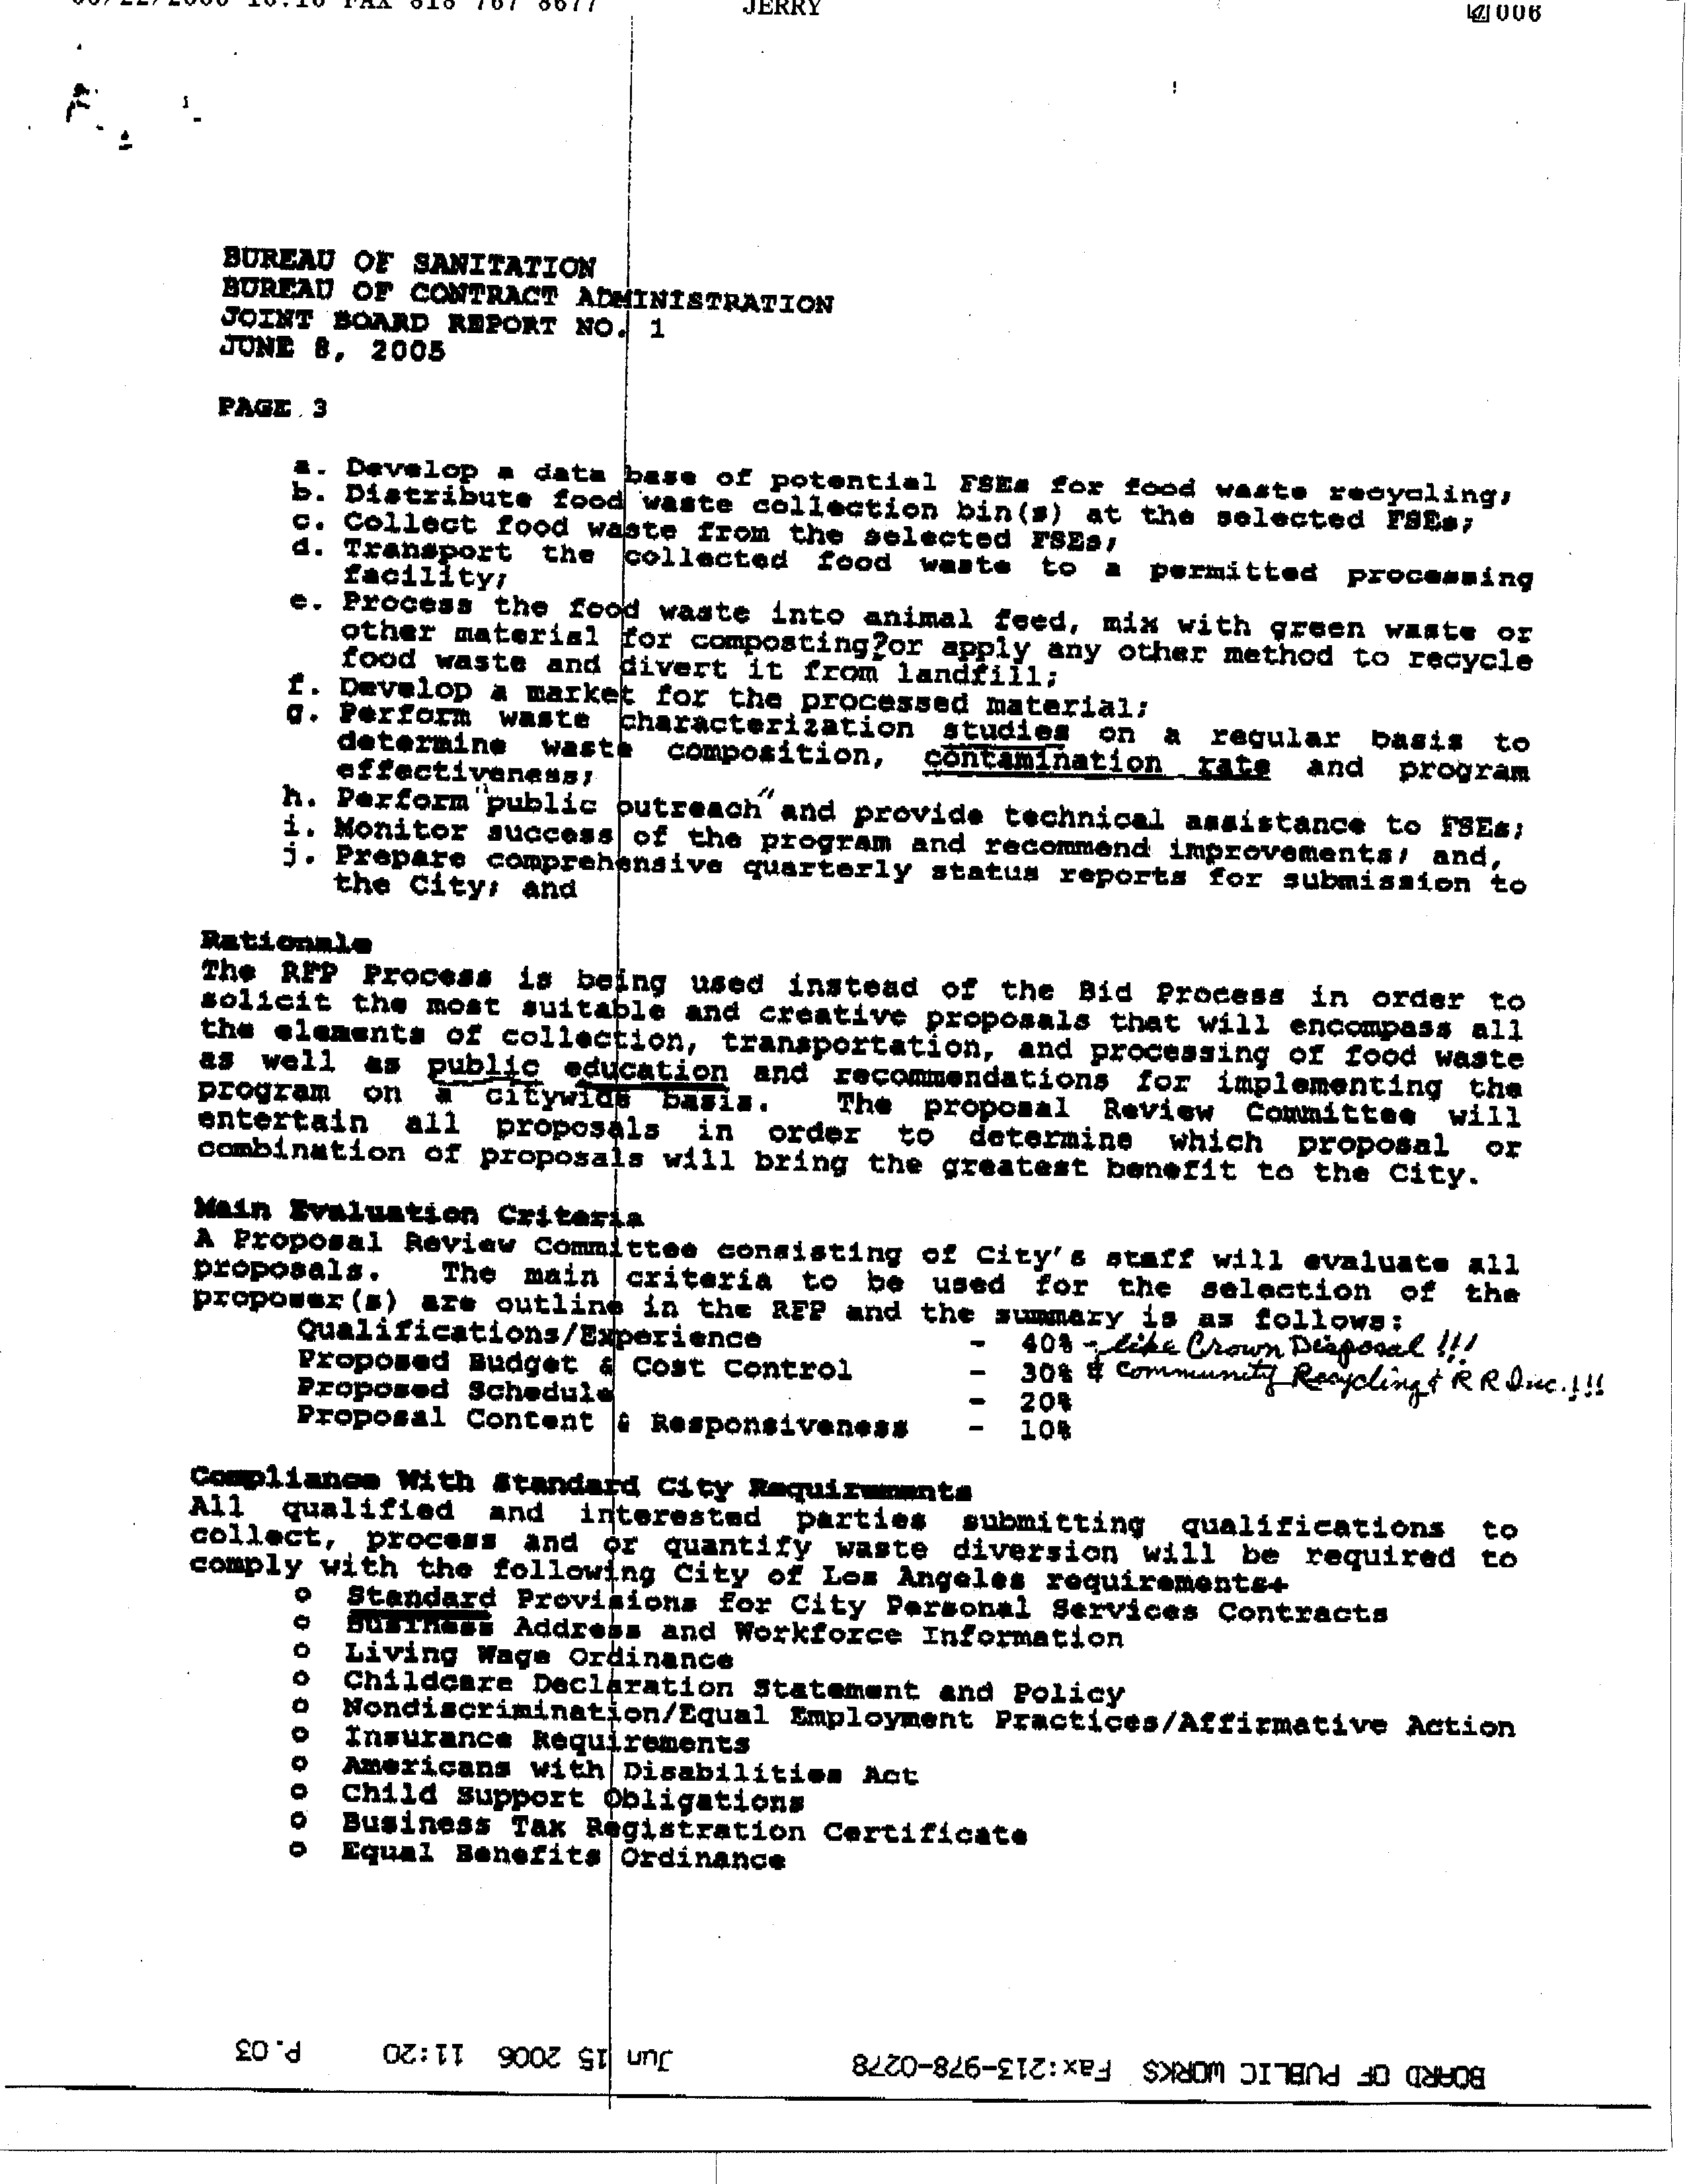
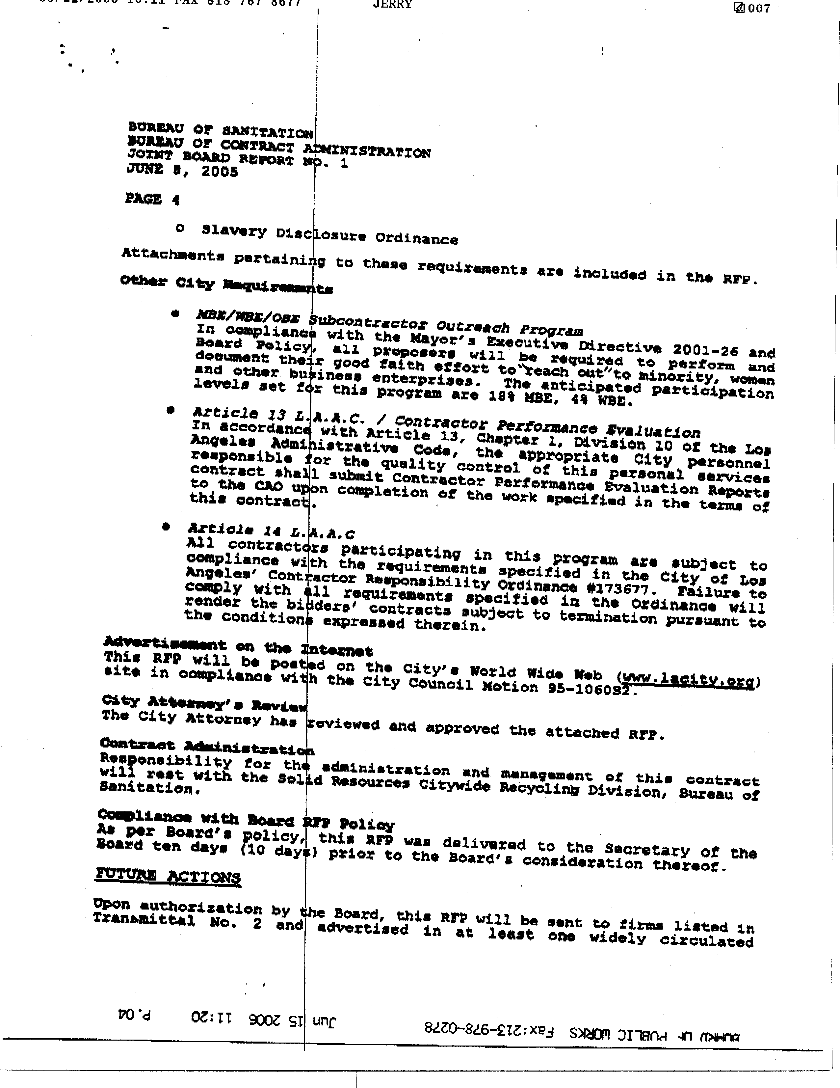
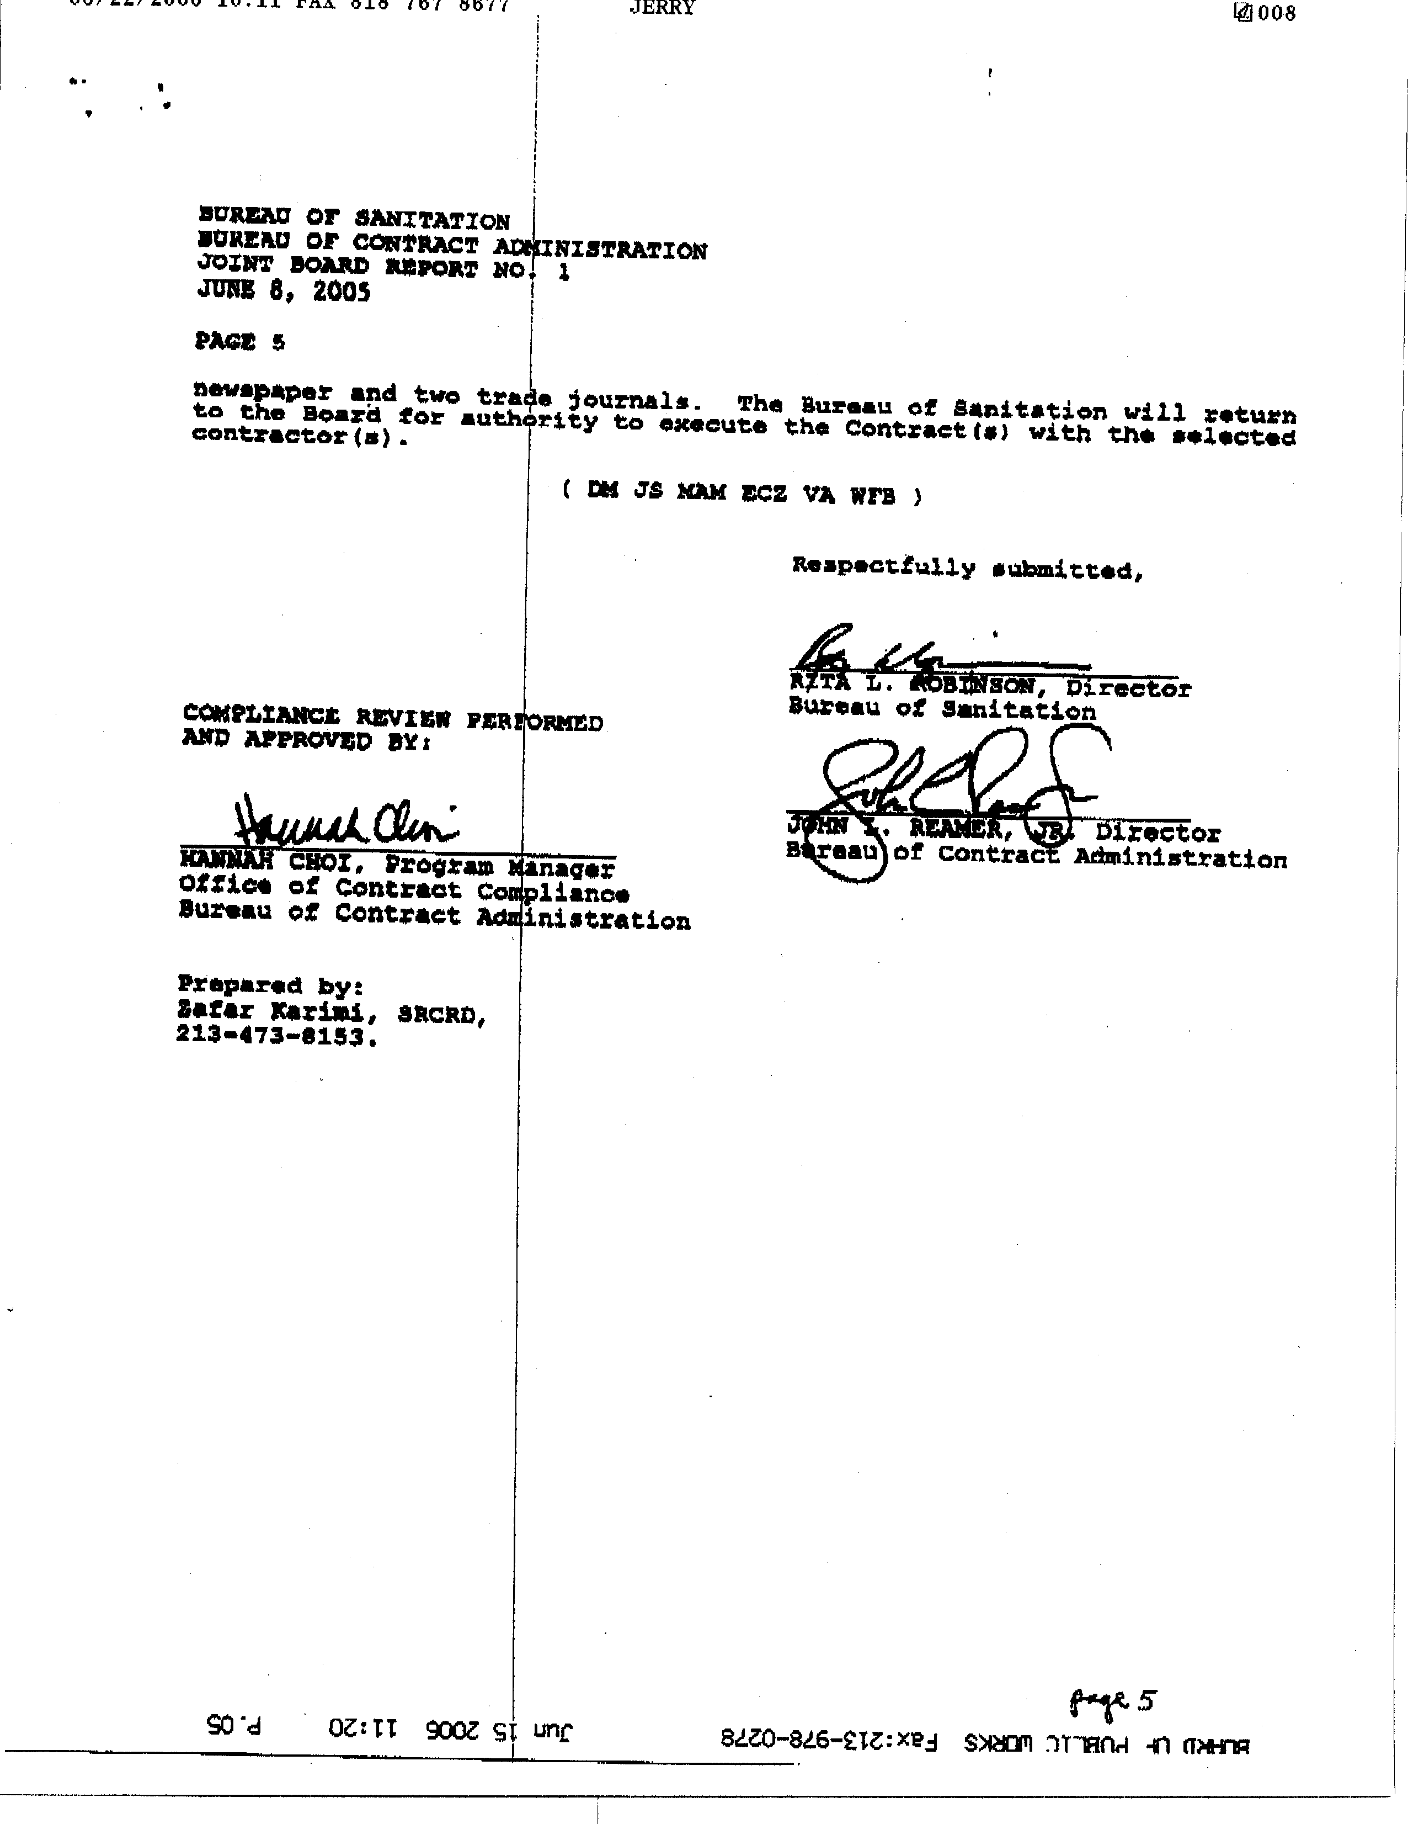
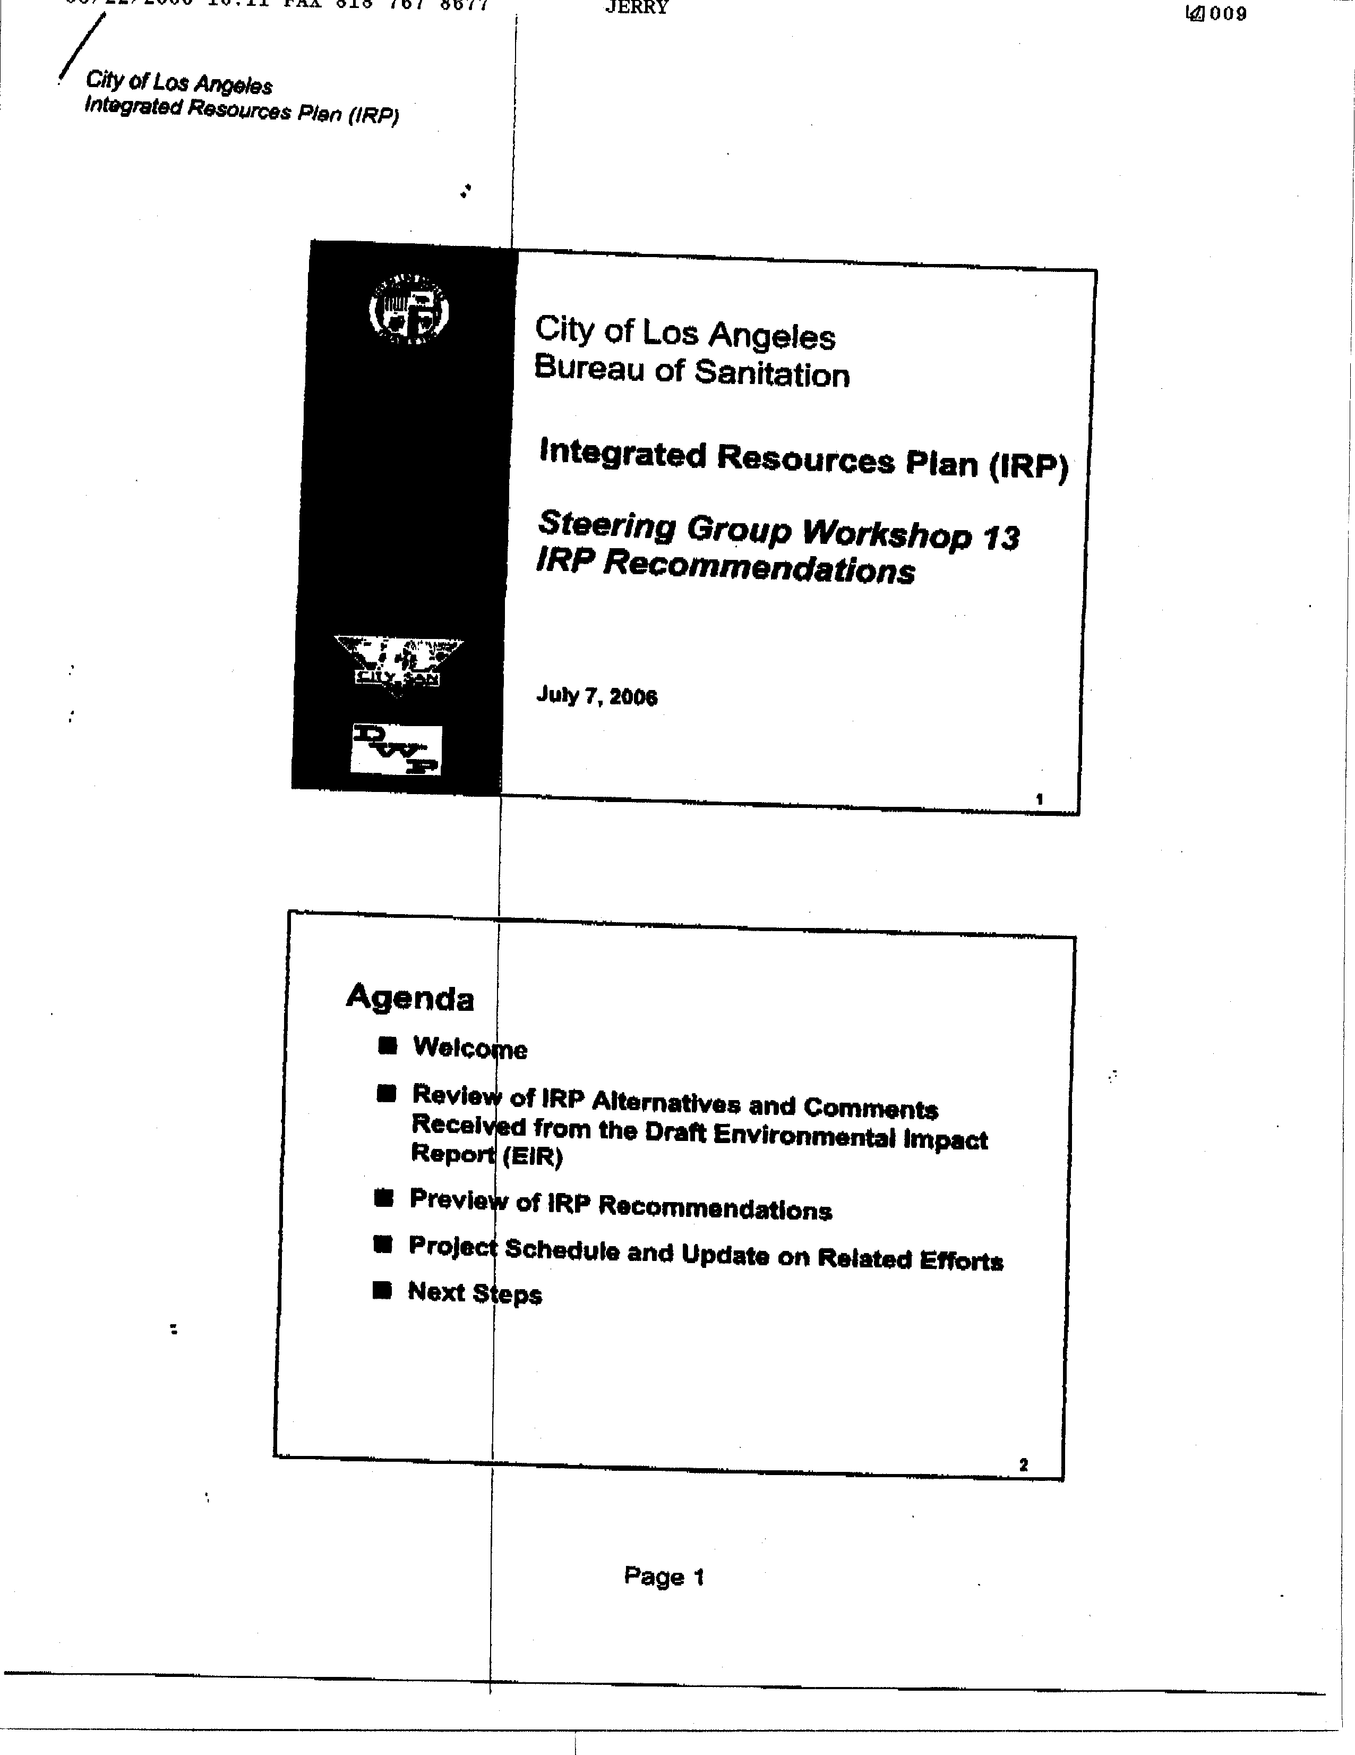
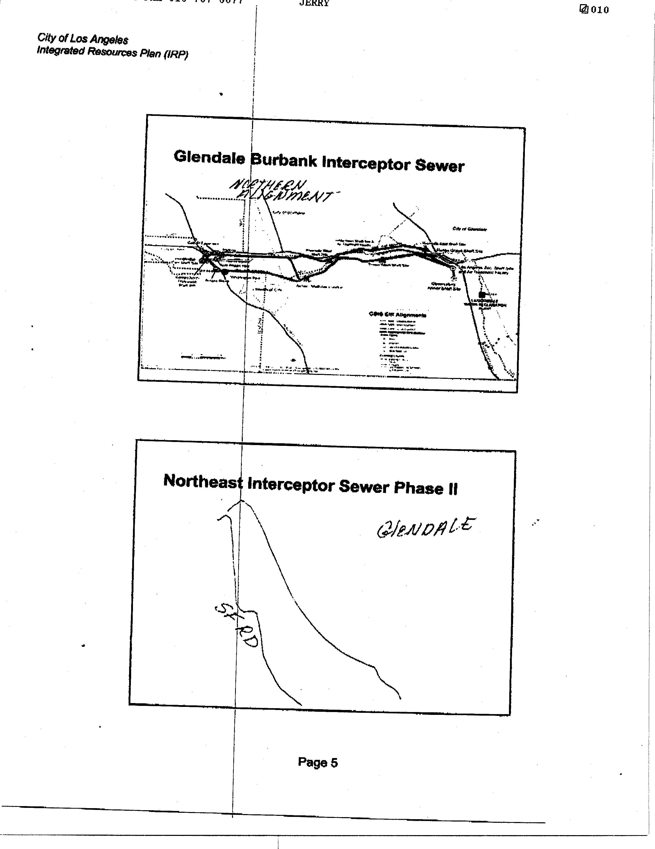
4-3
4-4
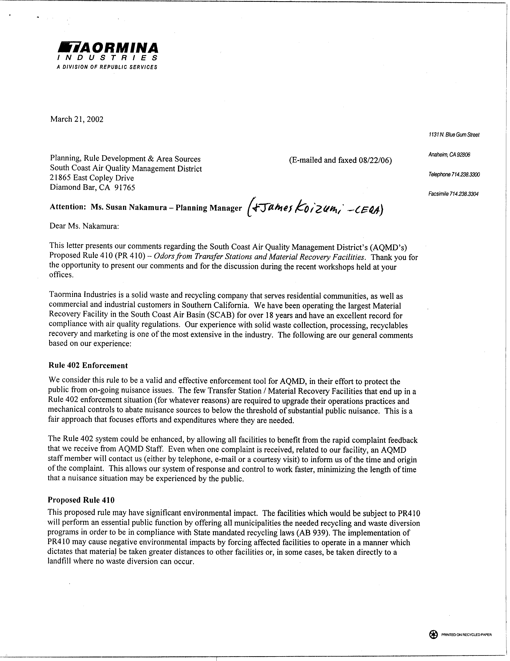
4-1
4-2
4-3
4-4
Responses to Comment Letter #1
California Integrated Waste Management Board
August 22, 2006

Response 1-1
In the PR 410 Staff Report and the Final Environmental Assessment, the odor complaint data have been updated. Based on the SCAQMD’s data, 11 percent of the facilities represent 84 percent of the complaints from transfer stations and MRFs between 2001 and 2005.

Response 1-2
Although the total number of odor complaints could not be verified, this does not mean they did not occur. As a result, total number of odor complaints indicates that there is a need for PR 410. However, in response to the request, a new figure showing verified odor complaints has been added to the Staff Report and the Final EA.

Response 1-3
This comment references a later comment. See response 1-6.

Response 1-4
SCAQMD CEQA evaluation does not directly examine the impacts of cost from a proposed project. Financial impacts are evaluated in the socioeconomic report on a proposed project. The socioeconomic report for PR 410 was available to the public on September 5, 2006 and distributed to the PR 410 Working Group on September 6, 2006.

Regarding new facilities, the two planned transfer stations and MRFs that are identified in the CIWMB’s Solid Waste Information System database, these facilities are expected to meet the requirements specified in PR 410 for new facilities. One facility is planning an enclosure and the other is expected to comply with the buffer zone requirement. Regarding existing facilities, the requirements in the PR 410 OMP are based on practices and odor controls that are currently being used in existing transfer stations and MRFs that the AQMD has visited. The PR 410 OMP is designed to allow the operator the flexibility to select the control options and to tailor the specific provisions to fit their current operations.

The commenter states that the cost of compliance with PR 410 could result in fewer transfer stations or material recovery facilities (MRFs) available in the region to receive solid waste and recyclable materials, which would cause longer hauling distances to landfills or transfer stations where expensive control measures are not required increasing traffic and air pollution. The commenter does not provide any specific examples or support for this comment.

PR 410 would not regulate facilities that handle less than 100 tons per day of municipal solid waste (MSW). It does not pertain to direct transfer facilities, defined in California Code of Regulations (CCR), Title 14, Division 7, Chapter 3, Article 6.0, Section 17402(a); facilities handling only nonhazardous ash, CCR, Title 14, Division 7, Chapter 3, Article 5.8; or facilities handling only construction, demolition, and inert debris (CDI) materials, CCR, Title 14, Division 7, Chapter 3, Article 5.9; or sealed container transfer operations, as defined in the CCR, Title 14, Division 7, Chapter 3, Article 6.0, subsection 17402(a), or recycling centers that meet the standards under CCR, Title 14, Division 7, Chapter 3, Article 6.0, Section 17402.5.

Operators at existing transfer stations and MRFs that are permitted to handle between 100 and 250 tons per day of MSW would be required to prepare and submit a PR 410 odor management plan (OMP) to SCAQMD or an alternate odor management plan to the Local Enforcement Agency (LEA). Operators at these facilities are also required to install a contact sign and prepare an odor complaint protocol. In addition, the operators are required to sweep the tipping floor, transfer tunnel and facility perimeter and maintain a written log of community complaints. It should be noted that operators at these facilities are already required to sweep facilities pursuant to state requirements. The average annualized cost of PR 410 OMP is estimated at about $22,230 per affected facility. See the Socioeconomic Report for detailed assumptions.

Operators at existing transfer station or MRFs that have a permitted throughput between 250 and 1,000 tons per day of MSW would be required to implement an odor control strategy to control odor from the tipping floor as part of the OMP or alternative OMP requirements. Odor control strategies include a misting system, wind barriers, partial enclosure, complete enclosure, or an equivalent odor control measure approved by the SCAQMD Executive Officer. Existing facilities are expected to implement a misting system to comply with this requirement. No facilities were identified that would need to construct partial or full enclosures for the tipping floor comply with this requirement. The remaining requirements on these facilities are the same as the one for facilities with throughput greater than 100 tons of MSW per day. The average annualized cost for a facility with permitted throughput between 250 and 1,000 tons per day is estimated at $24, 263.

Operators at existing transfer station or MRFs that are permitted to handle 1,000 or greater tons per day of MSW would be required to implement an odor control strategy to control odor from the tipping floor, transfer tunnel and MRFs. Odor control strategies for the tipping floor included a partial enclosure, full enclosure, or an equivalent odor control measure approved by the SCAQMD Executive Officer. Odor control strategies for the transfer tunnel include misting systems or physical barriers at the entrance or exit of the transfer tunnel, maximum drop heights from the trucks to the tipping floor, or an equivalent odor control measure approved by the SCAQMD Executive Officer. Odor control strategies for MRFs include partial enclosure, full enclosure, or an equivalent odor control measure approved by the SCAQMD Executive Officer. No facilities were identified that would be required to fully enclosure or partially enclosure tipping floors or MRFs to comply with PR 410. Only two facilities were identified that may add an additional wall to an existing partial enclosures to satisfy the requirement. The remaining requirements on these facilities are the same as the one for facilities with throughput between 250 to 1,000 tons of MSW per day. The average annualized cost for a facility in this category is estimated at $44,513.

New or modified facilities that handle 1,000 or more tons per day of MSW would be required to submit an OMP or alternative OMP with odor control for operators that handle 250 tons or more per day of MSW. SCAQMD staff reviewed proposed transfer stations and MRFs and found that all facilities that would be required to build full enclosure or demonstrate a sufficient buffer zone to comply with PR 410 have already included these odor controls as part of the proposed project or as mitigation required by the lead agencies. Therefore, PR 410 would require all proposed transfer stations and MRFs in the district to include odor control that is already required by the lead agencies that are currently reviewing land use permit applications.

No examples or support for the opinion expressed in the comment that PR 410 would result in fewer transfer stations or MRFs is provided. SCAQMD staff’s detailed analysis in the socioeconomic report did not identify any costs that would not be born by affected facilities or that would result in fewer transfer stations or MRFs; therefore, the increase traffic and adverse air quality impacts implied by the opinion expressed in the comment are not expected to occur. SCAQMD staff believes that the air quality impacts were fully and correctly evaluated in the Draft EA.

Response 1-5
Based on comments received from industry representatives, Proposed Rule 410 has been modified such that trucks that are pre-loaded are not required to be parked in a covered area. The proposed rule requires that trucks that are pre-loaded and parked overnight and that they must be covered with an 18-oz vinyl tarp or the equivalent.

Response 1-6
The comment repeats the opinion expressed in Comment 1-4 that PR 410 would result in fewer transfer stations or MRFs, and concludes that this would impact landfill diversion goals. As stated in Response 1-4, the commenter has not provided any support for the assertion that the cost of complying with PR 410 would result in fewer transfer stations or MRFs. Response 1-4 concludes that there is no indication that PR 410 would result in fewer transfer stations or MRFs. The commenter’s concern about landfill diversion goals is based upon the opinion that implementing PR 410 would result in fewer transfer stations or MRFs. However, no information or other data are provided that supports the opinion that implementing PR 410 would result in fewer transfer stations or MRFs. As a result, potential effects on landfill diversion goals expressed in this comment are not expected to occur.

Response 1-7
The comment expresses the opinion that increased illegal dumping may occur as a result of reduced availability of transfer stations or MRFs as a result of implementing PR 410. As stated in Response 1-4, the commenter has not provided any information regarding “CIWMB staff’s experience” or other data that supports the opinion that implementing PR 410 would result in fewer transfer stations or MRFs. Response 1-4 concludes that there is no indication that implementing PR 410 would result in fewer transfer stations or MRFs. The commenter’s concern about illegal dumping is based upon opinion that implementing PR 410 would result in fewer transfer stations or MRFs. However, no information or other data are provided that supports the opinion that implementing PR 410 would result in fewer transfer stations or MRFs. As a result, potential effects of on illegal dumping expressed in this comment are not expected to occur.

Responses to Comment Letter #2
California Refuse Removal Council – Southern District, Inland Empire Disposal Association, Los Angeles County Waste Management Association, and Solid Waste Association of Orange County
August 22, 2006

Response 2-1
SCAQMD staff disagrees with the opinion expressed in this comment that the adverse impacts from PR 410 are significant and require an EIR equivalent document. The environmental analysis completed in the Draft EA is thorough and complete and address all direct and indirect environmental effects. These statements are supported by the following responses to comments.

SCAQMD staff disagrees with the opinion expressed in the comment that managing odors does not lend itself to a regulatory framework. The SCAQMD staff believes that a proactive regulatory approach to address odors will minimize the migration of odors off-site that may affect communities surrounding a transfer station or MRF.

The technology for analyzing odor emissions may not easily lend itself to a rule where requirements are based on objective emission standards r. However, SCAQMD staff believes that there is a need to establish minimum standards to control odors. Implementation of PR 410 in conjunction with Rule 402 will provide a more comprehensive regulatory approach to address odors from transfer stations and MRFs.

Response 2-2
SCAQMD staff disagrees with the opinion expressed in the comment that evaluation of environmental impacts from implementing PR 410 and the decision that a scoping meeting was not required contain “fatal flaws.” The SCAQMD staff agrees that the transfer stations and MRFs are integral to meeting the AB 939 recycling goals. PR 410 establishes minimum standard, but allows facilities the flexibility to select the compliance option that best fits their existing operations. Most of the elements incorporated in the Rule 410 OMP are based on control strategies or practices that are being implemented at existing transfer stations and MRFs.

Although the commenter implies that PR 410 would impact or restrict the ability of operators to use transfer stations and MRFs to comply with AB 939, the commenters do not provide any information or other data to support for the opinion that PR 410 would impact or restrict the ability of operators to use transfer stations and MRFs to comply with AB 939. The average annualized cost per facility is $36,761.

The majority of affected transfer stations and MRFs contract with cities and local municipalities for collection of waste materials and charge a tipping fee for their waste disposal. It is expected that these facilities pass on the additional cost resulting from PR 410 to their downstream customers, i.e., cities and local municipalities, by raising their tipping fees by at least $0.82 to $1.29 per ton of MSW disposed. This number was arrived at by dividing the total annualized cost of PR 410 for a typical modified or new facility by the total annual throughput of that facility. The average tipping fee is assumed about $30 to $40 per ton. (”Schedule of Rates for Solid Waste Transfer and Disposal Facilities”).

The Draft EA correctly concluded that implementing PR 410 would not generate significant adverse environmental impacts to any environmental topics. Since no significant impacts were identified in the Draft EA, the proper conclusion is that PR 410 would not generate any statewide, regional or area wide significance. Since no significant impacts were identified a Negative Declaration equivalent document was the appropriate document to be prepared. No scoping meeting is required by CEQA for Negative Declaration equivalent document. Therefore, SCAQMD staff was not required to hold a scoping meeting.

SCAQMD has held four working group meetings, a public workshop and a public consultation meeting for PR 410. The Integrated Waste Management District and various LEAs have attended these meetings. Cities, organizations, companies and individuals who have requested to receive the Notice of Completion (NOC) for the Draft EA were sent the NOC either by facsimile, US Post or e-mail. A newspaper notice was published in the Los Angeles Times on July 21, 2006. Commenter Paul Ryan, who signed the comment letter from the California Refuse Removal Council – Southern District, Inland Empire Disposal Association, Los Angeles County Waste Management Association, and Solid Waste Association of Orange County has attended the majority of the working group meetings. It is assumed that in addition to the extensive public outreach conducted for PR 410, Mr. Ryan has notified the members of his organization of PR 410 of the environmental document. The public outreach performed for PR 410 has been very extensive and is consistent with the outreach performed for other SCAQMD rules and rule amendments. Therefore, SCAQMD disagrees with the opinion that public outreach has been less than sufficient.

Response 2-3
Subdivision (a) of PR 410 specifically states that the purpose of the rule is to, “establish odor management practices and requirements to reduce odors from municipal solid waste transfer stations and material recovery facilities.” Consistent with this purpose, PR 410 is expected to reduce odors from transfer station and MRF operations and the net effect is expected to reduce odors at existing transfer stations and MRFs across the district as stated in the Draft EA.

PR 410 allows facility operators to select from a menu of odor control options that best fits their operations. The AQMD staff recognizes that some options provide better capture of odors than others. For example, a full enclosure will provide greater control of odor emissions than a partial enclosure. Even if the best control option is selected, there are other variables that may result in odor nuisances such as housekeeping, meteorological conditions, an extremely odiferous load, processing rate of the waste, etc. The SCAQMD staff believes that the PR 410 OMP provides a comprehensive approach that provides a better opportunity to minimize off-site odors from transfer stations and MRFs than if PR 410 was not implemented.

Response 2-4
The cumulative impacts working group is an outgrowth of the Governing Board’s September 2002 Environmental Justice Enhancements for FY200-03, in which the Board directed staff to report on the feasibility of rulemaking to address cumulative impacts of air toxics beyond current SCAQMD requirements. Further, at its January 2003 meeting, the Board directed staff to develop a white paper on regulatory options for addressing cumulative impacts form air pollution. The commenters are directed to read the Cumulative Impacts White Paper, which can be downloaded from the SCAQMD website at http://www.aqmd.gov/hb/2003/030929a.html.

The purpose of the White Paper was to:
- present a forward-looking comprehensive strategy of how the SCAQMD intends to identify and further address cumulative impacts of air pollution, so that all communities in the South Coast receive equitable treatment and attention regarding their local air quality concerns;
- ensure fair and consistent treatment of local businesses as it carries out this facet of environmental justice; and
- points out potential ways to achieve more substantial progress in public health protection.

The White Paper was a starting point, developed with input from the Cumulative Impacts Working Group, whose members have spent much time and energy contributing their expert knowledge, experience, and suggestions to this path finding effort. The working group met seven times. Input was also incorporated from five Community Forums held throughout the four-county region in June and July, and nine public meetings in August 2002, which included local government and communities meetings.
The White Paper presented staff’s recommendations regarding options for assessing cumulative impacts from sources of air toxics. It includes consideration of input received from the California Air Resources Board (ARB), U.S. Environmental Protection Agency (EPA), local government representatives, industry, and environmental and community groups on the Working Group, as well as input from community meetings. Key policy issues addressed during the working group process include, but were not limited to, scope of the program (i.e., stationary and/or mobile sources; cancer and/or non-cancer health effects; and including particulate emissions), defining high impact areas for specific actions to reduce cumulative exposures, and potential approaches to address cumulative impacts.
The Final EA has been revised to incorporate verified complaints. Reference to a “high” number of complaints has been modified. Please refer to response to comment 1-2.
Response 2-5
As noted in Response 2-2, PR 410 is not anticipated to generate significant adverse environmental impacts. As a result, project alternatives are not required pursuant to CEQA Guidelines §15252(a)(2)(B) so a negative declaration equivalent documents was appropriate and was prepared.

SCAQMD staff disagrees with the opinion expressed in the comment that adequate enforcement of Rule 402 makes PR 410 unnecessary. Enforcement of Rule 402 does not necessarily prevent odors from affected facilities, since by design of Rule 402 inspectors respond to odor complaints after they have occurred. PR 410 is expected to reduce or minimize odors not only from the “bad actors,” but still help or prevent or reduce potential odor impacts from other facilities in the future.

Staff has stated on several occasions during the Working Group meetings that Rule 410 is necessary in order to take a proactive approach to control of odors from transfer stations and MRFs, by setting minimum standards for odor control. During the rule development process, staff visited over 15 transfer stations and MRFs. Staff visited facilities with and without verified complaints and found that although facilities may have had no or very little complaints the facility still had off-site odors. In this rule development, staff has worked with the affected industry as well as the regulatory and enforcement agencies in an attempt to minimize agency overlap, has provided two options for facilities to submit the required information through the Rule 410 OMP or the Alternative OMP, and has provided a menu of options for odor control that a facility operator can choose from, thereby allowing the operator flexibility to select the most appropriate control option for the facility configuration and operating practices. SCAQMD staff feels the proposed rule is a balanced approach to potential odor issues at transfer stations and MRFs. Rule 402 serves as a backstop for facilities at which odor problems persist after rule adoption, if the proposed rule is adopted.

Response 2-6
The Final EA for PR 410 has been updated to include a discussion of verified odor complaint data. Complaints from transfer stations and MRFs can come from any odor generating source within the facility. Based on site visits to transfer stations and MRFs the three primary areas for odor sources are the tipping floor, green waste processing area, and MRF. Some transfer stations have had odor problems from their transfer tunnel also. Each transfer station and MRF that the AQMD staff visited had a variety of odor techniques that they implemented to minimize odors. Odor control strategies included misting of water or deodorants or odor neutralizers on the waste in the tipping floor and green waste operations, physical barriers such as wind barriers or partial or full enclosures, and a variety of housekeeping techniques. All facilities that staff had visited during the rule development process used sweepers in and around the perimeter of the facility. Some facilities had an odor protocol that they implemented when they received a complaint or when they received an odiferous load. As previously indicated, many of these techniques are incorporated in the Odor Management Plan, and the proposed rule allows facilities the flexibility to tailor these requirements to their specific operation.

Response 2-7
Under paragraph (f)(4) of Proposed Rule 410, the Rule 410 OMP shall include all information required in Appendix A of Proposed Rule 410. The specific information that is to be included in an OMP is based on the permitted throughput of the facility. All facilities with permitted throughput greater than 100 tons per day are required to submit an OMP that addresses the “Required Elements”. Facilities greater than 250 tons per day and less than or equal to 1,000 tons per day are required to include odor control strategies for the tipping floor. Facilities greater than 1,000 tons per day are required to provide more stringent controls on their tipping floor, transfer tunnel, and MRF.

The OMP would be approved if all the OMP is complete and addresses all elements required in Appendix A of the proposed rule. The proposed rule provides sufficient time for a facility to submit and begin implementation of a Rule 410 OMP. The proposed rule allows facilities submitting a Rule 410 OMP over a year to submit and receive approval of the Rule 410 OMP. In addition, to ensure implementation of the proposed rule will be smooth, the AQMD staff has committed in the adopting resolution to work with the LEAs regarding the requirements and implementation of Proposed Rule 410.

The AQMD staff has worked with the CIWMB and LEAs to ensure that implementation of the proposed rule will not result in potential conflicts or agency overlaps. Under the proposed rule, if a facility elects to submit a Rule 410 OMP, the SCAQMD staff will review and enforce that OMP. If a facility elects to submit an Alternative OMP, the LEA will approve and enforce the Alternative OMP. This approach will ensure that that there is no agency overlap for approval and implementation of the Rule 410 OMP or the Alternative OMP.

Proposed Rule 410 was also modified to allow the LEA additional time, if needed to approve an Alternative OMP if a permit revision is needed and there is a delay due to compliance with CEQA or any other local or state law. The Executive Officer will allow additional time, in six month increments for the LEA to approve an Alternative OMP in this situation. This should further ensure that implementation of Proposed Rule 410 will not interfere with solid waste permitting or other requirements for transfer stations and MRFs. In addition, based on comments from the LEAs and the CIWMB, it is likely that most facilities that submit an AOMP will not request a permit revision. The AOMP will be in addition to the solid waste permit, thus would impact the existing elements in a solid waste permit.

Implementation of Proposed Rule 410 is in addition to implementation and compliance with Rule 402. The SCAQMD will continue to implement and enforce Rule 402. Thus, a facility for example, can potentially receive an NOV for an odor nuisance and a separate enforcement action for non-compliance with implementation of an OMP or AOMP.

Response 2-8
SCAQMD staff disagrees with the opinion expressed in the comment that the analysis in the Draft EA is “fatally flawed.” The comparison between the analysis of impacts in Rules 1133.1/1133.2 and PR 410 is not appropriate because the 1133 Rules, in particular Rule 1133.2, contain different requirements compared to PR 410. Proposed Rule 410 allows new facilities to either comply by enclosing their operations or to ensure that there is a 1,000 foot buffer zone. Under Rule 1133.2, there was no buffer zone option.

First, with respect to the analysis of Rules 1133.1 and 1133.2, in the EA, the EA states that for most environmental topics any impacts will result primarily from Rule 1133.2, so this discussion focuses on that rule. With regards to requirements for new facilities, it is clearly stated in the EA for Rules 1133.1/1133.2 that the analysis focuses only on existing facilities. This is the same approach taken for the analysis of PR 410, which also focuses primarily on existing facilities. Analysis of two new facilities that were identified by the CIWMB’s SWIS database as planned was also included. One of the facilities is planning to construct an enclosure and the other facility will comply with the buffer zone requirement. During the preparation of the EA for Rules 1133.1/1133.2, no affected facilities were undergoing the permit process. In such cases, where new facilities are not planned or under going the permitting process, environmental impacts are not reasonably foreseeable, so there is no obligation for a lead agency to analyze impacts in this situation. To do so would be speculative, which is inconsistent with CEQA Guidelines §15145.

As stated in the Draft EA for PR 410, “SCAQMD staff identified 12 facilities that receive 1,000 tons per day or less of municipal solid waste. Five of the twelve facilities do not have enclosed or partially enclosed tipping floors. It is assumed that these five facilities would install misting systems, and increase housekeeping activities, such as sweeping, to reduce odors in accordance with an approved OMP.

SCAQMD staff identified 27 facilities that receive over 1,000 tons per day of solid waste. Twenty-five of the facilities currently meet the minimum standards for tipping floor odor control (misting systems or partial enclosures). SCAQMD staff assumes that, at the two facilities, operators would add additional walls to existing buildings to control odors from the tipping floor. Staff assumes that 12 facilities would need to install misting systems to reduce odors. All 27 facilities are expected to install weather stations and increase housekeeping activities.” Since no existing facilities were identified that would require the construction of partial or full enclosures, no environmental impacts from the construction of partial or full enclosures would occur.

SCAQMD staff reviewed existing proposals for transfer and MRF facilities and all proposed transfer and MRF facilities identified would meet the new facility requirements in PR 410. Therefore, PR 410 would not generate any new impacts at known proposed transfer and MRF facilities.

Since SCAQMD staff identified all known construction impacts for existing transfer and MRF facilities and known proposed transfer and MRF facilities, SCAQMD staff did evaluate all environmental construction impacts associated with PR 410.

Since all existing identified proposed transfer and MRF facilities would meet the requirements of PR 410, it is expected that any future proposed transfer and MRF facilities would be required to meet the requirements of PR 410. However, no information is known about future transfer and MRF facilities proposed after the adoption of PR 410. Therefore, these projects are speculative and are outside of the scope of PR 410, as stated in the Draft EA, and impacts cannot be analyzed.

Response 2-9
This comment summarizes the information on page 1-13 of the Draft EA. No response is necessary.

Response 2-10
SCAQMD staff disagrees with the opinion expressed in this comment that dispersion of odors is a potentially significant effect of PR 410. This opinion is based on the erroneous assumption that implementing PR 410 would increase odors at affected facilities. As already noted in the Draft EA and in PR 410, the purpose of PR 410 is to establish odor management practices and requirements to reduce odors from municipal solid waste transfer stations and material recovery facilities. To the extent that PR 410 reduces odors at affected facilities, this is an environmental benefit not an impact. Therefore, mitigation is not required.

Response 2-11
Odor emission modeling and rate can assist in selecting the best management practice or control strategy. However, the OMP and associated odor control strategies are generic techniques that have been proven to reduce odors in general practice. Application of the OMP requirements is expected to reduce odors at any transfer station or MRF, especially in comparison to those facilities that do not install such odor reduction techniques.

Response 2-12
Maskants and neutralizers are not required by PR 410. PR 410 only requires that facilities that use maskants and neutralizer identify the maskants and neutralizer used. Further, PR 410 only allows the use of odor maskants or odor neutralizers that are non-toxic and meet all applicable local, state and federal requirements. It should be noted that based on discussions with industry representatives, that many facilities are electing to use odor neutralizers as opposed to odor maskants because operators have found that maskants can be as or more offensive than the odor that is being masked.

Response 2-13
See discussion in Responses 2-10 and 2-11.

Response 2-14
Source testing is not used to identify nuisance odors from solid waste transfer stations and MRFs. Nuisance odors are established by odor complaints that are verified by AQMD inspectors. Refer to Figure 1-2 in the Final EA to see the total number of verified odor complaints received by the SCAQMD by year between the years 2001 and 2005. As the commenters have stated earlier, nuisance is subjective. The odor control strategies suggested by PR 410 have been effective in reducing odors from transfer stations and MRFs throughout the district, and therefore are included in PR 410.

Response 2-15
SCAQMD staff disagrees with the opinion expressed in the comment that PR 410 would create significant energy demand impacts. Energy use for the worst-case impacts from PR 410 at existing and known proposed transfer stations and MRFs are included in the Draft EA. Most existing and identified proposed transfer stations already comply with enclosure requirements in PR 410. Only two facilities were identified that may install additional walls to existing partial enclosures to comply with PR 410. Minor increases in diesel fuel from construction, sweeping, and maskant or neutralizer deliveries, and additional electrical demand from misting systems were determined to be less than significant. The commenter does not identify any specific new sources of energy consumption; therefore, no analysis can be completed. Therefore, the energy analysis and significance determinations presented in the Draft EA are correct.

Response 2-16
SCAQMD staff disagrees with the opinion expressed in this comment that PR 410 will affect land use and planning at the local level. First, as already noted, PR 410 requires implementing odor management practices at facilities, which will serve to reduce odors not disperse odors. Second, affected facilities must comply with local land use ordinances, zoning requirements, general plan policies in order to be built. To the extent that PR 410 may require additional walls to be built, these would have to comply with the Uniform Building Code and local building codes of the jurisdiction in which the facility is located.

Proposed Rule 410 provides two compliance options for new facilities. New facilities can either demonstrate that they have a 1,000 feet buffer zone or that the odor generating activities of their facility will occur in a complete enclosure. Under the proposed rule, the buffer zone must not include any area zoned for residential and mixed use within 1,000 feet and that there is not a school or school under construction within 1,000 feet of any odor generating source within the facility. Under the second option, the facility can build an enclosure for the tipping floor and MRF, that meets the specific design requirements of Proposed Rule 410. In addition, the buffer zone demonstration would be a one time only demonstration for the new or modified OMP or AOMP. Proposed Rule 410 allows the facility to select one of the two compliance options. Proposed Rule 410 does not require nor is it intended to require that a city of county re-zone an area. During the development of PR 410, the AQMD staff received comments that a facility that is located in a remote area should be allowed to demonstrate compliance without building an enclosure. This buffer zone compliance option was intended to allow this compliance flexibility.

The SCAQMD has legal authority to regulate odors from transfer stations and MRFs as explained in the Staff Report. The proposed rule does not require a buffer zone, but if it did, that would be a valid exercise of the SCAQMD’s authority as described in the Staff Report.

Response 2-17
SCAQMD staff disagrees with the opinion expressed in the comment that implementing PR410 would create significant adverse solid waste impacts. PR 410 does not require odiferous organic waste to be directly landfilled. The PR 410 OMP requires that facility operators specify a protocol for handling odiferous loads that may result in offsite odor complaints. The proposed rule allows the operator to tell the SCAQMD how they plan on dealing with odiferous waste. Based on discussions with industry representatives during Working Group Meetings and during site visits, operators use a variety of strategies to deal with odiferous loads. Some of the strategies that operators currently use are to divert the load directly to a landfill. Other strategies include packing the odiferous portion of the load on the bottom of a transfer truck, or spot treating the odiferous portion of the load on the tipping floor. The protocol is required to include procedures to handle odiferous loads, reduce odors and prevent future odor complaints. This protocol allows the facility the flexibility to develop a protocol for handling odiferous loads that best fits their operations and their recycling goals.

Response 2-18
SCAQMD staff disagrees with the opinion expressed in this comment that SCAQMD lacks understanding of solid waste management. A discussion of AB 939 is included on page 1-4 of the Draft EA. No conflicts between PR 410 and AB 939 were identified; therefore, no environmental impacts were identified. The commenters state that conflicts would occur, but do not provide any specific examples or support for the statement. Since no conflicts between PR 410 and AB 939 have been identified; therefore, no environmental impacts are identified.

The commenters imply that PR 410 adds “more layer of regulatory control that are redundant and potentially overlap and/or conflict with other regulations. SCAQMD staff did not identify any regulatory control that are redundant or potentially overlap or conflict with other regulations. The commenters do not present specific examples or support for their comment. Since no regulatory requirements that are redundant or potentially overlap or conflict with other regulations have been identified, no impacts are identified.

Response 2-19
SCAQMD staff disagrees with the opinion expressed in this comment that the analysis in the Draft EA for PR 410 was somehow inadequate. The Draft EA contains a comprehensive analysis of all environmental topics contained in the environmental checklist. The commenters have not provided any data or other information that contradicts the analysis in the Draft EA. The analysis in the Draft EA is supported by facts to the extent they were available and staff, therefore, disagrees that the analysis is in any way inadequate or needs to be revised or re-evaluated. As a result staff disagrees that the Draft EA triggers any of the criteria in the CEQA Guidelines §15075.5 that would require recirculation of the Draft EA.
Responses to Comment Letter #3
East Valley Coalition
August 22, 2006

Response 3-1
The commenter has raised concerns regarding actions taken by the Board of the Public Works of the City of Los Angeles. The commenter’s concerns are noted, but are outside the scope of the proposed project. Therefore, no response is required or provided.
Responses to Comment Letter #4
Taormina Industries
August 22, 2006

Response 4-1
SCAQMD staff disagrees with the opinion expressed in the comment that adequate enforcement of Rule 402 is sufficient in making PR 410 unnecessary. Enforcement of Rule 402 does not prevent odors from affected facilities, since inspectors respond to odor complaints after they have occurred. PR 410 is a proactive approach that is expected to prevent or reduce potential odor impacts from all affected facilities.

Staff has stated on several occasions during the Working Group meetings that Rule 410 is necessary, in order to take a proactive approach to control of odors from transfer stations and MRFs, by setting minimum standards for odor control. During the rule development process, the SCAQMD staff visited facilities that have and have not received complaints. The SCAQMD staff found that eventhough, the SCAQMD staff did not receive complaints many of the facilities had off-site odor impacts. The SCAQMD staff used the complaints to identify this industry, however, through additional site visits it was determined that there is a need to address odors from transfer stations and MRFs.

In this rule development, staff has worked with the affected industry as well as the regulatory and enforcement agencies in an attempt to minimize agency overlap. Under Proposed Rule 410, facilities have the option to either submit a Rule 410 OMP or an Alternative OMP. The Rule 410 OMP has a menu of options for odor control that a facility operator can choose from, thereby allowing the operator flexibility to select the most appropriate control option for the facility configuration and operating practices. SCAQMD staff feels the proposed rule is a balanced approach to potential odor issues at transfer stations and MRFs. Rule 402 serves as a backstop for facilities at which odor problems persist after rule adoption, if the proposed rule is adopted.

Response 4-2
SCAQMD staff agrees that the affected facilities perform essential public services in order to assist all municipalities in their need to recycle and perform waste diversion programs to reduce waste streams to landfills. The commenter states PR 410 could result in longer hauling distances to landfills or transfer stations or directly to a landfill where no waste diversion can occur. The commenter does not provide any specific examples or support for this comment. SCAQMD staff does not believe that facilities would be forced to operate in a manner which dictates that material be taken greater distances to other facilities or, in some cases, be taken directly to a landfill where no waste diversion can occur.

PR 410 provides flexibility to which an affected facility may comply with PR 410 requirements. PR 410 does not require odiferous organic waste to be directly landfilled. PR 410 only requires that facility operators specify a protocol for handling odiferous loads that may result in offsite odor complaints. The protocol is required to include procedures to handle odiferous loads, reduce odors and prevent odor complaints.

In practice, SCAQMD staff is aware that some affected facilities currently have a “protocol for odiferous loads” whereby, a driver who picks up a load which contains an unusually odorous load that they are instructed to drive directly to a landfill instead of to their designated transfer station or MRF. SCAQMD staff does not foresee a reason, if this rule is adopted, why a facility would have to divert its normal operation to require material be taken to other facilities, since those facilities would also have to comply with PR410 requirements if located within SCAQMD jurisdiction.

PR 410 would not regulate facilities that handle less than 100 tons per day of municipal solid waste (MSW). It does not pertain to direct transfer facilities, defined in California Code of Regulations (CCR), Title 14, Division 7, Chapter 3, Article 6.0, Section 17402(a); facilities handling only nonhazardous ash, CCR, Title 14, Division 7, Chapter 3, Article 5.8; or facilities handling only construction, demolition, and inert debris (CDI) materials, CCR, Title 14, Division 7, Chapter 3, Article 5.9; sealed container transfer operations, CCR, Title 14, Division 7, Chapter 3, Article 6.0, subsection 17402(a), or recycling centers, CCR, Title 14, Division 7, Chapter 3, Article 6.0, section 17402.5..

Please refer to response to comment 1-4.

Response 4-3
SCAQMD staff disagrees with the opinions expressed in this comment. As stated in Response 4-2, the commenter has not provided any information or other data that supports the opinion that implementing PR 410 would result in fewer transfer stations or MRFs. In regard to truck traffic and vehicle emissions, see Response 4-2.

The comment expresses the opinion that increased illegal dumping may occur as a result of reduced availability of transfer stations or MRFs as a result of implementing PR 410. As stated in Response 1-4, the commenter has not provided any information or other data that supports the opinion that implementing PR 410 would result in fewer transfer stations or MRFs or an increase of illegal dumping. Response 4-2 concludes that there is no indication that implementing PR 410 would result in fewer transfer stations or MRFs. The commenter’s concern about illegal dumping is based upon opinion that implementing PR 410 would result in fewer transfer stations or MRFs. However, no information or other data are provided that supports the opinion that implementing PR 410 would result in fewer transfer stations or MRFs. As a result, potential effects of on illegal dumping and associated impacts (including storm water discharge) expressed in this comment are not expected to occur.

Response 4-4
The ommenter repeats previous opinions expressed in this comment letter. See discussion in Responses 4-1 through 4-3.

The Lewis-Presley Air Quality Management Act, Health & Safety Code §§40400-40540.
California Energy Commission, California Alternative Fuels Infrastructure Program Evaluation 2003, October 2003.

