south coast air quality management district

Final Environmental Assessment for:

Proposed Rule 1148.1 - Oil and Gas Production Wells
Proposed Amended Rule 222 - Filing Requirements for Specific Emission Sources Not Requiring a Written Permit Pursuant to Regulation II

March 5, 2004

SCAQMD No. 031120JK

Executive Officer
Barry R. Wallerstein, D. Env.
Deputy Executive Officer
Planning, Rule Development, and Area Sources
Elaine Chang, DrPH
Assistant Deputy Executive Officer
Planning, Rule Development, and Area Sources
Laki Tisopulos, Ph.D., P.E.
Planning and Rules Manager
CEQA and Socioeconomic Analysis
Susan Nakamura

Author: James Koizumi, Air Quality Specialist, CEQA

Technical Kennard Ellis, Air Quality Engineer II
Assistance:

Reviewed By: Steve Smith, Ph.D. - Program Supervisor, CEQA
Larry Bowen, P.E. - Planning and Rules Manager
Ed Muehlbacher, P.E. - Program Supervisor
Francis Keeler - Senior Deputy District Counsel
John Olvera – Senior Deputy District Counsel
South coast air quality management district
governing board

CHAIRMAN: WILLIAM A. BURKE, Ed.D.
Speaker of the Assembly Appointee

VICE CHAIR: S. ROY WILSON, Ed.D.
Supervisor, Fourth District
Riverside County Representative

MEMBERS:

MICHAEL D. ANTONOVICH
Supervisor, Fifth District
Los Angeles County Representative

JANE W. CARNEY
Senate Rules Committee Appointee

WILLIAM S. CRAYCRAFT
Councilmember, City of Mission Viejo
Cities Representative, Orange County

BEATRICE J.S. LAPISTO-KIRTLEY
Councilmember, City of Bradbury
Cities Representative, Los Angeles County, Eastern Region

Ronald O. Loveridge
Mayor, City of Riverside
Cities Representative, Riverside County

BILL POSTMUS
Supervisor, First District
San Bernardino County Representative

JAN PERRY
Councilmember, City of Los Angeles
Cities Representative, Los Angeles County, Western Region

JAMES W. SILVA
Supervisor, Second District
Orange County Representative

CYNTHIA VERDUGO-PERALTA
Governor's Appointee

DENNIS YATES
Councilmember, City of Chino
Cities Representative, San Bernardino County

EXECUTIVE OFFICER:

BARRY R. WALLERSTEIN, D.Env

PREFACE
This document constitutes the Final Environmental Assessment (EA) for proposed Rule 1148.1 – Oil and Gas Production Operations, and proposed amended Rule 222 – Filing Requirements for Specific Emission Sources Not Requiring a Written Permit Pursuant to Regulation II. The Draft EA was released for a 30-day public review and comment period from November 20, 2003, to December 19, 2003. Two comment letters were received from the public. These comment letters and responses to the comments are included in Appendix D of this Final EA. To facilitate identification, modifications to the document since its draft form are included as underlined text and text removed from the document is indicated by strikethrough.
PR 1148.1 and PAR 222 were presented for consideration and approval to the Governing Board on January 9, 2004. Based on comments from California Department of Conservation, Division of Oil, Gas and Geothermal Resources (DOGGR) at the January hearing, the Governing Board postponed the decision on PR 1148.1 and PAR 222 until the March 5, 2004 Governing Board meeting to allow more discussion between DOGGR and SCAQMD. SCAQMD staff held two meetings with the DOGGR and industry on January 28, 2004 and February 5, 2004 and a public consultation meeting on February 26, 2004. PR 1148.1 was revised to address comments by DOGGR.
PR 1148.1 currently contains an exemption for oil and gas production wells that produce no more than one barrel per day of oil or no more than 200 standard cubic feet per day per facility. The effect of this exemption would be a decrease in the produced gas VOC emission reduction. Previously, the entire baseline of 1,660 pounds per day of VOC (0.83 ton per day) from produced gas would have been reduced. With the exemption, 1,651 pounds per day (0.83 ton per day) of VOC emissions from the produced gas would be reduced, which is a loss of nine pounds of VOC per day reduced per day. The exemption applies only to produced gas emissions, thus the amount of VOC reduced from organic liquid evaporation would remain the same at 1,936 pounds per day (0.97 ton per day). Therefore, the overall VOC emission reductions from organic liquid evaporation and control of produced gas would be decreased from 3,513 pounds per day (1.76 ton per day) to 3,504 pounds per day (1.75 ton per day). To be conservative, it was assumed that all facilities that do not currently control untreated produced gas would control their produced gas, since secondary emissions from control technologies increase project impacts. When secondary emissions are included, the overall VOC emission reductions from PR 1148.1 would be decreased from 3,509 pounds per day (1.75 ton per day) to 3,500 pounds per day (1.75 ton per day). While the overall VOC emission reductions would decrease because of the exemption for small facilities, PR 1148.1 would still reduce VOC emissions from a currently unregulated source.
Other minor modifications have been made to the Final EA for clarity and continuity. Staff has reviewed the above modifications to PR 1148.1 and concluded that none of the modifications alter any conclusions reached in the Draft EA, nor provide significant new information relative to the draft document that would require recirculation of the Draft EA pursuant to CEQA Guidelines §15088.5. This conclusion is supported by substantial evidence in the administrative record. Therefore, this document is now a Final EA.

Table of contents
CHAPTER 1 - PROJECT DESCRIPTION
Introduction 1-1
California Environmental Quality Act 1-2
CEQA Documents for Proposed Rule 1148.1 and Proposed Amended Rule 222 1-2
Other Documents for Rule 222 1-3
Project Location 1-4
Project Objective 1-5
Project Background 1-5
Project Description 1-15
Emission Inventory and Emission Reductions 1-19
Control Technology Review 1-21

CHAPTER 2 - ENVIRONMENTAL CHECKLIST
Introduction 2-1
General Information 2-1
Potentially Significant Impact Areas 2-2
Determination 2-2
General Effects of the Proposed Project 2-3
Environmental Checklist and Discussion 2-4

FIGURES
Figure 1-1 - South Coast Air Quality Management District 1-4
Figure 1-2 – Artificial Lift Pumping Unit 1-9
Figure 1-3 – A Typical Well 1-12

TABLES
Table 1-1 - Existing Baseline VOC Emission Estimates for Wellheads and Well Cellars 1-20
Table 1-2 – Emissions Reductions from Proposed Rule 1148.1 1-21
Table 2-1 – VOC Baseline Emissions and Emission Reductions 2-8
Table 2-2 - Well Cellar Pump-out Schedule 2-9
Table 2-3 – Emissions from Additional Well Cellar Pump-outs 2-10
Table 2-4 -Viable Produced Gas Control Technology Cost 2-12
Table 2-5 - Exhaust Emissions from Two Flares and 83 Process Heaters 2-15
Table 2-6 - Exhaust Emissions from Two Internal Combustion Engines and
83 Process Heaters 2-15
Table 2-7 - Total Operational Emissions and Significance Evaluation with Flares
and Process Heaters 2-16
Table 2-8 - Total Operational Emissions and Significance Evaluation with Internal
Combustion Engines and Process Heaters 2-16
Table 2-9- Emissions from Construction of Two Flares 2-17
Table 2-10 - City of Los Angeles Noise Requirements 2-35
Table of contents (continued)

APPENDICES
Appendix A – Preliminary Draft of Proposed Rule 1148.1 – Oil and Gas Production Operations
Appendix B – Proposed Amended Rule 222 – Filing Requirements for Specific Emission Sources Not Requiring a Written Permit Pursuant to Regulation II
Appendix C – Calculations and Assumptions
Appendix D – Response to Comments
Abbreviations and Acronyms

Abbreviation/Acronym | Description
AB | Assembly Bill
AER | Annual Emission Reporting
ALIMEN (GI/LV) | Alimentary system (Gastrointestinal system and liver)
ALP | Airport Layout Plan
APCD | Air pollution control district
API | American Petroleum Institute
AQMP | Air Quality Management Plan
BACT | Best Available Control Technology
Basin | South Coast Air Basin
BGP | Burbank, Glendale and Pasadena
Btu | British thermal unit
CEQA | California Environmental Quality Act
CNEL | Community Noise Equivalent Level
CNS/PNS | Central or peripheral nervous system
CO | Carbon monoxide
CV/BL | Cardiovascular or blood system
dB | Decibels
dBA | Decibels “A” scale
DOGGR | California Department of Conservation’s Division of Oil, Gas & Geothermal Resources
EA | Environmental Assessment
ENDO | Endocrine system
EYE | Eye
FAA | Federal Aviation Administration
FAR | Federal Aviation Regulation
Gas Company, The | Southern California Gas Company
HI | Hazard Index
HQ | Hazard Quotient
I & M | Inspection and management
ICE | Internal combustion engine
IMMUN | Immune system
IS | Initial Study
KIDN | Kidney
LACT | Lease Automated Custody Transfer
LADWP | Los Angeles Department of Water and Power
LDAR | Leak Detection and Repair
MDAB | Mojave Desert Air Basin
MICR | Maximum individual cancer risk
MWD | Metropolitan Water District
NO2 | Nitrogen dioxide
NOP | Notice of Preparation
NOx | Oxides of nitrogen
NSR | New Source Review
OSHA | Occupational Safety and Health Administration
PAR | Proposed amended Rule
PM10 | Particulate matter less than 10 microns in aerodynamic diameter
PPM | Parts per million
PR | Proposed Rule
RCRA | Resource Conservation and Recovery Act
REPR | Reproductive system/Development

Abbreviations and Acronyms (Continued)

Abbreviation/Acronym | Description
RESP | Respiratory system
RWQCB | Regional Water Quality Control Board
SBCAPCD | Santa Barbara County Air Pollution Control District
SCAQMD | South Coast Air Quality Management District
SCE | Southern California Edison
SDG&E | San Diego Gas and Electric
SIP | State Implementation Plan
SKIN | Skin
SO2 | Sulfur dioxide
SOx | Sulfur oxides
SSAB | Salton Sea Air Basin
TAC | Toxic Air Contaminant
TOC | Total Organic Compounds
UBC | Uniform Building Code
USEPA | United States Environmental Protection Agency
VAPCD | Ventura Air Pollution Control District
VOC | Volatile organic compound

C H A P T E R 1 - P R O J E C T O V E R V I E W

Introduction
California Environmental Quality Act
CEQA Documentation for Proposed Rule 1148.1 and Proposed Amended Rule 222
Other CEQA Documents for Rule 222
Project Location
Project Objective
Project Background
Project Description
Emission Inventory and Emission Reductions
Control Technology Review

introduction
The California Legislature created the South Coast Air Quality Management District (SCAQMD) in 1977 as the agency responsible for developing and enforcing air pollution control rules and regulations in the South Coast Air Basin (Basin) and portions of the Salton Sea Air Basin and Mojave Desert Air Basin referred to here as the district. By statute, the SCAQMD is required to adopt an air quality management plan (AQMP) demonstrating compliance with all federal and state ambient air quality standards for the district. Furthermore, the SCAQMD must adopt rules and regulations that carry out the AQMP. The 2003 AQMP concluded that major reductions in emissions of volatile organic compounds (VOCs) and oxides of nitrogen (NOx) are necessary to attain the air quality standards for ozone and particulate matter (PM10). Proposed Rule (PR) 1148.1 – Oil and Gas Production Wells, would implement portions of the 2003 AQMP Control Measure FUG-05 – Emission Reductions from Fugitive Emission Sources (VOC).

There are three SCAQMD rules that address fugitive emissions at oil and gas production fields. Rule 1148 – Thermally Enhanced Oil Recovery Wells limits the VOC emissions from steam drive wells. Rule 1173 – Control of Volatile Organic Compound Leaks and Releases from Components at Petroleum Facilities and Chemical Plants, addresses VOC leaks and releases from pumps, valves, and other components. Rule 1176 – VOC Emissions from Wastewater Systems, controls emissions from sumps, wastewater separators and associated control equipment.

PR 1148.1 would control VOC emissions from wellheads, well cellars and untreated produced gas at oil and gas production operations. Well cellar maintenance and other activities at oil and gas production facilities are overseen by the State of California, Department of Conservation, Division of Oil, Gas and Geothermal Resources (Division of Oil and Gas DOGGR), in accordance with California Code of Regulations, Article 3, Section 1774 - Oilfield Facilities and Equipment Maintenance. The proposed rule would work in concert with state regulations. The well cellar control strategies are similar to those adopted and enforced by Santa Barbara County Air Pollution Control District (SBCAPCD) as Rule 344. PR 1148.1 would implement these control measures as required by California Health and Safety Code Section 40920.5, which requires SCAQMD to adopt all feasible control measures.

Rule 222 was designed to simplify and streamline the permit process by reducing the number of permit applications required by SCAQMD. The rule identifies specific types of equipment that individually have negligible emissions and minimal toxic health effects, but in aggregate may have significant emissions and health risk. Operators of such equipment are required to file information with SCAQMD which includes a description of the equipment, facility information, and other data for estimating emissions and determining compliance. Compliance is achieved for such equipment by meeting existing rule and recordkeeping requirements. The implementation of Rule 222 has resulted in a filing program for low-emitting equipment as a means of keeping track of such equipment as an alternative to the conventional permitting process. PAR 222 requires filing for additional equipment that previously was not subject to Rule 222, which includes wellheads, well cellars, and well pumps that would be regulated under PR 1148.1

california environmental quality act
PR 1148.1 and PAR 222 are a “project” as defined by the California Environmental Quality Act (CEQA). SCAQMD is the lead agency for the project and has prepared this Draft Final Environmental Assessment (EA) with no significant adverse impacts pursuant to its Certified Regulatory Program. California Public Resources Code §21080.5 allows public agencies with regulatory programs to prepare a plan or other written document in lieu of an environmental impact report or negative declaration once the Secretary of the Resources Agency has certified the regulatory program. SCAQMD's regulatory program was certified by the Secretary of the Resources Agency on March 1, 1989, and is codified as SCAQMD Rule 110. Pursuant to Rule 110, SCAQMD has prepared this Draft Final EA. A Final EA was presented to the Governing Board on January 9, 2004. The Governing Board postponed decision upon PR 1148.1 and PAR 222 until March 5, 2004 to allow more discussion between the California Department of Conservation, Division of Oil, Gas and Geothermal Resources (DOGGR), and SCAQMD. This Final EA reflects changes made to PR 1148.1 after discussions between DOGGR, the oil and gas production industry, and SCAQMD.

CEQA and Rule 110 require that potential adverse environmental impacts of proposed projects be evaluated and that feasible methods to reduce or avoid significant adverse environmental impacts of these projects be identified. To fulfill the purpose and intent of CEQA, the SCAQMD has prepared this Draft Final EA to address the potential adverse environmental impacts associated with the proposed project. The Draft Final EA is a public disclosure document intended to: (a) provide the lead agency, responsible agencies, decision makers and the general public with information on the environmental effects of the proposed project; and, (b) be used as a tool by decision makers to facilitate decision making on the proposed project. SCAQMD’s review of the proposed project shows that the project would not have a significant adverse effect on the environment. Therefore, pursuant to CEQA Guidelines §15252, no alternatives or mitigation measures are included in this Draft Final EA. The analysis in Chapter 2 supports the conclusion of no significant adverse environmental impacts.

CEQA documentation for Proposed Rule 1148.1 and Proposed Amended Rule 222
The following CEQA documents have previously been prepared for PR 1148.1 and PAR 222. Copies of these documents are available by calling the SCAQMD’s Public Information Center at (909) 396-2039.

Notice of Preparation of a Draft Environmental Assessment for Proposed Rule 1148.1 – Oil and Gas Production Wells and Proposed Amended Rule 222 – Filing Requirements for Specific Emission Sources Not Requiring a Written Permit Pursuant to Regulation II, August 21, 2003 (SCAQMD, No. 081503JK): The Notice of Preparation/Initial Study (NOP/IS) of a Draft EA for PR 1148.1 and PAR 222 was released for a 30-day public review period from August 21, 2003, to September 19, 2003. The IS contained a brief project description and the environmental checklist, as required by state CEQA Guidelines. The environmental checklist contained a preliminary analysis of potential adverse environmental effects that may result from implementing the proposed amendments. The NOP/IS identified air quality, energy, hazards and hazardous materials, and transportation/traffic as the only areas that may be adversely affected by the proposed project. Subsequent to the release of the NOP/IS, SCAQMD has had additional public consultation meetings with industry and modified PR 1148.1. The NOP/IS as circulated for public review is no longer consistent with the current approach to implementing FUG-05; therefore, the SCAQMD has withdrawn the NOP/IS. The revised project was re-evaluated, and no significant impacts from the project were found. Therefore, because the impacts were determined not to be significant, SCAQMD is preparing prepared a Draft EA with no significant impacts.

Draft Environmental Assessment for Proposed Rule 1148.1 – Oil and Gas Production Wells and Proposed Amended Rule 222 – Filing Requirements for Specific Emission Sources Not Requiring a Written Permit Pursuant to Regulation II, August 21, 2003 (SCAQMD, No. 081503JK): The Draft EA contained a brief project description and the environmental checklist, as required by state CEQA Guidelines. The environmental checklist contained an analysis of potential adverse environmental effects that may result from implementing the proposed amendments. Because no significant impacts were expected a Draft EA was released for a 30-day public review and comment period from November 20, 2003, to December 19, 2003. Two comment letters were received from the public.

Other CEQA Documents for Rule 222
The following CEQA documents have previously been prepared for Rule 222. Copies of these documents are available by calling the SCAQMD’s Public Information Center at (909) 396-2039.

Environmental Assessment for Proposed Amended Rule 219 – Equipment Not Requiring a Written Permit Pursuant to Regulation II, Proposed Rule 222 – Filing Requirements for Specific Emission Sources Not Requiring a Written Permit Pursuant to Regulation II, and Proposed Amended Rule 401 – Visible Emissions, August 14, 1998 (SCAQMD, No. 980421JDN): On September 11, 1998, SCAQMD Governing Board adopted Rule 222 and amended Rule 219. The proposal removed charbroilers and negative air machines used for asbestos removal from Rule 219 and placed them into the Rule 222 pilot program. The Rule 222 pilot program required operators of small sources, with straightforward compliance conditions and minimal recordkeeping requirements, to provide a description of the source, data necessary to estimate emissions, and compliance information. Because no significant impacts were expected an EA was released for a 30-day review from July 16, 1998 to August 14, 1998. Ten comment letters were received; however, no modifications altered the conclusions presented in the Draft EA. A NOP/IS was released for a 30-day review from April 21, 1998 to May 26, 1998. The NOP/IS identified “air quality” as the only area that may be adversely affected by the proposed project. The Draft EA concluded that although air quality would be adversely affected, by the proposed project as a result of future emission reductions foregone from moving charbroilers from Rule 219 to Rule 222, the impact would not be significant.

Notice of Exemption for Rule 219 – Equipment Not Requiring a Permit Pursuant to Regulation II, Rule 222 - Filing Requirements for Specific Emission Sources Not Requiring a Permit Pursuant to Regulation II, May 19, 2000: A Notice of Exemption was prepared for amendments to Rules 219 and 222. PAR 222 added boilers and process heater sources with heat rate inputs of 1,000,000 (British thermal units) Btu per hour up to 2,000,000 Btu per hour which are exempt under Rule 219.

project location
PR 1148.1 and PAR 222 would affect all on-shore oil producing wells, wellheads, well cellars, and untreated produced gas operations within the SCAQMD’s jurisdiction, unless specifically exempt. The SCAQMD has jurisdiction over an area of 10,743 square miles, consisting of the four-county South Coast Air Basin (Basin), the Riverside County portions of the Salton Sea Air Basin (SSAB) and Mojave Desert Air Basin (MDAB). The Basin, which is a subarea of the SCAQMD’s jurisdiction, is bounded by the Pacific Ocean to the west and the San Gabriel, San Bernardino, and San Jacinto Mountains to the north and east. The Basin includes all of Orange County and the non-desert portions of Los Angeles, Riverside, and San Bernardino counties. The Riverside County portion of the SSAB is bounded by the San Jacinto Mountains in the west and spans eastward up to the Palo Verde Valley. The federal nonattainment area (known as the Coachella Valley Planning Area) is a subregion of both Riverside County and the SSAB that is bounded by the San Jacinto Mountains to the west and the eastern boundary of the Coachella Valley to the east (Figure 1-1).
Figure 1-1
South Coast Air Quality Management District

PROJECT OBJECTIVE
PR 1148.1 would implement portions of control measure FUG-05 – Emission Reductions from Fugitive Sources (VOC), as the 2003 AQMP. The well cellar control strategies are similar to those adopted and enforced by Santa Barbara County Air Pollution Control District (SBCAPCD) as Rule 344. PR 1148.1 would implement these control strategies as required by California Health and Safety Code Section 40920.5, which requires SCAQMD to adopt all feasible control measures.

Specifically, PR 1148.1 would reduce VOC emissions from wellheads and well cellars located at oil and gas production facilities through emission control technologies, and an enhanced self-inspection and maintenance program.

Rule 222 requires facility to file information for charbroilers, negative air machines and boilers or process heaters with ratings between 1,000,000 and 2,000,000 Btu per hour. This information includes description of the equipment, facility information and other data for estimating emissions and determining compliance. PAR 222 would add wellheads, well cellars and well pumps to the list of equipment of equipment in Rule 222. By adding this equipment, PAR 222 would assist in streamlining the permit process by reducing the number of application required by the SCAQMD, and improve the district emission inventory.

PROJECT BACKGROUND
The 2003 AQMP Control Measure FUG-05 is applicable to fugitive VOC emissions from oil and gas production facilities briefly described below. The AQMP 2003 Control Measure FUG-05 combines three control measures that were part of the 1999 Amendment to the 1997 Ozone SIP Revision for the South Coast Air Basin. 03FUG-05 combines 99FUG-04 – Further Control of Emissions from Fugitive Sources, 99FUG-05 – Further Emission Reductions from Large Fugitive VOC Sources, and 99ADV-FUG – Long-Term Control for Fugitive Emissions. 03FUG-05 would be implemented in two steps:

- Development of data to characterize and quantify fugitive emissions from the petroleum, chemical-related industries and other manufacturing sources, and
- Assessment of technologies to determine the availability and feasibility of technical solutions and the design and implementation of cost effective control options that would further reduce fugitive VOC emission from these industries.

SCAQMD rule development staff began the rule development process for PR 1148.1 to implement the control measure FUG-05 in December 2002. SCAQMD rule development staff met with the Division of Oil and Gas DOGGR on March 4, 2003. On April 4, 2003, the SCAQMD presented PR 1148.1 to the public during a scoping meeting for review and comment. The purpose of the public meeting was to solicit input from the public on the rule proposal and to solicit input on the scope and content of the environmental analysis.

Rule 222 was adopted on September 11, 1998 and subsequently amended on May 19, 2000 to help simplify and streamline the permitting process by reducing the number of permit applications required by the SCAQMD. The rule identifies specific types of equipment that individually have negligible emissions and minimal toxic health affects. PAR 222 requires filing for additional equipment that previously was not subject to Rule 222, which includes wellheads, well cellars, and well pumps that would be regulated under PR 1148.1. The addition of wellheads, well cellars, and well pumps would allow the SCAQMD to regulate and enforce PR 1148.1 without requiring oil and gas facilities to permit these pieces of equipment.

A NOP/IS was prepared pursuant to CEQA, and the SCAQMD’s certified regulatory program (Rule 110). Based on the requirements in the propose rule at the time, the NOP/IS concluded that further evaluation of air quality, energy, hazards and hazardous materials, and transportation/traffic impacts from implementing the proposed project was necessary, and that an EA would be prepared, which included an analysis of project alternatives. The NOP/IS document was circulated for a 30-day public comment period between August 21, 2003, and September 19, 2003, and no comments were received.

Subsequent to the release of the NOP/IS and additional public consultation meetings with industry, SCAQMD staff modified the rule language for PR 1148.1. SCAQMD rule development staff conducted a survey of 150 of the 220 facilities in the district. Based on a review of the SCAQMD permitting database, and telephone calls made to facility operators in conjunction with the 2001 Division of Oil and Gas DOGGR Annual Report, rule development staff determined that 135 of the 220 oil and gas production facilities directed their produced gas to gas treatment for use offsite or to gas control systems. Based on the DOGGR 2001 Annual Report, eight facilities would be exempt from the produced gas requirements of PR 1148.1, because they produce no more than one barrel per day of oil or no more than 200 standard cubic feet of produced gas per day per facility. However, to be conservative Iit was assumed the remaining that all 85 facilities (220 – 135 = 85) that do not currently control their produced gas would be required to control produced gas, since increasing the number of control technology increases project impacts pursuant to PR 1148.1. One hundred of the facilities contacted responded to the SCAQMD, and all facilities stated that process heaters would be their primary choice to control produced gas VOCs. SCAQMD rule development staff estimated that 83 of the 85 facilities would require 400,000 Btu per hour rated heaters. The two remaining facilities would require two million Btu per hour rated process heaters. However, while SCAQMD rule development staff believes that the two larger facilities would choose process heaters because the heat could be used to assist to heat organic liquid for transfer; the difference in cost between heaters and flares are not as great for two million Btu per hour units. In addition, although the cost for internal combustion engines (ICEs) is higher than process heaters, facilities may choose ICEs because of the mechanical work provided by the ICEs. Because the emissions from flares are greater, this analysis assumes the two larger facilities would install flares or ICEs as “worst-case” emissions scenarios. As a result of this assumption and the resulting analysis, potentially significant adverse impacts associated with VOC emission control technology identified in the NOP/IS for the previous version of PR 1148.1 to air quality, energy, hazards and hazardous materials, and transportation/traffic, are not expected to occur and are discussed in more detail in Chapter 2. Further, analysis of modified PR 1148.1 identified no significant adverse impacts. Consequently, the SCAQMD has withdrawn withdrew the NOP/IS and prepared this a Draft EA with no significant impacts.

Two comment letters were received from the public. These comment letters and responses to the comments are included in Appendix D of this Final EA. Subsequent to the release of the Draft EA, PR 1148.1 (d)(5)(B) was altered to read that the operator must pump out the well cellar when, “the depth of the accumulated organic liquid exceeds two (2) inches if the well is located within 100 meters of a sensitive receptor.”

PR 1148.1 and PAR 222 were presented for consideration and approval to the Governing Board on January 9, 2004. Based on comments from DOGGR at the January hearing, the Governing Board postponed the decision on PR 1148.1 and PAR 222 until the March 5, 2004 Governing Board meeting to allow more discussion between DOGGR and SCAQMD. SCAQMD staff held two meetings with the DOGGR and industry on January 28, 2004 and February 5, 2004 and a public consultation meeting on February 26, 2004. PR 1148.1 was revised to address concerns by DOGGR and industry. Staff as reviewed the recent modification to PR 1148.1 and concluded that none of the modifications alter any conclusions reached in the Draft EA, nor provide significant new information relative to the draft document that would require recirculation of the Draft EA pursuant to CEQA Guidelines §15088.5. This conclusion is supported by substantial evidence in the administrative record. Therefore, this document is now a Final EA.
The focus of this Draft Final EA is to evaluate potentially significant adverse environmental impacts as a result of implementing the current proposed project. Chapter 2 includes a discussion supporting the conclusion of this Draft Final EA that the proposed project would not cause significant environmental impacts.

The following section provides background information on oil and gas production facilities that would be regulated by PR 1148.1.

Oil and Gas Production and Related Operations
The oil and gas production in California are divided into six districts. Oil and gas production facilities within SCAQMD’s jurisdiction are located primarily in District 1 and the northwest section of District 2. District 1 and District 2 are the second and third largest oil and gas producing districts in California, respectively. District 1 includes most of Los Angeles County and all of Orange, Riverside, San Bernardino, Imperial and San Diego counties. A small section of northwest Los Angeles County is located in District 2. Most of the producing oil and gas operations in District 1 are located in Los Angeles and Orange Counties with 75 percent of the 2001 production coming from the from the following oil and gas production facilities: Wilmington, Huntington Beach, Inglewood, Long Beach, and Brea-Olinda. For 2001, these five oil fields had a combined total of 2,688 production wells. Wilmington had 1,228 production wells; Brea-Olinda 527; Inglewood 341; Huntington Beach 324; and Long Beach 268.

In 2001, there were 43 active oil and gas production facilities with 4,164 oil producing wells in District 1. The SCAQMD portion of District 2 had 419 oil producing wells. Of the 4,164 producing oil wells, 3,169 wells were onshore, while the remaining 995 were offshore wells. The total number of District 1 and 2 on-shore wells in the SCAQMD’s jurisdiction in 2001 was 3,588.

The 2,688 production wells located in the five major producing oil-fields represent almost 85 percent of the onshore wells in District 1. Also, there were 72 new wells drilled and another 52 wells completed in 2001 in District 1 alone.

Oil and gas production involves bringing crude oil from the subsurface to the surface and preparing it for shipment to the refinery. This process involves drilling, well construction, treatment, separation and storage. PR 1148.1 would control VOC emissions from onshore wells exclusively.
In oil drilling operations, two well types are commonly drilled; exploratory and development. Exploratory wells are drilled into unknown formations in search of oil and natural gas. Development wells are wells that are drilled within an area that has already proved productive. Once oil or natural gas is discovered in commercial quantity, development wells are drilled to recover as much of the oil or natural gas as possible. There are also service wells which are drilled for injecting liquids or pipeline quality gases into an underground formation in order to increase the pressure and force the oil toward the producing wells. Service wells also include wells drilled for the underground disposal of salt water produced with the oil and gas.

During the last 40 years, rotary drilling techniques have been improved so that the drill string can follow a curved path as the hole gets deeper. Such controlled directional drilling can tap reserves that are inaccessible by vertical drilling. This technique is very useful and has allowed oil deposits lying beneath the Pacific Ocean off California to be reached by wells drilled directionally from shore.

When discovered, a crude oil reservoir contains a mixture of water, oil and natural gas in small pore spaces in reservoir rock. Initially, the reservoir holds the mixture of fluids and natural gas under considerable pressure, caused by the hydrostatic pressure of the groundwater. At high pressure a large part of the natural gas is dissolved in the oil. The water and the natural gas in solution combine to provide the driving force for moving the oil into the well where it is pushed by the underlying pressure.

Producing naturally, a field may yield 20 to 30 percent of the original oil in place, but usually much less. However, when pressures in the oil reservoir fall to levels where a well will not produce by natural extraction processes, some method of artificial lift must be used. Some artificial lift methods include rod-beam pumping, gas lift, hydraulic pumping and subsurface hydraulic pumping. The pumping unit is a complete set of surface equipment necessary to impart an up and down motion which allows oil to be pushed to the surface.

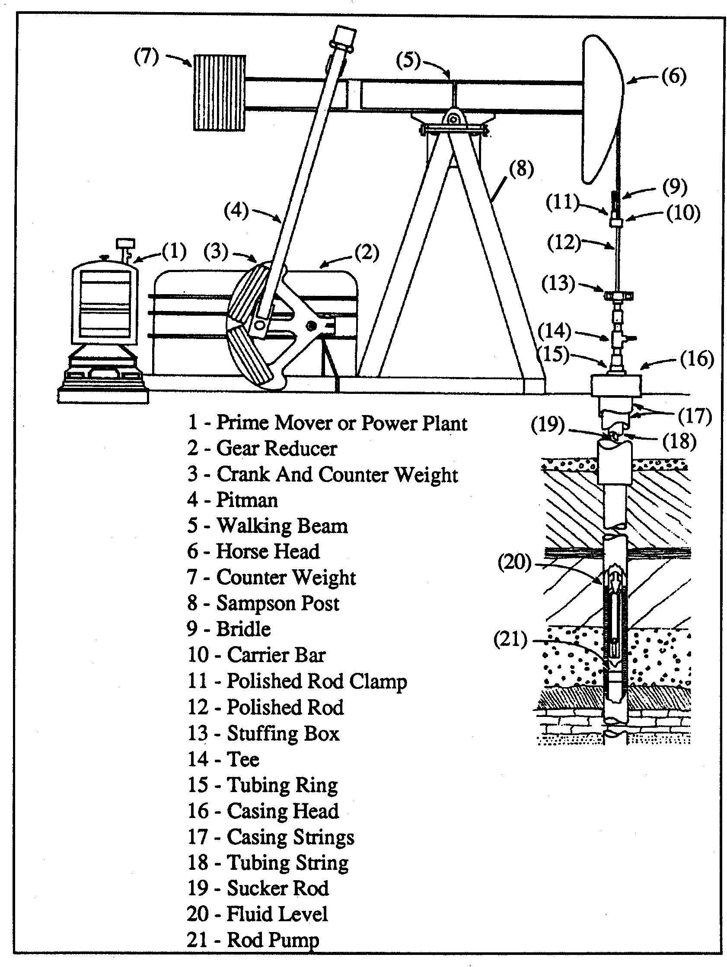
Source: Figure 301.4, Oil Field Production, Compliance Assistance Program CARB Compliance Division, July 1992

Figure 1-2
Artificial Lift Pumping Unit
After drilling, an oil well is constructed, which is essentially a pipeline reaching from the top of the ground to the oil-producing formation. It is through this pipe that oil is brought to the surface. The pipeline is a series of joints of a special kind of pipe (casing) screwed together to form a continuous tube or string for the oil and gas to flow (Figure 1-2). Sometimes in drilling a well, more than one commercially productive formation is found. In such cases a separate tubing string is run inside the casing for each productive formation. Production from the separate formations is directed through the proper tubing strings and is isolated from the others by packers that seal the annular space between the tubing strings and casing. These are known as multiple completion wells.

To control the flow of oil and gas from the time the well starts producing, a set of valves and control equipment is put in place at the top of the well. This arrangement is sometimes referred to as a wellhead or “Christmas tree” because of its many branch-like fittings. It is usually made of steel and it forms a seal to prevent well fluids from blowing or leaking at the surface. The wellhead is sometimes made up of many heavy fittings with certain parts of the wellhead designed to hold pressures up to 20,000 pounds per square inch. In other cases, wellheads may be just a simple assembly to support the weight of the tubing in the well and may not be built to hold pressure. The kind of head and configuration to be used is determined by well conditions, with high pressure formations requiring heavy, high-pressure wellheads.

At the top of the wellhead is the stuffing box. The stuffing box is a metal container that compresses flexible material or packing to seal off pressure inside the tubing to prevent liquid and gas from being pulled by the polished rod into the open air.

Fugitive emissions from the oil, water and gas flow may occur at valves, flanges and threaded connections on the wellhead. To reduce these fugitive emissions, it is important for sources to have a routine program of inspection and repair of equipment to detect and eliminate conditions that may result in a breakdown.

Abandoned Wells
When an oil or gas reservoir is depleted, the well is abandoned and the site is cleaned up. The hole is plugged with cement to protect all underground strata, prevent any flow or leakage at the surface and protect water zones. Salvageable equipment is removed; pits used in the operations are filled in and the site is regraded. Where practical the ground is replanted with grass or other kinds of vegetation and sometimes residential, commercial or industrial sites are constructed.

Well Cellars
In most cases the wellhead resides in the well cellar which is a small subsurface containment (see Figure 1-3). Based on SCAQMD staff investigation, well cellars were determined to be the source of considerable fugitive emissions (Preliminary Staff Report for Proposed Rule 1148.1 – Oil and Gas Production Wells and Proposed Amended Rule 222 – Filing Requirements for Specific Emissions Sources Not Requiring a Written Permit Pursuant to Regulation II [Preliminary Staff Report for PR 1148.1 and PAR 222] dated August 12, 2003). Well cellars can be lined or unlined and there can be one or more wellheads allocated to a well cellar. On average, a well cellar has approximate dimensions of six feet by six feet with a depth of between five to eight feet. In the absence of containers used to catch discarded liquid (crude/water) produced during sampling and maintenance at the wellhead, there is an accumulation of crude oil that falls to the bottom of the well cellar. Because catch containers are not universally used, it is common to find accumulation of crude oil in the bottom of well cellars. Also, since there needs to be access to wellheads for maintenance and sampling, well cellars are uncovered and become sources of volatile organic compound emissions when crude oil is collected in this containment.

Separation and Treatment
After the well fluids and gas reach the wellhead they are transferred to a treatment plant. At the treatment plant the crude oil, natural gas, produced water and solid contaminants are separated and treated. A treatment plant can be simple or complex and can take many different forms depending on treatment needs. Typically, the treatment plant includes a well flow-line manifold in addition to separators, free water knockout vessels, heaters (if crude is heavy), heater-treaters, wash tanks, stock tanks, wastewater separators or oil/water separators, sumps, pits, ponds and a vapor recovery unit.

Some of the equipment that require permits by the SCAQMD include American Petroleum Institute (API) separators and clean-out sumps which are usually part of the wastewater system permit unit. Open ditches also require a permit, but there are no active permits currently in the district. Issues related to wastewater associated with sump separation and treatment processes are addressed in SCAQMD Rule 1176.

The well fluids (oil/water) and gas mixture flow to a well manifold that connects with each well in the field. From the manifold, the mixture is directed to either a test or a production separator. Test separators separate and measure the three phases separately and are used to determine the production of each well from the field. Under normal conditions, the mixture flows to a production separator where gas is separated from the mixture. From there, the oil/water stream flows to a free knockout vessel, a heater treater, a wash tank and an oil/water separation vessel where water is removed from the oil. After there is a sufficient reduction of water content, the oil flows to an oil storage or stock tank. Upon sale, the oil flows through Lease Automated Custody Transfer (LACT) units for metering.

Gases removed from the oil during treatment may be 1) burned as fuel; or 2) treated and sold. Gas collected from separators and oil treaters, along with vapors from storage tanks, may be processed through a dehydration unit (usually glycol). This unit removes the water from the gas before it is put into a sales pipeline or used again in the dehydration process. PR 1148.1 will seek to ensure that facilities in the South Coast Basin practice one of the two options listed above or a combination of these. A commonly used option is a gas-fired heater which burns the facility’s gas and produces heat to reduce the viscosity of the crude oil product. Reducing the viscosity of crude oil facilitates the handling within the production operation or the transport via pipeline to the refineries.

The oily water collected from the separators and the oil treaters may flow directly to a sump or may flow to a water treatment facility prior to disposal. At the water treatment facility the oil content of the water is reduced by skimming tanks, dissolved air flotation units, pits, filters or a combination of these methods. The water may be used on-site, discharged to the surface, or injected back into water injection wells or disposal wells. All of the separation vessels usually have vapor recovery. Recovered vapors are piped back to the gas pipeline for dehydration.

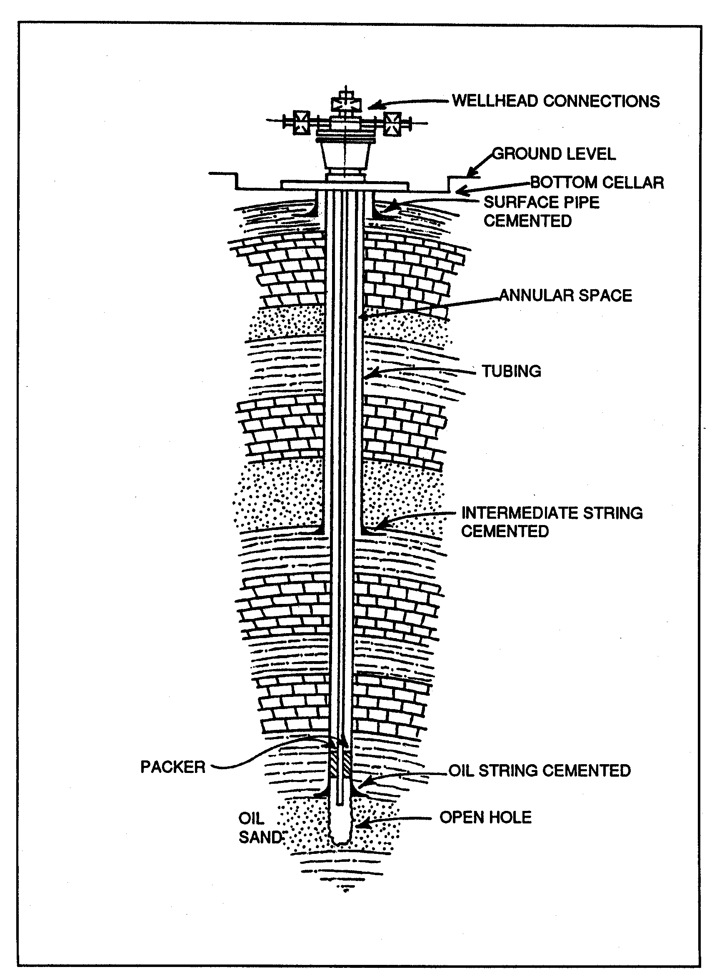
Source: Figure 301.2, Oil Field Production, Compliance Assistance Program CARB Compliance Division, July 1992

Figure 1-3
A Typical Well

Overview of Other Current Regulatory Requirements Applicable to Oil and Gas Production Facilities
There are currently four SCAQMD rules that regulate the emissions of fugitive VOCs at oil and gas production facilities.

Rule 1148 - Thermally Enhanced Oil Recovery Wells
Rule 1148 was adopted in 1982 and has never been amended. Rule 1148 applies to thermally enhanced oil recovery wells, and limits VOC emissions to 4.5 pounds per day or less per well whether or not the wells are connected to vapor control systems.

Rule 1173 - Control of Volatile Organic Compound Leaks and Releases from Components at Petroleum Facilities and Chemical Plants
Rule 1173 was adopted in 1989 and last amended in 2002. The purpose of the rule is to reduce VOC leaks from components such as valves, fittings, pumps, compressors, pressure relief devices, diaphragms, hatches, sight glasses and meters at refineries, chemical plants, oil and gas production fields, natural gas processing plants and pipeline transfer stations.

Rule 1176 - Sumps and Wastewater Separators
Rule 1176 was adopted in November 1989 and last amended in September 1996. It applies to wastewater systems and associated control equipment located at petroleum refineries, onshore oil production fields, off-shore oil production platforms, chemical plants and industrial facilities. Sumps and wastewater separators are required to be covered with either a floating cover equipped with seals or a fixed cover, equipped with a closed vent system vented to an air pollution control system.

Currently, under Rule 1176(i)5(H), well cellars used in emergencies at oil production fields are exempt if clean-up procedures are implemented within 24 hours after each emergency occurrence and completed within ten calendar days.

Other Regulatory Requirements Pertaining to Oil and Gas Production in California
The SCAQMD is required by California Health and Safety Code Section 40920.5 to adopt all feasible control measures. The following subsections summarize regulations adopted by other agencies or other regulatory requirements that control VOCs from oil and gas production facilities.

Public Resources Code
Public Resources Code §§ 3300-3314 and §§ 3350–3353 prohibit persons from willfully allowing natural gas from land containing oil or gas to escape into the atmosphere. These are requirements applicable throughout California. The Division of Oil and Gas DOGGR is responsible for enforcing this code.

Santa Barbara County APCD

Rule 344
Santa Barbara County Air Pollution Control District (SBCAPCD) adopted Rule 344 on November 10, 1994. The purpose of the rule is to address VOC emissions associated with sumps, pits and well cellars in Santa Barbara County. Relative to well cellars, this rule seeks to minimize the collection of crude oil in well cellars, requiring operators to use a portable container with a cover whenever a valve at the wellhead is opened. Operators are also required to initiate pump-outs when the well cellar liquid depths exceed 50 percent of the total well cellar depth.

Rule 325
On January 25, 1994, SBCAPCD adopted Rule 325. This rule applies to equipment used in the production, gathering, storage, processing, and separation of crude oil and natural gas prior to custody transfer. The rule requires that emissions of produced gas be controlled at all times using properly maintained and operated systems that direct all produced gas to a gas plant, a flare or any other device that has a VOC vapor removal efficiency of at least 90 percent by weight.

Ventura County Air Pollution Control District
Ventura Air Pollution Control District (VAPCD) adopted Rule 71.4 on October 4, 1998. Rule 71.4 applies to sumps, pits, and well cellars at facilities where petroleum is produced, gathered, separated, processed or stored in Ventura County. The rule prohibits operators or owners to store crude oil or other petroleum products in well cellars, except during periods of maintenance and well work-over. Storage is not allowed for more than five calendar days. Rule 71.4 provides an exception for storage during emergencies as long as clean-up procedures are implemented within 24 hours of each emergency and completed within 15 calendar days.

California Department of Conservation Division of Oil, Gas & Geothermal Resources
Currently, the maintenance of well cellars at oil and gas production operations in California is overseen by the Department of Conservation’s Division of Oil, Gas & Geothermal Resources (Division of Oil and Gas DOGGR). The Public Resources Code, Division 3, Chapters One through Four, governs the regulatory functions of the Division of Oil and Gas DOGGR. The Code charges the Division of Oil and Gas DOGGR with the responsibility of supervising oil, gas and geothermal well drilling, operation, maintenance, plugging and abandonment operations to prevent the damage to life, health, property and natural resources. More specifically the Division of Oil and Gas DOGGR must:

- Prevent damage to underground oil, gas and geothermal deposits;
- Prevent damage to underground and surface waters suitable for irrigation or domestic use;
- Prevent other surface environmental damage, including subsidence;
- Prevent conditions that may be hazardous to life or health; and
- Encourage the wise development of oil, gas and geothermal resources through good conservation and engineering practices.

The Division of Oil and Gas DOGGR’s programs include well permitting and testing; safety inspections; oversight of production and injection projects; environmental lease inspections; idle-well testing; inspecting oilfield tanks, pipelines, and sumps; hazardous and orphan-well plugging and abandonment contracts; and subsidence monitoring.

PROJECT DESCRIPTION

Recent Modifications to PR 1148.1
The following changes to PR 1148.1 were made subsequent to the January 9, 2004 Governing Board Meeting and are incorporated in this Final EA:
- Well drilling and abandonment operations were added to Requirement (d)(3). The operator is required to pump out or remove organic liquid that accumulates in the well no later than two days after maintenance, drilling, well plugging, or workover activity is completed. To accommodate safety concerns with the addition of drilling to requirement (d)(3), the provision to allow storage of organic liquid in a portable enclosed storage vessel equipped with air pollution control equipment was qualified with “except where safety requirements established in a written company safety manual deem it impractical during drilling operations.”
- Requirement (d)(5)(B) was altered to provide additional flexibility for complying with the well pump-out provision. Requirement (d)(5)(B) would allow operators to determine the need for a pump-out by measuring the depth of accumulated organic liquid using a copper coat gauge or any other instrument deemed acceptable by the Executive Officer. Pump-out or removal of organic liquid would be required when the depth of accumulated organic liquid exceeds two inches. This modification deletes the provision that this pump-out is applicable only to wells within 100 meters of a sensitive receptor.
- Requirement (d)(7) was modified to exempt components already regulated by Rule 1173 to prevent duplicability with another rule.
- Requirement (d)(8) was added which prohibits operators from circumventing the rule by rendering well cellars ineffective or installing wells without well cellars after the rule is adopted.
- A provision that allows facilities to measure organic liquid depth in well cellars using a “copper coat” gauge or any other measuring instrument determined to be acceptable by the Executive Officer or USEPA Method 21 was added to Operator inspection requirement (e)(4). This provision previously required inspection only according to USEPA Method 21. This provision applies to: stuffing boxes and well cellars within two days of discovery of organic liquid leakage observed by daily visual inspections of stuffing boxes not located in or above a well cellar; weekly visual inspections of stuffing boxes in or above well cellars; and within eight hours of stuffing boxes or produced gas handling and control equipment located 100 meters or less from a sensitive receptor.
- A provision to exempt well drilling and well abandonment operations was added to exemption (h)(2) provided that maintenance and repair, drilling or abandonment operations are conducted in a safe manner that minimizes emissions to the atmosphere. This provision previously applied only to wells undergoing maintenance and repair.
- Exemption (h)(2) for small producers was added based on discussions with DOGGR. Oil and gas production wells in operation after the date PR1148.1 is adopted and that produced no more than one barrel per day of oil or no more than 200 standard cubic feet per day of produced gas per facility, would be exempt from PR 1148.1, provided that such production wells are not located within 100 meters of a sensitive receptor, and provided the production can be demonstrated from annual production records. Demonstration of produced gas production shall be based on metered measurement of the gas. This revision will reduce the amount of VOC emission reductions identified in the previous version of PR 1148.1; however, PR 1148.1 will still reduce VOC emissions from wells and well cellar sources at oil and gas production facilities, which are currently unregulated.

PR 1148.1 Description
PR 1148.1 would reduce VOC emissions from well cellars located at on-shore oil and gas production facilities. PR 1148.1 would implement portions of 2003 AQMP control measure FUG-05, which includes phase III of the 1999 AQMP FUG-05. The following summarizes the main requirements of the proposed rule as recently modified. A copy of PR 1148.1 as recently modified can be found in Appendix A.

Purpose
The purpose of this rule is to reduce emissions of volatile organic compounds (VOCs) from the wellheads, the well cellars and the handling of produced gas at on-shore oil and gas production facilities.

Applicability
This rule would apply to on-shore oil producing wells, well cellars, and produced gas handling activities at onshore facilities where petroleum is produced, gathered, separated, processed and stored. Natural gas distribution, transmission and associated storage operations are not subject to PR 1148.1.

Definitions
This subdivision lists keywords related to oil and gas production wells and defines them for clarity and to enhance enforceability. For example, oil production field is defined as a facility where crude petroleum production and handling are conducted.

Requirements
- Operators of facilities shall not allow the are in violation of the rule if the well cellar total organic compound (TOC) concentration to exceeds 500 parts per million (ppm) as determined by USEPA Method 21 in the well cellar.
- Effective July 1, 2004, operators of wellheads would be prohibited from shall not allow any opening valves to be opened at a wellhead unless a portable container, which must remain closed to the atmosphere when not in use, is used to catch any organic liquids.
- No person shall purposely store The operator shall not allow organic liquid to be stored in a well cellar. Notwithstanding, dDuring periods of maintenance, well drilling, abandonment operations, or well work-over, operators would be required to remove any organic liquid that accumulates in the well cellar no later than two days after maintenance, drilling, well plugging, or work-over activity is complete. Except where safety requirements established in a written safety mainual or policy deem it impractical during drilling operations, the operator may store organic liquid in If a Baker tank portable enclosed storage vessel is used to store material, it shall be provided it is equipped with carbon canisters air pollution control equipment to reduce TOC emissions to less than 250 ppm outlet concentration calculated as methane. USEPA Reference Method 21 measurements would be required at filling and weekly thereafter to ensure compliance of the 250 ppm standard.
- Immediately before a well is steamed or after a wellhead is steam cleaned, liquid accumulated in the well cellar shall be pumped out.
- The operator shall pump out or remove any organic material accumulated in the well cellar within five calendar days of discovery or, within 24 hours if the well cellar is located within 100 meters of a sensitive receptor, or when the operator or SCAQMD inspection determines that the total TOC concentration in the any well cellar is greater than 250 ppm as determined by USEPA Method 21,. In lieu of USEPA Method 21, an operator may measure or the depth of oil/petroleum phase of the accumulated liquid using a “copper coated” gauge or any other measuring instrument determined to be acceptable by the Executive Officer. The liquid must be pump-out when the depth exceeds two inches in a well cellar within 100 meters of a sensitive receptor.
- Effective January 1, 2006, no the operator would not be allowed to intentionally vent natural gas or produced gas into the atmosphere. The operator would be required to control produced gas with either a system handling gas for fuel, sale or underground injection; or another device approved by the SCAQMD Executive Officer with a demonstrated control efficiency of at least 95 percent by weight or by demonstrating an outlet VOC concentration of 50 ppm using Method 21. If the control device uses supplementary natural gas to control VOC, it shall be equipped with a device that automatically shuts off the flow of natural gas in the event of a flame-out or pilot failure.
- Except as Rule 1173 applies to components of For produced gas handling activities within 100 meters of a sensitive receptor, the operator would be required to repair any gaseous leaks of 250 ppm TOC or greater within 24 hours of leak discovery or take actions to prevent the release of TOC emissions to the atmosphere until repairs have been completed.
- Effective March 5, 2004, no person shall remove or otherwise render ineffective a well cellar at an oil and gas production well except for purposes of abandonment to be certified by DOGGR or drill a new oil and gas production well unless a well cellar is installed for containment of fluids.

Operator Inspection Requirements
- Effective, July 1, 2004, operators shall perform daily audio-visual inspections of all stuffing boxes which are not located in a well cellar; weekly audio-visual inspections of all stuffing boxes located in or above a well cellar; daily audio-visual inspections of all stuffing boxes or produced gas handling and control equipment located 100 meters or less from a sensitive receptor. Receptor distance would be determined as the distance measured from the stuffing box or produced gas handling and control equipment to the property line of the nearest sensitive receptor.
- Notwithstanding the requirements above, operators shall perform monthly visual inspections of all stuffing boxes which are fitted with an adaptor, closed crude oil collection container, and well shut off switch.
- Effective July 1, 2004, operators would be required to inspect all well cellars quarterly for liquid leaks according to USEPA Method 21.
- Within eight hours of an observed organic liquid leak during an inspection at a facility within 100 meters of a sensitive receptor, or within two days of an observed leak during an inspection at any other facility, the operator shall conduct an inspection of the stuffing box and well cellar according to USEPA Method 21, or if the instrument required to determine TOC concentration per USEPA Method 21 is not available to the operator, the organic liquid depth can be measured using a “copper coat” gauge or any other measuring instrument determined to be acceptable by the Executive Officer.

Recordkeeping Requirements
- The operator would be responsible for maintaining all records that document the purchase and installation of stuffing box adaptors for compliance with PR 1148.1 at the facility or facility headquarters.
- The operator would be responsible for maintaining all records of inspection, repair, and pump-outs required by PR 1148.1 in a form approved by the Executive Officer at the facility or facility headquarters for three years, five years for Title V facilities, and make records available to the Executive Officer upon request.
- The operator would be responsible for maintaining production records and other applicable information and documents demonstrating eligibility for any exemption claimed.

Test methods
Proposed rule language requires approved test methods to be used in determining TOC and VOC concentration and control efficiency.

Exemptions
- The operator may request an exemption from PR 1148.1 for any wells that have been idle and out of operation for more than six months; for wells that have been certified as abandoned; or for water, gas, or steam injection wells.
- Pump-out and produced gas control requirements would not apply to any well or produced gas handling system undergoing maintenance and repair, well drilling and well abandonment operations, provided the maintenance and repair, drilling or abandonment operation is conducted in a safe manner that minimizes emissions to the atmosphere..
- Organic liquid control requirements would not apply to well cellars used for emergency containment, which are compliant with Rule 1176 if clean-up procedures are implemented within 24 hours after each emergency occurrence and completed within ten calendar days.
- The provisions of paragraph (d)(6) of this rule shall not apply to oil and gas production wells in operation as of March 5, 2004, that produce no more than one barrel per day of oil or no more than 200 standard cubic feet per day of produced gas per facility, provided that such wells are not located within 100 meters of a sensitive receptor, and provided the production can be demonstrated from annual production records. Demonstration of produced gas production shall be based on metered measurement of the gas.

PAR 222 Description
PAR 222 would include provisions for well cellars, wellheads and well pumps. The following summarizes the main requirements of the proposed amended rule. A copy of PAR 222 can be found in Appendix B.

Purpose
No changes have been proposed to purpose of the rule.

Applicability
PAR 222 would apply to owners/operators of well cellars, wellheads and well pumps beginning July 1, 2004, unless the SCAQMD Executive Officer determines that the source cannot operate in compliance with applicable rules and regulations. If the source cannot operate in compliance with applicable rules and regulations a permit is required.

Definitions
Definitions for well cellars, wellheads and well pumps are added to PAR 222 for clarity and to enhance enforceability.

Requirements
No changes proposed to the requirements of the rule.

Compliance Date

No changes proposed to the compliance dates of the rule.

EMISSIONS INVENTORY AND EMISSION REDUCTIONS

Baseline Emissions Inventory
Baseline emissions for this proposed rule include VOC emission from wellheads, well cellars, and produced gas. The total VOC emissions baseline from well cellars and untreated produced gas is 4,080 pounds per day. The VOC emission baseline for PR 1148.1 is presented in Table 1-1. Detailed emissions estimations are presented in Appendix C.

The organic liquid evaporation VOC emissions baseline from well cellars, 2,420 pounds of VOC per day (1.21 tons per day), was developed from area sources reported in the 1997 emissions inventory in the 2003 AQMP, and updated with point sources from the 2000-01 Annual Emission Reporting Program.

The untreated produced gas released to the atmosphere VOC emissions baseline of 1,660 pounds per day (0.83 ton per day) was developed from the produced gas presented in the 2001 DOGGR Annual Report of the State’s Division of Oil and Gas, a survey of the SCAQMD permitting database, and a telephone survey completed by SCAQMD rule development staff.

Table 1-1
Existing VOC Emission Baseline Estimates for Wellheads and Well Cellars

Description | VOC  (pounds/day)
Organic Liquid Evaporationª | 2,420
Untreated Produced Gas Released to Atmosphere^{b} | 1,660
Total | 4,080
a) Area sources from the 2000-01 Annual Emission Reporting Program and point sources from the 1997 emissions inventory in the 2003 AQMP
b) 2001 DOGGR Annual Report of the State’s Division of Oil and Gas and approximately one percent of the produced gas is released uncontrolled to the atmosphere

Emission Reductions
PR 1148.1 would regulate emissions generated from both organic liquid evaporation and untreated produced gas released to the atmosphere. However, only emissions reductions associated with control of petroleum or organic liquid would be creditable towards SIP emission reductions, since these emissions are have been included in the SIP emissions inventory. Emission reductions from the control of produced gas would not be used towards SIP emission reductions, since these emissions were not included as part of the SIP inventory.

Organic Liquid Evaporation
PR 1148.1 is similar to Rule 1173 in that the proposed rule will require quarterly VOC measurements of VOC concentration of well cellars. Based on 14 years of experience with the inspection and maintenance requirements of Rule 1173, staff has estimated a control factor of 84 percent for Rule 1173. To be conservative, VOC control efficiency of emissions from the wellheads and well cellars the use of portable containers, faster pump-out and repair requirements, and the associated improved management, inspection and maintenance program is estimated to be 80 percent. The emission baseline from well cellars is 2,420 pounds of VOC per day (1.21 tons per day). Eighty percent control of 2,420 pounds of VOC per day (1.21 tons per day) is 1,936 pounds of VOC per day (0.97 tons per day). These SIP creditable reductions are presented in Table 1-2. Detailed emission and emission reduction calculations can be found in Appendix C.

Untreated Produced Gas Released to Atmosphere
PR 1148.1 requires operators to control produced gas using a properly maintained and operated system that directs all produced gas to either a system handling gas for fuel, sale, or underground injection or a device with a VOC removal efficiency demonstrated to be at least 95 percent. The emissions baseline for untreated produced gas released to the atmosphere is 1,660 pounds of VOC per day (0.83 ton per day). However, based on the DOGGR 2001 Annual Report, it is expected that eight facilities would be exempt from the produced gas requirements of PR 1148.1, because they produce no more than one barrel per day of oil or no more than 200 standard cubic feet of produced gas per day. Approximately, nine pounds of VOC emission reductions would be lost based on this exemption for small facilities; therefore, 1,651 pounds of VOC per day (0.80 ton per day) would be available from the baseline to be reduced as a result of implementing PR 1148.1 as modified. Ninety-five percent control of 1,660 1,651 pounds of VOC emissions per day (0.83 0.80 ton per day) is 1,577 1,526 pounds of VOC per day (0.79 0.76 ton per day). Detailed emission and emission reduction calculations can be found in Appendix C.

Table 1-2
Emissions Reductions for Proposed Rule 1148.1

Description | VOC Reduction  (pounds/day) | SIP Creditable
Organic Liquid Evaporation | 1,936 | Yes
Produced Gas Released to Atmosphere | 1,577 1,526 | No
Total Reductions | 3,513 3,462

Control TECHNOLOGY Review
The following subsections describe control techniques for reducing fugitive emissions from well cellars. There are three primary techniques for reducing VOC emissions: (a) sample management, (b) equipment installation and repair, and (c) implementing an inspection and maintenance program.

Sample Management
Sample management is a simple technique that can be implemented by operators at oil production facilities. It is based on the good work practice standard of catching and collecting discarded liquid produced at the wellhead during sampling. The use of a portable container whenever a valve is opened prevents the crude oil from falling to the bottom of the well cellar or on the ground, spreading out and emitting from the surface of the accumulation. The container is equipped with a cover, which is required to be closed whenever crude oil is not being collected, to significantly reduce VOC emissions to the atmosphere. The collected crude oil is typically added back to a separation treatment system.

Equipment Installation, Maintenance and Repair

Crude Oil
Three possible equipment installations/modifications and component maintenance and repair are briefly described below.

Adapter Installation
This technology involves the installation of an adapter to the stuffing box for the pump rod of the oil well. The adaptor includes a reservoir to collect leakage from the stuffing box packing. Similar to the use of a container under Sample Management described earlier, the use of a portable container prevents the crude oil from falling to the bottom of the well cellar or on the ground, spreading out and emitting from the surface of the accumulation. The reservoir is equipped with a cover, which is required to be closed whenever crude oil is not being collected, to significantly reduce VOC emissions to the atmosphere.

Stuffing Box Maintenance
This option involves the increased maintenance and repair of the stuffing box. The stuffing box is a packing gland, chamber, or “box” used to hold packing material compressed around a moving pumping rod to prevent escape of gas or liquid. Therefore, adjusting or replacing the packing will reduce the fugitive emissions resulting from the accumulation of crude oil in the well cellar or on the ground and eliminating associated clean-up costs.

Closed-Purge Systems
A closed-purge system captures leaking liquid and either returns it to a production system or routes it to a closed disposal system. The control efficiency of a closed-purge system depends on the percentage of leakage that is routed to the disposal system. A closed-purge system can be installed on a single component or on a group of components. The control efficiency of closed-purge system can be at least 95 percent.

Produced Gas
There are four control options for controlling VOC emissions from produced gas: flares, gas plant, other combustion devices and carbon adsorbers. These four options for controlling produced gas are briefly described below.

Flares
Natural gas is a byproduct of many oil and gas production facilities. Facilities use flares to burn off natural gas when their compressors break down, are being serviced, or when there is another problem in the natural gas production system. Flares are typically used when the heating value of the gas cannot be recovered economically because of intermittent or uncertain flow or when process upsets occur as referred to above. Some operators may flare all their natural gas if they do not recover it. Flares may also be used on the vapor recovery system at a loading rack or tank battery. Only a small amount of inspection is required for flaring units. Flares typically do not produce any visible emissions, with only a flame produced in stack of a flaring unit. They must also have a continuous ignition system and records of flare usage are typically kept by the operator at the facility.

Some types of flares include steam-assisted, air-assisted and pressure head flares. Steam- assisted flares are single burner tips, elevated above ground that burn the vented gases in a diffusion flame. This type of flare system injects steam into the combustion zone to promote turbulence and to induce air into the flame. Steam-assisted flares also account for the majority of flares installed. Flares can typically achieve a VOC destruction efficiency of at least 95 percent.

Discussions with the SBCAPCD have revealed that many small oil and gas production facilities in its jurisdiction have installed their own operator-built flares tailored to their individual gas treatment needs and meet rule requirements.

Gas Plant
The overall objective of an oil and gas production facility is to prepare the oil and gas for pipeline transport. The oil is usually transferred to a pipeline terminal and eventually to a refinery, while the gas may be sold to a pipeline company for further sale or transported directly to a gas plant for additional treatment. The types of process equipment required at a production facility depend on the quality of the well-head product and whether or not both oil and gas are produced by the well.

Natural gas exiting the separators is composed primarily of methane, ethane, propane and butane, which may also contain impurities such as nitrogen, helium, carbon dioxide, hydrogen sulfide, mercaptans and water. Condensable hydrocarbons are recovered from the gas using absorption, refrigeration or gas expansion processes. Water is removed by passing the gas through equipment such as glycol dehydrators, where water is absorbed by the glycol. This water is ultimately vented as steam from the glycol reboiler.

Gas sweetening and product separation are often conducted at a gas plant that is not located at the oil and gas production facility. In order to “sweeten” sour natural gas, hydrogen sulfide and carbon dioxide are usually scrubbed from the gas using an amine solution in an absorption tower. The acid gas stream may be flared, incinerated or processed further in a sulfur-recovery facility, and the scrubbed gas stream is further processed to separate products.

Gas plants may be cost-prohibitive for small oil and gas production facilities and therefore are not regarded as a cost effective control option and are not considered further in the analysis in Chapter 2.

Other Combustion Devices
Gases removed from the oil during treatment may be combusted as fuel. The fuel may be used in devices such as ICEs, process heaters, heater treaters, boilers, steam generators or turbines. In addition to controlling emissions, these combustion devices generate useful energy or heat. At some facilities ICEs are used to drive pumps, compressors and other prime movers involved in oil and gas production operations. Process heaters are used to heat organic liquid for easier transfer or to assist in the water separation process.

Most combustion devices would require Best Available Control Technology (BACT). BACT for ICEs, boilers, steam generators and turbines would typically include catalyst for exhaust emissions and sulfur removal for the produced gas prior to combustion.

Carbon Adsorbers
Activated carbon systems can also be used to control VOC emissions. In situations where the carbon is virgin material, the VOC reduction efficiency would be high. Once the activated carbon is spent, it would have to be replaced by additional carbon, and the spent carbon would have to be regenerated. Carbon adsorption has not been used to control produced gas VOC emissions from oil and gas facilities, therefore, it is unlikely facilities would choose this option and will not considered further in the analysis in Chapter 2.

Inspection and Maintenance
A required inspection and maintenance (I & M) program is effective in reducing fugitive VOC emissions. In this approach, the four most important factors in determining the control effectiveness are: (1) to determine that a leak is occurring or has occurred, (2) to correct the cause of the leak, (3) to remove or cleanup the accumulation of VOC emitting material, and (4) to reduce the frequency at which the leaks are occurring. An I & M program can be designed to identify oil production well components that emit sufficient amounts of material to warrant reducing excessive emissions through repair.

To determine the effectiveness or a control factor for well cellars, staff analyzed two rules that require an I & M program: AQMD Rule 1173 – Control of Volatile Organic Compound Leaks and Releases from Components at Petroleum Facilities and Chemical Plants; and SBCAPCD Rule 344 - Petroleum Sumps, Pits and Well Cellars.

AQMD Rule 1173 requires the use of a Leak Detection and Repair (LDAR) program. LDAR incorporates the elements of an I & M program. However, LDAR goes one step further in that it requires quantifying the fugitive gaseous VOC leaks with a portable analyzer, per USEPA Reference Method 21. Inspections with VOC measurements for heavy liquid pumps are required on a quarterly basis. All other components must meet an emission concentration. A conservative estimate of a control factor for components (pumps, valves, connectors, etc.) in heavy liquid service (including crude oil) was documented as 84 percent. (Rule 1173 Staff Report – October 10, 2002).

SBCAPCD Rule 344 requires the use of a sample management program and an inspection and maintenance program that includes the installation of an adapter system and/or maintenance and repair to reduce fugitive VOC emissions. A 70 percent control factor was estimated by Santa Barbara staff. Although not explicitly stated in the rule, permitting staff at the SBCAPCD require weekly inspections as a permit condition when issuing well cellar permits.

Under its February 1996 SIP-approved rule, SBCAPCD was able to reduce well cellar VOC emissions from 406 tons per year in the baseline inventory year of 1995 to 94 tons per year in inventory year 1997; an overall 77 percent reduction in fugitive VOC emissions from well cellars. Although some of the emission reductions can be attributed to shutdowns, the majority of the reported VOC emission reductions were a result of implementing programs such as sample management and inspection and maintenance of well cellars as required by SBCAPCD Rule 344.

PR 1148.1 is similar to Rule 1173, in that the proposed rule will require quarterly VOC measurements of VOC concentration of well cellars. Staff has estimated a control factor of 84 percent for Rule 1173. Therefore, to estimate projected VOC emission reductions resulting from use of portable containers and the associated inspection and maintenance program of well cellars, a conservative control factor of 80 percent has been used. This control factor is considered conservative compared to SCAQMD’s experience with the inspection and maintenance programs under Rule 1173 that have resulted in significantly fewer leaking components at affected facilities.

C H A P T E R 2 - E N V I R O N M E N T A L C H E C K L I S T

Introduction
General Information
Potentially Significant Impact Areas
Determination
General Effects of the Proposed Project
Environmental Checklist and Discussion
INTRODUCTION
The environmental checklist provides a standard evaluation tool to identify a project's potential adverse environmental impacts. The following environmental checklist has been used as an evaluation tool to identify and discuss potential significant adverse environmental impacts associated with the implementation of PR 1148.1.
PAR 222 only requires application submittal and recordkeeping requirements. Therefore, PAR 222 has no significant adverse impacts on the environment and will not be evaluated further.

GENERAL INFORMATION
Project Title: | PR 1148.1 – Oil and Gas Production Wells and PAR 222 – Filing Requirements for Specific Emission Sources Not Requiring a Written Permit Pursuant to Regulation II
Lead Agency Name: | South Coast Air Quality Management District
Lead Agency Address: | 21865 E. Copley Drive  Diamond Bar, CA 91765-4182
CEQA Contact Person: | Mr. James Koizumi (909) 396-3234 (jkoizumi@aqmd.gov)
Rule Contact Person(s): | Mr. Kennard Ellis (909) 396-2457 (kellis@aqmd.gov)
Project Sponsor: | South Coast Air Quality Management District  21865 E. Copley Drive  Diamond Bar, CA 91765-4182
Project Description: | PR1148.1 – Oil and Gas Production Wells, would reduce VOC emissions from oil and gas production wellheads and the well cellars located at oil and gas production facilities through an enhanced self-inspection and maintenance program. Proposed amended Rule (PAR) 222 – Filing Requirements for Filing Requirements for Specific Emission Sources Not Requiring a Written Permit Pursuant to Regulation II, would add reporting requirements for well cellars, wellheads and well pumps regulated under PR 1148.1.
General Plan Designation and Zoning: | Not Applicable.
Surrounding Land Uses and Setting: | Not Applicable.
Other Public Agencies Whose Approval is Required: | None.

POTENTIALLY SIGNIFICANT IMPACT AREAS
The following environmental impact areas have been evaluated to determine their potential to be affected by the proposed project. As indicated by the checklist on the following pages, environmental topics marked with a “” may be adversely affected. An explanation relative to the determination of impacts can be found following the checklist for each area.
◻ | Aesthetics | ◻ | Geology and Soils | ◻ | Population and Housing
◻ | Agricultural Resources | ◻ | Hazards and Hazardous Materials | ◻ | Public Services
☑ | Air Quality | ◻ | Hydrology and Water Quality | ◻ | Recreation
◻ | Biological Resources | ◻ | Land Use and Planning | ◻ | Solid/Hazardous Waste
◻ | Cultural Resources | ◻ | Mineral Resources | ◻ | Transportation./Traffic
◻ | Energy | ◻ | Noise | ◻ | Mandatory Findings
DETERMINATION
On the basis of this initial evaluation:
☑ | I find that the proposed project, in accordance with findings made pursuant to CEQA Guidelines (California Code of Regulations, Title 14 §15252), COULD NOT have a significant effect on the environment, and that an ENVIRONMENTAL ASSESSMENT with no significant impacts will be prepared.
◻ | I find that although the proposed project could have a significant effect on the environment, there will NOT be significant effects in this case because mitigation measures have been incorporated into the project. An ENVIRONMENTAL ASSESSMENT with no significant impacts will be prepared.
◻ | I find that the project MAY have a significant effect(s) on the environment, and an ENVIRONMENTAL ASSESSMENT will be prepared.
Date: November 19, 2003 Signature: 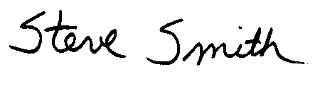
Steve Smith, Ph.D.
Program Supervisor, CEQA
Planning, Rule Development and Area Sources
GENERAL EFFECTS OF THE PROPOSED PROJECT

CEQA Guidelines §15360 defines the "environment" as the physical conditions which exist within the area which would be affected by a proposed project including land, air, water, minerals, flora, fauna, ambient noise, and objects of historic or aesthetic significance.

PR 1148.1 has been evaluated relative to the environmental topics identified in the environmental checklist below, e.g., aesthetics, agricultural resources, biological resources, etc. Implementing PR 1148.1 is not expected to adversely affect the existing environment for the environmental topics identified in the environmental checklist because its primary effect is to reduce VOC emissions from wellheads, well cellars and handling of produced gas at onshore oil and gas production facilities. PR 1148.1 affects operations at existing facilities; it does not promote construction of new facilities. Therefore, potential adverse impacts that result from construction of new structures and changes in existing land uses are not anticipated, e.g., no impacts to agricultural resources, cultural resources, geology and soils, hydrology and water quality, land use and planning, etc.

Implementation of PR 1148.1 is expected to generate secondary adverse environmental impacts in the process of reducing VOC emissions, such as, from pump-out fugitives, and vehicle exhaust from construction and vacuum trucks. To be conservative, SCAQMD rule development staff estimates 85 facilities would need to install produced gas VOC control from the Department of Oil and Gas 2001 Annual Report, a review of the SCAQMD permitting database, and a telephone survey of industry. In addition, SCAQMD rule development staff estimates that 83 facilities would choose process heaters to control produced gas VOC emissions, because the produced gas flow is low enough that process heaters are the least expensive option, and can be used to enhance flow or assist with oil and water separation. SCAQMD rule development staff assumes that the remaining two facilities would most likely install process heaters. Based on the amount of produced gas released, these two facilities would each require a two million British thermal unit (Btu) per hour combustion VOC control device. At this size, flares and process heaters may cost the same. ICEs are more expensive than process heaters at two million Btu per hour ratings, however, facilities may choose ICEs because of the mechanical work that could be supplied by these engines. Flares and ICEs generate more emissions than process heaters, and therefore, potentially more adverse air quality impacts. Therefore, to be conservative this EA assumes that the two largest facilities would choose either flares or ICEs to control produced gas VOC emissions. Pump-out fugitives are released by the evaporation of organic liquid as it is transferred from the well cellar to the vacuum truck, and from the vacuum truck to the oil and water separator. Vehicle exhaust emissions are generated from construction equipment and vehicles, and from the vacuum trucks.

As stated in Chapter 1, gas plants and carbon absorbers are not considered viable control technologies. Gas plants are cost-prohibitive for small oil and gas production facilities. Carbon adsorbers have not been used to control produced gas VOC emission from oil and gas facilities. In addition, carbon adsorption is typically only cost effective at very low flow rates. Therefore, carbon adsorption is not considered a viable option. Neither gas plants nor carbon adsorption will be analyzed further.

PAR 222 would only require applications and recordkeeping. Therefore, PAR 222 would not adversely affect the physical environment, and will not be evaluated further.

ENVIRONMENTAL CHECKLIST AND DISCUSSION

 | Potentially Significant Impact | Less Than Significant Impact | No  Impact
I. AESTHETICS. Would the project:

- Have a substantial adverse effect on a scenic vista? | ◻ | ◻ | ☑
- Substantially damage scenic resources, including, but not limited to, trees, rock outcroppings, and historic buildings within a state scenic highway? | ◻ | ◻ | ☑
- Substantially degrade the existing visual character or quality of the site and its surroundings? | ◻ | ◻ | ☑
d) Create a new source of substantial light or glare that would adversely affect day or nighttime views in the area? | ◻ | ◻ | ☑

- Aesthetics – Impact Discussion
a) - c) PR 1148.1 does not require construction of new facilities, but would regulate VOC emissions at existing facilities. With the exception of modifications to the stuffing boxes, no visible modifications to wellheads are required by PR 1148.1. Visible control technologies, such as flares, ICEs or other combustion sources, may be selected by facilities to control production gas VOCs. Typically, oil and gas production wells facilities are located within predominantly industrial or commercial areas. These areas are generally void of scenic resources. The visual character of the area is expected to remain the same and is not expected to be degraded due to onsite facility modifications.

d) Although flares are shielded, the flame may be visible depending on flare design, gas flow and meteorology. Existing affected facilities would most likely be located in appropriate land use and zoning areas that are not usually located in residential communities, so any new light sources, if any, would not be noticeable to residents. PR 1148.1 does not require oil and gas production well operations to occur at night, so complying with the proposed rule is not expected to require additional electrical lighting. Further, flare are not expected to be widely used as a compliance option, because flares may not be cost-effective for most affected operations and may be prohibited by local ordinance.

Based upon the above considerations, significant adverse aesthetic impacts are not expected to occur from implementing PR 1148.1, and will not be analyzed further.

 | Potentially Significant Impact | Less Than Significant Impact | No  Impact
II. AGRICULTURE RESOURCES. Would the project:

a) Convert Prime Farmland, Unique Farmland, or Farmland of Statewide Importance (Farmland), as shown on the maps prepared pursuant to the Farmland mapping and Monitoring Program of the California Resources Agency, to non- agricultural use? | ◻ | ◻ | ☑
b) Conflict with existing zoning for agricultural use, or a Williamson Act contract? | ◻ | ◻ | ☑
c) Involve other changes in the existing environment which, due to their location or nature, could result in conversion of Farmland, to non-agricultural use? | ◻ | ◻ | ☑

- Agriculture Resources – Impact Discussion
a) - c) PR 1148.1 affects oil and gas production activities at existing facilities. The proposed project is intended to reduce VOC from oil and gas production facilities. Any operational modifications or site changes initiated to comply with PR 1148.1 would occur within the boundaries of existing industrial facilities which would not be expected to include agricultural uses or areas designated as farmland. Operational modifications or site changes to comply with PR 1148.1 would not require the conversion of any farmland to a non-agricultural use or conflict with any existing agricultural zoning including Williamson Act contracts.

Based upon the above considerations, significant adverse agricultural resource impacts are not expected to occur from implementing PR 1148.1, and will not be analyzed further.

 | Potentially Significant Impact | Less Than Significant Impact | No  Impact
III. AIR QUALITY. Would the project:

- Conflict with or obstruct implementation of the applicable air quality plan | ◻ | ☑ | ◻
- Violate any air quality standard or contribute to an existing or projected air quality violation? | ◻ | ☑ | ◻

 | Potentially Significant Impact | Less Than Significant Impact | No  Impact
- Result in a cumulatively considerable net increase of any criteria pollutant for which the project region is non-attainment under an applicable federal or state ambient air quality standard (including releasing emissions that exceed quantitative thresholds for ozone precursors)? | ◻ | ☑ | ◻
- Expose sensitive receptors to substantial pollutant concentrations? | ◻ | ☑ | ◻
- Create objectionable odors affecting a substantial number of people? | ◻ | ☑ | ◻
- Diminish an existing air quality Rule or future compliance requirement resulting in a significant increase in air pollutant(s)? | ◻ | ◻ | ☑

III. Air Quality – Impact Discussion
It is the responsibility of the SCAQMD to ensure that state and federal ambient air quality standards are achieved and maintained in its geographical jurisdiction. Health-based air quality standards have been established in California and by the federal government for the following criteria air pollutants: ozone, carbon monoxide (CO), nitrogen dioxide (NO₂), particulate matter less than 10 microns (PM10), sulfur dioxide (SO₂) and lead. Attainment of the state and federal ambient air quality standards protects the public in general from the adverse effects of criteria pollutants which are known to have adverse human health effects. These standards were established to protect sensitive receptors within a margin of safety from adverse health impacts due to exposure to air pollution. PR 1148.1 is expected to reduce VOC emissions, which are precursors to ozone. Reducing criteria pollutant precursor emissions would help improve air quality, which would provide health benefits to sensitive receptors.

Unlike primary criteria pollutants that are emitted directly from an emissions source, ozone is a secondary pollutant, formed in the atmosphere by a photochemical reaction of certain primary pollutants. Ozone is a deep lung irritant, causing the passages to become inflamed and swollen. Implementation of PR 1148.1 would reduce VOC emissions which would result in reducing ozone concentrations in the district.

The proposed project is expected to reduce VOC emissions from wellheads, well cellars and production gas. While the proposed project is expected to contribute to the overall reduction of VOCs in the region and aid the SCAQMD in achieving compliance with the federal and state ambient air quality standards in the district, secondary emissions would be generated in achieving these reductions; however, emission increases are not expected to be significant as discussed below.

a) PR 1148.1 is intended to benefit air quality and is consistent with SCAQMD's 2003 AQMP, because it would implement a portion of AQMP control measure FUG-05. VOCs are precursors to ozone emissions for which ambient air quality standards are currently exceeded in the district. The proposed project is intended to reduce VOC emissions at oil and gas production well facilities.

b & d) The objective of PR 1148.1 is to reduce VOC emissions from oil and gas production wellheads, the well cellars that house the wellheads that control the flow of crude oil from onshore oil wells, and production gas at these facilities.

OPERATIONAL AIR QUALITY IMPACTS
The improved management, inspection and maintenance program is projected to achieve 80 percent VOC control efficiency of emissions from the wellheads and well cellars. The emissions baseline from well cellars of 2,420 pounds of VOC per day (1.21 tons per day) was developed from point sources from the 2000-01 Annual Emission Reporting Program and area sources from the 1997 emissions inventory in the 2003 AQMP. Eighty percent control of 2,420 pounds of VOC per day (1.21 tons per day) is 1,936 pounds of VOC emission reduced per day (0.97 ton per day). Emissions reductions associated with controlling petroleum or organic liquid are a part of the SIP emissions inventory; therefore, emission reductions anticipated from wellheads and well cellars are SIP creditable emission reductions (Table 2-1). Detailed emission and emission reduction calculations can be found in Appendix C.

Control equipment includes a required portable container with a cover to catch liquid leaked whenever a valve is opened at the wellhead, and the optional addition of a stuff box with an adapter. Inspection and maintenance programs include daily and weekly inspections unless an alternate schedule is approved by the SCAQMD. Operators are also required to pump-out well cellars no later than two days after well maintenance, drilling, well pulling or workover activity; immediately prior to steaming wells; after steam cleaning wellheads; and within five calendar days after it has been discovered that the TOC concentration in the any well cellar is greater than 250 ppm as measured according to USEPA Method 21, or if the instrument required to determine TOC concentration per USEPA Method 21 is unavailable, when the oil/petroleum depth exceeds two inches at a well cellar within 100 meters of a sensitive receptor. Operators with oil and gas production operations within 100 meters of a sensitive receptor are required to pump out or remove any organic liquid accumulated in the well cellar, and to repair any gaseous leaks of 250 ppm TOCs or greater measured according to USEPA Method 21 or when the depth of accumulated organic liquid exceeds two inches if the instrument for measuring TOC concentrations per USEPA Method 21 is not available within 24 hours of discovery. Containers or vehicles that hold crude oil or petroleum products are required to be equipped with carbon canisters.

PR 1148.1 would require that produced gas be controlled by a gas handling system for fuel, sale or underground injection; or a device with a VOC control efficiency of at least 95 percent. The emissions baseline for untreated produced gas released to the atmosphere is 1,660 pounds of VOC per day (0.83 tons per day). However, based on the DOGGR 2001 Annual Report, it is expected that eight facilities would be exempt from the produced gas requirements of PR 1148.1, because they produce no more than one barrel per day of oil or no more than 200 standard cubic feet of produced gas per day per facility. The number of facilities could change by 2005 and by whether the facility is within 100 meters of a sensitive receptor. Approximately, nine pounds of VOC emission reductions would be lost as a result of exempting small facilities from the produced gas requirements in PR 1148.1. Therefore, 1,651 pounds of VOC emissions per day (0.83 ton per day) would be available from the baseline to be reduced. Ninety-five percent control of 1,660 1,651 pounds of VOC emissions per day (0.83 ton per day) is 1,577 1,526 pounds of VOC emissions per day (0.79 0.76 ton per day). As stated earlier in Chapter 1, these emissions are not included in the SIP inventory, therefore, are not creditable towards SIP emission reductions (Table 2-1). These emissions will be retired to the benefit of air quality. Although these emissions are not SIP creditable, methods for controlling produced gas are considered to be part of the proposed project and, therefore, potential adverse environmental impacts from these control methods are evaluated in this Draft Final EA.

Further, given the compliance schedule for implementation and the various compliance options provided for operators to comply with the proposed rule, it is expected that facilities would install, use and maintain control equipment. Thus, implementation of PR 1148.1 is expected to result in an overall emission reduction of 4,080 3,504 pounds of VOC emissions per day.

Table 2-1
VOC Emissions Baseline and Reductions

Description | VOC Baseline Emissions  (pounds/day) | VOC  Reduction  (pounds/day) | SIP  Creditable
Organic Liquid Evaporation | 2,420 | 1,936 | Yes
Untreated Produced Gas Released to Atmosphere Subject to PR 1148.1 | 1,660 | 1,577 1,568 | No
Total | 4,080 | 3,513 3,504

There are potential secondary adverse air quality impacts associated with controlling VOC emissions as required by PR 1148.1. Well cellar pump-outs would produce criteria and/or toxic pollutant emissions from the pumping of petroleum liquid and exhaust emissions from the trucks. Exhaust emissions would also be produced by the construction and operation of combustion devices used to control untreated produced gas released to the atmosphere.

Well Cellar Pump-Out Emission Estimates
The previous version of PR 1148.1 in the IS, dated August 20, 2003, and Preliminary Staff Report, dated August 10, 2003, included a requirement for operators/owners to pump-out well cellars once the well cellar is filled over 50 percent of its capacity with any liquid. In discussions with industry, SCAQMD staff found that most of the facilities pump-out well cellars within one to two weeks after well work-over activity, within one to two weeks after a wellhead is steam cleaned, and within one to two weeks after the TOC concentration in the well cellar exceeds 250 ppm. PR 1148.1 would shorten the amount of time organic liquid remains in the wells before pump-out from one to two weeks to two days after well drilling, well plugging, or well work over, immediately after a wellhead is steam cleaned, and from one toor two weeks to five days after the TOC concentration in the well cellar exceeds 250 ppm, or if the instrument required to measure the TOC concentration is unavailable, when the depth of accumulated organic liquid exceeds two inches (Table 2-2). Operators with oil and gas production operations within 100 meters of a sensitive receptor are required to pump out or remove any organic liquid accumulated in the well cellar, and to repair any gaseous leaks of 250 ppm TOCs or greater measured according to USEPA Method 21 or when the depth of accumulated organic liquid exceeds two inches if the instrument for measuring TOC concentrations per USEPA Method 21 is not available within 24 hours of discovery instead of within two weeks. Although pump-outs will occur sooner after organic liquid accumulation or the TOC concentration reaches 250 ppm within the well cellars, the total number of pump-outs is not expected to increase substantially. Based on this information, SCAQMD rule development staff estimates that approximately 130 additional well cellar pump-outs would be required per year. Because there are 3,588 wells, it is assumed that well work-over, maintenance and inspections would be completed uniformly during the year. It is also assumed that leaks would be found in a statistically uniform fashion over the year. As a “worst-case” scenario, all of the pump-outs can be assumed to occur in a single quarter (60 working days), which takes into consideration pump-outs that would occur sooner compared to the existing situation; therefore, two to three pump-outs per day are expected (130 pump-outs per 60 working days). To be conservative, it was assumed that three pump-outs may occur per day.

Table 2-2
Well Cellar Pump-Out Schedule

Activity Description | Current Schedule | PR 1148.1 Schedule
Well work over | 1 to 2 weeks after | 2 days after
Well steamed | N/A | Immediately before
Well head steam cleaned | 1 to 2 weeks after | Immediately after
TOC concentration reaches 250 ppm in any well cellar or depth of organic liquid exceeds 2 inches for well cellars within 100 meters of a sensitive receptor. | 1 to 2 weeks after | 5 days after (24 hours residential or sensitive receptors)

Emissions for vacuum truck trips for well cellar pump-outs were estimated using a composite of 2004 diesel truck emission factors from EMFAC2002 Burden Model, and a 40-mile round trip. These emissions are presented in Table 2-3. Detailed emission calculations are presented in Appendix C.

Pump-out fugitive VOC emissions are released by the evaporation of organic liquid as it is transferred from the well cellar to the vacuum truck and from the vacuum truck to the oil and water separator. The crude oil splash loading emission factor from Table 5.2-5 of USEPA’s AP-42 was used to estimate these emissions. Pump-out fugitive emissions are presented in Table 2-3. Detailed emission calculations are presented in Appendix C.

Table 2-3
Emissions from Additional Well Cellar Pump-outs

Emissions | CO  (lb/day) | NOx  (lb/day) | VOC  (lb/day) | SOx  (lb/day) | PM10  (lb/day)
Vacuum Truck Exhaust | 3.1 | 3.7 | 0.4 | 0 | 0.1
Pump-out Fugitives |  |  | 1.4
Total | 3.1 | 3.7 | 1.8 | 0 | 0.1

Produced Gas Emission Estimates
The IS, dated August 20, 2003, and Preliminary Staff Report for the previous version of PR 1148.1 and PAR 222, dated August 10, 2003, estimated that 550 million cubic feet of untreated produced gas is currently released to the atmosphere based on the assumption that five percent of the produced gas reported to the Division of Oil and Gas DOGGR is released to the atmosphere. After further discussion with industry and SCAQMD inspectors, SCAQMD rule development staff now believes that approximately 100 million cubic feet of untreated produced gas is released to the atmosphere, which is about one percent of the produced gas reported to the Division of Oil and GasDOGGR.

Produced gas is a valuable commodity that can be sold for profit. Based on discussions with the affected industry, SCAQMD rule development staff has found that facilities that currently release untreated produced gas to the atmosphere, do so because it is not economical for them to capture this gas for fuel, sale or underground injection. The Division of Oil and Gas DOGGR, District 1 allows small facilities to vent up to 5,000 cubic feet per day of untreated produced gas to the atmosphere to prevent pump lock-up. Based on this premise, it is assumed that a major consideration for choice of VOC control technology would be cost. Other considerations include: conversion of produced gas into beneficial energy or useful heat, safety requirements, fire department prohibitions against constructing flares near residential areas, supplemental gas requirements because of insufficient volumes of gas to sustain flare combustion, labor requirements, and other governmental requirements or regulations. PR 1148.1 contains a produced gas exemption for facilities that produce no more than one barrel of oil per day or no more than 200 standard cubic feet per day of produced gas.

SCAQMD rule development staff has estimated that 85 oil and gas facilities do not control produced gas, would be required by PR 1148.1 to install VOC control technology and eight facilities would be exempted from produced gas portions of PR 1148.1. As stated earlier, the exemption of these eight facilities decreases the amount of VOC reductions reported perviously to those reported in this Final EA by nine pounds per day. However, to conservatively estimate the impact of controlling produced gas, it was assumed that all facilities that do not currently control their produced gas would be required to control produced gas, since adding control technology increases the impacts from the project. Of the 85 affected oil and gas facilities, rule development staff estimated that 83 facilities would require need a 400,000 Btu per hour rated process heater and two facilities would each require a two million Btu per hour rated process heater. However, to be conservative, because emissions from flares and ICEs are greater than process heaters, this Draft Final EA assumes that two large facilities requiring two million Btu per hour rated control devices would install either flares or ICEs.

Flares
The IS and Preliminary Staff Report for the previous version of PR 1148.1 and PAR 222, stated that most facilities that do not currently control produced gas would elect to use flares to control VOC emissions based on cost evaluation. After the IS was released, a requirement to add a device which would shutoff supplemental natural gas in the event of a flame-out or pilot light failure was included in PR 1148.1. SCAQMD rule development staff estimated that the shut off device would cost between $15,000 and $20,000 in addition to the base cost of the flares, which was between $20,000 and $40,000. Therefore, the total capital cost (which does not include installation) for flares with a shut-off device would be between $35,000 and $60,000. Annual operating costs for a flare would be approximately $5,000. Flares are expected to require more construction, than process heaters. Flare construction would require a concrete foundation, a hoist truck, and welders.

Flares may be prohibited by some local fire departments, because of their proximity to residents. Flares are the only combustion options that do not allow heat or energy produced by the combustion process to be recovered. Heat from process heaters can be used to assist with oil and water separation or assist in organic liquid transfer. Energy from ICEs can be used for mechanical work. However, heat and energy generated by combustion in flares is lost to the environment. Because the volumes of gas produced at affected facilities are typically too small to sustain flare combustion, process heaters are more likely to be the compliance option of choice, because combustion can still occur even though gas volumes are so small. Flares and ICEs may also require supplemental natural gas to maintain combustion. Based on conversations with a flare vendor, it was assumed that the amount of additional supplemental natural gas to keep the flare burning would be one-half of the amount of produced gas combusted. This supplemental natural gas would be purchased from local utilities.

Process Heaters
Process heaters would allow oil and gas facilities to use heat generated from the combustion of the untreated produced gas. Affected facilities could use this heat for oil and water separation processes or to heat the oil for better flow within the production process. The cost for process heaters ranges between $6,000 and $20,000 for devices with heat ratings of 400,000 Btu per hour and between $31,000 and $36,000 for heaters rated at two million Btu per hour. The annual operating and maintenance costs were estimated to be approximately $2,000 for either heater size. Therefore, it is believed that heaters would be a less expensive control option than flares. SCAQMD rule development staff estimates that 83 affected gas and oil facilities would require 400,000 Btu per hour process heaters, and two facilities would require two million Btu per hour process heaters. In addition, fire regulations may restrict the use of flares in residential areas. Based on these concerns and the fact that most affected facilities do not produce enough gas to sustain flare combustion, rule development staff assumed that oil and gas facilities that currently release untreated produced gas to the atmosphere would elect to use process heaters to control VOC emissions. Construction for the installation of a process heater is assumed to consist of laying a concrete pad, and installing the process heater.

Internal Combustion Engines
ICEs can be used to drive pumps, compressors and other prime movers involved in oil and gas production operations. ICEs would be required to comply with Rules 431.1 - Sulfur Content of Gaseous Fuels, 1110.1 - Emissions from Stationary Internal Combustion Engines, 1110.2 - Emissions from Gaseous - and Liquid-Fueled Internal Combustion Engines; and Regulations XIII – New Source Review and XIV – Toxics. Regulation XIII requirements would require BACT, which represents the cleanest commercially available pollution control. For ICEs for this project, BACT typically includes three-way catalyst to control combustion emissions and sulfur removal for the produced gas prior to combustion. A typical ICE costs approximately $45,000. Three-way catalyst control technology can cost approximately $8,000. Typically catalyst must be replaced after 8,000 hours of operation, which would be annually if the engines operate 24 hours per day, seven days per week, and 52 weeks a year. Catalyst replacement would cost $2,500. An additional $2,000 would be required per year for operation and maintenance costs.

A comparison of the viable produced gas control technology costs is presented in Table 2-4.

Table 2-4
Viable Produced Gas Control Technology Costsª

Description | Process Heater | Process Heater | Internal Combustion Engine | Flare
Rating | 400,000 Btu/hour | 2,000,000 Btu/hour | 120 bhp | 2,000,000 Btu/hour
Capital Cost | $6,000 to $20,000^{b} | $31,000 to $32,000^{b} | $53,000 with BACT | $35,000 to $60,000
Annual O & M Cost | $2,000 | $2,000 | $5,000 | $5,000
Average Overall Cost | $8,000 to $22,000 | $33,000 to $34,000 | $58,000 | $49,000 to $89,000
a) E-mail from Kennard Ellis to James Koizumi, titled Documentation for PR 1148.1 draft EA, dated November 13, 2003.
b) E-mail from Kennard Ellis to James Koizumi, titled PR 1148.1 - Oil & Gas Production Well, dated October 24, 2003.

SCAQMD Rule Development Staff Telephone Survey of Industry
SCAQMD rule development staff contacted 150 of the 220 oil and gas facilities in the district by telephone to obtain additional information on operating practices at the facilities. One hundred of the 150 facilities responded to the SCAQMD’s inquiry. Through the information gathered in this survey, a review of the SCAQMD permitting database and the Division of Oil and Gas 2001 Annual Report, rule development staff estimated that 135 out of the 220 oil and gas production facilities currently direct their produced gas to gas treatment for use offsite or to gas control systems. In addition, it was determined that the 135 facilities that sold, used or controlled the reported produced gas represented approximately 99 percent of the reported produced gas. Rule development staff verified that only smaller oil and gas facilities, which typically produce small volumes of gas, release untreated produced gas into the atmosphere; therefore, only one unit would be required needed per facility that does not already control produced gas. Rule development staff estimated from the DOGGR 2001 Annual Report that eight facilities would be exempt from the produced gas provisions of PR 1148.1, because they produced no more that one barrel of oil per day or no more than 200 standard cubic feet of produced gas per day per facility. However, to be conservative Iit was assumed the remaining that all 85 facilities (220 – 135 = 85) would be required to control produced gas pursuant to PR 1148.1. All of the facilities contacted stated that process heaters would be their preferred produced gas VOC control technology because process heaters are typically the least expensive, have the low operation and maintenance requirements, can operate on such low volumes of produced gas, and have the added benefit of useful heat. This is especially true of 83 of the facilities that rule development staff estimates would require need 400,000 Btu per hour rated heaters. The two remaining facilities would require two million Btu per hour rated process heaters. While the cost of heaters and flares are close at two million Btu per hour ratings, the added benefit of useful heat from the process heaters makes them more attractive than flares. Also, because of the high viscosity of oil and organic liquids produced in the district, the heat provided by combustion could assist the flow of these liquids during transfer.

Operational Criteria Emissions

Organic Liquid Evaporation
SCAQMD rule development staff estimated that approximately 130 additional pump-outs would be required by PR 1148.1 per year. Because there are 3,588 wells, it is assumed that well work-over, maintenance and inspections would be completed uniformly over the year. It is also assumed that leaks would be found in a uniform fashion over the year. However, as a “worst-case” scenario, this analysis assumes that all pump-outs would occur in a single quarter (60 working days). Based on this assumption, two to three pump-outs are expected per day (130 pump-outs per 60 days). To be conservative, it was assumed that three pump-outs may occur per day.

Criteria pollutant emissions, from vacuum truck diesel exhaust, were estimated assuming, three pump-outs per day, a 40-mile round trip for the vacuum trucks, and using 2004 emission factors from the EMFAC2002 Burden Model. Based on these assumptions, exhaust emissions from vacuum trucks were estimated to be 2.8 pounds of CO per day, 3.6 pounds of NOx per day, 0.4 pound of VOC per day, and 0.1 pounds of PM10 per day. The amount of SOx generated from the vacuum trucks is negligible. These emissions are presented in Tables 2-5 and 2-6. Detailed calculations are presented in Appendix C.

In addition to exhaust emissions, fugitive VOCs are generated from solvent evaporation during the transfer of organic liquid from the well to the vacuum truck, and from the vacuum truck to the oil/water separator. VOC emissions from the transfer of organic liquid during pump-outs were estimated assuming that two inches of organic liquid is pumped from an average well cellar of 36 square feet, and using the USEPA crude oil splash loading emission factor from Table 5.2-5 of AP-42. Based on these assumptions, approximately 1.35 pounds of VOC emissions would be generated from a maximum of three pump-outs per day. These emissions are presented in Tables 2-5 and 2-6.

Produced Gas
As stated earlier, based on the Division of Oil and Gas 2001 DOGGR Annual Report, a review of the SCAQMD permit database, and an industry phone survey, SCAQMD rule development staff assumed that 85 facilities would require control of VOC emissions from do not currently control their untreated produced gas to comply with the proposed rule. Eight facilities would be exempt from the produced gas requirements of PR 1148.1, because they produce no more than one barrel per day of oil or no more than 200 standard cubic feet of produced gas per day per facility. However, to be conservative, it is assumed that all facilities that do not control produced gas would control their produced gas, since adding control technology increases the impacts from the project. Based on the cost and utility analysis presented above, SCAQMD rule development staff assumed that 83 oil and gas facilities that would requireneed 400,000 Btu per hour VOC emission control technologies would choose process heaters to control VOC emissions from untreated produced gas. In addition to the cost and operational efficiency, potential fire regulations may prohibit use of flares at facilities with residential areas nearby. However, while SCAQMD rule development staff believes that the two larger facilities would choose process heaters because the heat could be used to assist to heat organic liquid for transfer; the difference in cost between heaters and flares are not as great for two million Btu per hour units. In addition, although the cost for ICEs is higher than process heaters, facilities may choose ICEs because of the mechanical work provided by the ICEs. Because the emissions from flares are greater, this analysis assumes the two larger facilities would install flares or ICEs as “worst-case” emissions scenarios.

Operational criteria emissions from process heaters were estimated using default CO, VOC, SOx and PM10 natural gas emission factors for external combustion devices from the 2002-2003 Annual Emissions Reporting Program, and the NOx emission factor of 67.9 pounds per million cubic feet of natural gas burned from Rule 1146.2 for Type I Units (rated at 75,000 Btu per hour to 400,000 Btu per hour). It was estimated in this analysis that 90.8 million cubic feet out of a total of 100 million cubic feet of untreated produced gas released to the atmosphere from the 83 facilities would be controlled by these process heaters. Tables 2-3 and 2-4 present the emission estimates for process heaters. Detailed emission calculations are presented in Appendix C.

Operational emissions from flares were estimated using default CO, VOC, SOx and PM10 emission factors for external combustion devices from the 2002-2003 Annual Emissions Reporting Program. The total amount of untreated produced gas released from the two facilities that may use flares was estimated to be 9.2 million cubic feet out of a total of 100 million cubic feet per year in the 2001 DOGGR Annual Report of the State’s Division of Oil and Gas. Based on conversations with a flare vendor, it was assumed that the amount of additional supplemental natural gas to keep the flare burning would be one-half of the amount of produced gas combusted. Therefore, criteria pollutant emissions from the combustion of production gas by flares were estimated by assuming that an additional 4.6 million cubic feet of supplemental natural gas (9.2 million cubic feet per year x 0.5) would be required to sustain combustion in the flares. Therefore, the total amount of gas combusted would be 13.8 million cubic feet (9.2 million cubic feet of produced gas from the well + 4.6 million cubic feet of natural gas). Criteria pollutant emissions from operation of control equipment were estimated by multiplying the 13.8 million cubic feet per year by default SCAQMD Annual Emission Reporting Program emissions factors. Criteria emissions generated from the expected flares are presented in Table 2-5. Detailed emission calculations are presented in Appendix C.

ICEs were also examined an alternative to using flares to control untreated produced gas VOCs at the two largest facilities. Operational emissions from ICEs were estimated using BACT limits for NOx, VOC, and CO and SOx and PM10 emission factors from the 2002-2003 Annual Emissions Reporting Program. ICEs were assumed to burn the same amount of produced and supplemental gas as flares. Criteria emissions generated from the expected ICEs are presented in Table 2-6. Detailed emission calculations are presented in Appendix C.

The two plausible “worst-case” scenarios are presented in Tables 2-5 and 2-6. Table 2-5 presents the exhaust emissions from using two flares and 83 process heaters to control untreated produced gas VOCs. Table 2-6 presents an alternative scenario where two ICEs and 83 process heaters are used to control untreated produced gas VOCs.

Table 2-5
Exhaust Emissions from Two Flares and 83 Process Heaters

Device | CO | NOx | VOC | SOx | PM10
Device | (lb/day) | (lb/day) | (lb/day) | (lb/day) | (lb/day)
Flares – 2 Units | 1.3 | 4.9 | 0.3 | 0.0 | 0.3
Process Heaters – 83 Units | 8.7 | 16.9 | 1.7 | 0.2 | 1.9
Total | 10.0 | 21.8 | 2.0 | 0.2 | 2.2

Table 2-6
Exhaust Emissions from Two Internal Combustion Engines and 83 Process Heaters

 | CO | NOx | VOC | SOx | PM10
 | (lb/day) | (lb/day) | (lb/day) | (lb/day) | (lb/day)
Internal Combustion Engines – 2 Units | 3.8 | 1.0 | 1.0 | 0.0 | 0
Process Heaters – 83 Units | 8.7 | 16.9 | 1.7 | 0.2 | 1.9
Total | 12.5 | 17.9 | 2.7 | 0.2 | 1.9

Operational Impacts
The total operational adverse air quality impacts from criteria pollutants were estimated by summing the emissions from pump-outs, vacuum truck exhaust, process heaters, flares or ICEs; minus the amount of VOC controlled by PR 1148.1 requirements. These emissions are then compared to the regional air quality significance thresholds as shown in Tables 2-7 and 2-8. Table 2-7 presents the total operational emissions from the scenario that would use two flares and 83 process heaters to control untreated produced gas VOCs. Table 2-8 presents the total operational emissions from the alternative scenario that would use two ICEs and 83 process heaters to control untreated produced gas VOCs. All estimated emissions are below regional air quality significance thresholds. Based on this evaluation, operational adverse air quality impacts from criteria pollutants for either scenario are less than significant.

Operational Toxic Emissions
Unlike criteria emission impacts which are evaluated on a regional scale, toxic emission impacts are evaluated on a localized scale. Operational toxic emissions were estimated using default emission factors from the New Reporting Procedures for AB2588 Facilities Reporting Their Quadrennial Air Toxic Emission Inventory in the Annual Emission Reporting Program (SCAQMD, 2003). It was assumed that the amount of additional natural gas to keep flares or ICEs burning would be one-half the amount of produced gas combusted. Detailed calculations are presented in Appendix C.

Table 2-7
Total Operational Emissions and Significance Evaluation with Process Heaters and Flares

 | CO | NOx | VOC | SOx | PM10
 | (lb/day) | (lb/day) | (lb/day) | (lb/day) | (lb/day)
Vacuum Trucks | 2.8 | 3.6 | 0.4 | 0 | 0.1
Pump-out Fugitives |  |  | 1.4
Process Heaters | 8.7 | 16.9 | 1.7 | 0.2 | 1.9
Flares | 1.3 | 4.9 | 0.3 | 0.0 | 0.3
VOC Control |  |  | -3,513  - 3,504
Total | 12.8 | 25.4 | -3,509  - 3,500 | 0.2 | 2.3
CEQA Significance Thresholds | 55 | 55 | 150 | 550 | 150
Significant? | No | No | No | No | No
Negative values represent emission reductions

Table 2-8
Operational Emissions and Significance Evaluation with Process Heaters and Internal Combustion Engines

 | CO | NOx | VOC | SOx | PM10
 | (lb/day) | (lb/day) | (lb/day) | (lb/day) | (lb/day)
Vacuum Trucks | 2.8 | 3.6 | 0.4 | 0 | 0.1
Pump-out Fugitives |  |  | 1.4
Process Heaters | 8.7 | 16.9 | 1.7 | 0.2 | 1.9
Internal Combustion Engines | 3.8 | 1.0 | 1.0 | 0.0 | 0
VOC Control |  |  | -3,513  - 3,504
Total | 15.3 | 21.5 | -3,509  - 3,500 | 0.2 | 2.0
CEQA Significance Thresholds | 55 | 55 | 150 | 550 | 150
Significant? | No | No | No | No | No
Negative values represent emission reductions

Toxic operational adverse air quality impacts were evaluated according to the Tier II risk assessment analysis presented in the Risk Assessment Procedures for Rules 1401 and 222, Version 6.0 (SCAQMD, August 18, 2000). The carcinogenetic risk estimated from burning the untreated produced gas currently released to the atmosphere in a flare (8.9 x 10⁻⁶) or ICE (4.92 x 10⁻⁶) was less than the significance threshold of an increase in the maximum individual cancer risk of 10 million (1 x 10⁻⁵). The chronic and acute noncarcinogenic hazard indices were less than the significance threshold of 1.0. Based on this evaluation, operational adverse air quality impacts from toxic pollutants are less than significant. Detailed calculations are presented in Appendix C.

CONSTRUCTION AIR QUALITY IMPACTS
As stated earlier in the operation air quality impacts above, it is assumed as a worst-case that 83 facilities would install process heaters and two facilities would install flares or ICEs. Although it is expected that the 85 facilities, that would require install untreated produced gas VOC control technology, would install these control units from January 2004 to January 2006 (two years); as a “worst-case” it could be assumed that all 85 control units would be installed in a single quarter (60 working days). Based on this assumption one unit (85 units/60 working days) would be installed per day. To be conservative, it was assumed that two units would be installed per day. As stated in the operational section above, process heaters and ICEs are expected to require less construction than flares because installing either process heaters or ICEs is not expected to require appreciable construction activities. Therefore, the construction of two flares would be the worst case scenario. Flare construction was divided into two phases: site preparation and construction of the flare. Site preparation was assumed to consist of building a five foot square concrete pad for the flare. Site preparation is assume to include: a front end loader, a haul truck and three construction workers. Emissions from the front end loader include diesel exhaust and fugitive dust. Combustion emissions were estimated for the delivery truck and construction worker vehicles. Sites that have existing infrastructure for the flare would only need to construct the flare. Flare construction is assumed to include: a hoist truck, electric welders, a generator for the welders, a flatbed truck and three construction workers. Combustion emissions were estimated for the hoist-truck, generator, flatbed truck, and construction worker vehicles. The emissions for construction of the flare are greater than the emissions for site preparation; therefore, construction becomes the “worst-case” emissions scenario (Table 2-9). Assuming that only the two facilities that require two million Btu per hour VOC control devices would possibly install flares, construction emissions from flares would not exceed the regional construction significance thresholds. Therefore, it is assumed that adverse construction impacts from this project are significant for NOx emissions. Detailed calculations are presented in Appendix C.

Table 2-9
Emissions from Construction of Two Flares

 | CO | VOC | NOx | SOx | PM10
Sources | lb/day | lb/day | lb/day | lb/day | lb/day
Site Preparation | 8 | 0 | 2 | 0 | 0
Flare Construction | 6 | 4 | 10 | 0 | 0
Significance Threshold | 550 | 75 | 100 | - | 150
Exceed Significance? | NO | NO | NO | N/A | NO

c) The air quality analysis of construction and operational emissions presented above conclude that the daily project-specific criteria pollutant emission increases associated with the implementation of PR 1148.1 are less than the SCAQMD's significance threshold and, therefore, not potentially significant. Since the proposed project would not result in project-specific significant air quality impacts, the proposed project is not expected to contribute to significant adverse cumulative impacts in conjunction with other projects that may occur concurrently with or subsequent to, the proposed project (CEQA Guidelines §15130(a)).
e) The overall intent of the proposed rules is to improve air quality by controlling VOC emissions, which are ozone precursor pollutants. Controlling VOC emissions from well cellars and produced gas would also reduce odors. The proposed VOC control technologies are expected to reduce objectionable odors associated with crude oil constituents.

f) Emissions from sources regulated by the proposed project are not currently controlled by other rules or regulations. Since PR 1148.1 implements a portion of 2003 AQMP control measure FUG-05, it is not expected to diminish an existing air quality rule or future compliance requirement resulting in a significant increase in air pollution.

Based on the above considerations, significant adverse impacts to air quality due to implementing PR 1148.1 are not expected to occur.

 | Potentially Significant Impact | Less Than Significant Impact | No  Impact
IV. BIOLOGICAL RESOURCES. Would the project:

a) Have a substantial adverse effect, either directly or through habitat modifications, on any species identified as a candidate, sensitive, or special status species in local or regional plans, policies, or regulations, or by the California Department of Fish and Game or U.S. Fish and Wildlife Service? | ◻ | ◻ | ☑
b) Have a substantial adverse effect on any riparian habitat or other sensitive natural community identified in local or regional plans, policies, or regulations, or by the California Department of Fish and Game or U.S. Fish and Wildlife Service? | ◻ | ◻ | ☑
c) Have a substantial adverse effect on federally protected wetlands as defined by §404 of the Clean Water Act (including, but not limited to, marsh, vernal pool, coastal, etc.) through direct removal, filling, hydrological interruption, or other means? | ◻ | ◻ | ☑
d) Interfere substantially with the movement of any native resident or migratory fish or wildlife species or with established native resident or migratory wildlife corridors, or impede the use of native wildlife nursery sites? | ◻ | ◻ | ☑

 | Potentially Significant Impact | Less Than Significant Impact | No  Impact
e) Conflicting with any local policies or ordinances protecting biological resources, such as a tree preservation policy or ordinance? | ◻ | ◻ | ☑
f) Conflict with the provisions of an adopted Habitat Conservation plan, Natural Community Conservation Plan, or other approved local, regional, or state habitat conservation plan? | ◻ | ◻ | ☑

IV. Biological Resources – Impact Discussion
a) Implementing the proposed project would not have a direct impact on candidate, sensitive or special status species, or the habitat within which they live. The proposed project may require changes in operating procedures at oil and gas production well facilities within the boundaries of an existing site. Existing oil and gas production well facilities do not typically support biological resources (either animal or plant species).

b) - d) PR 1148.1 does not include any requirements which would require any construction or facility modifications within riparian habitat or wetland areas or create a barrier to the movement of any native resident or migratory fish or wildlife species. These biological resources do not typically occur within the boundary of an existing light industrial or commercial facility. In addition, as stated previously, the siting of new oil and gas production well facilities is predominantly governed by the local jurisdiction, and not within the purview of the SCAQMD. The local jurisdiction sets standards and zoning guidelines regarding new development, and will approve or deny applications for building new facilities. During the permit process, the project proponent may be required to undertake a site-specific CEQA analysis to determine the impacts, if any, associated with the siting and construction of the new development.

e) & f) PR 1148.1 does not include any components which would conflict with local policies or ordinances protecting biological resources, or conflict with the provisions of an adopted Habitat or Natural Community Conservation Plan. PR 1148.1 establishes leak prevention, weekly inspection, and maximum holding timeframes for liquid in well cellars and produced gas control; which reduces emissions from inadvertent spills or leaks. The purpose of PR 1148.1 is to require oil and gas production well facilities to implement portable control devices and management programs to reduce VOC emissions. The proposed project would not require any land use changes which would conflict with any local policies protecting biological resources or habitat conservation plans.

Based upon the above considerations, implementing PR 1148.1 is not expected to adversely affect biological resources, and will not be analyzed further.

 | Potentially Significant Impact | Less Than Significant Impact | No  Impact
V. CULTURAL RESOURCES. Would the project:

- Cause a substantial adverse change in the significance of a historical resource as defined in CCR, Title 14 §15064.5? | ◻ | ◻ | ☑
- Cause a substantial adverse change in the significance of an archaeological resource pursuant to CCR, Title 14 §15064.5? | ◻ | ◻ | ☑
- Directly or indirectly destroy a unique paleontological resource or site or unique geologic feature? | ◻ | ◻ | ☑
- Disturb any human remains, including those interred outside formal cemeteries? | ◻ | ◻ | ☑

V. Cultural Resources – Impact Discussion
a) - d) Existing affected facilities are located predominantly in industrial or commercial areas. In general, these existing sites have been greatly disturbed and do not currently support historical resources, archaeological resources, unique paleontological resources, unique geologic features, or possible human remains. Controlling VOC emissions pursuant to PR 1148.1 would be performed within the confines of a currently operating facility, and would not extend outside the site boundary. These existing facilities have been previously disturbed and the likelihood of cultural resources at the site is minimal.

BACT requirements for new wellheads include a vacuum gas gathering system; or positive pressure gas gathering system; or incinerator or firebox. PR 1148.1 does not require siting and construction of oil production operations. The siting of any new facilities would be governed by the local jurisdiction, and not within the purview of the SCAQMD. The local jurisdiction sets standards and zoning guidelines regarding new development, and will approve or deny applications for building new facilities. During the permit process for a new facility, the project proponent may be required by the local jurisdiction to undertake a site-specific CEQA analysis to determine the impacts, if any, associated with the siting and construction of the new development.

Based on the above, implementing PR 1148.1 is not expected to adversely affect cultural resources, and will not be analyzed further.

 | Potentially Significant Impact | Less Than Significant Impact | No  Impact
VI. ENERGY. Would the project:

a) Conflict with adopted energy conservation plans? | ◻ | ◻ | ☑
b) Result in the need for new or substantially altered power or natural gas utility systems? | ◻ | ◻ | ☑
c) Create any significant effects on local or regional energy supplies and on requirements for additional energy? | ◻ | ☑ | ◻
d) Create any significant effects on peak and base period demands for electricity and other forms of energy? | ◻ | ◻ | ☑
e) Comply with existing energy standards? | ◻ | ◻ | ☑

- Energy – Impact Discussion
a) & e) PR 1148.1 does not require any action which would result in any conflict with an adopted energy conservation plan or violation of any energy conservation standard. The proposed project requires operational modifications and control equipment to reduce VOC emissions associated with maintenance activities and production gas; weekly inspections; and maximum time length requirements for liquid held in well cellars.

Further, any new facilities would be required to comply with energy conservation plans and standards as part of the building permit process undertaken with the local jurisdiction. The siting of new oil and gas production well facilities is predominantly governed by the local jurisdiction, and not within the purview of the SCAQMD. The local jurisdiction sets standards (including energy conservation) and zoning guidelines regarding new development, and will approve or deny applications for building new facilities. During the local land use permit process, the project proponent may be required by the local jurisdiction to undertake a site-specific CEQA analysis to determine the impacts, if any, associated with the siting and construction of new development.

b) Existing affected facilities are located predominantly in industrial or commercial areas. These areas have existing power and natural gas utilities. Additional energy requirements for proposed VOC control technologies are not expected to require additional utilities, but would tie into existing infrastructure. Therefore, PR 1148.1 is not expected to adversely affect energy utilities, and will not be analyzed further.

c) PR 1148.1 may require the installation of pollution control equipment which may require increased demand for power or natural gas resources. Based on the 2001 Division of Oil and Gas Annual Report, it was determined that approximately 11 billion cubic feet of produced gas was extracted from a total of 3,588 wells in the South Coast Air Basin. SCAQMD rule development staff found that slightly less that one percent of the produced gas (or 100 million cubic feet per year or 0.3 million cubic feet per day) is untreated or uncontrolled. Rule development staff estimate that the 83 facilities that produce natural gas in volumes that would support VOC control units of 400,000 Btu/hr rating would use process heaters. To be conservative, this Draft Final EA assumes, that the two largest affected facilities that produce untreated natural gas in volumes that would support VOC control units of two million Btu/hr rating, would choose to install flares to comply with PR 1148.1. Based on conversations with a flare vendor, it was assumed that the amount of additional supplemental natural gas to keep the flare burning would be one-half of the amount of produced gas combusted. The supplemental natural gas would be supplied by the local utility company.

SCAQMD rule development staff estimates that approximately 100 million cubic feet of untreated produced gas is currently released to the atmosphere, and nine million cubic feet of this untreated produced gas is released from the two facilities that this EA assumes may use flares. Therefore, based on the flare vendor’s assumption, 4.5 million cubic feet of supplemental natural gas would be required (9 million cubic feet x 0.5). Therefore, the total amount of gas combusted would be 104.5 million cubic feet (100 million cubic feet of produced gas from the wells + 4.5 million cubic feet of natural gas).

Natural gas is supplied by private companies such as Southern California Gas Company (Gas Company) and San Diego Gas and Electric (SDG&E); and municipal utilities such as Long Beach Gas and Electric Department and Southwest Gas Corporation.

Natural gas is supplied to the majority of the district by the Gas Company. The Gas Company supplies between 3.4 to 1.2 billion cubic feet of natural gas per day. The proposed supplemental natural gas required if the two largest facilities used flares would be 4.5 million cubic feet of gas per year (12,000 cubic feet per day). This is an increase of approximately 0.001 percent, which based on a telephone conversation with The Gas Company, is not considered significant.

Additional truck trips necessary for pump-out of well cellars may increase the amount of fuel burned. While this may create an increase in energy usage at the site, it does not indicate a significant increase in energy usage throughout the district, or the state; or conflict with any energy conservation plan or standard. Further, fuel use associated with truck trips associated with controlling VOC emissions is not considered a wasteful use of energy resources and, therefore, is not considered to be a significant adverse affect.

d) Electricity is transmitted to end-users through an extensive electricity distribution system. Electricity is supplied by local utilities such as Los Angeles Department of Water and Power, Imperial Irrigation District, Southern California Water District and Anza Electric Cooperative; privately-owned utilities such as Southern California Edison, and SDG&E; and municipal utilities such as Burbank, Glendale, Pasadena, Azusa, Vernon, Anaheim, Riverside, Banning and Colton. In addition to in-state resources, many of these entities purchase power from outside California. This project is not expected to substantially increase demand for electricity for control equipment associated with PR 1148.1. As a result, electricity demand associated with PR 1148.1 is expected to be insignificant and would not need new or substantially altered power utility systems nor create significant effects on energy supplies or peak and base period energy demands. PR 1148.1 is not expected to adversely affect peak and base period demands for electricity, and will not be analyzed further.

Based on the above, implementing PR 1148.1 is not expected to adversely affect energy resources.

 | Potentially Significant Impact | Less Than Significant Impact | No  Impact
VII. GEOLOGY AND SOILS. Would the project:

a) Expose people or structures to potential substantial adverse effects, including the risk of loss, injury, or death involving: | ◻ | ☑ | ◻
- Rupture of a known earthquake fault, as delineated on the most recent Alquist-Priolo Earthquake Fault Zoning Map issued by the State Geologist for the area or based on other substantial evidence of a known fault? | ◻ | ☑ | ◻
- Strong seismic ground shaking? | ◻ | ☑ | ◻
- Seismic–related ground failure, including liquefaction? | ◻ | ☑ | ◻
- Landslides? | ◻ | ☑ | ◻
b) Result in substantial soil erosion or the loss of topsoil? | ◻ | ◻ | ☑
c) Be located on a geologic unit or soil that is unstable or that would become unstable as a result of the project, and potentially result in on- or off-site landslide, lateral spreading, subsidence, liquefaction or collapse? | ◻ | ☑ | ◻
d) Be located on expansive soil, as defined in Table 18-1-B of the Uniform Building Code (1994), creating substantial risks to life or property? | ◻ | ☑ | ◻
e) Have soils incapable of adequately supporting the use of septic tanks or alternative wastewater disposal systems where sewers are not available for the disposal of wastewater? | ◻ | ◻ | ☑

VII. Geology and Soils – Impact Discussion
a), c) & d) Southern California is an area of known seismic activity. Accordingly, existing facilities must conform to the Uniform Building Code (UBC) and all other applicable codes to ensure structural integrity in effect at the time the facilities were constructed. PR 1148.1 may require some installation and construction of control equipment, at these existing facilities, which could expose people or structures to the risk of loss, injury, or death from seismic-related factors.

The UBC is considered to be a standard safeguard against major structural failures and loss of life. The goal of the UBC is to provide structures that will: (1) resist minor earthquakes without damage; (2) resist moderate earthquakes without structural damage but with some non-structural damage; and (3) resist major earthquakes with collapse but with some structural and non-structural damage. The UBC bases seismic design on minimum lateral seismic forces ("ground shaking"). The UBC requirements operate on the principle that providing appropriate foundations, among other aspects, helps to protect buildings from failure during earthquakes. The basic formulas used for the UBC seismic design require determination of the seismic zone and site coefficient, which represents the foundation conditions at the site.

Any potentially affected facilities that are located in areas where there has been historic occurrence of liquefaction, e.g., coastal zones, or existing conditions indicate a potential for liquefaction, including expansive or unconsolidated granular soils and a high water table, may have the potential for liquefaction induced impacts at the project sites. The UBC requirements consider liquefaction potential and establish more stringent requirements for building foundations in areas potentially subject to liquefaction. Therefore, compliance with the UBC requirements is expected to minimize the potential impacts associated with liquefaction. The issuance of building permits from the local cities or counties will assure compliance with the UBC requirements. Therefore, no significant impacts from liquefaction are expected and this potential impact will not be considered further.

b) Installing control equipment does not require appreciable site preparation that would result in dust generating activities, so there would be not loss of top soil. Similarly, operation activities to comply with the proposed rule do not generate dust that could result in the loss of top soil.

e) Septic tanks or other similar alternative wastewater disposal systems are typically associated with small residential projects in remote areas. The proposed rule may require installation and construction of control technologies. Installation of new septic tanks is not a requirement of the proposed project. As a result, the use of septic tanks or other alternative wastewater disposal systems are not apart of the proposed project and will not be analyzed further.

Based on the above, significant adverse geology and soils impacts are not expected as a result of implementing PR 1148.1, and will not be analyzed further.

 | Potentially Significant Impact | Less Than Significant Impact | No  Impact
VIII. HAZARDS AND HAZARDOUS MATERIALS. Would the project:

a) Create a significant hazard to the public or the environment through the routine transport, use, and disposal of hazardous materials? | ◻ | ☑ | ◻
- Create a significant hazard to the public or the environment through reasonably foreseeable upset and accident conditions involving the release of hazardous materials into the environment? | ◻ | ☑ | ◻
- Emit hazardous emissions, or handle hazardous or acutely hazardous materials, substances, or waste within one-quarter mile of an existing or proposed school? | ◻ | ☑ | ◻
- Be located on a site which is included on a list of hazardous materials sites compiled pursuant to Government Code §65962.5 and, as a result, would create a significant hazard to the public or the environment? | ◻ | ◻ | ☑
- For a project located within an airport land use plan or, where such a plan has not been adopted, within two miles of a public airport or public use airport, would the project result in a safety hazard for people residing or working in the project area? | ◻ | ◻ | ☑
- For a project within the vicinity of a private airstrip, would the project result in a safety hazard for people residing or working in the project area? | ◻ | ☑ | ◻
- Impair implementation of or physically interfere with an adopted emergency response plan or emergency evacuation plan? | ◻ | ☑ | ◻

 | Potentially Significant Impact | Less Than Significant Impact | No  Impact
- Expose people or structures to a significant risk of loss, injury or death involving wildland fires, including where wildlands are adjacent to urbanized areas or where residences are intermixed with wildlands? | ◻ | ☑ | ◻
i) Significantly increased fire hazard in areas with  flammable materials? | ◻ | ◻ | ☑

VIII. Hazards and Hazardous Materials – Impact Discussion
a) - c), & i) PR 1148.1 would require controlling VOCs from production gas emissions using one of the following compliance options: a system handling gas for fuel, sale or underground injection; or a device with a VOC vapor removal efficiency of at least 95 percent.

PR 1148.1 requires new and existing oil and gas production facilities to implement control technology and management practices to reduce VOC emissions. Depending on its composition crude oil varies in flammability. After it is pumped from the ground crude oil begins to separate into lighter and heavier components. The lighter components are more flammable. Reducing the residence time of petroleum liquid in well cellars, would reduce the flammability risk. Pursuant to local and county fire prevention and safety requirements, facilities are required to maintain appropriate site management practices to prevent fire hazards.

Currently, there are no specific restrictions on storage of organic liquid in portable enclosed storage vessels at oil and gas production facilities during maintenance, well drilling, abandonment operations, or well workover. Rules 463, 1149, 1173, 1178 apply to storage tanks and ancillary components. PR 1148.1 was recently modified to reduce explosive or fire hazards by restricting storage of organic liquid in portable enclosed storage vessels during drilling operations when safety requirements deem it impractical.

A significant hazard to the public may occur through a reasonably foreseeable upset or accidental release of production gas or natural gas introduced to assist or maintain combustion of production gas in a flare.

The largest release of untreated produced gas reported to the Division of Oil and Gas in its 2001 Annual Report from a single facility was 4.8 million cubic feet. Additional natural gas may be required to sustain combustion in the flares. Based on conversations with a flare vendor, it was assumed that the amount of supplemental natural gas to keep flares burning would be at the two largest affected facilities one-half of the amount of produced gas combusted. SCAQMD rule development staff estimates that 7.2 million cubic feet of gas per year (4.8 million cubic feet untreated produced gas x 2.4 million cubic feet of supplemental natural gas) could be combusted at a single facility by flare under PR 1148.1.

Flares would be constructed and operated according to the appropriate American Petroleum Institute (API), building, land use and fire codes. Such codes would prevent overpressure, heat radiation exposure, fire hazards, or explosion of flare. Construction or operation of flares is not prohibited within one-quarter mile of a proposed or existing school. However, fire, building and API codes would protect the public from hazards associated with normal operation.

Some facilities are in remote areas or are not inspected on a daily basis; therefore, the NOP/IS listed hazards and hazardous materials as a potential significant impact because of explosive hazards associated with a possible flame loss. After the release of the NOP/IS, PR 1148.1 was amended, adding the requirement for a mechanism with a flame detection device that would shut off supplemental natural gas flow, if the flame were to be extinguished or the pilot light fail. The required mechanism would prevent uncombusted natural gas from escaping if the flame were extinguished, and prevent an explosive hazard. The release of untreated produced gas to the atmosphere would be the same as the current practice; therefore, no increase explosive risk would occur. In addition the gas would be released approximately 30 feet above ground level at the tip of the stack, and because of the clearance zone required around flares in general, the uncombusted gas should disperse, also reducing risk of explosion.

Existing facilities are not prohibited from operating within a quarter-mile of a school. PR 1148.1 would reduce the amount of VOCs by 80 percent from organic liquid evaporation and by 95 percent from produced gas. The removal of organic liquid from well cellars and control of untreated produced gas released to the atmosphere would reduce flammable and explosive hazards. Facilities that elect to use combustion devices would generate hazardous combustion emissions, but not in amounts that exceed SCAQMD significance thresholds. These impacts are addressed under Air Quality and are not expected to be significant.

Based on the above analysis of the currently proposed project, PR 1148.1 is not expected to have a significant adverse impact on the public from the routine transport, use, and disposal of hazardous materials, through reasonably foreseeable upset and accident conditions involving the release of hazardous materials into the environment, nor significantly increase fire hazard in areas with flammable materials.

d) Government Code §65962.5 typically refers to a list of facilities that may be subject to Resource Conservation and Recovery Act (RCRA) permits. Although some facilities regulated by PR 1148.1 may be on such a list, most affected facilities are not expected to be on this list, and would not typically generate large quantities of hazardous waste. For any facilities affected by the proposed rule that are on the Government Code §65962.5 list, it is anticipated that they would continue to manage any and all hazardous materials and hazardous waste, in accordance with federal, state and local regulations. Therefore, although PR 1148.1 may impact sites with RCRA permits, this project is not expected to create a significant hazard to the public or the environment.

e) & f) The proposed project affects primarily existing industrial facilities, but VOC control technologies, may create new impacts that could affect either public or private airport land use plans. VOC control technologies would be constructed and operated according to the appropriate American Petroleum Institute (API), building, land use and fire codes. Such codes would prevent overpressure, heat radiation exposure, fire hazards, or explosion of flare. VOC control technologies may be constructed and operated within two miles of a proposed or existing airport. However, fire, building and API codes would protect the public from hazards associated with normal operation. Therefore, this project is not expected to result in a safety hazard for people residing or working in the project area even within the vicinity of an airport.

g) The proposed project would not impair implementation of, or physically interfere with any adopted emergency response plan or emergency evacuation plan. Any existing commercial or industrial facilities affected by the proposed project would typically have their own emergency response plans. Facilities that choose to use combustion to control production gas may need to update their emergency response plan. Any new facilities would be required to prepare emergency response and evacuation plans as part of the land use permit review and approval process conducted by local jurisdictions for new development. Emergency response plans are typically prepared in coordination with the local city or county emergency plans to ensure the safety of not only the public (surrounding local communities), but the facility employees as well. Therefore this project is not expected to impair implementation of or physically interfere with an adopted emergency response plan or emergency evacuation plan.

h) PR 1148.1 would affect oil and gas production well facilities which are typically located in industrial or commercial land use areas, and appropriately zoned to not be located in high risk fire hazard wildland areas. Since the proposed project would affect primarily existing facilities, there are no new risks associated with wildland fires. Therefore, people and structures are not expected to be exposed to significant risk of loss, injury or death involving wildland fires.

Based on the preceding discussion no significant adverse impacts to energy are expected.

 | Potentially Significant Impact | Less Than Significant Impact | No  Impact
IX. HYDROLOGY AND WATER QUALITY. Would the project:

a) Violate any water quality standards or waste discharge requirements? | ◻ | ◻ | ☑
- Substantially deplete groundwater supplies or interfere substantially with groundwater recharge such that there would be a net deficit in aquifer volume or a lowering of the local groundwater table level (e.g. the production rate of pre-existing nearby wells would drop to a level which would not support existing land uses or planned uses for which permits have been granted)? | ◻ | ◻ | ☑
c) Substantially alter the existing drainage pattern of the site or area, including through alteration of the course of a stream or river, in a manner that would result in substantial erosion or siltation on- or off-site? | ◻ | ◻ | ☑

 |  |  | Potentially Significant Impact |  |  | Less Than Significant Impact |  |  | No  Impact
d) Substantially alter the existing drainage pattern of the site or area, including through alteration of the course of a stream or river, or substantially increase the rate or amount of surface runoff in a manner that would result in flooding on- or off-site? |  | ◻ |  | ◻ |  |  | ☑
e) Create or contribute runoff water which would exceed the capacity of existing or planned stormwater drainage systems or provide substantial additional sources of polluted runoff? |  | ◻ |  | ◻ |  |  | ☑
f) Otherwise substantially degrade water quality? |  | ◻ |  | ◻ |  |  | ☑
g) Place housing within a 100-year flood hazard area as mapped on a federal Flood Hazard Boundary or Flood Insurance Rate Map or other flood hazard delineation map? |  |  | ◻ |  |  | ◻ |  |  | ☑
h) Place within a 100-year flood hazard area structures that would impede or redirect flood flows? |  |  | ◻ |  |  | ◻ |  |  | ☑
i) Expose people or structures to a significant risk of loss, injury or death involving flooding, including flooding as a result of the failure of a levee or dam? |  |  | ◻ |  |  | ◻ |  |  | ☑
j) Inundation by seiche, tsunami, or mudflow? |  |  | ◻ |  |  | ◻ |  |  | ☑
k) Exceed wastewater treatment requirements of the applicable Regional Water Quality Control Board? | ◻ |  |  |  | ◻ |  |  | ☑
l) Require or result in the construction of new water or wastewater treatment facilities or expansion of existing facilities, the construction of which could cause significant environmental effects? | ◻ |  |  |  | ◻ |  |  | ☑
m) Require or result in the construction of new storm water drainage facilities or expansion of existing facilities, the construction of which could cause significant environmental effects? | ◻ |  |  |  | ◻ |  |  | ☑

 |  | Potentially Significant Impact |  | Less Than Significant Impact |  | No  Impact
n) Have sufficient water supplies available to serve the project from existing entitlements and resources, or are new or expanded entitlements needed? |  | ◻ |  | ◻ |  | ☑
o) Require in a determination by the wastewater treatment provider that serves or may serve the project that it has adequate capacity to serve the project's projected demand in addition to the provider's existing commitments? | ◻ |  | ◻ |  | ☑

- Hydrology and Water Quality – Impact Discussion
a), f) & k) Oil and gas production well operations potentially subject to PR 1148.1 are not water intensive activities that would produce great quantities of wastewater as a result of complying with the proposed rule. Wastewater is generated by the existing oil water separation process. The amount of wastewater may increase slightly because the well cellar liquid is removed quicker therefore allowing less time for the water to evaporate from the well cellar. It is not expected that the slight incremental increase in the amount of wastewater produced that could occur at affected facilities would result in a violation of water quality standards, a degradation of water quality or exceedance of applicable Regional Water Quality Control Board (RWQCB) requirements. However, increased inspections and quickly removing the liquid from the well cellars reduces the chance that liquid might leak from the well cellar into the soil/groundwater or overflow into the soil/groundwater, thus, providing a slight beneficial effect on groundwater.

It is assumed that affected facilities that currently generate wastewater and are subject to waste discharge or pretreatment requirements currently comply with, and would continue to comply with, all relevant wastewater requirements, waste discharge regulations, stormwater runoff standards, and any other relevant requirements for direct discharges into sewer systems or from the site. Further, it is not expected that complying with PR 1148.1 would necessitate modifying any existing discharge or pre-treatment permits. These standards and permits require water quality monitoring and reporting for onsite water-related activities. As a result, it is not expected that implementing PR 1148.1 would cause any exceedances of water quality standards or waste discharge requirements.

b), l), n) & o) Although affected oil and gas production facilities may currently use water as part of their industrial operation, there are no provisions of PR 1148.1 that would substantially increase the demand for water at affected facilities. Consequently, existing and future water supplies are expected to be sufficient for supplying any incremental water demand increases that may occur at affected facilities. As a result, PR 1148.1 is not expected to result in the need for construction of new water or wastewater facilities or expansion of existing facilities.

The proposed project does not require the direct or indirect use of groundwater as a specified water source, or any activities which would deplete groundwater supplies or interfere substantially with groundwater recharge such that there would be a net deficit in aquifer volume or the lowering of the local groundwater table level.

While it is not possible to predict water shortages in the future, existing entitlements and resources in the district provide sufficient water supplies that currently exceed demand. According to the Metropolitan Water District (MWD), the largest supplier of water to California, MWD expects to be able to meet 100 percent of its member agencies’ water needs for the next ten years, even during times of critical drought. MWD and its member agencies have identified and are implementing programs and projects to assure continued reliable water supplies for at least the next 20 years. MWD is expected to continue providing a reliable water supply through developing a portfolio of diversified water sources that includes: cooperative conservation; water recycling; and groundwater storage, recovery, and replenishment programs. Other additional water supplies would be supplied in the future as a result of water transfer from other water agencies, desalination projects and state and federal water initiatives, such as CALFED and California’s Colorado River Water Use Plan. (Metropolitan Water District Annual Progress Report to the California's State Legislature, February 2002.)

c), d), e) & m) Although PR 1148.1 may require installation of control equipment, it does not require the construction of buildings or structures, or require any action which would involve grading. Since PR 1148.1 would affect existing facilities where the sites have already been graded and structures constructed, no runoff which could affect on-site or off-site drainage patterns is expected.

As already noted, the proposed project is not expected to substantially increase an affected facility's demand for water, so little or no increase in water runoff is expected. As a result, the proposed project would not be expected to directly alter the course of a river or stream that would result in substantial erosion, siltation, or flooding on or offsite, increase the rate or amount of surface runoff that would exceed the capacity of existing or planned stormwater drainage systems, etc. Consequently, PR 1148.1 would not be expected to require construction of new storm water discharge facilities or expansion of existing facilities.

g), h), i) & j) PR 1148.1 is not expected to include the construction of new housing or the relocation of existing homes within a 100-year flood hazard area. The proposed project specifically affects existing oil and gas production operations and does not require the construction of any new facilities. As a result, the proposed project would not directly create significant new risks from flooding; expose people or structures to significant new risk of loss, injury or death involving flooding; or increase existing risks, if any, of inundation by seiche, tsunami, or mudflow.

Based upon the above, significant adverse hydrology and water quality impacts are not expected from implementing PR 1148.1, and will not be analyzed further.

 | Potentially Significant Impact | Less Than Significant Impact | No  Impact
X. LAND USE AND PLANNING. Would the project:

a) Physically divide an established community? | ◻ | ◻ | ☑
b) Conflict with any applicable land use plan, policy, or regulation of an agency with jurisdiction over the project (including, but not limited to the general plan, specific plan, local coastal program or zoning ordinance) adopted for the purpose of avoiding or mitigating an environmental effect? | ◻ | ◻ | ☑
c) Conflict with any applicable habitat conservation or natural community conservation plan? | ◻ | ◻ | ☑

- Land Use and Planning – Impact Discussion
a) - c) The proposed project would not divide an established community. It is assumed that existing facilities currently comply with local zoning ordinance and General Plan land use designations for these sites. There are no provisions of the proposed project, which would require a change in the existing land use plans, policies or regulations.

The proposed project contains no requirements to construct buildings or structures which would divide an established community. Any facility modifications initiated to comply with the proposed project at existing facilities would occur completely within the boundaries of the affected facilities and, therefore, would not be expected to conflict with any applicable land use plan, policy or regulation; or conflict with any applicable habitat conservation or natural community conservation plan. Existing facilities are usually located within industrial or commercial areas consistent with current land use designations and zoning.

As a result of the above, significant adverse land use and planning impacts are not expected from implementing PR 1148.1, and will not be analyzed further.

 | Potentially Significant Impact | Less Than Significant Impact | No  Impact
XI. MINERAL RESOURCES. Would the project:

a) Result in the loss of availability of a known mineral resource that would be of value to the region and the residents of the state? | ◻ | ◻ | ☑
b) Result in the loss of availability of a locally important mineral resource recovery site delineated on a local general plan, specific plan or other land use plan? | ◻ | ◻ | ☑
XI. Mineral Resources – Impact Discussion
a) & b) PR 1148.1 affects oil and gas production operations typically located within industrial or commercial areas. The proposed project does not require the construction of any building or structure, or require any other physical action which would result in the loss of, or substantially increase the demand for, any mineral resource that would be of value to the region/state, or be delineated on a general, special or other land use plan. Further, any site modification to comply with PR 1148.1 would occur within the boundaries of the existing facilities.

As a result of the above, significant adverse mineral resource impacts are not expected from implementing PR 1148.1, and will not be analyzed further.

 | Potentially Significant Impact | Less Than Significant Impact | No  Impact
XII. NOISE. Would the project result in:

a) Exposure of persons to or generation of noise levels in excess of standards established in the local general plan or noise ordinance, or applicable standards of other agencies? | ◻ | ◻ | ☑
b) Exposure of persons to or generation of excessive groundborne vibration or groundborne noise levels? | ◻ | ◻ | ☑
c) A substantial permanent increase in ambient noise levels in the project vicinity above levels existing without the project? | ◻ | ◻ | ☑
d) A substantial temporary or periodic increase in ambient noise levels in the project vicinity above levels existing without the project? | ◻ | ◻ | ☑
e) For a project located within an airport land use plan or, where such a plan has not been adopted, within two miles of a public airport or public use airport, would the project expose people residing or working in the project area to excessive noise levels? | ◻ | ◻ | ☑
f) For a project within the vicinity of a private airstrip, would the project expose people residing or working in the project area to excessive noise levels? | ◻ | ◻ | ☑

XII. Noise – Impact Discussion
a) -f) Noise is usually defined as sound that is undesirable because it interferes with speech communication and hearing, is intense enough to damage hearing, or is otherwise annoying (unwanted noise). Sound levels are measured on a logarithmic scale in decibels (dB). The universal measure for environmental sound is the "A" weighted sound level, dBA, which is the sound pressure level in decibels as measured on a sound level meter using the A-weighted filter network. "A" scale weighting is a set of mathematical factors applied by the measuring instrument to shape the frequency content of the sound in a manner similar to the way the human ear responds to sounds.

The State Department of Aeronautics and the California Commission of Housing and Community Development have adopted the Community Noise Equivalent Level (CNEL). The CNEL is the adjusted noise exposure level for a 24-hour day and accounts for noise source, distance, duration, single event occurrence frequency, and time of day. The CNEL considers a weighted average noise level for the evening hours, from 7:00 p.m. to 10:00 p.m., increased by five dBA, and the late evening and morning hour noise levels from 10:00 p.m. to 7:00 a.m., increase by 10 dBA. The daytime noise levels are combined with these weighted levels and averaged to obtain a CNEL value. The adjustment accounts for the lower tolerance of people to noise during the evening and nighttime periods relative to the daytime period.

Federal, state and local agencies regulate environmental and occupational, as well as, other aspects of noise. Federal and state agencies generally set noise standards for mobile sources, while regulation of stationary sources is left to local agencies. Local regulation of noise involves implementation of General Plan policies and Noise Ordinance standards, which are general principles, intended to guide and influence development plans. Noise Ordinances set forth specific standards and procedures for addressing particular noise sources and activities. The Occupational Safety and Health Administration (OSHA) sets and enforces noise standards for worker safety.

One example of local jurisdiction requirements might be the City of Los Angeles. Existing operational noise generated from typical oil and gas operations in Los Angeles would be subject to the City of Los Angeles Noise Element of the General Plan and/or the City of Los Angeles Municipal Code. Table 2-10 summarizes these requirements. Other local jurisdictions typically have similar requirements.

Table 2-10
City of Los Angeles Noise Requirements

Requirement | Construction Limit (dBA) | Operational Limit (exterior dBA except where noted)
Noise Element of the General Plan of the City of Los Angeles | 65 dBA CNEL or less - considered "conditionally acceptable" for residential use.  70-75 dBA CNEL - considered "conditionally acceptable for industrial use". | 65 dBA CNEL or less - considered "conditionally acceptable" for residential use.  70-75 dBA CNEL - considered "conditionally acceptable" for industrial use.
City of Los Angeles Municipal Code Chapter XI, Article 2, §112.05 | Requires that noise levels generated by construction equipment within a residential zone not exceed 75 dBA. | Not applicable.
City of Los Angeles Municipal Code Chapter IV, Article 1, §41.40 | Construction activities prohibited without a special permit between the hours of 10:00 p.m. and 7:00 a.m. | Not applicable.

The proposed project affects primarily existing facilities and would not generate excessive noise levels outside the boundaries of the affected facilities, or expose people residing or working in the project area to excessive noise levels. The proposed project requires no additional equipment to the existing facilities which would cause noise level to exceed ambient levels.

Construction-related Noise
PR 1148.1 may require construction activities to add control equipment to reduce VOC emissions. Existing sites have been previously prepared for the oil and gas production wells, therefore, large potentially noise intensive construction equipment would not be needed to prepare the site, and install and construct control equipment. In general, given ambient noise levels near affected facilities, noise attenuation (the lowering of noise levels over distances), and compliance with local noise ordinances, potential construction noise impacts are not expected to be significant.

Operational Noise
Noise is a by-product of existing oil and gas production operations. Employees and equipment at existing affected facilities currently perform activities which create noise, such as, pumping oil from wells, maintenance, and truck loading/unloading. Noise ordinances and noise general plan requirements typically govern activities at existing facilities. Contributors to ambient noise levels at typical facilities include onsite equipment and mobile sources. PR 1148.1 does not require the installation of any equipment which could be defined as a major contributor to ambient noise levels. Additional truck trips and increased pumping of petroleum liquid from well cellars may increase ambient noise levels. However, PR 1148.1 is not expected to cause an increase in noise above current existing ambient noise levels.

Also, local noise levels are usually governed by noise elements within a local jurisdiction's General Plan, and/or local noise ordinances. Because of the attenuation rate of noise based on distance from the source, it is unlikely that noise levels exceeding local noise ordinances would occur beyond a facility's boundaries.

As a result of the above, significant adverse noise impacts are not expected from implementing PR 1148.1 and will not be analyzed further.

 | Potentially Significant Impact |  | Less Than Significant Impact |  | No  Impact
XIII. POPULATION AND HOUSING. Would the project:

a) Induce substantial growth in an area either directly (for example, by proposing new homes and businesses) or indirectly (e.g. through extension of roads or other infrastructure)? | ◻ |  | ◻ |  | ☑
b) Displace substantial numbers of existing housing, necessitating the construction of replacement housing elsewhere? | ◻ |  | ◻ |  | ☑
c) Displace substantial numbers of people, necessitating the construction of replacement housing elsewhere? |  | ◻ |  | ◻ |  | ☑

XIII. Population and Housing – Impact Discussion
a) The proposed project would not require any actions which would, either directly or indirectly, affect the district’s population or population distribution. The intent of the proposed rule is to reduce VOC emissions from oil and gas and related operations. The proposed project does not induce growth either directly or indirectly. The proposed project affects existing facilities located in predominantly industrial or commercial areas. It is expected that the existing labor pool within the area surrounding each facility would accommodate any labor requirements which might be necessary to install control systems required during construction. It is not expected, however, that affected facilities would be required to hire additional personnel to comply with the proposed project once operational; and as such, would not result in changes in population densities or induce significant growth in population.

b) & c) The proposed project affects primarily existing facilities and would not require construction or operation of equipment outside the boundaries of the affected facilities. Therefore, since activities related to the requirements of PR 1148.1 occur onsite at oil and gas production facilities, the proposed project is not expected to displace substantial numbers of existing housing necessitating the construction of replacement housing elsewhere, or displace substantial numbers of people necessitating the construction of replacement housing.

As a result of the above, significant adverse impacts to population or housing are not expected from implementing PR 1148.1 and will not be analyzed further.

 | Potentially Significant Impact | Less Than Significant Impact | No  Impact
XIV. PUBLIC SERVICES. Would the proposal result in substantial adverse physical impacts associated with the provision of new or physically altered governmental facilities, need for new or physically altered government facilities, the construction of which could cause significant environmental impacts, in order to maintain acceptable service ratios, response times or other performance objectives for any of the following public services:

a) Fire protection? | ◻ | ◻ | ☑
b) Police protection? | ◻ | ◻ | ☑
c) Schools? | ◻ | ◻ | ☑
d) Parks? | ◻ | ◻ | ☑
e) Other public facilities? | ◻ | ◻ | ☑

XIV. Public Services – Impact Discussion
a) - b) The proposed project does not require any action which would alter and, thereby, adversely affect existing public services, or require an increase in governmental facilities or services to support the affected existing facilities. Current fire, police and emergency services are expected to be adequate to serve existing facilities, and the proposed project would not result in the need for new or physically altered government facilities in order to maintain acceptable service ratios, response times, or other performance objectives.

Although the proposed project may require or involve the use of flammable or explosive materials (natural gas), it is not expected to generate an emergency situation that would require additional fire or police protection, or impact acceptable service ratios or response times, because the control technologies which would require the use of natural gas would be added to smaller facilities spread out the district. Larger facilities should already include produced gas recovery or control. Compliance with state and local fire codes is expected to minimize the need for additional fire protection services.

These facilities are located in industrial areas with fire and police agencies that are capable of responding to potential accidental releases of natural gas. Facilities that choose combustion equipment to control produced gas would need to update their emergency response plans to deal with upsets.

c) – e) As noted in Section "XIII. Population and Housing," no provisions of the proposed project would induce population growth, which would result in the need for additional schools, parks or other public facilities.

As a result of the above, significant adverse impacts to public services are not expected from implementing PR 1148.1 and will not be analyzed further.

 | Potentially Significant Impact | Less Than Significant Impact | No  Impact
XV. RECREATION.

a) Would the project increase the use of existing neighborhood and regional parks or other recreational facilities such that substantial physical deterioration of the facility would occur or be accelerated? | ◻ | ☑ | ◻
b) Does the project include recreational facilities or require the construction or expansion of recreational facilities that might have an adverse physical effect on the environment? | ◻ | ◻ | ☑

XV. Recreation – Impact Discussion
a) & b) The proposed project does not require any action which would promote or alter existing populations or densities in the district. There are no provisions of the proposed project that would directly or indirectly affect land use plans, policies or ordinances or regulations. Land use and other planning considerations are determined by local governments; no land use or planning requirements would be altered by the proposal. No provisions of this proposed project would either directly, or indirectly, cause an increase in the district's population that could increase the use of neighborhood/regional parks or recreational facilities, thereby causing any accelerated deterioration. Further, the proposed project would not involve the use of recreational facilities or require the construction of new, or expansion of existing, recreational facilities to the detriment of the environment.

As a result of the above, significant adverse impacts to recreation facilities are not expected as a result of implementing PR 1148.1, and will not be analyzed further.

 | Potentially Significant Impact |  | Less Than Significant Impact |  | No  Impact
XVI. SOLID/HAZARDOUS WASTE. Would the project:

a) Be served by a landfill with sufficient permitted capacity to accommodate the project’s solid waste disposal needs? |  | ◻ |  | ◻ |  | ☑
b) Comply with federal, state, and local statutes and regulations related to solid and hazardous waste? | ◻ |  | ◻ |  | ☑
XVI. Solid/Hazardous Waste – Impact Discussion
a & b) Existing oil and gas production facilities must currently comply with applicable federal, state and local regulations governing solid waste operations. The objective of PR 1148.1 is to establish controls and management practices to minimize VOC emissions from organic and petroleum liquid evaporation and production gas at oil and gas production sites. The organic and petroleum liquid removed from the well cellars is considered product and placed into the oil water separators. Therefore, while the liquid is hazardous, it is not a solid waste. Viable untreated produced gas VOC control options, such as flares, ICEs or process heaters are not expected to generate solid or hazardous waste.

As a result of the above, significant adverse solid or hazardous waste impacts are not expected from implementing PR 1148.1 and will not be analyzed further.

 | Potentially Significant Impact | Less Than Significant Impact | No  Impact
XVII. TRANSPORTATION/TRAFFIC. Would the project:

a) Cause an increase in traffic that is substantial in relation to the existing traffic load and capacity of the street system (i.e., result in a substantial increase in either the number of vehicle trips, the volume to capacity ratio on roads, or congestion at intersections)? | ◻ | ☑ | ◻
- Exceed, either individually or cumulatively, a level of service standard established by the county congestion management agency for designated roads or highways? | ◻ | ☑ | ◻
- Result in a change in air traffic patterns, including either an increase in traffic levels or a change in location that results in substantial safety risks? | ◻ | ☑ | ◻
- Substantially increase hazards due to a design feature (e.g. sharp curves or dangerous intersections) or incompatible uses (e.g. farm equipment)? | ◻ | ◻ | ☑
e) Result in inadequate emergency access? | ◻ | ◻ | ☑
f) Result in inadequate parking capacity? | ◻ | ◻ | ☑
g) Conflict with adopted policies, plans, or programs supporting alternative transportation (e.g. bus turnouts, bicycle racks)? | ◻ | ◻ | ☑
XVII. Transportation/Traffic – Impact Discussion
a) & b) PR 1148.1 would cause a slight increase in truck traffic from both construction and operational emissions. It is assumed that construction occurs before January 2006, and operation after January 2006.

The Preliminary Staff Report for PR 1148.1 and PAR 222 dated August 12, 2003 estimated that 335 stuffing box adaptors and 132 flares would be required by PR 1148.1. Subsequent analysis by SCAQMD rule development staff has estimated that 85 facilities would control require untreated produced gas VOC control (83 facilities requiring a 400,000 Btu per hour process heater and two requiring a two million Btu per hour process heater). Each facility is expected to require need only one untreated produced gas VOC control device. It is assumed that construction of the stuffing box adapters would require one trip per stuffing box adapter. Stuffing box adaptors are expected to be replaced during normal operation and maintenance activity and, therefore, these are not considered additional trips.

Although it is expected assumed that the 85 facilities that would require install untreated produced gas VOC control technology, would install these units from January 2004 to January 2006 (two years), as a worst cause it could be assumed that all 85 control units would be installed in a single quarter (60 working days). Based on this assumption one unit (85 units/60 working days) would be installed per day. To be conservative, it was assumed that two units would be replaced per day. Flares would require the most construction of the VOC control devices (flares, ICEs, or process heaters). It was assumed that flares would require a delivery truck and up to four construction workers. Therefore, PR 1148.1 would require at the most eight additional one-way trips (2 units x 4 one-way trips = 8 additional trips). One-way trips are examined in this section instead of two-way trips, because traffic would be affected only while the vehicles are traveling on roads. A vehicle cannot be traveling to a site and returning at the same time.

Stuffing box adaptors would be required by January 1, 2005. Produced gas control would be required by January 1, 2006. It assumed that installation of the stuffing box adaptors and produced gas VOC control would occur between the date PR 1148.1 is adopted and the respective compliance date for installing the appropriate control technology. In addition, construction operations are temporary; occur over a short time span, and at facilities throughout the district. Therefore, it is not expected that installation of control technology would affect the level of service (or volume-to-capacity ratio) at a single intersection at the same time. Therefore, the construction related truck trip from the project is not expected to significantly impact traffic.

PR 1148.1 is not expected to cause an increase in traffic from operations substantially in relation to the existing traffic load and capacity of the street system in the district. PR 1148.1 would increase the number of pump truck trips. Based on a “worst-case” analysis, it is only expected to add a total of three additional pump-outs daily to the district (see Air Quality). Further, the existing estimated 278 affected facilities are located throughout the entire district. It is unlikely that truck trips leaving two or more facilities would affect the level of service (or volume-to-capacity ratio) at a single intersection at the same time. Therefore, the additional pump truck trips from the project are not expected to significantly impact traffic.

If both flares are constructed (8 trips) on the same day as three pump-outs (3 trips) occur, this would add less than 11 (8 + 3 trips) one-way trips across the district. An increase of 11 one-way trips caused by PR 1148.1 is not expected to significantly impact traffic load, capacity, or level of service either locally or regionally.

c) The proposed project production gas control technology requirements are not expected to significantly influence or affect air traffic patterns. Oil and gas production facilities that vent untreated produced gas to the atmosphere near an air field may be restricted from constructing flares. Facilities near air fields should review the following documents before considering flares or other air pollution control devices that may affect navigable air space:

- Federal Aviation Regulations 14 CFR, part 77, Objects Affecting Navigable Airspace. These regulations present the requirements for notice to the (Federal Aviation Agency) FAA of proposed construction or alteration and provides standards for determining obstructions to navigable airspace.

- FAA Advisory Circulars

- AC 70/7460-2K, Proposed Construction or Alteration of Objects that May Affect the Navigable Airspace provides information to persons proposing to erect or alter an object that may affect navigable airspace. The circular explains the requirement to notify the FAA before construction begins, and the FAA’s responsibility to respond to the notice.

- AC 70/7460-1, Obstruction Marking and Lighting provides standards for marking and lighting structures that may affect navigable airspace.

- AC 150/5190-4, A Model Zoning Ordinance to Limit Height of Objects around Airports, describes a model-zoning ordinance for controlling the height of objects around airports.

- AC 150/5345-43, Specification for Obstruction Lighting Equipment, presents specification for obstruction lighting system equipment.

- FAA Forms

- FAA Form 7460-1, Notice of Proposed Construction or Alteration, provided to notify the FAA of proposed construction or alteration of an object that may affect navigable airspace.

- FAA Form 7460-2, Notice of Actual Construction or Alteration, provided to notify the FAA of progress or abandonment.

Oil and gas production facilities that meet the following criteria would be required to notify the FAA:

- Within 20,000 feet of an airport or seaplane base with at least one runway more than 3,200 feet in length and the object would exceed a slope of 100:1 horizontally (100 feet horizontally for each 1 foot vertically) from the nearest point of the nearest runway.

- Within 10,000 feet of an airport or seaplane base that does not have a runway more than 3,200 feet in length and the object would exceed a 50:1 horizontal slope (50 feet horizontally for each 1 foot vertically) from the nearest point of the nearest runway.

- Within 5,000 feet of a heliport and would exceed a 25:1 horizontal slope (25 feet horizontally for each 1 foot vertically) from the nearest landing and takeoff area of that heliport.

It should be noted that facilities on airports must comply with all Federal Aviation Administration (FAA) requirements relative to proposed construction or alteration of objects that may affect navigable airspace. Federal Aviation Regulation (FAR) Part 77 requires that all such construction on an airport be coordinated with FAA prior to commencement, using FAA Form 7460-1, Notice of Proposed Construction or Alteration - even if the proposed improvement is depicted on the approved Airport Layout Plan (ALP). This is because the FAA must determine that the height, layout and composition of the structure are consistent with the ALP, and that it would not obstruct the navigable airspace or adversely affect such FAA facilities as navigational aids or buried cables. Off-airport structures that might affect navigable airspace are also covered under FAR Part 77. Compliance with FAR Part 77 is expected to preclude any significant adverse impact affecting airport operations since an obstruction hazard would be considered in the FAA review.

Facilities that meet the above criteria may significantly adversely impact navigable airspace and would be required to mark or light the obstructing object according to FAA requirements.

Based on the above analysis PR 1148.1 would not result in a change in air traffic patterns including an increase in traffic levels or a change in location that results in substantial safety risks.

d) PR 1148.1 affects oil and gas production activities at existing facilities. Any operational modifications or site changes initiated to comply with PR 1148.1 would occur within the boundaries of existing industrial facilities. PR 1148.1 is not expected to change the footprint of the wells, since no changes to the wells, except for the addition of stuff box adaptors, are required by the proposed rule. Installation of VOC control technologies may require additional space; however, it is not expected that oil and gas production wells or treatment plants would be located near emergency access or parking facilities. Pump-out delivery trucks are expected to use roadways currently used to access the wells. The proposed project does not require or include any facility modifications which would necessitate hazardous design features either onsite, or offsite; or necessitate incompatible vehicular uses (e.g. farm equipment). The siting of a new facility would undergo a review of the site plan and other documents by the local land use authority to also ensure no hazardous design features are incorporated into the development application. Therefore, the project is not expected to substantially increase hazards due to a design feature.

e) - g) The proposed project does not require any changes to an existing facility which would impact emergency access, parking capacity, or conflict with alternative transportation policies, plans or programs already in place. The siting of a new facility would undergo a review of the site plan and other documents to ensure adequate emergency access, parking capacity and consistency with alternative transportation policies, plans or programs. Therefore, the project is not expected to adversely impact emergency access; parking capacity; nor adopted policies, plans or programs.

 | Potentially Significant Impact | Less Than Significant Impact | No  Impact
XVIII. MANDATORY FINDINGS OF SIGNIFICANCE.

a) Does the project have the potential to degrade the quality of the environment, substantially reduce the habitat of a fish or wildlife species, cause a fish or wildlife population to drop below self-sustaining levels, threaten to eliminate a plant or animal community, reduce the number or restrict the range of a rare or endangered plant or animal or eliminate important examples of the major periods of California history or prehistory? | ◻ | ☑ | ◻
b) Does the project have impacts that are individually limited, but cumulatively considerable? ("Cumulatively considerable" means that the incremental effects of a project are considerable when viewed in connection with the effects of past projects, the effects of other current projects, and the effects of probable future projects) | ◻ | ☑ | ◻
c) Does the project have environmental effects that will cause substantial adverse effects on human beings, either directly or indirectly? | ◻ | ☑ | ◻

XVIII. Mandatory Findings of Significance
a) As discussed in Sections I through XVII, the proposed project does not have the potential to significantly adversely affect the environment, reduce or eliminate any plant or animal species or destroy prehistoric records of the past. The proposed project sets forth control and administrative requirements and air quality management measures intended to reduce VOC emissions primarily from oil and gas production well operations in the district. Existing facilities have already been greatly disturbed and currently do not support habitat, wildlife species, or historic resources. In addition, any site modifications would take place within the boundaries of the existing facility. Therefore, the proposed project would not adversely affect wildlife resources or eliminate important examples of the major periods of California history or prehistory.
b) Based on the foregoing analyses, since the proposed project would not result in significant adverse project-specific environmental impacts, it is not expected to cause cumulative impacts in conjunction with other projects that may occur concurrently with or subsequent to the proposed project. Furthermore, potential adverse impacts from implementing PR 1148.1 would not be "cumulatively considerable" pursuant to CEQA Guidelines §15130(a)(3) because there are no, or only minor incremental impacts and there would be no contribution to a significant cumulative impact caused by other projects that would exist in absence of the proposed project. Therefore, there is no potential for significant adverse cumulative or cumulatively considerable impacts to be generated by the proposed project.
c) Based on the foregoing analyses, the proposed project is not expected to cause significant adverse effects on human beings. The direct impact from the proposed project is VOC emissions reductions from affected facilities. Reducing VOCs, precursors to ozone, is expected to positively affect human health by reducing population exposure to ozone in the district. Reducing criteria pollutant and/or precursor emissions contributes to improving air quality in the district, which would result in direct beneficial health effects. Facilities may choose combustion to control production gas, which may generate secondary criteria and toxic emissions. Impacts from these secondary adverse impacts have been evaluated in this Draft Final EA, and are not expected to cause substantial adverse effects on human beings, either directly or indirectly

As discussed in items I through XVIII above, the proposed project is not expected to cause significant adverse environmental effect.

A P P E N D I X A

P R O P O S E D R U L E 1 1 4 8 . 1 - O I L A N D G A S P R O D U C T I O N
W E L L S

P R O P O S E D R U L E 1 1 4 8 . 1
In order to save space and avoid repetition, please refer to the latest version of the proposed Rule 1148.1 located elsewhere in the rule package.
The version “PR 1148.1 November 19, 2003” of the proposed rule was circulated with the Draft Environmental Assessment that was released on November 20, 2003 for a 30-day public review and comment period ending December 19, 2003. The version “PR 1148.1 January 9, 2004” of the proposed rule was circulated with the Final EA that was released in the Governing Board package on January 9, 2004.
Original hard copies of the Draft EA and previous Final EA release on January 9, 2004, which include the versions “PR 1148.1” (November 19, 2003) and “PR 1148.1 (January 9, 2004) of the proposed rule, can be obtained through the SCAQMD Public Information Center at the Diamond Bar headquarters or by calling (909) 396-2039.

A P P E N D I X B

P R O P O S E D A M E N D E D R U L E 2 2 2 - F I L I N G
R E Q U I R E M E N T S F O R S P E C I F I C E M I S S I O N S O U R C E S
N O T R E Q U I R I N G A W R I T T E N P E R M I T P U R S U A N T T O
R E G U L A T I O N I I

P R O P O S E D A M E N D E D R U L E 2 2 2
In order to save space and avoid repetition, please refer to the latest version of the proposed amended Rule 222.1 located elsewhere in the rule package.
The version “PAR 1148 222 September 25, 2003” of the proposed rule was circulated with the Draft Environmental Assessment that was released on November 20, 2003 for a 30-day public review and comment period ending December 19, 2003. No changes were made to PAR 222.
Original hard copies of the Draft Environmental Assessment, which include the version “PAR 222” (September 25, 2003) of the proposed rule, can be obtained through the SCAQMD Public Information Center at the Diamond Bar headquarters or by calling (909) 396-2039.

A P P E N D I X C

C A L C U L A T I O N S A N D A S S U M P T I O N S

SIP Creditable VOC Emission Inventory from Well Cellars
The current emission inventory was established based on reported emissions by oil and gas facilities for the fiscal year 2000-01. In 2000-01, 54 oil and gas production facilities reported 1,240 pounds per day of VOC emissions from the well cellars to the SCAQMD Annual Emissions Reporting (AER) program. Almost 80 percent of the total VOC emissions came from 13 the facilities identified in the inventory. Fifteen of these 54 facilities included in the inventory were determined to be Title V facilities which account for 64 percent of the total emissions inventory.

To determine the contribution of area sources (oil and gas operations that did not report emissions under the AER program), staff used the 1997 emissions inventory in 2003 AQMP, which estimates fugitive VOC emissions from well cellars as 1,180 pounds per day. Therefore, the total fugitive VOC emissions from all well cellars (point and area sources) are estimated to be 2,420 pounds per day for 2000-01.

PR 1148.1 is similar to Rule 1173 in that the proposed rule will require quarterly VOC measurements of VOC concentration of well cellars. Based on 14 years of experience with the inspection and maintenance requirements of Rule 1173, staff has estimated a control factor of 84 percent for Rule 1173. Therefore, a conservative control factor of 80 percent was estimated by SCAQMD rule development staff for this proposal. It is expected that actual control effectiveness would be higher than that based on the frequency of inspection required and experience from other inspection and maintenance control programs. However, since there are no empirical data yet for this type of source, a conservative factor was selected.

Data/Assumptions:
- 2000-01 AER well cellar VOC emissions (point source) 1,240 pounds per day
- Unreported well cellar VOC emissions 2003 AQMP (area source) 1,180 pounds per day
- Estimated Total Inventory 2,420 pounds per day
- VOC control factor 80%

Projected emission reductions by implementation of PR 1148.1:

Daily VOC Emissions from Well Cellars
Emissions, lb/day = 2000-01 AER well cellar emissions + Unreported well cellar emissions
Emissions, lb/day = 1,240 lb/day + 1,180 lb/day = 2,420 lb/day
Emission, ton/day = 2,420 lb/day x (1 ton/2,000 lb) = 1.21 ton/day

Daily VOC Emissions Reductions from Well Cellars
Emission Reduction, lb/day = Emissions, lb/day x VOC control factor
Emission Reduction, lb/day = 2,420 x 80% = 1,936 lb/day
Emission Reduction, ton/day = 1,936 lb/day x (1 ton/2,000 lb) = 0.97 ton/day

OPERATIONAL EMISSIONS

Pump-out Emissions
SCAQMD rule development staff makes the following assumptions:

Wet Season
Currently, facilities have reported that during the rainy season there is on average one pump-out per well cellar because of either a liquid organic leak or because of a rainstorm. It is assumed that any pump-out required by PR 1148.1 would overlap the normal one pump-out that is currently done. The Preliminary Staff Report dated August 10, 2003, included a requirement to pump out well cellars when the liquid depth exceeds 50 percent of the well cellar depth. The current rule amendment requirements excluded the need for a pump-out when the liquid depth exceeds 50 percent of the well cellar depth and, therefore, would result in no additional pump-outs during the wet season.

Dry Season
In the August 2003 Preliminary Staff Report calculations, it was estimated that 20 percent of the well cellars (653 well cellars) would be pumped out per year. However, in the current amended rule requirements, the well cellar pump-outs were adjusted to reflect that the 653 pump-outs are part of existing industry practice and that PR 1148.1 would result in an additional 20 percent (653 x 0.20 = 130) of the current 653 of pump-outs.

Number of Pump-outs
Based on these assumptions the total number of pump-outs annually is:

Total Wet Season Pump-outs = no additional pump-outs
Total Dry Season Pump-outs = 653 cellars x 20% = 130 pump-outs
Total Annual Pump-outs = 0 + 130 = 130 pump-outs

Annual VOC Emissions
Assumptions:
- The average amount of petroleum product in each well cellar is 45 gallons (6 foot x 6 foot well x 2 inches of petroleum product per PR 1148.1)
- Crude oil splash loading emission factor from Table 5.2-5 of USEPA’s AP-42
- Two pump events (pump-out of well cellar and pump-into oil/water separator)
- Well cellar pump-out emissions are the same as the oil/water separator pump-in emissions

Emissions, lb/year = Number of Events x Total Annual Pump-outs x Average Amount Pumped, gal x Emission Factor, lb/gals
Emissions, lb/year = 2 pump events x 130 pump-outs x 45 gallons x 0.005 lb/gallon = 58.5 lb/year
Emissions, ton/year = (58.2 lb/year)/(2,000 lb/ton) = 0.03 ton/year

Maximum Daily VOC Emissions
Assumptions:
- The average amount of petroleum product in each well cellar is 45 gallons (6 foot x 6 foot well x 2 inches of petroleum product per PR 1148.1)
- A maximum of three wells need pumping at each facility
- Crude oil splashed loading emission factor from Table 5.2-5 of USEPA’s AP-42
- Two pump events (pump-out of well cellar and pump-into oil/water separator)
- Well cellar pump-out emissions are the same as the oil/water separator pump-in emissions

Emissions, lb/year = Number of Events x Number of Pump-outs x Average Amount Pumped, gal x Emission Factor, lb/gals
Emissions, lb/year = 2 pump events x 3 pump-outs x 45 gal x 0.005 lb/gal = 1.35 lb/day

Vacuum Truck Emissions
Based on this information, SCAQMD rule development staff estimates that approximately 130 additional well cellar pump-outs would be required by PR 1148.1 per year. Because there are 3,588 wells, it is assumed that well work-over, maintenance and inspections would be completed uniformly during the year. It is also assumed that leaks would be found in a uniform fashion over the year. However, as a “worst-case” scenario, all of the pump-outs can be assumed to occur in a single quarter (60 working days); two pump-outs per day are expected (130 pump-outs/60 working days). To be conservative, it was assumed that a total of three pump-outs may occur per day in the district.

Annual VOC Emission

Assumptions
- A single trip is made for each pump-out.
- The average round trip including on-site travel is 40 miles.

VOC, lb/year = EF, lb/mile x Number of Trucks Annually x Average Round Trip, miles
= 0.003148 lb/mile x 130 trucks/year x 40 mile round trip = 16.4 lb/year
VOC, ton/year = (16.4 lb/year)/(2,000 lb/ton) = 0.008 ton/year

Daily Criteria Emissions
Assumption
- Three wells undergo pump-out per day.
- The average round trip including on-site travel is 40 miles.

VOC, lb/day = EF, lb/mile x Number of Trucks Daily x Average Round Trip, miles
=0.003148 lb/mile x 3 trucks/day x 40 mile round trip = 0.4 lb/day

Table C-1
“Worst-Case” Pump Truck Emissions

Pollutant | EF,  lb/mile | No of Trucks | Average  Round Trip,  miles | Emissions,  lb/day
CO | 0.023090 | 3 | 40 | 2.8
NOx | 0.029607 | 3 | 40 | 3.6
VOC | 0.003148 | 3 | 40 | 0.4
SOx | 0.000243 | 3 | 40 | 0
PM10 | 0.000519 | 3 | 40 | 0.1

Produced Gas
Production gas emissions are not apart of the of the current SIP inventory. Because these emissions are not included in the SIP inventory, they are not creditable toward SIP emission reductions. Emission reductions from control of produced gas would be retired for the benefit of air quality.

Currently, the AQMD does not have detailed records documenting the amount of produced gas for oil and gas production facilities. The 2001 Annual Report of the Division of Oil and Gas reported produced gas from approximately 2,800 wells located at onshore facilities in the AQMDdistrict as 11 billion cubic feet for the year 2001. Approximately 99 percent of the produced gas is directed to on-site gas treatment equipment, on-site control equipment, such as heaters, flares, ICEs or boilers, or directed to other facilities, such as the Southern California Gas Company or other facilities using pipeline quality “natural gas.” Therefore, the remaining approximately one percent of the produced gas, which is 100 million cubic feet (0.91% x 11 billion cubic feet) of produced gas is uncontrolled and vented directly to the atmosphere.

Produced gas is primarily methane and non-methane hydrocarbon compounds. Since methane does not typically contribute to ozone formation, only the reduction in non-methane hydrocarbons would be considered as VOC emission reductions from PR 1148.1. The volume of produced gas was determined from data listed in the Division of Oil & Gas 2001 DOGGR Annual Report and SCAQMD permitting database. The average molecular weight of the produced gas from the oil wells is assumed to be that of a typical natural gas based on five different constituents listed in the Petroleum Engineering Handbook. The gas density was calculated using the average molecular weight of the produced gas divided by the gas constant of 379.4 cubic feet per pound-mole (ideal gas at standard conditions).

Data/Assumptions:
Untreated Volume of Produced Gas 100 million cubic feet per year (MMcf/yr)
Gas Molecular Weight (MW) 23 lb/lb-mole (average)
Gas Density 0.0606 pound per cubic feet (lb/cf)
Produced Gas Methane Content 90% (average)
Control Technology Destruction Efficiency 95%

Baseline - Total Uncontrolled Produced Gas VOCs from Oil Wells
VOC Emission, lb/day = Untreated Volume of Produced Gas, cf/year x (1 - Produced Gas Methane Content) x Gas Density, lb/cf x (1 year/365 days)
VOC Emission, lb/day = 100 x 10⁶, cf/year x (1 – 0.9) x 0.0606, lb/cf x (1 year/365 days) = 1,660 lb/day
VOC Emission, ton/day = 1,660 lb/day x (1/2,000 lb) = 0.83 ton/day

Produced Gas at Exempt Facilities
The current version of PR 1148.1 exempts production wells that produce no more that one barrel per day or no more than 200 standard cubic feet of produced gas per day per facility provided the production of oil can be demonstrated from annual production records. Demonstration of produced gas production would be based on metered measurement of gas. SCAQMD rule development staff estimated that eight facilities would qualify for this exemption based on oil production presented in the DOGGR 2001Annual Report. The amount of exempted produced gas was estimated from the amount presented in the DOGGR 2001 Annual Report. Where produced gas was not reported SCAQMD rule development staff assumed that 200 cubic feet of gas was generated. Based on this analysis SCAQMD rule staff estimates that approximately 1,600 cubic feet of produced gas per day or 582,400 cubic feet of produced gas per year would be exempted from PR 1148.1 requirements. This analysis is presented in Table C-2.
Table C-2
2001 Oil and Gas Production for Facilities Reporting Less Than One Barrel Per Well Dailyª

Operator | Field Name | Nunber of Producing Wells | 2001 Oil Production (barrels/  year) | 2001 Oil Production (barrels/  day)^{b} | Gas/Oil Ratio | 2001 Gas Produced (1,000 cubic feet/year) | 2001 Gas Production (cubic feet/  well/day)^{c} | Exempted Gas Production (cubic feet/  day)^{d}
Graner Oil Co. | Lawndale | 0 | 0 | 0.00 | 0 | 0 | 0 | 0
The Termo Company | Las Llajas (Santa Susana) | 1 | 0 | 0.00 | NR | 8,213 | 22,501 | Not Exempt
Hoag Memorial Hospital | Newport | 3 | 0 | 0.00 | NR | 34,273 | 31,296 | Not Exempt
Montara Petroleum Co. | Del Valle | 0 | 0 | 0.00 | 2 | 0 | 0 | 0
Emil Plegel | Santa Fe Springs | 1 | 21 | 0.06 | NR | NR | NR | 200
Ruchti Oil Co., Inc. | Torrance | 3 | 36 | 0.10 | NR | NR | NR | 200
W.M. Elliott | Huntington Beach | 3 | 52 | 0.14 | 4,827 | 251 | 229 | Not Exempt
Mauro J. Dentino | Richfield | 1 | 94 | 0.26 | NR | NR | NR | 200
Robert A. New | Mahla (S.B.) | 1 | 158 | 0.43 | NR | NR | NR | 200
Hathway Co. | Santa Fe Springs | 1 | 188 | 0.52 | NR | NR | NR | 200
Cather, Barnes & Cree | Huntington Beach | 1 | 197 | 0.54 | 11,066 | 2,180 | 5,973 | Not Exempt
B.G. Patel | Los Angeles | 2 | 309 | 0.85 | NR | NR | NR | 200
Dentino Oil Co. Inc.. | Richfield (Orange Co) | 3 | 341 | 0.93 | NR | NR | NR | 200
Manley Oil Company Inc. | Los Angeles City | 1 | 359 | 0.98 | NR | NR | NR | 200
Total Gas Produced (cubic feet/day)^{e} |  |  |  |  |  |  |  |  | 1,600
NR – Not reported
a) Data from the 2001 DOGGR Annual Report unless otherwise noted
b) 2001 Oil Production, barrel/day =(2001 Oil Production, barrel/year)/(365 days/year)
c) 2001 Gas Production, cubic feet/day = (2001 Gas Production, 1,000 cubic feet/year x 1,000 cubic feet)/(365 days/year) or 200 cubic feet/day
d) 2001 Gas Production, cubic feet/well/day = (2001 Gas Production, cubic feet/day)/(Number of Producing Wells – Shut-in Wells)

Uncontrolled Produced Gas from Oil Wells Subject to PR 1148.1
Uncontrolled Produced Gas, cf/year = Total Uncontrolled Produced Gas, cf/year – Exempt Untreated Produced Gas, cf/year
Uncontrolled Produced Gas, cf/year = 100 x 10⁶ cf/year – 5.824 x 10⁵ cf/year = 99.4 x 10⁶ cf/year

Uncontrolled Produced Gas VOCs from Oil Wells Subject to PR 1148.1
VOC Emission, lb/day = Uncontrolled Produced Gas Subject to PR 1148.1, cf/year x (1 - Produced Gas Methane Content) x Gas Density, lb/cf x (1 year/365 days)
VOC Emission, lb/day = 99.4 x 10⁶ cf/year x (1 – 0.9) x 0.0606, lb/cf x (1 year/365 days) = 1,651 lb/day
VOC Emission, ton/day = 1,651 lb/day x (1/2,000 lb) = 0.83 ton/day

Exempt Uncontrolled Produced Gas VOCs from Oil Wells
Exempt Uncontrolled Produced Gas, lb/day = Total Uncontrolled Produced Gas VOC, lb/day –Uncontrolled Produced Gas VOCs, lb/day
Exempt Uncontrolled Produced Gas, lb/day = 1,660 lb/day – 1,651 lb/day = 9 lb/day

The VOC Emission Reductions from Control of Produced Gas from Oil Wells
VOC emission reductions from control of produced gas from oil wells were estimated by multiplying the emissions by the control efficiency of 95 percent required by PR 1148.1.

VOC Emission Reduction, lb/day = Emissions, lb/day x Control Efficiency
VOC Emission Reduction, lb/day = 1,660 1,651 lb/day x 0.95 = 1,577 1,568 lb/day
VOC Emission Reduction, ton/day = 1,577 1,571 lb/day x (1/2,000 lb) = 0.79 0.78 ton/day

VOC Control Technology Evaluation
The IS and Preliminary Staff Report for the previous versions of PR 1148.1 and PAR 222 estimated that 550 million cubic feet of untreated produced gas is currently released to the atmosphere based on the assumption that five percent of the produced gas reported to the Division of Oil and Gas DOGGR is released to the atmosphere. After further discussion with industry and SCAQMD inspectors, SCAQMD rule development staff now believes that approximately 100 million cubic feet of untreated produced gas is released to the atmosphere, which is about one percent of the produced gas reported to the Division of Oil and Gas.

Produced gas is a valuable commodity that can be sold for profit. Based on discussion with industry, SCAQMD rule development staff has found that facilities that currently release untreated produced gas to the atmosphere, do so because it is not economical for them to capture this gas for fuel, sale or underground injection. Based on this premise, it is assumed that a major consideration for choice of VOC control technology would be cost. Other considerations include: conversion of produced gas into beneficial energy, safety requirements, supplemental gas requirements, labor requirements, and other governmental requirements or regulations.

Flares
The IS and Preliminary Staff Report for the previous versions of PR 1148.1 and PAR 222 stated that most facilities that do not currently control produced gas would elect to use flares to control VOC emissions based on cost evaluation. After the IS was released, a requirement to add a device which would shut off supplemental natural gas in the event of a flame-out or pilot light failure was included in PR 1148.1. SCAQMD rule development staff estimated that the shut off device would cost between $15,000 and $20,000, in addition to the base cost of the flares, which was between $20,000 and $40,000. Therefore, the total capital cost for flares would be between $35,000 and $60,000. Flares are expected to require more construction, than process heaters and carbon adsorption. Flare construction would require a concrete foundation, a hoist truck, and welders.

Flares may be prohibited by local fire departments, because of proximity to residents. Flares are the only combustion option that does not allow heat or energy produced by the combustion process to be recovered. Heat from process heaters can be used to assist with oil and water separation or assist in organic liquid transfer. Energy from ICEs can be used for mechanical work. However, heat and energy generated by combustion in flares is lost to the environment. Flares may also require supplemental natural gas to maintain combustion. Based on conversations with a vendor, it was assumed that the amount of additional supplemental natural gas to keep the flare burning would be one-half of the amount of produced gas combusted. This supplemental natural gas would be purchased from local utilities. Based on cost, unrecovered heat/energy, and need for supplemental natural gas, flares are not expected to be a likely control option.

Process Heaters
Process heaters would allow oil and gas facilities to use heat generated from the combustion of the untreated produced gas. Affected facilities could use this heat for oil and water separation processes or to heat the oil for better flow within the production process. The cost for process heaters ranges between $6,000 and $20,000 for devices with heat ratings between 400,000 Btu per hour and between $31,000 and $36,000 for two million Btu per hour heat ratings. Therefore, it is believed that heaters would be a less expensive control option than flares. SCAQMD rule development staff estimates that affected gas and oil facilities would require heaters below two million Btu per hour. In addition, fire regulations may restrict the use of flares in residential areas. Based on these concerns, it was assumed that oil and gas facilities that currently release untreated produced gas to the atmosphere would elect to use process heaters to control VOC emissions. However, because the cost differences between flares and process heaters are not as extreme for two million Btu per hour units, and the emission from flares and ICEs are greater than process heaters, this EA assumes that the two largest facilities would install and operate flares or ICEs. Construction emissions for the installation of process heaters are assumed to be negligible, because no construction equipment would be needed.

Internal Combustion Engines
ICEs can be used to drive pumps, compressors and other prime movers involved in oil and gas production operations. ICEs would be required to comply with Rules 431.1 - Sulfur Content of Gaseous Fuels, 1110.1 - Emissions from Stationary Internal Combustion Engines, 1110.2 - Emissions from Gaseous - and Liquid-Fueled Internal Combustion Engines, Regulations XIII – New Source Review, and XIV – Toxics. Regulation XIII requirements would require BACT which typically includes catalyst to control combustion emissions and sulfur removal for the produced gas prior to combustion. Such control technology can cost $30,000 and require an addition $12,000 to install. Typically catalyst must be replaced after 8,000 hours of operation, which would be annually if the engines are run 24 hours per day, seven days per week, and 52 weeks a year. Based on control technology cost, and operation and maintenance requirements, ICEs are not expected to be as desirable as process heaters.

Carbon Adsorption
Carbon adsorption has not been used to control VOCs from untreated produced gas. Carbon adsorption produces criteria emissions from the delivery and removal of carbon drums. The initial installation of carbon adsorption system is low compared to other control options; however, maintenance and operational cost are higher. Carbon adsorption systems typically consist of a pair of activated carbon drums placed in a parallel configuration. Testing for hydrocarbons is completed between the two containers. When hydrocarbons are detected, the first cylinder is replaced with the end cylinder and a new cylinder is place at the end. Therefore, because carbon adsorption has not been used for this purpose and has operation and maintenance costs that exceeds both process heaters and flares costs, it is not expected to be a viable control option.
Table C-2 3
Viable Produced Gas Control Technology Costsª

Description | Process Heater | Process Heater | Internal Combustion Engine | Flare
Rating | 400,000 Btu/hour | 2,000,000 Btu/hour | 120 bhp | 2,000,000 Btu/hour
Capital Cost | $6,000 to $20,000^{b} | $31,000 to $32,000^{b} | $53,000 with BACT | $35,000 to $60,000
Annual O & M Cost | $2,000 | $2,000 | $5,000 | $5,000
Average Overall Cost | $8,000 to $22,000 | $33,000 to $34,000 | $58,000 | $49,000 to $89,000
a) E-mail from Kennard Ellis to James Koizumi, titled Documentation for PR 1148.1 draft EA, dated November 13, 2003.
b) E-mail from Kennard Ellis to James Koizumi, titled PR 1148.1 - Oil & Gas Production Well, dated October 24, 2003.

SCAQMD Rule Development Staff Telephone Survey of Industry
SCAQMD rule development staff contacted 150 of the 220 oil and gas facilities in the district by telephone to obtain additional information on operating practices. One hundred of the 150 facilities responded to the SCAQMD’s inquiry. Through the information gathered in this survey, a review of the SCAQMD permitting database and the Division of Oil and Gas 2001 Annual Report, rule development staff estimated that 135 out of the 220 oil and gas production facilities currently direct their produced gas to gas treatment for use offsite or gas control systems. Rule development staff estimated that eight facilities would be exempt from the produced gas provisions of PR 1148.1, because they produced no more that one barrel of oil per day or no more than 200 standard cubic feet of produced gas per day per facility. However, to be conservative Iit was assumed the remaining that all 85 facilities (220 - 135 = 85) that do not currently control their produced gas would be required to control produced gas, since adding control technology increases the impacts from the project. In addition, it was determined that approximately 99 percent of the reported produced gas was sold, used or controlled. Rule development staff verified that only smaller oil and gas facilities release untreated produced gas into the atmosphere, therefore, only one unit would be required needed per facility. Operators at all of the facilities contacted stated that process heaters would be their preferred produced gas VOC control technology, because process heaters are typically the least expensive, have the low operation and maintenance requirements, and have the added benefit of useful heat. This is especially true of 83 of the facilities that would require 400,000 Btu per hour heaters. The two remaining facilities would require two million Btu per hour process heaters. While the cost of heaters and flares are close at two million Btu per hour ratings, the added benefit of useful heat from the process heaters made them more attractive than flares. Also, because of the high viscosity of oil and organic liquids produced in the district, the heat provided by combustion would assist the flow of these liquids during transfer. However, to be conservative because flares and ICEs generate more emissions than process heaters, this EA assumes that the two largest facilities would choose to install and operate flares or ICEs.

Untreated Produced Gas Combusted by VOC Control Technology
As stated earlier, SCAQMD rule development staff estimates that a total of 100 million cubic feet of untreated produced gas is released to the atmosphere per year across the district. The two facilities that could choose flares currently release 9.2 million cubic feet of untreated produced gas to the atmosphere per year. Therefore, it is estimated that 90.8 million cubic feet of untreated produced gas would be burned in process heaters per PR 1148.1.

Criteria Pollutant Emission from the Combustion of Produced Gas by Process Heaters

VOC, CO, PM10 and SOx emission factors were taken from Table 1 – Default Emission Factors for External Combustion Equipment in Form B1 – Permitted Annual Emissions from Fuel Combustion in Boilers, Ovens, Furnaces and Heaters of the SCAQMD, Annual Emissions Reporting Program, 2003. NOx emission factor was developed from the NOx concentration requirement of 55 ppm in Rule 1146.2 for Type I Units (rated at 75,000 Btu per hour to 400,000 Btu per hour).

NOx Emission Factor, lb/MMcf = (Rule 1146.2 Type I NOx concentration limit, ppm)/(NOx Conversion at 3% O₂, lb/MMBtu/hour) x Conversion, MMBtu/MMcf
NOx Emission Factor, lb/MMcf = (55 ppm)/(850 ppm-MMBtu/lb) x 1,050 MMBtu/MMcf
= 67.9 lb/MMcf

Table C-3 4
Process Heater Emission Factors

VOC Emission Factor  lb/MMcf | NOx Emission Factor  lb/MMcf | SOx Emission Factor  lb/MMcf | CO Emission Factor  lb/MMcf | PM Emission Factor  lb/MMcf
7 | 67.9 | 0.83 | 35 | 7.5
SCAQMD, Annual Emissions Reporting Program, 2003. Form B1, Table 1.
SCAQMD, Rule 1146.2, Type 1 Unit NOx emission factor
The emission factors for non-boiler emission factors are the same. Emission factors for boilers are less, except for CO, which is 84 lb/MMcf.

Emission, lb/day = Total Gas Combusted, MMcf/year x Emission Factor, lb/MMCf x (1 year/365 days)
VOC Emission, lb/day = 90.8 MMcf/year x 7 lb/MMcf x (1 year/365 days) = 1.74 lb/day
NOx Emission, lb/day = 90.8 MMcf/year x 67.9 lb/MMcf x (1 year/365 days) = 17.0 lb/day
SOx Emission, lb/day = 90.8 MMcf/year x 0.83 lb/MMcf x (1 year/365 days) = 0.21 lb/day
CO Emission, lb/day = 90.8 MMcf/year x 35 lb/MMcf x (1 year/365 days) = 8.7 lb/day
PM Emission, lb/day = 90.8 MMcf/year x 7.5 lb/MMcf x (1 year/365 days) = 1.9 lb/day

Table C-4 5
Process Heater Emissions

 | VOC  lb/day | NOx  lb/day | SOx  lb/day | CO*  lb/day | PM  lb/day
Emissions | 1.7 | 17.0 | 0.2 | 8.7 | 1.9
* The CO emissions if the boiler emission factor was used would be 21 lb/day.

Criteria Emissions from the Combustion of Produced Gas by Flares
As stated above, this EA assumes that 9.2 million cubic feet of untreated produced gas would be burned in flares. Based on conversations with a vendor, it was assumed that the amount of additional supplemental natural gas to keep the flare burning would be one-half of the amount of produced gas combusted. Criteria emissions from the combustion of production gas by flares were estimated by assuming that an additional 4.6 million cubic feet of natural gas would be required to sustain combustion in the flares. This additional natural gas is often referred to as supplemental or make-up natural gas. The supplemental natural gas would be supplied by the local utility company. Therefore, the total amount of gas combusted would be 13.8 million cubic feet (9.2 million cubic feet of untreated produced gas from the well + 4.6 million cubic feet of natural gas). Emission factors were taken from Table 1 – Default Emission Factors for External Combustion Equipment in Form B1 – Permitted Annual Emissions from Fuel Combustion in Boilers, Ovens, Furnaces and Heaters in the SCAQMD, Annual Emissions Reporting Program, 2003. Default Annual Emission Reporting criteria emission factors for all non boiler external combustion equipment is the same. Boilers have higher CO emission factors. Therefore, flares would generate the “worst-case” emissions.

Table C-5 6
Flare Emission Factors

VOC Emission Factor  lb/MMcf | NOx Emission Factor  lb/MMcf | SOx Emission Factor  lb/MMcf | CO Emission Factor  lb/MMcf | PM Emission Factor  lb/MMcf
7 | 130 | 0.83 | 35 | 7.5
SCAQMD, Annual Emissions Reporting Program, 2003. Form B1, Table 1.
The emission factors for non-boiler emission factors are the same. Emission factors for boilers are less, except for CO, which is 84 lb/MMcf.

Total Gas Combusted, MMcf/year = Untreated Volume of Produced Gas, MMcf/year + Make up Natural Gas, MMcf/year
Total Gas Combusted, MMcf/year = 9.2 MMcf/year + 4.6 MMcf/year = 13.8 MMcf/year

Emission, lb/day = Total Gas Combusted, MMcf/year x Emission Factor, lb/MMCf x (1 year/365 days)
VOC Emission, lb/day = 13.8 MMcf/year x 7 lb/MMcf x (1 year/365 days) = 0.3 lb/day
NOx Emission, lb/day = 13.8 MMcf/year x 130 lb/MMcf x (1 year/365 days) = 4.9 lb/day
SOx Emission, lb/day = 13.8 MMcf/year x 0.83 lb/MMcf x (1 year/365 days) = 0.03 lb/day
CO Emission, lb/day = 13.8 MMcf/year x 35 lb/MMcf x (1 year/365 days) = 1.3 lb/day
PM Emission, lb/day = 13.8 MMcf/year x 7.5 lb/MMcf x (1 year/365 days) = 0.3 lb/day

Table C-6 7
Flare Emissions

 | VOC  lb/day | NOx  lb/day | SOx  lb/day | CO  lb/day | PM  lb/day
Emissions | 0.3 | 4.9 | 0.03 | 1.3 | 0.3
* The CO emissions if the boiler emission factor was used would be 3.2 lb/day.

Criteria Emissions from the Combustion of Produced Gas by Internal
Combustion Engine
The two largest facilities could choose to control their untreated produced gas with ICEs. The energy from the ICEs could be used to drive pumps, compressors and other prime movers involved in oil and gas production operations. As presented in the criteria combustion from flares section above, the total amount of gas combusted at these two facilities would be 13.8 million cubic feet (9.2 million cubic feet of untreated produced gas from the well + 4.6 million cubic feet of supplemental natural gas). BACT emission factors were used to estimate NOx, VOC, and CO emissions. SOx and PM10 emission factors were taken from Table 1 – Default Emission Factors for Internal Combustion Engines in Form B2 – Permitted Annual Emissions from Fuel Combustion in Internal Combustion Engines and Turbines in the SCAQMD, Annual Emissions Reporting Program, 2003.

Table C-7 8
Internal Combustion Engine Emission Factors

BACT  VOC Emission Factorª  g/bhp-hr/hr | BACT  NOx Emission Factorª  g/bhp-hr/hr | SOx Emission Factor  lb/MMcf | BACT  CO Emission Factorª  g/bhp-hr/hr | PM Emission Factor  lb/MMcf
0.15 | 0.15 | 0.6 | 0.6 | 0
a) SCAQMD, BACT limits for rich-burn engines controlled by three-way catalyst.
b) SCAQMD, Annual Emissions Reporting Program, 2003. Form B1, Table 1.

Total Gas Combusted, MMcf/year = Untreated Volume of Produced Gas, MMcf/year + Make up Natural Gas, MMcf/year
Total Gas Combusted, MMcf/year = 9.2 MMcf/year + 4.6 MMcf/year = 13.8 MMcf/year

Emission, lb/day = Emission Factor, g-bhp-hr/hr x Rating, bhp-hr x (pound/454 g) x (24 year/1 day)
VOC Emission, lb/day = 0.04 g-bhp-hr/hr x 120 bhp x (pound/454 g) x (24 year/1 day) = 1.0 lb/day
NOx Emission, lb/day = 0.04 g-bhp-hr/hr x 120 bhp x (pound/454 g) x (24 year/1 day) = 1.0 lb/day
CO Emission, lb/day =0.6 g-bhp-hr/hr x 120 bhp x (pound/454 g) x (24 year/1 day) = 3.8 lb/day

Emission, lb/day = Total Gas Combusted, MMcf/year x Emission Factor, lb/MMcf x (1 year/365 day)
SOx Emission, lb/day = 13.8 MMcf/year x 0.6lb/MMcf x (1 year/365 day) = 0.02 lb/day
PM Emission, lb/day = 13.8 MMcf/year x 0 lb/MMcf x (1 year/365 day) = 0 lb/day

Table C-8 9
Internal Combustion Engine Emissions

 | BACT  VOC  lb/day | BACT  NOx  lb/day | SOx  lb/day | BACT  CO  lb/day | PM  lb/day
Emissions | 1.0 | 1.0 | 0.02 | 3.8 | 0

Evaluation of Criteria Pollutants Emitted from Combustion of Produced Gas
As shown above, external combustion of produced gas would generate non-VOC criteria pollutants while controlling VOCs. These emissions were compared to the SCAQMD Regional Significance Thresholds. NOx, VOC, SOx, CO and PM10 emissions are below the SCAQMD Regional Significance Thresholds.

Summary of Operational Criteria Emissions Significance
A summary of criteria emissions and reductions are presented in Table C-9 10. VOC reductions from both control of organic liquid evaporation and untreated produced gas released to the atmosphere total 3,513 pounds per day. As stated earlier all 3,513 pounds per day of reductions are used for this evaluation, however, only the reductions in organic liquid evaporation would be used toward SIP emission reductions. Emissions reductions for untreated produced gas released to the atmosphere will be retired for the benefit of air quality.

If flares are used to control produced gas VOCs at the two largest facilities, secondary emission sources would generate 12.8 pounds of CO per day, 25.4 pounds of NOx per day, 3.8 pounds of VOC per day, 0.2 pound of SOx per day, and 2.3 pounds of PM10 per day. With the secondary criteria emissions, the VOC reductions would become 3,509 pounds of VOC per day.

If ICEs are used to control produced gas VOCs at the two largest facilities, secondary emission sources would generate 15.3 pounds of CO per day, 21.5 pounds of NOx per day, 4.5 pounds of VOC per day, 0.2 pound of SOx per day, and 2.0 pounds of PM10 per day. With the secondary criteria emissions, the VOC reductions would become 3,510 pounds of VOC per day.

Based on this analysis for either scenario (flares or ICEs) all operational emissions from this project are below the criteria significance thresholds.

Table C-9 10
Total Operational Emissions and Significance Evaluation with Flares and Process Heaters

 | CO | NOx | VOC | SOx | PM10
 | (lb/day) | (lb/day) | (lb/day) | (lb/day) | (lb/day)
VOC Reductions
Organic Liquid |  |  | -1,936
Produced Gas |  |  | - 1,577  - 1,568*
VOC Reduction Total |  |  | -3,513  - 3,504
Secondary Emission Sources
Pump-out Fugitives |  |  | 1.4
Vacuum Trucks | 2.8 | 3.6 | 0.4 | 0 | 0.1
Process Heaters | 8.7 | 16.9 | 1.7 | 0.2 | 1.9
Flares | 1.3 | 4.9 | 0.3 | 0 | 0.3
Secondary Emissions Total | 12.8 | 25.4 | 3.8 | 0.2 | 2.3
Project Total | 12.8 | 25.4 | -3,509  - 3,500 | 0.2 | 2.3
CEQA Significance Thresholds | 550 | 55 | 55 | 150 | 150
Significant? | No | No | No | No | No
Negative values represent emission reductions
* VOC reductions will not be assumed in SIP emissions. Reductions will be retired to for the benefit of the environment.

Table C-10 11
Total Operational Emissions and Significance Evaluation with Internal Combustion Engines and Process Heaters

 | CO | NOx | VOC | SOx | PM10
 | (lb/day) | (lb/day) | (lb/day) | (lb/day) | (lb/day)
VOC Reductions
Organic Liquid |  |  | -1,936
Produced Gas |  |  | - 1,577  - 1,568*
VOC Reduction Total |  |  | -3,513  - 3,504
Secondary Emission Sources
Pump-out Fugitives |  |  | 1.4
Vacuum Trucks | 2.8 | 3.6 | 0.4 | 0 | 0.1
Process Heaters | 8.7 | 16.9 | 1.7 | 0.2 | 1.9
Internal Combustion Engines | 3.8 | 1.0 | 1.0 | 0.0
Secondary Emissions Total | 15.3 | 21.5 | 4.5 | 0.2 | 2.0
Project Total | 15.3 | 21.5 | -3,509  - 3,500 | 0.2 | 2.0
CEQA Significance Thresholds | 550 | 55 | 55 | 150 | 150
Significant? | No | No | No | No | No
Negative values represent emission reductions
* VOC reductions will not be assumed in SIP emissions. Reductions will be retired to for the benefit of the environment.

Health Risk Assessment
Toxic pollutants are evaluated on a localized scale (i.e., the adverse impact of a source on the surrounding neighborhood). Therefore, the “worst-case” heath risk impact would occur to the community surrounding the facility that releases the most untreated produced gas to the atmosphere. This facility would generate the most emissions, if it chose to combust the untreated produced gas to control VOC emissions.

This health risk assessment was completed based on the Tier II analysis presented in the SCAQMD, Risk Assessment Procedures for Rules 1401 and 222, Version 6.0, August 18, 2000. The closer the source is to the receptor and the lower the release height, the higher the emissions. Therefore, the shortest receptor to source distance (25 meters) and lowest release heights (14 feet for point sources and less than or equal to 20 feet for volume sources) provided by the Tier II analysis were used.

Carcinogenic and Chronic Noncarcinogenic Worst-case
The two facility dependent variables are the amount of untreated produced gas generated and the meteorological adjustment factor (MET). SCAQMD rule development staff estimated the amount of untreated produced gas to the atmosphere from the Division of Oil and Gas – 2001 Annual Report and telephone calls with over 150 of the 220 facilities. Based on these sources, SCAQMD rule development staff estimated that 4.8 million cubic feet was the largest amount of untreated produced gas released from a single facility. The second largest amount of untreated produced gas released from a single facility was 4.4 million cubic feet. The facility releasing the largest amount of produce gas is in El Segundo, which has MET factors of 0.66 for volume sources and 0.68 for point sources. The facility releasing second largest amount of produced gas is in Long Beach, which has MET factors of 0.99 for volume sources and 1.0 for point sources. The carcinogenic and chronic noncarcinogenic risks are estimated using the following equations:

Maximum Individual Cancer Risk (MICR) = TAC emissions, ton/yr x Dispersion Factor, (μg/m³)/ (ton/yr) x Meteorological Correction Factor x Unit Risk Factor, (μg/m³)⁻¹ x Multi Pathway Adjustment Factor

Chronic Hazard Quotient (HQc) = [Emissions, ton/year x Dispersion Factor (μg/m³)/(ton/year) x Adjustment Factor x Multi Pathway Adjustment Factor]/Chronic REL, μg/m³

Based on these equations, it can be seen that the carcinogenic and chronic non-carcinogenic risks are proportional the amounts of toxic air contaminants (TACs) released and the meteorological correction factor. The amounts of TACs released are proportional to the amount of untreated produced gas released or burned. Because of these two relationships, the amount of carcinogenic or chronic non-carcinogenic risk is proportional to the amount of untreated produced gas released or burned and the meteorological correction factor. These relationships are presented in Table C-11 12. Based upon these relationships, the facility in Long Beach would represent the “worst-case” adverse impact (Table C-12 13).

Table C-11 12
Relationship between Location and Carcinogenic and Chronic Non-Carcinogenic Risk

Carcinogenic or Chronic Non-carcinogenic Risk ∝ Mass of Toxic Air Contaminants x MET
and
Mass of Toxic Air Contaminants ∝ Produced Gas Released or Burnt
Therefore,
Carcinogenic or Chronic Non-carcinogenic Risk ∝ Produced Gas Released or Burnt x MET

Table C-12 13
Toxic Adverse Impact Facility Comparison

Location | Source Type | Produced Gas, MMcf/yr | Meteorological Correction Factor (MET) | Produced Gas x MET | Expected Adverse Impact
El Segundo | Volume | 4.8 | 0.66 | 3.2
 | Point | 4.8 | 0.68 | 3.3
Long Beach | Volume | 4.4 | 0.99 | 4.4 | Worst-case
 | Point | 4.4 | 1.00 | 4.4 | Worst-case

Acute Noncarcinogenic Worst-case
The acute non-carcinogenic risks are estimated using the following equations:

Acute Hazard Quotient (HQa) = [Emissions, lb/hr x Dispersion Factor (μg/m³)/(lb/hr) x REL Adjustment Factor]/Acute REL, μg/m³

The acute noncarcinogenic risk for point sources is dependent on location. The REL adjustment factor for TACs with RELs averaged over four, six and seven hours is dependent on location. Based on these equations, it can be seen that the acute non-carcinogenic risks are proportional to the amounts of toxic air contaminants (TACs) released and the REL adjustment factor. The amounts of TACs released are proportional to the amount of untreated produced gas released or burned. Because of these two relationships, the amount of carcinogenic or chronic non-carcinogenic risk is proportional to the amount of untreated produced gas released or burned and the REL adjustment factor. The facility in Long Beach has a higher REL adjustment factor for point sources than the facility in El Segundo; however, the relationship is reversed for volume sources. These relationships are presented in Table C-13 14. Since the volumes sources represent the exiting setting and the point sources represent the flares required by PR 1148.1. The project risk is represented by the point sources or flares, therefore the “worst-case” for the project should be used. Based upon these relationships, the facility in Long Beach would represent the “worst-case” adverse acute noncarcinogenic impact from the project (Table C-14 15). All acute noncarcinogenic risk calculations will be completed for the Long Beach facility.

Table C-13 14
Relationship between Location and Acute Carcinogenic Risk

Acute Non-carcinogenic Risk ∝ Mass of Toxic Air Contaminants x REL Adjustment Factor
and
Mass of Toxic Air Contaminants ∝ Produced Gas Released or Burnt
Therefore,
Acute Non-carcinogenic Risk ∝ Produced Gas Released or Burnt x REL Adjustment Factor

Table C-14 15
Toxic Adverse Impact Facility Comparison

Location | Source Type | Produced Gas, MMcf/yr | REL Adjustment Factor for RELs Averaged over 4, 6 and 7 Hours | Produced Gas x MET | Expected Adverse Impact
El Segundo | Volume | 4.8 | 0.94 | 4.51 | Worst-case
 | Point | 4.8 | 0.66 | 3.168
Long Beach | Volume | 4.4 | 0.92 | 4.05
 | Point | 4.4 | 0.77 | 3.388 | Worst-case

VOC Control Technology
Additional natural gas may be required to sustain combustion in flares. Based on conversations with a vendor, it was assumed that amount of additional natural gas to keep the flare burning would be one-half of the amount of produced gas combusted. Therefore, a total of 13.8 million cubic feet of gas could be burned by a flare as noted previously.

Flares were chosen for this analysis because the default emission factors for external fuel combustion from flares were the highest presented in the SCAQMD, New Reporting Procedures for AB2588 Facilities Reporting Their Quadrennial Air Toxic Emission Inventory in the Annual Emission Reporting Program, 2003. In addition, flares would also require supplemental natural gas to sustain combustion.

Process heaters are expected to be preferred to flares because of lower capital, operational, and maintenance cost. However flares generate more conservative adverse impacts, because flares use supplemental gas in addition to the produced gas, and have higher emission factors. Change in health risk from facilities with existing combustion equipment were assumed to be negligible, because it was assumed that produced gas combusted in at facilities with existing combustion equipment would not change the emissions of those pieces of equipment, but would reduce the amount of natural gas current used at these facilities.

Table C-15 16
Default Toxic Natural Gas External Combustion Emission Factors

Pollutant | <10 MMBtu/hr External Combustion  (lb/MMcf) | 10-100 MMBtu/hr External Combustion (lb/MMcf) | >100 MMBtu/hr External Combustion (lb/MMcf) | Flare (lb/MMcf) | Turbine (lb/MMcf) | Internal Combustion Engines (lb/MMcf)
Benzene | 0.008 | 0.0058 | 0.0017 | 0.159 | 0.0122 | 1.61
1,3-Butadiene | - | - | - | - | 0.00044 | 0.676
Carbon Tetrachloride | - | - | - | - | - | 0.0181
Ethylene Dibromide | - | - | - | - | - | 0.0217
Ethylene Dichloride | - | - | - | - | - | 0.0115
Formaldehyde | 0.017 | 0.0123 | 0.0036 | 1.169 | 0.724 | 20.9
PAHs (w/o Naphthalene) | 0.0001 | 0.0001 | 0.0001 | 0.003 | 0.00092 | -
Methylene Chloride | - | - | - | - | - | 0.042
Naphthalene | 0.0003 | 0.0003 | 0.0003 | 0.011 | 0.00133 | 0.099
Vinyl Chloride | - | - | - | - | - | 0.00732
1,1,2,2-Tetrachloroethane | - | - | - | - | - | 0.0258
1,1,2-Trichloroethane | - | - | - | - | - | 0.0156
1,2-Dichloropropane | - | - | - | - | - | 0.0133
1,3-Dichloropropene | - | - | - | - | - | 0.013
Acetaldehyde | 0.0043 | 0.0031 | 0.0009 | 0.043 | 0.0408 | 2.85
Acrolein | 0.0027 | 0.0027 | 0.0008 | 0.01 | 0.00653 | 2.68
Ammonia* | 18 | 18 | 18 | - | 18 | 18
 | - | - | - | - | - | 0.014
Ethyl benzene | 0.0095 | 0.0069 | 0.002 | 1.444 | 0.0326 | 0.0253
Propylene oxide | - | - | - | - | 0.0296 | -
Hexane | 0.0063 | 0.0046 | 0.0013 | 0.029 | - | -
Methanol | - | - | - | - | - | 3.12
Styrene | - | - | - | - | - | 0.0121
Toluene | 0.0366 | 0.0265 | 0.0078 | 0.058 | 0.133 | 0.569
Xylene | 0.0272 | 0.0197 | 0.0058 | 0.029 | 0.0653 | 0.199
*SCAQMD, New Reporting Procedures for AB2588 Facilities Reporting Their Quadrennial Air Toxic Emission Inventory in the Annual Emission Reporting Program, 2003.

Toxics from Uncontrolled Produced Gas at Oil Wells
The amount of toxics emitted from uncontrolled produced gas was estimated from the volume of untreated produced gas and the direct-from-well average hazardous air pollutant (HAP) composition of the extracted stream or recovered product presented in the USEPA Oil and Natural Gas Production and Natural Gas Transmission and Storage - Background Information for Proposed Standards.
Table C-16 17
USEPA HAP Composition of Extracted Stream

Property | Benzene | Toluene | Ethyl Benzene | Xylene | n-Hexane
Concentration,ª ppm_{v} | 104 | 56 | 6 | 34 | 420
Molecular Weight,^{b} lb/mol | 78.1 | 92.1 | 106.2 | 106.2 | 86.2
a) USEPA, Oil and Natural Gas Production and Natural Gas Transmission and Storage - Background Information for Proposed Standards, April 1997, EPA-453/R-94-079a, September 1997. Table 2-1.
b) NIOSH, 2003

Emission, lb/year = Untreated Volume of Produced Gas, cf/year x Gas Density, lb/cf x (Toxic Conc., ppm/1,000,000) x (Molecular Weight of Toxic, lb/mole)/(Molecular Weight of Natural Gas, lb/mole)
Benzene Emission, lb/year = 4.4 x 10⁶, cf/year x 0.0606, lb/cf x (104/1,000,000) x (78.1 lb/mol)/(23 lb/mol) = 94 lb/year

Table C-17 18
Untreated Produced Gas Emissions

 | Benzene | Toluene | Ethyl Benzene | Xylene | n-Hexane
Emissions, lb/year | 94 | 111 | 128 | 128 | 104
Emissions, ton/year | 0.047 | 0.056 | 0.064 | 0.064 | 0.052
Emissions, lb/hour | 0.011 | 0.013 | 0.015 | 0.015 | 0.012

Toxic Emissions from the Combustion of Production Gas by Flares for Carcinogenic and Chronic Noncarcinogenic Risk
Default emission factor for fuel combustion SCAQMD, New Reporting Procedures for AB2588 Facilities Reporting Their Quadrennial Air Toxic Emission Inventory in the Annual Emission Reporting Program, 2003 were used to estimate emission from the combustion of produced and supplemental gas by flares.

Total Gas Combusted, MMcf/year = Untreated Volume of Produced Gas, MMcf/year + Make up Natural Gas, MMcf/year
Total Gas Combusted, MMcf/year = 4.4 MMcf/year + 2.2 MMcf/year = 6.6 MMcf/year

Emission, lb/year = Total Gas Combusted, MMcf/year x Emission Factor, lb/MMcf
Emissions, ton/year = (Emissions, lb/year)/(2,000 lb/ton)
Emission, lb/hr = (Emissions, lb/year)/(365 day/year)/(24 hour/day)
Benzene Emission, lb/year = 6.6 MMcf/year x 0.159, lb/MMcf = 1.05 lb/year
Benzene Emission, ton/year = (1.05 lb/year)/(2,000 lb/ton) = 5.25x10⁻⁴ ton/year
Benzene Emission, lb/hr = (1.05 lb/year)/(365 day/year)/(24 hour/day) = 1.20x10⁻⁴ lb/hr

Table C-18 19
Emissions of Combustion of Production Gas by Flares

 | Emission Factor*  (lb/MMscf) | Emissions  (lb/yr) | Emissions  (ton/yr) | Emissions  (lb/hr)
Benzene | 0.159 | 1.05 | 5.25E-04 | 1.20E-04
Formaldehyde | 1.169 | 7.72 | 3.86E-03 | 8.81E-04
PAHs | 0.003 | 0.02 | 1.00E-05 | 2.28E-06
Napthalene | 0.011 | 0.07 | 3.50E-05 | 7.99E-06
Acetaldehyde | 0.043 | 0.28 | 1.40E-04 | 3.20E-05
Acrolein | 0.01 | 0.07 | 3.50E-05 | 7.99E-06
Ethyl benzene | 1.444 | 9.53 | 4.77E-03 | 1.09E-03
Hexane | 0.029 | 0.19 | 9.50E-05 | 2.17E-05
Toluene | 0.058 | 0.38 | 1.90E-04 | 4.34E-05
Xylene | 0.029 | 0.19 | 9.50E-05 | 2.17E-05
*SCAQMD, New Reporting Procedures for AB2588 Facilities Reporting Their Quadrennial Air Toxic Emission Inventory in the Annual Emission Reporting Program, 2003.

Toxic Emissions from the Combustion of Production Gas by Internal Combustion for Carcinogenic and Chronic Noncarcinogenic Risk
Default emission factors for fuel combustion from SCAQMD, New Reporting Procedures for AB2588 Facilities Reporting Their Quadrennial Air Toxic Emission Inventory in the Annual Emission Reporting Program, 2003 were used to estimate emission from the combustion of produced and supplemental gas by ICEs. Small engines like the ICEs proposed for PR 1148.1 are rich-burn engines; therefore, rich-burn emission factors were used. ICEs would be required to install BACT for NOx, VOC and CO according to SCAQMD Regulation XIII. Current BACT for NOx, VOC and CO for ICEs is three-way catalyst. TACs, listed in the AB2588 guidance for ICEs burning natural gas, are VOCs. A ninety percent control factor was assumed for VOC control by three-way catalyst. BACT for lean-burn engines would be SCR, which would be much more expensive that three-way catalyst. Therefore, the assumption of rich-burn engines is valid.

Total Gas Combusted, MMcf/year = Untreated Volume of Produced Gas, MMcf/year + Make up Natural Gas, MMcf/year
Total Gas Combusted, MMcf/year = 4.4 MMcf/year + 2.2 MMcf/year = 6.6 MMcf/year

Emission, lb/year = Total Gas Combusted, MMcf/year x Emission Factor, lb/MMcf x (1 – Control Factor)
Emissions, ton/year = (Emissions, lb/year)/(2,000 lb/ton)
Emission, lb/hr = (Emissions, lb/year)/(365 day/year)/(24 hour/day)
Benzene Emission, lb/year = 6.6 MMcf/year x 1.61 lb/MMcf x (1-0.90) = 1.06 lb/year
Benzene Emission, ton/year = (1.06 lb/year)/(2,000 lb/ton) = 5.32x10⁻⁴ ton/year
Benzene Emission, lb/hr = (1.06 lb/year)/(365 day/year)/(24 hour/day) = 1.21x10⁻⁴ lb/hr

Table C-19 20
Emissions of Combustion of Production Gas by Internal Combustion Engines

 | EF  (lb/MMscf) | Emissions  (lb/yr) | Emissions  (tons/yr) | Emissions  (lb/hr)
Benzene | 1.61 | 1.06E+00 | 5.32E-04 | 1.21E-04
1,3-Butadiene | 0.676 | 4.46E-01 | 2.23E-04 | 5.09E-05
Carbon Tetrachloride | 0.0181 | 1.20E-02 | 6.00E-06 | 1.37E-06
Ethylene Dibromide | 0.0217 | 1.40E-02 | 7.00E-06 | 1.60E-06
Ethylene Dichloride | 0.0115 | 8.00E-03 | 4.00E-06 | 9.13E-07
Formaldehyde | 20.9 | 1.38E+01 | 6.90E-03 | 1.57E-03
Methylene Chloride | 0.042 | 2.80E-02 | 1.40E-05 | 3.20E-06
Naphthalene | 0.099 | 6.50E-02 | 3.25E-05 | 7.42E-06
Vinyl Chloride | 0.00732 | 5.00E-03 | 2.50E-06 | 5.71E-07
1,1,2,2-Tetrachloroethane | 0.0258 | 1.70E-02 | 8.50E-06 | 1.94E-06
1,1,2-Trichloroethane | 0.0156 | 1.00E-02 | 5.00E-06 | 1.14E-06
1,2-Dichloropropane | 0.0133 | 9.00E-03 | 4.50E-06 | 1.03E-06
1,3-Dichloropropene | 0.013 | 9.00E-03 | 4.50E-06 | 1.03E-06
Acetaldehyde | 2.85 | 1.88E+00 | 9.41E-04 | 2.15E-04
Acrolein | 2.68 | 1.77E+00 | 8.85E-04 | 2.02E-04
Ammonia* | 18 | 1.19E+01 | 5.94E-03 | 1.36E-03
Chloroform | 0.014 | 9.00E-03 | 4.50E-06 | 1.03E-06
Ethyl benzene | 0.0253 | 1.70E-02 | 8.50E-06 | 1.94E-06
Methanol | 3.12 | 2.06E+00 | 1.03E-03 | 2.35E-04
Styrene | 0.0121 | 8.00E-03 | 4.00E-06 | 9.13E-07
Toluene | 0.569 | 3.76E-01 | 1.88E-04 | 4.29E-05
Xylenes | 0.199 | 1.31E-01 | 6.55E-05 | 1.50E-05

Estimation of Carcinogenic Heath Risk

Carcinogenic Health Risk from Untreated Produced Gas
Maximum Individual Cancer Risk (MICR) = Emissions, ton/yr x Dispersion Factor, (μg/m³)/ (ton/yr) x Meteorological Correction Factor x Unit Risk Factor, (μg/m³)⁻¹ x Multi Pathway Adjustment Facto
Benzene MICR = 0.047 ton/year x 2.90x10⁻⁵ (μg/m³)⁻¹ x 1.76 x 30.49 (μg/m³)/(ton/yr) x 0.99
= 4.11x10⁻⁵

Table C-20 21
Carcinogenic Risk from Untreated Produced Gas Released to Atmosphere

 | Emissions  (tons/yr) | Unit Riskª  (μg/m³)⁻¹ | Dispersion Factor^{b}  (μg/m³)/(ton/yr) | Meteorological Correction Factor^{c} | Multi Pathway Adjustment Factorª | Carcinogenic Risk
Benzene | 0.047 | 2.90E-05 | 30.49 | 0.99 | 1 | 4.11E-05
a) SCAQMD, Risk Assessment Procedures for Rules 1401 and 222, Version 6.0, August 18, 2000, Tables Effective for Applications Deemed Complete on or after February 7, 2003, Table 5A, Volume Source Operating More Than 24 Hour/Day, area <3,000 ft², height < 20 ft, downwind distance 25 m
b) SCAQMD, Risk Assessment Procedures for Rules 1401 and 222, Version 6.0, August 18, 2000, Tables Effective for Applications Deemed Complete on or after February 7, 2003, Table 8A
c) Table 5B, Meteorological Correction Factors

Carcinogenic Health Risk from Combustion Products of Flares
Maximum Individual Cancer Risk (MICR) = Emissions, ton/yr x Dispersion Factor, (μg/m³)/ (ton/yr) x Meteorological Correction Factor x Unit Risk Factor, (μg/m³)⁻¹ x Multi Pathway Adjustment Factor
Benzene MICR = 5.25x10⁻⁴ ton/year x 2.90x10⁻⁵ (μg/m³)⁻¹ x 1.00 x 49.68 (μg/m³)/(ton/yr)x 1
= 8.87x10⁻⁶

Table C-21 22
Carcinogenic Risk from Combustion of Produced Gas in Flare

 | Emissions  (tons/yr) | Unit Riskª (μg/m³)⁻¹ | Dispersion Factor^{b}  (μg/m³)/(ton/yr) | Meteorological Correction Factor^{c} | Multi Pathway Adjustment Factorª | Carcinogenic Risk
Benzene | 5.25E-04 | 2.90E-05 | 49.68 | 1.00 | 1 | 7.56E-07
Formaldehyde | 3.86E-03 | 6.00E-06 | 49.68 | 1.00 | 1 | 1.15E-06
PAHs | 1.00E-05 | 1.10E-03 | 49.68 | 1.00 | 12.7 | 6.94E-06
Acetaldehyde | 1.40E-04 | 2.70E-06 | 49.68 | 1.00 | 1 | 1.88E-08
Total |  |  |  |  |  | 8.87E-06
a) SCAQMD, Risk Assessment Procedures for Rules 1401 and 222, Version 6.0, August 18, 2000, Tables Effective for Applications Deemed Complete on or after February 7, 2003, Table 3A, Point Source Operating More Than 24 Hour/Day, height < 24 ft, downwind distance 25 m
b) SCAQMD, Risk Assessment Procedures for Rules 1401 and 222, Version 6.0, August 18, 2000, Tables Effective for Applications Deemed Complete on or after February 7, 2003, Table 8A
c) Table 3B, Meteorological Correction Factors

Carcinogenic Health Risk from Combustion Products of Internal Combustion Engines
Maximum Individual Cancer Risk (MICR) = Emissions, ton/yr x Dispersion Factor, (μg/m³)/ (ton/yr) x Meteorological Correction Factor x Unit Risk Factor, (μg/m³)⁻¹ x Multi Pathway Adjustment Factor
Benzene MICR = 5.32x10⁻⁴ ton/year x 2.90x10⁻⁵ (μg/m³)⁻¹ x 1.00 x 49.68 (μg/m³)/(ton/yr)x 1
= 7.66x10⁻⁷

Table C-22 23
Carcinogenic Risk from Combustion of Produced Gas in Internal Combustion Engines
 | Emissions  (tons/yr) | Unit Risk (ug/m³)⁻¹ | Dispersion Factor  (ug/m³)/ (ton/yr) | Met Correction Factor | Multi Pathway Adjustment Factor | Carcinogenic Risk
Benzene | 5.32E-04 | 2.90E-05 | 49.68 | 1.00 | 1 | 7.66E-07
1,3-Butadiene | 2.23E-04 | 1.70E-04 | 49.68 | 1.00 | 1 | 1.88E-06
Carbon Tetrachloride | 6.00E-06 | 4.20E-05 | 49.68 | 1.00 | 1 | 1.25E-08
Ethylene Dibromide | 7.00E-06 | 7.10E-05 | 49.68 | 1.00 | 1 | 2.47E-08
Ethylene Dichloride | 4.00E-06 | 2.20E-05 | 49.68 | 1.00 | 1 | 4.37E-09
Formaldehyde | 6.90E-03 | 6.00E-06 | 49.68 | 1.00 | 1 | 2.06E-06
Methylene Chloride | 1.40E-05 | 1.00E-06 | 49.68 | 1.00 | 1 | 6.96E-10
Vinyl Chloride | 2.50E-06 | 7.80E-05 | 49.68 | 1.00 | 1 | 9.69E-09
1,1,2,2-Tetrachloroethane | 8.50E-06 | 5.80E-05 | 49.68 | 1.00 | 1 | 2.45E-08
1,1,2-Trichloroethane | 5.00E-06 | 1.60E-05 | 49.68 | 1.00 | 1 | 3.97E-09
1,2-Dichloropropane | 4.50E-06 | 1.00E-05 | 49.68 | 1.00 | 1 | 2.24E-09
1,3-Dichloropropene | 4.50E-06 | 1.60E-05 | 49.68 | 1.00 | 1 | 3.58E-09
Acetaldehyde | 9.41E-04 | 2.70E-06 | 49.68 | 1.00 | 1 | 1.26E-07
Chloroform | 4.50E-06 | 5.30E-06 | 49.68 | 1.00 | 1 | 1.18E-09
Total |  |  |  |  |  | 4.92E-06

Evaluation of Carcinogenic Health Risk
For the purpose of this analysis, an increase in cancer of ten persons in a million or greater is considered significant (1.0 x 10⁻⁵). Health risks from combustion of produced gas in flares (8.9 x 10⁻⁶) or ICEs (4.92 x 10⁻⁶) are below the significance threshold for risk (1.0 x 10⁻⁵). Controlling the untreated produced gas by combustion would also reduce the health risk from 4.1 x 10⁻⁵ to 8.9 x 10⁻⁵ for 83 process heaters and two a flares or 4.92 x 10⁻⁶ for the alternate scenario of 83 process heaters and two an ICEs. Therefore, because controlling untreated produce gas would reduce health risk and is below the significance criteria, increased carcinogenic risk of 10 in a million, the project is considered insignificant.

Estimation of Non-Carcinogenic Health Risk
The non-carcinogenic risks for untreated produced gas and combustion products from flares were evaluated according to the Tier II analysis presented in the SCAQMD, Risk Assessment Procedures for Rules 1401 and 222, Version 6.0, August 18, 2000. The shortest receptor to source distance (25 meters) and source heights provided by the Tier II analysis were used. Non-carcinogenic health risk is evaluated by estimating hazard indices for target organs.

Non Carcinogenic Chronic Health Risk from Untreated Produced Gas

Table C-23 24
Non-Carcinogenic Chronic Risk Parameters

 | Emissions  (ton/yr) | Chronic RELª  (μg/m³) | Dispersion Factor^{b}  (μg/m³)/ (ton/yr) | Meteorological Correction Factor^{c} | Multi Pathway Adjustment Factorª
Benzene | 0.0470 | 60 | 60.49 | 0.99 | 1
Toluene | 0.0555 | 300 | 60.49 | 0.99 | 1
Ethyl benzene | 0.0640 | 2000 | 60.49 | 0.99 | 1
Xylene | 0.0640 | 700 | 60.49 | 0.99 | 1
n-Hexane | 0.0520 | 7000 | 60.49 | 0.99 | 1
a) SCAQMD, Risk Assessment Procedures for Rules 1401 and 222, Version 6.0, August 18, 2000, Tables Effective for Applications Deemed Complete on or after February 7, 2003, Table 8A
b) SCAQMD, Risk Assessment Procedures for Rules 1401 and 222, Version 6.0, August 18, 2000, Tables Effective for Applications Deemed Complete on or after February 7, 2003, Table 5A, area source < 3,000 ft², height < 20 ft, downwind distance 25 m, and Table 5B, Meteorological Correction Factors
c) SCAQMD, Risk Assessment Procedures for Rules 1401 and 222, Version 6.0, August 18, 2000, Tables Effective for Applications Deemed Complete on or after February 7, 2003, Table 8C

Chronic Hazard Quotient (HQc) = [Emissions, ton/year x Dispersion Factor (μg/m³)/(ton/year) x Meteorological Correction Factor x Adjustment Factor]/Chronic REL, μg/m³
Chronic Hazard Index (HIc) = Σ (HQc target organ)

HQc Benzene = (0.0470 ton/year x 60.49 (μg/m³)/(lb/hr) x 0.99 x 1)/(60 μg/m³) = 0.047
HIc CNS/PNS = HQc benzene + HQc toluene + HQc xylene + HQc n-hexane
= 0.047 + 0.011 +0.0055 +0.00045 = 0.064

Table C-24 25
Non-Carcinogenic Chronic Risk from Untreated Produced Gas Release to Atmosphere

 | CV/BL | CNS/PNS | ENDO | EYE | KIDN | ALIMEN  GI/LV | REPR | RESP
Benzene | 4.69E-02 | 4.69E-02 |  |  |  |  | 4.69E-02
Toluene |  | 1.11E-02 |  |  |  |  | 1.11E-02 | 1.11E-02
Ethyl benzene |  |  | 1.92E-03 |  | 1.92E-03 | 1.92E-03 | 1.92E-03
Xylene |  | 5.48E-03 |  |  |  |  |  | 5.48E-03
n-Hexane |  | 4.45E-04
Total | 4.69E-02 | 6.39E-02 | 1.92E-03 |  | 1.92E-03 | 1.92E-03 | 5.99E-02 | 1.66E-02
d) SCAQMD, Risk Assessment Procedures for Rules 1401 and 222, Version 6.0, August 18, 2000, Tables Effective for Applications Deemed Complete on or after February 7, 2003, Table 10A
CV/BL: Cardiovascular or blood system
CNS/PNS: Central or peripheral nervous system
ENDO: Endocrine system
EYE: Eye (this category added for August amendments due to OEHHA classifications)
KIDN: Kidney
GI/LV: Gastrointestinal system and liver
RESP: Respiratory system
REPR: Reproductive system/Development

Non Carcinogenic Chronic Health Risk from Combustion Products of Flares

Table C-25 26
Non-Carcinogenic Chronic Risk Parameters

 | Emissions  (ton/yr) | Chronic RELª  (ug/m³) | Dispersion Factor^{b}  (ug/m³)/ (ton/yr) | Meteorological Correction Factor | Multi Pathway Adjustment Factorª
Benzene | 5.25E-04 | 60 | 49.68 | 1.00 | 1
Formaldehyde | 3.86E-03 | 3 | 49.68 | 1.00 | 1
Napthalene | 3.50E-05 | 9 | 49.68 | 1.00 | 1
Acetaldehyde | 1.40E-04 | 9 | 49.68 | 1.00 | 1
Acrolein | 3.50E-05 | 0 | 49.68 | 1.00 | 1
Ethyl benzene | 4.77E-03 | 2000 | 49.68 | 1.00 | 1
Hexane | 9.50E-05 | 7000 | 49.68 | 1.00 | 1
Toluene | 1.90E-04 | 300 | 49.68 | 1.00 | 1
Xylene | 9.50E-05 | 700 | 49.68 | 1.00 | 1
a) SCAQMD, Risk Assessment Procedures for Rules 1401 and 222, Version 6.0, August 18, 2000, Tables Effective for Applications Deemed Complete on or after February 7, 2003, Table 8A
b) SCAQMD, Risk Assessment Procedures for Rules 1401 and 222, Version 6.0, August 18, 2000, Tables Effective for Applications Deemed Complete on or after February 7, 2003, Table 3A, point source, height >14 to 24 ft, downwind distance 25 m.

Chronic Hazard Quotient (HQc) = [Emissions, ton/year x Dispersion Factor (μg/m³)/(ton/year) x Meteorological Correction Factor x Adjustment Factor x Multi Pathway Adjustment Factor]/Chronic REL, μg/m³
Chronic Hazard Index (HIc) = Σ (HQc target organ)

HQc Benzene = (5.25x10⁻⁴ ton/year x 49.68 (μg/m³)/(lb/hr) x 1.0 x 1)/(60 μg/m³) = 4.35x10⁻⁴
HIc CNS/PNS = HQc benzene + HQc hexane + HQc toluene + HQc xylene
= 4.35x10⁻⁴ + 6.74x10⁻⁷+ 3.15x10⁻⁵ + 6.74x10⁻⁶ = 4.75x10⁻³

Table C-26 27
Non-Carcinogenic Chronic Risk from Combustion of Produced Gas in Flare

 | CV/BL | CNS/PNS | ENDO | EYE | KIDN | ALIMEN  GI/LV | REPR | RESP
Benzene | 4.35E-04 | 4.35E-04 |  |  |  |  | 4.35E-04
Formaldehyde |  |  |  | 6.39E-02 |  |  |  | 6.39E-02
Napthalene |  |  |  |  |  |  |  | 1.93E-04
Acetaldehyde |  |  |  |  |  |  |  | 7.73E-04
Acrolein |  |  |  | 2.90E-02 |  |  |  | 2.90E-02
Ethyl benzene |  |  | 1.18E-04 |  | 1.18E-04 | 1.18E-04 | 1.18E-04
Hexane |  | 6.74E-07
Toluene |  | 3.15E-05 |  |  |  |  | 3.15E-05 | 3.15E-05
Xylene |  | 6.74E-06 |  |  |  |  |  | 6.74E-06
Total | 4.35E-04 | 4.74E-04 |  | 9.29E-02 |  |  | 5.85E-04 | 9.39E-02
SCAQMD, Risk Assessment Procedures for Rules 1401 and 222, Version 6.0, August 18, 2000, Tables Effective for Applications Deemed Complete on or after February 7, 2003, Table 10A
CV/BL: Cardiovascular or blood system
CNS/PNS: Central or peripheral nervous system
ENDO: Endocrine system
EYE: Eye
KIDN: Kidney
ALIMEN (GI/LV): Alimentary system (Gastrointestinal system and liver)
RESP: Respiratory system
REPR: Reproductive system/Development

Non Carcinogenic Chronic Health Risk from Combustion Products of Internal Combustion Engines

Table C-27 28
Non-Carcinogenic Chronic Risk Parameters
 | Emissions  (ton/yr) | Chronic RELª  (ug/m³) | Dispersion Factor^{b}  (ug/m³)/ (ton/yr) | Meteorological Correction Factor | Multi Pathway Adjustment Factorª
Benzene | 5.32E-04 | 6.00E+01 | 49.68 | 1.00 | 1
1,3-Butadiene | 2.23E-04 | 2.00E+01 | 49.68 | 1.00 | 1
Carbon Tetrachloride | 6.00E-06 | 4.00E+01 | 49.68 | 1.00 | 1
Ethylene Dibromide | 7.00E-06 | 8.00E-01 | 49.68 | 1.00 | 1
Ethylene Dichloride | 4.00E-06 | 4.00E+02 | 49.68 | 1.00 | 1
Formaldehyde | 6.90E-03 | 3.00E+00 | 49.68 | 1.00 | 1
Methylene Chloride | 1.40E-05 | 4.00E+02 | 49.68 | 1.00 | 1
Naphthalene | 3.25E-05 | 9.00E+00 | 49.68 | 1.00 | 1
Acetaldehyde | 9.41E-04 | 9.00E+00 | 49.68 | 1.00 | 1
Acrolein | 8.85E-04 | 6.00E-02 | 49.68 | 1.00 | 1
Ammonia* | 5.94E-03 | 2.00E+02 | 49.68 | 1.00 | 1
Chloroform | 4.50E-06 | 3.00E+02 | 49.68 | 1.00 | 1
Ethyl benzene | 8.50E-06 | 2.00E+03 | 49.68 | 1.00 | 1
Methanol | 1.03E-03 | 4.00E+03 | 49.68 | 1.00 | 1
Styrene | 4.00E-06 | 9.00E+02 | 49.68 | 1.00 | 1
Toluene | 1.88E-04 | 3.00E+02 | 49.68 | 1.00 | 1
Xylenes | 6.55E-05 | 7.00E+02 | 49.68 | 1.00 | 1
a) SCAQMD, Risk Assessment Procedures for Rules 1401 and 222, Version 6.0, August 18, 2000, Tables Effective for Applications Deemed Complete on or after February 7, 2003, Table 8A
b) SCAQMD, Risk Assessment Procedures for Rules 1401 and 222, Version 6.0, August 18, 2000, Tables Effective for Applications Deemed Complete on or after February 7, 2003, Table 3A, point source, height >14 to 24 ft, downwind distance 25 m.

Chronic Hazard Quotient (HQc) = [Emissions, ton/year x Dispersion Factor (μg/m³)/(ton/year) x Meteorological Correction Factor x Adjustment Factor x Multi Pathway Adjustment Factor]/Chronic REL, μg/m³
Chronic Hazard Index (HIc) = Σ (HQc target organ)

HQc Benzene = (5.32x10⁻⁴ ton/year x 49.68 (μg/m³)/(lb/hr) x 1.0 x 1)/(60 μg/m³) = 4.40x10⁻⁴
HIc CNS/PNS = HQc benzene + HQc carbon tetrachloride + HQc methylene chloride + HQc styrene + HQc toluene+ HQc xylene
= 4.40x10⁻⁴ + 7.45x10⁻⁶+ 1.74x10⁻⁶ + 2.21x10⁻⁷ +3.11x10⁻⁵ +4.65 x10⁻⁶ = 4.85x10⁻⁴

Table C-28 29
Non-Carcinogenic Chronic Risk from Combustion of Produced Gas in an Internal
Combustion Engines

 | CV/BL | CNS/PNS | ENDO | EYE | KIDN | ALIMEN GI/LV | REPR | RESP
Benzene | 4.40E-04 | 4.40E-04 |  |  |  |  | 4.40E-04
1,3-Butadiene |  |  |  |  |  |  | 5.54E-04
Carbon Tetrachloride |  | 7.45E-06 |  |  |  | 7.45E-06 | 7.45E-06
Ethylene Dibromide |  |  |  |  |  |  | 4.35E-04
Ethylene Dichloride |  |  |  |  |  | 4.97E-07
Formaldehyde |  |  |  | 1.14E-01 |  |  |  | 1.14E-01
Methylene Chloride | 1.74E-06 | 1.74E-06
Naphthalene |  |  |  |  |  |  |  | 1.79E-04
Acetaldehyde |  |  |  |  |  |  |  | 5.19E-03
Acrolein |  |  |  | 7.32E-01 |  |  |  | 7.32E-01
Ammonia* |  |  |  |  |  |  |  | 1.48E-03
Chloroform |  |  |  |  | 7.45E-07 | 7.45E-07 | 7.45E-07
Ethyl benzene |  |  | 2.11E-07 |  | 2.11E-07 | 2.11E-07 | 2.11E-07
Methanol |  |  |  |  |  |  | 1.28E-05
Styrene |  | 2.21E-07
Toluene |  | 3.11E-05 |  |  |  |  | 3.11E-05 | 3.11E-05
Xylene |  | 4.65E-06 |  |  |  |  | 4.65E-06
Total | 4.42E-04 | 4.85E-04 | 2.11E-07 | 8.47E-01 | 9.56E-07 | 8.91E-06 | 1.49E-03 | 8.53E-01
SCAQMD, Risk Assessment Procedures for Rules 1401 and 222, Version 6.0, August 18, 2000, Tables Effective for Applications Deemed Complete on or after February 7, 2003, Table 10A
CV/BL: Cardiovascular or blood system
CNS/PNS: Central or peripheral nervous system
ENDO: Endocrine system
EYE: Eye
KIDN: Kidney
ALIMEN (GI/LV): Alimentary system (Gastrointestinal system and liver)
RESP: Respiratory system
REPR: Reproductive system/Development

Non Carcinogenic Acute Health Risk from Untreated Produced Gas

Table C-29 30
Non-Carcinogenic Acute Risk Parameters

 | Emissions  (lb/hr) | Acute REL  (μg/m³) | Dispersion Factor  (μg/m³)/ (lb/hr) | REL Adjustment Factor
Benzene | 1.07E-02 | 1,300 | 1,532.1 | 0.73
Toluene | 1.27E-02 | 37,000 | 1,532.1 | 1
Xylene | 1.46E-02 | 22,000 | 1,532.1 | 1
a) SCAQMD, Risk Assessment Procedures for Rules 1401 and 222, Version 6.0, August 18, 2000, Tables Effective for Applications Deemed Complete on or after February 7, 2003, Table 8A
b) SCAQMD, Risk Assessment Procedures for Rules 1401 and 222, Version 6.0, August 18, 2000, Tables Effective for Applications Deemed Complete on or after February 7, 2003, Table 7, area source < 3,000 ft², height < 20 ft, downwind distance 25 m.
c) SCAQMD, Risk Assessment Procedures for Rules 1401 and 222, Version 6.0, August 18, 2000, Tables Effective for Applications Deemed Complete on or after February 7, 2003, Table 8C

Acute Hazard Index (HIa) = [Emissions, lb/hr x Dispersion Factor (μg/m³)/(lb/hr) x REL Adjustment Factor]/Acute REL, μg/m³
Acute Hazard Index (HIa) = Σ (HQa target organ)

HQa Benzene = (0.0107 lb/hr x 1,532.1 (μg/m³)/(lb/hr)x 0.92)/(1,300 μg/m³) = 0.0116
HIa eye = HQa toluene+ HQa xylene
HIa eye = 5.25x10⁻⁴ + 1.02x10⁻³ = 1.54x10⁻³

Table C-30
Non-Carcinogenic Acute Risk from Untreated Produced Gas Release to Atmosphere

 | CV/BL^{d} | CNS/PNS^{d} | EYE^{d} | IMMUN^{d} | REPR^{d} | RESP^{d}
Benzene | 1.16E-02 |  |  | 1.16E-02 | 1.16E-02
Toluene |  | 5.25E-04 | 5.25E-04 |  | 5.25E-04 | 5.25E-04
Xylene |  |  | 1.02E-03 |  |  | 1.02E-03
Total | 1.16E-02 | 5.25E-04 | 1.54E-03 | 1.16E-02 | 1.22E-02 | 1.54E-03
d) SCAQMD, Risk Assessment Procedures for Rules 1401 and 222, Version 6.0, August 18, 2000, Tables Effective for Applications Deemed Complete on or after February 7, 2003, Table 10B
CV/BL: Cardiovascular or blood system
CNS/PNS: Central or peripheral nervous system
EYE: Eye (this category added for August amendments due to OEHHA classifications)
IMMUN: Immune system
RESP: Respiratory system
REPR: Reproductive system/Development

Non Carcinogenic Acute Health Risk from Combustion Products of Flares

Table C-31 32
Non-Carcinogenic Acute Risk Parameters

 | Emissions  (lb/hr) | Acute RELª  (μg/m³) | Dispersion Factor^{b}  (μg/m³)/(lb/hr) | AF^{c}
Benzene | 1.20E-04 | 1,300 | 2,000 | 0.73
Formaldehyde | 8.81E-04 | 94 | 2,000
Acrolein | 7.99E-06 | 0 | 2,000
Toluene | 4.34E-05 | 37,000 | 2,000
Xylene | 2.17E-05 | 22,000 | 2,000
a) SCAQMD, Risk Assessment Procedures for Rules 1401 and 222, Version 6.0, August 18, 2000, Tables Effective for Applications Deemed Complete on or after February 7, 2003, Table 8A
b) SCAQMD, Risk Assessment Procedures for Rules 1401 and 222, Version 6.0, August 18, 2000, Tables Effective for Applications Deemed Complete on or after February 7, 2003, Table 6, point source, height >14 to 24 ft, downwind distance 25 m.
c) SCAQMD, Risk Assessment Procedures for Rules 1401 and 222, Version 6.0, August 18, 2000, Tables Effective for Applications Deemed Complete on or after February 7, 2003, Table 8C

Acute Hazard Quotient (HQa) = [Emissions, lb/hr x Dispersion Factor (μg/m³)/(lb/hr) x Adjustment Factor]/Acute REL, μg/m³
Acute Hazard Index (HIa) = Σ (HQa target organ)

HQa Benzene = (1.20x10⁻⁴ lb/hr x 2,000 (μg/m³)/(lb/hr)x 0.73)/(1,300 μg/m³) = 1.35x10⁻⁴
HIa immun = 1.35x10⁻⁴ +1.88x10⁻² = 1.89x10⁻²

Table C-32 33
Non-Carcinogenic Acute Risk from Combustion of Produced Gas in Flare

 | CV/BL | CNS/PNS | EYE | IMMUN | REPR | RESP
Benzene | 1.35E-04 |  |  | 1.35E-04 | 1.35E-04
Formaldehyde |  |  | 1.88E-02 | 1.88E-02 |  | 1.88E-02
Acrolein |  |  | 8.41E-02 |  |  | 8.41E-02
Toluene |  | 2.34E-06 | 2.34E-06 |  | 2.34E-06 | 2.34E-06
Xylene |  |  | 1.97E-06 |  |  | 1.97E-06
Total | 1.35E-04 | 2.34E-06 | 1.03E-01 | 1.89E-02 | 1.37E-04 | 1.03E-01
SCAQMD, Risk Assessment Procedures for Rules 1401 and 222, Version 6.0, August 18, 2000, Tables Effective for Applications Deemed Complete on or after February 7, 2003, Table 10B
CV/BL: Cardiovascular or blood system
CNS/PNS: Central or peripheral nervous system
EYE: Eye (this category added for August amendments due to OEHHA classifications)
IMMUN: Immune system
RESP: Respiratory system
REPR: Reproductive system/Development

Non Carcinogenic Acute Health Risk from Combustion Products of Internal Combustion Engines

Table C-33 34
Non-Carcinogenic Acute Risk Parameters

 | Emissions  (lb/hr) | Acute RELª  (μg/m³) | Dispersion Factor^{b}  (μg/m³)/(lb/hr) | AF^{c}
Benzene | 1.21E-04 | 1,300 | 2,000 | 0.73
Carbon Tetrachloride | 1.37E-06 | 1,900 | 2,000 | 0.73
Formaldehyde | 1.57E-03 | 94 | 2,000 | 1
Methylene Chloride | 3.20E-06 | 14,000 | 2,000 | 1
Vinyl Chloride | 5.71E-07 | 180,000 | 2,000 | 1
Acrolein | 2.02E-04 | 0.19 | 2,000 | 1
Ammonia* | 1.36E-03 | 3,200 | 2,000 | 1
Chloroform | 1.03E-06 | 150 | 2,000 | 0.73
Methanol | 2.35E-04 | 28,000 | 2,000 | 1
Styrene | 9.13E-07 | 21,000 | 2,000 | 1
Toluene | 4.29E-05 | 37,000 | 2,000 | 1
Xylenes | 1.50E-05 | 22,000 | 2,000 | 1
a) SCAQMD, Risk Assessment Procedures for Rules 1401 and 222, Version 6.0, August 18, 2000, Tables Effective for Applications Deemed Complete on or after February 7, 2003, Table 8A
b) SCAQMD, Risk Assessment Procedures for Rules 1401 and 222, Version 6.0, August 18, 2000, Tables Effective for Applications Deemed Complete on or after February 7, 2003, Table 6, point source, height >14 to 24 ft, downwind distance 25 m.
c) SCAQMD, Risk Assessment Procedures for Rules 1401 and 222, Version 6.0, August 18, 2000, Tables Effective for Applications Deemed Complete on or after February 7, 2003, Table 8C

Acute Hazard Quotient (HQa) = [Emissions, lb/hr x Dispersion Factor (μg/m³)/(lb/hr) x Adjustment Factor]/Acute REL, μg/m³
Acute Hazard Index (HIa) = Σ (HQa target organ)

HQa benzene = (1.21x10⁻⁴ lb/hr x 2,000 (μg/m³)/(lb/hr)x 0.73)/(1,300 μg/m³) = 1.36x10⁻⁴
HIa immun = 1.36x10⁻⁴ +3.35x10⁻² = 3.36x10⁻²

Table C-34 35
Non-Carcinogenic Acute Risk from Combustion of Produced Gas in an Internal Combustion Engine

 | CV/BL | CNS/PNS | EYE | IMMUN | ALIMEN  GI/LV | REPR | RESP
Benzene | 1.36E-04 |  |  | 1.36E-04 |  | 1.36E-04
Carbon Tetrachloride |  | 1.05E-06 |  |  | 1.05E-06 | 1.05E-06
Formaldehyde |  |  | 3.35E-02 | 3.35E-02 |  |  | 3.35E-02
Methylene Chloride |  | 4.57E-07
Vinyl Chloride |  | 6.34E-09 | 6.34E-09 |  |  |  | 6.34E-09
Acrolein |  |  | 2.13E+00 |  |  |  | 2.13E+00
Ammonia* |  |  | 8.48E-04 |  |  |  | 8.48E-04
Chloroform |  | 1.00E-05 |  |  |  | 1.00E-05
Methanol |  | 1.68E-05
Styrene |  |  | 8.70E-08 |  |  |  | 8.70E-08
Toluene |  | 2.32E-06 | 2.32E-06 |  |  | 2.32E-06 | 2.32E-06
Xylenes |  |  | 1.36E-06 |  |  |  | 1.36E-06
Total | 1.36E-04 | 3.06E-05 | 2.16E+00 | 3.36E-02 | 1.05E-06 | 1.50E-04 | 2.16E+00
SCAQMD, Risk Assessment Procedures for Rules 1401 and 222, Version 6.0, August 18, 2000, Tables Effective for Applications Deemed Complete on or after February 7, 2003, Table 10B
CV/BL: Cardiovascular or blood system
CNS/PNS: Central or peripheral nervous system
EYE: Eye (this category added for August amendments due to OEHHA classifications)
IMMUN: Immune system
GI/LV: Gastrointestinal system and liver
RESP: Respiratory system
REPR: Reproductive system/Development

Estimation of Non-Carcinogenic Health Risk
Project specific non-carcinogenetic health risk is considered significant if an HI is greater than or equal to 1.0. No HI exceeded 1.0, for either untreated produced gas released to the atmosphere or for combustion of produced gas and natural gas in flares or ICEs.

Construction Emissions
SCAQMD rule development staff assumed that 85 pieces of VOC control technology would be required installed for facilities to comply with the proposed rule. It assumed that only smaller oil and gas facilities release untreated produced gas into the atmosphere, and that these facilities would choose to control VOC using process heaters based on cost. SCAQMD rule development staff assumed that 83 of the facilities would require need 400,000 Btu per hour VOC control technologies and two facilities would require two million Btu per hour VOC control technologies. Based on the cost analysis presented in the operational emissions above, SCAQMD rule development staff assumed that oil and gas facilities would choose process heaters to control VOC emission from untreated produced gas.

As stated in the operational section above, construction emissions from process heaters and carbon adsorbers are estimated from vehicle travel. It is assumed that construction of these control devices would require one delivery truck and three construction workers.

Flare construction was divided into two phases: site preparation and construction of the flare. Site preparation was assumed to consist of building a five foot square concrete pad for the flare. Sites that have existing infrastructure for the flare would only need to construct the flare. The emissions for construction of the flare are greater than the emissions for site preparation; therefore, construction becomes the worst emissions phase (Table C-39 40).

SCAQMD rule development staff assumed that 83 facilities would need 400,000 Btu per heaters and no facilities would choose carbon adsorption. Facilities are not required to control produced gas until January 1, 2006. Because facilities have two years to install these control units and only one per facility is expected, it was assumed that at the most two control units would be installed per day even if all units were installed in a single quarter which consists of 60 working days (85 units/60 working days = one unit per day, two units per day to be conservative). It was assumed that only the two facilities requiring two million Btu per hour VOC control devices would possibly use flares. The worst-case would be if both facilities installed flares on the same day. Construction emissions for two flares would not exceed the regional construction significance thresholds. Therefore, it is assumed that adverse construction impacts from this project are not significant.
Table C-35 36
Site Preparation Emission Estimates

Construction Activity
Site Preparation
Site Preparation Schedule - 1 Day
Activity | Equipment Type | No. of Equipment | hr/day | Crew Size
Portable Equipment Operation | Tractor/Loader/Backhoe | 1 | 1.00 | 3
Construction Equipment Emission Factors
 | CO | VOC | NOx | SOx | PM10
Equipment Type | lb/BHP-hr | lb/BHP-hr | lb/BHP-hr | lb/BHP-hr | lb/BHP-hr
Tractor/Loader/Backhoe | 0.015 | 0.003 | 0.022 | 0.002 | 0.001
Source: Table A9-8-B, SCAQMD CEQA Air Quality Handbook, 1993.
Assumed equipment is diesel fueled.
Construction Equipment Ratings and Load Factors
Equipment Type | Rating (hp) | Load Factor (%)
Tractor/Loader/Backhoe | 77 | 46.5
Other Equipment (Water Truck) | 161 | 62
Source: Tables A9-8-C and A9-8-D, SCAQMD CEQA Air Quality Handbook, 1993.
Fugitive Dust Clearing Parameters
Silt Contentª | Mean Wind Speed (mph)^{b}
6.9 | 10
a) USEPA, AP-42, Jan 1995, Table 11.9-3 Typical Values for Correction Factors Applicable to the Predictive Emission Factor Equations
b) Mean wind speed - maximum of daily average wind speeds reported in 1981 meteorological data.
Table C-35 36 (Continued)
Site Preparation Emission Estimates

Fugitive Dust Material Handling
Aerodynamic Particle Size Multiplierª | Mean Wind Speed^{b} | Moisture Content^{c} | Dirt Handled^{d}
 | mph |  | lb/day
0.35 | 10 | 7.9 | 16.5
a) USEPA, AP-42, Jan 1995, Section 13.2.4 Aggregate Handling and Storage Piles, p 13.2.4-3 Aerodynamic particle size multiplier for < 10 μm
b) Mean wind speed - maximum of daily average wind speeds reported in 1981 meteorological data.
c) USEPA, AP-42, Jan 1995, Table 11.9-3 Typical Values for Correction Factors Applicable to the Predictive Emission Factor Equations
d) Assuming two inches cleared off one acre [(2 in x yd/36 in) x (5 sq ft/27 sq ft/sq yd) x 1,600 lb/cubic yd= 430,222 lb/day]
Construction Vehicle (Mobile Source) Emission Factors
Vehicle Travel | CO | VOC | NOx | SOx | PM10
 | lb/mile | lb/mile | lb/mile | lb/mile | lb/mile
Offsite (Haul Truck - Heavy-Heavy Duty) | 0.02309 | 0.029607 | 0.003148 | 0.000243 | 0.000519
Offsite (Construction Worker Vehicle) | 0.01815 | 0.001935 | 0.002014 | 0.00001 | 0.000078
Source: CARB's EMFAC2002 V2.2, BURDEN Model, 2004
Construction Worker Number of Trips and Trip Length
Vehicle | No. of One-Way | One-Way Trip Length | Idling Time
 | Trips/Day | (miles) | (min)
Offsite (Construction Worker) | 3 | 20 | 0
Offsite (Haul Truck)* | 1 | 20 | 10
* Assumed 10 cubic yd truck capacity and two inch cleared off five square feet [(2 inches x yd/36 ft) x (5 sq ft x 27sq ft/sq yd) = 0.010 cubic yd]
Table C-35 36 (Continued)
Site Preparation Emission Estimates

Incremental Increase in Onsite Combustion Emissions from Construction Equipment
Equation: Emission Factor (lb/BHP-hr) x No. of Equipment x Work Day (hr/day) x Equipment rating (hp) x Load Factor (%/100) = Onsite Construction Emissions (lb/day)
 | CO | VOC | NOx | SOx | PM10
Equipment Type | lb/day | lb/day | lb/day | lb/day | lb/day
Tractor/Loader/Backhoe | 0.54 | 0.11 | 0.79 | 0.07 | 0.04
Total | 0.5 | 0.1 | 0.8 | 0.1 | 0.04
Incremental Increase in Fugitive Dust Emissions from Construction Operations
Equations:
Clearingª: 0.75 x (silt content^{1.5})/(mean wind speed^{1.4}) = PM10 Emissions (lb/day)
Material Handling^{c}: (0.0032 x aerodynamic particle size multiplier x (wind speed (mph)/5)^{1.3}/(moisture content/2)^{1.4} x dirt handled (lb/day)/2,000 (lb/ton)) = PM10 Emissions (lb/day)
 | Unmitigated PM10 | Mitigated PM10 | Mitigation Measure^{d}
Description | lb/day | lb/day
Clearing | 0.54 | 0.36 | Watering at least once a day per Rule 403 (34% control efficiency)
Material Handling | 0.00 | 0.00 | Watering at least once a day per Rule 403 (34% control efficiency)
Total | 0.54 | 0.36
a) USEPA, AP-42, Jan 1995, Table 11.9-1, Equation for bulldozing, overburden ≤ 10 μm
b) Tables A9-9-E SCAQMD CEQA Air Quality Handbook, 1993
c) USEPA, AP-42, Jan 1995, Section 13.2.4 Aggregate Handling and Storage Piles, Equation 1
d) Rule 403 mitigation plus covering of storage piles when not in use.
Incremental Increase in Offsite Combustion Emissions from Construction Vehicles
Equation: Emission Factor (lb/mile) x No. of One-Way Trips/Day x 2 x One Way Trip Length (mile) = Offsite Construction Emissions (lb/day)
 | CO | VOC | NOx | SOx | PM10
Vehicle | lb/day | lb/day | lb/day | lb/day | lb/day
Offsite (Construction Worker) | 2.18 | 0.23 | 0.24 | 0.00 | 0.01
Offsite (Haul Truck) | 0.92 | 0.13 | 1.18 | 0.01 | 0.02
Total | 3.10 | 0.36 | 1.43 | 0.01 | 0.03
Table C-35 36 (Continued)
Site Preparation Emission Estimates

Total Incremental Regional Emissions from Construction Activities
 | CO | VOC | NOx | SOx | PM10
Sources | lb/day | lb/day | lb/day | lb/day | lb/day
On and Off-site Emissions | 4 | 0 | 2 | 0 | 0
Significance Threshold | 550 | 75 | 100 | - | 150
Exceed Significance? | NO | NO | NO | N/A | NO

Table C-36 37
Flare Construction Emission Estimates

Construction Activity
Building of Flare
Construction Schedule - 1 Day
Activity | Equipment Type | No. of Equipment | hr/day | Crew Size
Portable Equipment Operation | Hoist Truck (Fork Lift) | 1 | 4.00 | 4
 | Generator Set < 50 hp | 1 | 4.00
 | Electric Welders | 1 | 4.00
Construction Equipment Combustion Emission Factors
 | CO | VOC | NOx | SOx | PM10
Equipment Type* | lb/BHP-hr | lb/BHP-hr | lb/BHP-hr | lb/BHP-hr | lb/BHP-hr
Hoist Truck (Fork Lift) | 0.013 | 0.003 | 0.031 | 0.002 | 0.0015
Generator Set < 50 hp | 0.011 | 0.002 | 0.018 | 0.002 | 0.0001
Source: Table A9-8-B, SCAQMD CEQA Air Quality Handbook, 1993.
Construction Equipment Ratings and Load Factors
Equipment Type* | Rating (hp) | Load Factor (%)
Hoist Truck (Fork Lift) | 83 | 30
Generator Set < 50 hp | 22 | 74
Electric Welders | N/A | N/A
Source: Tables A9-8-C and A9-8-D, SCAQMD CEQA Air Quality Handbook, 1993.
Assumed equipment is diesel fueled except the welders which are powered by the generator.
Construction Vehicle (Mobile Source) Emission Factors
Vehicle Travel | CO | VOC | NOx | SOx | PM10
 | lb/mile | lb/mile | lb/mile | lb/mile | lb/mile
Offsite (Flatbed Truck - Heavy-Heavy Duty) | 0.02309 | 0.029607 | 0.003148 | 0.000243 | 0.000519
Offsite (Construction Worker Vehicle) | 0.01815 | 0.001935 | 0.002014 | 0.00001 | 0.000078
Source: CARB's EMFAC2002 V2.2, BURDEN Model, 2004
Table C-36 37 (Continued)
Flare Construction Emission Estimates

Construction Worker Number of Trips and Trip Length
Vehicle | No. of One-Way Trips/Day | Trip Length (miles)
Offsite (Construction Worker) | 4 | 20
Offsite (Flatbed Truck) | 1 | 20
Incremental Increase in Onsite Combustion Emissions from Construction Equipment
Equation: Emission Factor (lb/BHP-hr) x No. of Equipment x Work Day (hr/day) x Equipment rating (hp) x Load Factor (%/100) = Onsite Construction Emissions (lb/day)
 | CO | VOC | NOx | SOx | PM10
Equipment Type | lb/day | lb/day | lb/day | lb/day | lb/day
Hoist Truck (Fork Lift) | 1.29 | 0.30 | 3.09 | 0.20 | 0.15
Generator Set < 50 hp | 0.72 | 0.13 | 1.17 | 0.13 | 0.01
Electric Welders | 0.00 | 0.00 | 0.00 | 0.00 | 0.00
Total | 2.0 | 0.4 | 4.3 | 0.3 | 0.2
Incremental Increase in Offsite Combustion Emissions from Construction Vehicles
Equation: Emission Factor (lb/mile) x No. of One-Way Trips/Day x 2 x Trip length (mile) = Offsite Construction Emissions (lb/day)
 | CO | VOC | NOx | SOx | PM10
Vehicle | lb/day | lb/day | lb/day | lb/day | lb/day
Offsite (Construction Worker) | 2.90 | 0.31 | 0.32 | 0.00 | 0.01
Offsite (Flatbed Truck) | 0.92 | 1.18 | 0.13 | 0.01 | 0.02
Total | 4 | 1 | 0 | 0 | 0
Total Incremental Combustion Emissions from Construction Activities
 | CO | VOC | NOx | SOx | PM10
Sources | lb/day | lb/day | lb/day | lb/day | lb/day
On and Off-Site Emissions | 6 | 2 | 5 | 0 | 0.2
Significance Threshold | 550 | 75 | 100 | - | 150
Exceed Significance? | NO | NO | NO | N/A | NO

Table C-37 38
Worst Case Pump Truck Emissions

Pollutant | EF,  lb/mile | No Trucks | Average  Round Trip,  miles | Emissions,  lb/day
CO | 0.025508 | 4 | 40 | 4.1
NOx | 0.031208 | 4 | 40 | 5.0
VOC | 0.003362 | 4 | 40 | 0.5
SOx | 0.000241 | 4 | 40 | 0.04
PM10 | 0.001003 | 4 | 40 | 0.2

Table C-38 39
Emissions from Construction of One Flare

 | CO | VOC | NOx | SOx | PM10
Sources | lb/day | lb/day | lb/day | lb/day | lb/day
Site Preparation | 4 | 0 | 2 | 0 | 0
Flare Construction | 6 | 2 | 5 | 0 | 0

Table C-39 40
Emissions from Construction of Two Flares

 | CO | VOC | NOx | SOx | PM10
Sources | lb/day | lb/day | lb/day | lb/day | lb/day
Site Preparation | 8 | 0 | 2 | 0 | 0
Flare Construction | 6 | 4 | 10 | 0 | 0

A P P E N D I X D

R E S P O N S E T O C O M M E N T S

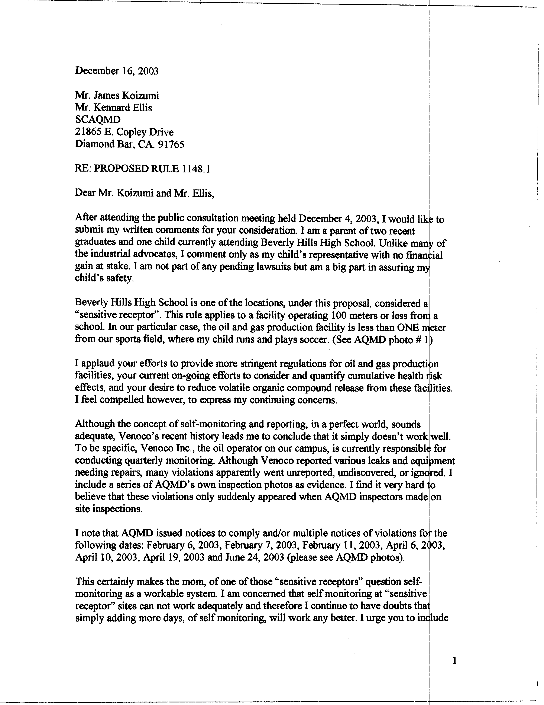
1-1
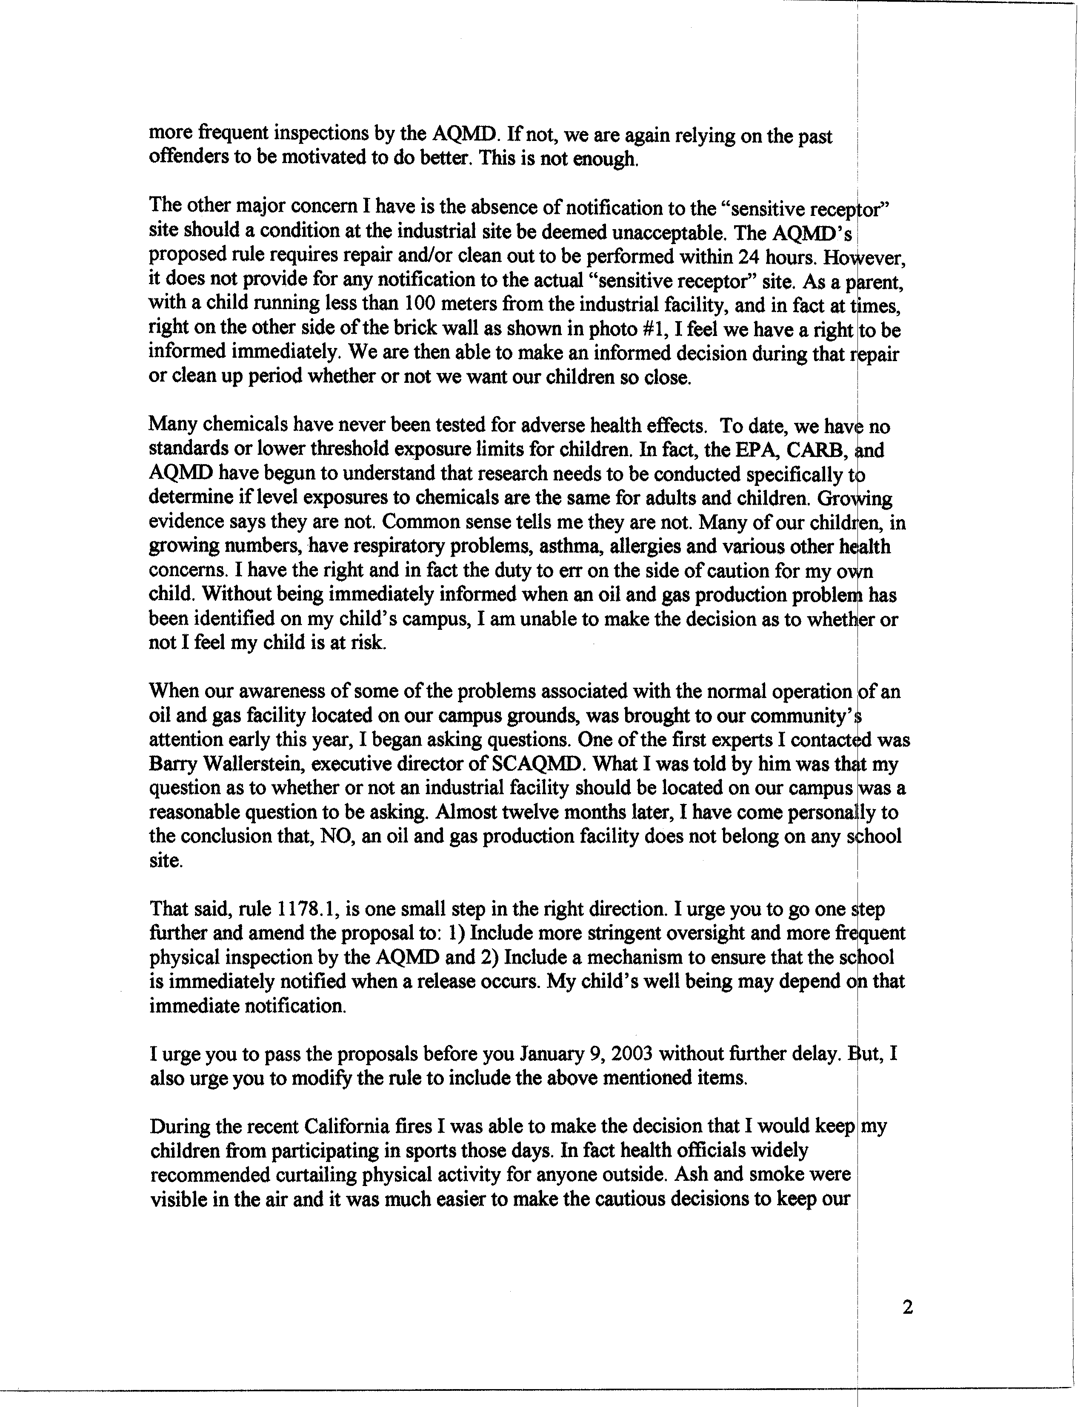
1-1
cont.
1-2
1-3
1-4
1-5
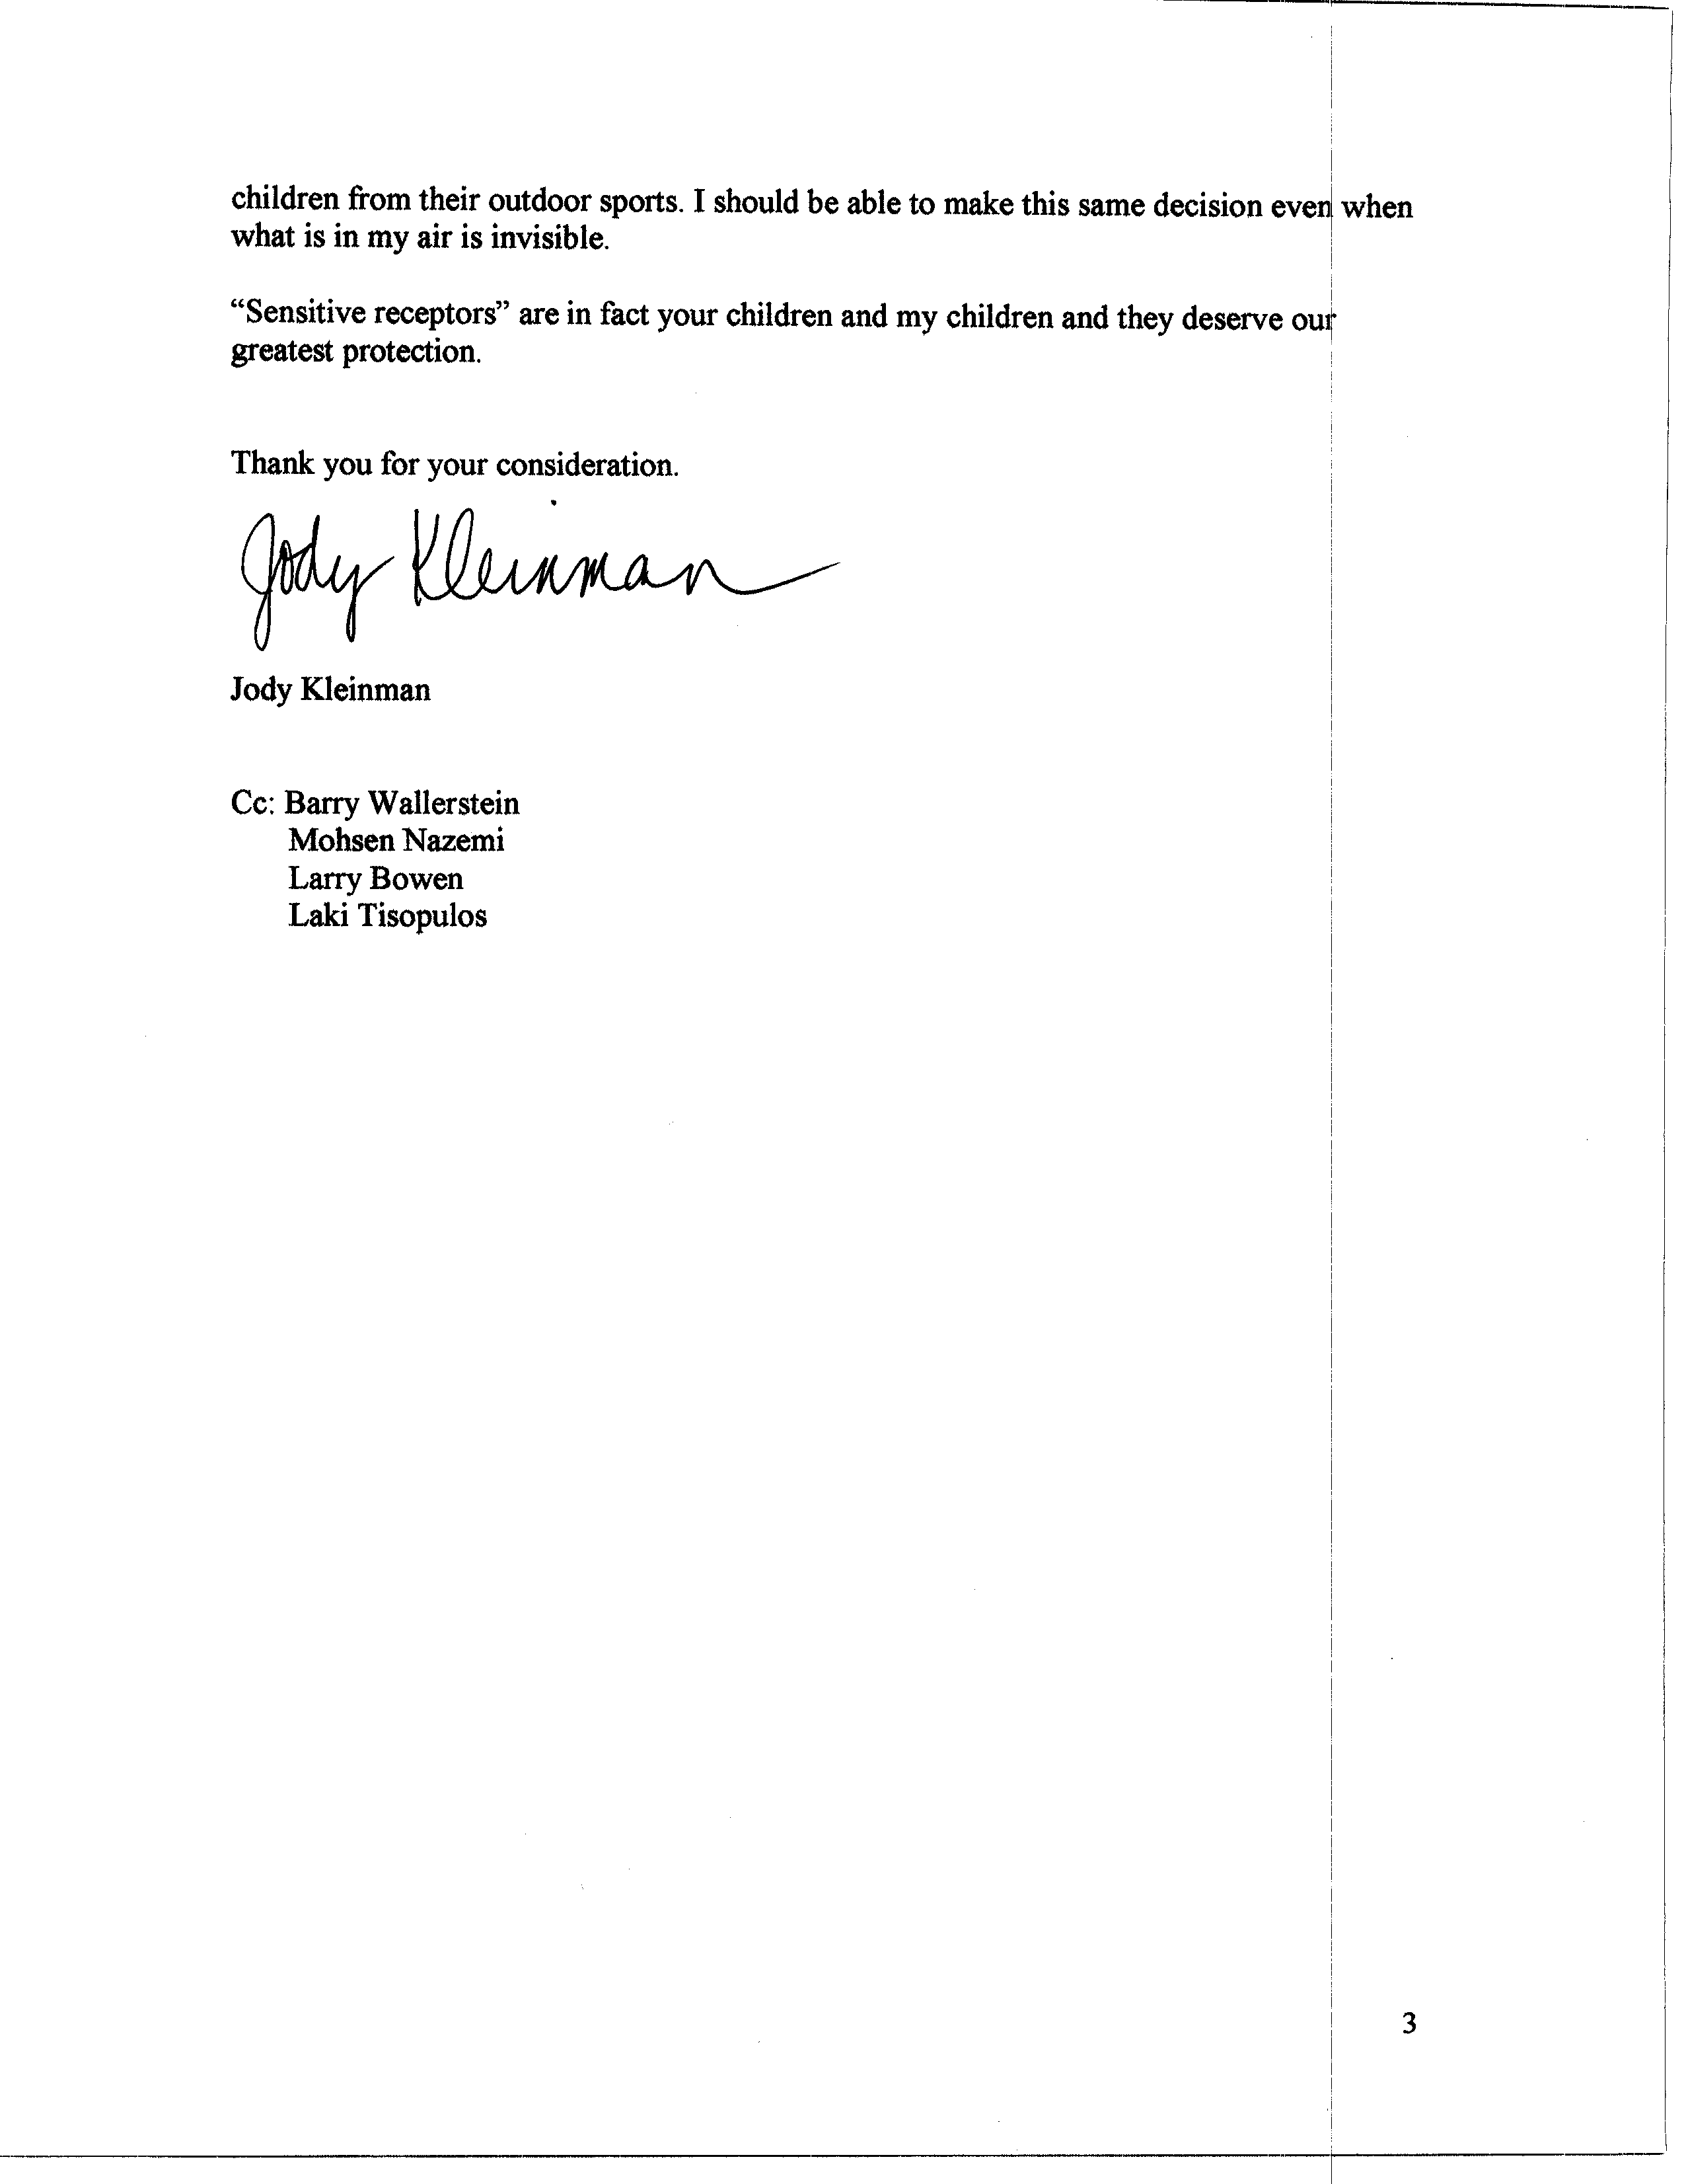
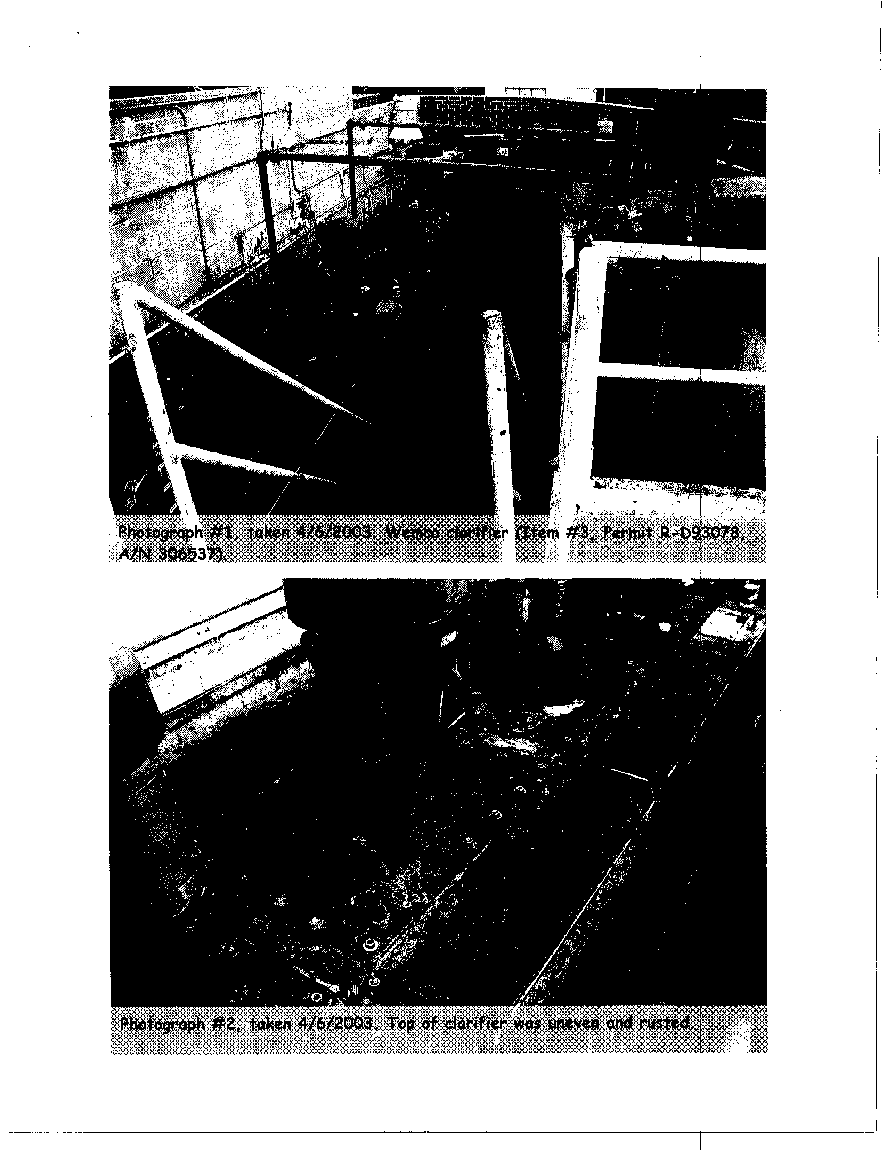

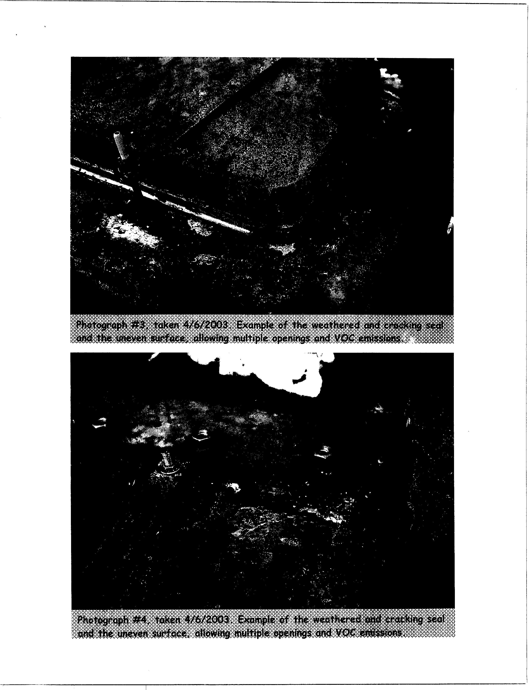
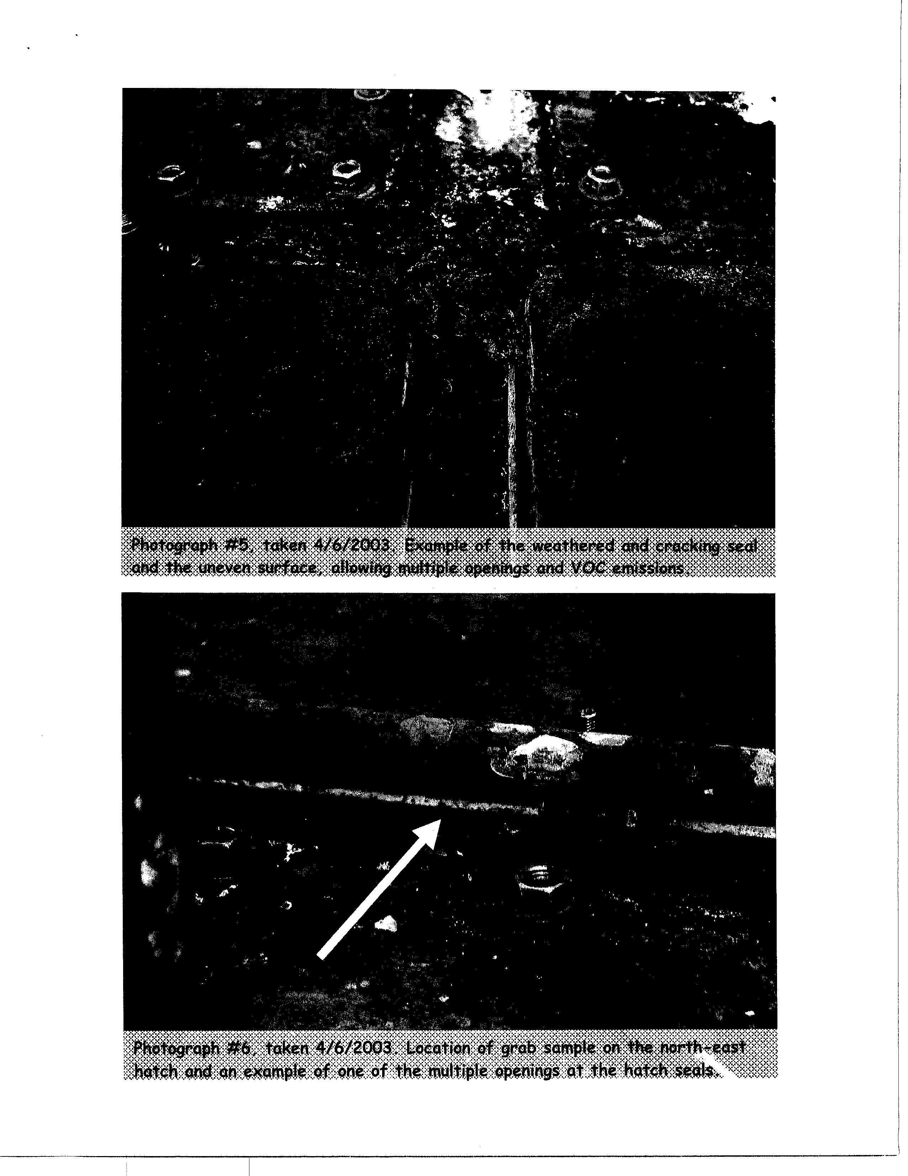
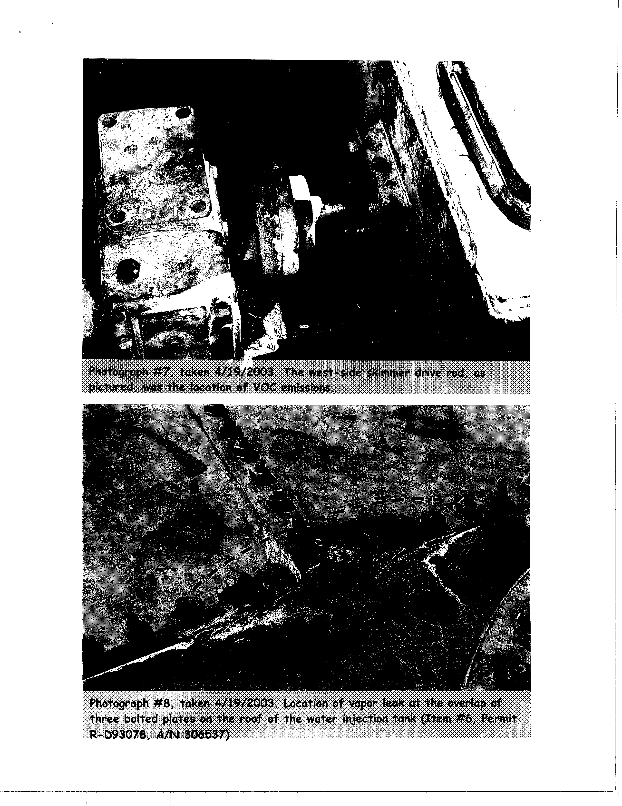
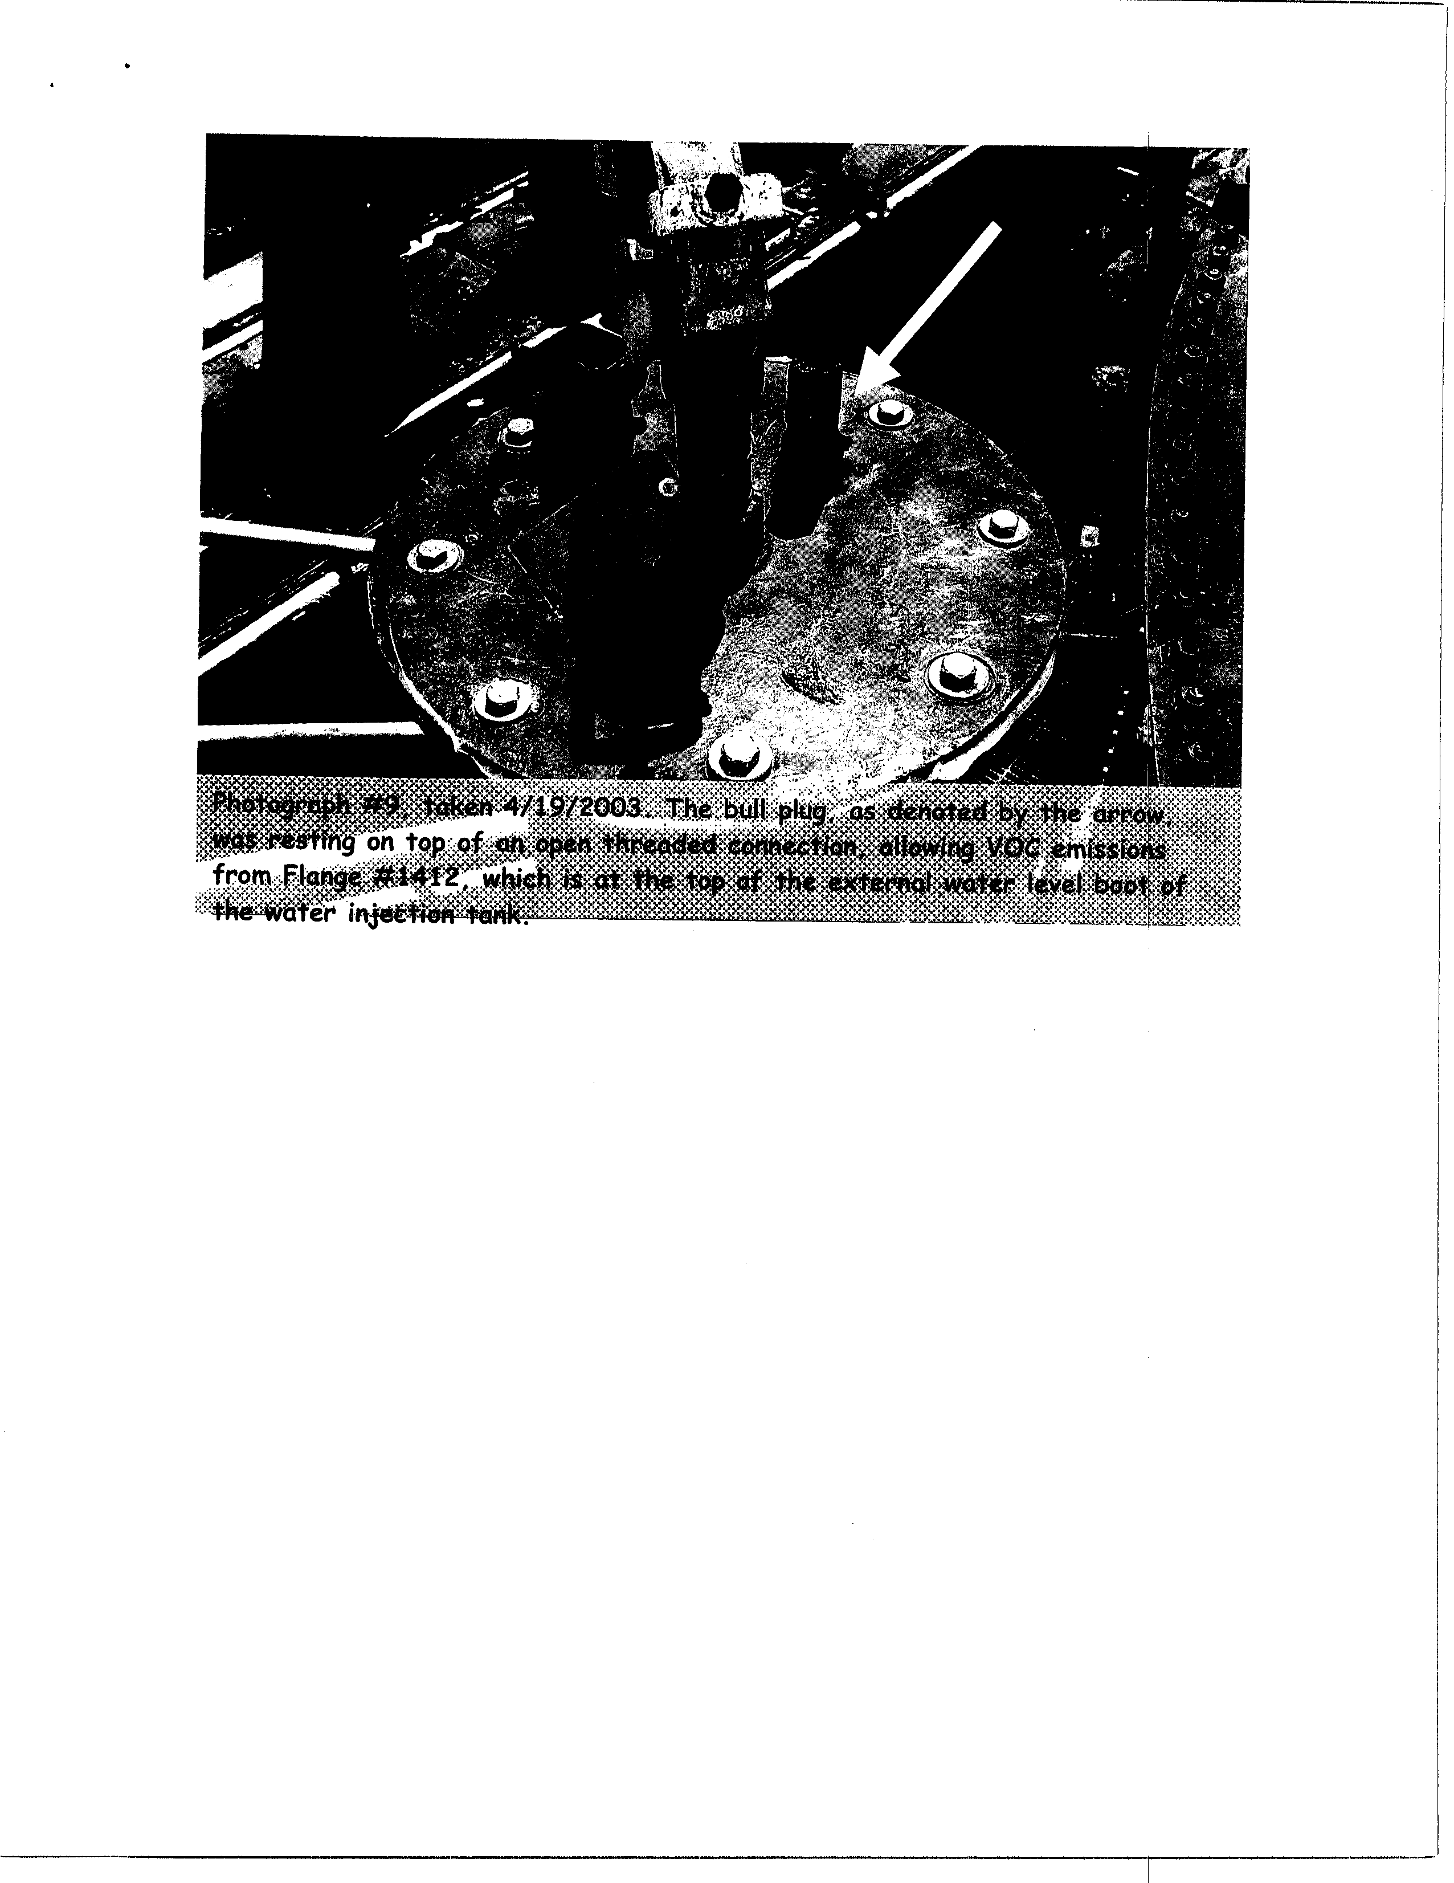
Responses to Comment Letter #1
Judy Kleinman
December 16, 2003

Response 1-1
Currently, there are no required inspection and maintenance (I & M) programs for oil and gas production wells. Staff acknowledges that some operators have implemented I & M programs for the well cellars at their facilities. However, based on inspections and site assessments showing accumulated organic liquid, and as evidenced by the number of complaints from the public regarding oil wells, staff has determined that a voluntary I & M program for well pumps and well cellars without specific air quality regulatory requirements has not been implemented consistently or to the same level of compliance throughout the oil and gas production industry. PR 1148.1 would remedy this inconsistency.

Although PR 1148.1 has self-monitoring elements, it is not a self-monitoring program. PR 1148.1 would be enforced by the SCAQMD; and affected facilities would be inspected by SCAQMD inspectors. Requiring affected oil and gas production facilities to conduct daily or monthly inspections is an effective tool to ensure that emissions from evaporating organic liquid or produced gas would be minimized. Inspections by SCAQMD compliance staff, in addition to recordkeeping requirements under PR 1148.1 would ensure that self-monitoring and reporting are verified. During SCAQMD inspections, inspectors would review the self-monitoring and self-reporting records required to would be retained by affected facilities. Inspection of facility records by SCAQMD inspectors is expected to reduce the amount of human error and deliberate deception. Self-monitoring and reporting elements have provided an effective tool in compliance and enforcement programs under SCAQMD Rules 1173, and 1150.1.

PR 1148.1 would impose additional monitoring and reporting requirements to those required by Rule 1173. The additional monitoring and reporting requirements would assist facilities and SCAQMD inspectors to identify and reduce emissions from organic liquid evaporation and produced gas. If concentrations exceed PR 1148.1 thresholds, facilities are required to pump out organic liquids or repair equipment.

Response 1-2
The rule limit of 250 ppm of TOC established in PR 1148.1 for pump-out or repair and the limit of 500 ppm for violation are considered to be equivalent to best available control technology (BACT) levels to protect the public and environment by reducing VOCs, which contribute to ground level ozone formation. PR 1148.1 requires TOC concentrations that exceed the proposed limits to be eliminated by pump out of well cellars and equipment repair to reduce or eliminate potential exposure by sensitive receptors to these emissions. In the case of affected facilities near sensitive receptors, well cellar pump out and equipment repair must be completed within 24 hours after the exceedence is discovered.

According to the Staff Report most facilities control produced gas and pump out well cellars before concentrations exceed the concentration thresholds established by the PR 1148.1. Facilities with existing produced gas control technologies were required to permit or register such equipment with the SCAQMD. Risk evaluation is required during the permit process and also may be required pursuant to Rule 1402 – Control of Toxic Air Contaminants from Existing Sources, which evaluates risk from facilities with existing permits. Mandatory pump out and equipment repair frequency under PR 1148.1 would ensure that the most diligent efforts are taken to correct the leak.

Based upon the air quality analysis in the Draft EA, those facilities that do not currently control produced gas or that do not pump out well cellars, as often as proposed by PR 1148.1, are not expected to generate significant adverse impacts once PR 1148.1 requirements are placed into effect. Control of produced gas and quicker well cellar pump out times at these facilities would reduce emissions by an expected 80 percent for liquid evaporation and 95 percent for produced gas emissions. Therefore, the SCAQMD does not expect that sensitive receptors would be significantly adversely impacted from affected facilities as long as well cellar pump outs and equipment repairs are made within the quicker time periods required by PR 1148.1. PR 1148.1 provides greater protection from emissions than without the rule.

Currently, the Health and Safety Code contains provisions for facilities that handle hazardous materials to include notification requirements in their business emergency response plans. Typically, the fire department is the agency designated to be notified by a company in the event of an emergency release. SCAQMD will monitor the recordkeeping on inspection, equipment repair and well cellar pump outs and these notification efforts. If the SCAQMD finds that equipment repair and well cellar pump-outs occur frequently and at concentrations substantially higher than the PR 1148.1 concentration thresholds, the SCAQMD may amend the rule at a future date to include notification of sensitive receptors.

Response 1-3
The commentator also states that the SCAQMD, CARB and EPA are investigating health standards for children. The SCAQMD does not establish health standards, but relies upon the expertise of CARB, OEHHA, and EPA. SCAQMD closely monitors the health standards established by these agencies and uses these standards to establish rule and regulatory limits. SCAQMD Rule 1401 – New Source Review of Toxic Air Contaminants, requires that the SCAQMD amend Rule 1401 to include carcinogenic risk values adopted by OEHHA within 150 days. SCAQMD Rule 1402 – Control of Toxic Air Contaminants from Existing Sources requires SCAQMD staff to evaluate the impact of any new or change in OEHHA risk values upon Rule 1402. These two mechanisms will ensure that the SCAQMD will expeditiously adopt any new risk standards set by OEHHA.

The SCAQMD recognizes that children, as sensitive receptors, may be more sensitive to the adverse affects of poor air quality. It is for this reason that PR 1148.1 contains more stringent provisions regarding well cellar pump outs and gaseous leak repair requirements. Similarly, at the SCAQMD’s September 2003 Governing Board Hearing the Board approved implementing the proposals in a white paper on cumulative impacts, which directs staff, among other things, to consider more stringent control requirements in new and existing SCAQMD rules for facilities within 100 meters of sensitive receptors, including schools.

Response 1-4
Some industrial operations may be incompatible land-uses when located next to a sensitive receptor such as a school; however, SCAQMD does not have authority over zoning or land use planning. Cities, counties and the school district are responsible for regulating where facilities are allowed to operate. The commentator should direct comments on zoning or land use to the appropriate land-use agency, the City of Beverly Hills.

As stated in the responses to items 1-2 and 1-3, and also evaluated in the Draft EA, significant adverse impacts are not expected from PR 1148.1. Instead, PR 1148.1 is expected to reduce organic liquid emissions from oil and gas production facilities, thus, reducing potential exposures to nearby populations. PR 1148.1 establishes control requirements that will provide greater protection from exposure to emissions from affected facilities than is currently the case. SCAQMD is monitoring work by OEHHA and is required to adopt any risk values that become more stringent.

Response 1-5
PR 1148.1 is currently scheduled to be considered for adoption by the SCAQMD at the January 9, 2004 public hearing.

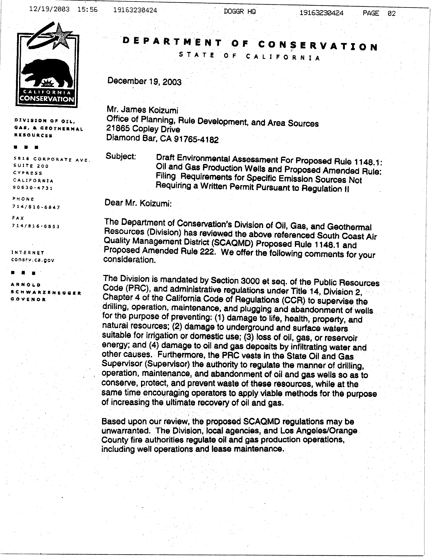
2-1
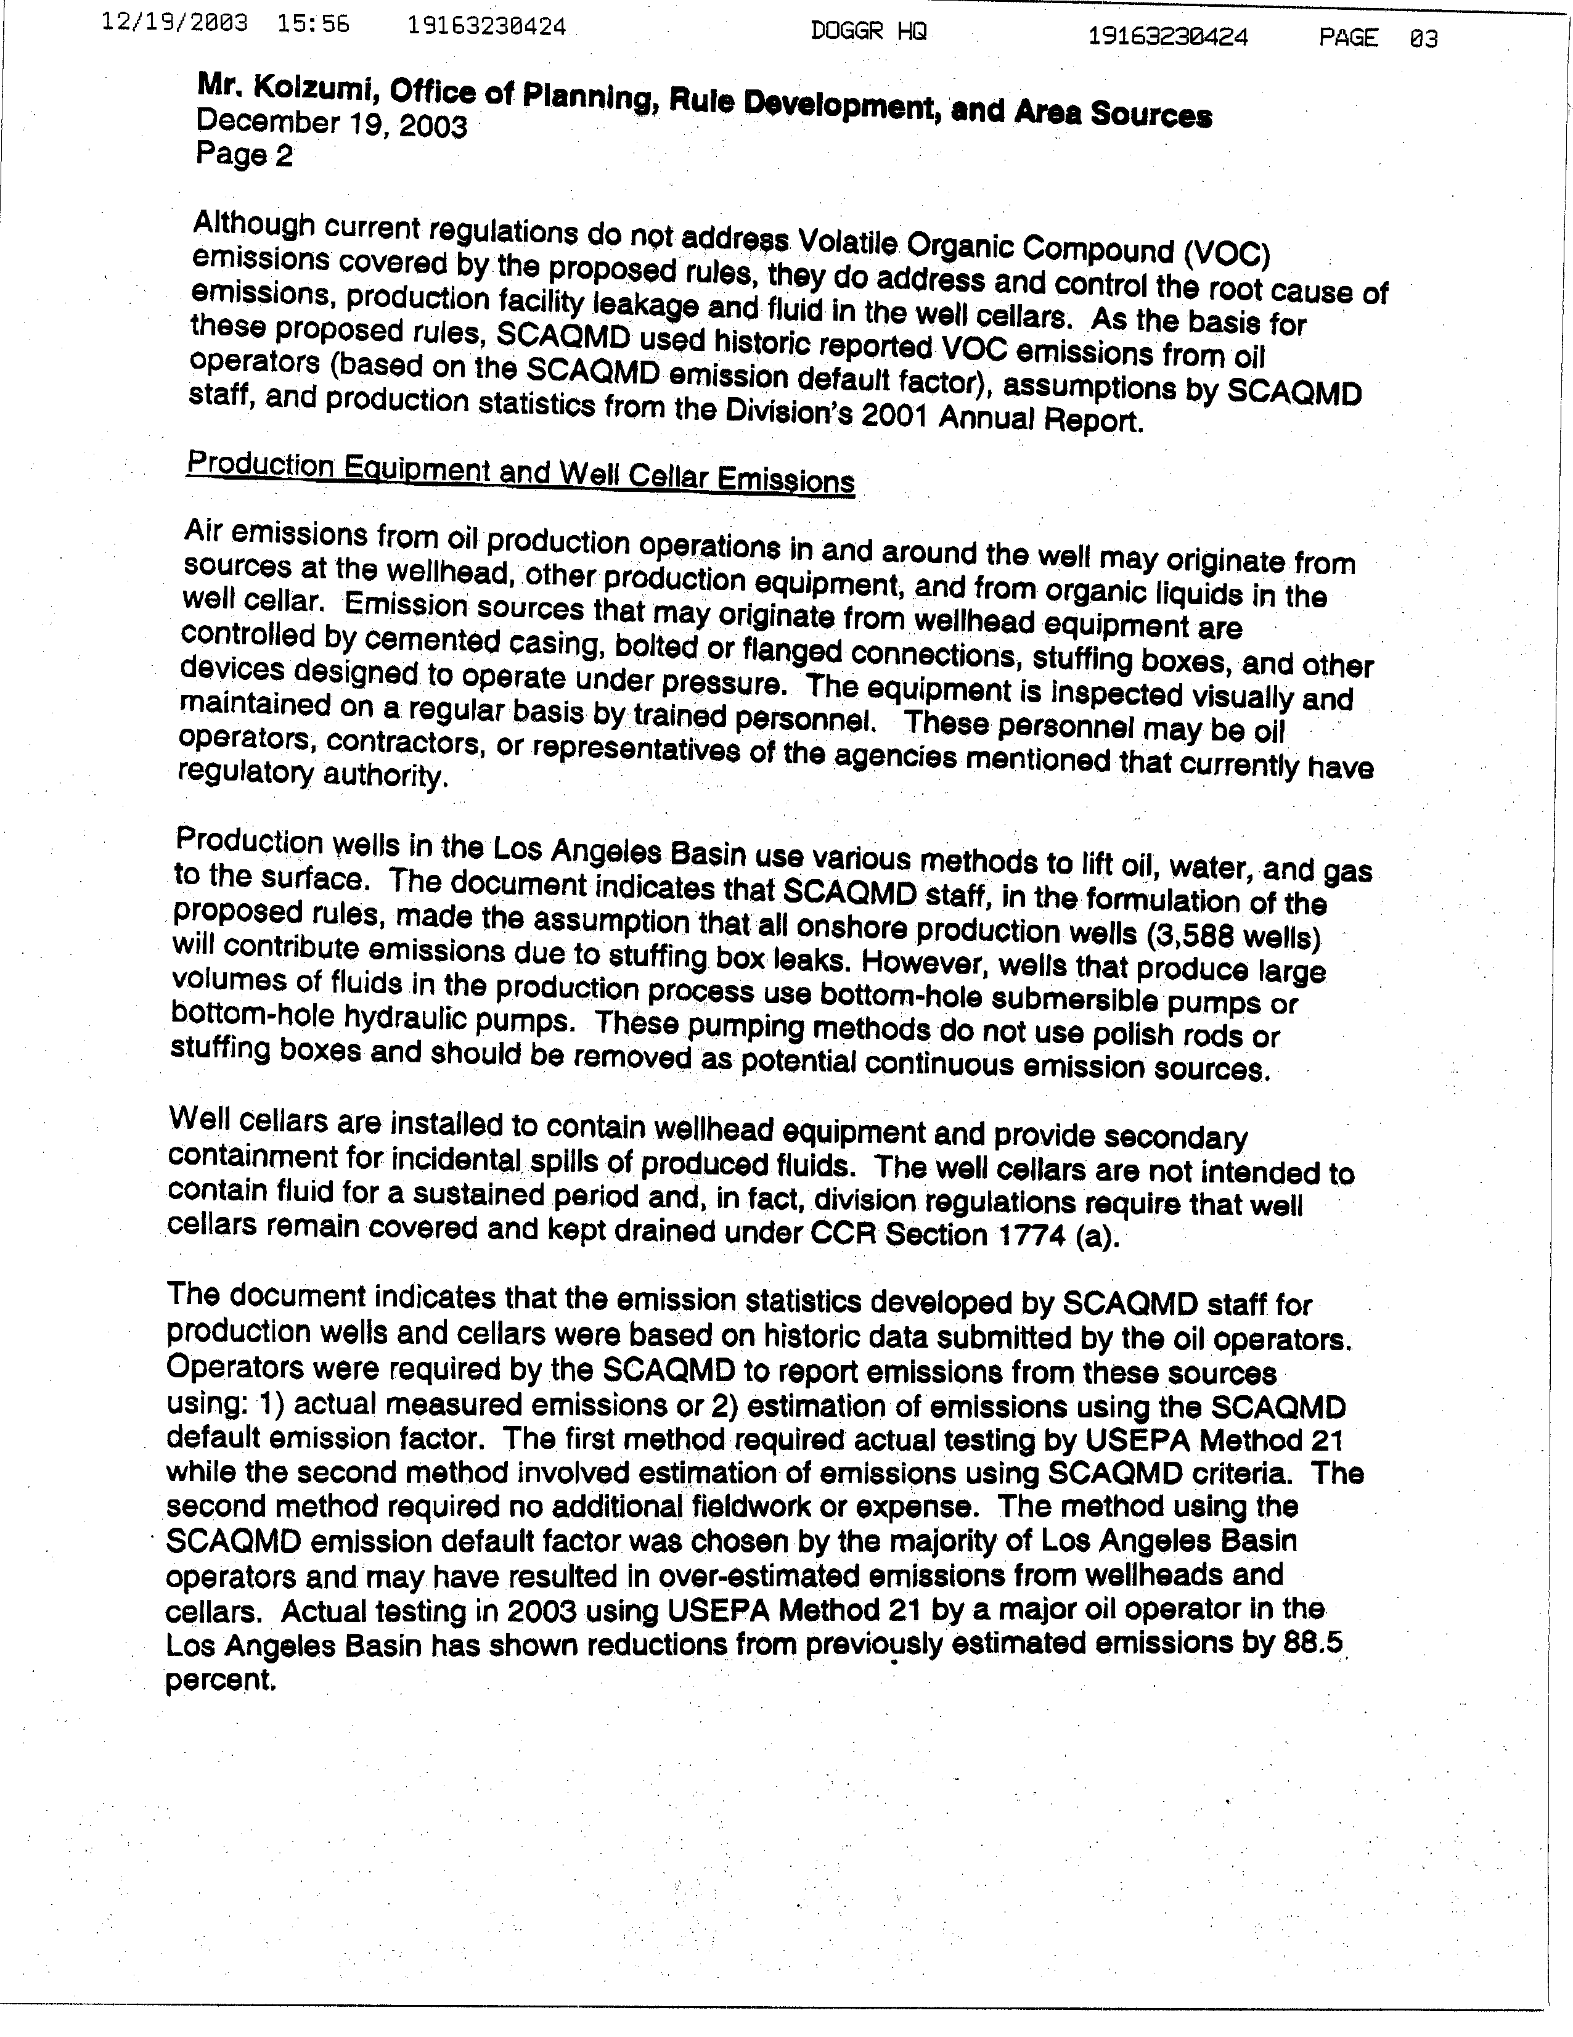
2-1
cont.
2-2
2-3
2-4
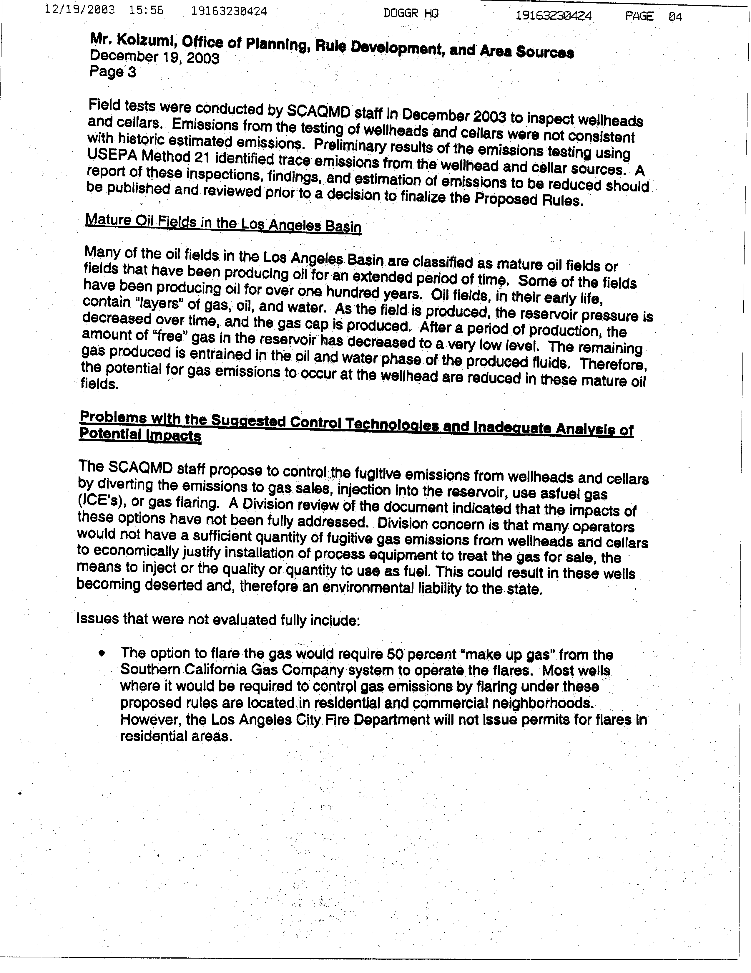
2-4
cont.
2-5
2-6
2-7
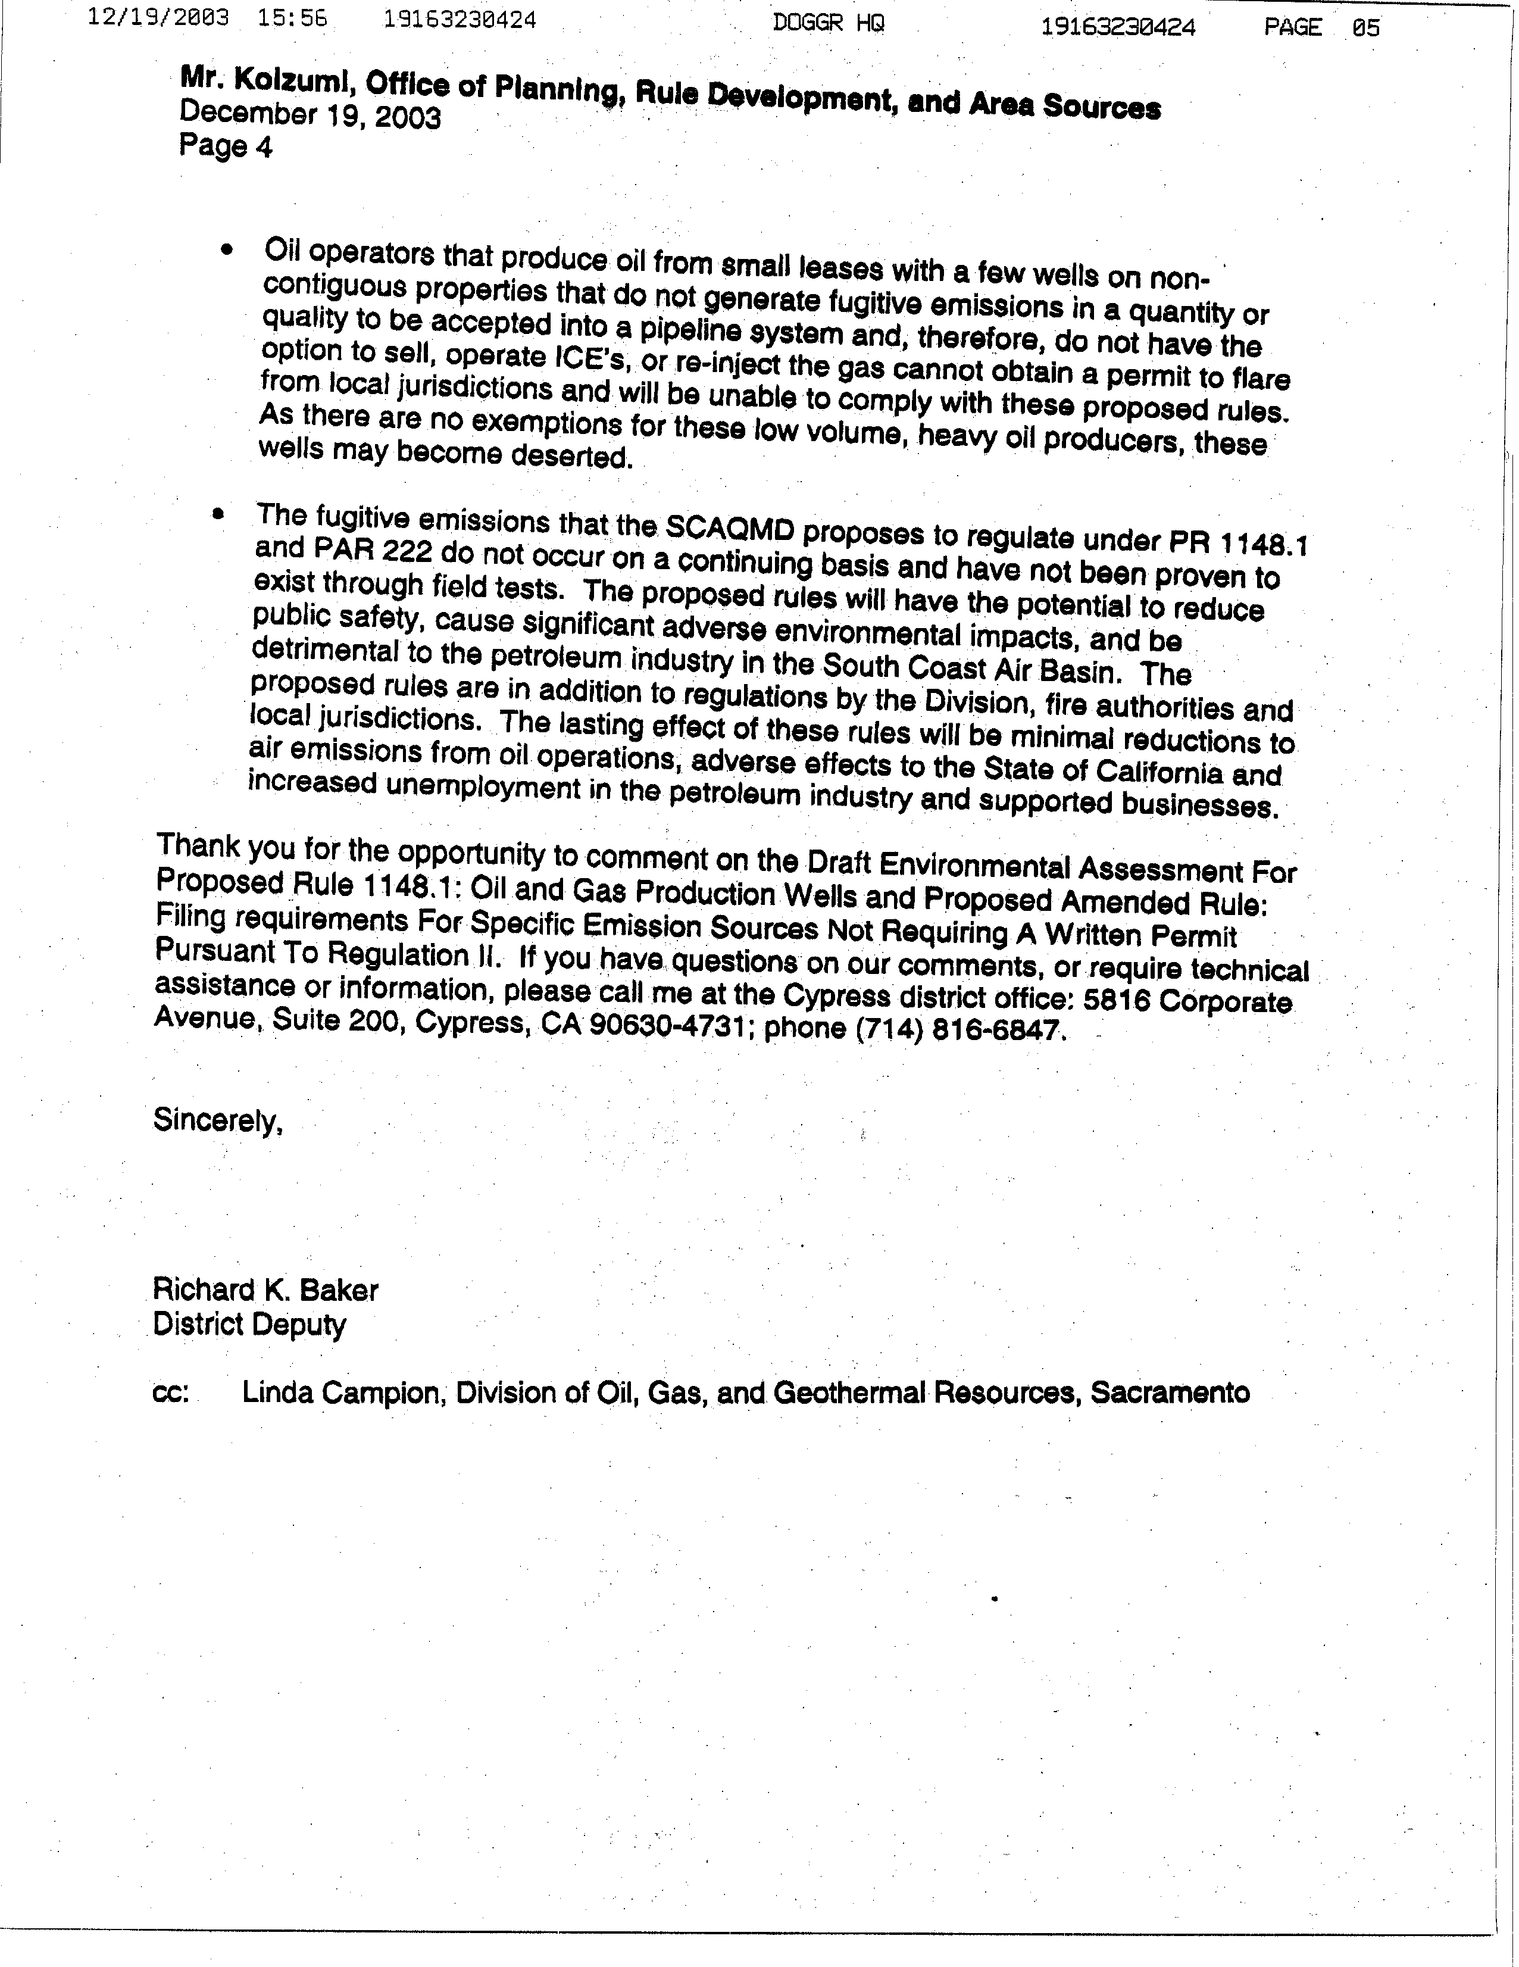
2-8
2-9
Responses to Comment Letter #2
Division of Oil and Gas, and Geothermal Resources
December 19, 2003

Response 2-1
Staff disagrees with the commentator that the proposed rule is unwarranted. The commentator explicitly states that it has the authority to conserve, protect, and prevent waste of oil and gas resources; however, the Division of Oil, Gas and Geothermal Resources (Division) acknowledged that the Division’s current regulations do not address the VOC emissions to be regulated by PR 1148.1. PR 1148.1 is needed by the SCAQMD to comply with reasonable further progress requirements to ultimately attain all state and federal ambient air quality standards for the area within its jurisdiction. Other agencies and authorities that regulate oil and gas production operations do not directly regulate or sufficiently limit the emission of VOCs into the atmosphere to the level necessary for the SCAQMD to comply with its legal mandates. The proposed requirement for an inspection and maintenance (I & M) program to reduce liquid leaks from oil wells and the requirement that operators vent their produced gas to a control device or system will reduce VOC emissions from oil and gas production operations that are need to improve air quality mandated by state and federal law. While the actions of other agencies to implement their regulatory requirements may supplement the effectiveness of PR 1148.1, they are by no means an adequate substitute.

Response 2-2
Staff is aware of the inspection and maintenance efforts of operators, contractors and the Division and that a properly maintained oil well produces minimal air contaminants. Staff also acknowledges that some operators have implemented an I & M program for the well cellars at their facilities. However, based on inspections and site assessments showing accumulated organic liquid, and as evidenced by the number of complaints from the public regarding oil wells, staff has determined that a voluntary I & M program for well pumps and well cellars without specific air quality regulatory requirements has not been implemented consistently or to the same level of compliance throughout the oil and gas production industry.

Staff’s analysis has determined that the stuffing boxes on the polished rods of the oil wells are a significant source of fugitive VOC emissions. However, all oil well pumps, including submersible and hydraulic pumps, and not only pumps with stuffing boxes have the potential to leak and, therefore, have the potential to emit VOCs into the atmosphere. This is documented by inspections conducted by staff and contractors at petroleum and chemical operations in conjunction with Rule 1173 inspections of flanges, values, etc.

Response 2-3
Although, well cellars are not intended to contain fluid for a sustained period under the California Code of Regulations (CCR), the fact is that inspectors have observed organic liquid (oil) in well cellars. The CCR does not sufficiently limit or specify the timeframe to remove organic liquid from well cellars to limit the release of fugitive VOCs to the atmosphere in an extreme non-attainment area for ozone. In addition, the covers used on wells cellars (many are of the open slot design) do not reduce the VOCs to the atmosphere caused directly by the evaporation of accumulated organic liquid or indirectly by the breach of containment of the oil/water mixtures caused by heavy rains and ground water infiltration from wells located at or below sea level or high water tables.

Response 2-4
When reporting emissions to the SCAQMD, operators of affected facilities can base their reporting on actual measured emissions or they can use approved default emission factors. Emission factors are used not only for reporting emissions, but also in determining the adequacy of equipment design and ongoing compliance with SCAQMD rules and regulations. Staff acknowledges that default emission factors are conservative by design in order to protect the public. The emission factor for well cellars was developed by the California Air Resources Board in conjunction with KVB (a consulting firm) and this factor is the basis of well cellar emission factors used by other air districts in California because it is the best factor currently available.

In the past, all but one oil and gas production facility have used the default emission factor in reporting emissions to the SCAQMD. One major facility has used an emission factor based on VOC measurements purportedly taken at that facility. To date, that facility has not provided staff with the data supporting this lower emission factor and therefore can only be considered preliminary at this time. It should be noted that: 1) This facility has already implemented an I & M inspection program that is similar to the program required in PR 1148.1 and the reported emissions (reductions) are consistent with staff’s analysis; and 2) the additional efforts by this facility, which may have resulted in actual reduced emissions, have not been universally adopted and implemented by the entire industry.

At the Friday, December 4, 2003 Public Consultation Meeting, the industry raised concerns regarding the requirement to measure TOC emissions at a distance of no more than three inches from the surface of accumulated organic liquid. To address this concern, staff coordinated with the industry representatives to determine if it is possible and practical to sample within three inches. On Tuesday, December 11, 2003, the industry arranged for the SCAQMD to conduct a small sampling, which consisted of a total of six well cellars located at two major facilities, to determine if the measurement of emissions in the well cellars could be taken at a distance within three inches of the surface of the accumulated liquid in the well cellar. The results of this limited sample indicated that in one well cellar containing predominately oil, there was a concentration gradient that increased by a factor of ten based on measurements at the well cellar cover (two ppm) compared to measurements at the surface of the liquid (25 ppm). The emissions measured at various depths within the well cellars containing mostly water with some oil did not vary much ranging from 0.5 to two ppm.

The above results are considered preliminary. Based on the fact that this sampling program was small and the data collected were limited, further study is needed before it can be concluded that the established emission factor can be replaced. However, staff disagrees that these preliminary findings should delay the Public Hearing of PR 1148.1. The documented success of a required I & M program to reduce emissions, the mandated requirement to reduce fugitive VOC emissions, and the concerns expressed by the public regarding emissions from oil and gas production facilities, especially those located near schools and other sensitive receptors, warrant the earliest consideration by the SCAQMD Governing Board to adopt PR 1148.1.
Response 2-5
Staff acknowledges that produced gas can be entrained in the liquid oil phase, especially for mature oil field wells. Although the potential to emit for oil wells associated with mature oil fields may be reduced, staff has determined that the venting of produced gas at the wellhead still occurs. In addition to the direct venting of produced gas, the proposed rule also requires that the entrained produced gas not be released to the atmosphere at any other point further downstream of the oil well unless it is vented to an air pollution control device. Produced gas emitted to the atmosphere contains VOC that contribute to the non-attainment status of state and federal ambient air quality standards for ozone in particular in the district. These VOC emissions from this source category simply cannot be ignored and will be reduced through the implementation of PR 1148.1.

Response 2-6
The staff proposal identifies a number of techniques to control produced gas, including the use of small process heaters to control the produced gas from low production wells. Based on discussion with relatively small oil well operators, the use of process heaters was identified as preferable to the use of small flares and, therefore, it is expected that flares would not be the primary compliance option of choice, even for the small operator. Heaters are less expensive, less polluting, easier to maintain, and allow for the useful heat/energy to be recovered (to heat the oil to make it easier to pump to process/storage), as compared to the use of flares. Heater manufacturers have stated that heaters are available to process very low gas flow rates at small oil and gas production facilities, as small as 100,000 cubic feet or less of produced gas per year which are comparable to the size and configuration of residential swimming pool heaters and can be permitted in or near residential areas. To ensure, however, that potential adverse impacts are not underestimated, the environmental analysis assumes that the two largest affected facilities, which release produced gas to the atmosphere, will install flares, even though it is likely that they will also install heaters. The environmental analysis, including all assumptions made, can be found in Chapter 2 of the EA.

Although there may be the instance that even the low cost of a small heater could cause an operator to desert a well, it is unlikely there would be the widespread desertion of wells implied by the commentator, particularly when the commentator’s regulations prohibit the deserting of oil wells.

Response 2-7
The commenter states that the Los Angeles City Fire Department will not issue permits for flares in residential areas. Table C-12 13 on page C-13 14 in Appendix C of the Draft EA lists the two facilities that may use flares as El Segundo and Long Beach which are not in the jurisdiction of the Los Angeles City Fire Department. On page 2-10 the Draft EA in the second paragraph under the heading “Flares,” the Draft EA states, “Flares may be prohibited by some local fire departments, because of their proximity to residents.” The staff report assumes that all facilities would install process heaters instead of flares. Flares were used as the primary compliance option by the two largest facilities that release untreated produced gas to the atmosphere, as part of the environmental analyses, to ensure that potential adverse impacts from implementing PR 1148.1 would not be underestimated even at the largest affected facilities. PR 1148.1 would not require flares. If all affected oil and gas production facilities are prevented from using flares by fire departments, then PR 1148.1 would not generate significant adverse impacts to air quality, since heaters generate less emissions. Therefore, since all facilities may choose process heaters this comment does not alter the conclusion of the EA which states that PR 1148.1 would not adversely impact any environmental area.

Response 2-8
As stated in comment 2-7, flares are not required by PR 1148.1. Small facilities may use process heaters to fulfill produced gas control requirements of PR 1148.1. By using process heaters, these low-volume, heavy oil produces would comply with PR 1148.1 and could use the heat generated by the heaters to assist with oil and water separation or oil transfer, if desired. The staff report demonstrates that heaters are cost effective control technologies. Since process heaters are viable produced gas control options, the commentator’s conclusion that facilities would desert wells because flares could not be used is not demonstrated.

Response 2-9
Staff disagrees with the comment that the emissions do not occur on a continuing basis and have not been proven to exist through field tests. Staff has observed and measured VOC emissions in the field. Contrary to the statement of the commentator, PR 1148.1 will enhance public safety and improve the environment by reducing VOC emissions in the SCAQMD, including those areas near sensitive receptors.

In addition, since process heaters can be used to control produced gas and PR 1148.1 requires all produced control technology to be equipped with a device that automatically shuts off the flow of natural gas in the event of a flame-out or pilot failure, this comment does not demonstrate PR 1148.1 reduces public safety. The draft EA concludes that PR 1148.1 does not generate significant adverse impacts to hazards or hazardous materials.

The VOC emission reductions resulting from the implementation of PR 1148.1 are needed to comply with the ambient air quality standards of both the California Clean Air Act (CCAA) and the federal Clean Air Act. The CCAA also requires the SCAQMD to adopt all feasible control measures. Three air pollution control districts in California have also adopted rules that regulate the operation of well cellars and two districts regulate the venting of produced gas from oil well operations.

Staff’s review of the regulations from the other authorities mentioned by the commentator that regulate oil and gas production operations show that these authorities do not have in place sufficient requirements to reduce fugitive VOC emissions to the level that will be achieved through the implementation of PR 1148.1. The emission inventory used by staff was based on the emissions reported to the SCAQMD. The emission factors used to calculate the reported emissions are appropriate for emissions reporting (see Response 4).

Through this rule development, staff has determined that most of the requirements in PR 1148.1 are already in place at the larger oil and gas production facilities and can be implemented fairly readily at most of the remaining facilities. Those remote wells and in particular, those wells located near sensitive receptors, will require additional resources with additional costs to industry. Although operators may shut down some marginal oil wells rather than comply with the requirements of PR 1148.1, this will not result in endemic desertion of oil wells by small operators. Based on its analysis of oil wells and well cellars, I & M programs, and control techniques and technology, staff has determined that PR 1148.1 is both technically feasible and cost effective.

According to the socioeconomic impact analysis of PR 1148.1 and PAR 222, an average of 86 jobs could be forgone annually from the future projected growth between 2004 and 2020. This represents about 0.0009 percent of the average annual jobs estimated in the four-county area from 2004 to 2020. It is also projected that the mining sector where oil and gas production facilities belong and petroleum industry would incur three and one job forgone, respectively, on the average annual basis, between 2004 and 2020. The job impact here is considered within the noise of the Regional Economic Models, Inc. model used for this analysis.

The Lewis Presley Air Quality Management Act, 1976 Cal. Stats., ch 324 (codified at Health & Safety Code, §§40400 40540).
Health & Safety Code, §40460 (a).
Health & Safety Code, §40440 (a).
Telephone conversations with Rich Baker, Division of Oil and Gas, District 1 and Steve Field, Division of Oil and Gas, District 2, November 14, 2003.
Telephone conversation from James Koizumi to Richard Barca, Southern California Gas, September 17, 2003.

