south coast air quality management district

Final Environmental Assessment for:
Proposed Amended Rule 1145 - Plastic, Rubber, Leather, & Glass Coatings

November 11, 2004
SCAQMD No. 040902MK

Executive Officer
Barry R. Wallerstein, D.Env.
Deputy Executive Officer
Planning, Rule Development and Area Sources
Elaine Chang, DrPH
Assistant Deputy Executive Officer
Planning, Rule Development and Area Sources
Laki Tisopulos, Ph.D., P.E.
Planning and Rules Manager
Susan Nakamura

Author: Michael Krause Air Quality Specialist

Technical Ricardo Rivera Air Quality Specialist
Assistance: Helmy Sultan, Ph.D. Air Quality Specialist
Kennard Ellis Air Quality Engineer II

Reviewed By: Steve Smith, Ph.D. Program Supervisor
Frances Keeler Senior Deputy District Counsel
Larry Bowen, P.E. Planning and Rules Manager
Ed Muehlbacher, P.E. Program Supervisor
South coast air quality management district
governing board

Chairman: WILLIAM A. BURKE, Ed.D.
Speaker of the Assembly Appointee

Vice Chairman: S. ROY WILSON, Ed.D.
Supervisor, Fourth District
Riverside County Representative

MEMBERS:

MICHAEL D. ANTONOVICH
Supervisor, Fifth District
Los Angeles County Representative

JANE CARNEY
Senate Rules Committee Appointee

WILLIAM CRAYCRAFT
Councilmember, City of Mission Viejo
Cities Representative, Orange County

BEATRICE J.S. LAPISTO-KIRTLEY
Mayor, City of Bradbury
Cities Representative, Los Angeles County, Eastern Region

RONALD O. LOVERIDGE
Mayor, City of Riverside
Cities Representative, Riverside County

JAN PERRY
Councilmember, Ninth District
Cities Representative, Los Angeles County, Western Region

BILL POSTMUS
Supervisor, First District
San Bernardino County Representative

JAMES SILVA
Supervisor, Second District
Orange County Representative

CYNTHIA VERDUGO-PERALTA
Governor's Appointee

DENNIS YATES
Councilmember, City of Chino
Cities Representative, San Bernardino County

EXECUTIVE OFFICER:

BARRY R. WALLERSTEIN, D.Env.
Preface

The Draft Environmental Assessment (EA) for the proposed amendments to Rule 1145 – Plastic, Rubber, Leather and Glass Coatings was circulated for a 30-day public review and comment period from September 2, 2004 to October 1, 2004. Two public comment letters were received that did not directly comment on the Draft EA but raised concerns with the proposed project. Minor modifications were made to the project description and, therefore, the Draft EA has been modified so it is now a Final EA. Deletions and additions to the text of the EA are denoted using strikethrough and underlined, respectively. Changes to the project description are minor and do not change the conclusions made in the Draft EA or worsen the environmental impact analyzed in the Draft EA. Pursuant to CEQA Guidelines §15073.5(c)(2), recirculation is not necessary since the information provided does not result in new avoidable significant effects.
Table of contents

CHAPTER 1 - PROJECT DESCRIPTION

Introduction 1-1
Legislative Authority 1-1
California Environmental Quality Act 1-2
Project Location 1-3
Project Background 1-4
Project Objectives 1-7
Project Description 1-7
Methods to Achieve Emission Reductions 1-10

CHAPTER 2 - ENVIRONMENTAL CHECKLIST

Introduction 2-1
General Information 2-1
Environmental Factors Potentially Affected 2-2
Determination 2-2
Environmental Checklist and Discussion 2-4

APPENDIX A - Proposed Amended Rule 1145
APPENDIX B - Comments on the Draft EA and Responses to the Comments

List of Figures

Figure 1-1: South Coast Air Quality Management District 1-3

List of Tables

Table 1-1: Current and Proposed Emission Limits for Coatings
Affected by PAR 1145 1-9
Table 1-2: Affected Existing Coating Categories and Potential Low-VOC
Coating Technologies to Comply with PAR 1145 1-11
Table 2-1: Air Quality Significance Thresholds 2-7
Table 2-2: Anticipated VOC Emission Reduction from PAR 1145 2-9
List of Tables (concluded)

Table 2-3: Regulatory Exposure Limits of Conventional and Possible
Replacement Solvents 2-15
Table 2-4: Chemical Characteristics of Coating Solvents 2-28
Table 2-5: Historical and Projected POTW Impact From Reformulated
Coatings 2-34

C H A P T E R 1 - P R O J E C T D E S C R I P T I O N

Introduction
Legislative Authority
California Environmental Quality Act
Project Location
Project Background
Project Objectives
Project Description
Methods to Achieve Emission Reductions

Introduction
Volatile organic compound (VOC) emissions are major contributors to the formation of ozone (key ingredient of smog) in the South Coast Air Basin (Basin). The formation of ozone occurs as VOCs react with oxides of nitrogen (NOx) in the atmosphere. Ozone, a criteria pollutant, has been shown to adversely affect human health. It also contributes to the formation of another criteria pollutant, particulate matter with a diameter less than 10 microns (PM10) and with a diameter less than 2.5 microns (PM2.5).
South Coast Air Quality Management District (SCAQMD) Rule 1145 – Plastic, Rubber and Glass Coatings, was adopted on July 8, 1983, to control VOC emissions from the application of coatings to any plastic, rubber or glass products. Typical examples of these substrates include plastic signs, plastic toys, plastic counter tops, fiber glass boats, glass mirrors and rubber balls. The coatings are sprayed, dipped, rolled, or flowed onto the substrate. Since its adoption, Rule 1145 has been amended 14 times.
The SCAQMD is proposing to lower the VOC content limit for three existing coating categories (general coatings, mirror backing roll coated coatings, and optical coatings), add one new coating category for leather coatings with five four subcategories (sealer coat, color coat, stain coat, top coat and antique coat), add an extreme performance two-component coatings category, provide a limited exemption for polyurethane shoe sole coating operations, clarify alternative application techniques by demonstrating equivalent transfer efficiency to HVLP spray application; eliminate unnecessary definitions, update existing definitions, and update the testing methodology requirements. The proposed amendments also include a change in the rule’s title to include leather coating operations.
Pursuant to the California Environmental Quality Act (CEQA) (California Public Resources Code § 21000 et seq.), this Environmental Assessment (EA) includes an analysis of the potential adverse environmental impacts of implementing proposed amended Rule (PAR) 1145. The environmental analysis determined that while there are potential adverse impacts to air quality from the inclusion of leather operations and from the new exemption for polyurethane shoe sole coatings, lowering the VOC content limits from the other coating categories will provide an overall air quality benefit from the proposed rule amendments. No other environmental topic areas were identified that could be significantly adversely affected by the proposed amended rule.

LEGISLATIVE AUTHORITY
The California Legislature created the SCAQMD in 1977 (Lewis-Presley Air Quality Management Act, California Health and Safety Code §§ 40400 et seq.) as the agency responsible for developing and enforcing air pollution control rules and regulations in the Basin and portions of the Salton Sea Air Basin and Mojave Desert Air Basin. By statute, SCAQMD is required to adopt an air quality management plan (AQMP) demonstrating compliance with all state and federal ambient air quality standards for the District [California Health and Safety Code § 40460(a)]. Furthermore, SCAQMD must adopt rules and regulations that carry out the AQMP [California Health and Safety Code, § 40440(a)]. The 2003 AQMP concluded that major reductions in emissions of VOCs and NOx are necessary to attain the air quality standards for ozone and PM10. Rule 1145 was originally adopted and subsequently amended to carry out these mandates. PAR 1145 will implement, in part, the 2003 AQMP stationary source control measure CTS-10: Miscellaneous Industrial Coatings and Solvent Operations.

CALIFORNIA ENVIRONMENTAL QUALITY ACT
The proposed amendments to Rule 1145 are a "project" as defined by CEQA (California Public Resources Code §21080.5). SCAQMD is the lead agency for the proposed project and has prepared appropriate environmental analysis pursuant to its certified regulatory program (SCAQMD Rule 110). California Public Resources Code §21080.5 allows public agencies with regulatory programs to prepare a plan or other written document in lieu of an environmental impact report (EIR) once the Secretary of the Resources Agency has certified the regulatory program. The SCAQMD’s regulatory program was certified by the Secretary of the Resources Agency on March 1, 1989, and is codified as SCAQMD Rule 110.
CEQA requires that the potential adverse environmental impacts of proposed projects be evaluated and that feasible methods to reduce or avoid significant adverse environmental impacts of these projects be identified. To fulfill the purpose and intent of CEQA, the SCAQMD has prepared this Draft EA to address the potential adverse environmental impacts associated with the proposed amendments to Rule 1145. This Draft EA is intended to: (a) provide the lead agency, responsible agencies, decision makers and the general public with detailed information on the environmental effects of the proposed project; and, (b) to be used as a tool by decision makers to facilitate decision making on the proposed project.
All comments received during the public comment period on the analysis presented in the Draft EA will be responded to and included in the Final EA. Prior to making a decision on the proposed amendments, the SCAQMD Governing Board must review and certify the EA as providing adequate information on the potential adverse environmental impacts of the proposed amended rule.
SCAQMD’s review of the proposed project shows that the project would not have significant adverse effects on the environment. Therefore, pursuant to CEQA Guidelines §15252, no alternatives or mitigation measures are required or included in this Draft EA. The analysis in Chapter 2 supports the conclusion of no significant adverse environmental impacts.

project location
PAR 1145 would apply to the SCAQMD’s entire jurisdiction. The SCAQMD has jurisdiction over an area of 10,473 square miles (referred to hereafter as the district), consisting of the four-county South Coast Air Basin (Basin) and the Riverside County portions of the Salton Sea Air Basin (SSAB) and the Mojave Desert Air Basin (MDAB). The Basin, which is a subarea of the SCAQMD’s jurisdiction, is bounded by the Pacific Ocean to the west and the San Gabriel, San Bernardino, and San Jacinto Mountains to the north and east. The 6,745 square-mile Basin includes all of Orange County and the nondesert portions of Los Angeles, Riverside, and San Bernardino counties. The Riverside County portion of the SSAB and MDAB is bounded by the San Jacinto Mountains in the west and spans eastward up to the Palo Verde Valley. The federal nonattainment area (known as the Coachella Valley Planning Area) is a subregion of both Riverside County and the SSAB and is bounded by the San Jacinto Mountains to the west and the eastern boundary of the Coachella Valley to the east (Figure 1-1).
Figure 1-1
South Coast Air Quality Management District

PROJECT BACKGROUND
When originally adopted in 1983, Rule 1145 regulated three coating categories: general, camouflage, and military specification. To further reduce VOC emissions from other coating activities the rule has been amended fourteen times since the date of adoption and currently contains nine coating categories including general, military specification, multi-colored, mold seal, vacuum metalizing, mirror backing, optical, electrical dissipating and shock-free, and metallic coatings.

Affected Facilities
Plastic, rubber, and glass coating operations are multi-industry operations that may be observed in many industries including, aerospace, electronic, automotive, medical, and other manufacturing industries. Of the three substrates currently regulated by Rule 1145, the largest quantity of VOC emissions come from the coating of plastic products. The number of facilities/manufacturers located within the district that apply coatings to glass or rubber substrates is limited. There are approximately 200 facilities in the district that use plastic, rubber and glass coatings subject to Rule 1145. Based on 2002/2003 emissions data reported under the Annual Emissions Reporting (AER) program, the SCAQMD’s permitting database and Category Emissions Sources (CES) 87650 for area source VOC emissions, the estimated emissions inventory for plastic, rubber, leather and glass coating operations is 1.6 tons per day. Taking into consideration the growth of the industry as projected in the 2003 AQMP, the 2010 annual average emissions inventory is 2.46 tons per day. The following paragraphs discuss the coating categories affected by the proposed amendments.

General Coatings: One- and Two- Component
The general coating category is subcategorized into one-and two-component coatings. Desirable performance characteristics for coatings on plastic products include good adhesion, surface flexibility, chemical resistance, adequate hardness, impact resistance and abrasion resistance. If a coating cannot pass these performance tests, the product becomes unacceptable for customer use. One coating may perform well on a particular plastic substrate while that same coating on another plastic substrate will not meet the same performance standards. Each plastic substrate must be considered on an individual basis when looking for a compatible coating. The key to formulating a successful coating is the resin selection. As more resins become available, formulating acceptable coatings at lower VOC content limits become possible. Coatings may also be formulated with exempt compounds with the objective of reducing the VOC content of the coating product. Exempt compounds are solvents which are deemed non-photochemically reactive and do not contribute to the formation of ozone. Exempt solvent such as acetone and parachlorobenzotrifluoride (PCBTF) have been successfully used in coating formulations regulated by Rule 1145.
The two types of coatings that are most widely used in the two-component category are polyurethanes and epoxies. Both types of coatings use a part A and part B component. Part A is the resin or pigment which is used to form the coating layer. Part B consists of the hardener and/or catalyst which is the material that is used to initiate and complete the cross linking or curing of the coating film. If a product calls for a decorative finish with adequate surface protection, then a polyurethane is normally used. This is generally the case for most of the plastic products being coated with two-component coatings. If a product requires protection from harsh environmental conditions, then an epoxy is used.

Extreme Performance Coatings: Two- Component
Extreme performance coatings are coatings with the following with an intended use subject to the following: a) chronic exposure to corrosive, caustic or acidic agents, chemicals, chemical fumes, chemical mixtures, or solutions; or b) repeated exposure to temperatures in excess of 250ºF; or c) repeated heavy abrasion including mechanical wear and repeated scrubbings with industrial grade solvents, cleaners or scouring agents.

Mirror Backing : Roll Coated
Mirror backing coatings are used in the process of making mirrors. Five basic inputs are needed to make a mirror: glass, a tin solution, a silver solution, a copper solution, and mirror backing coating. Most mirrors are made by placing clean pieces of glass flat on a conveyor belt, which moves the glass through the various stations where the solutions and paint are applied to the back of each piece of glass. The first layer applied to the glass is a tin solution, which is an adhesion promoter so that the silver will bond to the glass. After the tin solution, a silver solution is applied, which creates a metal film on the glass surface, giving the mirror its reflective surface. The third step is to apply a copper solution, which helps keep the silver from oxidizing and creates a surface to which the mirror backing coating will adhere. Finally, the mirror backing coating is applied. The mirror backing coating adds a hard coating that protects the solutions from becoming scratched or damaged and further protects the silver solution from corrosion.

Optical Coatings
Optical coatings and filters are manufactured for a wide variety of customer specific requirements, as well as advanced windows and assemblies for military platforms, munitions, and space applications. Advanced beam control applications include space surveillance and astronomy, airborne and space sensor programs, and high energy laser systems. Precision optics includes a wide variety of composites and substances used to make lightweight specialty optics. Innovative uses have been developed with beryllium, silicon carbide and proprietary composites for optical applications.

Leather Coatings
Coatings placed on leather products, such as belts, saddles, holsters, boots, shoes, vehicle upholstery and furniture, may serve a variety of purposes. The leather coatings may serve to protect, color, dye, refinish or even repair the leather product. There are five four different types of leather coatings (sealer, color, stain, top and antique) that will be regulated by PAR 1145. These coatings are currently being used by the one known facility within the district that performs leather coating operations.
Leather sealer coatings tend to be acrylic finish (60 grams per liter) used to seal light weight and soft leather. They can be applied either by hand or sprayed. Water is used to thin the sealer product. Color coatings are a water-base finish (60 grams per liter) that penetrate the leather substrate and provide color depth from a wide variety of colors. They can also be used for tinting and antiquing embossed and tooled leathers. Color coatings can stain a background, and at the same time achieve the two-tone antique effect, emphasizing the tooling or embossing. They are typically applied with a soft cloth, sponge, wool skin or spray and then wiped off as soon as possible after application. The longer the finish remains on the leather surface, the darker the tinting of the background. Certain leather stains (216 grams per liter) and dyes contain natural oils that assist in preserving the original leather texture and leave the leather soft and manageable. Leather top coatings (120 grams per liter) is a clear coat applied to the leather substrate after the application of a sealer, stain, color or antique coating. Antique leather coatings (156 grams per liter) can impart a two-tone effect, emphasizing the tooling, embossing or carving. Leather sealers should be applied before antiquing. The antique coating can be applied with a soft cloth, sponge, wool skin or by spray. If sprayed, however, thinning is typically necessary.
Currently, there is no rule that specifically regulates leather coating operations other than Rule 442 – Usage of Solvents, which limits the VOC emissions from solvents to 833 pounds per month (28 pounds per day) per facility. The proposed amendments to Rule 1145 would regulate leather coatings with five four subcategories (sealer coat, color coat, stain coat, top coat and antique coat) and will limit the VOC content of each leather coating type used in leather operations. The new leather coating categories would also be subject to the existing Rule 1145 transfer efficiency requirements. While Rule 1145 will not limit the overall emissions from the one known leather facility within the district, the one affected facility is not expected to exceed ten tons of VOC per year (55 pounds per day) or it would become subject to Title V requirements.

Polyurethane Shoe Sole Coatings
Polyurethane is a highly versatile plastic that can be manufactured directly in the mold from its chemical components. Polyurethane resins for shoe manufacturers became increasingly important in the early 1970’s because polyurethane's unique physical characteristics such as high elasticity, abrasion resistance, flexibility, durability, comfort, and low weight provided the shoe sole business a product compatible with footwear materials as well as providing customer comfort and product performance. There are a variety of soles (mid-sole, out-sole, in-sole, and direct-sole) that can be manufactured depending upon anticipated usage. Polyurethane shoe sole products are also known to be oil-resistant and cold-resistant.
There is one known facility in the district that uses a one-component polyurethane shoe sole coating. As a one-component coating, the polyurethane shoe sole coating is subject to the general one-component coating VOC content limit in Rule 1145. That facility, however, is currently under a variance to exceed the required VOC content limit for general one-component coating because it has not been able to yield an acceptable product that meets performance requirements based on numerous coating tests using low-VOC technology over the last several years. As a result, PAR 1145 includes an exemption from the one-component general coating VOC content limit.

Project Objectives
The objectives of PAR 1145 are to:
- Implement, in part, the 2003 AQMP stationary source control measure CTS-10: Miscellaneous Industrial Coatings and Solvent Operations; and
- Further reduce VOC emissions in the district from the plastic, rubber and glass coating industries by lowering coating VOC content limits; and
- Subject the new leather coating categories to the same transfer efficiency requirements as other coating regulated by Rule 1145.

PROJECT DESCRIPTION
A summary of the requirements of PAR 1145 is provided below. A copy of the proposed amended Rule 1145 is included in Appendix A.
Purpose and Applicability
Leather coating operations have been added as an industry application subject to the requirements of Rule 1145.
Definitions
The following definitions are proposed to be changed:

- “Carpet backing” will be deleted;
- “Coating” has been modified to further clarify the type of film that is created;
- “Extreme Performance Coating” has been added to define the coatings that qualify for the VOC content limits for the new coating category of the same name.
- “High-volume, low-pressure (HVLP) spray” has been modified to clarify where the air pressure is measured;
- Leather coating definitions have been added for each of the five new leather coating subcategories to define the coatings that qualify for the VOC content limits for each new leather coating subcategory of the same name.
- “Stencil coating” has been amended to further describe the type of coating;
- “Vacuum Metalizing” has been updated to include “Physical Vapor Deposition (PVD)” which is another name for vacuum metalizing; and
- “Volatile Organic Compound (VOC)” has been modified to reference SCAQMD Rule 102 (Definitions) to ensure consistency with other SCAQMD rules.
Requirements
Paragraph (c)(1), Prohibition of Specification will be removed from the requirements subdivision (c) of the rule and placed in subdivision (g) of the rule in order to improve rule clarity.
A new coating category for leather coatings has been established that includes five four subcategories to specifically regulate the different types of leather coatings available. The VOC content limits for the leather coatings reflect the actual VOC content limits currently being used by the leather coating operation within the district. Therefore, the leather category limits are proposed to become effective at the date of adoption of the proposed amendments to Rule 1145. The new leather coating subcategories and their proposed VOC content limits are listed in Table 1-1. In addition, the VOC content limit for a certain coatings types currently regulated by Rule 1145, including general, mirror backing roll coated, and optical coatings, will be lowered and are also listed in Table 1-1. Although the VOC content limits for the general, mirror backing, and the optical coating categories are proposed to be lowered based on available resin technology and compliant coatings that are currently in the marketplace, the new limits for these categories do not become effective until two years after the date of adoption. The reason for the proposed compliance date of January 1, 2007, is to allow coatings formulators additional time to develop the appropriate coating formulations that will best work with specific applications.
Table 1-1
Current and Proposed Emission Limits for Coatings Affected by PAR 1145
Coating Category | Current VOC Limit (g/l) | Current VOC Limit (lb/gal) | Proposed VOC Limit  (g/l) | Proposed VOC Limit  (lb/gal)
General Coatings
One Component | 275 | 2.3 | 120 | 1.0⁽¹⁾
Two Component | 420 | 3.5 | 300  120 | 2.5⁽³⁾  1.0⁽⁴⁾
Extreme Performance Coatings
Two Component | - | - | 420 | 3.5⁽³⁾
Mirror Backing
Roll Coated | 430 | 3.6 | 312 | 2.6⁽¹⁾
Optical Coatings | 800 | 6.7 | 50 | 0.4⁽¹⁾
Leather Coatings
Sealer Coat | - | - | 60 | 0.5⁽²⁾
Color Coat | - | - | 60 | 0.5⁽²⁾
Top Coat | - | - | 120 | 1.0⁽²⁾
Stain Coat | - | - | 216 | 1.8⁽²⁾
Antique Coat | - | - | 156 | 1.3⁽²⁾
- Effective January 1, 2007
- Effective at date of adoption of rule amendments
- Effective January 1, 2006
- Effective January 1, 2008

An alternative compliant application method is allowed if proven to be equivalent or better than the current HVLP transfer efficiency requirements. The 65 percent transfer efficiency wording will be replaced with the requirement to be equivalent or better than current HVLP transfer efficiency requirements for consistency with other coating rules. The modification will allow the condition to always be consistent with the current HVLP transfer efficiency requirements, which is particularly important if the HVLP transfer efficiency requirements change in the future.
Recordkeeping Requirements
No changes are proposed for this subdivision.
Compliance Test Methods
Compliance test methods will be modified to update and make them consistent with other SCAQMD rules, as applicable.
Alternative Emission Control
No changes are proposed for this subdivision.
Prohibition of Specification and Sales
The requirements of prohibition of specification in subdivision (c) section of the rule have been placed in subdivision (g) of the rule in order to improve rule clarity and a section regarding the prohibition of sales has been added to be consistent with other SCAQMD coating rules.
Rule 442 Applicability
No changes are proposed for this subdivision.
Exemptions
Clarify the petition approval and approval process for exemption of mask coatings.
The one-component general coating VOC content limit shall not apply to polyurethane shoe sole coatings as long as the exempt coatings do not have a VOC content greater than 800 grams per liter and that the difference in emissions from the one-component general coating and the VOC content limit of exempt coating does not exceed 11 pounds per day.

methods to achieve emission reductions
Compliance with the future VOC content limits established by the proposed amendments to Rule 1145 are expected to be met by modifying the chemistry of the coating material to reduce the VOC content of the coatings. Staff has identified both existing coatings and resin technologies that already can achieve the future emission limits being proposed for Rule 1145. In addition, staff has identified compliant coatings available for use in the marketplace. Table 1-2 lists the affected coating categories and the potential coating technologies anticipated to comply with PAR 1145. Since the coating technology for the leather coating operations is not expected to change from what is currently being used, the leather coatings are not listed in Table 1-2.
Although coatings may be formulated both in the liquid and solid form, the predominant form of coatings for plastics and rubber substrates is in the form of a liquid. Glass coatings may be in liquid or solid form (100 percent solid coatings). Liquid coatings consist of four main components: resin (vehicles/binders), solvent, pigment, and additives. The resin is the part of the coating that dictates the performance characteristics of the coating including hardness and durability. The solvent portion of the coating keeps the coating liquid and controls viscosity, conductivity, and set-up time of the coating. The pigment portion of the coating not only provides the desired color characteristics, but may also influence the strength, adhesion, weather-ability and durability of the coating. Additives are used to aid in the stability and manufacturability, mar resistance, durability, and drying time of the final coating.
The application of coatings whether liquid or solid coating is, in general, a two-step process that involves pre-treatment or cleaning and the actual coating application process. Pretreatment of plastic and rubber surfaces is necessary to increase adhesion and electrical conductivity, reduce surface defects and reduce the interference of the mold release agents.
Table 1-2
Affected Existing Coating Categories and Potential Low-VOC
Coating Technologies to Comply with PAR 1145
Coating Category | Coating Technology | Description of Coating Technology | VOC Achieved with Coating Technology (lbs/gal) | Proposed VOC Limit after 1/1/07  (lbs/gal)
General Coatings:  One-Component | Water-based acrylic/  urethane hybrid | Water-based hybrid polymer for use on various plastic substrates. | 0.5 | 1.0
General Coatings:  One-Component | Water-based urethane | Water-based urethane for decorative finishing of a wide range of plastic materials. | < 0.2 -0.6 | 1.0
General Coatings:  Two-Component | Water-based urethane | Water-based urethane for decorative finishing of a wide range of plastic materials. | < 0.2 – 0.6 | 1.0
General Coatings:  Two-Component | Water-based epoxy | Water-based multi use epoxy resin coating. | 1.0 | 1.0
Mirror Backing: Roll Coated | Modified alkyd system | Solvent-based mirror backing topcoat | 2.6 | 2.6
Optical Coatings | Ultraviolet (UV) | High solids UV coating | 0.1 | 0.4

Generally, coating adhesion to plastic and rubber substrates can be improved by solvent treatment, abrasion, or abrasive blasting. The suitable application method to be used for plastic and rubber coating depends on the work piece (design, material), the coating material, the number of workpieces and batch sizes, requirements demanded of the coating (e.g. decorative appearance, corrosion protection), economic factors and environmental regulatory requirements. Atomizing coating application technologies include air (pneumatic) atomization, airless (hydraulic) atomization, combined airmix (air assisted airless), HVLP application, electrostatic applications, and hot spraying applications. Dip coating is one of the oldest and simplest application methods. Dip coating includes conventional dipping and electrodeposition (explained below).
The performance of a coating depends on the use of a proper curing technique. Adhesion to the subsequent layer may be adversely affected by an undercured coating. Curing temperature and time are also essential. Curing and hardening can be either physical or chemical. Other curing methods also include curing with a heat carrier or hot air circulation; radiation such as infrared (IR), ultraviolet (UV), electron beam (EB); laser beam; plasma arc; and curing by means of an electrical process such as inductive curing, high frequency and microwave.

Waterborne Coatings
Waterborne coatings were developed in the 1950’s to provide noncombustible and nontoxic coatings. Waterborne coatings are electrodeposition coatings in which negatively charged particles (anaphoresis) and the positively charged particles (cataphoresis) are deposited from an aqueous solution onto the surface of the substrate. Water has a high dipole moment, which means high boiling point despite its low molecular mass. Compared to the application of solventborne coatings, waterborne coatings required longer drying time or the need to supply heat energy to evaporate the water and dry the coating film. Waterborne resins/binders include water-soluble resins, emulsified/dispersed resins, hybrid resins or a combination of water soluble and emulsified resins.

Ultraviolet Curable Coatings
Radiation curing coatings include UV and EB solventless liquid coatings that polymerize a combination of monomers and oligopolymers onto a substrate. UV and EB energy are advanced technologies that are used for curing today’s high performance polymers. These forms of energy interact directly with the components of the coatings, as a catalyst, to form polymer bonds. The UV or visible light energy is generated by using medium pressure mercury lamps, pulsed xenon lamps or lasers. UV curable coatings are currently being used in the coating of plastic products subject to Rule 1145. Some of the benefits of UV-curable coatings are (a) zero dry time (allows product to be shipped immediately), (b) little-to-no VOC emissions as compared to water- and solvent-based coatings, and (c) less floor space required for product in transition from drying to packaging and shipping.

Alternative Controls
Rule 1145 currently allows use of add-on control equipment as an option for achieving compliance. Although add-on control equipment may be most effective for some operators, it could be prohibitively expensive for others, particularly those that are small businesses or have low throughputs. Therefore, it is offered as an option rather than a mandated requirement. In general, however, the most widely used method for control of surface coating VOC emissions is modifying the chemistry of the coating material to reduce the VOC content of the coating and improvement in application methods to improve transfer efficiency. Therefore, reformulating affected coatings to lower VOC content levels will be analyzed as the method of control to comply with the proposed amendments to Rule 1145.

C H A P T E R 2 - E N V I R O N M E N T A L C H E C K L I S T

Introduction
General Information

Environmental Factors Potentially Affected
Determination
Environmental Checklist and Discussion

INTRODUCTION
The environmental checklist provides a standard evaluation tool to identify a project's adverse environmental impacts. This checklist identifies and evaluates potential adverse environmental impacts that may be created by the PAR 1145 – Plastic, Rubber and Glass Coatings.

GENERAL INFORMATION
Project Title: | Proposed Amended Rule 1145 – Plastic, Rubber and Glass Coatings
Lead Agency Name: | South Coast Air Quality Management District
Lead Agency Address: | 21865 Copley Drive  Diamond Bar, CA 91765
CEQA Contact Person: | Michael A. Krause (909) 396-2706
Rule Contact Person: | Ricardo Rivera (909) 396-3069
Project Sponsor's Name: | South Coast Air Quality Management District
Project Sponsor's Address: | 21865 Copley Drive  Diamond Bar, CA 91765
General Plan Designation: | Not applicable
Zoning: | Not applicable
Description of Project: | The SCAQMD is proposing to lower the VOC content limit for three existing coating categories (general coatings, mirror backing roll coated coatings, and optical coatings), add one new coating category for leather coatings with five four subcategories (sealer coat, color coat, stain coat, top coat and antique coat), add an extreme performance two-component coatings category, provide a limited exemption for polyurethane shoe sole coating operations, clarify alternative application techniques by demonstrating equivalent transfer efficiency to HVLP spray application; eliminate unnecessary definitions, update existing definitions, and update the testing methodology requirements.
Surrounding Land Uses and Setting: | Not applicable
Other Public Agencies Whose Approval is Required: | Not applicable

environmental factors POTENTIALLY Affected
The following environmental impact areas have been assessed to determine their potential to be affected by the proposed project. None of the environmental topics are expected to be adversely affected by the proposed project. An explanation relative to the determination of impacts can be found following the checklist for each area.
◻ | Aesthetics | ◻ | Geology and Soils | ◻ | Population/  Housing
◻ | Agricultural Resources | ◻ | Hazards and Hazardous Materials | ◻ | Public Services
◻ | Air Quality | ◻ | Hydrology and Water Resources | ◻ | Recreation
◻ | Biological Resources | ◻ | Land Use and Planning | ◻ | Solid/Hazardous Waste
◻ | Cultural Resources | ◻ | Mineral Resources | ◻ | Transportation/Circulation.
◻ | Energy | ◻ | Noise | ◻ | Mandatory Findings

DETERMINATION
On the basis of this initial evaluation:
☑ | I find the proposed project, in accordance with those findings made pursuant to CEQA Guideline §15252, COULD NOT have a significant effect on the environment, and that an ENVIRONMENTAL ASSESSMENT with no significant impacts will be prepared.
◻ | I find that although the proposed project could have a significant effect on the environment, there will NOT be significant effects in this case because revisions in the project have been made by or agreed to by the project proponent. An ENVIRONMENTAL ASSESSMENT with no significant impacts will be prepared.
◻ | I find that the proposed project MAY have a significant effect(s) on the environment, and an ENVIRONMENTAL ASSESSMENT will be prepared.
◻ | I find that the proposed project MAY have a "potentially significant impact" on the environment, but at least one effect 1) has been adequately analyzed in an earlier document pursuant to applicable legal standards, and 2) has been addressed by mitigation measures based on the earlier analysis as described on attached sheets. An ENVIRONMENTAL ASSESSMENT is required, but it must analyze only the effects that remain to be addressed.
◻ | I find that although the proposed project could have a significant effect on the environment, because all potentially significant effects (a) have been analyzed adequately in an earlier ENVIRONMENTAL ASSESSMENT pursuant to applicable standards, and (b) have been avoided or mitigated pursuant to that earlier ENVIRONMENTAL ASSESSMENT, including revisions or mitigation measures that are imposed upon the proposed project, nothing further is required.

Date September 2, 2004 Signature: 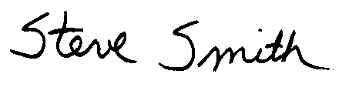
Steve Smith, Ph.D.
Program Supervisor
Planning, Rule Development & Area Sources

ENVIRONMENTAL CHECKLIST AND DISCUSSION

 | Potentially Significant Impact | Less Than Significant Impact | No Impact
I. AESTHETICS. Would the project:

- Have a substantial adverse effect on a scenic vista? | ◻ | ◻ | ☑
- Substantially damage scenic resources, including, but not limited to, trees, rock outcroppings, and historic buildings within a state scenic highway? | ◻ | ◻ | ☑
- Substantially degrade the existing visual character or quality of the site and its surroundings? | ◻ | ◻ | ☑
- Create a new source of substantial light or glare which would adversely affect day or nighttime views in the area? | ◻ | ◻ | ☑

Significance Criteria
The proposed project impacts on aesthetics will be considered significant if:
The project will block views from a scenic highway or corridor.
The project will adversely affect the visual continuity of the surrounding area.
The impacts on light and glare will be considered significant if the project adds lighting which would add glare to residential areas or sensitive receptors.

Discussion
- a), b): Lowering the VOC content in coatings, as well as regulating leather coating operations and the polyurethane shoe sole operations, will likely occur at existing affected facilities located in industrial, institutional, or commercial areas. Except for a possible replacement or installation of a heating unit, no major construction activities are associated with the proposed amendments. As a result, construction equipment and material will not be needed and stockpiling of construction materials will not result from the proposed project.
I. c): Because compliance will likely rely on coating reformulation, no new construction of buildings or other structures are anticipated so scenic resources will not be obstructed and the existing visual character of sites in the vicinity of affected facilities will not be degraded.
- d): There are no components in PAR 1145 that would require construction activities at night. Further, coating activities typically occur inside industrial or commercial buildings. Therefore, PAR 1145 is not expected to create a new source of substantial light or glare that would adversely affect day or nighttime views in the area. Therefore, the proposed project is not expected to create significant adverse aesthetic impacts.
Based on the above consideration, significant adverse impacts to aesthetics are not expected from PAR 1145. Since there are no significant adverse impacts, no mitigation measures are required.

 | Potentially Significant Impact | Less Than Significant Impact | No Impact
II. AGRICULTURE RESOURCES. Would the project:

a) Convert Prime Farmland, Unique Farmland, or Farmland of Statewide Importance (Farmland), as shown on the maps prepared pursuant to the Farmland mapping and Monitoring Program of the California Resources Agency, to non- agricultural use? | ◻ | ◻ | ☑
b) Conflict with existing zoning for agricultural use, or a Williamson Act contract? | ◻ | ◻ | ☑
c) Involve other changes in the existing environment which, due to their location or nature, could result in conversion of Farmland, to non-agricultural use? | ◻ | ◻ | ☑

Significance Criteria

Project-related impacts on agricultural resources will be considered significant if any of the following conditions are met:
The proposed project conflicts with existing zoning or agricultural use or Williamson Act contracts.

The proposed project will convert prime farmland, unique farmland or farmland of statewide importance as shown on the maps prepared pursuant to the farmland mapping and monitoring program of the California Resources Agency, to non-agricultural use.

The proposed project would involve changes in the existing environment, which due to their location or nature, could result in conversion of farmland to non-agricultural uses.

Discussion
- a) - c): As previously discussed, no major construction is associated with the proposed rule amendments . Further, the coating activities would occur at existing affected facilities located in industrial, institutional, or commercial areas. Therefore, the proposed project would not result in any construction of new buildings or other structures that would convert farmland to non-agricultural use or conflict with zoning for agricultural use or a Williamson Act contract. Since the proposed project would not substantially change the equipment or process in which the coatings are applied, there are no provisions in the proposed amended rule that would affect land use plans, policies, or regulations. Land use and other planning considerations are determined by local governments and no land use or planning requirements will be altered by the proposed project.
Based on the above consideration, significant adverse impacts to agriculture resources are not expected from PAR 1145. Since there are no significant adverse impacts, no mitigation measures are required.

 | Potentially Significant Impact | Less Than Significant Impact | No Impact
III. AIR QUALITY. Would the project:

a) Conflict with or obstruct implementation of the applicable air quality plan? | ◻ | ◻ | ☑
b) Violate any air quality standard or contribute to an existing or projected air quality violation? | ◻ | ◻ | ☑
c) Result in a cumulatively considerable net increase of any criteria pollutant for which the project region is non-attainment under an applicable federal or state ambient air quality standard (including releasing emissions that exceed quantitative thresholds for ozone precursors)? | ◻ | ◻ | ☑
d) Expose sensitive receptors to substantial pollutant concentrations? | ◻ | ◻ | ☑
e) Create objectionable odors affecting a substantial number of people? | ◻ | ◻ | ☑
f) Diminish an existing air quality rule or future compliance requirement resulting in a significant increase in air pollutant(s)? | ◻ | ◻ | ☑
Significance Criteria

Impacts will be evaluated and compared to the significance criteria in Table 2-1. If impacts equal or exceed any of the following criteria, they will be considered significant.
TABLE 2-1
Air Quality Significance Thresholds

Mass Daily Thresholds
Pollutant | Construction | Operation
NOx | 100 lbs/day | 55 lbs/day
VOC | 75 lbs/day | 55 lbs/day
PM10 | 150 lbs/day | 150 lbs/day
SOx | 150 lbs/day | 150 lbs/day
CO | 550 lbs/day | 550 lbs/day
Lead | 3 lbs/day | 3 lbs/day

TAC Thresholds
Toxic Air Contaminants  (TACs) | Maximum Incremental Cancer Risk > 10 in 1 million  Hazard Index > 1.0 (project increment)  Hazard Index > 3.0 (facility-wide)
TABLE 2-1 (concluded)
Air Quality Significance Thresholds

Odor Thresholds
Odor | Project creates an odor nuisance pursuant to SCAQMD Rule 402

Ambient Air Quality for Criteria Pollutants
NO₂  1-hour average  annual average | 20 ug/m³ (= 1.0 pphm)  1 ug/m³ (= 0.05 pphm)
PM10  24-hour  annual geometric mean  24-hour construction | 2.5 ug/m³  1.0 ug/m³  10.4 ug/m³
Sulfate  24-hour average | 1 ug/m³
CO  1-hour average  8-hour average | 1.1 mg/m³ (= 1.0 ppm)  0.50 mg/m³ (= 0.45 ppm)

PM10 = particulate matter less than 10 microns in size, ug/m3 = microgram per cubic meter; pphm = parts per hundred million; mg/m3 = milligram per cubic meter; ppm = parts per million; TAC = toxic air contaminant; AHM = Acutely Hazardous Material. NO₂ ₌ Nitrogen Oxide, CO = Carbon Monoxide, VOC = Volatile Organic Compounds, SOx = Sulfur Oxide.

Discussion
III. a): PAR 1145 would not conflict with or obstruct, air quality plan implementation. In fact, PAR 1145 will implement, in part, the 2003 AQMP stationary source control measure CTS-10: Miscellaneous Industrial Coatings and Solvent Operations. The proposed rule amendments are expected to achieve a 52 percent reduction in VOC emissions from the affected facilities subject to Rule 1145. This VOC emission reduction is consistent with in the primary purpose of the SCAQMD’s AQMP which is to control emissions to attain and maintain all federal and state ambient air quality standards for the district. The 2003 AQMP concluded that major reductions in emissions of VOC and NO_{x} are necessary to attain the air quality standards for ozone, PM2.5, and PM10. As noted in Table 2-2, the overall VOC emissions from this industry will be reduced approximately 2542 pounds per day which will assist the SCAQMD’s progress in attaining the ambient air quality standards for ozone.
III. b): The proposed project will eventually achieve an overall VOC emission reduction listed in Table 2-2, which will assist in achieving the air quality standards.
Table 2-2
Anticipated VOC Emission Reductions from PAR 1145
 | Current |  |  | Proposed |  |  | Emissions Reductions
Coating Category | EstimatedUsage  (gals/year) | VOC Content Limit  (lbs/gal) | Emissions  (lbs/year) | Estimated Usage  (gals/year) | VOC Content Limit  (lbs/gal) | Emissions  (lbs/year) | (lbs/year) |  | (lbs/day)¹
General One Component | 312,059 | 2.3 | 717,736 | 185,749 | 1.0 | 185,749 | 531,987 |  | 1457
General Two Component | 102,534 | 3.5 | 358,868 | 64,084 | 1.0 | 64,084 | 294,784 |  | 808
Mirror Backing – Roll Coated | 7,476 | 3.6 | 26,915 | 5,404 | 2.6 | 14,050 | 12,865 |  | 35
Optical | 13,391 | 6.7 | 89,717 | 3,517 | 0.4 | 1,407 | 88,310 |  | 242
TOTAL EMISSIONS (lbs/year) |  |  | 1,193,236 |  |  | 265,290
TOTAL EMISSION REDUCTIONS (pounds per year) & (pounds per day) |  |  |  |  |  |  |  | 927,946 | 2542
¹ based on 365 days of coatings per year.

Construction Impacts
The proposed project would primarily affect the future formulation of plastic, rubber, leather, and glass coatings and, therefore, does not require physical changes or modifications involving construction activities. Thus, no construction air quality impacts will result from the proposed project.
Operational Impacts
The overall objective of the proposed project is to reduce VOC emissions from plastic, rubber, leather and glass coatings by lowering the VOC content limit from three existing coating categories. The emission reductions for the proposed amendments to Rule 1145 are estimated based on a comparison of the current and proposed emissions limits on a per solid basis. When calculating the emission reductions presented in Table 2-2 the emission reductions are based on a comparison of the current and proposed VOC content limit as well as on the difference in the solids content of the current and proposed type of coatings. In general, the solids content of the proposed coatings tend to be higher than the solids content of the coatings currently used by the affected coating industry. Table 2-2 provides the anticipated VOC emission reduction for each of the coating categories affected by the proposed amendments. The total estimated emissions inventory is derived from survey data and other information received from facility operators.
The new VOC content limits for the three existing coating categories listed in Table 2-2 will not be required until January 1, 2007, and, therefore, the VOC emission reductions will not be achieved until then. The inclusion of the leather coating category and the exemption for polyurethane shoe sole coatings, however, will be effective at the time of rule adoption and both these amendments to the rule will result in potential adverse air quality impacts.
As noted earlier, the proposed amendments to Rule 1145 will establish a new category for leather coatings with five four subcategories (sealer coat, color coat, stain coat, top coat and antique coat), which will limit the VOC content of each leather coating type used in leather operations. The leather coating categories will also become subject to the transfer efficiency requirements in Rule 1145. The proposed VOC content limits for the leather coatings are based on the typical VOC content of leather coatings that are currently being used at the one affected facility. Although the VOC content limit will not change from what is currently used, the rule does not limit the overall VOC emissions from the facility. Currently, the one affected facility is subject to Rule 442 - Usage of Solvents, which limits the facility to 833 pounds per month (28 pounds per day) of VOC emissions from solvent containing products. Assuming PAR 1145 is adopted by the Governing Board, the affected facility that uses leather coatings would become subject to the VOC content limits in PAR 1145 and would no longer be subject to the monthly VOC emission constraints of Rule 442. Once the monthly emission constraint is removed from the affected facility, VOC emissions from leather coatings at this facility could increase substantially.
It is assumed for this analysis that the affected facility will not generate emissions exceeding ten tons of VOC per year (55 pounds per day) or it would become subject to Title V requirements. The reason for this assumption is that the Title V program (Regulation XXX) imposes substantial administrative and regulatory burdens on an affected facility. Establishing the VOC content requirements for leather coatings and assuming that operators of affected facility would increase leather coating usage to the maximum amount possible that allows them to avoid becoming a Title V facility could increase VOC emissions by 27 pounds per day (55 pounds per day - 28 pounds per day).
The second adverse air quality impact anticipated for PAR 1145 is generated by exempting the polyurethane shoe sole coating from complying with the general one-component coating VOC content limit. This exemption only applies if emissions from this coating category do not exceed 11 pounds per day. Therefore, operators of the one affected facility using polyurethane shoe sole coating could potentially increase their total VOC emissions up to 11 pounds per day.
In total, PAR 1145 could result in 38 pounds per day (27 pounds per day + 11 pounds per day) of VOC increase until January 1, 2007, which is when the new VOC content limits for the existing three coating categories (general, mirror backed and optical) become effective. The potential increase in VOC emissions, however, is not significant since 38 pounds per day is less than 55 pounds per day which is the SCAQMD’s CEQA significance operational threshold for VOC emissions.
Operational Impacts – Toxic Air Contaminants
Proposed amended Rule 1145 would modify the VOC content limit of plastic, rubber and glass coatings, but does not dictate any particular product formulation. The proposed project may, however, result in the use of coatings with toxic constituents. Since there are many different coating manufacturers and coating formulations, as well as many different cleaning applications, the specific chemical composition of reformulated coating products is not known. Based upon currently available information, the primary replacement solvents are expected to be two exempt solvents - acetone and PCBTF - as possible replacements for currently used solvents.
It is assumed that products compliant with the proposed amendments to Rule 1145 would be formulated by using exempt compounds to extend or replace many organic solvents that contain toxic compounds included in currently used cleaning products. Commonly used compounds that would likely be replaced include, for example, toluene, xylene and mineral spirits (stoddard solvent).
Typical Conventional Solvents
Toluene
The largest use for toluene is in the production of benzene. Toluene is also used as an octane booster or enhancer in gasoline, as a raw material for toluene diisocyanate, as a solvent, and in solvent extraction processes. As a solvent, it may be used in aerosol spray paints, wall paints, lacquers, inks, adhesives, natural gums, and resins, as well as in a number of consumer products, such as spot removers, paint strippers, cosmetics, perfumes, and antifreezes.
Breathing large amounts of toluene for short periods of time adversely affects the human nervous system, the kidneys, the liver, and the heart. Effects range from unsteadiness and tingling in fingers and toes to unconsciousness and death. Direct, prolonged contact with toluene liquid or vapor irritates the skin and the eyes. Human health effects associated with breathing or otherwise consuming smaller amounts of toluene over long periods of time are not known. Repeatedly breathing large amounts of toluene, such as when "sniffing" glue or paint, can cause permanent brain damage. As a result, humans can develop problems with speech, hearing, and vision. Humans can also experience loss of muscle control, loss of memory, and decreased mental ability. Exposure to toluene can also adversely affect the kidneys. Laboratory animal studies and, in some cases, human exposure studies show that repeat exposure to large amounts of toluene during pregnancy can adversely affect the developing fetus. Other studies show that repeat exposure to large amounts of toluene adversely affects the nervous system, the kidneys, and the liver of animals.
The Clean Air Act Amendments of 1990 list toluene as a hazardous air pollutant. Toluene is also listed in Table I of SCAQMD Rule 1401 – New Source Review of Toxic Air Contaminants.
Xylene
Xylene occurs naturally in petroleum and coal tar and is formed during forest fires. Chemical industries produce xylene from petroleum. It is one of the top 30 chemicals produced in the United States in terms of volume.
Xylene is used as a solvent and in the printing, rubber, and leather industries. It is also used as a cleaning agent, paint thinner, and in paints and varnishes. It is found in small amounts in airplane fuel and gasoline.
Xylene adversely affects the brain. High levels of exposure for short periods (14 days or less) or long periods (more than one year) can cause headaches, lack of muscle coordination, dizziness, confusion, and changes in one's sense of balance. Exposure of persons to high levels of xylene for short periods can also cause irritation of the skin, eyes, nose, and throat; difficulty in breathing; problems with the lungs; delayed reaction time; memory difficulties; stomach discomfort; and possibly changes in the liver and kidneys. It can cause unconsciousness and even death at very high levels.
Studies of unborn animals indicate that high concentrations of xylene may cause increased numbers of deaths, and delayed growth and development. In many instances, these same concentrations also cause damage to the mothers. It is unknown if xylene harms the unborn child if the mother is exposed to low levels of xylene during pregnancy.
The International Agency for Research on Cancer (IARC) has determined that xylene is not classifiable as to its carcinogenicity in humans. Human and animal studies have not shown xylene to be carcinogenic, but these studies are not conclusive and do not provide enough information to conclude that xylene does not cause cancer.
The Clean Air Act Amendments of 1990 list xylene as a hazardous air pollutant. Because xylene can cause adverse health affects other than cancer, it is listed in Table I of Rule 1401.
Possible Solvent Replacements
Acetone
Acetone is a manufactured chemical that is also found naturally in the environment. It occurs naturally in plants, trees, volcanic gases, forest fires, and as a product of the breakdown of body fat. It is present in vehicle exhaust, tobacco smoke, and landfill sites. Acetone is used to make plastic, fibers, drugs, and other chemicals. It is also used to dissolve other substances. Industrial processes contribute more acetone to the environment than natural processes.

Acetone is absorbed into the bloodstream and carried to all the organs in the body. If it is a small amount, the liver breaks it down to chemicals that are not harmful and uses these chemicals to make energy for normal body functions. Breathing moderate-to-high levels of acetone for short periods of time, however, can cause nose, throat, lung, and eye irritation; headaches; light-headedness; confusion; increased pulse rate; effects on blood; nausea; vomiting; unconsciousness and possibly coma; and shortening of the menstrual cycle in women. Swallowing very high levels of acetone can result in unconsciousness and damage to the skin in the mouth. Skin contact can result in irritation and damage to your skin.

Health effects from long-term exposures are known mostly from animal studies. Kidney, liver, and nerve damage, increased birth defects, and lowered ability to reproduce (males only) occurred in animals exposed long-term. It is not known if these same effects would occur in people. California does not list acetone as a reproductive toxicant under Proposition 65.

The Department of Health and Human Services, the International Agency for Research on Cancer, and the EPA have not classified acetone for carcinogenicity. Acetone does not cause skin cancer in animals when applied to the skin. It is unknown, however, if breathing or swallowing acetone for long periods will cause cancer. Studies of workers exposed to it found no significant risk of death from cancer.

Acetone has not been identified by CARB as a toxic air contaminant (TAC) under AB 1807, but is listed in Category 3 (substances which are being evaluated for entry into Category 2) on the TAC Identification List. Acetone is also included in the list of “Substances for which emissions must be quantified” under AB 2588 Air Toxics “Hot Spots” Program. The 1990 Clean Air Act Amendments do not list acetone as a hazardous air pollutant.
PCBTF
Though PCBTF has been commercially produced since the early 1960’s toxicity data on this compound is less complete than other possible replacement solvents. PCBTF had originally been used as an intermediate in the production of other compounds, but more recently has been marketed as a cleaning solvent. Available toxicity information is presented below.
PCBTF is slightly irritating to the eyes and to the skin. Uses of PCBTF include industrial solvent cleaning, aerosols, adhesives, coatings, and inks. Under these applications, the major routes of exposure are considered to be through the skin and by inhalation. The estimated rat oral LD50 is greater than 6.8 grams per kilogram (g/kg); the acute dermal toxicity (LD50) value is greater than 2.7 grams per kilogram in rabbits. The acute inhalation toxicity LD50 is 4,479 ppm.
PCBTF is not absorbed into the body to any appreciable extent. Most of the material is either exhaled back or excreted. At concentration levels of greater than 250 ppm of PCBTF and for exposures greater than 90 days slight liver damage was observed. Animal studies indicate that PCBTF is not a reproductive toxin. Potential chronic toxicity or carcinogenicity data on PCBTF was not available.
Neither the California Air Pollution Control Officers Association nor the USEPA has developed non-cancer health standards for acute or chronic exposures to PCBTF. The State of California has not listed PCBTF as a reproductive toxin under Proposition 65. Neither the International Agency for Research on Cancer nor the USEPA has classified PCBTF for carcinogenicity. PCBTF is not listed under California’s Proposition 65 as a carcinogen and has not been identified by CARB as a TAC under AB 1807. PCBTF is not listed under AB 2588 Air Toxics “Hot Spots” Program or as a hazardous air pollutant under the 1990 Clean Air Act Amendments.
Comparison of Conventional Solvents and Possible Replacement Solvents
The potential for significant adverse toxic impacts is dependent on a number of variables. These include the specific chemical composition of the coatings used to meet the requirements of the amendments, the amounts that are used, and the chemical composition of the materials to be replaced (i.e., coatings formulated with conventional solvents also may contain toxic or otherwise hazardous air pollutants). Previous analyses of the potential toxic impacts from the use of reformulated solvent products have determined that the toxicity of conventional solvent replacements is generally offset by the toxicity of the solvents that they would replace.
As noted in Chapter 1, coatings may also be formulated with exempt compounds such as acetone and PCBTF, with the objective of reducing the VOC content of the coating product. Exempt compounds are solvent which are deemed non-photochemically reactive and so do not contribute to the formation of ozone. In 1995, the USEPA determined that acetone and PCBTF have low photochemical reactivity and should be exempted from consideration as a VOC. A number of solvents, including acetone, are listed as Group I exempt compounds in Rule 102, which are non-VOC by definition. PCBTF was initially listed as a Group II exempt compound because, when it was classified as an exempt compound, toxicity information on it was still being compiled. The toxicity information on PCBTF was substantially reviewed by OEHHA and, based on the results of that review, PCBTF was moved to Group I exempt compound list.
As illustrated in Table 2-3, some of the replacement solvents have lower or less severe TLVs, PELs, and IDLHs than traditional solvents. For example, acetone would be considered less toxic than all the listed traditional solvents.
Table 2-3
Regulatory Exposure Limits of Conventional and Possible Replacement Solvents
Solvents | TLV (ppm)¹ | PEL (ppm) ² | IDLH (ppm)³

Conventional Solvents
Toluene | 50 | 200 | 500
Xylene | 100 | 100 | 900*
Stoddard Solvent | 100 | 500 | 3,400

Replacement Solvents
Acetone | 500 | 1000 | 2,500*
PCBTF⁴ | Not Established | Not Established | Not Established
¹ ACGIH
² OSHA
³ NIOSH
⁴ Manufacturer recommends an exposure limit of 25 ppm
* Based on 10 percent of the lower explosive limit
Based on the comparisons of toxicity and regulatory exposure limits, it is concluded that the increased use of toxics in reformulated coatings will generally be balanced by a concurrent decrease in the use of toxic materials in currently used affected coatings. Toxic air contaminant impacts would not be expected to change significantly from existing conditions. Considering the toxicity of currently used conventional solvents, there is no substantive evidence that shows the use of those solvents identified as possible replacements would result in significant adverse toxic air contaminant impacts
III. c): No significant potential adverse air quality impact related to implementation of PAR 1145 will result from the lowering of the VOC content limits, inclusion of leather coatings or limited exemption of polyurethane shoe sole coatings. There will be a slight potential increase in VOC emissions from the inclusion of leather coatings and the limited exemption of polyurethane shoe sole coatings, however, it was determined to be less than the SCAQMD’s significance operational threshold for VOC and, therefore, not significant. The reason for the emission increase and calculation of the potential increase can be found below in subsection III. f). Because the inclusion of leather coatings and the limited exemption of polyurethane shoe sole coatings takes place when the rule amendments are adopted, the potential increase in VOC emissions would be experienced after the date of adoption of the rule amendments and up to January 1, 2007, when the three existing coatings will be subject to the lower VOC content limits and the emission reductions will be generated. The emission reductions will provide an overall air quality benefit from PAR 1145. Since PAR 1145 will not result in project-specific significant air quality impacts, it is not expected to cause cumulative impacts in conjunction with other projects that may occur concurrently with or subsequent to the proposed project (CEQA Guidelines §15130(a)). The proposed project’s contribution to a potentially significant cumulative impact is rendered less than cumulatively considerable and thus, is not significant (CEQA Guidelines §15064(i)(2)).
III. d): Affected facilities are not expected to expose sensitive receptors to substantial pollutant concentrations form the implementation of PAR 1145 for the following reasons: 1) there are no significant operational increases of VOC emissions associated with the proposed rule amendments; 2) implementing PAR 1145 is ultimately expected to reduce VOC emissions in the district by approximately 1.3 tons per day; 3) replacement solvents are expected to be formulated with less toxic materials than currently used in affected coatings; and 4) the use of future compliant materials must comply with all applicable SCAQMD rules and regulations, e.g., Rules 1401 and 1402, which limit the use of materials that emit toxic air contaminants. Therefore, significant adverse air quality impacts to sensitive receptors are not expected from implementing Rule 1145.
III. e): The odor characteristics of affected coatings are not expected to change with the use of reformulated coatings because the operation of coating plastics, rubber or glass is not expected to change at the affected facilities. In fact, the conditions will improve over time as facilities switch to low-VOC materials, such as water-based solvents. If enough acetone is used in the reformulation, there could be a potential adverse odor impact. However, local governments typically have ordinances that are intended to protect the public from adverse odors and the SCAQMD Rule 402 – Nuisance, also protects the public from adverse odor impacts.
- f): The proposed project reduces VOC content limit of three existing coatings which will improve air quality and not diminish an existing air quality rule or future compliance requirement.
Based on the above consideration, significant adverse impacts to air quality are not expected from PAR 1145. Since there are no significant adverse impacts, no mitigation measures are required.

 | Potentially Significant Impact | Less Than Significant Impact | No Impact
IV. BIOLOGICAL RESOURCES. Would the project:

a) Have a substantial adverse effect, either directly or through habitat modifications, on any species identified as a candidate, sensitive, or special status species in local or regional plans, policies, or regulations, or by the California Department of Fish and Game or U.S. Fish and Wildlife Service? | ◻ | ◻ | ☑
b) Have a substantial adverse effect on any riparian habitat or other sensitive natural community identified in local or regional plans, policies, or regulations, or by the California Department of Fish and Game or U.S. Fish and Wildlife Service? | ◻ | ◻ | ☑
c) Have a substantial adverse effect on federally protected wetlands as defined by §404 of the Clean Water Act (including, but not limited to, marsh, vernal pool, coastal, etc.) through direct removal, filling, hydrological interruption, or other means? | ◻ | ◻ | ☑
d) Interfere substantially with the movement of any native resident or migratory fish or wildlife species or with established native resident or migratory wildlife corridors, or impede the use of native wildlife nursery sites? | ◻ | ◻ | ☑
e) Conflicting with any local policies or ordinances protecting biological resources, such as a tree preservation policy or ordinance? | ◻ | ◻ | ☑
f) Conflict with the provisions of an adopted Habitat Conservation plan, Natural Community Conservation Plan, or other approved local, regional, or state habitat conservation plan? | ◻ | ◻ | ☑

Significance Criteria

Impacts on biological resources will be considered significant if any of the following criteria apply:
The project results in a loss of plant communities or animal habitat considered to be rare, threatened or endangered by federal, state or local agencies.

The project interferes substantially with the movement of any resident or migratory wildlife species.

The project adversely affects aquatic communities through construction or operation of the project.

Discussion
IV. a), b), d): In the short term, PAR 1145 would have a slight, but not significant, increase in VOC emissions. The proposed amendments would provide an overall VOC emission reduction and, thus, would be a benefit to air quality. Therefore, the proposed amendments to Rule 1145 will have no direct or indirect impacts that could adversely affect plant or animal species or the habitats on which they rely in the SCAQMD’s jurisdiction. The activity takes place at existing facilities and, the net effect of implementing the proposed amended rule will be improved air quality resulting from reduced VOC emissions, which is expected to be beneficial for both plant and animal life. Modifications at existing affected facilities to switch to low-VOC materials, such as water-based or exempt solvents would not require acquisition of additional land or conversion of any riparian habitats or sensitive natural communities where endangered or sensitive species may be found.
IV. c): Acquisition of protected wetlands is not expected to be necessary to switch to low-VOC materials, such as water-based or exempt solvents. Affected facilities would be allowed to continue existing operating practices so the proposed amended rule will not directly remove, fill or interrupt any hydrological system or have an adverse effect on federally protected wetlands.
- e), f):There are no provisions in the proposed amended rule that would adversely affect land use plans, local policies or ordinances, or regulations. Land use and other planning considerations are determined by local governments and no land use or planning requirements will be altered by the proposed project. Proposed amended Rule 1145 would not affect in any way habitat conservation or natural community conservation plans, agricultural resources or operations, and would not create divisions in any existing communities.
Based on the above consideration, significant adverse impacts to biological resources are not expected from PAR 1145. Since there are no significant adverse impacts, no mitigation measures are required.

 | Potentially Significant Impact | Less Than Significant Impact | No Impact
V. CULTURAL RESOURCES. Would the project:

- Cause a substantial adverse change in the significance of a historical resource as defined in §15064.5? | ◻ | ◻ | ☑
- Cause a substantial adverse change in the significance of an archaeological resource as defined in §15064.5? | ◻ | ◻ | ☑
- Directly or indirectly destroy a unique paleontological resource or site or unique geologic feature? | ◻ | ◻ | ☑
d) Disturb any human remains, including those interred outside formal cemeteries? | ◻ | ◻ | ☑

Significance Criteria

Impacts to cultural resources will be considered significant if:
The project results in the disturbance of a significant prehistoric or historic archaeological site or a property of historic or cultural significance to a community or ethnic or social group.

Unique paleontological resources are present that could be disturbed by construction of the proposed project.

The project would disturb human remains.

Discussion
V. a) - d): There are existing laws in place that are designed to protect and mitigate potential impacts to cultural resources. Coating operations for plastics, rubber and glass affected by Rule 1145 take place at existing facilities and won’t require major construction activities such as grading, trenching, etc. Therefore, cultural resources would not be disturbed. As a result, the proposed project has no potential to cause a substantial adverse change to a historical or archaeological resource, directly or indirectly destroy a unique paleontological resource or site or unique geologic feature, or disturb any human remains, including those interred outside formal cemeteries.
Based on the above consideration, significant adverse impacts to cultural resources are not expected from PAR 1145. Since there are no significant adverse impacts, no mitigation measures are required.

 | Potentially Significant Impact | Less Than Significant Impact | No Impact
VI. ENERGY. Would the project:

a) Conflict with adopted energy conservation plans? | ◻ | ◻ | ☑
b) Result in the need for new or substantially altered power or natural gas utility systems? | ◻ | ◻ | ☑
c) Create any significant effects on local or regional energy supplies and on requirements for additional energy? | ◻ | ◻ | ☑
d) Create any significant effects on peak and base period demands for electricity and other forms of energy? | ◻ | ◻ | ☑
e) Comply with existing energy standards? | ◻ | ◻ | ☑

Significance Criteria

Impacts to energy and mineral resources will be considered significant if any of the following criteria are met:
The project conflicts with adopted energy conservation plans or standards.

The project results in substantial depletion of existing energy resource supplies.

An increase in demand for utilities impacts the current capacities of the electric and natural gas utilities.

The project uses non-renewable resources in a wasteful and/or inefficient manner.

Discussion
VI. a), e): Lowering VOC content limits at affected facilities will not conflict with adopted energy conservation plans or be out of compliance with existing energy standards because affected equipment would basically continue current operations. PAR 1145 is not expected to substantially increase the demand for electricity at affected facilities (see next paragraph), and, therefore, would not be expected to interfere with existing or future energy conservation plans because these are typically targeted to residential consumers, etc.
VI. b), c), d): The plastic, rubber or glass coating operations are not expected to substantially change at the affected facilities. However, if an operator of an affected coating facility, such as an optical coating operation, decides to switch to a UV curing system, new heating lamps will need to be installed. While there is an electricity demand from the UV lamps, the demand is not expected to increase from the demand of an existing conventional oven. In fact, UV curing systems use approximately 30 percent of the energy usage needed to operate a conventional oven. Since there will be no additional demand for electricity, the need for new or substantially altered power or natural gas utility systems will not result from the proposed project. The proposed project will have a non-significant effect on the electricity capacity and, therefore, no significant impact on peak or base demands for electricity.
Based on the above consideration, significant adverse impacts to energy are not expected from PAR 1145. Since there are no significant adverse impacts, no mitigation measures are required.

 | Potentially Significant Impact | Less Than Significant Impact | No Impact
VII. GEOLOGY AND SOILS. Would the project:

a) Expose people or structures to potential substantial adverse effects, including the risk of loss, injury, or death involving: | ◻ | ◻ | ☑
- Rupture of a known earthquake fault, as delineated on the most recent Alquist-Priolo Earthquake Fault Zoning Map issued by the State Geologist for the area or based on other substantial evidence of a known fault? | ◻ | ◻ | ☑
- Strong seismic ground shaking? | ◻ | ◻ | ☑
- Seismic–related ground failure, including liquefaction? | ◻ | ◻ | ☑
- Landslides? | ◻ | ◻ | ☑
b) Result in substantial soil erosion or the loss of topsoil? | ◻ | ◻ | ☑
c) Be located on a geologic unit or soil that is unstable or that would become unstable as a result of the project, and potentially result in on- or off-site landslide, lateral spreading, subsidence, liquefaction or collapse? | ◻ | ◻ | ☑
d) Be located on expansive soil, as defined in Table 18-1-B of the Uniform Building Code (1994), creating substantial risks to life or property? | ◻ | ◻ | ☑
e) Have soils incapable of adequately supporting the use of septic tanks or alternative waste water disposal systems where sewers are not available for the disposal of waste water? | ◻ | ◻ | ☑

Significance Criteria

Impacts on the geological environment will be considered significant if any of the following criteria apply:
Topographic alterations would result in significant changes, disruptions, displacement, excavation, compaction or over covering of large amounts of soil.

Unique geological resources (paleontological resources or unique outcrops) are present that could be disturbed by the construction of the proposed project.

Exposure of people or structures to major geologic hazards such as earthquake surface rupture, ground shaking, liquefaction or landslides.

Secondary seismic effects could occur which could damage facility structures, e.g., liquefaction.

Other geological hazards exist which could adversely affect the facility, e.g., landslides, mudslides.

Discussion
VII. a): The coating activities affected by PAR 1145 take place at existing affected facilities so the proposed amendments to Rule 1145 will not expose people to potential substantial geological effects greater than what they are exposed to already. Lowering the VOC content limit at existing coating facilities will not expose people or structures to new risks of loss, injury, or death involving: rupture of an earthquake fault, seismic ground shaking, ground failure or landslides.
VII. b): The proposed project will not require major construction activities (e.g., grading, trenching, refilling and repaving), so no potential impacts to existing geophysical conditions are anticipated. Because the affected coating activities take place at existing facilities on established foundations, no soil is expected to be disrupted. Therefore, no substantial soil erosion or loss of topsoil is expected from the existing affected facilities as a result of lowering the VOC content limit of four coating categories.
VII. c), d): PAR 1145 is expected to alter the types of coatings used at existing affected facilities and, therefore, will not involve locating any structures on soil that is unstable or expansive as defined in Table 18-1-B of the Uniform Building Code. However, as already noted, no soil disturbance is anticipated from delaying the compliance requirement, therefore, no further destabilization of unstable soils would be expected that could cause on- or off-site landslides, lateral spreading, subsidence, liquefaction or collapse.
VII. e): The proposed project does not involve the installation of septic tanks or alternative waste water disposal systems. Therefore, this type of soil impact will not occur.
Based on the above consideration, significant adverse impacts to geology and soils are not expected from PAR 1145. Since there are no significant adverse impacts, no mitigation measures are required.

 | Potentially Significant Impact | Less Than Significant Impact | No Impact
VIII. HAZARDS AND HAZARDOUS MATERIALS. Would the project:

a) Create a significant hazard to the public or the environment through the routine transport, use, and disposal of hazardous materials? | ◻ | ◻ | ☑
- Create a significant hazard to the public or the environment through reasonably foreseeable upset and accident conditions involving the release of hazardous materials into the environment? | ◻ | ◻ | ☑
- Emit hazardous emissions, or handle hazardous or acutely hazardous materials, substances, or waste within one-quarter mile of an existing or proposed school? | ◻ | ◻ | ☑
- Be located on a site which is included on a list of hazardous materials sites compiled pursuant to Government Code §65962.5 and, as a result, would create a significant hazard to the public or the environment? | ◻ | ◻ | ☑
- For a project located within an airport land use plan or, where such a plan has not been adopted, within two miles of a public airport or public use airport, would the project result in a safety hazard for people residing or working in the project area? | ◻ | ◻ | ☑
- For a project within the vicinity of a private airstrip, would the project result in a safety hazard for people residing or working in the project area? | ◻ | ◻ | ☑
- Impair implementation of or physically interfere with an adopted emergency response plan or emergency evacuation plan? | ◻ | ◻ | ☑
- Expose people or structures to a significant risk of loss, injury or death involving wildland fires, including where wildlands are adjacent to urbanized areas or where residences are intermixed with wildlands? | ◻ | ◻ | ☑
- Significantly increased fire hazard in areas with flammable materials? | ◻ | ◻ | ☑

Significance Criteria

Impacts associated with hazards will be considered significant if any of the following occur:
Non-compliance with any applicable design code or regulation.

Non-conformance to National Fire Protection Association standards.

Non-conformance to regulations or generally accepted industry practices related to operating policy and procedures concerning the design, construction, security, leak detection, spill containment or fire protection.

Exposure to hazardous chemicals in concentrations equal to or greater than the Emergency Response Planning Guideline (ERPG) 2 levels.

Discussion
VIII. a), b), c): The existing plastic, rubber and glass coating operations are not expected to change at the affected facilities and, thus, the amount of solvents used in affected coatings are not expected to change. To comply with the lower VOC content limits, coatings are expected to be formulated with less or different solvents (such as acetone or PCBTF) and more water, which is not hazardous. No additional transport of the solvents is expected and, thus, no new hazards to the public will be created through transport, use or disposal of hazardous materials. In addition, adverse worker exposure (e.g., applicators of the coatings) to hazardous materials within the new formulations is not expected.
The following safety practices and application techniques are recommended by the National Association of Corrosion Engineers (NACE) and the Society for Protective Coatings during the application of coatings including future compliant coatings. Thus, applicators are not expected to require additional training regarding the proper handling or application of compliant coatings containing hazardous materials which will further reduce the applicator’s exposure because these safety measures tent to be established in existing affected facilities.
Worker Isolation – Areas where coatings with hazardous materials are applied should be restricted to essential workers. If feasible, these workers should avoid direct contact with hazardous materials by using automated equipment or area with plenty of ventilation.
Protective Clothing and Equipment – When there is potential for hazardous material exposure, workers should be provided with and required to use appropriate personal protective clothing and equipment such as coveralls, footwear, chemical-resistant gloves and goggles, full faceshields, and suitable respiratory equipment.
Respiratory Protection – Only the most protective respirators should be used for situations involving exposures to hazardous materials because they have poor warning properties, are potent sensitizers, or may be carcinogenic. These respirators include:
Any respiratory protection program must, at a minimum, meet the requirements of the OSHA respiratory protection standard [29 CFR 1910.134]. Respirators must be certified by NIOSH and MSHA according to 30 CFR or by NIOSH (effective July 19, 1995) according to 42 CFR 84. A complete respiratory protection program should include: (1) regular training and medical evaluation of personnel, (2) fit testing, (3) periodic environmental monitoring, (4) periodic maintenance, inspection, and cleaning of equipment, (5) proper storage of equipment, and (6) written standard operating procedures governing the selection and use of respirators. The program should be evaluated regularly. The following publications contain additional information about selection, fit testing, use, storage, and cleaning of respiratory equipment: NIOSH Guide to Industrial Respiratory Protection [NIOSH 1987a] and NIOSH Respiratory Design Logic [NIOSH 1987b]. Examples of complying with these regulations include the following:
- Any self-contained breathing apparatus with a full facepiece operated in a pressure-demand or other positive-pressure mode, and
- Any supplied-air respirator with a full facepiece operated in a pressure-demand or other positive-pressure mode in combination with an auxiliary self-contained breathing apparatus operated in a pressure-demand or other positive-pressure mode.
Worker and Employer Education – Worker education is vital to a good occupational safety and health program. OSHA requires that workers be informed about:
- Materials that may contain or be contaminated with hazardous materials;
- The nature of the potential hazard [29 CFR 1910.1200]. Employers must transmit this information through container labeling, MSDSs, and worker training;
- The serious health effects that may result from hazardous material exposures; and
- Any materials that may contain or be contaminated with hazardous materials.
Additionally, workers should take the following steps to protect themselves from hazardous material exposure:
- Be aware that the highest hazardous material concentrations may occur inside containment structures.
- Wash hands and face before eating, drinking, or smoking outside the work area.
- Participate in medical monitoring and examination programs, air monitoring programs, or training programs, offered by your employer.
As a result of being delisted as a VOC by the USEPA, CARB, and many air districts, acetone usage has been steadily increasing irrespective of the currently proposed amendments. In any event, it is likely that for some solvent coating categories acetone usage could increase. An increase in acetone usage may increase the number of trucks or rail cars that transport acetone within the state. However, the safety characteristics of individual trucks or rail cars that transport acetone will not be affected by the proposed amendments. The consequences (exposure effects) of an accidental release of acetone are directly proportional to the size of the individual transport trucks or rail cars and the release rate. Although the probability of an accidental release of acetone could increase, the severity of an incident involving acetone transport will not change as a result of the proposed project. This holds true for the transport of other replacement solvents.
Any increase in accidental releases of compliant acetone-based coatings during transport would be expected to result in a concurrent reduction in the number of accidental releases of existing cleaning materials. Many conventional cleaning solvents are as flammable as acetone, so there would generally be little or no net change in the hazard consequences from the reformulation of coatings to comply with the proposed amendments.
Consequently, the proposed amendments to Rule 1145 will not create a significant new hazard to the public or create a reasonably foreseeable upset involving the release of hazardous materials. Similarly, emissions from affected facilities will not increase but will decrease.
VIII. d): Government code §65962.5 refers to hazardous waste handling practices at facilities subject to the Resources Conservation and Recovery Act (RCRA). Since the proposed project would lower the usage of hazardous materials, hazardous waste handling practices, if any, at regulated facilities would not be affected.
VIII. e), f): Even for facilities that may be located near airports or private airstrips, the proposed project will not create new safety hazards because the coating operations are not expected to change, only the types of coatings used may change.
VIII. g): The coating activity has no effect on a facility’s ability to comply, and not interfere, with all applicable rules and regulations, including any government codes, airport land use plans, adopted emergency response plans and emergency evacuation plans.
VIII. h,) i): Eventually, affected facilities will be required to comply with lower VOC content limit requirements, which is likely to happen through reformulation of the solvent or conversion to alternative technologies. It is generally anticipated that the reformulation will entail the use of water-based components or low-VOC materials less hazardous or flammable than currently being used. As previously discussed, acetone could be chosen as a solvent in the reformulation. As shown in Table 2-4, the flammability classifications by the NFPA are the same for acetone, toluene and xylene. Acetone has a low flashpoint with a high Lower Explosive Limit, which means that acetone vapors will not cause an explosion unless the vapor concentration exceeds 26,000 ppm. In contrast, solvents currently used in coating formulations poses a much greater risk of explosion, such as toluene with vapors that can cause an explosion at 13,000 ppm, and the concentration of xylene vapors that could cause an explosion is even lower at 10,000 ppm. Under operating guidelines of working with flammable coatings under well-ventilated areas, as prescribed by the fire department codes, it would be difficult to achieve concentrated streams of such vapors.
Table 2-4
Chemical Characteristics of Coating Solvents
C o n v e n t i o n a l S o l v e n t s
Chemical  Compound | M.W. ª | Boiling Point  (@760 mmHg, ºF) |  | Evap.  Rate  (@25 ºC) | Flash point  (ºF) | LEL/UEL^{b}  (% by Vol.) | Auto-ignition  Temperature  (ºC) | Vapor Pressure  (mmHg @  20 ºC) |  | Flammability Classification ^{c}  (NFPA) ^{d}
Toluene | 92 | 111 |  | 2.0 | 41 | 1.2/7 | 538 | 22 |  | 3
Xylene | 106 | 139 |  | 0.8 | 81 | 1.0/6.6 | 499 | 6 |  | 3
Stoddard Solvent | 144 | 154-188 |  | 0.1 | 109-113 | 1/7 | 232 | 1.1 |  | 2
R e p l a c e m e n t S o l v e n t s
Chemical  Compound | M.W. ª | Boiling Point  (@760 mmHg, ºF) | Evap.  Rate  (@25 ºC) |  | Flash point  (ºF) | LEL/UEL^{b}  (% by Vol.) | Auto-ignition  Temperature  (ºC) |  | Vapor Pressure  (mmHg @  20 ºC) | Flammability Classification ^{c}  (NFPA) ^{d}
Acetone | 58 | 56 | 6.1 |  | -4 | 2.6/12.8 | 538 |  | 180 | 3
PCBTF | 181 | 282 | 0.9 |  | 109 | 0.9/10.5 | 97 |  | 5.3 | 1
Source: OxyChem Specialty Business Group
ª Molecular weight
^{b} Lower explosive limit/upper explosive limit
^{c} Flammability Rating: 0 = Not Combustible; 1 = Combustible if heated; 2 = Caution: Combustible liquid flash point of 100º to 200ºF; 3 = Warning: Flammable liquid flash point below 100ºF; 4 = Danger: Flammable gas or extremely flammable liquid
^{d} NFPA = National Fire Protection Association
Chemistry classes at all levels from grade school to universities, as well as industrial laboratories, use acetone for wiping down counter tops and cleaning glassware. Additional uses for acetone include solvent for paint, varnish, lacquers, inks, adhesives, floor coatings, and cosmetic products including nail polish and nail polish remover.
Labels and MSDSs accompanying acetone-based products caution the user regarding acetone’s flammability and advises the user to “keep the container away from heat, sparks, flame and all other sources of ignition. The vapors may cause flash fire or ignite explosively. Use only with adequate ventilation.” All of the large coating manufacturers currently offer pure acetone for sale in quart or gallon containers with similar warnings.
The Uniform Fire Code and Uniform Building Code set standards intended to minimize risks from flammable or otherwise hazardous materials. Local jurisdictions are required to adopt the uniform codes or comparable regulations. Local fire agencies require permits for the use or storage of hazardous materials and permit modifications for proposed increases in their use. Permit conditions depend on the type and quantity of the hazardous materials at the facility. Permit conditions may include, but are not limited to, specifications for sprinkler systems, electrical systems, ventilation, and containment. The fire departments make annual business inspections to ensure compliance with permit conditions and other appropriate regulations. Consequently, local fire departments ensure that adequate permit conditions are in place to protect against potential risk of upset from the use of hazardous materials. However, any use of hazardous materials at affected facilities is not expected to change as a result of implementing the proposed project.
Based on the above consideration, significant adverse impacts to hazards and hazardous materials are not expected from PAR 1145. Since there are no significant adverse impacts, no mitigation measures are required.

 | Potentially Significant Impact | Less Than Significant Impact | No Impact
IX. HYDROLOGY AND WATER QUALITY. Would the project:

a) Violate any water quality standards or waste discharge requirements? | ◻ | ◻ | ☑
- Substantially deplete groundwater supplies or interfere substantially with groundwater recharge such that there would be a net deficit in aquifer volume or a lowering of the local groundwater table level (e.g. the production rate of pre-existing nearby wells would drop to a level which would not support existing land uses or planned uses for which permits have been granted)? | ◻ | ◻ | ☑
c) Substantially alter the existing drainage pattern of the site or area, including through alteration of the course of a stream or river, in a manner that would result in substantial erosion or siltation on- or off-site? | ◻ | ◻ | ☑
d) Substantially alter the existing drainage pattern of the site or area, including through alteration of the course of a stream or river, or substantially increase the rate or amount of surface runoff in a manner that would result in flooding on- or off-site? | ◻ | ◻ | ☑
e) Create or contribute runoff water which would exceed the capacity of existing or planned stormwater drainage systems or provide substantial additional sources of polluted runoff? | ◻ | ◻ | ☑
f) Otherwise substantially degrade water quality? | ◻ | ◻ | ☑
g) Place housing within a 100-year flood hazard area as mapped on a federal Flood Hazard Boundary or Flood Insurance Rate Map or other flood hazard delineation map? | ◻ | ◻ | ☑
h) Place within a 100-year flood hazard area structures which would impede or redirect flood flaws? | ◻ | ◻ | ☑
i) Expose people or structures to a significant risk of loss, injury or death involving flooding, including flooding as a result of the failure of a levee or dam? | ◻ | ◻ | ☑
j) Inundation by seiche, tsunami, or mudflow? | ◻ | ◻ | ☑
k) Exceed wastewater treatment requirements of the applicable Regional Water Quality Control Board? | ◻ | ◻ | ☑
l) Require or result in the construction of new water or wastewater treatment facilities or expansion of existing facilities, the construction of which could cause significant environmental effects? | ◻ | ◻ | ☑
m) Require or result in the construction of new storm water drainage facilities or expansion of existing facilities, the construction of which could cause significant environmental effects? | ◻ | ◻ | ☑
n) Have sufficient water supplies available to serve the project from existing entitlements and resources, or are new or expanded entitlements needed? | ◻ | ◻ | ☑
o) Require in a determination by the wastewater treatment provider which serves or may serve the project that it has adequate capacity to serve the project's projected demand in addition to the provider's existing commitments? | ◻ | ◻ | ☑

Significance Criteria

Potential impacts on water resources will be considered significant if any of the following criteria apply:
Water Quality:

The project will cause degradation or depletion of ground water resources substantially affecting current or future uses.

The project will cause the degradation of surface water substantially affecting current or future uses.

The project will result in a violation of National Pollutant Discharge Elimination System (NPDES) permit requirements.

The capacities of existing or proposed wastewater treatment facilities and the sanitary sewer system are not sufficient to meet the needs of the project.

The project results in substantial increases in the area of impervious surfaces, such that interference with groundwater recharge efforts occurs.

The project results in alterations to the course or flow of floodwaters.

Water Demand:

The existing water supply does not have the capacity to meet the increased demands of the project, or the project would use a substantial amount of potable water.

The project increases demand for water by more than five million gallons per day.

Discussion
IX. a), b), f), n), o): Lowering the VOC content limit of coatings at affected facilities will have no direct or indirect impact on hydrology and water quality resources because the reformulated coatings used at affected facilities are not expected to change the amount of water currently used. Equipment used in connection with waterbased coatings is typically cleaned with normal tap water. In addition, coating applicators are not expected to improperly dispose the waste generated from the waterborne coatings into the ground, storm drains, or sewer systems because there should be no change to the current practices for waste disposal. Therefore, PAR 1145 will not adversely affect water resources, water quality standards, groundwater supplies, water quality degradation, existing water supplies or wastewater treatment facilities.
In the past the SCAQMD has received comments that with the increased use of water-borne technologies to meet the lower VOC content limits, there will be a greater trend of coating applicators to improperly dispose of the waste generated from these coatings into the ground, storm drains, or sewer systems. However, there are no data to support this contention. In any event, there are several reasons why there should be no significant increase over current practices for improper disposal due to greater use of water-borne coatings.
Results from a survey of coating contractors/users determined that a majority either dispose of the waste material properly as required by the coating manufacturer’s MSDS or recycle the waste material regardless of type of coating. Based upon these results, there is no reason to expect that paint users will change their disposal practices, especially those that dispose of wastes properly, with the implementation of PAR 1145.
Impacts to water quality from reformulated coatings (i.e., water-based coatings) would be due to the increased use of water for clean-up and the potential resultant increased discharge into the sewer system. Publicly owned treatment works (POTWs) in the region are expected to be able to accommodate the potential increase in wastewater associated with reformulated coating. (The POTWs have an overall capacity of about 1,700 million gallons per day – see Table 2-5.) Further, state and federal regulations are expected to promote the development and use of coatings formulated with non-hazardous solvents. Based on discussions with resin manufacturers and coating formulators, the trend in coating technologies is to replace toxic/hazardous solvents with less toxic/hazardous solvents. Therefore, wastewater which may be generated from reformulated coatings is expected to contain less hazardous materials than the wastewater generated for solvent-based coating operations, thereby reducing toxic influent to the POTWs. The amount of increased wastewater generated from coating operations would be well within the capacity of the regions POTWs. Consequently, wastewater impacts from coating reformulation are not considered significant.
It should be noted that the coating organizations provide the public and painting users with information as to the environmentally sound coating disposal practices. These public outreach programs are expected to reduce the amount of coating waste material entering the sewer systems, storm drainage systems, and being dumped on the ground. Therefore, further reducing any water quality impacts associated with the improper disposal of compliant coatings.
Future compliant coatings are expected to be formulated primarily with water-borne technologies. As a result, more water will be used for clean-up and the resultant wastewater material could be disposed of into the public sewer system. It is anticipated that current coating equipment (i.e., spray guns, rollers, and brushes) clean-up practices of using water will continue into the future. Table 2-5 illustrates the “worst-case” potential increase of waste material likely to be received by POTWs in the district as a result of implementing PAR 1145.
In addition, as discussed earlier, water-borne coatings are increasingly becoming less toxic than current coatings. To that extent, it is likely that adverse impacts to water quality will actually decrease as compared to the existing situation. Table 2-8 shows the historical and projected POTW impact from reformulated coatings.
Table 2-5
Historical and Projected POTW Impact From Reformulated Coatings
Year | POTW Average  Daily Flowª  (mgd) | POTW Capacity^{b}  (mgd) | Estimated Usage (gallons/year) | Coatings Disposal  Daily Flow^{c}  (mgd) | Total Impacts  (% Increase)
2003 | 1394.00 | 1687.30 | 435,460 | 0.0012 | 0.00007
2006 | 1394.00 | 1687.30 | 258,754 | 0.0007 | 0.00004
ª 2002 data of total average daily wastewater flows handled by all POTWs greater than 10 mgd in the district (2003 AQMP).
^{b} Based on design daily flows by all POTWs greater than 10 mgd in the district (2003 AQMP).
^{c} Assumes that one gallon of water will be used to clean-up equipment for every gallon of coating applied. The figures for Coatings Disposal Flow are based on the annual emissions inventory of the affected coating categories (2003) and their projected future sales until compliance in 2006; originally expressed in mgy, they are converted to mgd by dividing by 365.
mgd = millions of gallons per day
The potential increase is considered to be well within the existing and projected capacity of POTWs in the district. Hence, wastewater impacts associated with the disposal of water-borne clean-up waste material generated from PAR 1145 affected coating categories are not considered significant. With the increasing trend toward less toxic water-borne, it is likely that there will be less adverse impacts to water quality. Therefore, PAR 1145 will not adversely affect water resources, water quality standards, groundwater supplies, water quality degradation, existing water supplies or wastewater treatment facilities.
IX. c), d), e): The proposed project is expected to result in reformulation of plastic, rubber, and glass coatings used at existing facilities. Consequently, no major construction activities will be necessary to comply with PAR 1145, so the proposed project will not alter any existing drainage patterns, increase the rate or amount of surface runoff water that would exceed the capacity of existing or planned stormwater drainage systems.
IX. g), h): PAR 1145 will not require constructing new housing in a 100-year flood hazard area. PAR 1145 will affect the formulation of coatings used at existing coating facilities so any flood hazards would be part of the existing setting.
IX. i), j): Since PAR 1145 affects operations at existing facilities and does not require construction of new facilities, it will not alter existing flood risks or risks from seiches, tsunami’s or mudflow conditions.
IX. k): Since the proposed project will not change coating operations at affected facilities, no changes to existing wastewater treatment permits would be necessary so they would still be expected to comply with existing wastewater treatment requirements of the applicable Regional Water Quality Control Board.
IX. l), m): Because no increased water or waste results from the coating activity, the proposed project would not generate additional volumes of water that could exceed the capacity of existing stormwater drainage systems or require the construction of new wastewater or stormwater drainage facilities.
Based on the above consideration, significant adverse impacts to hydrology and water quality are not expected from PAR 1145. Since there are no significant adverse impacts, no mitigation measures are required.

 | Potentially Significant Impact | Less Than Significant Impact | No Impact
X. LAND USE AND PLANNING. Would the project:

a) Physically divide an established community? | ◻ | ◻ | ☑
b) Conflict with any applicable land use plan, policy, or regulation of an agency with jurisdiction over the project (including, but not limited to the general plan, specific plan, local coastal program or zoning ordinance) adopted for the purpose of avoiding or mitigating an environmental effect? | ◻ | ◻ | ☑
c) Conflict with any applicable habitat conservation or natural community conservation plan? | ◻ | ◻ | ☑

Significance Criteria

Land use and planning impacts will be considered significant if the project conflicts with the land use and zoning designations established by local jurisdictions.

Discussion
X. a.): Lowering the VOC content limit of certain coatings at affected facilities will not create divisions in any existing communities because this provision applies generally to operations at existing facilities.
X. b), c): Operations at coating facilities would still be expected to comply, and not interfere, with any applicable land use plans, zoning ordinances, habitat conservation or natural community conservation plans. There are no provisions of the proposed project that would directly affect these plans, policies, or regulations. Land use and other planning considerations are determined by local governments and no present or planned land uses in the region or planning requirements will be altered by the proposed project.
Based on the above consideration, significant adverse impacts to land use and planning are not expected from PAR 1145. Since there are no significant adverse impacts, no mitigation measures are required.

 | Potentially Significant Impact | Less Than Significant Impact | No Impact
XI. MINERAL RESOURCES. Would the project:

a) Result in the loss of availability of a known mineral resource that would be of value to the region and the residents of the state? | ◻ | ◻ | ☑
b) Result in the loss of availability of a locally-important mineral resource recovery site delineated on a local general plan, specific plan or other land use plan? | ◻ | ◻ | ☑

Significance Criteria

Project-related impacts on mineral resources will be considered significant if any of the following conditions are met:
The project would result in the loss of availability of a known mineral resource that would be of value to the region and the residents of the state.
The proposed project results in the loss of availability of a locally-important mineral resource recovery site delineated on a local general plan, specific plan or other land use plan.

Discussion
XI. a), b): There are no provisions of the proposed amended rule that would directly result in the loss of availability of a known mineral resource, such as aggregate, coal, shale, etc. of value to the region and the residents of the state, or of a locally-important mineral resource recovery site delineated on a local general plan, specific plan or other land use plan. The proposed project would lower the VOC content of certain coatings at existing facilities which needs no mineral resource to reformulate.
Based on the above consideration, significant adverse impacts to mineral resources are not expected from PAR 1145. Since there are no significant adverse impacts, no mitigation measures are required.

 | Potentially Significant Impact | Less Than Significant Impact | No Impact
XII. NOISE. Would the project result in:

a) Exposure of persons to or generation of noise levels in excess of standards established in the local general plan or noise ordinance, or applicable standards of other agencies? | ◻ | ◻ | ☑
b) Exposure of persons to or generation of excessive groundborne vibration or groundborne noise levels? | ◻ | ◻ | ☑
c) A substantial permanent increase in ambient noise levels in the project vicinity above levels existing without the project? | ◻ | ◻ | ☑
d) A substantial temporary or periodic increase in ambient noise levels in the project vicinity above levels existing without the project? | ◻ | ◻ | ☑
e) For a project located within an airport land use plan or, where such a plan has not been adopted, within two miles of a public airport or public use airport, would the project expose people residing or working in the project area to excessive noise levels? | ◻ | ◻ | ☑
f) For a project within the vicinity of a private airstrip, would the project expose people residing or working in the project area to excessive noise levels? | ◻ | ◻ | ☑

Significance Criteria

Impacts on noise will be considered significant if:
Construction noise levels exceed the local noise ordinances or, if the noise threshold is currently exceeded, project noise sources increase ambient noise levels by more than three decibels (dBA) at the site boundary. Construction noise levels will be considered significant if they exceed federal Occupational Safety and Health Administration (OSHA) noise standards for workers.

The proposed project operational noise levels exceed any of the local noise ordinances at the site boundary or, if the noise threshold is currently exceeded, project noise sources increase ambient noise levels by more than three dBA at the site boundary.

Discussion
XII. a), b), c), d): Plastic, rubber, leather and glass coating operations are generally not considered to be noise intensive operations. PAR 1145 will primarily affect the formulation of coatings used at existing facilities and does not contain any components that would generate noise, excessive groundborne vibration, or substantially increase ambient noise levels at affected facilities. Thus, the lowering of the VOC content limit requirement of coatings used at affected facilities is not expected to generate no additional noise impacts.
XII. e), f): Since the proposed project is not expected to generate any noticeable change in noise levels at existing facilities, it will not subject people residing or working in the project area or within then vicinity of a public airport or private airstrip to excessive noise levels.
Based on the above consideration, significant adverse impacts to noise are not expected from PAR 1145. Since there are no significant adverse impacts, no mitigation measures are required.

 | Potentially Significant Impact | Less Than Significant Impact | No Impact
XIII. POPULATION AND HOUSING. Would the project:

a) Induce substantial growth in an area either directly (for example, by proposing new homes and businesses) or indirectly (e.g. through extension of roads or other infrastructure)? | ◻ | ◻ | ☑
b) Displace substantial numbers of existing housing, necessitating the construction of replacement housing elsewhere? | ◻ | ◻ | ☑
c) Displace substantial numbers of people, necessitating the construction of replacement housing elsewhere? | ◻ | ◻ | ☑

Significance Criteria

Impacts of the proposed project on population and housing will be considered significant if the following criteria are exceeded:
The demand for temporary or permanent housing exceeds the existing supply.

The proposed project produces additional population, housing or employment inconsistent with adopted plans either in terms of overall amount or location.

Discussion
XIII. a), b), c): Human population in the SCAQMD’s jurisdiction is anticipated to grow regardless of implementing the proposed project. The proposal would lower the VOC content limit of certain coatings, which will not require additional employees since the operating process at affected facilities is not expected to change. The population will not grow directly as a result of the proposed amended rule and the coating activity will not indirectly induce growth in the area of the coating facilities. The construction of single- or multiple-family housing units would not be required as a result of implementing the proposed project. Therefore, existing housing or populations in the district are not anticipated to be displaced necessitating the construction of replacement housing elsewhere.
Based on the above consideration, significant adverse impacts to population and housing are not expected from PAR 1145. Since there are no significant adverse impacts, no mitigation measures are required.

 | Potentially Significant Impact | Less Than Significant Impact | No Impact
XIV. PUBLIC SERVICES. Would the proposal result in substantial adverse physical impacts associated with the provision of new or physically altered governmental facilities, need for new or physically altered government facilities, the construction of which could cause significant environmental impacts, in order to maintain acceptable service ratios, response times or other performance objectives for any of the following public services:

a) Fire protection? | ◻ | ◻ | ☑
b) Police protection? | ◻ | ◻ | ☑
c) Schools? | ◻ | ◻ | ☑
d) Parks? | ◻ | ◻ | ☑
e) Other public facilities? | ◻ | ◻ | ☑

Significance Criteria

Impacts on public services will be considered significant if the project results in substantial adverse physical impacts associated with the provision of new or physically altered governmental facilities, or the need for new or physically altered government facilities, the construction of which could cause significant environmental impacts, in order to maintain acceptable service ratios, response time or other performance objectives.

Discussion
XIV. a), b): Although acetone, which is flammable, could be used in the reformulation of compliant coatings, it is not expected to generate a significant fire hazard at the affected facilities. As noted in the “Hazards/Hazardous Materials” section, operating under the guidelines of working with flammable coatings in well-ventilated areas, as prescribed by the fire department codes, it would be difficult to achieve concentrated streams of such vapors to cause an explosion. In addition, the Uniform Fire Code and Uniform Building Code set standards intended to minimize risks from flammable or otherwise hazardous materials. Thus, use of compliant coatings formulated with acetone is not expected to create significant hazard impacts that would increase demand for fire or police protection.
XIV. c), d): Because coating operations affected by PAR 1145 are not expected to change, affected facilities are not expected to require new employees. Consequently, no new impacts to schools, parks or other recreational facilities are foreseen as a result of implementing the proposed amendments to Rule 1145.
XIV. e): The proposal would not result in the need for new or physically altered government facilities in order to maintain acceptable service ratios, response times or other performance objectives.
Based on the above consideration, significant adverse impacts to public services are not expected from PAR 1145. Since there are no significant adverse impacts, no mitigation measures are required.

 | Potentially Significant Impact | Less Than Significant Impact | No Impact
XV. RECREATION.

a) Would the project increase the use of existing neighborhood and regional parks or other recreational facilities such that substantial physical deterioration of the facility would occur or be accelerated.? | ◻ | ◻ | ☑
b) Does the project include recreational facilities or require the construction or expansion of recreational facilities that might have an adverse physical effect on the environment? | ◻ | ◻ | ☑

Significance Criteria

Impacts to recreation will be considered significant if:

The project results in an increased demand for neighborhood or regional parks or other recreational facilities.

The project adversely affects existing recreational opportunities.

Discussion
XV. a), b): As discussed under “Land Use and Planning” above, there are no provisions in the proposed project that would affect land use plans, policies or ordinances, or regulations. Land use and other planning considerations are determined by local governments; no land use or planning requirements will be altered by the proposal. As already noted in item XII, Population and Housing, the proposed project is not expected to increase population growth in the district because no additional employees would be required at affected facilities so no additional demand for parks is anticipated. Further, the proposed amendments would not increase the use of existing neighborhood and regional parks or other recreational facilities or include recreational facilities or require the construction or expansion of recreational facilities that might have an adverse physical effect on the environment.
Based on the above consideration, significant adverse impacts to recreation are not expected from PAR 1145. Since there are no significant adverse impacts, no mitigation measures are required.

 | Potentially Significant Impact |  | Less Than Significant Impact | No Impact
XVI. SOLID/HAZARDOUS WASTE. Would the project:

a) Be served by a landfill with sufficient permitted capacity to accommodate the project’s solid waste disposal needs? | ◻ | ◻ |  | ☑
b) Comply with federal, state, and local statutes and regulations related to solid and hazardous waste? | ◻ |  | ◻ | ☑

Significance Criteria

The proposed project impacts on solid/hazardous waste will be considered significant if the following occur:

The generation and disposal of hazardous and non-hazardous waste exceeds the capacity of designated landfills.

Discussion
XVI. a), b): In general, coating operations at affected facilities are not expected to change and, therefore, no new solid or hazardous waste will be generated as a result of lowering the VOC content limit of certain coatings in Rule 1145. Affected facilities would continue to complying with federal, state, and local statutes and regulations related to solid and hazardous waste handling and disposal. Therefore, potential solid waste impacts are considered not significant.
Based on the above consideration, significant adverse impacts to solid/hazardous waste are not expected from PAR 1145. Since there are no significant adverse impacts, no mitigation measures are required.

 | Potentially Significant Impact | Less Than Significant Impact | No Impact
XVII. TRANSPORTATION/CIRCULATION Would the project:

a) Cause an increase in traffic which is substantial in relation to the existing traffic load and capacity of the street system (i.e., result in a substantial increase in either the number of vehicle trips, the volume to capacity ratio on roads, or congestion at intersections)? | ◻ | ◻ | ☑
- Exceed, either individually or cumulatively, a level of service standard established by the county congestion management agency for designated roads or highways? | ◻ | ◻ | ☑
- Result in a change in air traffic patterns, including either an increase in traffic levels or a change in location that results in substantial safety risks? | ◻ | ◻ | ☑
- Substantially increase hazards due to a design feature (e.g. sharp curves or dangerous intersections) or incompatible uses (e.g. farm equipment)? | ◻ | ◻ | ☑
e) Result in inadequate emergency access? | ◻ | ◻ | ☑
f) Result in inadequate parking capacity? | ◻ | ◻ | ☑
g) Conflict with adopted policies, plans, or programs supporting alternative transportation (e.g. bus turnouts, bicycle racks)? | ◻ | ◻ | ☑

Significance Criteria

Impacts on transportation/traffic will be considered significant if any of the following criteria apply:

Peak period levels on major arterials are disrupted to a point where level of service (LOS) is reduced to D, E or F for more than one month.

An intersection’s volume to capacity ratio increase by 0.02 (two percent) or more when the LOS is already D, E or F.

A major roadway is closed to all through traffic, and no alternate route is available.

There is an increase in traffic that is substantial in relation to the existing traffic load and capacity of the street system.

The demand for parking facilities is substantially increased.

Water borne, rail car or air traffic is substantially altered.

Traffic hazards to motor vehicles, bicyclists or pedestrians are substantially increased.

The need for more than 350 employees

An increase in heavy-duty transport truck traffic to and/or from the facility by more than 350 truck round trips per day

Increase customer traffic by more than 700 visits per day.

Discussion
XVII. a), b), f): Coating practices at affected facilities are not expected to change and, therefore, no additional transportation/circulation impacts will directly or indirectly a result of lowering the VOC content limit of certain coatings in Rule 1145. No new employees are needed as a result of implementing the proposed amendments and therefore no new worker trips that could increase traffic or affect in any way the level of service designation for any roadways will result from the proposed amendments. Similarly, additional parking would not be required from implementing PAR 1145. Because the coating operation is not expected to change, no new or additional raw materials will be needed and, therefore, no transport trips that could affect the level of service for roadways will be generated from the continued operation of the coating activity.
XVII. c): Air traffic patterns are not expected to be directly or indirectly affected by the proposed amended rule because the coating activity will not require any air transportation nor will it interfere with air traffic. All applicable local, state and federal requirements would continue to be complied with so no increase in any safety risks is expected.
XVII. d), e): The proposed amendments to Rule 1145 does not have direct or indirect impact on specific construction design because the proposed project does not require or induce the construction of roadway design features. PAR 1145 simply lowers the VOC content limit of certain coatings for affected equipment, so it is expected that the coating operation would not change.
XVII. g): Affected facilities would still be expected to comply with, and not interfere with adopted policies, plans, or programs supporting alternative transportation. The lowering of the VOC content limit of certain coatings in Rule 1145 will not hinder compliance with any applicable alternative transportation plans or policies.
Based on the above consideration, significant adverse impacts to transportation/circulation are not expected from PAR 1145. Since there are no significant adverse impacts, no mitigation measures are required.

 | Potentially Significant Impact | Less Than Significant Impact | No Impact
XVIII. MANDATORY FINDINGS OF SIGNIFICANCE.

a) Does the project have the potential to degrade the quality of the environment, substantially reduce the habitat of a fish or wildlife species, cause a fish or wildlife population to drop below self-sustaining levels, threaten to eliminate a plant or animal community, reduce the number or restrict the range of a rare or endangered plant or animal or eliminate important examples of the major periods of California history or prehistory? | ◻ | ◻ | ☑
- Does the project have impacts that are individually limited, but cumulatively considerable? ("Cumulatively considerable" means that the incremental effects of a project are considerable when viewed in connection with the effects of past projects, the effects of other current projects, and the effects of probable future projects) | ◻ | ◻ | ☑
c) Does the project have environmental effects that will cause substantial adverse effects on human beings, either directly or indirectly? | ◻ | ◻ | ☑

Discussion
XVIII. a): As discussed in items I through XVII above, the proposed amended rule has no potential to cause significant adverse environmental effects because it would a result in an overall VOC emission reduction and will primarily involve a reformulation of the coatings used in existing operations at existing facilities. The VOC emission reduction will improve air quality which should benefit other environmental areas such as biological resources and aesthetics. Therefore, the proposed project is not expected to degrade the quality of the environment, substantially reduce the habitat of a fish or wildlife species, cause a fish or wildlife population to drop below self sustaining levels, threaten to eliminate a plant or animal community, reduce the number or restrict the range of a rare or endangered plant or animal. Similarly, PAR 1145 would not eliminate important examples of the major periods of California history or prehistory or otherwise degrade cultural resources.
XVIII.b) Based on the foregoing analyses, since PAR 1145 will not result in project-specific significant environmental impacts, PAR 1145 is not expected to cause cumulative impacts in conjunction with other projects that may occur concurrently with or subsequent to the proposed project. Furthermore, PAR 1145 impacts will not be "cumulatively considerable" because the incremental impacts are not considerable when viewed in connection with the effects of past, current, or probable future projects.
XVIII.c) Based on the foregoing analyses, PAR 1145 is not expected to cause significant adverse effects on human beings, either directly, or indirectly.

A P P E N D I X A

P R O P O S E D A M E N D E D R U L E 1 1 4 5

In order to save space and avoid repetition, please refer to the latest version of the proposed amended Rule 1145 located elsewhere in the final rule package. The “August 25, 2004” version of the proposed amended rule was circulated with the Draft EA that was released on September 2, 2004 for a 30-day public review and comment period ending October 1, 2004.
Original hard copies of the Draft EA, which include the “August 25, 2004” version of the proposed amended rule, can be obtained through the SCAQMD Public Information Center at the Diamond Bar headquarters or by calling (909) 396-2039.

A P P E N D I X B

C O M M E N T S O N T H E D R A F T E A
A N D R E S P O N S E S T O T H E C O M M E N T S

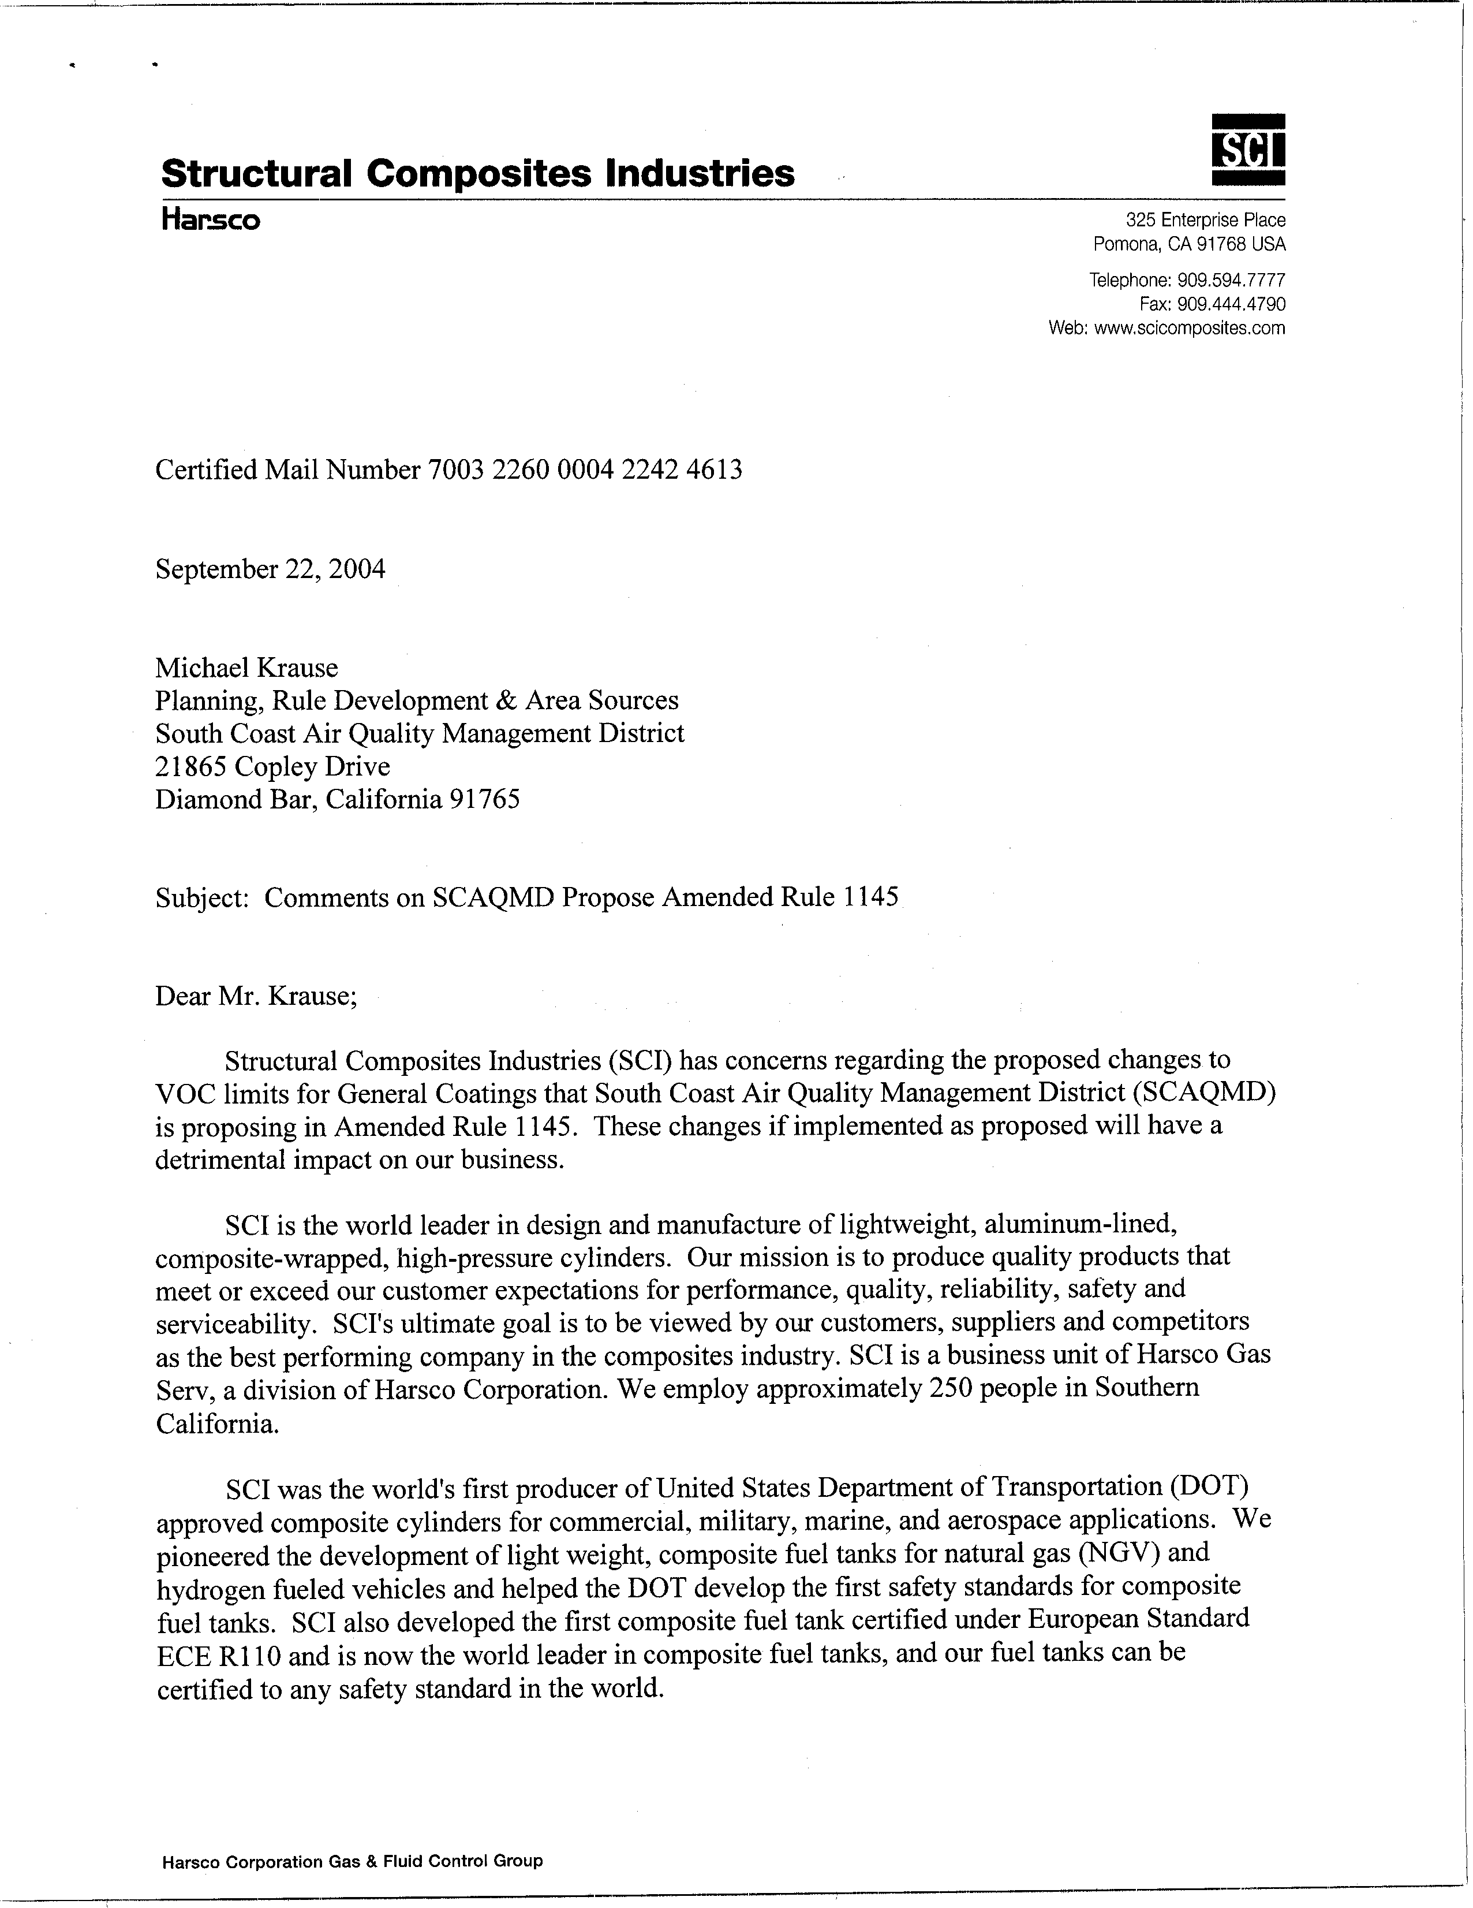
1-1
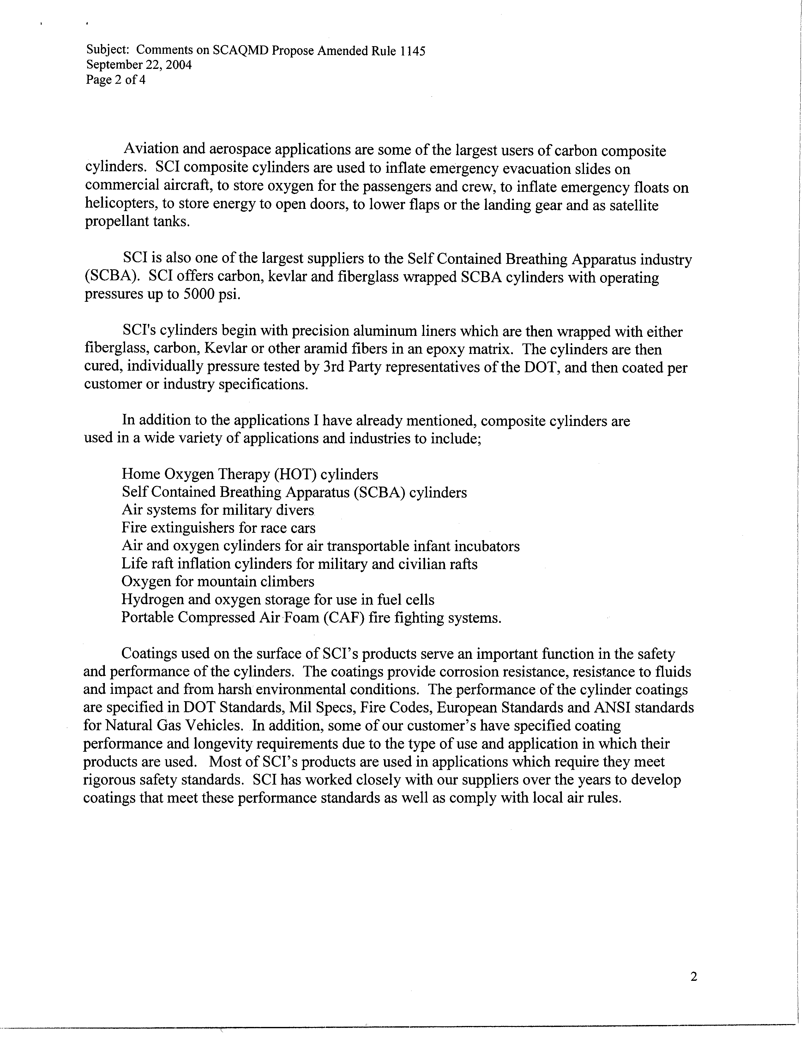
1-1
cont.
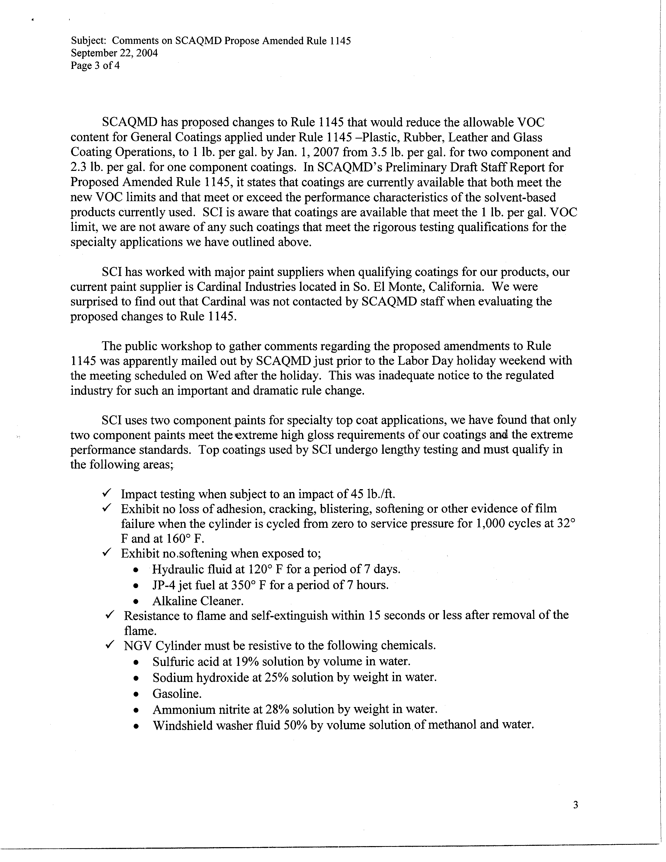
1-2
1-3
1-4
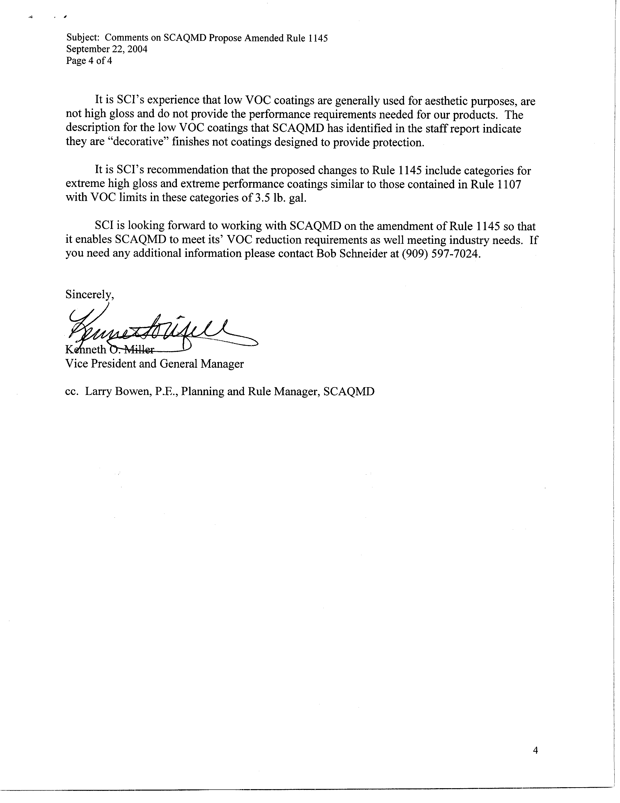
1-5
1-6
COMMENT LETTER # 1
FROM STRUCTURAL COMPOSITE INDUSTRIES

Kenneth O. Miller

September 22, 2004
Response to Comment 1-1:
The SCAQMD is aware of the commentator’s concerns with the proposed amendments to Rule 1145 and how the amendments will affect the various products designed and manufactured by Structural Composite Industries (SCI). The intention of the proposed amendments is to reduce the VOC content of coatings applied to plastic, rubber, leather and glass substrates using compliant coatings currently available and sold to affected users. The goal of the coating manufacturers is to formulate compliant coatings to meet existing performance requirements, safety standards, operating conditions, durability/longevity, reliability, as well as satisfy aesthetic interests. The compliance dates to meet the lower VOC content levels are projected in the future to allow additional time for more compliant coatings to become available, as well as ensure the coating manufacturers have enough time to formulate compliant coatings that meet the standards required by government agencies and provide quality products that meet the customer’s expectations.
Response to Comment 1-2:
At the September 8, 2004, public workshop the industry provided comments regarding the need to extend the compliance date for two-component general coatings in order to allow more time to formulate at 1.0 pound per gallon. The SCAQMD staff learned that two-component general coatings are currently formulated and sold at a VOC content level lower than the existing 3.5 pounds per gallon limit. Therefore, staff is recommending an update to the proposed rule amendments. Two-component general coatings will be required to be formulated at 2.5 pounds of VOC per gallon by January 1, 2006 and will be provided an additional year to comply with a 1.0 pound per gallon VOC content limit.
In response to the commentator’s concerns with two-component general coatings meeting the performance standards and rigorous testing qualifications for specialty applications, the SCAQMD staff is proposing the addition of a new coating category for extreme performance coatings. Staff has determined that the extreme performance coatings category is necessary to meet strict corrosion resistance requirement of other regulatory agencies. As of January 1, 2006 when other two-component coatings are required to be formulated at 2.5 pounds VOC per gallon, extreme performance two-component coatings will be able to maintain the current VOC limit of 3.5 pounds per gallon. The existing emissions from this type of coating are approximately six pounds per day so the analysis in the Draft EA will not worsen air quality impacts but rather reduce the anticipated air quality benefit from the rule amendments.
Response to Comment 1-3:
This is not true. Cardinal was contacted by SCAQMD staff. On Tuesday, August 31, 2004, a week before Labor Day weekend, the CEQA team mailed a public notice regarding the availability of the Draft Environmental Assessment, which included the proposed rule amendments and public workshop information, to our Cardinal contact, Vice President Robert Sypowicz. In addition, both the CEQA document and the Notice of Completion were posted on the SCAQMD’s CEQA website, and the public workshop was listed on the calendar page on the SCAQMD’s website. It is not the intention of the SCAQMD to avoid contacting affected coating manufacturers. On the contrary, it is in our best interest to involve the affected industry in the rule making process as early as possible to discuss any concerns and work to resolve those concerns so the rule adoption/amendment will be supported at the public hearing.
Response to Comment 1-4:
As noted in Response to Comment 1-2, the SCAQMD staff is proposing the addition of a new coating category for extreme performance coatings which should alleviate the commentator’s concern of performance standards with regards to their two-component coatings. While some high gloss coatings will qualify as an extreme performance coating, SCAQMD staff has determined, based on product information received from other coating manufacturers, that two-component high gloss coatings which comply with the future VOC content limit of 1.0 pound per gallon are currently available.
Response to Comment 1-5:
Please refer to Responses to Comments 1-2 and 1-4 regarding the proposed VOC content limit for extreme performance two-component coatings and high gloss coatings.
Response to Comment 1-6:
The SCAQMD looks forward to the commentator’s support of the SCAQMD proposal of a new coating category for extreme performance two-component coatings and is able to continue manufacturing and selling high gloss coatings in compliance with the VOC content limits in the rule.

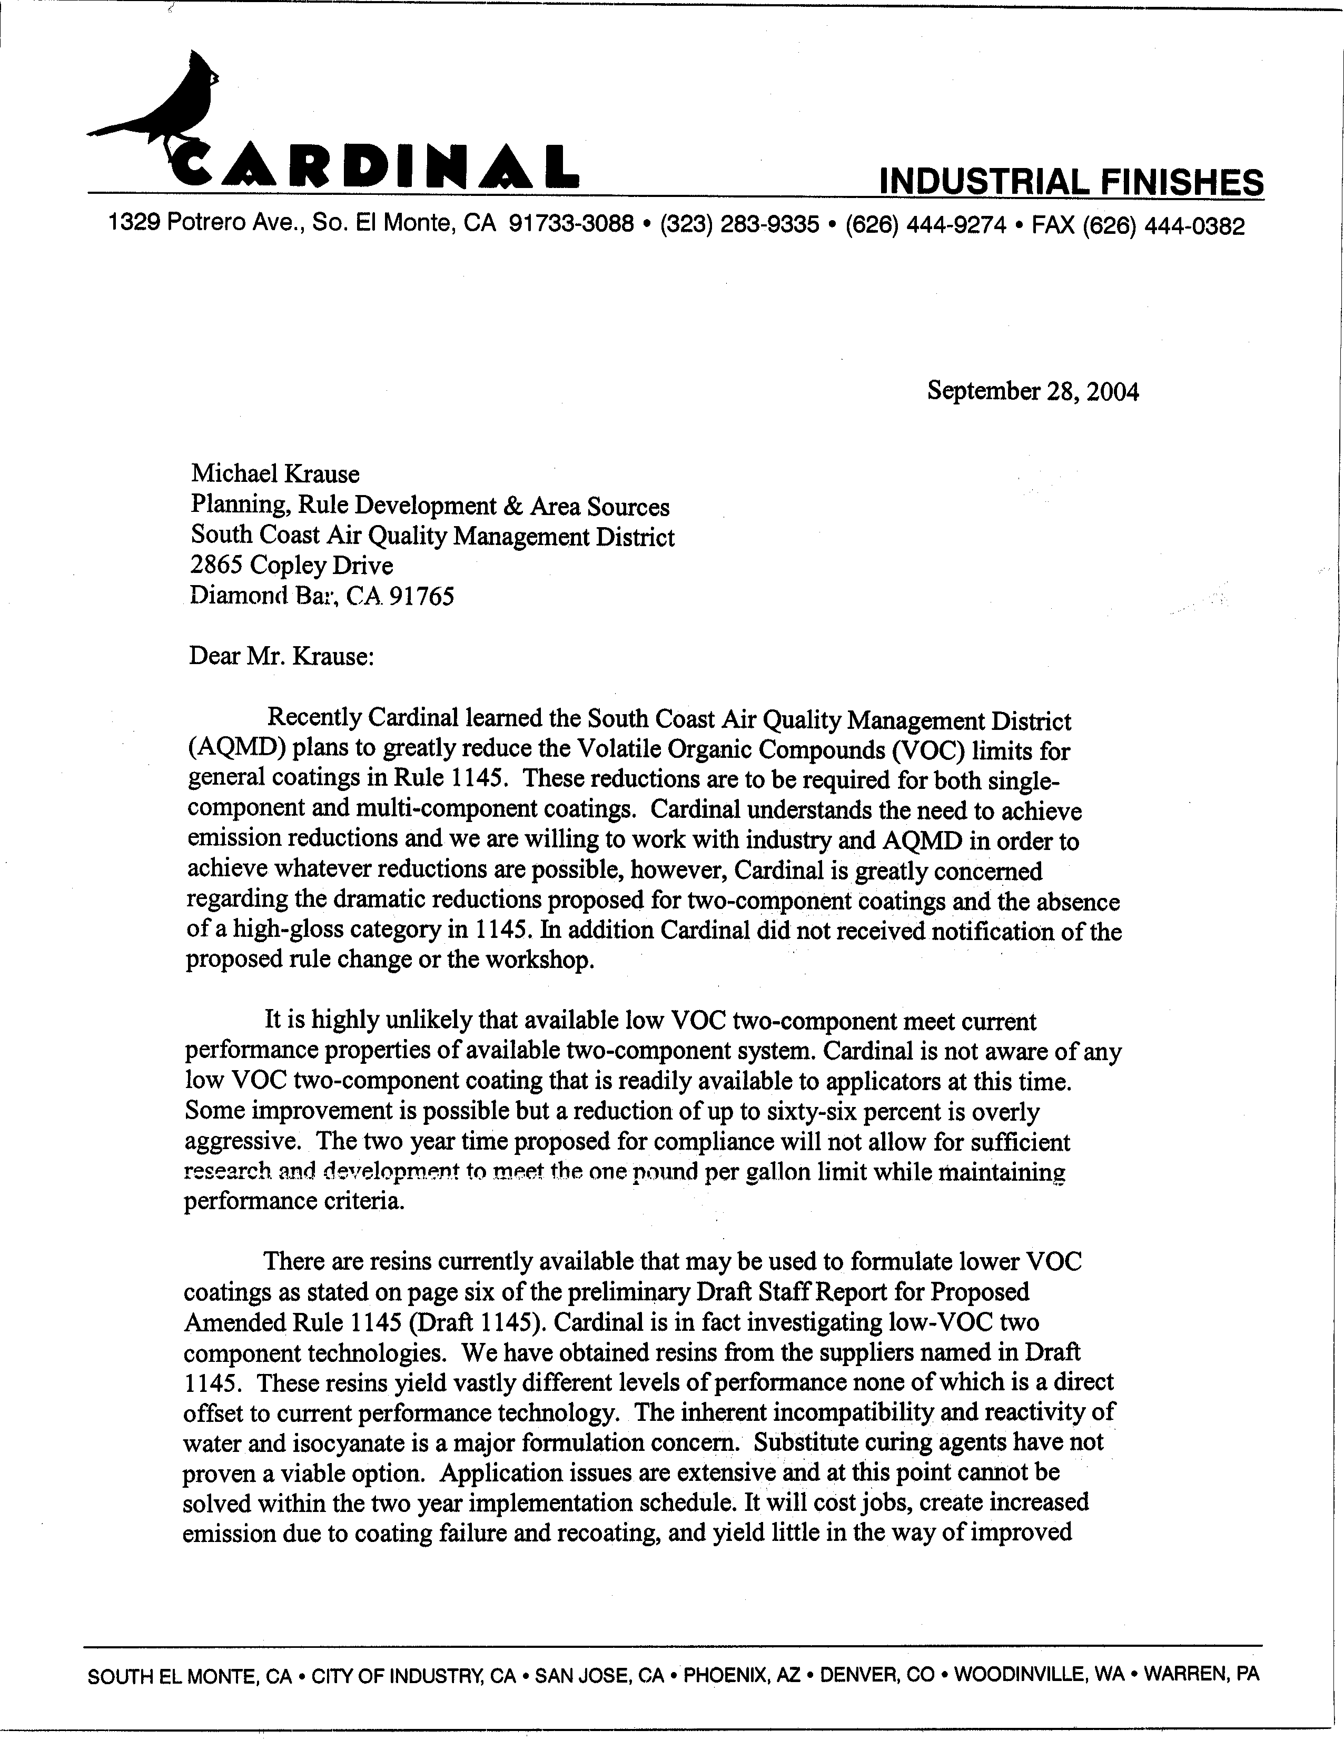
2-1
2-2
2-3
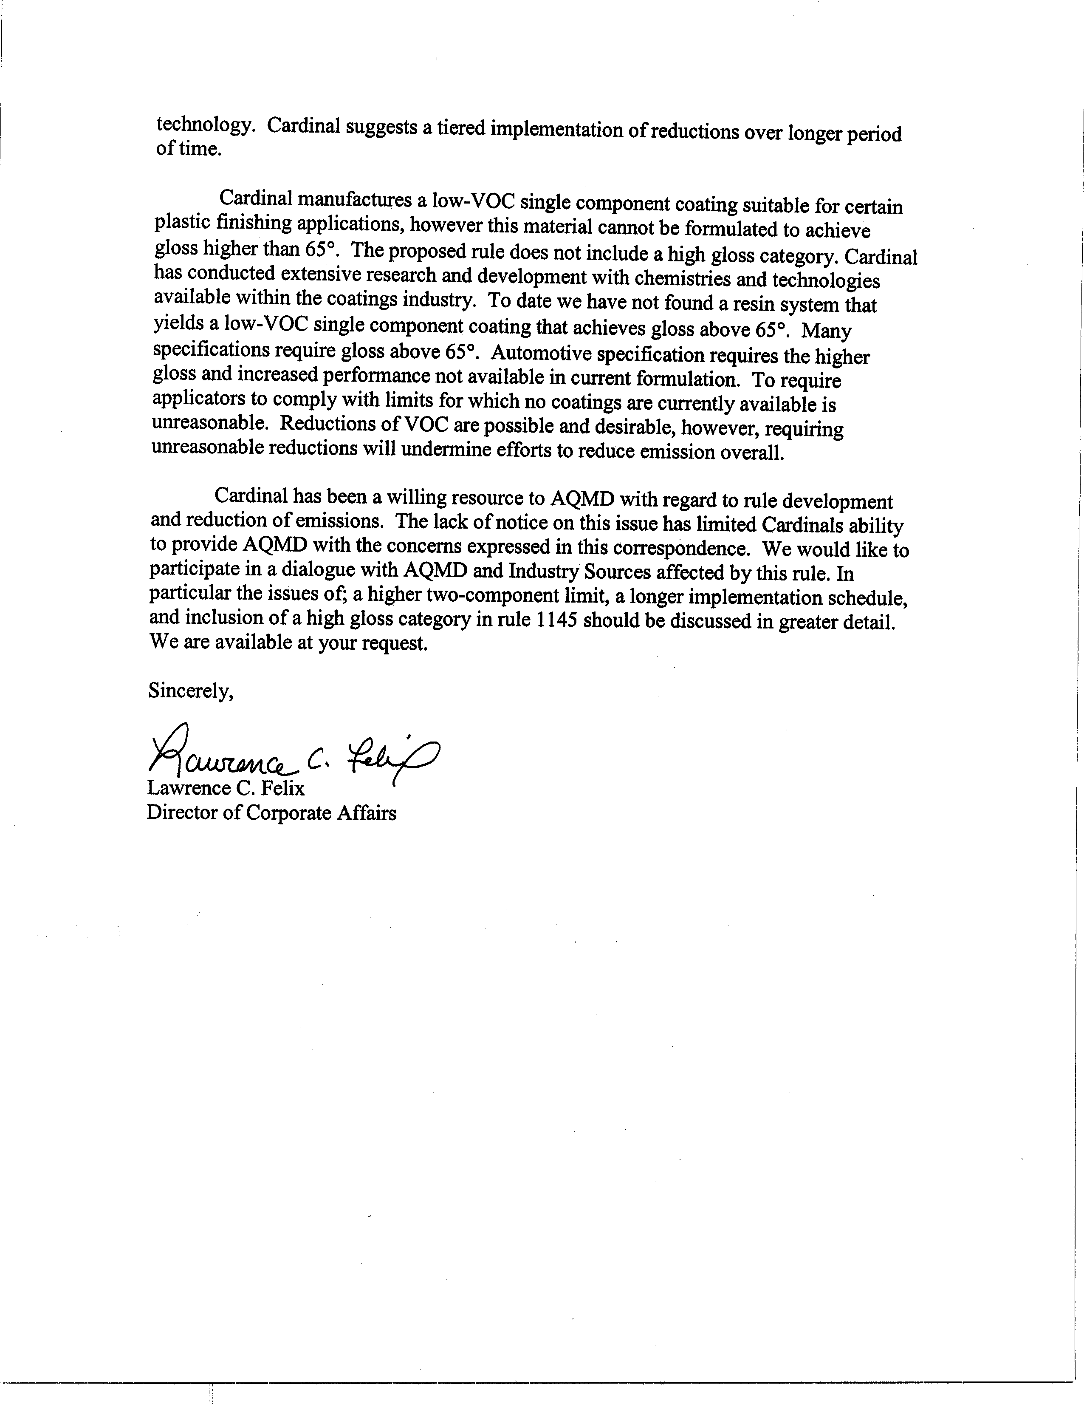
2-3
cont.
2-4
2-5
COMMENT LETTER # 2
FROM CARDINAL INDUSTRIAL FINISHES

Lawrence C. Felix

September 28, 2004
Response to Comment 2-1:
In response to the concern of the “dramatic reduction” for two-component coatings, SCAQMD staff is recommending an interim VOC content limit and an extension of the final compliance date. Two-component general coatings will be required to be formulated at 2.5 pounds of VOC per gallon by January 1, 2006 and will be provided an additional year to comply with a 1.0 pound per gallon VOC content limit. Further, the SCAQMD staff is proposing the addition of a new coating category for extreme performance coatings. As of January 1, 2006 when other two-component coatings are required to be formulated at 2.5 pounds VOC per gallon, extreme performance two-component coatings will be able to maintain the current VOC limit of 3.5 pounds per gallon.
With regards to the high gloss coatings, some may qualify as an extreme performance coating and its associated VOC content limit. However, other high gloss coatings will be required to comply with the established coating categories and their associated VOC content limit. SCAQMD staff has determined, based on product information received from other coating manufacturers, that two-component high gloss coatings which comply with the future VOC content limit of 1.0 pound per gallon are currently available.
Cardinal was contacted by SCAQMD staff. On Tuesday, August 31, 2004, the CEQA team mailed a public notice regarding the availability of the Draft Environmental Assessment, which included the proposed rule amendments and public workshop information, to our Cardinal contact, Vice President Robert Sypowicz. In addition, both the CEQA document and the Notice of Completion were posted on the SCAQMD’s CEQA website, and the public workshop was listed on the calendar page on the SCAQMD’s website.
Response to Comment 2-2:
As noted in Response to Comment 2-1, SCAQMD staff is proposing the addition of a new coating category for extreme performance coatings which should alleviate the commentator’s concern of performance standards with regards to their two-component coatings. Also, SCAQMD staff is recommending an interim VOC content limit for general two-component coatings and an extension of the final compliance date until January 1, 2008 providing a three year implementation schedule.
Response to Comment 2-3:
The SCAQMD staff is accepting the commentator’s suggestion of a tiered implementation schedule for two-component coating as outlined in Response to Comment 2-1.
Response to Comment 2-4:
Please refer to Response to Comment 2-1 regarding high gloss coatings subject to the appropriate coating category in Rule 1145, including the new extreme performance two-component coating category, and its associated VOC content limit.
Response to Comment 2-5:
The SCAQMD appreciates the participation of the affected coating manufacturers. It is in our best interest to involve the affected industry in the rule making process as early as possible to discuss any concerns and work to resolve those concerns so the rule adoption/amendment will be supported at the public hearing. While a public workshop notice might not have been sent to a Cardinal respresentative at your El Monte office, it was not our intention to avoid contacting affected industry. Please refer to Response to Comment 2-1 with regards to an interim two-component coating VOC limit, longer implementation schedule and subjectivity of high gloss coatings.

