south coast air quality management district

FINAL Environmental Assessment for

Proposed Rule 1133 Composting and Related Operations - General Administrative Requirements;
Proposed Rule 1133.1 Chipping and Grinding Activities; and
Proposed Rule 1133.2 Emission Reductions from Co-Composting Operations.

December 2002

Executive Officer
Barry R. Wallerstein, D. Env.
Deputy Executive Officer
Planning, Rule Development, and Area Sources
Elaine Chang, DrPH
Planning and Rules Manager
CEQA and Socioeconomic Analysis
Susan Nakamura

Author: Kathy C. Stevens, Air Quality Specialist, CEQA

Technical Tuyet-Le Pham, Rule Development Staff
Assistance: Ricardo A. Rivera, Air Quality Specialist

Reviewed By: Frances Keeler – Senior Deputy District Counsel
Steve Smith, Ph.D. - Program Supervisor, CEQA
Zorik Pirveysian - Planning and Rules Manager, PM

South coast air quality management district
governing board

CHAIRMAN: WILLIAM A. BURKE, Ed.D.
Speaker of the Assembly Appointee

VICE CHAIR: S. ROY WILSON, Ed.D.
Supervisor, Fourth District
Riverside County Representative

MEMBERS:

FRED AGUIAR
Supervisor, Fourth District
San Bernardino County Representative

MICHAEL D. ANTONOVICH
Supervisor, Fifth District
Los Angeles County Representative

HAL BERNSON
Councilmember, City of Los Angeles
Cities Representative, Los Angeles County, Western Region

JANE W. CARNEY
Senate Rules Committee Appointee

WILLIAM S. CRAYCRAFT
Councilmember, City of Mission Viejo
Cities Representative, Orange County

BEATRICE J.S. LAPISTO-KIRTLEY
Councilmember, City of Bradbury
Cities Representative, Los Angeles County, Eastern Region

Ronald O. Loveridge
Mayor, City of Riverside
Cities Representative, Riverside County

LEONARD PAULITZ
Mayor Pro Tem, City of Montclair
Cities Representative, San Bernardino County

JAMES W. SILVA
Supervisor, Second District
Orange County Representative

CYNTHIA VERDUGO-PERALTA
Governor's Appointee

EXECUTIVE OFFICER:

BARRY R. WALLERSTEIN, D.Env
Table of contents

CHAPTER 1 - PROJECT OVERVIEW

Introduction 1-1
Legislative Authority 1-1
California Environmental Quality Act 1-2
Project Location 1-2
Project Objective 1-3
Project Background 1-4
Composting and Related Operations - General Terms 1-4
Project Description 1-6
Emissions Inventory and Emissions Reductions 1-8

CHAPTER 2 - ENVIRONMENTAL CHECKLIST

Introduction 2-1
General Information 2-1
Potentially Significant Impact Areas 2-2
Determination 2-2
General Effects of the Proposed Project 2-3
Additional Information Related to New Co-Composting Facilities 2-4
Environmental Checklist and Discussion 2-5

APPENDIX A - DRAFT RULE LANGUAGE

PR 1133 Composting and Related Operations - General Administrative
Requirements.
PR 1133.1 Chipping and Grinding Activities.
PR 1133.2 Emission Reductions from Co-composting Operations.

APPENDIX B - CALCULATIONS AND ASSUMPTIONS FOR DETERMINING CONSTRUCTION EMISSIONS ASSOCIATED WITH PR 1133.2

APPENDIX C – COMMENTS AND RESPONSES ON THE DRAFT EA

PREFACE

The Draft Environmental Assessment (EA) for the proposed rules 1133 – Composting and Related Operations; 1133.1 – Chipping and Grinding Activities; and 1133.2 – Emission Reductions from Co-Composting Operations was circulated for a 30-day public review and comment period from October 16, 2002 to November 14, 2002. Six public comment letters were received. Responses to the comment letters, as well as the comment letters, are included in this Final EA. Deletions and additions to the test of the Final EA are denoted using strikeout and underline, respectively. Based upon input received on the proposed project, modifications have been made to the proposed rules as necessary. All modifications have been evaluated to determine how they may affect the environmental analysis previously prepared for the proposed project. Based upon review of the modifications, the SCAQMD has concluded that none of the modifications represent conditions that would require recirculation of the Draft EA pursuant to CEQA Guidelines §15073.5 (see in particular §15073.5(c)(2)).

C H A P T E R 1 - P R O J E C T O V E R V I E W

Introduction
Legislative Authority
California Environmental Quality Act
Project Location
Project Objective
Project Background
Composting and Related Operations - General Terms
Project Description
Emissions Inventory and Emissions Reductions

introduction
The South Coast Air Quality Management District (referred to as the district) has one of the worst air quality problems in the nation. Though there have been significant improvements in air quality over the last two decades, some air quality standards are still exceeded relatively frequently and by a wide margin.
The 1994 Air Quality Management Plan (AQMP), the 1997 AQMP and the 1999 Amendments to the 1997 Ozone State Implementation Plan (SIP) for the district included Control Measure WST - 02 - Emission Reductions from Composting. As described in WST-02, the control measure was to be implemented in two phases. The first phase was to better quantify emissions from composting activities. The second phase, to be implemented if emissions from composting and related operations continued to be a substantial emission source, was to identify control options to reduce emissions from composting activities that were technically feasible and cost-effective.
The proposed project [Proposed Rule (PR) 1133, Composting and Related Operations - General Administrative Requirements; Proposed Rule 1133.1 - Chipping and Grinding Activities; and Proposed Rule 1133.2 - Emission Reductions from Co-composting Operations] would implement, control measure WST-02-Emission Reductions from Composting. The objective of PR 1133 is to establish a district-wide database of facilities who conduct composting and related operations. Currently, there are approximately 75 facilities that would be subject to the requirements of PR 1133. The air quality objective of PR 1133.1 is generally to establish maximum holding and processing time requirements for greenwaste chipping and grinding activities in order to minimize ammonia (NH3) and volatile organic compounds (VOC) emissions from inadvertent decomposition associated with stockpiling. There are approximately 47 chipping and grinding operations in the district that would be subject to the requirements of PR 1133.1. The air quality objective of PR 1133.2 is to reduce NH3 and VOC emissions from new and existing co-composting operations. There are approximately 12 existing co-composting facilities in the district that would be subject to the requirements of PR 1133.2. (Based on the new definition of co-composting operations, nine existing facilities are expected to be regulated by PR1133.2.)

Although there is currently no source specific rule regulating emissions from composting operations, operators of existing composting and related facilities located within the SCAQMD’s jurisdiction are subject to the following rules as applicable: (1) Rule 401 - Visible Emissions; (2) Rule 402 – Nuisance; and (3) Rule 403 - Fugitive Dust. For this reason, PR 1133, PR 1133.1 and PR 1133.2 are being promulgated to address source specific emissions from composting and related operations to implement control measure WST-02 from the AQMP as amended in 1999.
Throughout this document, the reference to “proposed project” or “PR 1133/PR 1133.1/PR 1133.2” are one in the same and used interchangeably.
LEGISLATIVE AUTHORITY
The California Legislature created the South Coast Air Quality Management District (SCAQMD) in 1977 as the agency responsible for developing and enforcing air pollution control rules and regulations in the South Coast Air Basin, and portions of the Salton Sea Air Basin and the Mojave Desert Air Basin (collectively known as the “district”). By statute, the SCAQMD is required to adopt an AQMP demonstrating compliance with all federal and state ambient air quality standards for the district. The SCAQMD must then adopt rules and regulations that carry out the AQMP. PR 1133, PR 1133.1 and PR 1133.2 will implement AQMP control measure WST-02. Reducing emissions from these sources will help achieve and maintain, state and federal ambient air quality standards in the district.
california environmental quality act (CEQA)

PR 1133, PR 1133.1 and PR 1133.2 are a “project” as defined by CEQA Guidelines §15378. SCAQMD is the lead agency for the project and has prepared this draft Environmental Assessment (EA) with no significant adverse impacts pursuant to its certified regulatory program. California Public Resources Code §21080.5 allows a public agency to prepare a plan or other written document in lieu of an environmental impact report once the Secretary of the Resources Agency has certified its regulatory program. SCAQMD's regulatory program was certified by the Secretary of the Resources Agency on March 1, 1989, and codified as SCAQMD Rule 110. Pursuant to Rule 110, SCAQMD prepared this Final draft EA to evaluate potential significant adverse environmental impacts associated with implementing PR 1133, PR 1133.1 and PR 1133.2.
An environmental impact is defined as an impact to the physical conditions which exist within the area which would be affected by a proposed project, including land, air, water, minerals, flora, fauna, noise, or objects of historic significance. CEQA and Rule 110 require that potential significant adverse environmental impacts of proposed projects be evaluated, and that feasible methods to reduce or avoid these significant adverse environmental impacts be implemented. To fulfill the purpose and intent of CEQA, the SCAQMD has prepared this Final draft EA to address the potential significant adverse environmental impacts associated with implementing PR 1133, PR 1133.1 and PR 1133.2. The Final draft EA is a public disclosure document intended to: (a) provide the lead agency, responsible agencies, decision makers and the general public with information on the environmental effects of the proposed project; and, (b) be used as a tool by decision makers to facilitate decision making on the proposed project.
SCAQMD's review of the proposed project shows that the project will not have significant adverse effects on the environment. Therefore, no alternatives or mitigation measures are required to be included in this draft EA to avoid or reduce any significant effects on the environment (CEQA Guidelines §15252(b)(2)). The environmental checklist and discussion in Chapter 2 supports the conclusion of no significant adverse environmental impacts.
All comments received during the public comment period on the analysis presented in the this draft EA, have been responded to and are will be responded to and included in Appendix C of the Final EA. Prior to making a decision on the three proposed rules, the SCAQMD Governing Board must review and certify the Final EA as providing adequate information on the potential adverse environmental impacts of PR 1133, PR 1133.1 and PR 1133.2.

project location
PR 1133 would affect all composting and related operations within the district; PR 1133.1 would affect all chipping and grinding activities within the district, unless specifically exempt; and PR 1133.2 would affect all new and existing co-composting operations within the district. The SCAQMD has jurisdiction over an area of 10,743 square miles, consisting of the four-county South Coast Air Basin (Basin), the Riverside County portions of the Salton Sea Air Basin (SSAB) and Mojave Desert Air Basin (MDAB). The Basin, which is a subarea of the SCAQMD’s jurisdiction, is bounded by the Pacific Ocean to the west and the San Gabriel, San Bernardino, and San Jacinto Mountains to the north and east. The Basin includes all of Orange County and the non-desert portions of Los Angeles, Riverside, and San Bernardino counties. The San Gabriel Mountains bound the Los Angeles County portion of MDAB (known as North County or Antelope Valley) to the south and west, the Los Angeles/Kern county border to the north, and the Los Angeles/San Bernardino county border to the east. The Riverside County portion of the SSAB is bounded by the San Jacinto Mountains in the west and spans eastward up to the Palo Verde Valley. The federal nonattainment area (known as the Coachella Valley Planning Area) is a subregion of both Riverside County and the SSAB that is bounded by the San Jacinto Mountains to the west and the eastern boundary of the Coachella Valley to the east (Figure 1-1).

Figure 1-1
South Coast Air Quality Management District

PROJECT OBJECTIVE
PR 1133, PR 1133.1 and PR 1133.2 are being proposed to implement control measure WST-02-Emission Reductions from Composting, as presented in the 1994 AQMP, 1997 AQMP, and the 1999 Amendments to the 1997 Ozone SIP.
PR 1133 sets forth administrative requirements for all new and existing composting and related operations. The objective of this proposed rule is to create an informational database through a one-time registration process, with annual updates. This database will include information such as the facility name and address, type of operation, processing protocols, feedstock and end products, amount of material entering and exiting the operation, and published tipping fee schedule for the preceding calendar year by feedstock.
PR 1133.1 generally establishes maximum holding and processing time requirements for greenwaste chipping and grinding activities in order to minimize NH3 and VOC emissions from inadvertent decomposition associated with stockpiling.
PR 1133.2 affects all new and existing co-composting facilities. The requirements are specific to the active and curing phases of these operations. The objective of this proposed rule is to reduce VOC and NH3 emissions from co-composting operations.
PROJECT BACKGROUND
The SCAQMD began the rule development process for PR 1133 in 2000 to satisfy the control measure requirements pursuant to the 1994 AQMP, 1997 AQMP, and the 1999 Amendments to the 1997 Ozone SIP. On August 22, 2001, the SCAQMD presented a draft rule to the PR 1133 working group for review and comment. An initial study/notice of preparation (IS/NOP) was prepared pursuant to CEQA, and the SCAQMD's certified regulatory program (Rule 110). Based on the project description at that time (e.g. complete enclosure of all composting and related facilities), the IS/NOP concluded that a further evaluation of air quality, solid waste, energy and transportation impacts from implementing the proposed project was necessary, and that a detailed environmental assessment would be prepared. The IS/NOP document was circulated for a 30-day public comment period between October 2, 2001 and October 31, 2001, and extensive comments were received.
The Technology Assessment for PR 1133, which included emissions characterization, control options, cost effectiveness, and recommendations for further regulatory development, was submitted to the SCAQMD Governing Board on April 5, 2002. The technology assessment satisfied the AQMP requirements. The SCAQMD Governing Board, at the PR 1133 pre-hearing on April 5, 2002, directed SCAQMD staff to reevaluate its approach to the implementation of WST-02. The SCAQMD Governing Board directed the rule development team to separate the various composting and related activities into separate rules and establish control measures specific to these various operations. As a result, three separate proposed rules were developed. The IS/NOP dated October 2001 and circulated for public comment between October 2, 2001 and October 31, 2001 was no longer consistent with the current approach to implementing WST-02. Consequently, the SCAQMD did not respond specifically to the comments submitted on the IS/NOP prepared for the August 10, 2001 version of PR 1133 and the IS/NOP was withdrawn.
Consistent with the Governing Board's direction, separate rule proposals were developed for the various composting activities, and evaluated in this EA. These currently proposed rules are substantially different than the original PR 1133 proposal dated August 2001.
The focus of the this draft EA was is to evaluate potential significant environmental impacts as a result of implementing the proposed project, PRs 1133, 1133.1 and 1133.2. Chapter 2 includes the discussion supporting the conclusion in the of this draft EA that the proposed project will not cause significant environmental impacts.

COMPOSTING AND RELATED OPERATIONS - GENERAL TERMS
The following paragraphs are intended to provide a basic understanding of the terms associated with composting and related activities.
What is Composting?
Composting is a biological aerobic process, which means it occurs in the presence of oxygen. Bacteria, fungi, and other microorganisms are essential to this process, which obtain energy from carbon sources being composted. Although nitrogen is required for the population growth of these microorganisms, excess nitrogen can generate ammonia and other odors. In addition, heat is generated as the microorganisms decompose the waste. The characteristics of the end compost material can vary.
What are Chipping and Grinding activities?
Chipping and grinding is an activity that mechanically reduces the size of various materials (e.g. greenwaste) according to the purpose for which the end product will be used. Chippers and grinders are used to shred the material, then the material is screened and separated to isolate and produce a certain size end product. Typical end products may be used for alternative daily cover (ADC) at landfills, soil amendments and slope stabilization materials, fuel in waste-to-energy facilities, nursery filler materials and mulch, raw material for greenwaste composting, or bulking agents for co-composting operations. Chipping and grinding activities can be stand-alone operations or part of another composting-related facility.
What is Co-Composting?
Co-composting is a category within composting operations where two or more types of feedstock are used in the process (e.g. biosolids [processed wastewater sludge], food waste, and/or animal manure) and mixed with a bulking agent such as greenwaste. Feedstocks are typically generated by wastewater treatment plants, dairies, stables, produce markets and restaurants.
What is Forced Aeration?
Forced aeration is a method of using a suction air system to pull air through a compost pile (negative pressure) or a blowing air system to push air through a compost pile (positive pressure). The emissions collected from the compost pile via negative pressure can be collected and vented to equipment designed to destroy the pollutant or odorous emissions. The emissions created by positive pressure are typically released into the atmosphere, and as such are difficult to capture. They can only be collected if the compost piles are enclosed or within a building.
What is aerated static pile and in-vessel composting?
ASP is a technology where forced aeration is used to control oxygen, temperature and moisture conditions in an open compost pile. Feedstock is piled over a base of porous materials which contain perforated aeration pipes that are connected to an air system that pulls or pushes air through the pile. In-vessel is a technology where forced aeration and mechanical turning are used to speed up the composting process in a closed environment. Feedstock can be confined within a building, a container, or a vessel, and the exhaust from the compost process is vented to emission control equipment.
What is a biofilter?
A biofilter is a type of emissions control system that is capable of biologically degrading contaminated emissions, such as NH3 and VOC. Biofilters use microorganisms who live in the biofilm (a thin layer of moisture surrounding the particles that make up the media) to adsorb and biologically degrade contaminated emissions and odors. For a biofilter to operate efficiently, a media must have a good adsorption capacity and good resistance to compaction, be able to provide a suitable environment for microorganism growth and reproduction, and have high porosity for minimal back pressure. Typically, biofilter media is made up of wood waste and compost, providing an air-filled porosity between 40% and 60% and a pH between six and eight.

PROJECT DESCRIPTION
The specific elements of PRs 1133, 1133.1 and 1133.2 are summarized below. The proposed rules are included in Appendix A. The changes to the project description summaries below, denoted by strikeout and underline, are administrative in nature and not expected to change the analysis of environmental impacts contained in this document.
PR 1133 includes the following components:
- Applies to owners or operators of composting and chipping and grinding facilities, unless otherwise exempt;

- Includes definitions of terms used in the proposed rule;

- Following adoption of the proposed rule, operators of composting, and chipping and grinding activities shall submit registration information, with annual updates thereafter. Registration information shall include: facility name and address, legal owner, facility contact person, number of employees, feedstock and products produced, applicable permits with other agencies, design capacity and throughput, facility process description, and a published tipping fee schedule for the preceding calendar year by feedstock;

- The initial registration compliance date for this proposed rule is July February 1, 2003 for existing facilities and prior to start of operation for new facilities. The registration update compliance date is no later than July February 1, 2004, and every year thereafter;

- The operator of the composting or chipping and grinding facility subject to the registration requirement will be subject to a one-time fee equivalent to the plan submittal fees in accordance with SCAQMD Rule 306; and

- The following types of facilities and operations are exempt from the requirements of PR 1133:
- portable chipping and grinding,
- community composting,
- agricultural composting,
- nursery composting,
- recreational facilities composting,
- backyard composting, and
- woodwaste chipping and grinding facilities.

PR 1133.1 includes the following components:

- Applies specifically to operators of chipping and grinding activities, unless otherwise exempt;

- Includes definitions of terms used in the proposed rule;

- PR 1133.1 generally establishes maximum holding and processing time requirements for greenwaste chipping and grinding activities in order to minimize NH3 and VOC emissions from inadvertent decomposition associated with stockpiling. Following adoption of the proposed rule, operators of chipping and grinding facilities shall be required to:

- Comply with SCAQMD Rule 403 - Fugitive Dust;

- Within two calendar three days of receipt (excluding federal and state official holidays), remove curbside greenwaste and/or food waste from the site or use for on-site application;

- Within three calendar seven days of receipt (excluding federal and state official holidays), remove non-curbside greenwaste from the site, or use for on-site application;

- Within 14 calendar days of receipt chip and grind, use onsite, or remove non-curbside greeenwaste;

- Within seven calendar days of receipt chip and grind, use onsite, or remove mixed greenwaste;

- Within three calendar days of being chipped and ground, remove chipped and ground curbside greenwaste from the site, or use chipped and ground greenwaste onsite.

- Maintain records on-site for two years (e.g. facility's SCAQMD registration and annual update information; date, type and amount of greenwaste and/or foodwaste received; and date, type and amount of greenwaste and/or foodwaste removed from the site and the location where it was taken).

- Alternative Compliance - In lieu of the holding and processing time requirements, the operator of a chipping and grinding activity shall remove from the site or use any curbside greenwaste and/or foodwaste for onsite application within seven days (excluding federal and state official holidays) of receiving such greenwaste and/or foodwaste provided the operator notifies the SCAQMD in accordance with the rule, and maintains at all times, an average temperature below 122°F at each curbside greenwaste and/or foodwaste pile in accordance with the temperature measurement procedures in subdivision (f);

- The effective compliance date is July 1, 2003; "upon rule adoption;"

- Exemptions:

- Chipping and grinding activities of greenwaste derived from the site and used onsite;
- Portable chipping and grinding, agricultural chipping and grinding, landclearing chipping and grinding, woodwaste chipping and grinding, and palm chipping and grinding; and
- Chipped and ground curbside greenwaste, provided the moisture content is less than 30% and the moisture content measurements are maintained onsite.

PR 1133.2 includes the following components:

- Applies to all new and existing co-composting facilities;

- Includes definitions of terms used in the proposed rule;

- Following adoption of the proposed rule, the following provisions apply:

New Facilities

To comply with PR 1133.2, new facilities will be required to choose one of the following compliance options:

- Pursuant to subdivision (d)(1): Conduct active composting operations within the confines of an enclosure and conduct curing operations using an aeration system. Exhaust emissions from the enclosure and aeration system shall be collected and vented to an emissions control system designed with a control device efficiency equal to or greater than 80 percent (by weight) for VOC, and 80 75 percent (by weight) for NH3.

OR,

- Pursuant to subdivision (h) and: In lieu of complying with the requirements of paragraph (d)(1), operators of new co-composting facilities may submit a compliance plan that demonstrates an overall emission reduction of 80 percent, by weight, for both VOC and NH3 emissions from the baseline emission factors. employ any composting method designed and operated to achieve equivalent emission reductions as outlined in paragraph (d)(1), provided the operator submits a Compliance Protocol in accordance with paragraph (e)(3).

Existing Facilities

To comply with PR 1133.2, existing facilities must perform the following:

- Employ a composting method designed to achieve an overall control efficiency equal to or greater than 70 percent (by weight) for VOC, and 65 percent (by weight) for NH3 emissions.

- Submit a Compliance Protocol in accordance with subdivision (e) at least six months prior to the effective date of compliance.

- The Compliance Protocol shall demonstrate that the selected composting method will reduce VOC and NH3 emissions by at least 70 and 65 percent, by weight, respectively, when compared with the SCAQMD's baseline emission factors, or operation-specific baseline emission factors.

- Operators of existing co-composting facilities shall submit a compliance plan that demonstrates an overall emission reduction of 70 percent, by weight, for both VOC and NH3 emissions from the baseline emission factors.

- Compliance schedule:

- Upon start-up rule adoption for new co-composting operations.
- January 1, 2007 2006, for existing co-composting operations with a facility design capacity of 100,000 tons of throughput or more a year.
- January 1, 2008 2007, for existing co-composting operations with a facility design capacity greater than or equal to 10,000, but less than 100,000 tons of throughput per year.
- January 1, 2009, for existing co-composting operations with a facility design capacity less than 10,000 tons of throughput per year.

The Executive Officer shall extend for up to three years the compliance date for an existing co-composting operation which, at the time of rule adoption, has less than three years remaining under a non-renewable conditional use permit beyond its effective compliance date. By June 1, 2003, the operator of such an operation must submit to the Executive Officer a copy of the conditional use permit and a letter from the responsible agency verifying that the permit is non-renewable and the date when the permit is expired.

- Exemptions:

- Agricultural composting operations, greenwaste composting operations, woodwaste composting operations, and co-composting operations with a design capacity of less than 1,000 tons of throughput per year.
- New and existing co-composting operations that (a) conduct co-composting operations using an aeration system that is vented to an emission control device with a control efficiency of 80 percent, by weight, for both VOC and NH3 emissions; (b) are owned and operated by a municipality which composts waste generated within the jurisdiction of the municipality; and (c) process less than 5,000 tons of biosolids or manure per year, combined.

EMISSIONS INVENTORY AND EMISSIONS REDUCTIONS

No emissions inventory was performed for PR 1133 based on the fact that this rule is administrative in nature and intended to create an informational database through a registration process.

No emissions inventory was compiled for PR 1133.1. This proposed rule generally establishes maximum holding and processing time requirements for greenwaste chipping and grinding activities in order to minimize NH3 and VOC emissions from inadvertent decomposition associated with stockpiling.

The emissions inventory for PR 1133.2 was developed based on 2001 annual throughput data from a number of facilities identified as being affected by the proposed rule and SCAQMD baseline emission factors. The current emissions inventory for affected facilities is 2.2 1.7 tons per day for VOC and 3.7 2.7 tons per day for NH3. This emissions inventory was estimated by multiplying the annual throughput of the number of facilities identified as being affected by the proposed rule, by AQMD baseline emission factors. For example:

yearly throughput (tons/yr) X emission factor (lbs/ton) = yearly emissions (lbs/year).

The VOC and NH3 baseline emission factors were derived from the results of SCAQMD source tests conducted in 1995 and 1996 for three windrow co-composting facilities. The baseline emission factor for VOC is 1.78 pounds per ton (lbs/ton) of product mix and the baseline emission factor for NH3 is 2.93 lbs/ton of product mix. (Refer to the Technology Assessment for PR 1133 dated March 22, 2002 for a detailed discussion of emission factor development.)

PR 1133.2 requires existing facilities to reduce VOC emissions by 70 percent and NH3 emissions by 70 65 percent. Based on this requirement, the estimated reductions and remaining emissions are outlined in Table 1-1 by compliance year. It should be noted that the emission inventory and reduction potential in Table 1 were originally based on 12 existing facilities. However, based on the new definition of co-composting operations, nine existing co-composting facilities would be regulated by PR 1133.2. The emission inventory and reductions associated with these facilities are also provided in the Staff Report for the proposed project.

TABLE 1-1
ESTIMATED EMISSION REDUCTIONS AND REMAINING EMISSIONS
FROM IMPLEMENTING THE PROPOSED PROJECT

YEAR
(tons/day)
 | 2006  2007 | 2007  2008 | 2009 | TOTAL  (tons/day)ª
NH3 Emission Reductions | 2.13 1.73 | 0.21 0.17 | 0.05 0.02 | 2.39 1.9
VOC Emission Reductions | 1.39 1.05 | 0.13 0.10 | 0.03 0.02 | 1.55 1.2
ª Numbers may not add up exactly due to rounding

C H A P T E R 2 - E N V I R O N M E N T A L C H E C K L I S T

Introduction
General Information
Potentially Significant Impact Areas
Determination
General Effects of the Proposed Project
Additional Information Related to New Co-Composting Facilities
Environmental Checklist and Discussion

INTRODUCTION
The environmental checklist provides a standard evaluation tool to identify a project's potential adverse environmental impacts. The following environmental checklist has been used as an evaluation tool to identify and discuss potential significant adverse environmental impacts associated with the implementation of PR 1133, PR 1133.1 and PR 1133.2.

GENERAL INFORMATION
Project Title: | PR 1133 - Composting and Related Operations - General Administrative Requirements; PR 1133.1 - Chipping and Grinding Activities; and PR 1133.2 - Emission Reductions from Co-composting Operations.
Lead Agency Name: | South Coast Air Quality Management District
Lead Agency Address: | 21865 E. Copley Drive  Diamond Bar, CA 91765-4182
CEQA Contact Person: | Ms. Kathy C. Stevens (909) 396-3439 (kstevens@aqmd.gov)
Rule Contact Person(s): | Ms. Tuyet-Le Pham (909) 396-3299 (tpham@aqmd.gov)  Mr. Ricardo Rivera (909) 396-3069 (rrivera@aqmd.gov)
Project Sponsor: | South Coast Air Quality Management District  21865 E. Copley Drive  Diamond Bar, CA 91765-4182
Project Description: | PR 1133 requires new and existing composting and related operations to complete an initial registration process, with annual updates thereafter. PR 1133.1 generally establishes maximum holding and processing time requirements for greenwaste chipping and grinding activities in order to minimize NH3 and VOC emissions from inadvertent decomposition associated with stockpiling. PR 1133.2 sets forth requirements for enclosure and aeration systems to reduce NH3 and VOC emissions from all new and existing co-composting facilities.
General Plan Designation and Zoning: | Not Applicable.
Surrounding Land Uses and Setting: | Not Applicable.
Other Public Agencies Whose Approval is Required: | None.

POTENTIALLY SIGNIFICANT IMPACT AREAS
The following environmental impact areas have been evaluated to determine their potential to be affected by the proposed project. As indicated by the checklist on the following pages, environmental topics marked with a “” may be adversely affected. An explanation relative to the determination of impacts can be found following the checklist for each area.
◻ | Aesthetics | ◻ | Geology and Soils | ◻ | Population and Housing
◻ | Agricultural Resources | ◻ | Hazards and Hazardous Materials | ◻ | Public Services
◻ | Air Quality | ◻ | Hydrology and Water Quality | ◻ | Recreation
◻ | Biological Resources | ◻ | Land Use and Planning | ◻ | Solid/Hazardous Waste
◻ | Cultural Resources | ◻ | Mineral Resources | ◻ | Transportation./Traffic
◻ | Energy | ◻ | Noise | ◻ | Mandatory Findings
DETERMINATION
On the basis of this initial evaluation:
☑ | I find that the proposed project, in accordance with findings made pursuant to CEQA Guidelines (California Code of Regulations, Title 14 §15252), COULD NOT have a significant effect on the environment, and that an ENVIRONMENTAL ASSESSMENT with no significant impacts has been prepared.
◻ | I find that although the proposed project could have a significant effect on the environment, there will NOT be significant effects in this case because mitigation measures have been incorporated into the project. an ENVIRONMENTAL ASSESSMENT with no significant impacts has been prepared.
◻ | I find that the project MAY have a significant effect(s) on the environment, and an ENVIRONMENTAL ASSESSMENT will be prepared to present a further evaluation of potential significant adverse environmental impacts.
Date: October 15, 2002 Signature: 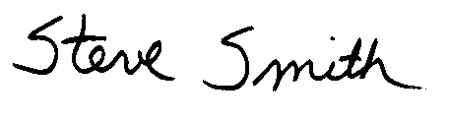
Steve Smith, Ph.D.
Program Supervisor, CEQA
Planning, Rule Development and Area Sources
GENERAL EFFECTS OF THE PROPOSED PROJECT

PR 1133

PR 1133 sets forth administrative requirements for all composting and related operations. The administrative requirements in PR 1133 would create an informational database of composting and related activities through an initial registration process, with annual updates thereafter.

CEQA Guidelines §15360 defines the "environment" as the physical conditions which exist within the area which will be affected by a proposed project including land, air, water, minerals, flora, fauna, ambient noise, and objects of historic or aesthetic significance. PR 1133 requires no construction or other action which would affect the physical environment. PR 1133 has been evaluated relative to the environmental topics identified in the environmental checklist below, e.g. aesthetics, agricultural resources, air quality, biological resources, etc. Because PR 1133 only imposes administrative requirements as part of a registration process, it can be seen with certainty that it will not create significant adverse impacts to any environmental topics identified in the environmental checklist. As a result, PR 1133 will not be evaluated or discussed further in any of the following individual environmental topic discussions.

PR 1133.1

PR 1133.1 generally establishes maximum holding and processing time requirements for greenwaste chipping and grinding activities in order to minimize NH3 and VOC emissions from inadvertent decomposition associated with stockpiling. PR 1133.1 outlines requirements for existing chipping and grinding activities located predominantly in light industrial or commercial areas, and will not, by itself cause the development of new chipping and grinding operations.

PR 1133.1 has been evaluated relative to the environmental topics identified in the environmental checklist below, e.g., aesthetics, agricultural resources, biological resources, etc. In general, implementing PR 1133.1 is not expected to adversely affect the existing environment for most of the environmental topics identified in the environmental checklist because its primary effect is to limit the holding and processing time for chipping and grinding operations. As a result, any environmental effects from implementing PR 1133.1 will only be discussed under the environmental topic that may be affected. If PR 1133.1 is not discussed under an environmental topic, it is not expected to adversely affect that environmental area.

PR 1133.2

Although PR 1133.2 applies to both new and existing co-composting operations, as discussed in the following subsection, this EA evaluates potential significant adverse environmental impacts associated with the implementation of this rule at existing facilities only. Based on a "worst-case" scenario; however, it is assumed that in order to meet the control efficiency requirements of the rule, the operators of the 12 known existing facilities that would be subject to the control requirements in PR 1133.2 will choose to enclose the active portions of their composting operations and install aeration systems. Further, it is assumed that operators of affected facilities will install control equipment based on the size of the facility and the date by which they must comply.

Operators of existing facilities are required to employ a composting method designed to achieve an overall control efficiency equal to or greater than 70 percent (by weight) for VOC, and 70 65 percent (by weight) for NH3 emissions; AND, submit a Compliance Protocol Plan in accordance with subdivision (e) at least six months prior to the effective date of compliance.

ADDITIONAL INFORMATION RELATED TO NEW CO-COMPOSTING FACILITIES
New co-composting facilities to be located within the district and which will include either an enclosure, an emission control device, or any equipment that performs an emission collection function, will be subject to the provisions of PR 1133.2 and SCAQMD's existing permitting process. As part of this permit process, these facilities would be subject to SCAQMD’s Regulation XIII, New Source Review (NSR), which includes Best Available Control Technology (BACT).

Pursuant to SCAQMD Rule 1303(a)(2), BACT for sources located at major polluting facilities shall be at least as stringent as Lowest Achievable Emissions Rate (LAER) as defined in the federal Clean Air Act §171(3) [42 U.S.C. Section 7501(3) ]. A major source is defined based on a facility's total emissions and the attainment status of the area in which it is located. The SCAQMD boundaries encompass three areas (Basin, SSAB and MDAB) and, as a result a major source may be defined differently depending on its location (Table 2-1).

Pursuant to SCAQMD Rule 1303(a)(3), BACT for sources not located at major polluting facilities shall be as specified in the BACT Guidelines for such source categories, unless the BACT specified in the guideline is less stringent than required by state law in which case BACT shall be as defined in state law considering economic and technical feasibility.

As a result, PR 1133.2 will not impose any additional control requirements on new co-composting operations defined as major polluting sources. A minor facility would be a co-composting operation that emits less than the amount of emissions identified in Table 2-1.

TABLE 2-1
MAJOR POLLUTING FACILITIES DEFINED
(tons per year)

LOCATION | POLLUTANT
LOCATION | VOC | NOx | SOx | PM10 | CO
Basin | 10 | 10 | 100 | 70 | 50
Riverside County, SSAB | 25 | 25 | 100 | 70 | 100
Riverside County, MDAB | 100 | 100 | 100 | 100 | 100

Based on the preceding information, the analysis of potential significant adverse environmental impacts from implementing PR 1133.2 in this EA focuses on these impacts from existing facilities only. To evaluate a "worst-case" scenario; however, it is assumed that operators of existing facilities will choose to comply by enclosing the active portion of their operations and installing aeration systems in order to meet the control efficiency requirements of the proposed rule. Siting new co-composting facilities is governed by local jurisdictions and is not within the purview jurisdiction of the SCAQMD. The local jurisdiction sets land use guidelines and zoning standards regarding new development, and will approve or deny applications for building new facilities. This land use siting process would most likely involve the preparation of a project-specific CEQA document which would thoroughly evaluate the precise impacts associated with the development of a new co-composting facility in a particular location.

ENVIRONMENTAL CHECKLIST AND DISCUSSION

 | Potentially Significant Impact | Less Than Significant Impact | No  Impact
I. AESTHETICS. Would the project:

- Have a substantial adverse effect on a scenic vista? | ◻ | ◻ | ☑
- Substantially damage scenic resources, including, but not limited to, trees, rock outcroppings, and historic buildings within a state scenic highway? | ◻ | ◻ | ☑
- Substantially degrade the existing visual character or quality of the site and its surroundings? | ◻ | ◻ | ☑
d) Create a new source of substantial light or glare that would adversely affect day or nighttime views in the area? | ◻ | ◻ | ☑

- Aesthetics – Impact Discussion

a) - d) Any site modifications performed in order to comply with the proposed project will be conducted within the boundaries of the existing facility. Typically, co-composting facilities or chipping and grinding operations are located within predominantly light industrial or commercial areas. These areas are generally void of scenic resources. The visual character of the area is expected to remain the same and is not expected to be degraded due to onsite facility modifications.

Existing affected facilities would most likely be located in appropriate land use and zoning areas that are not usually located in residential communities, so any new light sources, if any, would not be noticeable to residents. PR 1133.2 does not require co-composting operations to occur at night, so complying with the proposed rule is not expected to require additional lighting. Further, constructing a facility which encloses the active phase of co-composting operations may improve the visual character of the area by keeping the activities out of open view, improving visibility, and controlling odorous emissions from being released offsite.

Based upon the above considerations, significant adverse aesthetic impacts are not expected to occur from implementing PR 1133, PR 1133.1 and PR 1133.2, and will not be analyzed further.

 | Potentially Significant Impact | Less Than Significant Impact | No  Impact
II. AGRICULTURE RESOURCES. Would the project:

a) Convert Prime Farmland, Unique Farmland, or Farmland of Statewide Importance (Farmland), as shown on the maps prepared pursuant to the Farmland mapping and Monitoring Program of the California Resources Agency, to non- agricultural use? | ◻ | ◻ | ☑
b) Conflict with existing zoning for agricultural use, or a Williamson Act contract? | ◻ | ◻ | ☑
c) Involve other changes in the existing environment which, due to their location or nature, could result in conversion of Farmland, to non-agricultural use? | ◻ | ◻ | ☑

- Agriculture Resources – Impact Discussion

a) - c) PR 1133.1 affects chipping and grinding activities at existing facilities and PR 1133.2 affects existing co-composting facilities. The proposed project is intended to reduce VOC and NH3 emissions from co-composting and minimize VOC and NH3 emissions from inadvertent decomposition associated with stockpiling at chipping and grinding facilities. Any operational modifications or site changes initiated to comply with PR 1133.1 or PR 1133.2 will occur within the boundaries of an existing facility. Operational modifications or site changes will not require the conversion of any farmland to a non-agricultural use or conflict with any existing agricultural zoning.

Based upon the above considerations, significant adverse agricultural resource impacts are not expected to occur from implementing PR 1133, PR 1133.1 and PR 1133.2, and will not be analyzed further.

 | Potentially Significant Impact | Less Than Significant Impact | No  Impact
III. AIR QUALITY. Would the project:

- Conflict with or obstruct implementation of the applicable air quality plan | ◻ | ◻ | ☑
- Violate any air quality standard or contribute to an  existing or projected air quality violation? | ◻ | ◻ | ☑
c) Result in a cumulatively considerable net increase of any criteria pollutant for which the project region is non-attainment under an applicable federal or state ambient air quality standard (including releasing emissions that exceed quantitative thresholds for ozone precursors)? | ◻ | ◻ | ☑
d) Expose sensitive receptors to substantial pollutant concentrations? | ◻ | ◻ | ☑
e) Create objectionable odors affecting a substantial number of people? | ◻ | ◻ | ☑
f) Diminish an existing air quality rule or future compliance requirement resulting in a significant increase in air pollutant(s)? | ◻ | ◻ | ☑

III. Air Quality – Impact Discussion

It is the responsibility of the SCAQMD to ensure that state and federal ambient air quality standards are achieved and maintained in its geographical jurisdiction. Health-based air quality standards have been established in California and by the federal government for the following criteria air pollutants: ozone, carbon monoxide (CO), nitrogen dioxide (NO2), particulate matter less than 10 microns (PM10), sulfur dioxide (SO2) and lead. Attainment of the state and federal ambient air quality standards protect sensitive receptors and the public in general from the adverse effects of criteria pollutants which are known to have adverse human health effects. These standards were established to protect sensitive receptors within a margin of safety from adverse health impacts due to exposure to air pollution. PR 1133.1 is expected to reduce VOC and NH3 emissions, which are precursors to ozone and PM10. Reducing criteria pollutants and precursor emissions will help improve air quality, which will provide health benefits to sensitive receptors.

Unlike primary criteria pollutants that are emitted directly from an emissions source, ozone is a secondary pollutant, formed in the atmosphere by a photochemical reaction of certain primary pollutants. Ozone is a deep lung irritant, causing the passages to become inflamed and swollen. Reducing VOC emissions will result in reducing ozone concentrations in the district.

By the year 2009, the proposed project is expected to reduce NH3 emissions by 2.39 tons per day and VOC emissions by 1.55 tons per day. Accordingly, the proposed project is expected to contribute to the overall improvement of air quality in the region and aid the SCAQMD in achieving compliance with the federal and state ambient air quality standards.

a) PR 1133.1 and PR 1133.2 are intended to benefit air quality and be consistent with, rather than conflict with, or obstruct, the implementation of the SCAQMD's AQMP. The three primary categories of composting operations (e.g. co-composting, greenwaste composting, and chipping and grinding) contribute to a sizeable amount of VOC and NH3 emissions in the district. VOC and NH3 are precursors to ozone and PM10 emissions, respectively, for which ambient air quality standards are current exceeded in the South Coast Air Basin. The proposed project is intended to reduce VOC and NH3 emissions from co-composting and minimize VOC and NH3 emissions from inadvertent decomposition associated with stockpiling at chipping and grinding facilities. The proposed project implements AQMP control measure WST-02 and is, therefore, consistent with the SCAQMD’s air quality goals and objectives for the region.

b) The objective of PR 1133.1 is generally to establish maximum holding and processing time requirements for greenwaste chipping and grinding activities in order to minimize NH3 and VOC emissions from inadvertent decomposition associated with stockpiling. PR 1133.1 requires no construction or other action which would increase emissions and, thus, violate any air quality standard or contribute to an existing or projected air quality violation.

CONSTRUCTION AIR QUALITY IMPACTS

The analysis of air quality impacts from implementing PR 1133.2 assumes a "worst-case" scenario that all 12 known affected existing co-composting facilities will choose to enclose the active portion of their co-composting operation and install aeration systems. As a result, this EA includes the assessment of construction emissions associated with enclosure. Appendix B outlines in detail the calculations and assumptions for determining the construction emissions associated with PR 1133.2.

The following is a summary of the construction assumptions associated with the enclosure scenario.

- Construction will occur in three phases: (1) site preparation; (2) equipment delivery and unloading; and (3) installation of pollution control equipment and supporting systems.

- Emission sources are both mobile sources (e.g. offsite-worker vehicles and onsite construction equipment) and fugitive dust.

- Actual construction activities to put up an enclosure are estimated at two months.

- Construction activities will include best available control measures (BACM) in accordance with SCAQMD Rule 403.

- Facilities would most likely conduct construction activities based on compliance dates.

Table B-1 in Appendix B provides additional site-specific information for each of the 12 known affected facilities, the county where they are located, the facility throughput, enclosure square footage and acreage, and proposed compliance dates.

The final compliance date for each affected facility is based on the annual throughput of materials. Of the 12 known affected facilities, four must meet the 2007 2006 compliance date, four must meet the 2008 2007 compliance date and four must meet the 2009 compliance date. As a result, when calculating peak day construction emissions, it is assumed that all four facilities will conduct construction at the same time during each of the three construction phases, but construction activities for facilities with different compliance dates will not overlap.

It was assumed that phase I, site preparation, would generate most of the fugitive dust emissions, based on the need for "finish" grading. As a result, Table 2-2 summarizes the phase I construction emissions from both mobile source and fugitive dust emissions, by compliance date. The totals were then compared against SCAQMD significance thresholds. No criteria pollutant (CO, VOC, NOx, SOx, PM10) exceeded the SCAQMD significance thresholds for this activity.

TABLE 2-2
PHASE I - SITE PREPARATION
TOTAL CONSTRUCTION EMISSIONS
(lbs/day)

TOTAL CONSTRUCTION EMISSIONS
EMISSION SOURCE | CO | VOC | NOx | SOx | PM10
2007 2006  Mobile Sources  Fugitive Dust  TOTAL ⁽¹⁾ | 10.352  N/A  10.352 | 1.728  N/A  1.728 | 24.976  N/A  24.976 | 2.752  N/A  2.752 | 2.192  93.06  95.252
2008 2007  Mobile Sources  Fugitive Dust  TOTAL ⁽¹⁾ | 10.352  N/A  10.352 | 1.728  N/A  1.728 | 24.976  N/A  24.976 | 2.752  N/A  2.752 | 2.192  10.30  12.492
2009  Mobile Sources  Fugitive Dust  TOTAL ⁽¹⁾ | 10.352  N/A  10.352 | 1.728  N/A  1.728 | 24.976  N/A  24.976 | 2.752  N/A  2.752 | 2.192  1.94  4.132
SIGNIFICANCE THRESHOLDS ⁽²⁾ | 550 | 75 | 100 | 150 | 150

⁽¹⁾ These are the total construction emissions from both mobile sources and fugitive dust assuming all four facilities conduct construction at the same time.
⁽²⁾ SCAQMD significance thresholds.

In phase II it was assumed that emissions would be primarily generated by mobile sources during equipment delivery and unloading. Table 2-3 summarizes on-road motor vehicle (e.g. offsite worker vehicles and delivery trucks) and onsite construction equipment (e.g. 50 horsepower forklift) peak "worst-case day" emissions generated during phase II. The total emissions generated at one facility, and the total emissions generated at four facilities were compared against SCAQMD significance thresholds. No criteria pollutant (CO, VOC, NOx, SOx, PM10) exceeded the SCAQMD significance thresholds for this activity.

TABLE 2-3
PHASE II - EQUIPMENT DELIVERY AND UNLOADING
PEAK "WORST-CASE" DAY MOBILE SOURCES
(lbs/day)

ON-ROAD MOTOR VEHICLES AND ONSITE CONSTRUCTION EQUIPMENT
EMISSION SOURCE | CO | VOC | NOx | SOx | PM10
On-Road Motor Vehicles  Worker Vehicles ⁽¹⁾  Delivery Trucks ⁽²⁾  Onsite Construction Equipment  50 HP Forklift ⁽³⁾ | 1.38  0.12  1.44 | 0.12  0.03  0.424 | 0.08  0.54  3.528 | 0.00  0.01  0 | 0.06  0.03  0.248
TOTAL - ONE FACILITY ⁽⁴⁾ | 2.94 | 0.574 | 4.148 | 0.01 | 0.338
TOTAL - FOUR FACILITIES ⁽⁵⁾ | 11.76 | 2.296 | 16.592 | 0.04 | 1.352
⁽¹⁾ Assumes five construction workers and 25 roundtrip miles per day per worker [derived from URBEMIS2001 (summer values) ]
⁽²⁾ Assumes three trucks at 50 roundtrip miles per day per project [derived from URBEMIS2001 model (winter values) ]. Equipment delivery and unloading for one project on one day.
⁽³⁾ [Emission factor (EF) X hours of operation (H) X number of equipment (N)] Assumes one piece of equipment for eight hours per day per project. Example: Calculation for CO: 0.18 X 8 X 1 = 1.44
⁽⁴⁾ Total equipment delivery and unloading emissions at one facility in one day.
⁽⁵⁾ Total equipment delivery and unloading emissions at four facilities in one day.

Phase III emissions were assumed to be generated primarily by mobile sources during the installation of pollution control equipment. Table 2-4 summarizes on-road motor vehicle (e.g. offsite worker vehicles) and onsite construction equipment (e.g. 50 horsepower forklift, air compressor and welder) peak "worst- case day" emissions generated during phase III. The total emissions generated at one facility, and the total emissions generated at four facilities were compared against SCAQMD significance thresholds. No criteria pollutant (CO, VOC, NOx, SOx, PM10) exceeded the SCAQMD significance thresholds for this activity.

TABLE 2-4
PHASE III - INSTALLATION OF POLLUTION CONTROL EQUIPMENT
PEAK "WORST-CASE" DAY CONSTRUCTION EMISSIONS
(lbs/day)

ON-ROAD MOTOR VEHICLES AND ONSITE CONSTRUCTION EQUIPMENT
EMISSION SOURCE | CO | VOC | NOx | SOx | PM10
On-Road Motor Vehicles  Worker Vehicles ⁽¹⁾  Onsite Construction Equipment  50 HP Forklift ⁽²⁾  Air Compressor ⁽³⁾  Welder (<50HP) ⁽³⁾ | 1.38  1.44  1.562  1.386 | 0.12  0.424  0.284  0.252 | 0.08  3.528  2.557  2.268 | 0.00  0  0.284  0.252 | 0.06  0.248  0.142  0.126
TOTAL - ONE FACILITY ⁽⁴⁾ | 5.768 | 1.08 | 8.433 | 0.536 | 0.576
TOTAL - FOUR FACILITIES ⁽⁵⁾ | 23.072 | 4.32 | 33.732 | 2.144 | 2.304

⁽¹⁾ Assumes five construction workers and 25 roundtrip miles per day per worker [derived from URBEMIS 2001 (summer values) ]
⁽²⁾ [Emission factor (EF) X hours of operation (H) X number of equipment (N)] Assumes one piece of equipment for eight hours per day per project.
Example: Calculation for CO: 0.18 X 8 X 1 = 1.44
⁽³⁾ [Emission factor (EF) X brake-horsepower (BHP) X load factor (LF) X hours of operation (H) X number of equipment (N)] Assumes eight hours of operation per day per project for one piece of equipment.
Example: Air compressor calculation for CO: 0.011 X 37 X .48 X 8 X 1 = 1.562
⁽⁴⁾ Total Installation of Pollution Control Equipment and Supporting Systems at one facility in one day.
⁽⁵⁾ Total Installation of Pollution Control Equipment and Supporting Systems at four facilities in one day.

OPERATIONAL AIR QUALITY IMPACTS

The proposed project has no affect on operational emissions other than to reduce VOC and NH3 emissions. NH3 emissions will be reduced by 2.39 tons per day, and VOC emissions will be reduced by 1.55 tons per day by the year 2009. Therefore, it is not anticipated that implementing the proposed project will cause significant adverse air quality impacts. Further, given the compliance schedule for implementation and the various options provided for operators to comply with the proposed rules, it is expected that facilities will be able to afford the installation and maintenance of the control equipment or other control option selected. It is not likely that affected facilities would cease operations as a result of implementing 1133.2, requiring composted materials to be disposed of elsewhere, so there would be no additional indirect source emissions from waste haul trucks.

c) The air quality analysis of both construction and operational emissions concluded that the daily criteria pollutant emission increases associated with the implementation of PR 1133.1 and PR 1133.2 are less than the SCAQMD's significance threshold and, therefore, not significant. Since the proposed project will not result in project-specific significant air quality impacts, the proposed project is not expected to cause cumulative impacts in conjunction with other projects that may occur concurrently with or subsequent to the proposed project (CEQA Guidelines §15130(a)). The proposed project's contribution to a potentially significant cumulative impact is rendered less than cumulatively considerable and thus, is not significant (CEQA Guidelines §15064(i)(2)).

d) - f) The proposed project requires operational modifications and control equipment to reduce VOC and NH3 emissions from co-composting facilities and maximum holding and processing time requirements for greenwaste chipping and grinding activities in order to minimize NH3 and VOC emissions from inadvertent decomposition associated with stockpiling. The overall intent of the proposed rules is to improve air quality by controlling VOC and NH3 emissions, which are ozone and PM10 precursor pollutants. Controlling emissions from decomposition will also reduce odors. The proposed project will not expose sensitive receptors to substantial pollutant concentrations or create objectionable odors affecting a number of people. The proposed rule will not diminish an existing air quality rule or future compliance requirement resulting in a significant increase in air pollution.

PR 1133.1 would regulate emissions from a currently unregulated source. This proposed rule will not take the place of another rule, conflict with any existing rules, or displace the compliance goals of the district or the AQMP. The intent of this proposed rule is to reduce VOC and NH3 emissions from a source identified as a contributor to the overall PM10 and ozone levels in the district.

Based on the above considerations, significant adverse impacts to air quality due to implementing PR 1133, PR 1133.1 and PR 1133.2 are not expected, and will not be analyzed further.

 | Potentially Significant Impact | Less Than Significant Impact | No  Impact
IV. BIOLOGICAL RESOURCES. Would the project:

a) Have a substantial adverse effect, either directly or through habitat modifications, on any species identified as a candidate, sensitive, or special status species in local or regional plans, policies, or regulations, or by the California Department of Fish and Game or U.S. Fish and Wildlife Service? | ◻ | ◻ | ☑
b) Have a substantial adverse effect on any riparian habitat or other sensitive natural community identified in local or regional plans, policies, or regulations, or by the California Department of Fish and Game or U.S. Fish and Wildlife Service? | ◻ | ◻ | ☑
c) Have a substantial adverse effect on federally protected wetlands as defined by §404 of the Clean Water Act (including, but not limited to, marsh, vernal pool, coastal, etc.) through direct removal, filling, hydrological interruption, or other means? | ◻ | ◻ | ☑

d) Interfere substantially with the movement of any native resident or migratory fish or wildlife species or with established native resident or migratory wildlife corridors, or impede the use of native wildlife nursery sites? | ◻ | ◻ | ☑
e) Conflicting with any local policies or ordinances protecting biological resources, such as a tree preservation policy or ordinance? | ◻ | ◻ | ☑
f) Conflict with the provisions of an adopted Habitat Conservation plan, Natural Community Conservation Plan, or other approved local, regional, or state habitat conservation plan? | ◻ | ◻ | ☑

IV. Biological Resources – Impact Discussion
a) Implementing the proposed project will not have a direct impact on candidate, sensitive, or special status species, or the habitat within which they live. The proposed project may require changes in operating procedures at chipping and grinding facilities or modifications to existing co-composting facilities, which will occur within the boundaries of an existing site. Existing chipping and grinding and co-composting facilities do not typically support biological resources (either animal or plant species).

b) - d) Neither PR 1133.1 nor PR 1133.2 include any requirements which would require any construction or facility modifications within riparian habitat or wetland areas or create a barrier to the movement of any native resident or migratory fish or wildlife species. These biological resources do not typically occur within the boundary of an existing light industrial or commercial facility. In addition, as stated previously, the siting of new chipping and grinding and co-composting facilities is predominantly governed by the local jurisdiction, and not within the purview of the SCAQMD. The local jurisdiction sets standards and zoning guidelines regarding new development, and will approve or deny applications for building new facilities. During the permit process, the project proponent may be required to undertake a site-specific CEQA analysis to determine the impacts, if any, associated with the siting and construction of the new development.

e) & f) PR 1133.1 and PR 1133.2 does not include any components which would conflict with local policies or ordinances protecting biological resources, or conflict with the provisions of an adopted Habitat or Natural Community Conservation Plan. PR 1133.1 simply establishes maximum holding and processing timeframes for chipping and grinding operations to reduce emissions from inadvertent decomposition. The purpose of PR 1133.2 is to require co-composting facilities to implement control devices to reduce VOC and NH3 emissions. The proposed project will not require any land use changes which would conflict with any local policies protecting biological resources or habitat conservation plans.

Based upon the above considerations, implementing PR 1133, PR 1133.1 and PR 1133.2 is not expected to adversely affect biological resources, and will not be analyzed further.

 | Potentially Significant Impact | Less Than Significant Impact | No  Impact
V. CULTURAL RESOURCES. Would the project:

- Cause a substantial adverse change in the significance of a historical resource as defined in CCR, Title 14 §15064.5? | ◻ | ◻ | ☑
- Cause a substantial adverse change in the significance of an archaeological resource pursuant to CCR, Title 14 §15064.5? | ◻ | ◻ | ☑
- Directly or indirectly destroy a unique paleontological resource or site or unique geologic feature? | ◻ | ◻ | ☑
d) Disturb any human remains, including those interred outside a formal cemeteries? | ◻ | ◻ | ☑

V. Cultural Resources – Impact Discussion

a) - d) Existing affected facilities are located predominantly in light industrial or commercial areas. In general, these existing sites have been greatly disturbed and do not currently support historical resources, archaeological resources, unique paleontological resources, unique geologic features, or possible human remains. Modifications to existing facilities will be performed within the confines of a currently operating facility, and will not extend outside the site boundary. These existing facilities have been previously disturbed and the likelihood of cultural resources at the site are minimal.

The siting of any new facilities would be governed by the local jurisdiction, and not within the purview of the SCAQMD. The local jurisdiction sets standards and zoning guidelines regarding new development, and will approve or deny applications for building new facilities. During the permit process for a new facility, the project proponent may be required by the local jurisdiction to undertake a site-specific CEQA analysis to determine the impacts, if any, associated with the siting and construction of the new development. The proposed project does not include any requirements which would cause a substantial adverse change in the significance of a historic resource, archaeological resource, paleontological resource, or unique geologic feature. Further, modifications to existing facilities or the siting of new facilities in compliance the proposed rules would not require the disturbance of any human remains.

Based on the above, implementing PR 1133, PR 1133.1 and PR 1133.2 is not expected to adversely affect cultural resources, and will not be analyzed further.

 | Potentially Significant Impact | Less Than Significant Impact | No  Impact
VI. ENERGY. Would the project:

a) Conflict with adopted energy conservation plans? | ◻ | ◻ | ☑
b) Result in the need for new or substantially altered power or natural gas utility systems? | ◻ | ◻ | ☑
c) Create any significant effects on local or regional energy supplies and on requirements for additional energy? | ◻ | ◻ | ☑
d) Create any significant effects on peak and base period demands for electricity and other forms of energy? | ◻ | ◻ | ☑
e) Comply with existing energy standards? | ◻ | ◻ | ☑

- Energy – Impact Discussion
a) & e) Neither PR 1133.1 nor PR 1133.2 require any action which would result in any conflict with an adopted energy conservation plan or violation of any energy conservation standard. In general, PR 1133.1 establishes maximum holding and processing time requirements for greenwaste chipping and grinding activities in order to minimize NH3 and VOC emissions from inadvertent decomposition associated with stockpiling. PR 1133.1 does not require the construction of any building or structure, or the installation of any pollution control equipment which would require the addition of power or natural gas resources, or any associated utility systems. As a result, the proposed project is not expected to conflict with any adopted energy conservation plans or exceed energy standards.

Existing co-composting facilities may choose to enclose the active portion of their facility and install aeration equipment. While this may create an increase in energy usage at the site, it does not indicate a significant increase in energy usage throughout the district, or the state; or conflict with any energy conservation plan or standard. Nevertheless, it is expected that operators of co-composting facilities will comply with applicable energy conservation standards when conducting required modifications.

Further, any new facilities will be required to comply with energy conservation plans and standards as part of the building permit process undertaken with the local jurisdiction. The siting of new co-composting facilities is predominantly governed by the local jurisdiction, and not within the purview of the SCAQMD. The local jurisdiction sets standards (including energy conservation) and zoning guidelines regarding new development, and will approve or deny applications for building new facilities. During the local land use permit process, the project proponent may be required by the local jurisdiction to undertake a site-specific CEQA analysis to determine the impacts, if any, associated with the siting and construction of new development.

b), c) & d) Electricity is transmitted to end-users through an extensive electricity distribution system. Electricity distribution is provided within the SCAQMD's jurisdiction by Southern California Edison (SCE), the Los Angeles Department of Water and Power (LADWP), and the municipal utilities of Burbank, Glendale and Pasadena (BGP). In addition to in-state resources, many of these entities purchase power from outside California.

The Warren-Alquist State Energy Resources Conservation and Development Act, California Public Resources Code §25001 states that electrical energy is essential to the health, safety and welfare of the people of California and to the state economy, and that it is the responsibility of the state government to ensure that a reliable supply of electrical energy is maintained at a level consistent with the need for such energy for protection of public health and safety, for promotion of the general welfare, and for environmental quality protection.

In January 2001, the Governor of the State of California issued various Executive Orders in response to the need for additional energy in the state. These Executive Orders were developed to assist existing power plants increase their generation output, and assist power plants not currently operating, in obtaining approvals to be brought back online.

The proposed project is not expected to interfere with energy conservation efforts, but may require the use of equipment that uses electricity. The infrastructure to support this equipment may, or may not, already be in place at existing facilities. The demand for electric energy may increase locally at affected facilities; however, this increase is not expected to have a significant adverse impact on statewide or even regional energy resources. Based on the "2002-2012 Electricity Outlook Report" prepared by the California Energy Commission (CEC), February 2002, "the electricity outlook for the next several years is favorable for maintaining system reliability and moderating wholesale prices." This report assesses California's electricity system over the next ten years.

Since March 1998 when electricity deregulation started, the CEC has approved more than 30 power plant projects. Three "major" power plants, totaling 1,415 MW, came on line in 2001 and are producing electricity. Another 684 MW from "peaking" power plants were on line by early 2002. A total of 15 power plants amounting to 4,137.4 MW have come on line since deregulation.

Based on the CEC "2001 Database of California Power Plants" (current as of January 2002), and the CEC "Power Plant Project Status" (current as of September 2002), there are a total of 236 power plants within the SCAQMD. These power plant resources are in addition to the out-of-state resources available for use within the district. The current status of power plants within the district, by county, are broken down as follows:

Los Angeles County
A total of 122 operational power plants; five came on line after 2000.
Ø additional power plants are currently in the construction phase.
Five additional power plants are currently in the licensing phase.

Orange County
A total of 23 operational power plants; one came on line after 2000.
Ø additional power plants are currently in the construction phase.
Ø additional power plants are in the licensing phase.

Riverside County
A total of 46 operational power plants; seven came on line after 2000.
One additional power plant is currently in the construction phase.
Four additional power plants are in the licensing phase.

San Bernardino County
A total of 45 operational power plants; three came on line after 2000.
One additional power plant is currently in the construction phase.
Ø additional power plants are in the licensing phase.

Natural gas is a fossil fuel widely used by stationary sources in the district. It is consumed by end-users in the residential, commercial and industrial sectors. Natural gas use is also increasing in the transportation sector, which is beginning to use compressed natural gas (CNG) as an alternative clean motor vehicle fuel. Natural gas supply projections state that supplies will be available for the district well into the year 2010.

Based on the above, implementing PR 1133, PR 1133.1 and PR 1133.2 is not expected to adversely affect energy resources, and will not be analyzed further.

 | Potentially Significant Impact | Less Than Significant Impact | No  Impact
VII. GEOLOGY AND SOILS. Would the project:

a) Expose people or structures to potential substantial adverse effects, including the risk of loss, injury, or death involving: | ◻ | ◻ | ☑
- Rupture of a known earthquake fault, as delineated on the most recent Alquist-Priolo Earthquake Fault Zoning Map issued by the State Geologist for the area or based on other substantial evidence of a known fault? | ◻ | ◻ | ☑
- Strong seismic ground shaking? | ◻ | ◻ | ☑
- Seismic–related ground failure, including liquefaction? | ◻ | ◻ | ☑
- Landslides? | ◻ | ◻ | ☑
b) Result in substantial soil erosion or the loss of topsoil? | ◻ | ◻ | ☑
c) Be located on a geologic unit or soil that is unstable or that would become unstable as a result of the project, and potentially result in on- or off-site landslide, lateral spreading, subsidence, liquefaction or collapse? | ◻ | ◻ | ☑
d) Be located on expansive soil, as defined in Table 18-1-B of the Uniform Building Code (1994), creating substantial risks to life or property? | ◻ | ◻ | ☑
e) Have soils incapable of adequately supporting the use of septic tanks or alternative wastewater disposal systems where sewers are not available for the disposal of wastewater? | ◻ | ◻ | ☑

VII. Geology and Soils – Impact Discussion

a), c) & d) Southern California is an area of known seismic activity. Accordingly, existing chipping and grinding facilities currently conform to the Uniform Building Code and all other applicable codes to ensure structural integrity. PR 1133.1 will not require any construction or other action, at these existing facilities, which would expose people or structures to the risk of loss, injury, or death from seismic-related factors.

PR 1133.2 will not directly expose people or structures to earthquake faults, seismic shaking, seismic-related ground failure including liquefaction, landslides, mudslides or substantial soil erosion for the following reasons:

For existing facilities, any structural modifications conducted to comply with this proposed rule will occur within existing site boundaries. These existing facilities have already been located in accordance with local land use plans and zoning ordinances, and any structures erected onsite have been constructed on stable soils in accordance with the relevant Uniform Building Code (UBC) requirements. Based on the requirements in the UBC, any new facilities will not be located on expansive soils or other unstable geologic unit.

For new facilities, the siting of new co-composting facilities is predominantly governed by the local jurisdiction, and not within the purview of the SCAQMD. The local jurisdiction sets standards and zoning guidelines regarding new development, and will approve or deny applications for building new facilities. During the local land use permit process, the project proponent may be required to undertake a site-specific CEQA analysis by the local land use public agency to determine the impacts, if any, associated with the siting and construction of new development. Any new construction, at a new location, must also comply with relevant UBC requirements, and are subject to inspection to ensure compliance.

The UBC is considered to be a standard safeguard against major structural failures and loss of life. The goal of the UBC is to provide structures that will: (1) resist minor earthquakes without damage; (2) resist moderate earthquakes without structural damage but with some non-structural damage; and (3) resist major earthquakes with collapse but with some structural and non-structural damage. The UBC bases seismic design on minimum lateral seismic forces ("ground shaking"). The UBC requirements operate on the principle that providing appropriate foundations, among other aspects, helps to protect buildings from failure during earthquakes. The basic formulas used for the UBC seismic design require determination of the seismic zone and site coefficient, which represents the foundation conditions at the site.

Any potentially affected facilities that are located in areas where there has been historic occurrence of liquefaction, e.g., coastal zones, or existing conditions indicate a potential for liquefaction, including expansive or unconsolidated granular soils and a high water table, may have the potential for liquefaction induced impacts at the project sites. The UBC requirements consider liquefaction potential and establish more stringent requirements for building foundations in areas potentially subject to liquefaction. Therefore, compliance with the UBC requirements is expected to minimize the potential impacts associated with liquefaction. The issuance of building permits from the local cities or counties will assure compliance with the UBC requirements. Therefore, no significant impacts from liquefaction are expected and this potential impact will not be considered further.

b) Existing or new dust generating activities would be subject to Rule 403, so wind erosion is not anticipated. The requirements in the proposed project will not result in substantial soil erosion or the loss of topsoil. Facilities may physically move feedstock piles and compost materials (in various phases) around the site to accommodate operational modifications, but these activities are normal operational procedures and not a change to the existing setting as a result of the proposed rule. In addition, some areas of the site may be paved or changed in a way so as to further reduce the potential for soil or wind erosion. As a result, it is not anticipated that any components of the proposed project will cause soil erosion or the loss of topsoil.

e) Septic tanks or other similar alternative wastewater disposal systems are typically associated with small residential projects in remote areas. The proposed rules do not contain any requirements that generate construction of residential projects in remote areas. Facility modifications implemented to comply with the proposed rules will apply to facilities that are either already hooked up to appropriate sewerage, or will be (in the case of new facilities). As a result, the use of septic tanks or other alternative wastewater disposal systems will not be analyzed further.

Based on the above, significant adverse geology and soils impacts are not expected as a result of implementing PR 1133, PR 1133.1 and PR 1133.2, and will not be analyzed further.

 | Potentially Significant Impact | Less Than Significant Impact | No  Impact
VIII. HAZARDS AND HAZARDOUS MATERIALS. Would the project:

a) Create a significant hazard to the public or the environment through the routine transport, use, and disposal of hazardous materials? | ◻ | ◻ | ☑
- Create a significant hazard to the public or the environment through reasonably foreseeable upset and accident conditions involving the release of hazardous materials into the environment? | ◻ | ◻ | ☑
- Emit hazardous emissions, or handle hazardous or acutely hazardous materials, substances, or waste within one-quarter mile of an existing or proposed school? | ◻ | ◻ | ☑
- Be located on a site which is included on a list of hazardous materials sites compiled pursuant to Government Code §65962.5 and, as a result, would create a significant hazard to the public or the environment? | ◻ | ◻ | ☑
- For a project located within an airport land use plan or, where such a plan has not been adopted, within two miles of a public airport or public use airport, would the project result in a safety hazard for people residing or working in the project area? | ◻ | ◻ | ☑
- For a project within the vicinity of a private airstrip, would the project result in a safety hazard for people residing or working in the project area? | ◻ | ◻ | ☑
- Impair implementation of or physically interfere with an adopted emergency response plan or emergency evacuation plan? | ◻ | ◻ | ☑
- Expose people or structures to a significant risk of loss, injury or death involving wildland fires, including where wildlands are adjacent to urbanized areas or where residences are intermixed with wildlands? | ◻ | ◻ | ☑
i) Significantly increased fire hazard in areas with  flammable materials? | ◻ | ◻ | ☑

VIII. Hazards and Hazardous Materials – Impact Discussion

a) - c) The proposed project will not create a significant hazard to the public or the environment through the routine transport, use, and disposal of hazardous materials, due to the fact that the proposed rules do not require the transport, use, and disposal of hazardous materials. The reason for this conclusion is that chipping and grinding and composting facilities do not typically use hazardous materials or produce hazardous waste as part of their operating process or procedures. Further, based on the fact that the proposed rules do not require the transport, use and disposal of hazardous materials, PR 1133.1 and PR 1133.2 will not create a significant hazard to the public or environment through a reasonably foreseeable release of these materials into the environment.

Based on the above facts, there is little likelihood that affected facilities will emit hazardous emissions or handle hazardous materials, substances or waste within one-quarter mile of an existing or proposed school as a result of implementing the proposed rules. Chipping and grinding and co-composting facilities are typically located in light industrial or commercial areas, and not within centralized residential communities which would include a school. Further, PR 1133.1 and PR 1133.2 are intended to reduce overall VOC and NH3 emissions in the district. It is expected that the proposed rules would improve air quality, visibility and reduce odors surrounding existing facilities and, therefore, improve air quality, visibility and reduce odors surrounding any existing or proposed schools within one-quarter mile of affected facilities.

d) Government Code §65962.5 typically refers to a list of facilities that may be subject to Resource Conservation and Recovery Act (RCRA) permits. Most facilities affected by PR 1133.1 or PR 1133.2 are not expected to be on this list, and would not typically handle hazardous materials or generate large quantities of hazardous waste. For any facilities affected by the proposed rule that are on the Government Code §65962.5 list, it is anticipated that they would continue to manage any and all hazardous materials and hazardous waste, in accordance with federal, state and local regulations.

e) & f) The proposed project affects primarily existing composting and related facilities and would not create any new impacts that would affect either public or private airport land use plans.

g) The proposed project will not impair implementation of, or physically interfere with any adopted emergency response plan or emergency evacuation plan. Any existing commercial or light industrial facilities affected by the proposed project will typically have their own emergency response plans. Any new facilities will be required to prepare emergency response and evacuation plans as part of the land use permit review and approval process conducted by local jurisdictions for new development. Emergency response plans are typically prepared in coordination with the local city or county emergency plans to ensure the safety of not only the public (surrounding local communities), but the facility employees as well. Since the proposed project does not involve the use of hazardous materials, or generate hazardous waste, no changes to emergency response plans are anticipated.

h) PR 1133.1 and PR 1133.2 will affect chipping and grinding and co-composting facilities which are typically located in light industrial or commercial land use areas, and appropriately zoned to not be located in high risk fire hazard areas. Since the proposed project will affect primarily existing facilities, there are no new risks associated with wildland fires. Further, complying with the proposed project does not involve or increase the use of any substances that could contribute to wildland fires.

i) Chipping and grinding and co-composting facilities must comply with all local and county requirements for fire prevention and safety. The proposed project does not require any activities which would be in conflict with fire prevention and safety requirements, and thus would not create or increase fire hazards at these existing facilities. Further, facilities affected by the proposed rules do not typically include the routine use of flammable materials in their daily operations. As a result, the proposed project is not expected to increase fire hazards at facilities subject to the provisions of the proposed rules

PR 1133.2 requires new and existing co-composting facilities to implement control measures to reduce VOC and NH3 emissions. Typically these facilities do not use or store flammable materials. The process of decomposition of materials in a co-compost pile creates heat, which may create a fire potential, if not properly managed. Pursuant to local and county fire prevention and safety requirements, facilities are required to maintain appropriate site management practices to prevent fire hazards.

Based on the above, a significant adverse impact to hazards and hazardous materials is not expected as a result of implementing PR 1133, PR 1133.1 and PR 1133.2, and will not be analyzed further.

 | Potentially Significant Impact | Less Than Significant Impact | No  Impact
IX. HYDROLOGY AND WATER QUALITY. Would the project:

a) Violate any water quality standards or waste discharge requirements? | ◻ | ◻ | ☑

- Substantially deplete groundwater supplies or interfere substantially with groundwater recharge such that there would be a net deficit in aquifer volume or a lowering of the local groundwater table level (e.g. the production rate of pre-existing nearby wells would drop to a level which would not support existing land uses or planned uses for which permits have been granted)? | ◻ | ◻ | ☑
c) Substantially alter the existing drainage pattern of the site or area, including through alteration of the course of a stream or river, in a manner that would result in substantial erosion or siltation on- or off-site? | ◻ | ◻ | ☑
d) Substantially alter the existing drainage pattern of the site or area, including through alteration of the course of a stream or river, or substantially increase the rate or amount of surface runoff in a manner that would result in flooding on- or off-site? | ◻ | ◻ | ☑
e) Create or contribute runoff water which would exceed the capacity of existing or planned stormwater drainage systems or provide substantial additional sources of polluted runoff? | ◻ | ◻ | ☑
f) Otherwise substantially degrade water quality? | ◻ | ◻ | ☑
g) Place housing within a 100-year flood hazard area as mapped on a federal Flood Hazard Boundary or Flood Insurance Rate Map or other flood hazard delineation map? | ◻ | ◻ | ☑
h) Place within a 100-year flood hazard area structures that would impede or redirect flood flows? | ◻ | ◻ | ☑
i) Expose people or structures to a significant risk of loss, injury or death involving flooding, including flooding as a result of the failure of a levee or dam? | ◻ | ◻ | ☑
j) Inundation by seiche, tsunami, or mudflow? | ◻ | ◻ | ☑
k) Exceed wastewater treatment requirements of the applicable Regional Water Quality Control Board? | ◻ | ◻ | ☑
l) Require or result in the construction of new water or wastewater treatment facilities or expansion of existing facilities, the construction of which could cause significant environmental effects? | ◻ | ◻ | ☑
m) Require or result in the construction of new storm water drainage facilities or expansion of existing facilities, the construction of which could cause significant environmental effects? | ◻ | ◻ | ☑
n) Have sufficient water supplies available to serve the project from existing entitlements and resources, or are new or expanded entitlements needed? | ◻ | ◻ | ☑
o) Require in a determination by the wastewater treatment provider that serves or may serve the project that it has adequate capacity to serve the project's projected demand in addition to the provider's existing commitments? | ◻ | ◻ | ☑

- Hydrology and Water Quality – Impact Discussion
a), f) & k) Chipping and grinding operations subject to PR 1133.1 are not water intensive activities that would produce wastewater. Therefore, there are no provisions in PR 1133.1 that would substantially increase the amount of wastewater produced at affected facilities, resulting in a violation of water quality standards, a degradation of water quality or an exceedance of applicable Regional Water Quality Control Board (RWQCB) requirements.

PR 1133.2 requires modifications to existing co-composting facilities. The proposed project is not expected to increase the demand for water that would ultimately become wastewater. It is assumed that any affected facilities that currently generate wastewater and are subject to waste discharge or pretreatment requirements currently comply with and will continue to comply with all relevant wastewater requirements, waste discharge regulations, stormwater runoff standards, and any other relevant requirements for direct discharges into sewer systems or from the site. Any new facilities that will generate wastewater and be subject to waste discharge or pretreatment requirements will also comply with all relevant wastewater requirements, waste discharge regulations, stormwater runoff standards, and any other relevant requirements for direct discharges into sewer systems or from the site in order to obtain the permit or approval. These standards and permits require water quality monitoring and reporting for onsite water-related activities. Although not anticipated, should the volume or discharge limits change as a result of implementing the proposed project, the affected facilities would be required to consult with the appropriate regional water quality control board and/or the local sanitation district to discuss these changes. It is not expected, however, that implementing PR 1133.1 or PR 1133.2 will cause any exceedances of water quality standards or waste discharge requirements. All affected facilities will comply with any applicable requirements of the appropriate Regional Water Quality Control Boards, and any other applicable water quality regulations.

b), l), n) & o) Although affected chipping and grinding and co-composting facilities may currently use water to suppress fugitive dust, there are no provisions of PR 1133.1 that would substantially increase the demand for water at affected facilities. Consequently, existing water supplies are expected to be able to supply any incremental water demand increases that may occur at affected facilities.

PR 1133.2 contains no requirements that would increase water usage, impact existing water supplies, or increase wastewater generation at existing co-composting facilities subject to PR 1133.2. Further, PR 1133.2 does not require any activities which would result in the need to construct new water or wastewater treatment facilities, or expand existing water or wastewater facilities. No wastewater treatment provider will be required to make a determination of adequate capacity to serve the proposed project. Watering to control fugitive dust during construction would be required under SCAQMD Rule 403. Typically, water is brought into the site by water truck to be spread on the ground during construction. It is assumed "worst-case" that 8,000 gallons of water per acre per day will be required twice a day to comply with Rule 403. Based on this assumption (and deriving acreage information from Table B-1) construction activities at 2006 compliance facilities would require 225,600 gallons of water per day; 2007 compliance facilities would require 24,960 gallons of water per day; and 2009 would require 4,694 gallons of water per day. Both individually by compliance year, and in total by adding all three compliance years, 255,254 gallons of water per day will not exceed the SCAQMD significance threshold of 5,000,000 gallons per day. Further, it is not expected that new infrastructure to accommodate temporary additional water needs during construction will be necessary.

The proposed project does not require the direct or indirect use of groundwater as a specified water source, or any activities which would deplete groundwater supplies or interfere substantially with groundwater recharge such that there would be a net deficit in aquifer volume or the lowering of the local groundwater table level.

While it is not possible to predict water shortages in the future, existing entitlements and resources in the district provide sufficient water supplies that currently exceed demand. According to the Metropolitan Water District (MWD), the largest supplier of water to California, MWD expects to be able to meet 100 percent of its member agencies’ water needs for the next ten years, even during times of critical drought. MWD and its member agencies have identified and are implementing programs and projects to assure continued reliable water supplies for at least the next 20 years. MWD is expected to continue providing a reliable water supply through developing a portfolio of diversified water sources that includes: cooperative conservation; water recycling; and groundwater storage, recovery, and replenishment programs. Other additional water supplies will be supplied in the future as a result of water transfer from other water agencies, desalination projects and state and federal water initiatives, such as CALFED and California’s Colorado River Water Use Plan. (Metropolitan Water District Annual Progress Report to the California's State Legislature, February 2002.)

c), d), e) & m) PR 1133.1 does not require the construction of buildings or structures, or require any action which would involve grading. Consequently, no runoff which could affect on-site or off-site drainage patterns is expected.

As already noted, the proposed project is not expected to substantially increase an affected facility's demand for water, so little or no increase in water runoff is expected. As a result, the proposed project would not be expected to directly alter the course of a river or stream that would result in substantial erosion, siltation, or flooding on or offsite, increase the rate or amount of surface runoff that would exceed the capacity of existing or planned stormwater drainage systems, etc. Operational modifications to existing facilities which might include the construction of an enclosure and the moving of feedstock and compost piles, might temporarily alter onsite existing drainage patterns. These changes to drainage patterns or stormwater drainage facilities are not significant as new drainage patterns and facilities will be incorporated as part of the facility modifications. Further, the changes to these drainage patterns will not result in any surface runoff, flooding, sediment erosion or siltation offsite.

g), h), i) & j) Neither PR 1133.1 nor PR 1133.2 include the construction of new housing or the relocation of existing homes within a 100-year flood hazard area. The proposed project specifically affects existing chipping and grinding or co-composting operations and does not require the construction of any new facilities. As a result, the proposed project would not directly create significant risks from flooding; expose people or structures to significant risk of loss, injury or death involving flooding; or increase existing risks, if any, of inundation by seiche, tsunami, or mudflow.

Based upon the above, significant adverse hydrology and water quality impacts are not expected from implementing PR 1133, PR 1133.1 and PR 1133.2, and will not be analyzed further.

 | Potentially Significant Impact | Less Than Significant Impact | No  Impact
X. LAND USE AND PLANNING. Would the project:

a) Physically divide an established community? | ◻ | ◻ | ☑
b) Conflict with any applicable land use plan, policy, or regulation of an agency with jurisdiction over the project (including, but not limited to the general plan, specific plan, local coastal program or zoning ordinance) adopted for the purpose of avoiding or mitigating an environmental effect? | ◻ | ◻ | ☑
c) Conflict with any applicable habitat conservation or natural community conservation plan? | ◻ | ◻ | ☑

- Land Use and Planning – Impact Discussion
a) - c) The proposed project will not divide an established community. It is assumed that existing facilities currently comply with local zoning ordinance and general plan land use designations for these sites. There are no provisions of the proposed project, which would require a change in the existing land use plans, policies or regulations.

The proposed project contains no requirements to construct buildings or structures which would divide an established community. Operators of existing facilities who choose to enclose the active portion of co-composting, will conduct all of the modifications within the boundaries of the current operation. Any facility modifications initiated to comply with the proposed project at existing facilities will not conflict with any applicable land use plan, policy or regulation; or conflict with any applicable habitat conservation or natural community conservation plan. Existing facilities are usually located within light industrial or commercial areas consistent with current land use designations and zoning.

As a result of the above, significant adverse land use and planning impacts are not expected from implementing PR 1133, PR 1133.1 and PR 1133.2, and will not be analyzed further.

 | Potentially Significant Impact | Less Than Significant Impact | No  Impact
XI. MINERAL RESOURCES. Would the project:

a) Result in the loss of availability of a known mineral resource that would be of value to the region and the residents of the state? | ◻ | ◻ | ☑
b) Result in the loss of availability of a locally important mineral resource recovery site delineated on a local general plan, specific plan or other land use plan? | ◻ | ◻ | ☑

XI. Mineral Resources – Impact Discussion

a) & b) PR 1133.1 affects chipping and grinding operations typically located within light industrial or commercial areas. The proposed project does not require the construction of any building or structure, or require any other physical action which would result in the loss of, or substantially increase the demand for, any mineral resource that would be of value to the region/state, or be delineated on a general, special or other land use plan.

Any operational modifications initiated to comply with PR 1133.2 at existing facilities will not result in the loss of availability of a known mineral resource of value locally, regionally or statewide. Existing facilities are typically located in light industrial or commercial areas, and within locations which have been previously disturbed. Further, any site modification to comply with PR 1133.2 will occur within the boundaries of the existing facilities.

As a result of the above, significant adverse mineral resource impacts are not expected from implementing PR 1133, PR 1133.1 and PR 1133.2, and will not be analyzed further.

 | Potentially Significant Impact | Less Than Significant Impact | No  Impact
XII. NOISE. Would the project result in:

a) Exposure of persons to or generation of noise levels in excess of standards established in the local general plan or noise ordinance, or applicable standards of other agencies? | ◻ | ◻ | ☑
b) Exposure of persons to or generation of excessive groundborne vibration or groundborne noise levels? | ◻ | ◻ | ☑
c) A substantial permanent increase in ambient noise levels in the project vicinity above levels existing without the project? | ◻ | ◻ | ☑
d) A substantial temporary or periodic increase in ambient noise levels in the project vicinity above levels existing without the project? | ◻ | ◻ | ☑
e) For a project located within an airport land use plan or, where such a plan has not been adopted, within two miles of a public airport or public use airport, would the project expose people residing or working in the project area to excessive noise levels? | ◻ | ◻ | ☑
f) For a project within the vicinity of a private airstrip, would the project expose people residing or working in the project area to excessive noise levels? | ◻ | ◻ | ☑

XII. Noise – Impact Discussion

a) -e) Noise is usually defined as sound that is undesirable because it interferes with speech communication and hearing, is intense enough to damage hearing, or is otherwise annoying (unwanted noise). Sound levels are measured on a logarithmic scale in decibels (dB). The universal measure for environmental sound is the "A" weighted sound level, dBA, which is the sound pressure level in decibels as measured on a sound level meter using the A-weighted filter network. "A" scale weighting is a set of mathematical factors applied by the measuring instrument to shape the frequency content of the sound in a manner similar to the way the human ear responds to sounds.

The State Department of Aeronautics and the California Commission of Housing and Community Development have adopted the Community Noise Equivalent Level (CNEL). The CNEL is the adjusted noise exposure level for a 24-hour day and accounts for noise source, distance, duration, single event occurrence frequency, and time of day. The CNEL considers a weighted average noise level for the evening hours, from 7:00 p.m. to 10:00 p.m., increased by five dBA, and the late evening and morning hour noise levels from 10:00 p.m. to 7:00 a.m., increase by 10 dBA. The daytime noise levels are combined with these weighted levels and averaged to obtain a CNEL value. The adjustment accounts for the lower tolerance of people to noise during the evening and nighttime periods relative to the daytime period.

Federal, state and local agencies regulate environmental and occupational, as well as, other aspects of noise. Federal and state agencies generally set noise standards for mobile sources, while regulation of stationary sources is left to local agencies. Local regulation of noise involves implementation of General Plan policies and Noise Ordinance standards, which are general principles intended to guide and influence development plans. Noise Ordinances set forth specific standards and procedures for addressing particular noise sources and activities. The Occupational Safety and Health Administration (OSHA) sets and enforces noise standards for worker safety.

One example of local jurisdiction requirements might be the City of Los Angeles. Existing operational noise generated from typical composting and related operations in Los Angeles would be subject to the City of Los Angeles Noise Element of the General Plan and/or the City of Los Angeles Municipal Code. Table 2-5 summarizes these requirements. Other local jurisdictions have similar requirements.

Table 2-5
City of Los Angeles Noise Requirements

Requirement | Construction Limit (dBA) | Operational Limit (exterior dBA except where noted)
Noise Element of the General Plan of the City of Los Angeles | 65 dBA CNEL or less - considered "conditionally acceptable" for residential use.  70-75 dBA CNEL - considered "conditionally acceptable for industrial use". | 65 dBA CNEL or less - considered "conditionally acceptable" for residential use.  70-75 dBA CNEL - considered "conditionally acceptable" for industrial use.
City of Los Angeles Municipal Code Chapter XI, Article 2, §112.05 | Requires that noise levels generated by construction equipment within a residential zone not exceed 75 dBA. | Not applicable.
City of Los Angeles Municipal Code Chapter IV, Article 1, §41.40 | Construction activities prohibited without a special permit between the hours of 10:00 p.m. and 7:00 a.m. | Not applicable.

Construction-related Noise

PR 1133.1 is not expected to involve construction activities because the primary compliance requirement is related to maximum holding and processing time schedules, which requires no physical change to existing facilities.

PR 1133.2 may include some construction activities, should the facilities choose to enclose the active portion of their operations and install control equipment to comply with the proposed rule. Sources which may be expected to generate noise during temporary construction activities might include earth-moving equipment, trucks, work-crew vehicular traffic, compressors and generators. Table 2-6 presents a range of noise levels for various types of equipment that may be used at a typical construction site. Because of the nature of this activity, the types, numbers, periods of operation, loudness of equipment, and distance to the closest sensitive receptor/residence, will vary with each construction phase and the size of the co-composting project.

TABLE 2-6
TYPICAL CONSTRUCTION Noise SOURCES

Equipment Type | Typical Range (decibels)
Tractors/Crawlers/Dozers (up to 450 hp) | 78 to 82
Grader (300 hp) | 80
Diesel Trucks (100 to 400 hp) | 72 to 81
Backhoe (85 hp) | 76
Forklift (40 hp) | 75
Air Compressor (25 hp or 230 hp) | 75 or 80
Generator (22 hp or 550 hp) | 73 or 85 @ rated hp

These construction activities will increase noise levels for a short duration, but will cease once construction activities are complete. Further, co-composting facilities are typically located in light industrial or rural areas, removed from residential communities. Once construction activities cease, the enclosure itself may act as a barrier and reduce noise levels onsite.

In general, given ambient noise levels near affected facilities, noise attenuation (the lowering of noise levels over distances), and compliance with local noise ordinances, potential construction noise impacts are not expected to be significant.

Operational Noise

Noise is a by-product of existing chipping and grinding and co-composting operations. Employees at existing affected facilities currently perform activities which create noise, such as earth moving, chipping and grinding, and truck loading/unloading. Noise ordinances and noise general plan requirements typically govern activities at existing facilities. Contributors to ambient noise levels at typical facilities include onsite equipment and mobile sources. PR 1133.1 does not require the installation of any equipment which could be defined as a major contributor to ambient noise levels. PR 1133.1 is not expected to cause an increase in noise above current existing ambient noise levels.

Also, local noise levels are usually governed by noise elements within a local jurisdiction's general plan, and/or local noise ordinances. Because of the attenuation rate of noise based on distance from the source, it is unlikely that noise levels exceeding local noise ordinances would occur beyond a facility's boundaries.

In addition, PR 1133.2 is not expected to cause an increase in ambient [operational] noise levels in the area; expose people to excessive noise levels; cause an increase in groundborne vibration or noise levels; or exceed standards established in local plans or ordinances.

f) The proposed project affects primarily existing facilities and will not generate excessive noise levels outside the boundaries of the affected facilities, or expose people residing or working in the project area to excessive noise levels. The proposed project requires no additional equipment to the existing facilities which would cause noise level to exceed ambient levels.

As a result of the above, significant adverse noise impacts are not expected from implementing PR 1133, PR 1133.1and PR 1133.2 and will not be analyzed further.

 | Potentially Significant Impact | Less Than Significant Impact | No  Impact
XIII. POPULATION AND HOUSING. Would the project:

a) Induce substantial growth in an area either directly (for example, by proposing new homes and businesses) or indirectly (e.g. through extension of roads or other infrastructure)? | ◻ | ◻ | ☑
b) Displace substantial numbers of existing housing, necessitating the construction of replacement housing elsewhere? | ◻ | ◻ | ☑
c) Displace substantial numbers of people, necessitating the construction of replacement housing elsewhere? | ◻ | ◻ | ☑

XIII. Population and Housing – Impact Discussion

a) The proposed project will not require any actions which will, either directly or indirectly, affect the district’s population or population distribution. The intent of the proposed rules is to reduce VOC and NH3 emissions from composting and related operations. The proposed project does not induce growth either directly, or indirectly. The proposed project affects existing facilities located in predominantly industrial or commercial areas. It is expected that the existing labor pool within the area surrounding each facility would accommodate any labor requirements which might be necessary to install control systems required during construction. It is not expected, however, that affected facilities will be required to hire additional personnel to comply with the proposed project once operational; and as such, will not result in changes in population densities or induce significant growth in population.

b) & c) As noted above, implementing the proposed project might result in the need for construction workers to install control equipment at existing facilities to comply with the requirements of PR 1133.2. The increase in demand for construction workers would be minor and would be expected to last no later than 2009. Further, it is anticipated that construction workers could be drawn entirely from the local labor pool. The proposed project is not expected to result in the need for additional employees during the operational phase of the project.

Based on the foregoing, the proposed project is not expected to displace substantial numbers of existing housing necessitating the construction of replacement housing elsewhere, or displace substantial numbers of people necessitating the construction of replacement housing.

As a result of the above, significant adverse impacts to population or housing are not expected from implementing PR 1133, PR 1133.1 and PR 1133.2 and will not be analyzed further.

 | Potentially Significant Impact | Less Than Significant Impact | No  Impact
XIV. PUBLIC SERVICES. Would the proposal result in substantial adverse physical impacts associated with the provision of new or physically altered governmental facilities, need for new or physically altered government facilities, the construction of which could cause significant environmental impacts, in order to maintain acceptable service ratios, response times or other performance objectives for any of the following public services:

a) Fire protection? | ◻ | ◻ | ☑
b) Police protection? | ◻ | ◻ | ☑
c) Schools? | ◻ | ◻ | ☑
d) Parks? | ◻ | ◻ | ☑
e) Other public facilities? | ◻ | ◻ | ☑

XIV. Public Services – Impact Discussion

a) - e) The proposed project does not require any action which would alter and, thereby, adversely affect existing public services, or require an increase in governmental facilities or services to support the affected existing facilities. Current fire, police and emergency services are adequate to serve existing facilities, and the proposed project will not result in the need for new or physically altered government facilities in order to maintain acceptable service ratios, response times, or other performance objectives.

Because the proposed project does not require or involve the use of hazardous materials or hazardous waste, it will not generate an emergency situation that would require additional fire or police protection, or impact acceptable service ratios or response times. Also, as noted in Section "XIII. Population and Housing," no provisions of the proposed project will induce population growth, which would result in the need for additional schools, parks or other public facilities.

As a result of the above, significant adverse impacts to public services are not expected from implementing PR 1133, PR 1133.1 and PR 1133.2 and will not be analyzed further.

 | Potentially Significant Impact | Less Than Significant Impact | No  Impact
XV. RECREATION.

a) Would the project increase the use of existing neighborhood and regional parks or other recreational facilities such that substantial physical deterioration of the facility would occur or be accelerated.? | ◻ | ◻ | ☑
b) Does the project include recreational facilities or require the construction or expansion of recreational facilities that might have an adverse physical effect on the environment? | ◻ | ◻ | ☑

XV. Recreation – Impact Discussion

a) & b) The proposed project does not require any action which will promote or alter existing populations or densities in the district. There are no provisions of the proposed project that would directly or indirectly affect land use plans, policies or ordinances or regulations. Land use and other planning considerations are determined by local governments; no land use or planning requirements will be altered by the proposal. No provisions of this proposed project would either directly, or indirectly, cause an increase in the district's population that could increase the use of neighborhood/regional parks or recreational facilities, thereby causing any accelerated deterioration. Further, the proposed project will not involve the use of recreational facilities or require the construction of new, or expansion of existing, recreational facilities to the detriment of the environment.

As a result of the above, significant adverse impacts to recreation facilities are not expected as a result of implementing PR 1133, PR 1133.1 and PR 1133.2, and will not be analyzed further.

 | Potentially Significant Impact | Less Than Significant Impact | No  Impact
XVI. SOLID/HAZARDOUS WASTE. Would the project:

a) Be served by a landfill with sufficient permitted capacity to accommodate the project’s solid waste disposal needs? | ◻ | ◻ | ☑
b) Comply with federal, state, and local statutes and regulations related to solid and hazardous waste? | ◻ | ◻ | ☑

XVI. Solid/Hazardous Waste – Impact Discussion
a) Chipping and grinding activities are considered to be a component of the solid waste industry. The objective of PR 1133.1 is generally to establish maximum holding and processing time requirements for greenwaste chipping and grinding activities in order to minimize VOC and NH3 emissions from inadvertent decomposition associated with stockpiling. Some landfills include a chipping and grinding operation onsite, which reduces the size of wood and brush, so that the material can be used as alternative daily cover (ADC). These operations at landfills are exempt from specific components of the rule. (See Appendix A for exact exemption language in the draft PR 1133.1 would be subject to the requirements of PR 1133.1. As a result, this proposed rule is not expected to adversely impact landfill operations or landfill capacity because activities regulated by PR 1133.1 are already part of the current practices of affected chipping and grinding facilities.

PR 1133.1 will not require the addition of any costly equipment, building enclosures, or generate additional solid waste requiring disposal in local landfills, or transportation out of the district. Further, PR 1133.1 does not include or affect any requirements that would generate, store, transport or dispose of hazardous waste and, therefore, will not pose a hazardous waste impact.

Co-composting activities are considered to be a component of the solid waste industry, and a sub-set of the composting industry. PR 1133.2 is intended to reduce VOC and NH3 emissions, precursors to PM10 and ozone. The requirement for emission reductions at existing co-composting facilities is not expected to impact landfill capacity. The proposed rule provides substantial flexibility regarding compliance with the emissions control requirements, and based on annual throughput the proposed project provides considerable lead time before an affected facility must comply with the emission control requirements. For these reasons, the proposed project will not cause existing facilities to close or divert composting feedstock to landfills. Consequently, no significant adverse impacts to landfills are expected.

b) Existing chipping and grinding and co-composting facilities must currently comply with applicable federal, state and local regulations governing solid waste operations. The provisions of PR 1133.1 and PR 1133.2 will not alter, or reduce, the compliance requirements for these types of operations. These facilities are typically considered a non-hazardous operation and permitted by the California Integrated Waste Management Board and/or a local enforcement agency.
AB 939 - The California Integrated Waste Management Act of 1989
AB 939, known as the California Integrated Waste Management Act of 1989 (California Public Resources Code Section 40050-40063) was initiated to promote and maximize integrated waste management options. The impetus for AB 939 was to encourage innovative waste disposal practices and reduce the reliance on, and assumption that, the only method for solid waste disposal was by landfill.

AB 939 established an integrated waste management hierarchy that consisted of the following in order of importance: source reduction, recycling, composting, environmentally safe transformation, and land disposal of solid waste. The legislation mandated that each city in California meet solid waste diversion goals of 25 percent by 1995 and 50 percent by the year 2000. The law mandated a number of solid waste and landfill related surveys including county-wide surveys to determine the amount of waste being deposited annually, the amount of landfill space left and projections for the future, and a possible disposal fee added to the sales price of certain items. In addition, AB 939 required the preparation of a Source Reduction and Recycling Element (SRRE), a plan each city was to prepare to achieve the AB 939 mandates. The SRRE included eight components: 1) source reduction; 2) recycling; 3) composting; 4) special waste; 5) public education and information; 6) disposal facility capacity; 7) funding; and 8) integration. The SRRE was required to quantify and characterize waste produced and diverted in 1990. The allowable tonnages each city could landfill after the end of 1995 and 2000 were then established.
Proposed rules 1133, 1133.1 and 1133.2 will not have a significant adverse impact on the goals and objectives of AB 939. The proposed rules are intended to reduce air pollutant emissions, not cause the diversion of feedstock typically sent to composting and related facilities, nor cause these activities to cease operations.
As a result of the above, significant adverse solid or hazardous waste impacts are not expected from implementing PR 1133, 1133.1 or 1133.2 and will not be analyzed further.

 | Potentially Significant Impact | Less Than Significant Impact | No  Impact
XVII. TRANSPORTATION/TRAFFIC. Would the project:

a) Cause an increase in traffic that is substantial in relation to the existing traffic load and capacity of the street system (i.e., result in a substantial increase in either the number of vehicle trips, the volume to capacity ratio on roads, or congestion at intersections)? | ◻ | ☑ | ◻
- Exceed, either individually or cumulatively, a level of service standard established by the county congestion management agency for designated roads or highways? | ◻ | ◻ | ☑
- Result in a change in air traffic patterns, including either an increase in traffic levels or a change in location that results in substantial safety risks? | ◻ | ◻ | ☑
- Substantially increase hazards due to a design feature (e.g. sharp curves or dangerous intersections) or incompatible uses (e.g. farm equipment)? | ◻ | ◻ | ☑
e) Result in inadequate emergency access? | ◻ | ◻ | ☑
f) Result in inadequate parking capacity? | ◻ | ◻ | ☑
g) Conflict with adopted policies, plans, or programs supporting alternative transportation (e.g. bus turnouts, bicycle racks)? | ◻ | ◻ | ☑

XVII. Transportation/Traffic – Impact Discussion

a) PR 1133.1 is not expected to cause an increase in traffic that is substantial in relation to the existing traffic load and capacity of the street system. If chipped and ground material is used onsite there will be no increase in trips leaving the site. If chipped and ground material is currently removed from the site, the net effect of PR 1133.1 could be that the material would be removed sooner, but not as an additional trip. Further, existing affected facilities are located throughout the entire district. It is unlikely that truck trips leaving two or more facilities will affect the level of service (or volume-to-capacity ratio) at a single intersection at the same time.

PR 1133.2 is also not expected to cause an increase in traffic that is substantial in relation to the existing traffic load and capacity of the street system. Traffic will increase on a temporary basis during construction activities, assuming the facility chooses to enclose the active portion of their operations. Based on the construction assumptions discussed in Appendix B there will be a traffic increase of 5 trips per day in Phase I; 8 trips per day in Phase II; and 5 trips per day in Phase III. PR 1133.2 does not, however, require site modifications which would require the hiring of additional permanent employees, or require an increase in heavy-duty transport truck traffic to and/or from the facility by more than the SCAQMD significance threshold of 350 truck round-trips per day. Further, existing affected facilities are located throughout the entire district. It is unlikely that truck trips from two or more facilities will affect the level of service (or volume-to-capacity ratio) at a single intersection at the same time. Therefore, because the number of construction vehicle trips per construction phase is so low, the proposed project is not expected to impact the existing traffic load and capacity of the street system, or exceed the level of service standard established by the county congestion management agency for designated roads or highways.

The proposed project sets forth requirements to control VOC and NH3 emissions primarily from existing facilities, and includes a variety of options for operators to comply with the proposed rules. In addition, depending on a facility's annual throughput, there is a long lead time (three separate compliance schedule dates) before operators must comply with the emission control requirements. Based on the flexibility in compliance options and compliance schedules, facilities are not expected to cease operations. As a result, additional trips to divert chipping and grinding and compost feedstock materials to a location out of the district or out of state, are not expected.

b) The analysis of both construction and operational traffic concluded that the daily vehicle trips associated with the implementation of the proposed project are less than the SCAQMD's significance threshold and, therefore, not significant. Since the proposed project will not result in project-specific significant air quality impacts, the proposed project is not expected to cause cumulative impacts in conjunction with other projects that may occur concurrently with or subsequent to the proposed project (CEQA Guidelines §15130(a)). The proposed project's contribution to a potentially significant cumulative impact is rendered less than cumulatively considerable and thus, is not significant (CEQA Guidelines §15064(i)(2)).

c) The proposed project has no requirements that influence or affect air traffic patterns. Similarly, PR 1133.1 does not require the construction of any new buildings or structures that could alter or affect air traffic patterns. PR 1133.1 affects operating practices at existing chipping and grinding operations, and does not require any components that would affect air traffic or result in substantial safety risks. Enclosures constructed to comply with the control requirements of PR 1133.2 would be low profile buildings which would not be expected to affect or interfere with air traffic patterns and cause safety risks.

d) The proposed project does not require or include any facility modifications which would necessitate hazardous design features either onsite, or offsite; or necessitate incompatible vehicular uses (e.g. farm equipment). The siting of a new facility will undergo a review of the site plan and other documents by the local land use authority to also ensure no hazardous design features are incorporated into the development application.

e) - g) The proposed project does not require any changes to an existing facility which would impact emergency access, parking capacity, or conflict with alternative transportation policies, plans or programs already in place. The siting of a new facility would undergo a review of the site plan and other documents to ensure adequate emergency access, parking capacity and consistency with alternative transportation policies, plans or programs.

As a result of the above, significant adverse impacts to transportation/traffic are not expected from implementing PR 1133, PR 1133.1 and PR 1133.2, and will not be analyzed further.

 | Potentially Significant Impact | Less Than Significant Impact | No  Impact
XVIII. MANDATORY FINDINGS OF SIGNIFICANCE.

a) Does the project have the potential to degrade the quality of the environment, substantially reduce the habitat of a fish or wildlife species, cause a fish or wildlife population to drop below self-sustaining levels, threaten to eliminate a plant or animal community, reduce the number or restrict the range of a rare or endangered plant or animal or eliminate important examples of the major periods of California history or prehistory? | ◻ | ◻ | ☑
b) Does the project have impacts that are individually limited, but cumulatively considerable? ("Cumulatively considerable" means that the incremental effects of a project are considerable when viewed in connection with the effects of past projects, the effects of other current projects, and the effects of probable future projects) | ◻ | ◻ | ☑
c) Does the project have environmental effects that will cause substantial adverse effects on human beings, either directly or indirectly? | ◻ | ◻ | ☑

XVIII. Mandatory Findings of Significance
a) As discussed in Sections I through XVII, the proposed project does not have the potential to adversely affect the environment, reduce or eliminate any plant or animal species or destroy prehistoric records of the past. The proposed project sets forth administrative requirements and air quality control measures intended to reduce VOC and NH3 emissions primarily from composting operations in the district. Existing facilities have already been greatly disturbed and currently do not support habitat, wildlife species, or historic resources. In addition, any site modifications would take place within the boundaries of the existing facility. Therefore, the proposed project would not adversely affect wildlife resources or eliminate important examples of the major periods of California history or prehistory.
b) Based on the foregoing analyses, since the proposed project will not result in significant adverse project-specific environmental impacts, it is not expected to cause cumulative impacts in conjunction with other projects that may occur concurrently with or subsequent to the proposed project. Furthermore, potential adverse impacts from implementing PR 1133, PR 1133.1 and PR 1133.2 will not be "cumulatively considerable" pursuant to CEQA Guidelines §15130(a)(3) because there are no, or only minor incremental impacts and there will be no contribution to a significant cumulative impact caused by other projects that would exist in absence of the proposed project. Therefore, there is no potential for significant adverse cumulative or cumulatively considerable impacts to be generated by the proposed project.
c) Based on the foregoing analyses, the proposed project is not expected to cause adverse effects on human beings. The direct impact from the proposed project, however, is approximately 2.39 1.9 tons per day of NH3 and 1.55 1.2 tons per day of VOC emissions reductions from the atmosphere. Reducing VOC and NH3, precursors to PM10 and ozone, is expected to positively affect human health by reducing population exposure to PM10 and ozone in the district. Reducing criteria pollutant and/or precursor emissions contributes to improving air quality in the district, which will result in direct beneficial health effects.

As discussed in items I through XVIII above, the proposed project has no potential to cause significant adverse environmental effects.

A P P E N D I X A - D R A F T R U L E L A N G U A G E

Proposed Rule 1133
Composting and Related Operations - General Administrative Requirements; and
Proposed Rule 1133.1
Chipping and Grinding Facilities and Operations
Proposed Rule 1133.2
Emission Reductions from Co-Composting Operations

To save space and avoid repetition, the most current version of the above proposed rules can be found elsewhere in this Governing Board agenda item.

A P P E N D I X B

CALCULATIONS AND ASSUMPTIONS FOR DETERMINING CONSTRUCTION EMISSIONS ASSOCIATED WITH PR 1133.2

CALCULATIONS AND ASSUMPTIONS FOR DETERMINING CONSTRUCTION EMISSIONS ASSOCIATED WITH PR 1133.2

Although PR 1133.2 does not directly require all known existing co-composting to construct an enclosure to collect and vent emissions, this environmental analysis assumes a "worst-case" scenario in its evaluation of potential air quality impacts. The "worst-case" scenario assumes that all 12 facilities identified in Table D-1 will construct enclosures to comply with PR 1133.2. As a result, this appendix outlines the construction emissions based on the following assumptions.

Assumptions

1. Site specific characteristics of affected facilities are outlined in Table B-1.

2. Construction will occur in three standard phases: (1) Site Preparation; (2) Equipment Delivery and Unloading; and (3) Installation of Pollution Control Equipment and Supporting Systems. Peak "worst-case" day emissions are established for each of these three phases. The emission sources include on-road motor vehicles, onsite construction equipment and fugitive dust. Construction activities generate CO, VOC, NOx, SOx and PM10 emissions in pounds per day (lbs/day). The individual assumptions for evaluating each construction phase are outlined in footnotes after each table.

3. Emission factors for each piece of off-road equipment are in pounds per hour (lbs/hour). [See SCAQMD CEQA Handbook, April 1993, Table A9-8-A]

4. Assumptions regarding number of construction workers, number of worker vehicles, and round trip mileage per day per worker are outlined in the footnotes after each appropriate table.

5. Emission factors for on-road mobile sources (e.g. worker vehicles) were taken from the URBEMIS2001 model for construction worker commute trips. URBEMIS is the "Urban Emission Model" used to determine emissions from a variety of land use development projects. URBEMIS allows users to input a desired land use and generate estimates of the construction emissions PM10 (inhalable particulate matter), CO (carbon monoxide), VOC (volatile organic carbon), and NOx (oxides of nitrogen) associated with the land use.

6. Construction activities will include Best Available Control Measures (BACM) in accordance with SCAQMD Rule 403. For the purposes of this analysis, it is assumed that BACM is watering the site two times a day, which results in a control efficiency of 50 percent.

7. The duration for enclosure construction activities is assumed to be two months.

8. Facilities will most likely conduct construction activities based on compliance dates. For example, facilities who must comply with the 2007 2006 compliance date would have approximately three years to complete construction; 2008 2007 facilities would have approximately four years to complete construction; and 2009 facilities would have approximately six years to complete construction, once the rule becomes effective.

9. The "worst-case" timeframe for construction emissions is Phase I - Site Preparation. Table B-2 summarizes the total Phase I construction emissions based on compliance date, years 2006, 2007, 2008 or 2009. Because of the short duration time to complete a construction project, it is assumed that construction activities for facilities with the same compliance will occur concurrently. It is further assumed that construction phases for facilities with the same compliance year will not overlap with construction phases for other facilities with different compliance year because of the long lead time for compliance.

10. Further evaluation of the affected facilities listed in Table B-1 includes a is a 2007 facility which is already in compliance with PR 1133.2, and is actually operating within an enclosed structure. However, in order to calculate a "worst-case" scenario, this analysis assumed that all 12 facilities would have to enclose the active portion of their operations in order to meet the requirements of the proposed rule 1133.2. Further, several other facilities have been identified that may not ultimately be subject to PR 1133.2. For completeness and to maintain a conservative analysis, impacts to all 12 potentially affected facilities will continue to be evaluated.

11. Because affected facilities include existing operations, for grading it is assumed that the site is relatively flat and only requires finish grading.

TABLE B-1
SITE-SPECIFIC CHARACTERISTICS OF AFFECTED FACILITIES

FACILITY | COUNTY ⁽¹⁾ | FACILITY THROUGHPUT  (tons/year) ⁽²⁾ | ENCLOSURE ASSUMPTIONS  ⁽³⁾ |  | COMPLIANCE  SCHEDULE  (January 1) ⁽⁶⁾
FACILITY | COUNTY ⁽¹⁾ | FACILITY THROUGHPUT  (tons/year) ⁽²⁾ | Sq Ft ⁽⁴⁾ | Acres ⁽⁵⁾ | COMPLIANCE  SCHEDULE  (January 1) ⁽⁶⁾
A | SB | 200,491 | 150,368 | 3.5 | 2006 2007
B | SB | 140,000 | 105,000 | 2.4 | 2006 2007
C | RIV | 365,000 | 273,750 | 6.3 | 2006 2007
D | SB | 110,000 | 825,000 | 1.9 | 2006 2007
E | SB | 31,200 | 23,400 | 0.54 | 2007 2008
F | ORG | 29,484 | 22,113 | 0.51 | 2007 2008
G | SB | 18,000 | 13,500 | 0.31 | 2007 2008
H | LA | 10,536 | 7,902 | 0.2 | 2007 2008
I | LA | 197 | 147.75 | .0034 | 2009
J | LA | 7,837 | 5,877.8 | 0.13 | 2009
K | SB | 600 | 450 | 0.01 | 2009
L | ORG | 8,845 | 6,633.8 | 0.15 | 2009

⁽¹⁾ County designations: LA = Los Angeles; RIV = Riverside; SB = San Bernardino; ORG = Orange
⁽²⁾ SCAQMD staff conducted site visits, telephone and written surveys of the above facilities. Throughput numbers are facility-specific and were obtained at that time. For consistency the data were converted into tons/year. The calculation factor used for converting volumetric units to weight was 2.64yd³/ton.
⁽³⁾ The enclosure assumption is based on the Inland Empire Utilities Agency "RP-1 Compost Facility Conceptual Pre-Design Workshop Handout", dated August 16, 2001, which estimated requirements for enclosing both active and curing composting at a total of 1.5 square feet/ton of throughput. This analysis for PR 1133.2 assumes enclosure requirements for active composting only and therefore uses 1/2 of that total estimate, or 0.75 square feet/ton of throughput. These assumptions are based on enclosure plus aerated static pile (ASP) technology.
⁽⁴⁾ This number represents the estimated enclosure square footage, by multiplying the enclosure factor [0.75 sq feet] by the facility throughput.
⁽⁵⁾ This number represents the estimated acreage required for enclosure, by multiplying the enclosure square footage by the conversion factor of 2.296 x 10⁻⁵ or .00002296.
⁽⁶⁾ The compliance schedule was determined based on section (f) of PR 1133.2, which outlines a schedule for facility compliance based on design capacity.

TABLE B-2
PHASE I - SITE PREPARATION
PEAK "WORST-CASE" DAY MOBILE SOURCES
(lbs/day)

ON-ROAD MOTOR VEHICLES AND ONSITE CONSTRUCTION EQUIPMENT
EMISSION SOURCE | CO | VOC | NOx | SOx | PM10
On-Road Motor Vehicles  Worker Vehicles ⁽¹⁾  Onsite Construction Equipment  Motor Grader ⁽²⁾ | 1.38  1.208 | 0.12  0.312 | 0.54  5.704 | 0.00  0.688 | 0.06  0.488
TOTAL - ONE FACILITY ⁽³⁾ | 2.588 | 0.432 | 6.244 | 0.688 | 0.548
TOTAL - FOUR FACILITIES ⁽⁴⁾ | 10.352 | 1.728 | 24.976 | 2.752 | 2.192

⁽¹⁾ Assumes five construction workers and 25 roundtrip miles per day per worker [derived from URBEMIS 2001 (summer values) ]
⁽²⁾ [Emission factor (EF) X hours of operation (H) X number of equipment (N)] Assumes eight hours of operation per day per project for one piece of equipment.
Example: Calculation for CO is: 0.151 X 8 X 1 = 1.208
⁽³⁾ Assumes site preparation activities at one facility in one day.
⁽⁴⁾ Assumes site preparation activities at four facilities in one day.

TABLE B-3
PHASE I - SITE PREPARATION
ONSITE CONSTRUCTION EQUIPMENT EMISSION FACTORS
(lbs/hr )

EQUIPMENT TYPE | CO | VOC | NOx | SOx | PM10
Motor Grader | 0.151 | 0.039 | 0.713 | 0.086 | 0.061
Source: SCAQMD CEQA Air Quality Handbook (April 1993), Table A9-8-A (diesel)

TABLE B-4
PHASE I - SITE PREPARATION
PEAK "WORST-CASE" DAY FUGITIVE DUST
(lbs/day)

EMISSION SOURCE | PM10
Finish Grading at all four 2007 2006 Facilities | 93.06 ⁽¹⁾
Finish Grading at all four 2008 2007 Facilities | 10.30 ⁽¹⁾
Finish Grading at all four 2009 Facilities | 1.94 ⁽¹⁾

⁽¹⁾ The following calculation was performed for each of the four facilities within this specific compliance year and then totaled. Enclosure assumption acreage from Table B-1 X 2 (based on URBEMIS grading assumptions, double building size to consider that construction activities will extend outside of proposed enclosure footprint) X 0.25 (based on URBEMIS grading assumptions, only 25 percent of the site will be actively graded at any one time) X 26.4 (PM10 emission factor from SCAQMD CEQA Handbook Table A9-9) X 0.5 (control efficiency of watering to comply with SCAQMD Rule 403) = lbs/day (peak "worst-case" day if all four facilities conducted construction at the same time).

TABLE B-5
PHASE I - SITE PREPARATION
TOTAL CONSTRUCTION EMISSIONS
(lbs/day)

TOTAL CONSTRUCTION EMISSIONS
EMISSION SOURCE | CO | VOC | NOx | SOx | PM10
2007 2006  Mobile Sources  Fugitive Dust  TOTAL ⁽¹⁾ | 10.352  N/A  10.352 | 1.728  N/A  1.728 | 24.976  N/A  24.976 | 2.752  N/A  2.752 | 2.192  93.06  95.252
2008 2007  Mobile Sources  Fugitive Dust  TOTAL ⁽¹⁾ | 10.352  N/A  10.352 | 1.728  N/A  1.728 | 24.976  N/A  24.976 | 2.752  N/A  2.752 | 2.192  10.30  12.492
2009  Mobile Sources  Fugitive Dust  TOTAL ⁽¹⁾ | 10.352  N/A  10.352 | 1.728  N/A  1.728 | 24.976  N/A  24.976 | 2.752  N/A  2.752 | 2.192  1.94  4.132
SIGNIFICANCE THRESHOLDS ⁽²⁾ | 550 | 75 | 100 | 150 | 150

⁽¹⁾ These are the total construction emissions from both mobile sources and fugitive dust assuming all four facilities conduct construction at the same time.
⁽²⁾ SCAQMD significance thresholds.
TABLE B-6
PHASE II - EQUIPMENT DELIVERY AND UNLOADING
PEAK "WORST-CASE" DAY MOBILE SOURCES
(lbs/day)

ON-ROAD MOTOR VEHICLES AND ONSITE CONSTRUCTION EQUIPMENT
EMISSION SOURCE | CO | VOC | NOx | SOx | PM10
On-Road Motor Vehicles  Worker Vehicles ⁽¹⁾  Delivery Trucks ⁽²⁾  Onsite Construction Equipment  50 HP Forklift ⁽³⁾ | 1.38  0.12  1.44 | 0.12  0.03  0.424 | 0.08  0.54  3.528 | 0.00  0.01  0 | 0.06  0.03  0.248
TOTAL - ONE FACILITY ⁽⁴⁾ | 2.94 | 0.574 | 4.148 | 0.01 | 0.338
TOTAL - FOUR FACILITIES ⁽⁵⁾ | 11.76 | 2.296 | 16.592 | 0.04 | 1.352

⁽¹⁾ Assumes five construction workers and 25 roundtrip miles per day per worker [derived from URBEMIS 2001 (summer values) ]
⁽²⁾ Assumes three trucks at 50 roundtrip miles per day per project [derived from URBEMIS 2001 model (winter values) ]. Equipment delivery and unloading for one project on one day.
⁽³⁾ [Emission factor (EF) X hours of operation (H) X number of equipment (N)] Assumes one piece of equipment for eight hours per day per project. Example: Calculation for CO: 0.18 X 8 X 1 = 1.44
⁽⁴⁾ Total equipment delivery and unloading emissions at one facility in one day.
⁽⁵⁾ Total equipment delivery and unloading emissions at four facilities in one day.

TABLE B-7
PHASE II - EQUIPMENT DELIVERY AND UNLOADING
ONSITE CONSTRUCTION EQUIPMENT EMISSION FACTORS
(lbs/hr)

EQUIPMENT TYPE | CO | VOC | NOx | SOx | PM10
50 HP Forklift | 0.18 | 0.053 | 0.441 | 0 | 0.031
Source: SCAQMD CEQA Air Quality Handbook (April 1993), Table A9-8-A (diesel)

TABLE B-8
PHASE III - INSTALLATION OF POLLUTION CONTROL EQUIPMENT
PEAK "WORST-CASE" DAY CONSTRUCTION EMISSIONS
(lbs/day)

ON-ROAD MOTOR VEHICLES AND ONSITE CONSTRUCTION EQUIPMENT
EMISSION SOURCE | CO | VOC | NOx | SOx | PM10
On-Road Motor Vehicles  Worker Vehicles ⁽¹⁾  Onsite Construction Equipment  50 HP Forklift ⁽²⁾  Air Compressor ⁽³⁾  Welder (<50HP) ⁽³⁾ | 1.38  1.44  1.562  1.386 | 0.12  0.424  0.284  0.252 | 0.08  3.528  2.557  2.268 | 0.00  0  0.284  0.252 | 0.06  0.248  0.142  0.126
TOTAL - ONE FACILITY ⁽⁴⁾ | 5.768 | 1.08 | 8.433 | 0.536 | 0.576
TOTAL - FOUR FACILITIES ⁽⁵⁾ | 23.072 | 4.32 | 33.732 | 2.144 | 2.304

⁽¹⁾ Assumes five construction workers and 25 roundtrip miles per day per worker [derived from URBEMIS 2001 (summer values) ]
⁽²⁾ [Emission factor (EF) X hours of operation (H) X number of equipment (N)] Assumes one piece of equipment for eight hours per day per project.
Example: Calculation for CO: 0.18 X 8 X 1 = 1.44
⁽³⁾ [Emission factor (EF) X brake-horsepower (BHP) X load factor (LF) X hours of operation (H) X number of equipment (N)] Assumes eight hours of operation per day per project for one piece of equipment.
Example: Air compressor calculation for CO: 0.011 X 37 X .48 X 8 X 1 = 1.562
⁽⁴⁾ Total Installation of Pollution Control Equipment and Supporting Systems at one facility in one day.
⁽⁵⁾ Total Installation of Pollution Control Equipment and Supporting Systems at four facilities in one day.

TABLE B-9
PHASE III - INSTALLATION OF POLLUTION CONTROL EQUIPMENT
CONSTRUCTION EQUIPMENT EMISSION FACTORS

EQUIPMENT TYPE | CO | VOC | NOx | SOx | PM10
Air Compressor ⁽¹⁾ | 0.011 | 0.002 | 0.018 | 0.02 | 0.001
Welder (<50 HP) ⁽¹⁾ | 0.011 | 0.002 | 0.018 | 0.02 | 0.001
50 HP Forklift ⁽²⁾ | 0.18 | 0.053 | 0.441 | 0 | 0.031

⁽¹⁾ Emission factors are in pounds per brake horsepower-hour (lbs/bhp-hr). SCAQMD CEQA Air Quality Handbook (April 1993), Table A9-8-B (diesel)
⁽²⁾ Emission factors are in pounds per hour (lbs/hr). SCAQMD CEQA Air Quality Handbook (April 1993), Table A9-8-A (diesel).

TABLE B-10
PHASE III - INSTALLATION OF POLLUTION CONTROL EQUIPMENT
CONSTRUCTION EQUIPMENT LOAD FACTORS AND BRAKE HORSEPOWER

EQUIPMENT TYPE | LOAD FACTOR (LF) ⁽¹⁾ | BRAKE HORSEPOWER (HP) ⁽²⁾
Air Compressor | .48 | 37
Welder (<50 HP) | .45 | 35

⁽¹⁾ Load Factors derived from SCAQMD CEQA Air Quality Handbook (April 1993),
Table A9-8-D.
⁽²⁾ Brake Horsepower derived from SCAQMD CEQA Air Quality Handbook (April
1993), Table A9-8-C.

A P P E N D I X C

C O M M E N T L E T T E R S A N D
R E S P O N S E S T O T H E C O M M E N T S

C O M M E N T L E T T E R 1
Gresham, Savage, Nolan & Tilden, LLP
Elizabeth A. Ostoich
November 14, 2002

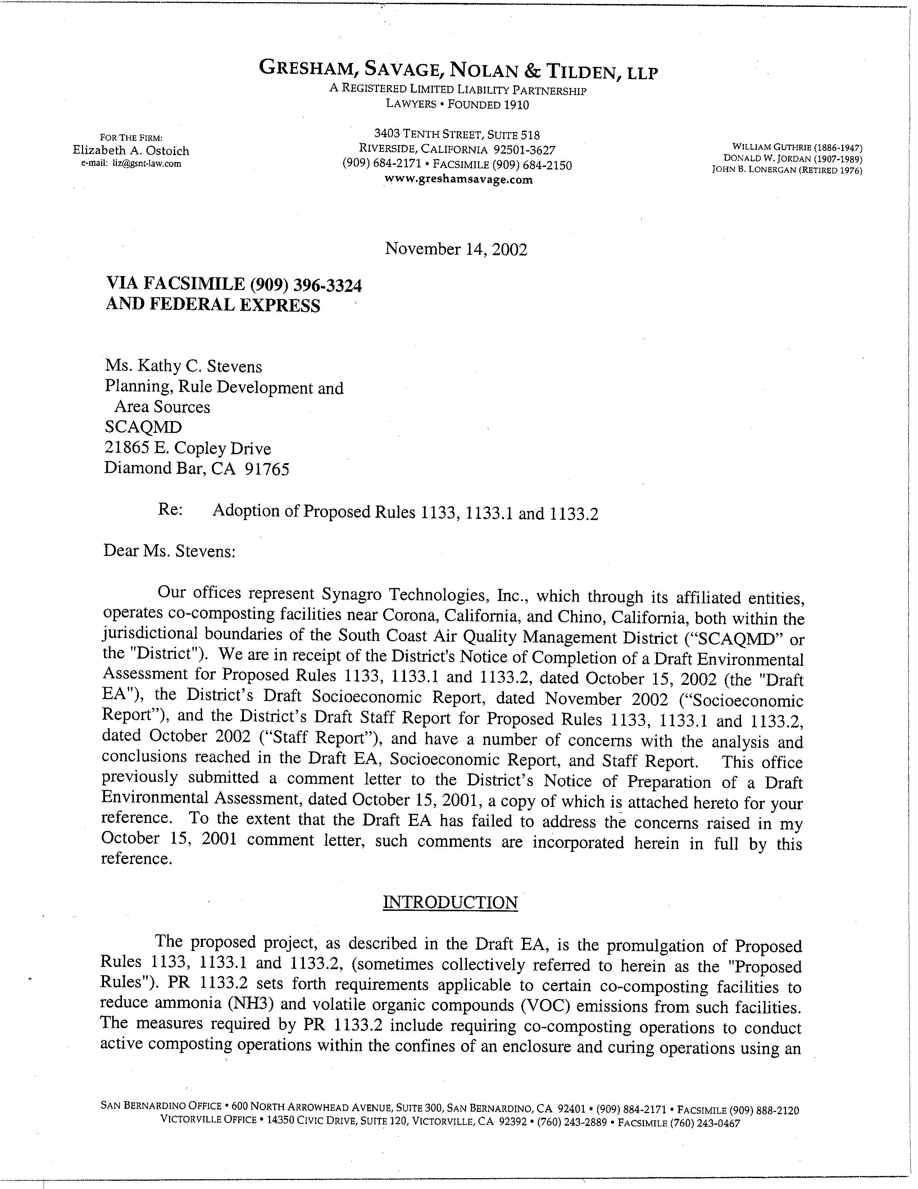
1-1
1-2

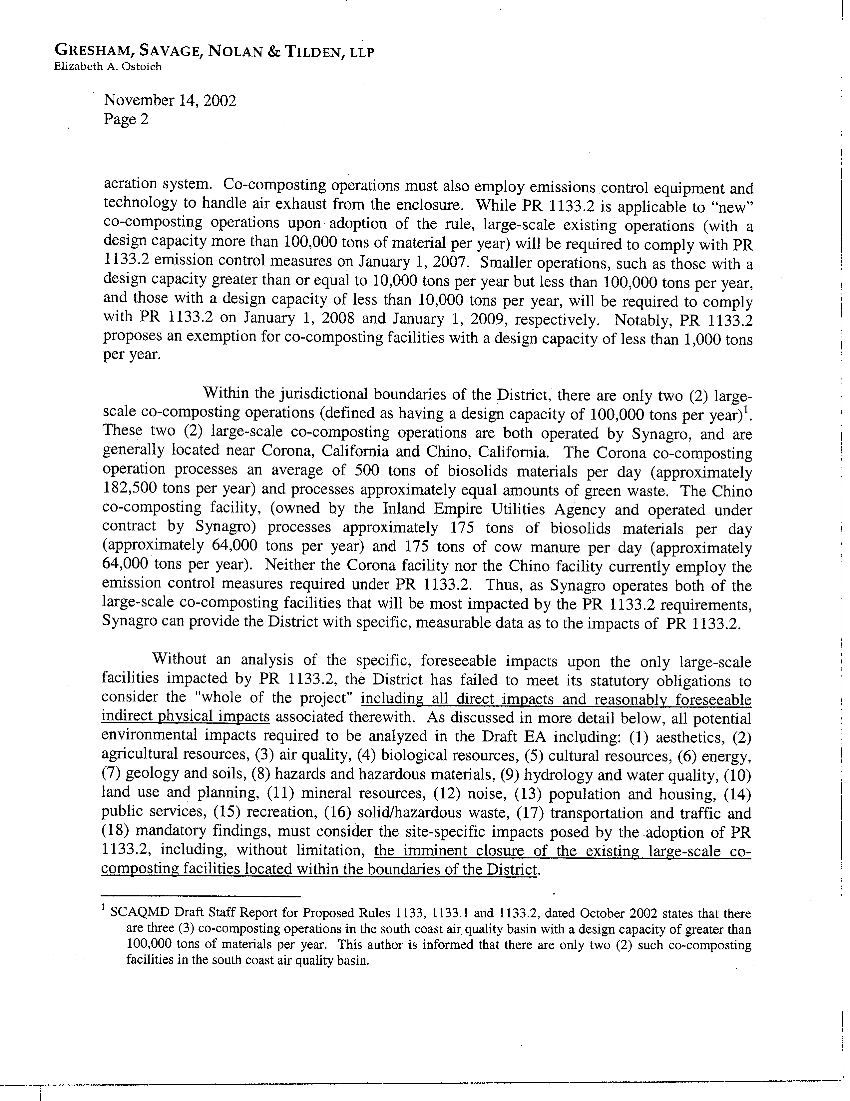
1-2
cont.
1-3
1-4
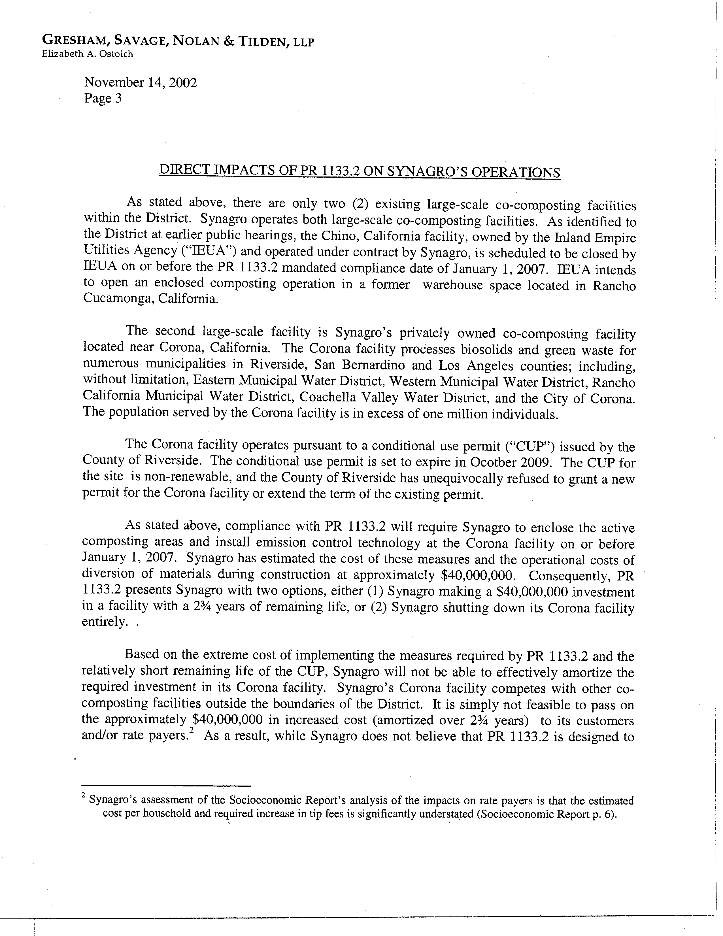
1-5
1-6
1-7
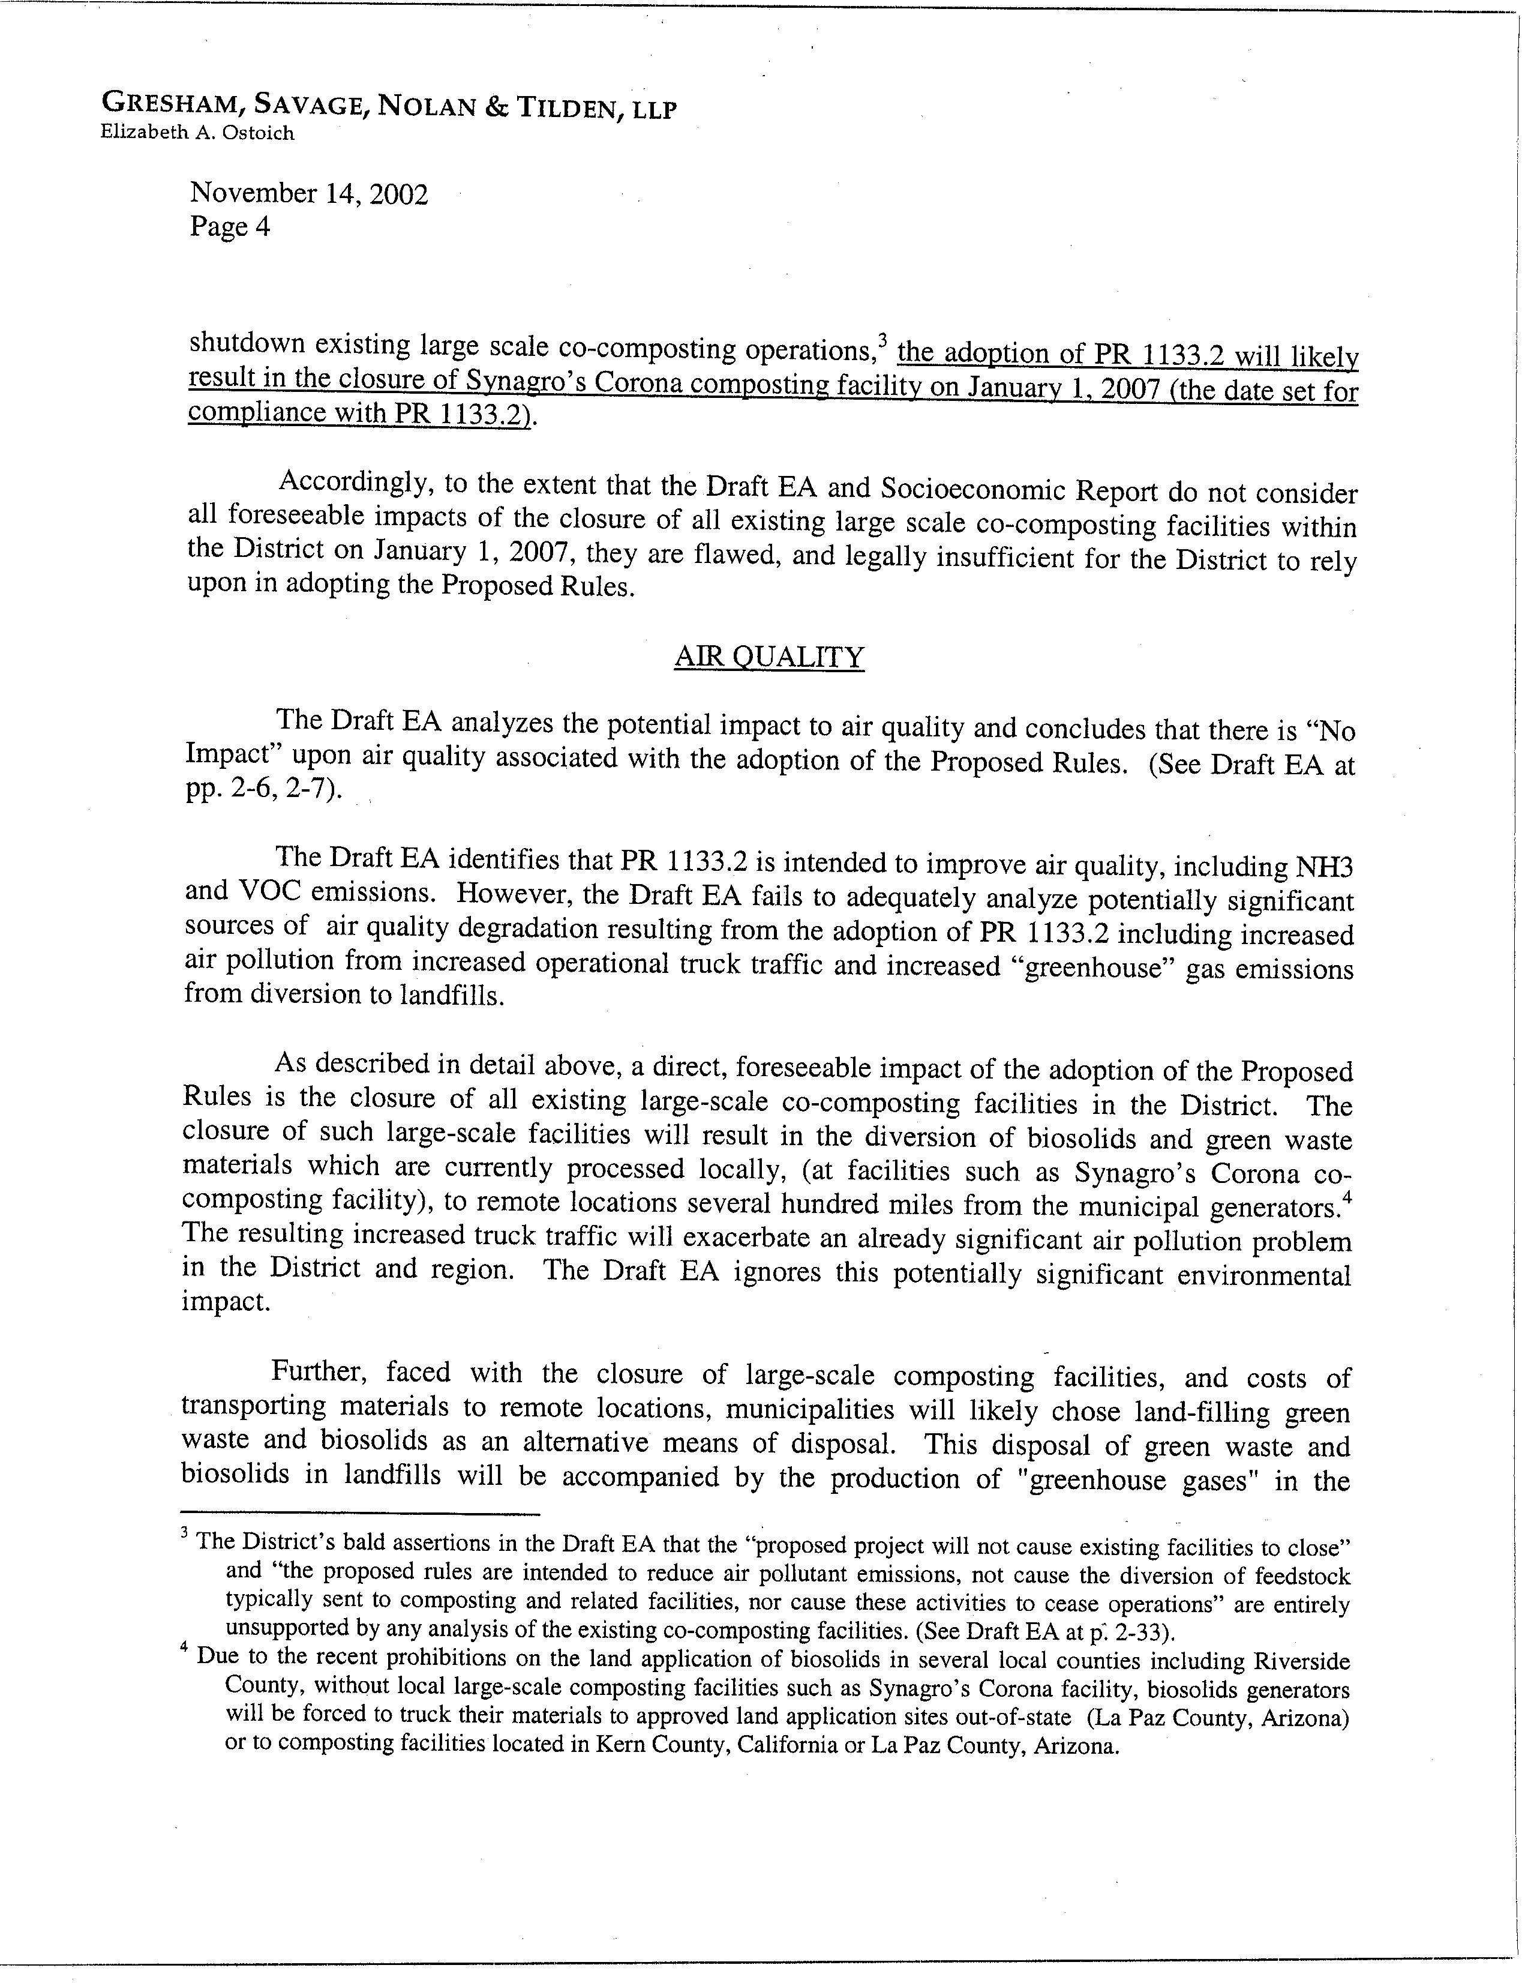
1-7
cont.
1-8
1-9
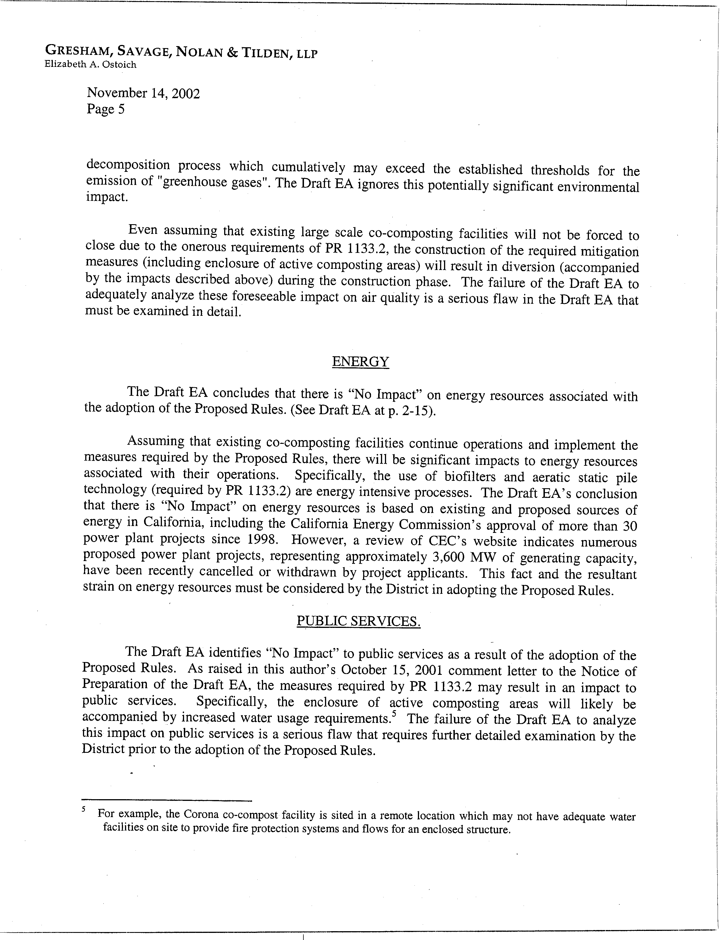
1-9
cont.
1-10
1-11
1-12
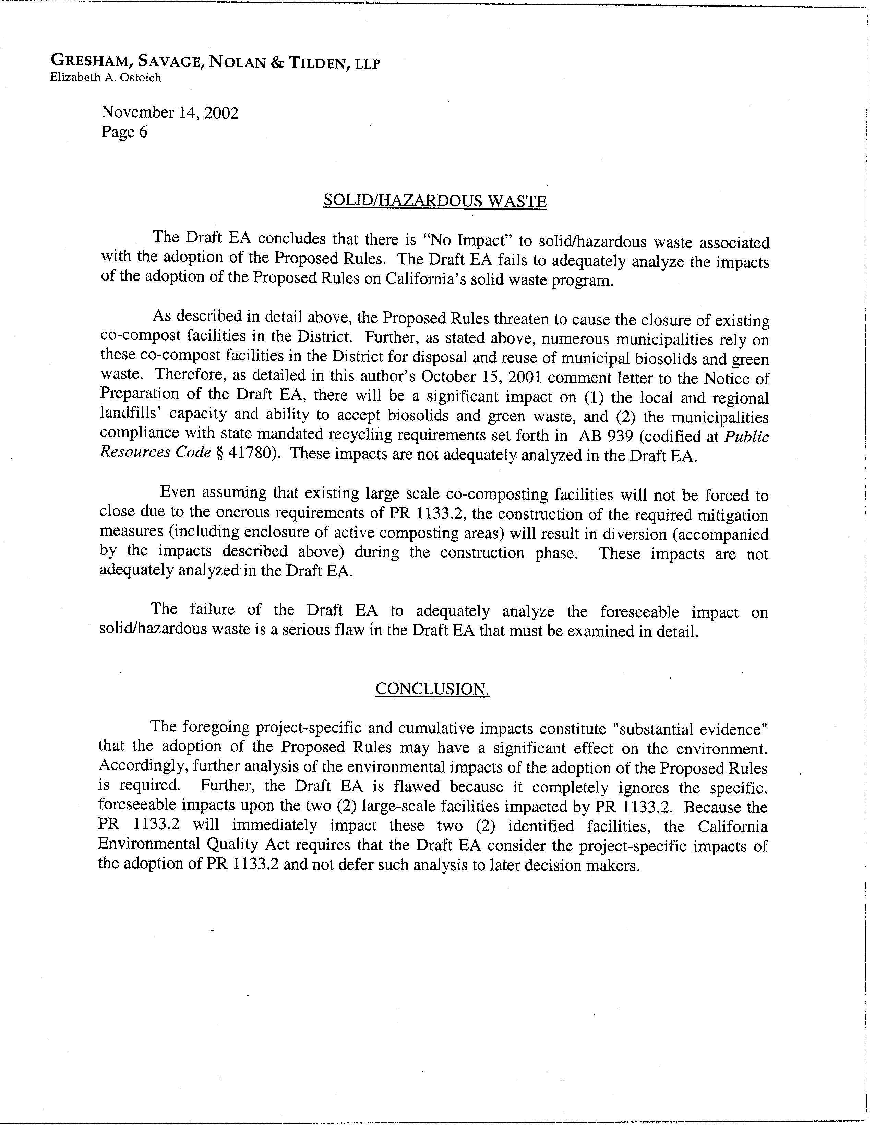
1-13
1-14
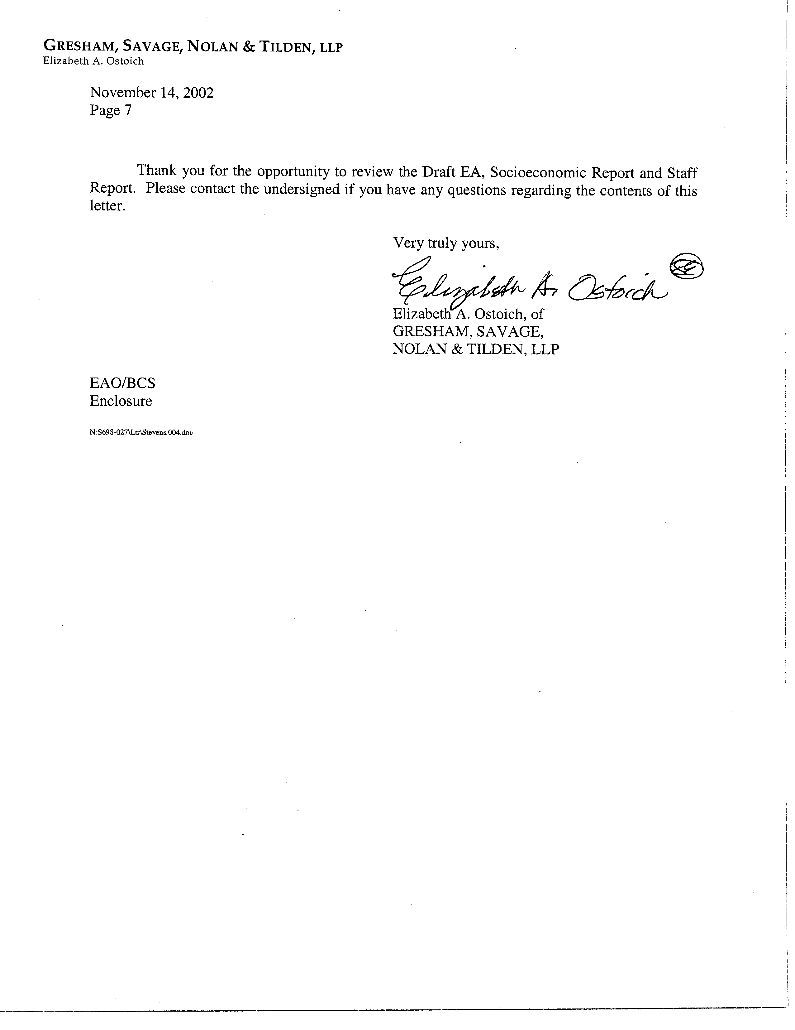
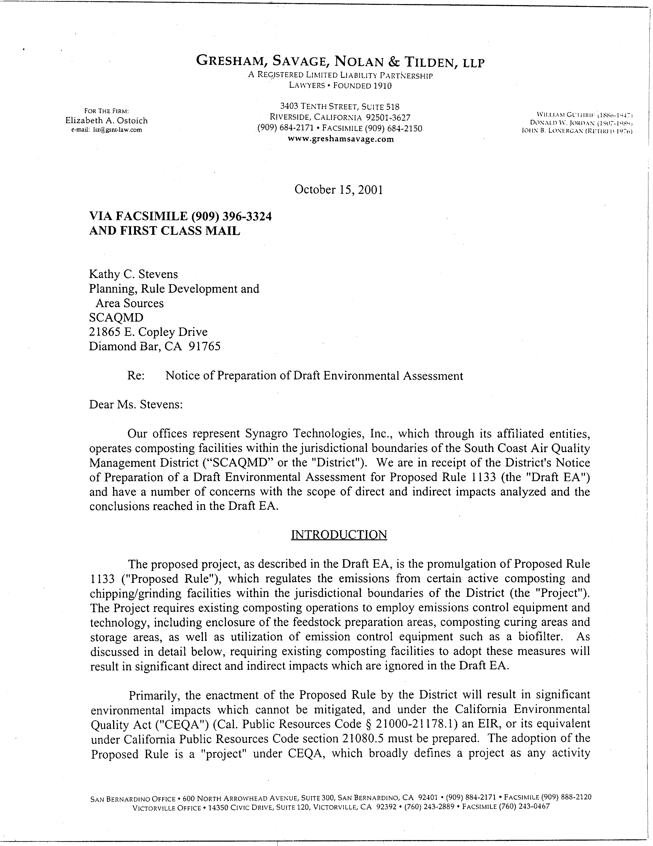
1-15
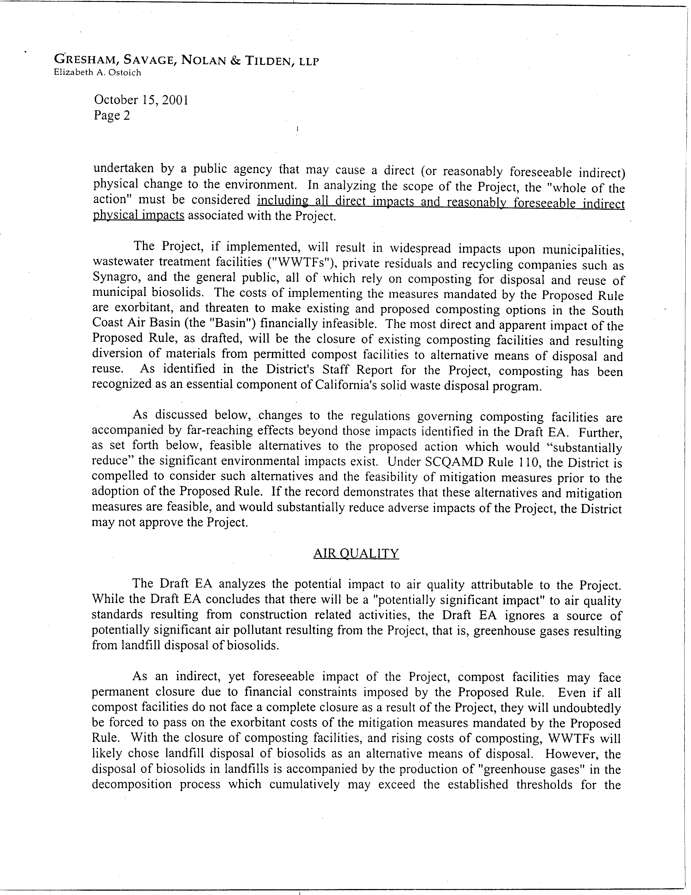
1-15
cont.
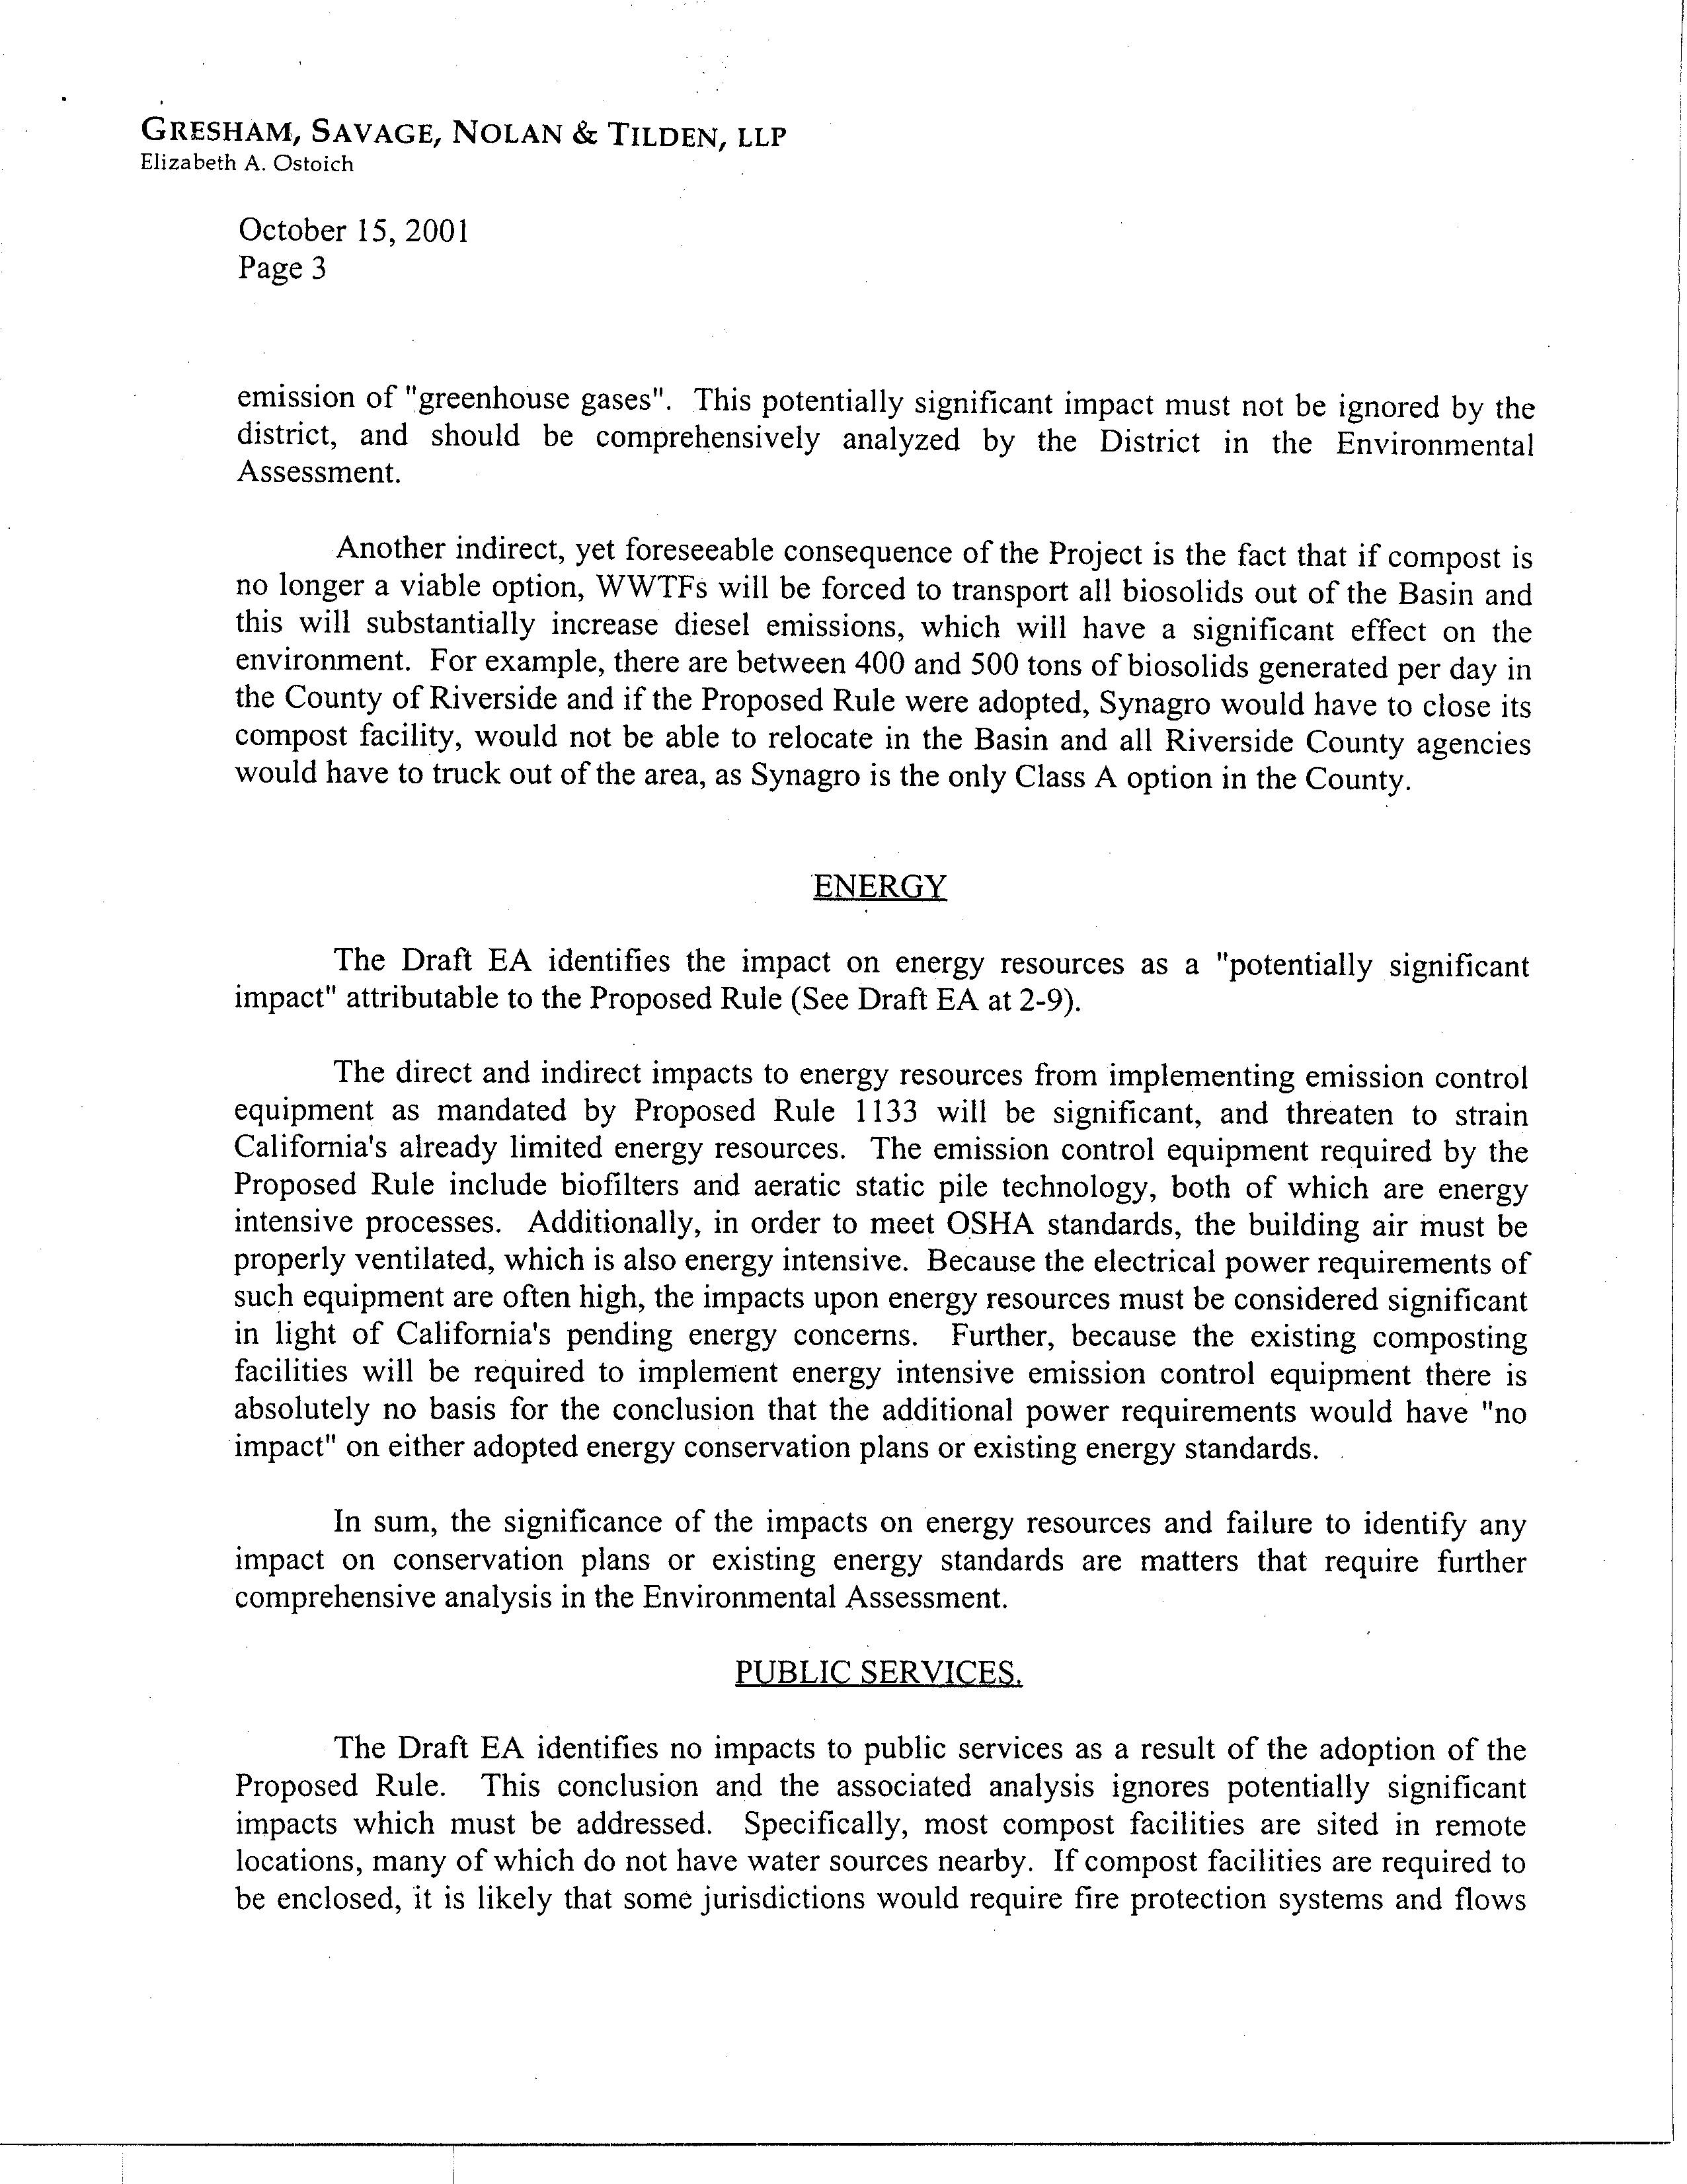
1-15
cont.
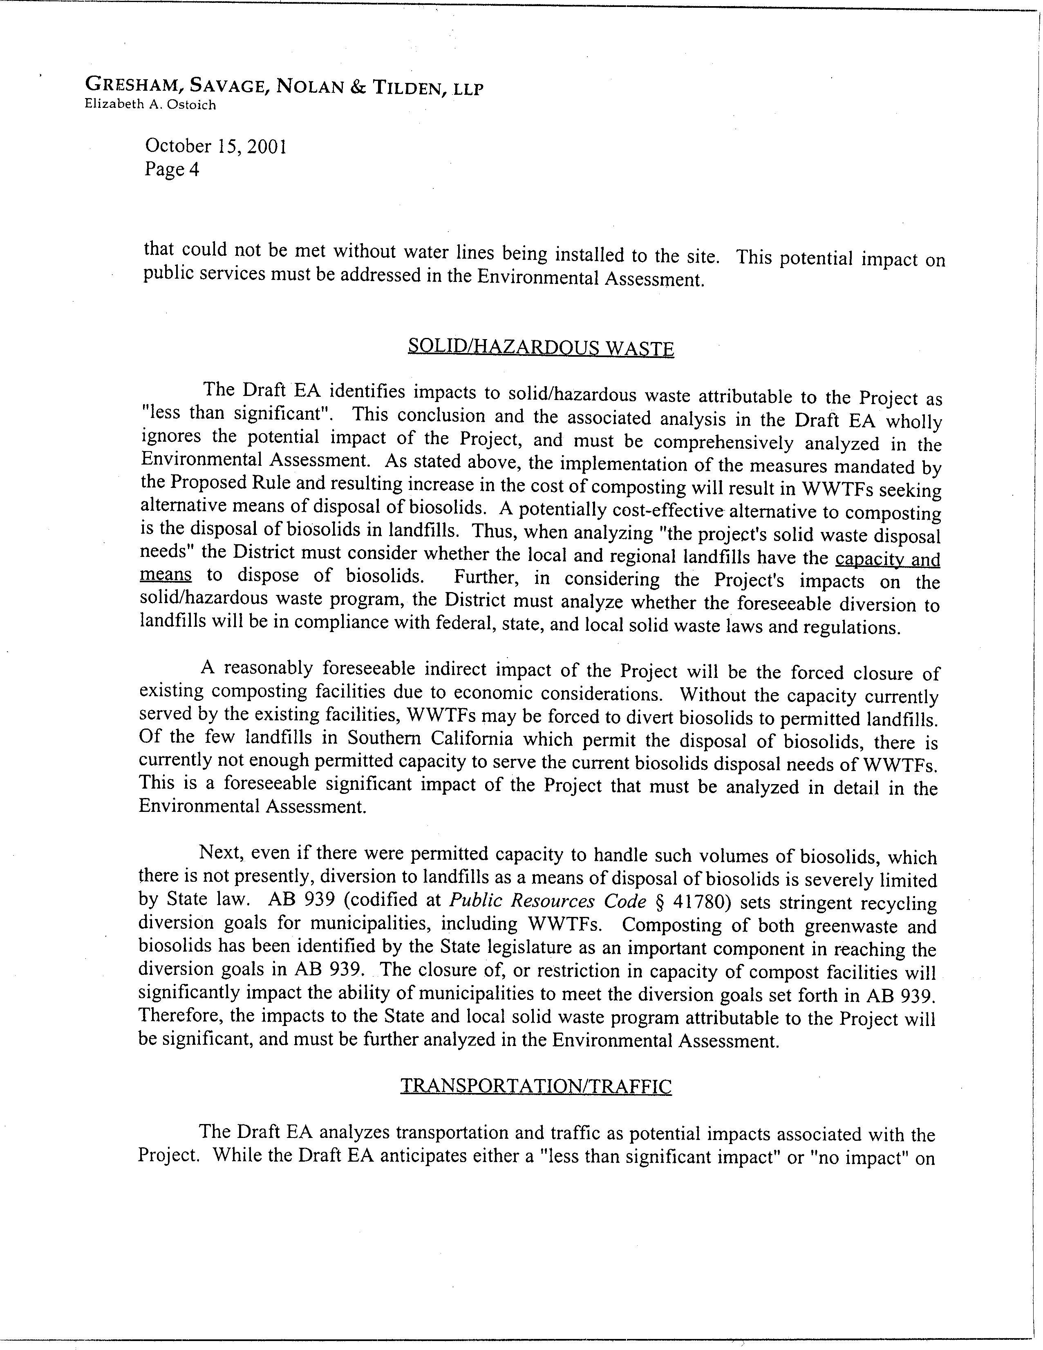
1-15
cont.
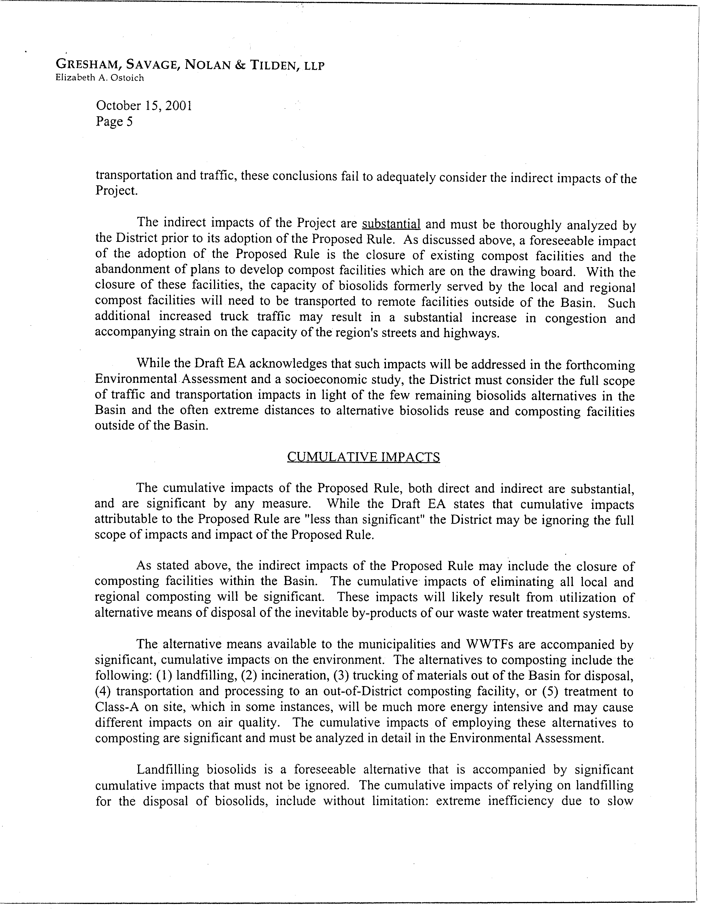
1-15
cont.
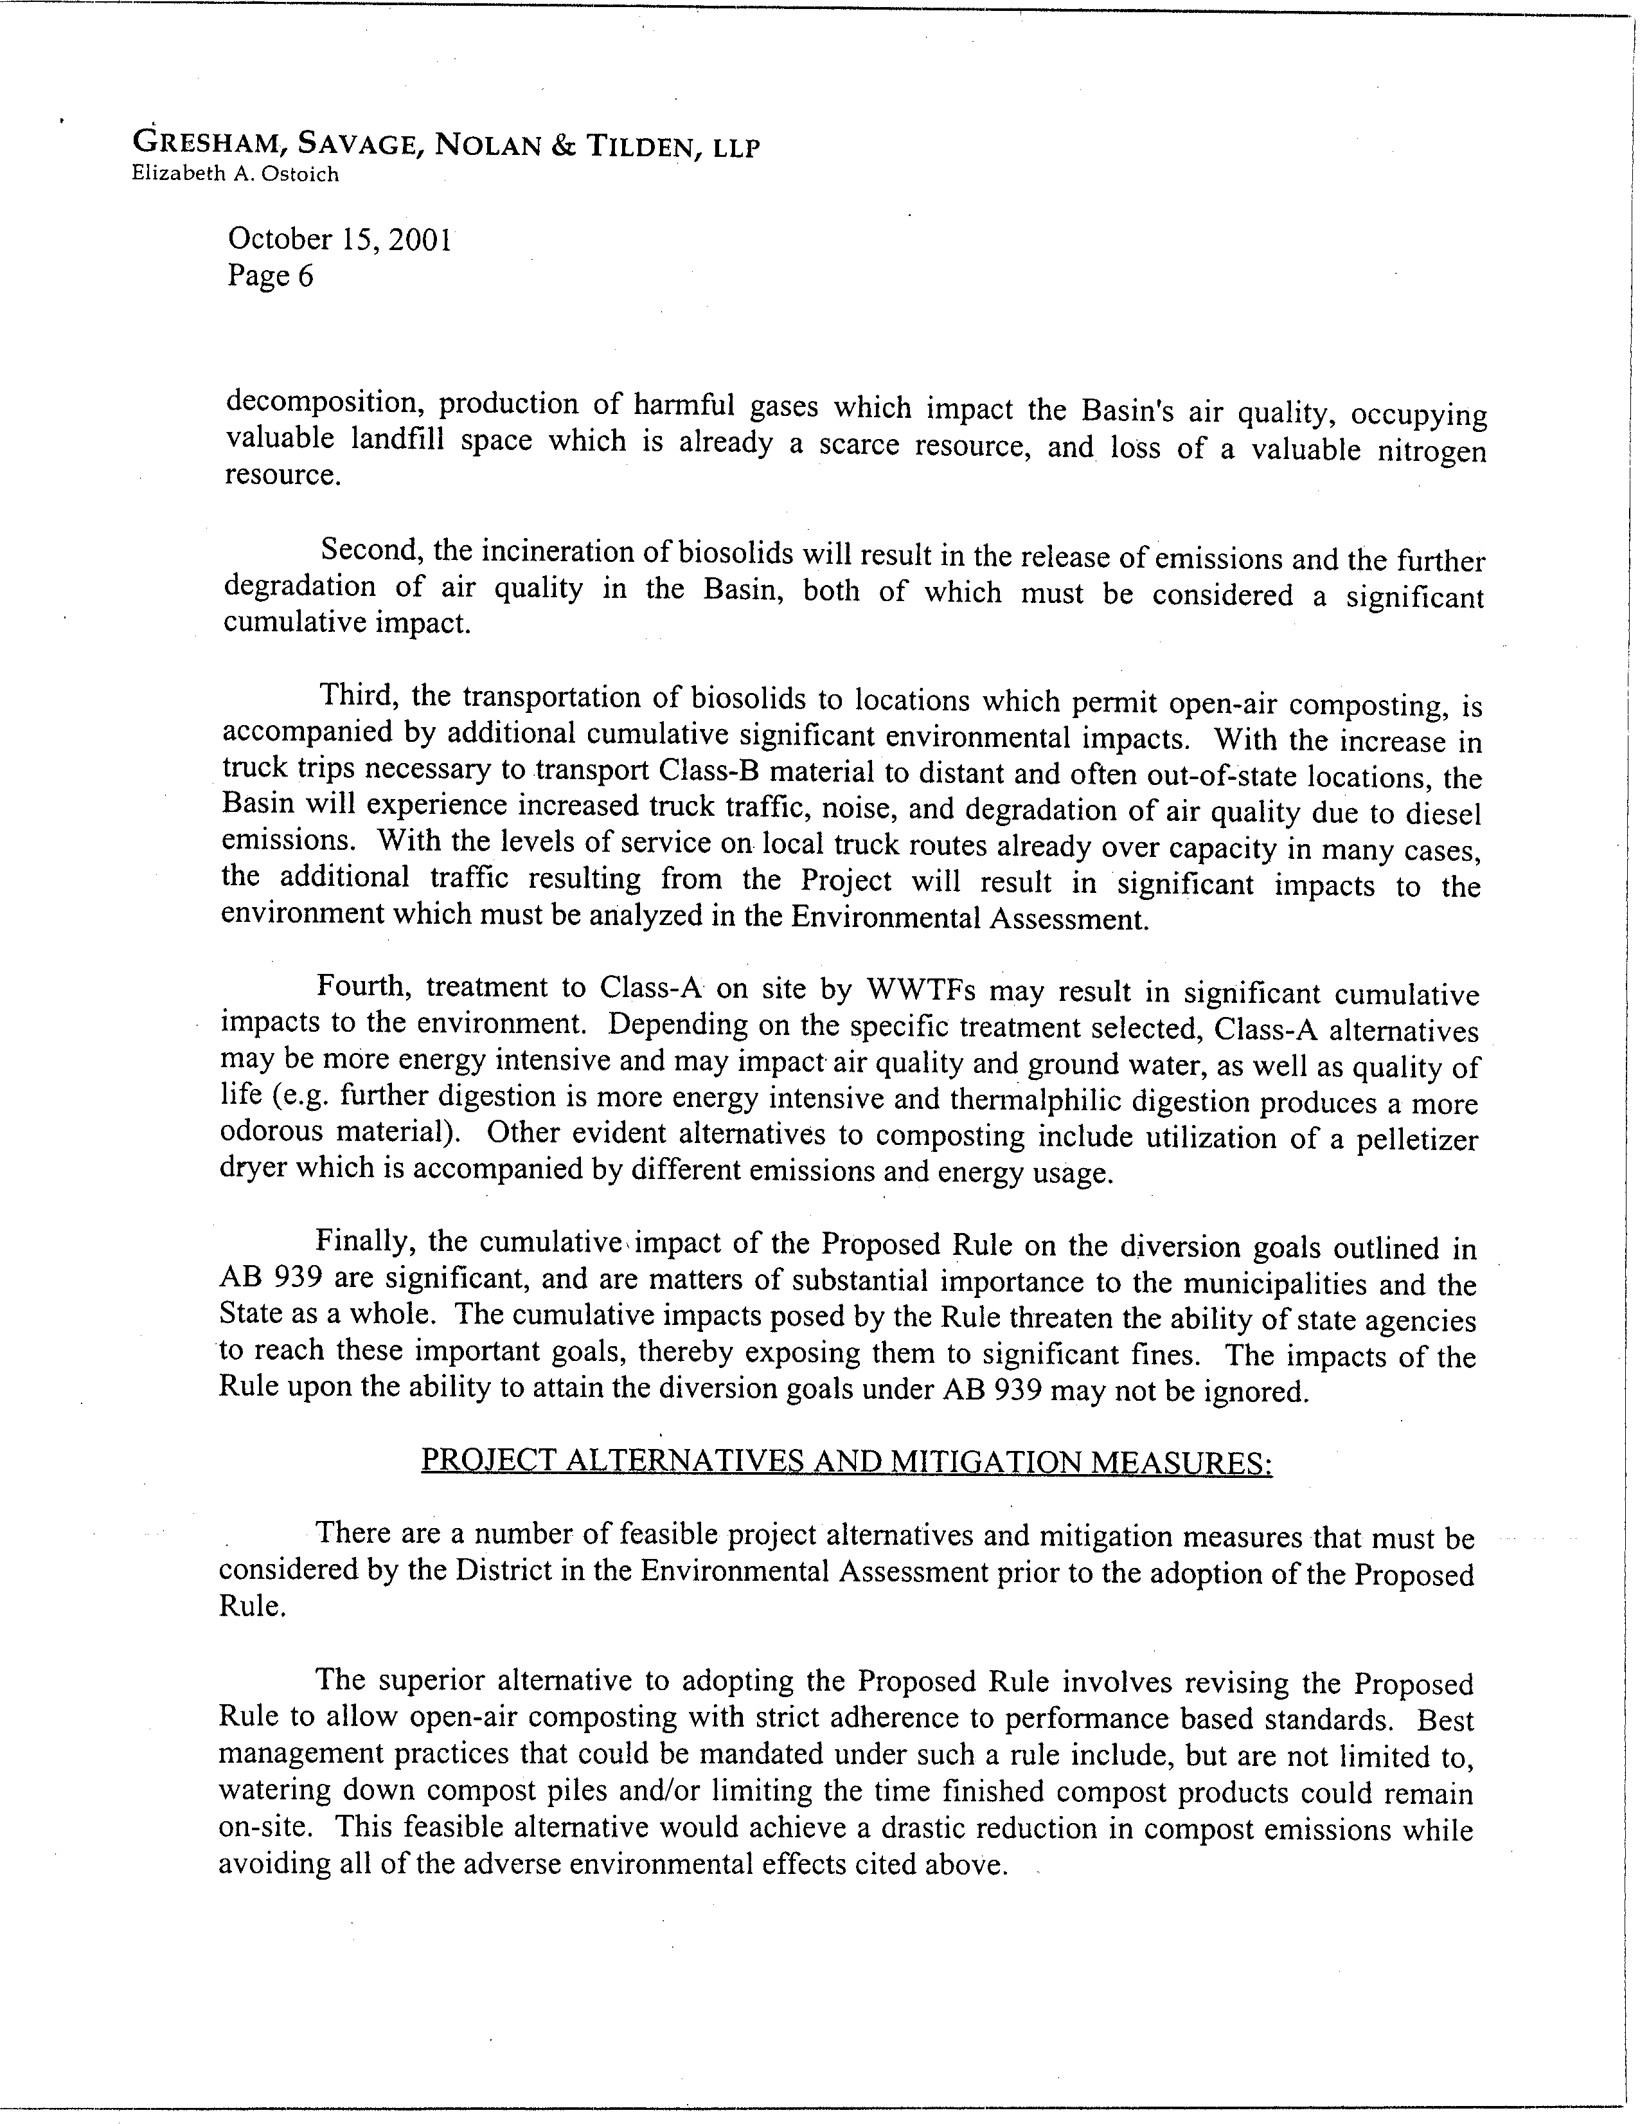
1-15
cont.
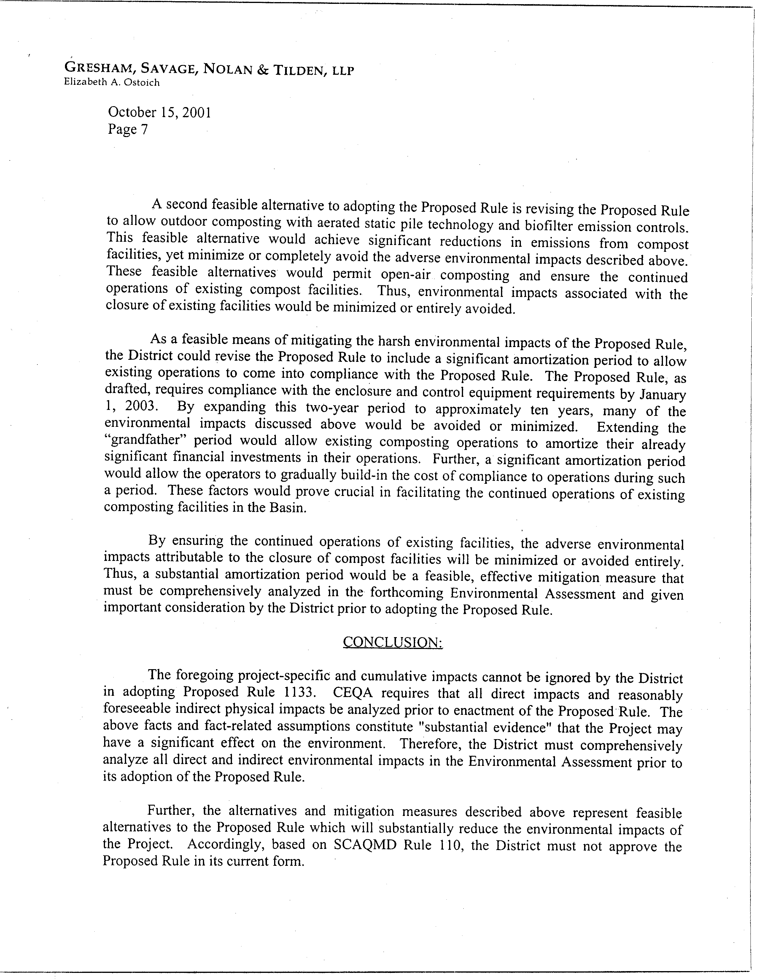
1-15
cont.
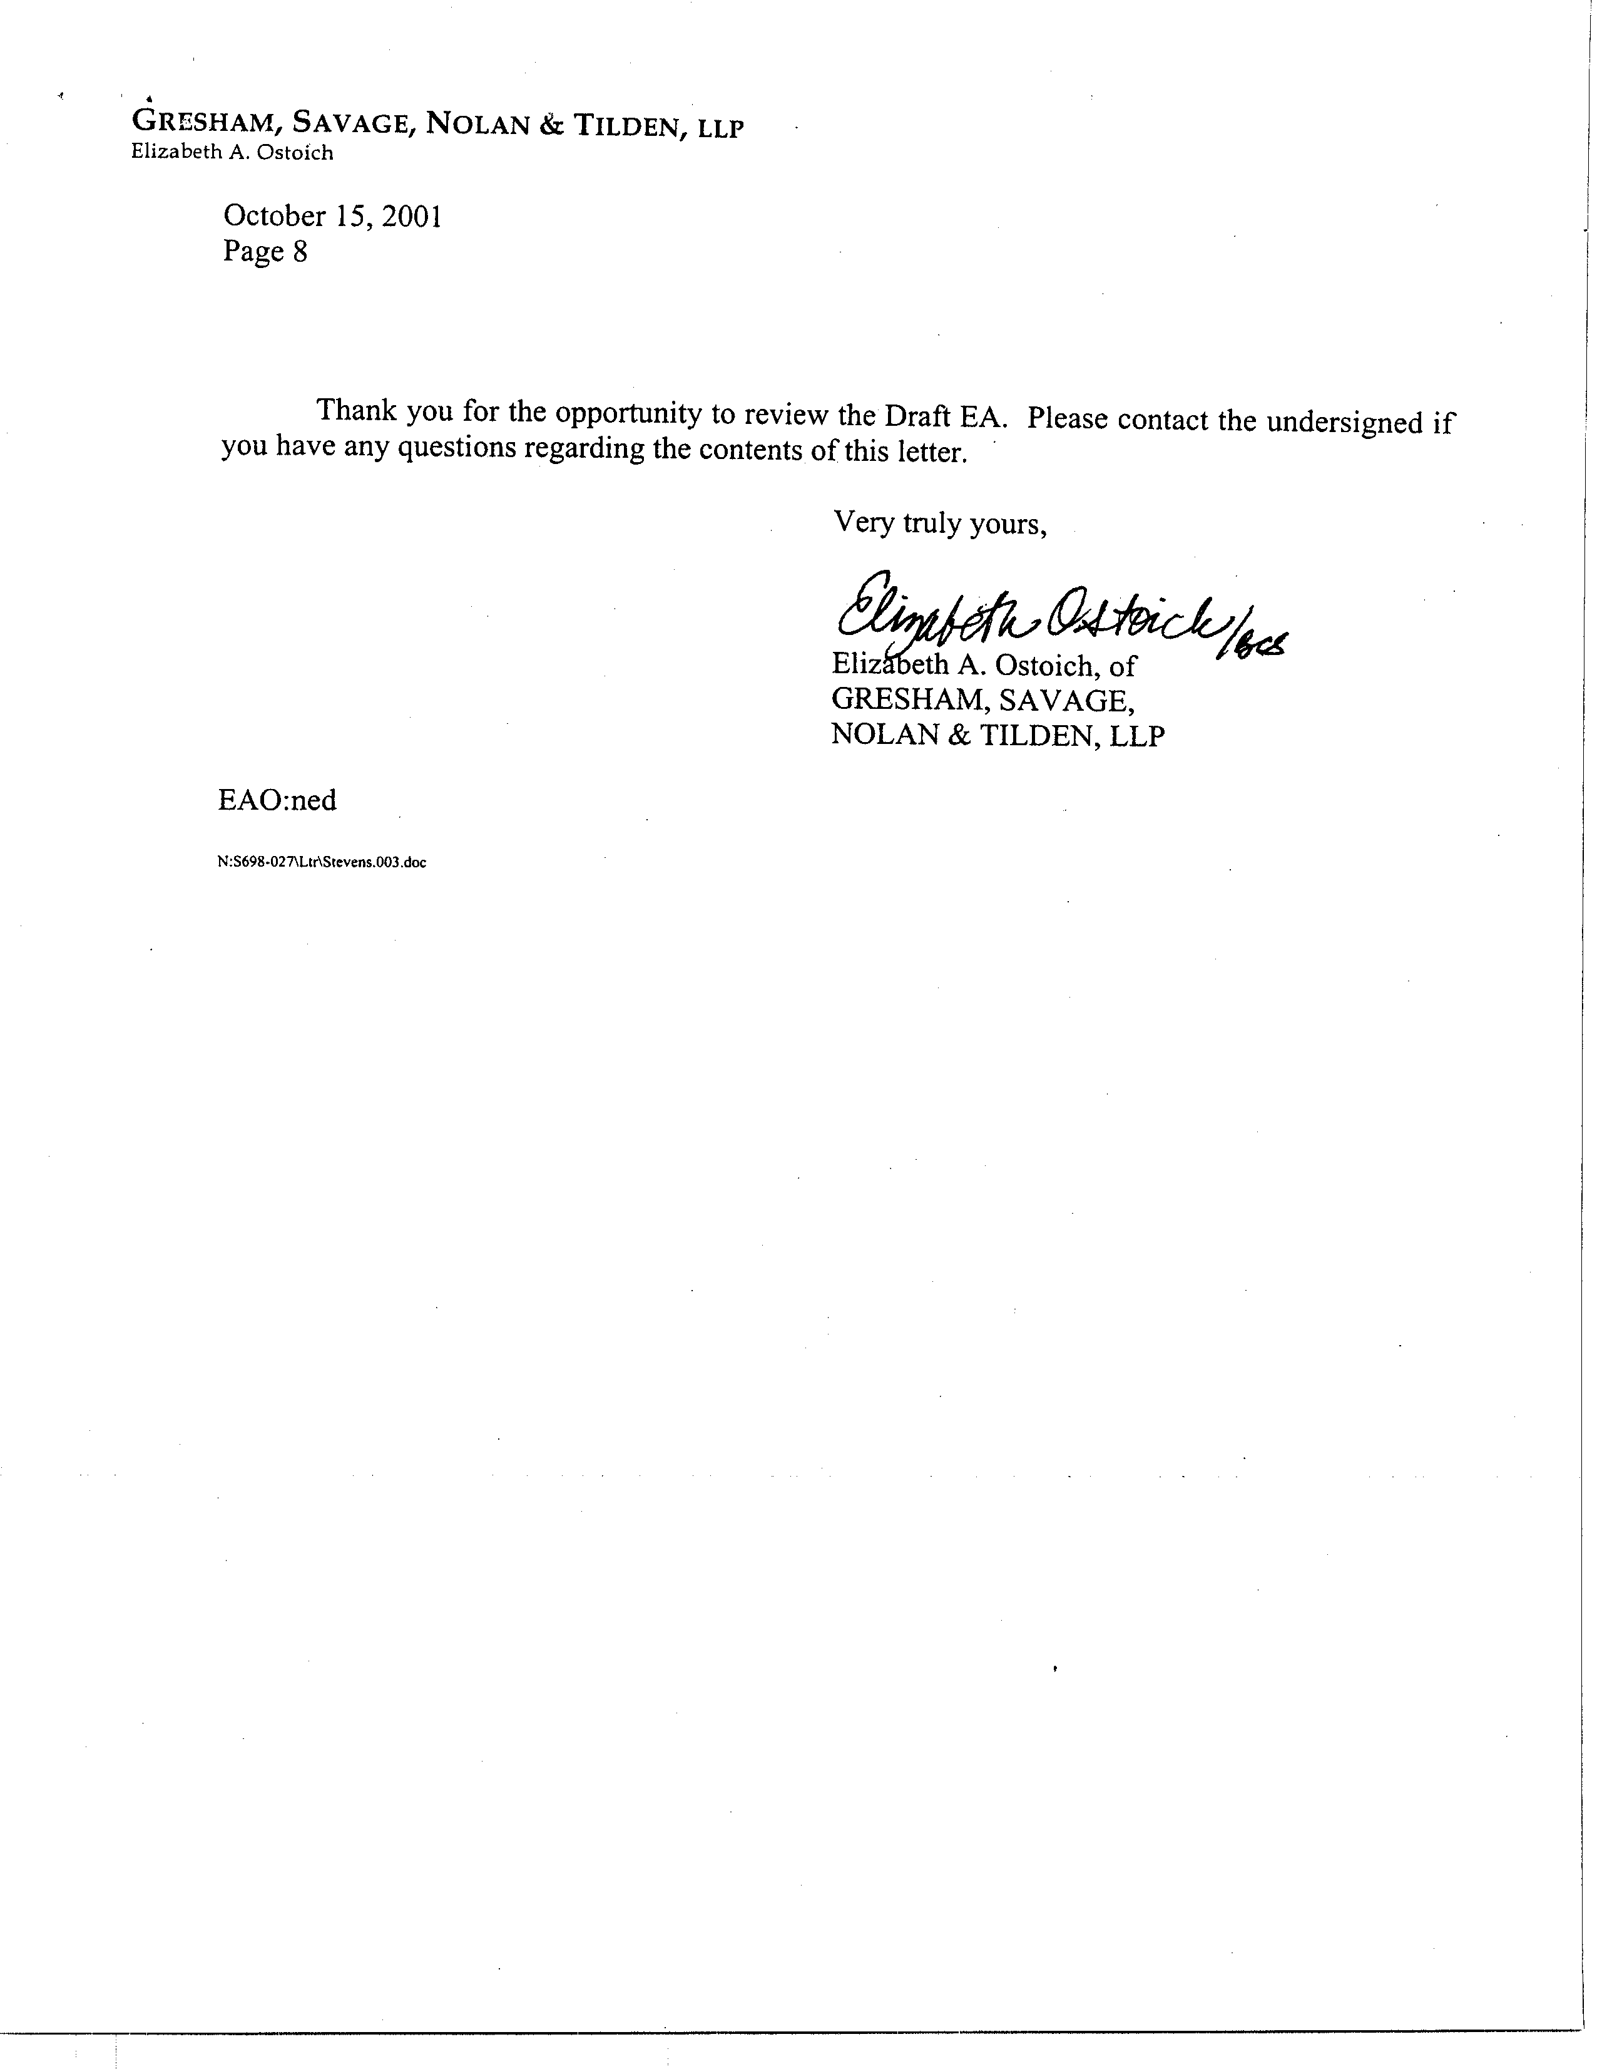
Response to Comments from Gresham, Savage, Nolan & Tilden, LLP

1-1 Responses to comments are provided below as they are appropriate to the current proposed project. The previously proposed project (e.g. the August 2001 version of PR 1133) and the environmental document (Initial Study dated October 2001) prepared for the previously proposed project were both withdrawn (see response 1-15). The previously proposed project is no longer the project currently being proposed or evaluated in the CEQA, Socioeconomic or Staff report documents. Therefore, the previously submitted comments are no longer applicable.

1-2 The proposed project includes proposed rules (PR) 1133, 1133.1 and 1133.2. PR 1133.2 is applicable to both new and existing co-composting operations. The purpose of PR 1133.2 is to reduce volatile organic compounds (VOCs) and ammonia (NH3) from these co-composting operations. PR 1133.2 requires new co-composting facilities to conduct all active operations within the confines of an enclosure and conduct curing operations using an aeration system (both vented to emissions control equipment). In lieu of these requirements, operators of new co-composting facilities may through a compliance plan process demonstrate an overall emission reduction of 80 percent, by weight, for both VOC and NH3 emissions from the baseline emission factors. The effective date of compliance for new co-composting facilities is “upon start-up.” For existing co-composting facilities, PR 1133.2 requires facilities to demonstrate an overall emission reduction of 70 percent by weight for both VOC and NH3 emissions from an affected facility’s baseline emission factors (through a compliance plan process). The effective compliance dates for existing facilities, based on throughput, are as follows: (1) January 1, 2007 – facility design capacity of 100,000 tons of throughput per year or more; (2) January 1, 2008 – facility design capacity greater than or equal to 10,000 but less than 100,000 tons of throughput per year; and (3) January 1, 2009 – facility design capacity less than 10,000 tons of throughput per year. PR 1133.2 includes an exemption for existing co-composting facilities with a design capacity of less than 1,000 tons of throughput per year.

1-3 The information collected by the SCAQMD reveals that there are two large co-composting facilities within the district. One facility is located in Corona, owned and operated by Synagro, and currently accepting approximately 500 tons of biosolids a day, and approximately another 500 tons of material as a bulking agent per day (e.g. green waste and horse shavings/bedding). The other facility is owned by Inland Empire Utilities Agency (IEUA) and includes two separate processes – one operated by Synagro (approximately 110,000 tons per year throughput) and the other operated by Earthwise Organics (approximately 140,000 tons per year throughput). With regard to providing the SCAQMD with “measurable data,” please refer to response 1-4.

1-4 This comment implies that the environmental analysis does not comply with specific provisions of CEQA, including considering the whole of the proposed project or performing an analysis of adverse impacts generated by the proposed project on the environmental topics identified by the commentator. The SCAQMD disagrees with this implication. The Draft EA was prepared in compliance with all relevant CEQA requirements. Further, the Draft EA assumed a “worst-case” scenario that 12 existing affected co-composting facilities would comply with the proposed project by constructing enclosures for the active portion of the composting activities and not the compliance plan option. The draft EA evaluated all potential environmental impacts as a result of the entire project (all three proposed rules), not site-specific impacts. Further, all 17 environmental impact categories were evaluated in the draft EA. As a result, no significant adverse environmental impacts were noted as a result of the implementation of the proposed rules.

1-5 The SCAQMD is aware that the open co-composting facility in Chino, owned by the Inland Empire Utilities Agency (IEUA), and operated under contract by Synagro, is scheduled to be closed on or before January 1, 2007. Further, the SCAQMD is also aware that an enclosed co-composting facility will be open in Rancho Cucamonga. This facility will be referred to as the Inland Empire Regional Composting Authority and will be a Joint Powers Agency operation owned jointly by IEUA and the Sanitation Districts of Los Angeles County. The analysis of environmental impacts took into consideration the fact that the existing Chino facility would comply with the requirements of PR 1133.2, even though it may be closing in the future.

1-6 According to the Riverside County Counsel’s Office, the actual status of the Synagro facility in Corona and future closure date is under a considerable amount of uncertainty and is currently the subject of litigation between Synagro and the County. Although CEQA may allow the SCAQMD to consider this uncertainty as speculative, the SCAQMD assumed in the Draft EA that the facility would continue to operate until October 2009, at which time its conditional use permit would expire and operations would cease. This assumption provides a “worst-case” analysis of potential construction and operational environmental impacts.

1-7 Many compliance options exist for the Synagro Corona facility. For example, Synagro could opt for early compliance and thus amortize costs over a longer period. With controls that have additional benefits of reducing odors along with the large air quality benefits, Synagro could apply in the future for an extension of the CUP. Additionally, based on input from the affected Synagro Corona facility PR 1133.2 has been modified as follows. “The Executive Officer shall extend for up to three years the compliance date for an existing co-composting operation which, at the time of rule adoption and one year before compliance is required, has less than 3 years remaining under a non-renewable conditional use permit beyond its effective compliance date. By June 1, 2003, the operator of such an operation must submit to the Executive Officer a copy of the conditional use permit and a letter from the responsible agency verifying that the permit is non-renewable and the date when the permit is expired”. Based on this modification, PR 1133.2 is not expected to affect the current anticipated closure date for the Synagro Corona facility.

1-8 The SCAQMD has prepared thorough and comprehensive CEQA and socioeconomic impact analyses. As indicated previously by the commentator, the IEUA facility will only be closed to accommodate relocation to a different area. This closure is not due to the proposed project and will not cause the diversion of materials to other waste disposal facilities. With regard to the Corona Synagro facility, the SCAQMD modified the rule proposal which may allow some relief by adding a provision that would allow the facility to seek an extension of the final compliance date (see responses 1-6 and 1-7).

1-9 The commentator implies in this comment that the existing large scale composting facilities are expected to close as a result of adopting PR 1133.2. This is not the case. As noted by the commentator in comments 1-5 and 1-6, these large scale composting facilities are already scheduled to terminate operations for reasons unrelated to the adoption of PR 1133.2. As previously discussed, the IEUA facility will be closing and relocating, and if the Synagro facility closes, it would be due to the expiration of its CUP, not as a result of the proposed rules. See response to comment 1-7 regarding the modification to PR 1133.2 that would allow the Synagro facility the option of seeking an extension of the final compliance date. The draft EA looks at environmental impacts as a result of PR 1133, 1133.1 and 1133.2 throughout the district, not just at a specific facility. As a result, the draft EA concludes that the proposed rules will not have a significant adverse impact on air quality. No increased operational truck traffic or greenhouse gas emissions are expected as a result of the implementation of the proposed rules.

1-10 Existing co-composting facilities are not required to enclose the active portion of their activities. Existing co-composting facilities are required to submit a compliance plan that demonstrates an overall emission reduction of 70 percent, by weight, for VOC and ammonia emissions. If they do enclose, there is not a need to cease operations during construction. Therefore, it is not expected that there will be a need to divert materials away from the existing facility. Further, the draft EA assumes a “worst-case” scenario that operators of the 12 existing facilities will choose to enclose their facilities and evaluates potential air quality impacts from construction emissions (Appendix B). Table 2-2 on page 2-9 of the draft EA reflects that it is assumed that Phase I construction activities will generate most of the fugitive dust emissions due to grading. Both mobile sources and fugitive dust emissions were calculated and no criteria pollutants exceeded the SCAQMD significance thresholds.

1-11 The SCAQMD disagrees with the commentator’s evaluation of the results of the energy discussion contained in the draft EA. PR 1133.2 does not specifically require the use of biofilters and aerated static pile technology. However, assuming these compliance options are used to comply with PR 1133.2, they are not energy intensive processes as claimed by the commentator.

As noted in the Draft EA, the proposed project, is not expected substantially increase demand for energy by affected facilities. PR 1133 is an administrative rule to create an information database for composting and related operations through a registration process. Creating a database of affected facilities would not be expected to increase demand for energy in any way. PR 1133.1 regulates activities that are already part of the existing practices at affected chipping and grinding facilities, so it would also not generate an increase in energy demand. PR 1133.2 results in an incremental increase in energy demand that would not be considered significant as indicated by the following.

Abbreviations key:
hr = hour | kW = kilowatt
yr = year | MW = megawatt
wk = week

Total number of facilities = 9
Total annual throughput 683,370 wet tons/yr
Operating schedule = 16 hr/day; 7day/wk; 52 wk/yr (5,824 hr/yr)
Electricity usage = 82 kW-hr/wet ton
Instantaneous district-wide electricity demand 8,115 MW (Year 2000 CEC projections)
Instantaneous electricity estimate = 82 kW-hr/wet ton x 683,370 wet ton/yr = 56,036,340 kW-hr/yr x 1 MW/1,000 kW = 56,036.34 MW-hr/yr x 1 yr/365 days x 1 work day/16 hr = 9.6 MW
9.6 MW/8115 MW x 100 = 0.12 percent of instantaneous district-wide demand

As shown in the above calculations, the total instantaneous electricity demand for all nine existing facilities subject to PR 1133.2 is substantially less than one percent, 0.12 percent. As a result electricity demand impacts from the proposed project would be considered less than significant as indicated in the Draft EA.

1-12 The commentator asserts that the “Public Services” section does not evaluate increased water demand from implementing the proposed project and that this is a “serious flaw that requires further detailed examination…” The analysis of water demand impacts can be found in the hydrology and water quality impacts discussion (Section IX in Chapter 2 of the Draft EA). The analysis of water demand impacts calculated projected water demand from construction activities. The analysis concluded that water demand impacts for construction at all affected facilities would not exceed the SCAQMD’s significance criteria. Further there is no reason to believe, or evidence presented by the commentator that enclosing existing composting operations would increase demand or usage beyond what is currently used to operate composting facilities. All co-composting facilities, both new and existing (including the facility in Corona), irrespective of the proposed project are required to have adequate water supply to the site. The proposed project does not require the construction of new co-composting facilities, rather it requires facilities to control emissions. This demand would not exhaust water supplies

1-13 The SCAQMD disagrees with the commentator’s opinion that the draft EA does not adequately analyze potential impacts on California’s solid waste program. It is unlikely that composting facilities would completely shut down during construction. Construction is only expected to occur concurrently at four facilities located throughout the district. Based on the total disposal capacity in the district, even if all four facilities diverted compost materials to landfills temporarily, this would not be expected to exceed the existing total disposal capacity in the district. The proposed rules do not threaten to cause the closure of existing co-composting facilities, nor will they adversely affect landfill capacity in the region. With regard to the anticipated closure of the two large co-composting facilities, see responses 1-5, 1-6, 1-7 and 1-8.

1-14 CEQA Guidelines §15384 states that, “Substantial evidence” means enough relevant information and reasonable inferences from this information that a fair argument can be made to support a conclusion, even though other conclusions might also be reached. Whether a fair argument can be made that the project may have a significant effect on the environment is to be determined by examining the whole record before the lead agency. Argument, speculation, unsubstantiated opinion or narrative, evidence which is clearly erroneous or inaccurate, or evidence of social or economic impacts which do not contribute to or are not caused by physical impacts on the environment does not constitute substantial evidence. Substantial evidence shall include facts, reasonable assumptions predicated upon facts and expert opinion support by facts. As noted previously in responses 1-5, 1-6, 1-7 and 1-8, closure of the two large scale co-composting facilities is unrelated to adopting PR 1133.2 and the Corona facility is not expected to close early because it can apply for an extension of the compliance date to match its planned closure.

1-15 The comments in the letter dated October 15, 2001 appear to reflect issues related to an earlier version of PR 1133 (August 10, 2001) which were evaluated in an Initial Study dated October 2001. On May 22, 2002 a letter was mailed from the SCAQMD to Ms. Elizabeth Ostoich explaining that the August 10, 2001 version of PR 1133, and the related Initial Study, had been withdrawn. The decision to withdraw this version of the rule was based on the April 5, 2002 pre-hearing, wherein input from industry, stakeholders and working group members was solicited. The proposed rules 1133, 1133.1 and 1133.2 are substantially different than the August 10, 2001 version of PR 1133. Responses to any relevant comments from the October 15, 2001 letter that have been repeated in the November 14, 2002 letter have been prepared.

C O M M E N T L E T T E R 2
California Integrated Waste Management Board
Mark de Bie
November 14, 2002
1-15
cont.
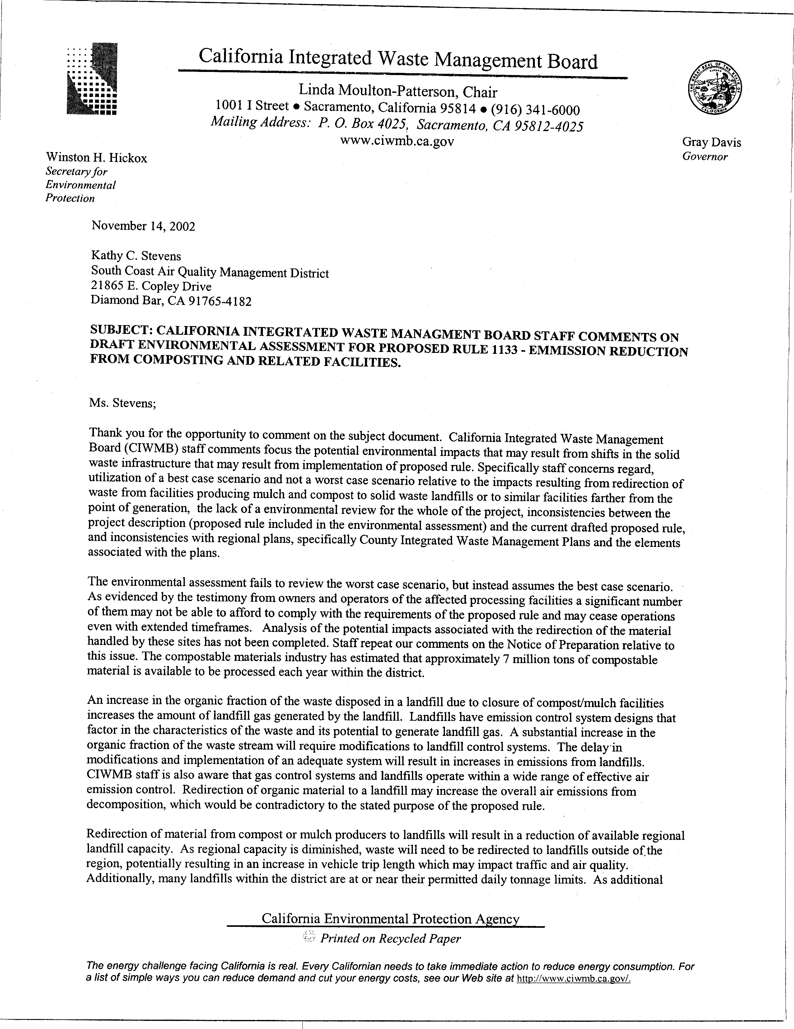
2-1
2-2
2-3

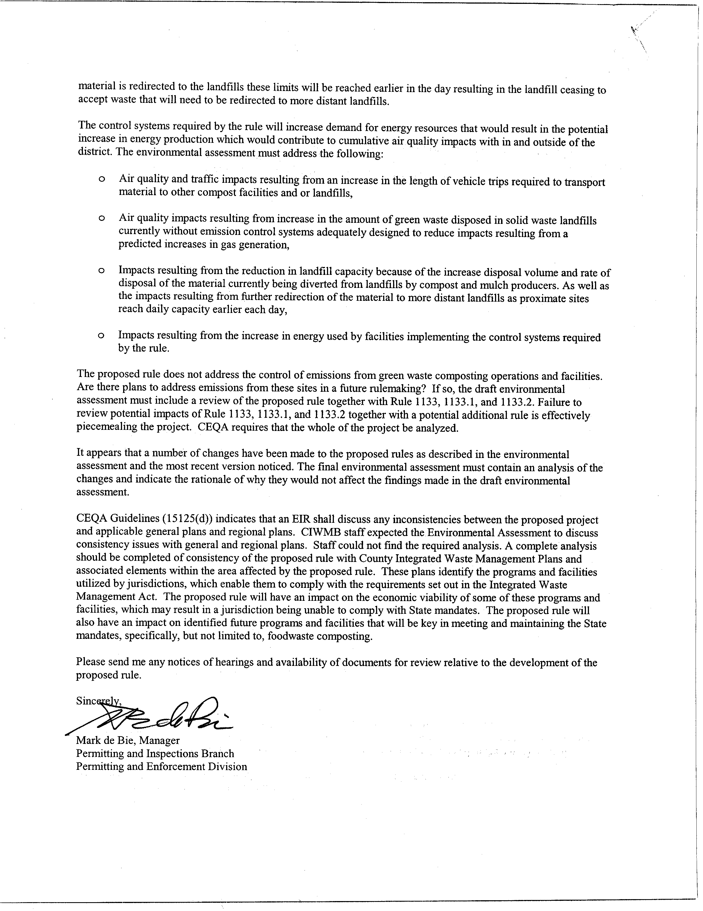
2-3
Cont.
2-4
2-5
2-6
2-7
2-8
Responses to Comments from California Integrated Waste Management Board

2-1 Based on the rule title in the subject block at the beginning of this comment letter, comments appear to reflect issues that were included in an earlier version of PR 1133 which were evaluated in an Initial Study dated October 2001. On May 22, 2002 a letter was mailed from the SCAQMD to Mr. Mark de Bie explaining that the August 10, 2001 version of PR 1133, and the related Initial Study, had been withdrawn. The decision to withdraw this version of the rule was based on the April 5, 2002 pre-hearing, wherein input from industry, stakeholders and working group members was solicited and received.

The proposed rules 1133, 1133.1 and 1133.2 are entirely new projects unrelated to the previously proposed project, which are also expected to reduce emissions from composting and related operations. The draft EA dated October 15, 2002 evaluated the potential adverse environmental impacts of these three proposed rules and is in no way intended to be associated with the environmental document circulated for public review between October 2 and October 31, 2001.

With regard to the specific alleged deficiencies, the first paragraph in this comment letter summarizes key issues discussed in greater detail in subsequent comments. Specific responses to each issue have been prepared in the following responses to comments.

2-2 The SCAQMD disagrees with the opinion that the current proposed project will cause existing affected facilities to cease operations because they will not be able to afford to comply with the proposed rules. For example, PR 1133 is an administrative rule to create an information database for composting and related operations through a registration process. According to the Socioeconomic Report for the proposed project, the total compliance cost for all existing affected facilities subject to PR 1133 would be $6,630 for the one-time registration fee or $89.59 per facility.

PR 1133.1 sets forth maximum holding time for chipping and grinding activities. According to the Socioeconomic Report for the proposed project, there are no additional compliance costs for holding processing time requirements because these activities are already part of the existing practices at affected chipping and grinding facilities.

PR 1133.2 requires new co-composting facilities to: conduct all active co-composting within the confines of an enclosure; conduct all curing using an aeration system that operates und negative pressure for no less than 90 percent of its blower operating cycle; and vent the exhaust from the enclosure and the aeration system to an emission control system designed and operated with a control efficiency equal to or greater than 80 percent, by weight for both VOC and NH3 emissions from the baseline emission levels through a compliance plan process. PR 1133.2 also requires existing co-composting facilities to demonstrate an overall emission reduction of 70 percent, by weight, for both VOC and NH3 emissions from the baseline emission levels through a compliance plan process. The Socioeconomic Report for the proposed project indicates that the average annual cost of PR 1133.2 is $14.80 million. This translates to an increase in the price to the public utility sector where composting facilities belong of 0.092 percent in the year 2020 compared to the baseline price in that year. Further, the estimated increase in cost per household is estimated to be $0.25 per month. These compliance costs represent a worst-case analysis that all existing co-composting facilities would have to install controls to comply with PR 1133.2. However, given that two existing facilities plan to move to enclosed facilities that would be vented to biofilters regardless of adoption of the proposed project and the potential extension of one facility’s compliance date, the regional economic impact of PR 1133.2 is expected to be about 10 percent of the above values.

The SCAQMD is currently aware of two large facilities that would be subject to PR 1133.2 that are expected to close. These closures, however, are unrelated to PR 1133.2 and are expected to occur with or without adopting PR 1133.2. It should be noted that the open co-composting facility in Chino, owned by the Inland Empire Utilities Agency (IEUA) is closing and being relocated to Rancho Cucamonga. For additional information the commentator is referred to the responses to comments 1-5, 1-6 and 1-7.

Finally, when the SCAQMD initially began analyzing potential adverse environmental impacts from the proposed project, including PR 1133.2, the SCAQMD identified 12 existing facilities expected to be subject to the requirements of PR 1133.2. Prior to release of the Draft EA the inventory of existing co-composting facilities was further refined and it was learned that three of the 12 facilities did not perform co-composting operations that would be subject to PR 1133.2. In an effort to ensure that impacts from PR 1133.2 were not underestimated, the analysis of impacts from 12 existing facilities remained in the Draft EA. As a result, it is likely that impacts resulting from adopting PR 1133.2 are overestimated.

2-3 The SCAQMD disagrees with the commentator’s opinion that the proposed project will cause the closure of affected facilities due to the costs of complying with the proposed rules, which would then result in formerly composted materials being disposed of in landfills. The commentator, however, provides no data or other evidence to support this opinion. As noted in responses to comments 2-1 and 2-2 above, proposed Rules 1133, 1133.1 and 1133.2 are not expected to cause affected facilities to close so it is unlikely that regulated materials would be redirected to landfills and cause adverse impacts to landfill capacity.

2-4 The issues identified in this comment were previously presented at the pre-hearing in April 2002, that presented cost information on the original version of Rule 1133. As noted in response to comment 2-1, the August 10, 2001 version of PR 1133 has been withdrawn. Requirements of the currently proposed rules are substantially different so the impacts identified in this comment are not expected to occur.

As already noted in response to comment 2-2, the proposed project is not expected to cause the closure of affected facilities. Therefore, diversion of compost materials to landfills is not anticipated and, as a result, air quality impacts from increased vehicle miles traveled will not be generated by the proposed project. Similarly, the proposed project would not be expected to adversely affect landfill capacities

The proposed project will have no effect on landfill gas generation at landfills because the proposed project is not expected to result in the diversion of green waste materials to landfills. PR 1133.1 regulates activities that are already part of the existing practices at affected chipping and grinding facilities. Consequently, PR 1133.1 imposes no additional compliance costs so it would not cause closure of any affected facilities.

As noted in the Draft EA, the proposed project, is not expected substantially increase demand for energy by affected facilities. PR 1133 is an administrative rule to create an information database for composting and related operations through a registration process. Creating a database of affected facilities would not be expected to increase demand for energy in any way. PR 1133.1 regulates activities that are already part of the existing practices at affected chipping and grinding facilities, so it would also not generate an increase in energy demand. PR 1133.2 results in an incremental increase in energy demand that would not be considered significant as indicated by the following.

Abbreviations key:
hr = hour | kW = kilowatt
yr = year | MW = megawatt
wk = week

Total number of facilities = 9
Total annual throughput 683,370 wet tons/yr
Operating schedule = 16 hr/day; 7day/wk; 52 wk/yr (5,824 hr/yr)
Electricity usage = 82 kW-hr/wet ton
Instantaneous district-wide electricity demand 8,115 MW (Year 2000 CEC projections)
Instantaneous electricity used = 82 kW-hr/wet ton x 683,370 wet ton/yr = 56,036,340 kW-hr/yr x 1 MW/1,000 kW = 56,036.34 MW-hr/yr x 1 yr/365 days x 1 work day/16 hr = 9.6 MW
9.6 MW/8115 MW x 100 = 0.12 percent of instantaneous district-wide demand

As shown in the above calculations, the total instantaneous electricity demand for all nine existing facilities subject to PR 1133.2 is substantially less than one percent, 0.12 percent. As a result electricity demand impacts from the proposed project would be considered less than significant as indicated in the Draft EA.

2-5 The Initial Study circulated in October 2001 and the associated rule language dated August 2001 were withdrawn (see response 2-1 above). The draft EA evaluates the currently proposed projects – proposed Rules 1133, 1133.1 and 1133.2, which do not regulate green waste composting operations. Development of a possible rule regulating green waste is currently not scheduled. Therefore, an evaluation of any potential future rulemaking associated with green waste composting would be speculative at this time.

2-6 Relative to the August 2001 version of the proposed project, see response 2-1 above. The October 2002 Draft EA is an entirely new environmental document, unrelated to the October 2001 Initial Study, which evaluated the potential adverse environmental impacts that could be generated by the currently proposed rules. The objectives of the currently proposed rules are to control VOC and NH3 emissions from composting and related operations. Any modifications to the proposed rules made after the release of the October 2002 Draft EA have been incorporated into the Draft EA and evaluated relative to their effects on the environmental analysis. None of the modifications made after the release of the Draft EA are considered to be substantial revisions that require recirculation of the EA pursuant to CEQA Guidelines §15073.5.

2-7 Te draft EA concluded that the proposed project would not be inconsistent with County Integrated Waste Management Plans and would not cause local jurisdictions to be unable to comply with AB 939. This conclusion is based on the fact that the environmental analysis for the propose project did not identify any significant adverse environmental impacts. Further, as indicated in response to comment 2-2, proposed Rules 1133 and 1133.1 will require no additional or minimal additional costs of affected facilities. Although control costs will be relatively high for facilities subject to PR 1133.2, the Socioeconomic Report did not indicate that affected facilities would go out of business. Consequently, it is unclear why the commentator assumes that the proposed project will affect the economic viability of waste management programs, especially since he provides no data or other information to support such a claim. Finally, the commentator appears to ignore the fact that the proposed project supplements CIWMB waste management requirements while providing public health benefits through reducing emissions from regulated facilities.

2-8 Your name and affiliation have been added to the CEQA mailing list for the proposed project and forwarded to the appropriate rule development staff.

C O M M E N T L E T T E R 3
County Sanitation Districts of Los Angeles County
Gregory Adams
November 12, 2002

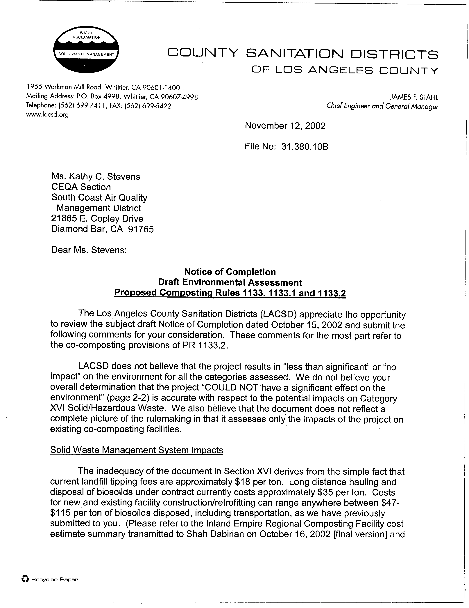
3-1
3-2
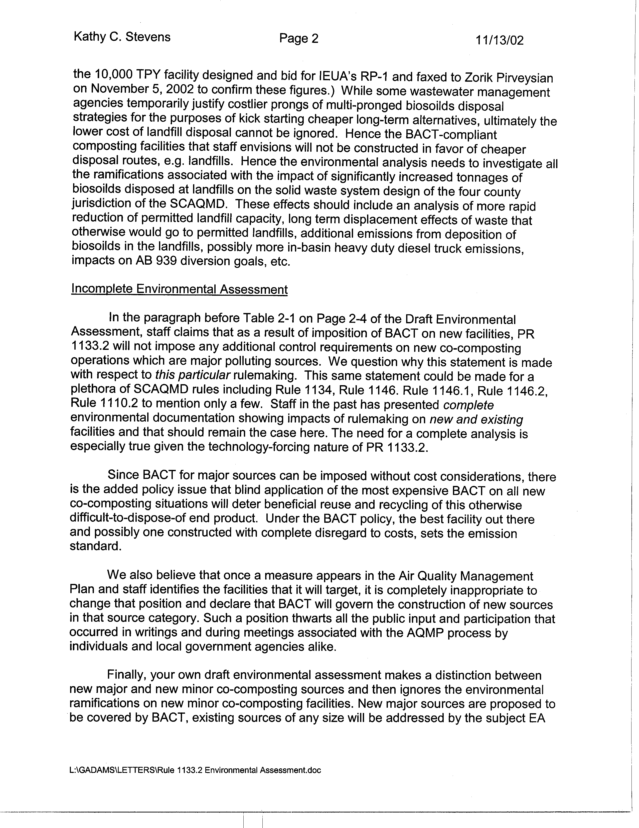
3-2
cont.
3-3
3-4
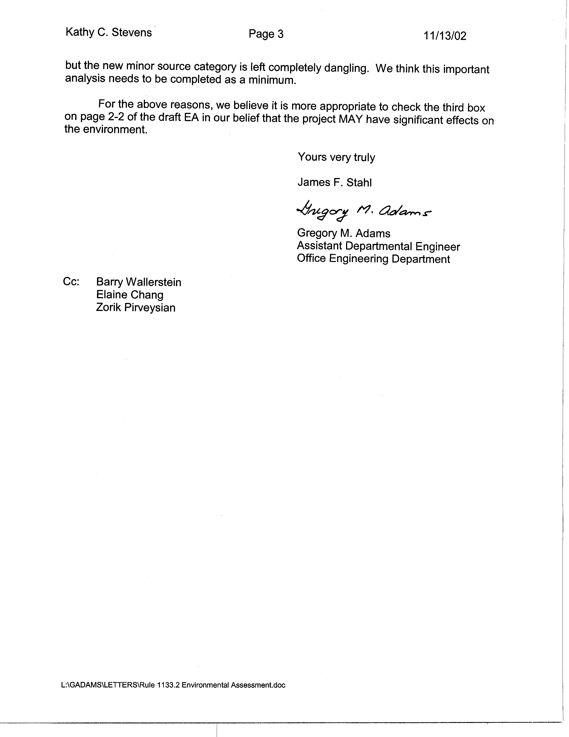
3-4
cont.
3-5
Responses to Comments from Sanitation Districts of Los Angeles County

3-1 The SCAQMD supports the conclusion of the draft EA that the proposed project will not have significant adverse impacts on the environment. Further, the SCAQMD disagrees with the commentator and believes the discussion of solid/hazardous waste issues is accurate, as explained in more detail in the following responses.

The analysis in the draft EA assumes a “worst-case” scenario for existing facilities affected by PR 1133.2. The draft EA did not include a discussion of specific affects on new facilities based on the fact that no physical information is available on any new facilities. CEQA Guidelines define “significant effect on the environment” as an adverse change in any of the physical conditions within the area affected by the project including land, air, water, minerals, flora, fauna, ambient noise, and objects of historic or aesthetic significance (CEQA Guidelines §15382), and any analysis of impacts from “future” development would be speculative. The proposed project does not require that chipping and grinding or co-composting facilities be built, the individual rules establish requirements for regulating emissions once a new facility is built. Further, issues related to siting new facilities would typically fall within the jurisdiction of local land use authorities, who would in turn prepare site-specific environmental documents. Although PR 1133.2 applies to new and existing facilities, in reality it would primarily apply to new facilities in limited circumstances where a new facility could comply with the emission reduction requirements without using equipment requiring a permit from the SCAQMD. The SCAQMD is unable to identify a scenario in which a co-composting facility would be able to control emissions without the use of equipment requiring SCAQMD permits. New co-composting facilities that control emissions using equipment subject to SCAQMD permit requirements would be subject to Regulation XIII – New Source Review, lowest achievable emission rate (LAER) or best available control (BACT) requirements, not PR 1133.2. Recent or planned new facilities in the district and in other areas of the country have indicated that they have or plan to enclose active and curing composting operations and vent to biofilters for reasons unrelated to PR 1133.2. Since these operations would comply with PR 1133.2, enclosures vented to a biofilter could be considered LAER/BACT. For these reasons, a discussion of environmental impacts from new facilities was not included in the draft EA.

3-2 The SCAQMD disagrees with the commentator’s opinion that the CEQA draft EA is inadequate in its discussion of potential solid waste impacts as stated in response to comment 3-1. Indeed the commentator acknowledges in this comment that future composting facilities would be subject to BACT requirements and, as such, costs would be related to complying with Regulation XIII, an existing regulation, BACT or LAER requirements not PR 1133.2 requirements. Consequently, the impacts identified by the commentator, i.e., effects on landfill capacity, emissions from disposal of biosolids, heavy-duty truck emissions, etc., are not anticipated as a result of adopting PR 1133.2

It should be noted that the commentator’s estimated compliance cost of $47-115 per ton is based on the assumption of complete enclosure of a co-composting facility. PR 1133.2 does not require complete facility/site enclosure. Instead, PR 1133.2 would allow both new and existing co-composting operations to employ any combinations of composting and control methods to demonstrate an overall control efficiency for VOC and ammonia emissions. The “worst-case” compliance cost of enclosing the active portions of an operation was estimated at $22 per ton of throughput.
The commentator assumes that in the future biosolids will be disposed at the local landfills as a result of adopting PR 1133.2. Assembly Bill (AB) 939--California Integrated Waste Management Act, mandates cities and counties to divert organic materials from landfills. As a result, disposal of biosolids in local landfills is extremely limited within the four-county area and, therefore, should not be considered as an option. As already noted, adopting PR 1133.2 is not expected to influence whether or not future composting facilities would be built as explained in response 3-1. As a result, the comment regarding the analysis of environmental impacts of increased tonnages of biosolids disposed at local landfills is not relevant.
3-3 The discussion entitled “Additional Information Related to New Co-Composting Facilities” was provided to inform the readers that the requirements in PR 1133.2 will not impose any additional control requirements beyond that required pursuant to the existing SCAQMD rules for New Source Review (NSR). As explained in response 3-1, any new facility that would fall under the permit process (e.g. a new co-composting facility) would fall under the SCAQMD’s NSR program. The application of either BACT or LAER is under the purview of the existing SCAQMD permit process and, therefore, is considered part of the existing setting not a component of the proposed project. Since Regulation XI rules typically apply to existing equipment, e.g., Rule 1134, the environmental analyses for these rules typically focus on the impacts of installing control equipment on the existing equipment. The environmental analyses for rules that apply specifically to new rules, e.g., Regulation XIII rules, Rule 1401, etc., typically include a projection of the number future equipment based on historical data. Since it is unlikely that PR 1133.2 will impose additional requirements on new equipment that are not already required under existing regulations, new equipment were not included in the analysis.

The comment regarding the “added policy issue of blind application of the most expensive BACT on all new co-composting situations…” indicates a misunderstanding of New Source Review requirements. Under federal New Source Performance Standards, major sources must comply with LAER requirements without consideration of economic impacts. SCAQMD New Source Review requirements cannot be less stringent than federal requirements. Complying with LAER may or may not require the most expensive equipment, the main criterion is that LAER be achieved. Minor sources, sources that have annual emissions less than major sources as defined in Rule 1302, are subject to BACT requirements, which can take into consideration economic impacts. Consequently, LAER requirements for major source composting facilities built in the future do not consider economic impacts, but this is existing federal policy, not policy being established by PR 1133.2.

3-4 The SCAQMD has not changed any policies related to analyzing the impacts of AQMP control measures as they are promulgated as rules. New stationary sources identified in AQMP control measures for which there is no source specific rule, but that are subject to permit requirements, would already be subject to New Source Review requirements. Generally, existing sources not subject to a source specific rule in the past would have been uncontrolled, like many of the existing composting facilities that would be regulated by PR 1133.2. Consequently, the environmental analyses prepared by the SCAQMD focus on impacts of reducing emissions from affected equipment only. This policy has not changed.

Regardless of whether a new co-composting facility is a major source subject to LAER or a minor source subject to BACT it is still subject to Regulation XIII requirements. As such, it is unlikely that PR 1133.2 would impose additional requirements beyond LAER or BACT. See also response to comment 3-1. Consequently, the analysis of impacts generated by the proposed project is more than adequate. In fact, the analysis of impacts generated by PR 1133.2 likely overestimates potential impacts. When the SCAQMD initially began analyzing potential adverse environmental impacts from the proposed project, including PR 1133.2, the SCAQMD identified 12 existing facilities expected to be subject to the requirements of PR 1133.2. Prior to release of the Draft EA the inventory of existing co-composting facilities was further refined and it was learned that three of the 12 facilities did not perform co-composting operations that would be subject to PR 1133.2. In an effort to ensure that impacts from PR 1133.2 were not underestimated, the analysis of impacts from 12 existing facilities remained in the Draft EA. As a result, it is likely that impacts resulting from adopting PR 1133.2 are overestimated.

3-5 For the reasons stated in responses 3-1 through 3-4 the SCAQMD disagrees with the commentator’s recommendation to check the third box on page 2-2 of the EA. Checking the first box, which indicates that the proposed project will not have a significant effect on the environment, remains appropriate.

C O M M E N T L E T T E R 4
County of Los Angeles, Dept. of Public Works
M. Michael Mohajer
November 14, 2002

3-4
cont.
3-5
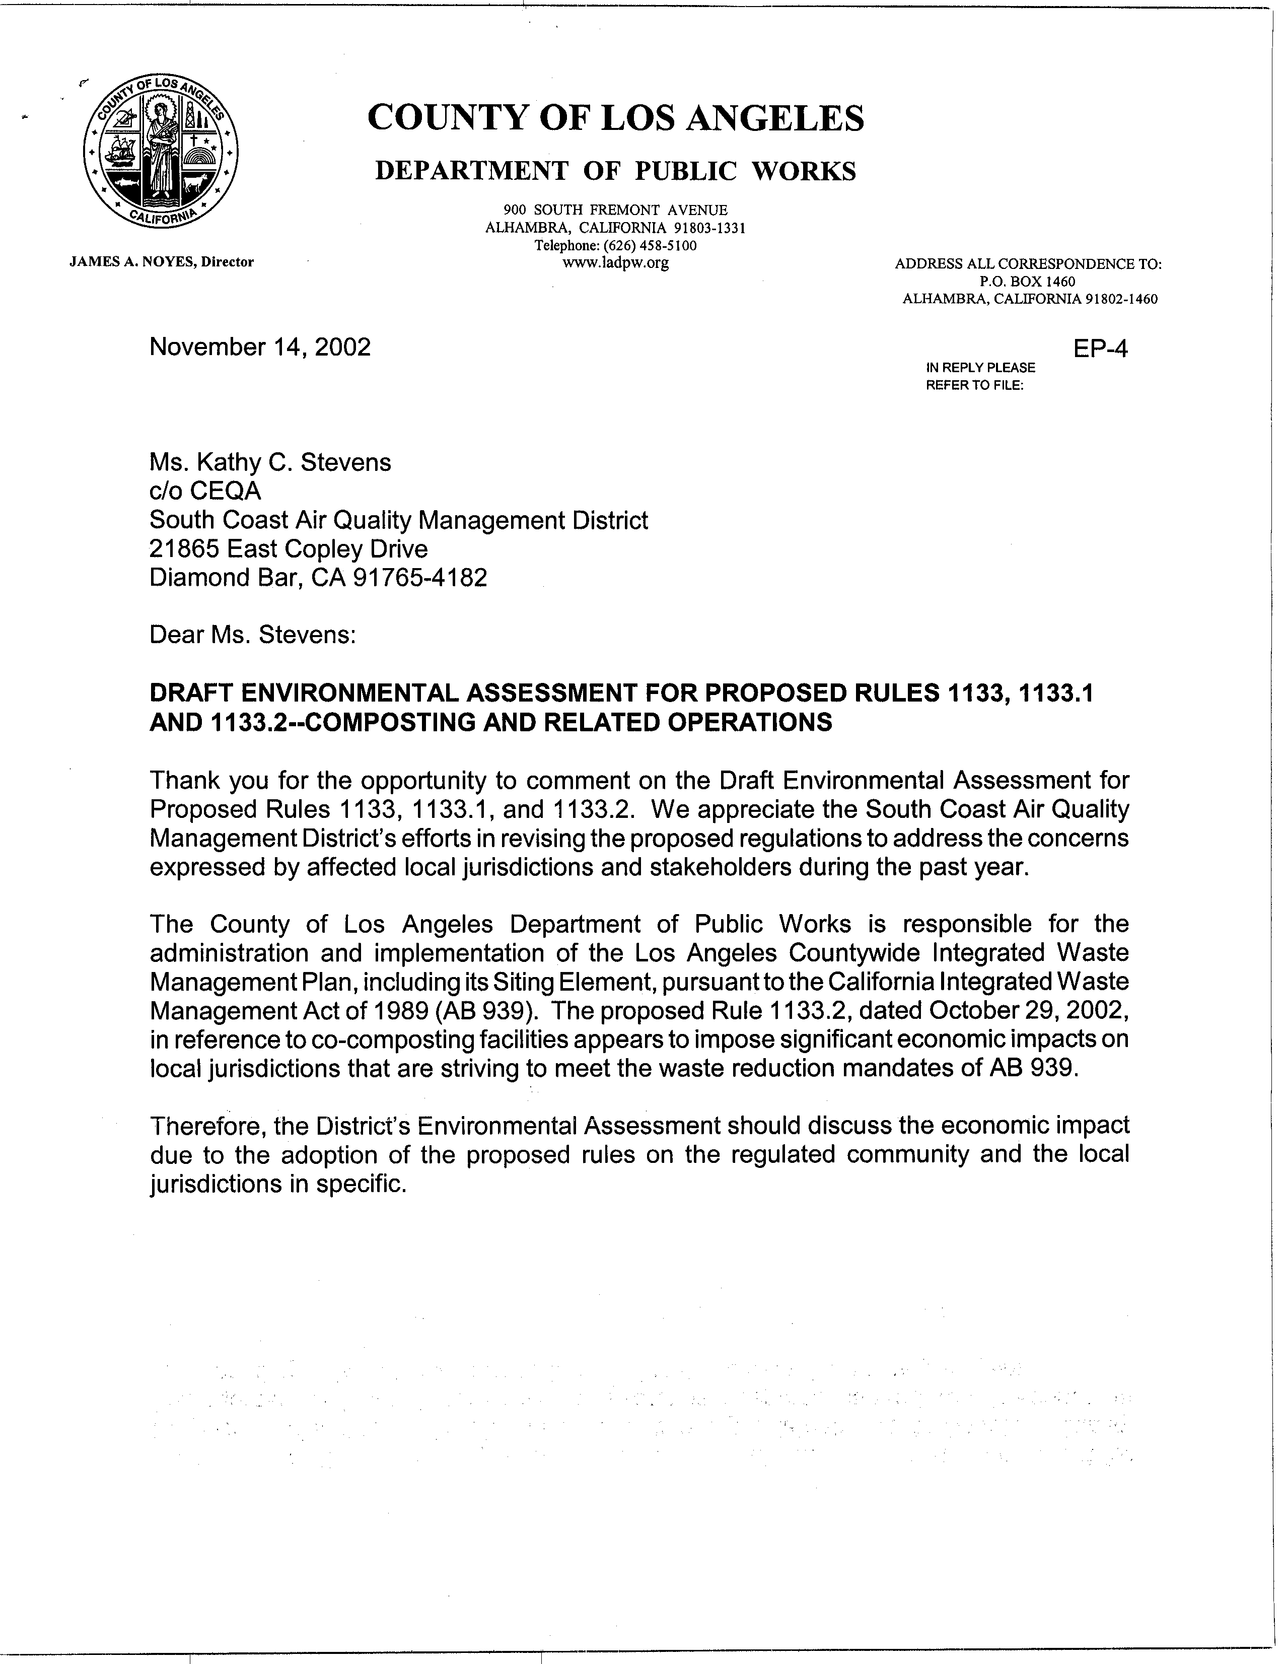
4-1
4-2

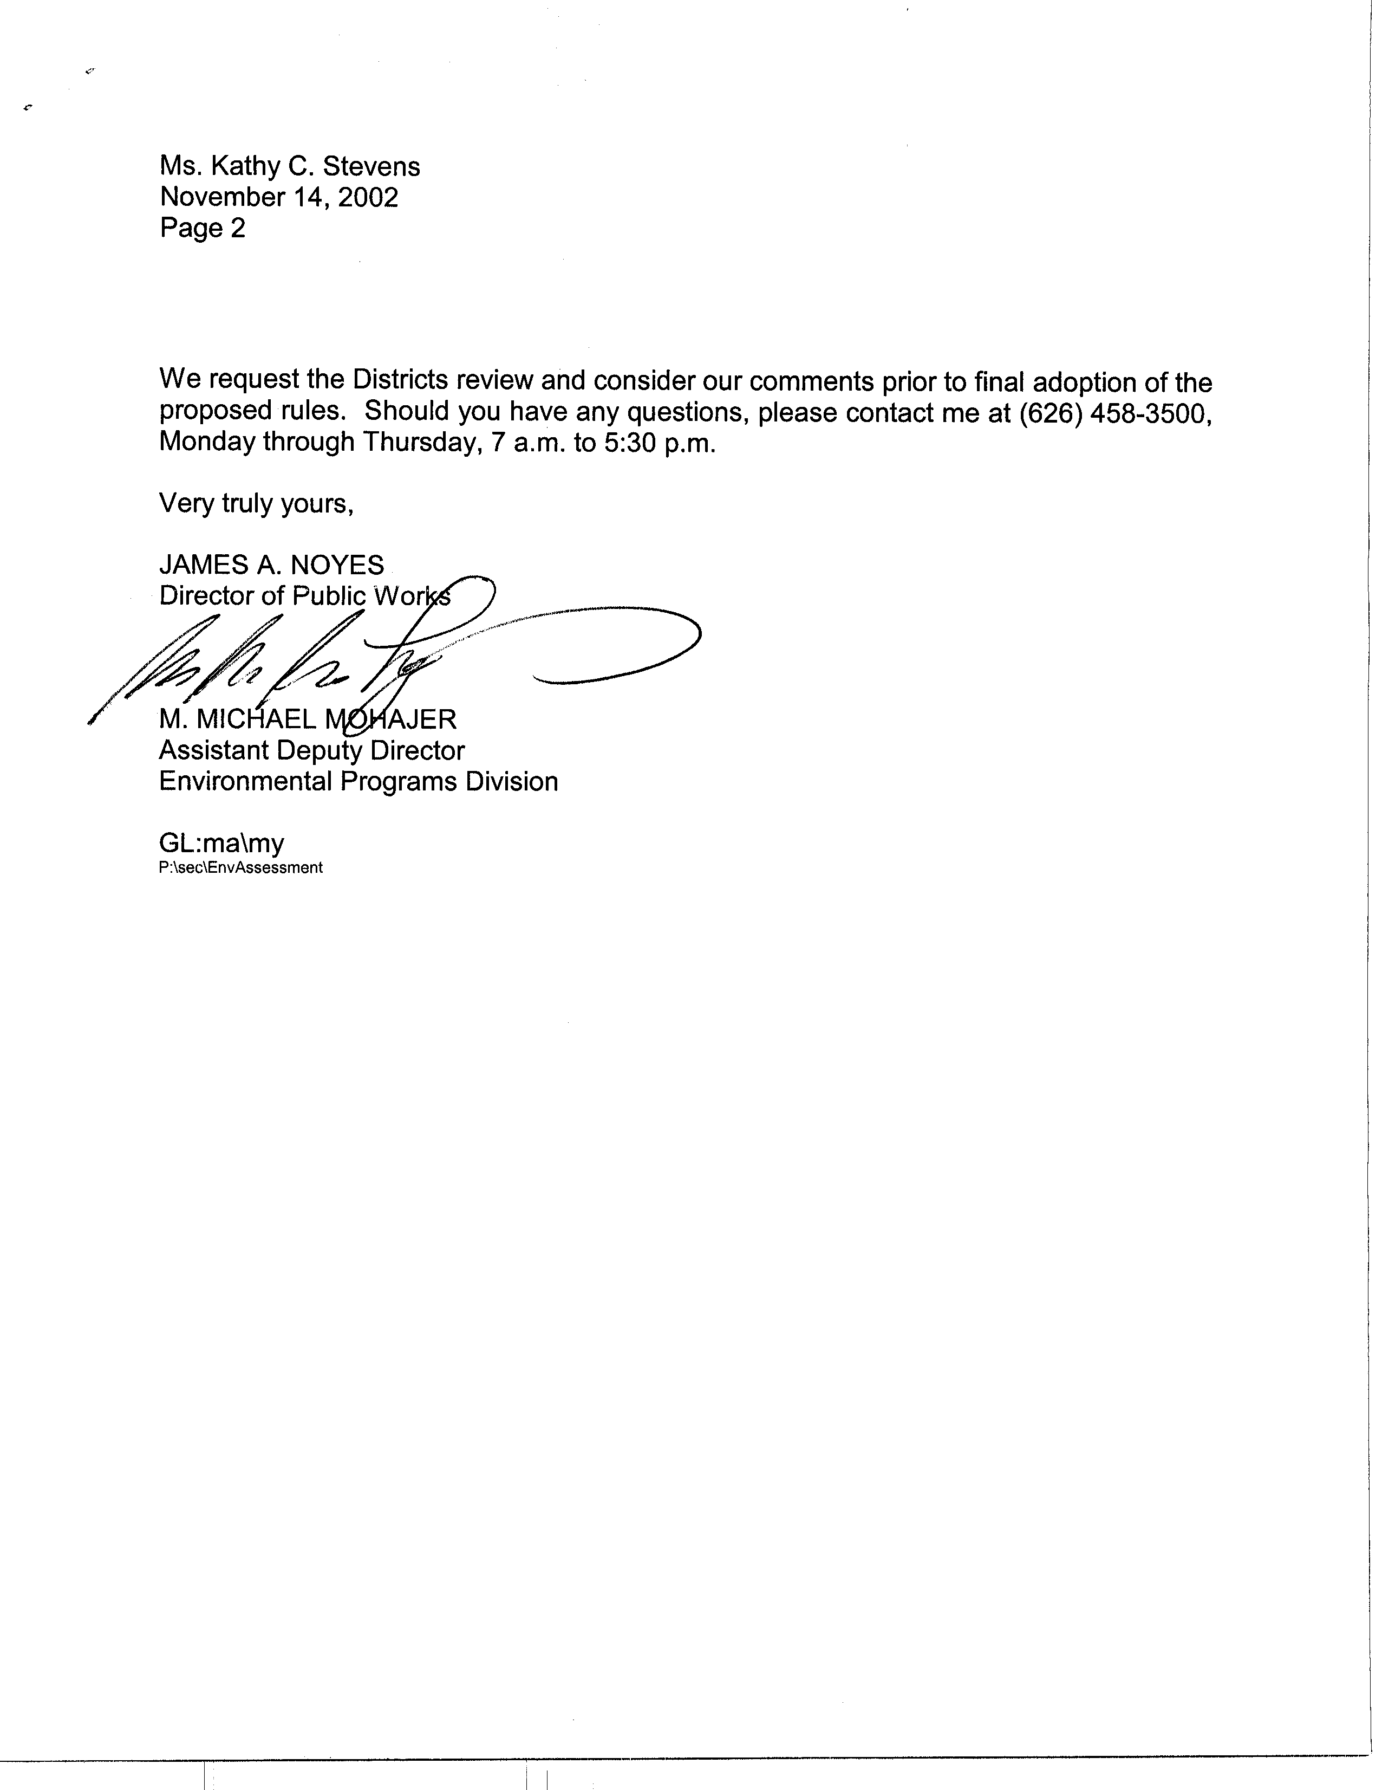
4-3
Response to Comments from Los Angeles County Department of Public Works

  - In response to the concerns and comments raised by affected local jurisdictions and stakeholders on the initial August 2001 version of proposed Rule 1133 and in response to concerns raised by the SCAQMD’s Governing Board, the August 2001 proposed rule was withdrawn. The currently proposed project, proposed Rules 1133, 1133.1 and 1133.2, has been developed with the intent to address and resolve those issues identified for the previously proposed project.

  - PR 1133.2 requires new co-composting facilities to: conduct all active co-composting within the confines of an enclosure; conduct all curing using an aeration system that operates und negative pressure for no less than 90 percent of its blower operating cycle; and vent the exhaust from the enclosure and the aeration system to an emission control system designed and operated with a control efficiency equal to or greater than 80 percent, by weight for both VOC and NH3 emissions from the baseline emission levels through a compliance plan process. PR 1133.2 also requires existing co-composting facilities to demonstrate an overall emission reduction of 70 percent, by weight, for both VOC and NH3 emissions from the baseline emission levels through a compliance plan process.

A comprehensive socioeconomic analysis was prepared for the proposed project, including PR 1133.2. The Socioeconomic Report for the proposed project indicates that the average annual cost of PR 1133.2 is $14.80 million. This translates to an increase in the price to the public utility sector where composting facilities belong of 0.092 percent in the year 2020 compared to the baseline price in that year. Further, the estimated increase in cost per household is estimated to be $0.25 per month. These compliance costs represent a worst-case analysis that all existing co-composting facilities would have to install controls to comply with PR 1133.2. However, given that two existing facilities plan to move to enclosed facilities that would be vented to biofilters regardless of adoption of the proposed project and the potential extension of one facility’s compliance date, the regional economic impact of PR 1133.2 is expected to be about 10 percent of the above values. The commentator is referred to the Socioeconomic Report for more detailed information on the proposed project.

  - Responses to all comments on the environmental analysis for PR 1133, PR 1133.1 and PR 1133.2 have been prepared and incorporated into the Final EA for the proposed project. The Final EA, Staff Report (including the proposed rules), and Socioeconomic Report will be included in the Board agenda item for the proposed project, which is submitted to SCAQMD Governing Board members for their review prior to the public hearing. The public hearing for these proposed rules is currently scheduled for January 10, 2003.

C O M M E N T L E T T E R 5
One Stop Landscape Supply Center
Louis Curti, President
November 12, 2002

4-3
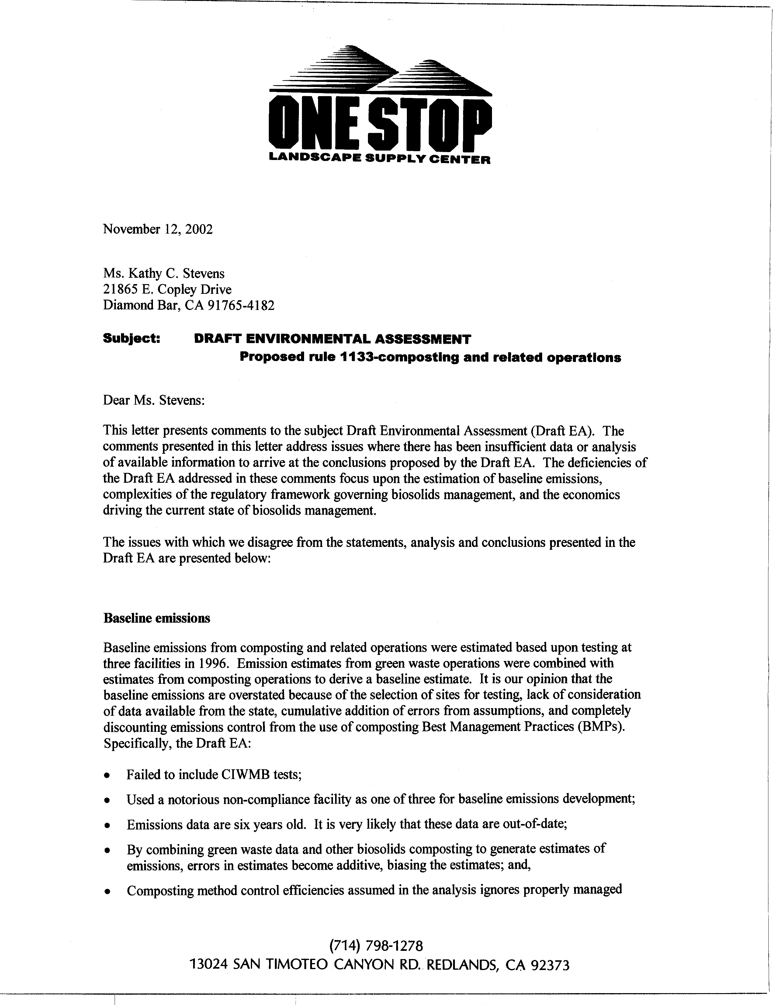
5-1
5-2
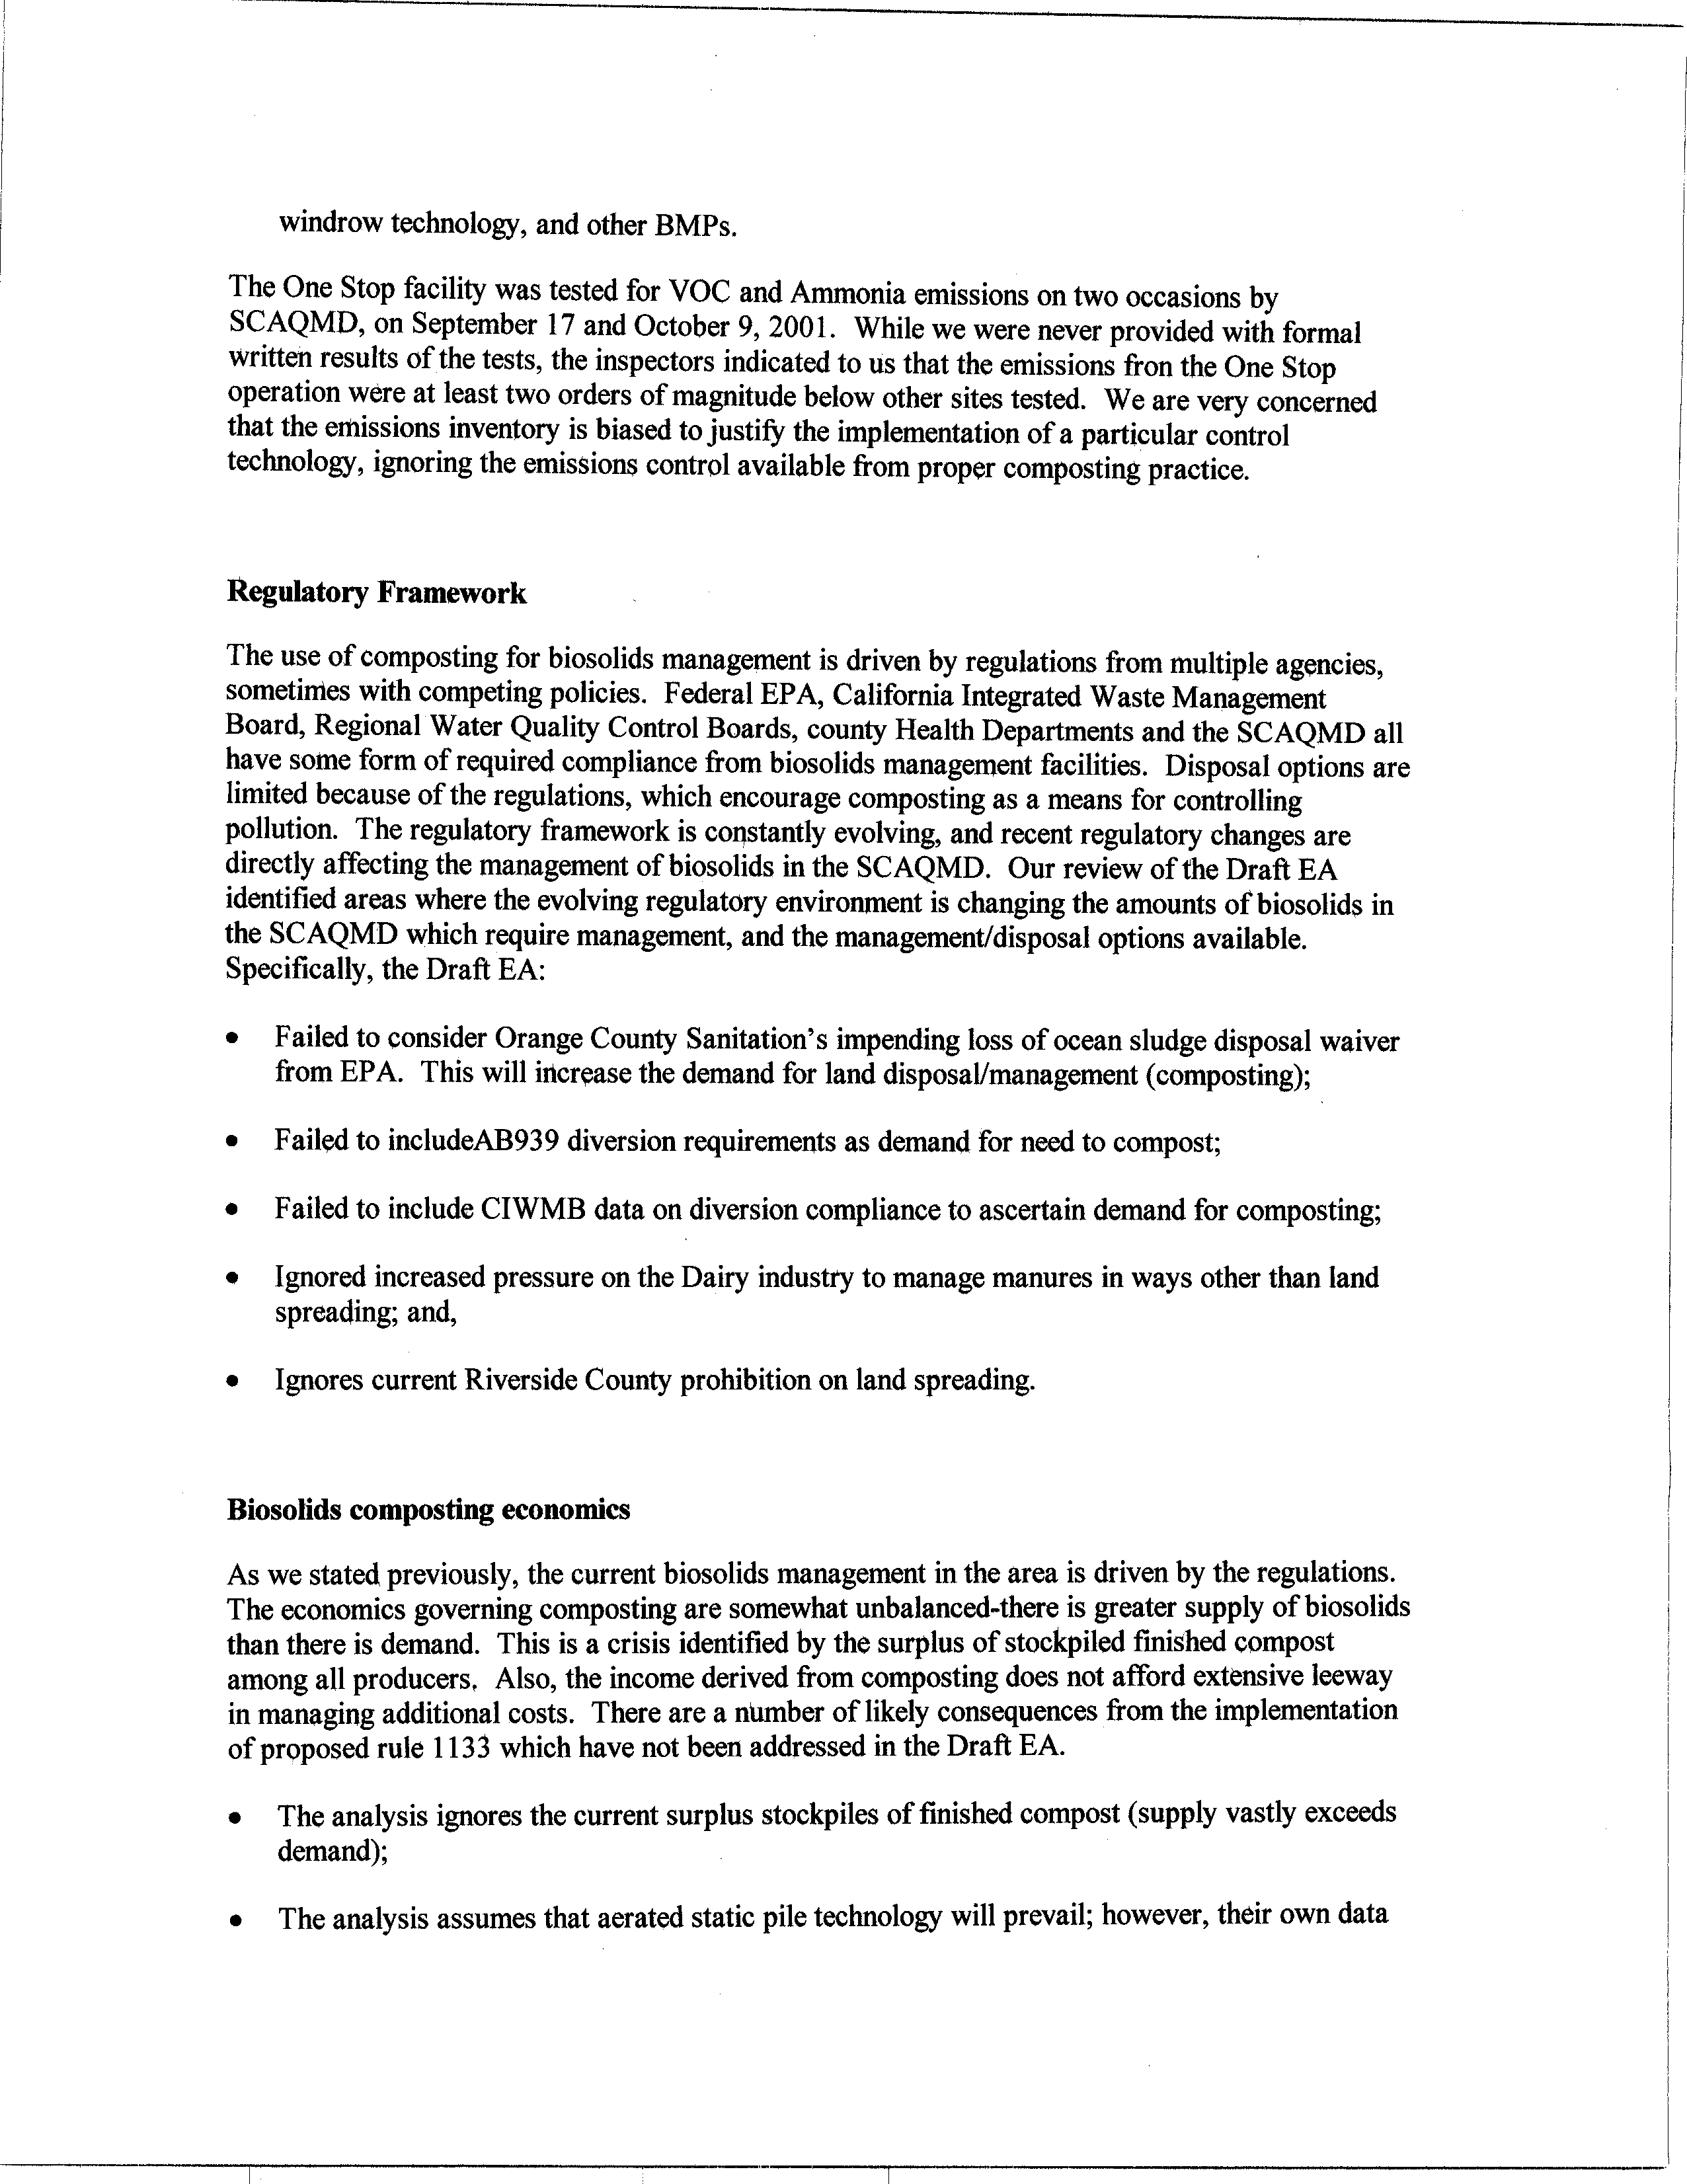
5-2
cont.
5-3
5-4
5-5
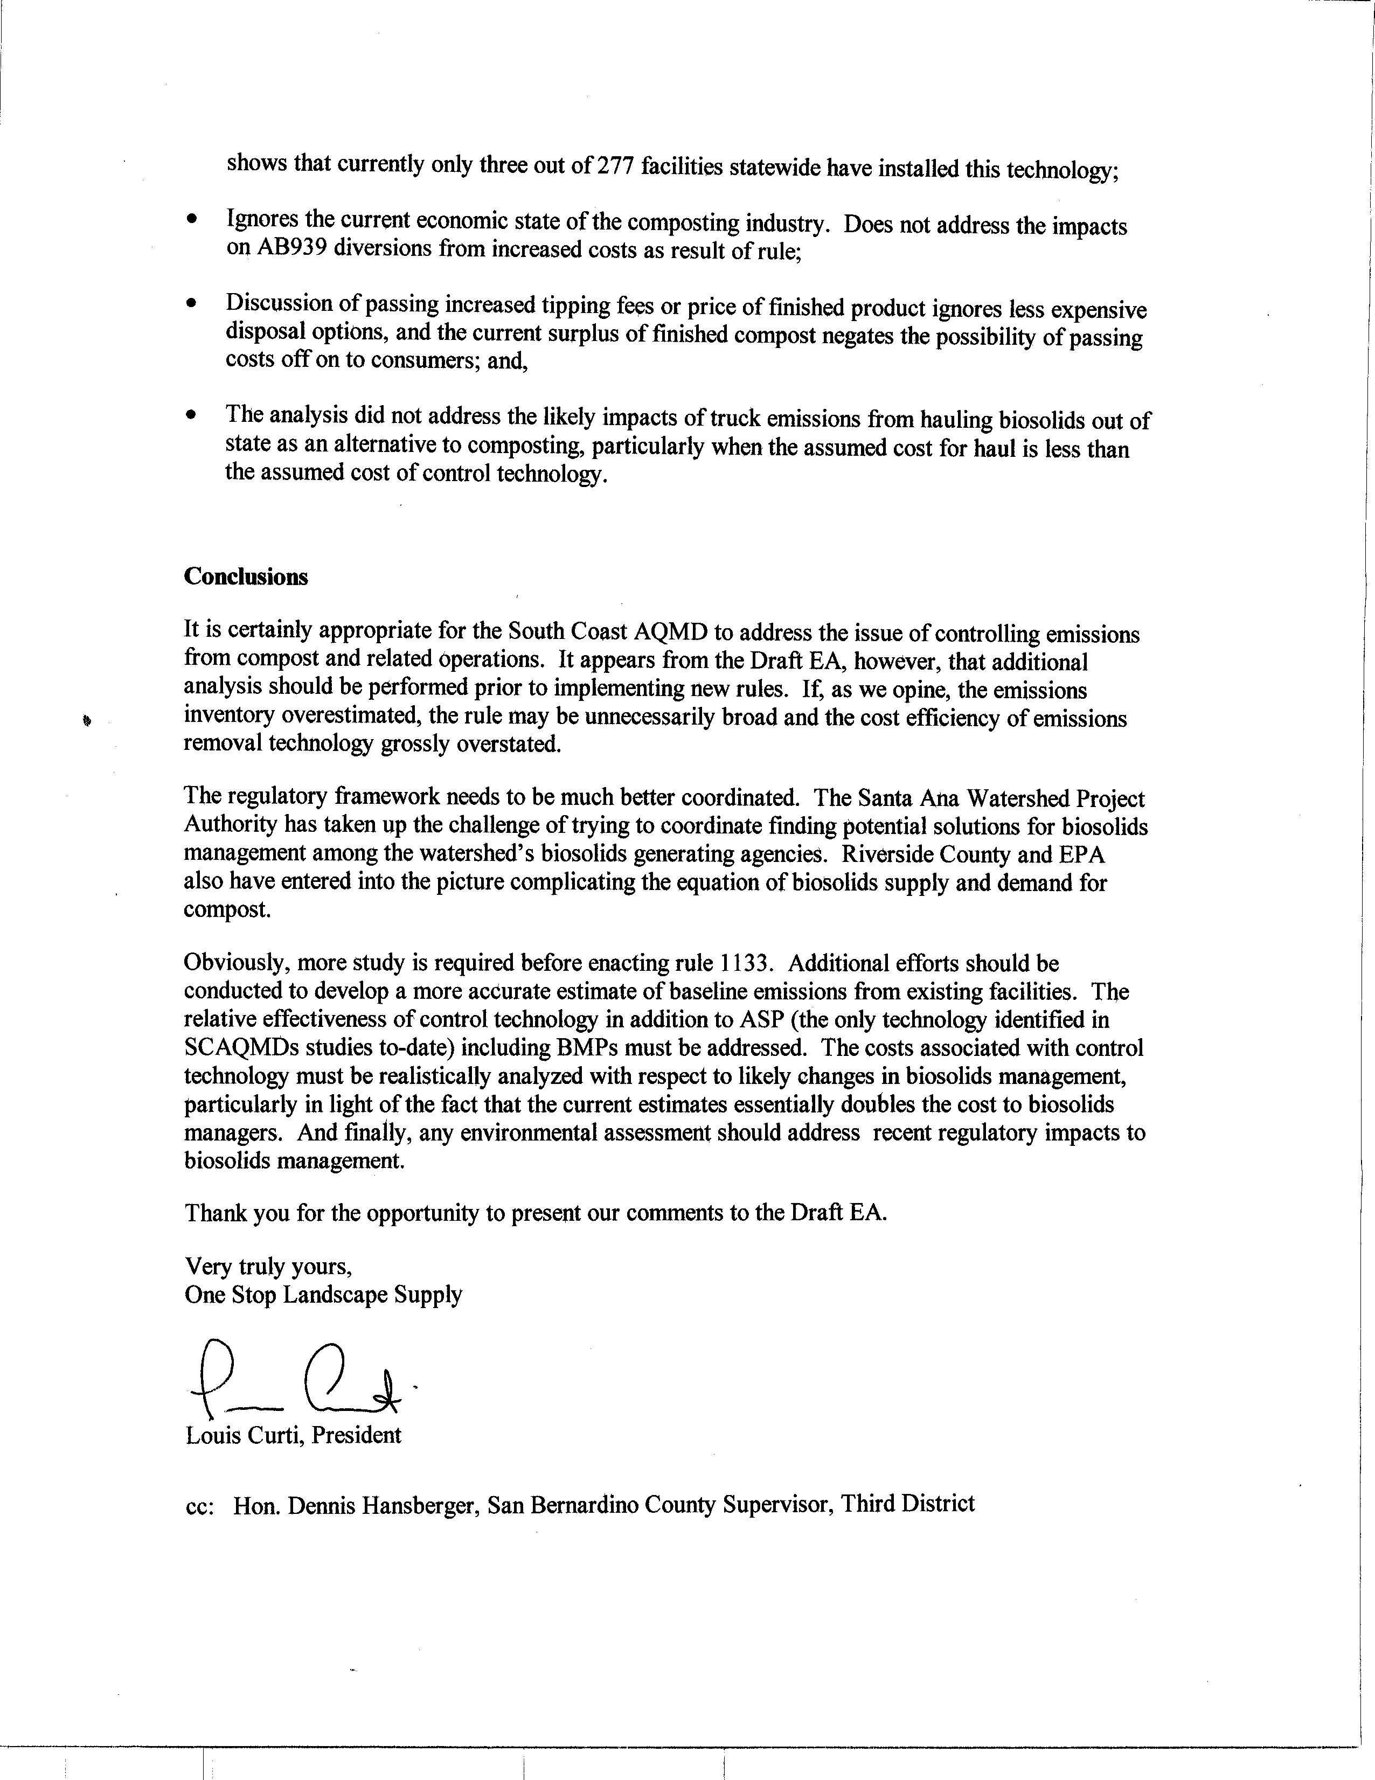
5-5 cont.
5-6
5-7
5-8
Response to Comments from One Stop Landscape Supply Center

5-1 The SCAQMD disagrees with the commentator's opinion that the analysis of environmental impacts in the Draft EA for the proposed project is deficient. The analysis of environmental impacts from the proposed project in the October 2002 Draft EA complies with all relevant CEQA requirements as explained in more detail in the following responses.

The Draft EA for proposed Rules 1133, 1133.1 and 1133.2 concludes that the proposed project (the implementation of all three proposed rules) will not have a significant adverse impact on the environment. As stated on page 1-2 of the draft EA, an environmental impact is defined as an impact to the physical conditions which exist within the area which would be affected by a proposed project, including land, air, water, minerals, flora, fauna, noise or objects of historic significant.

The analysis included in the draft EA focuses on the potential adverse impacts associated with (a) registration requirements in PR 1133; (b) maximum holding and processing time requirements in PR 1133.1, which are based on existing chipping and grinding practices; and (c) operational requirements to control ammonia (NH3) and VOC emissions from co-composting in PR 1133.2. The SCAQMD disagrees with the commentator's opinion that the draft EA is deficient based on the fact that it did not address the specific complexities of the regulatory framework governing biosolids management and the economics driving the current state of biosolids management. PR 1133 will not affect biosolids management because it is an administrative rule to create an information database for composting and related operations through a registration process. PR 1133.1 will not affect biosolids management because it sets forth maximum holding time for chipping and grinding activities, which are activities that are already part of the existing practices at affected chipping and grinding facilities. Similarly, PR 1133.2 does not establish requirements for biosolids management; it sets forth requirements for co-composting operations to reduce NH3 and VOC emissions. Although existing facilities would have to modify operations to comply with PR 1133.2 based on the cost analysis in the Socioeconomic Report (see also response to comment 5-5), there is no evidence that affected facilities could not afford the additional compliance costs, which will benefit public health through improving air quality in the region.

5-2 With regard to establishing a baseline emissions inventory, as stated on page 1-8 of the Draft EA, no emissions inventory was prepared for PR 1133 due to its administrative nature; and no emissions inventory was compiled for PR 1133.1 because it generally establishes maximum holding and processing time requirements, which are based on normal chipping and grinding activities and the purpose of the proposed rules is to prevent deterioration of existing emissions. The emissions inventory for PR 1133.2 was developed based on 2001 annual throughput data from a number of facilities identified as being affected by the proposed rule and SCAQMD baseline emission factors. The current emissions inventory for affected facilities is 1.67 tons per day for VOC and 2.74 tons per day for NH3. This emissions inventory was estimated by multiplying the annual throughput of the number of facilities identified as being affected by the proposed rule, by AQMD baseline emission factors using the following equation:

Eq. 1. Total annual emissions (lbs/year) = total yearly throughput (tons/yr) x emission factor (lbs/ton).

The emission factors used to estimate ammonia and VOC emissions from co-composting operations were developed based on data from three windrow co-composting facilities. As part of the PM10 Technical Enhancement Program (PTEP), the AQMD staff conducted an emission evaluation of four co-composting facilities that agreed to be tested, including one state-of-the art in-vessel facility where emissions are captured in an enclosure and vented to a biofilter. However, only data from windrow composting were used to develop the baseline emission factors for uncontrolled co-composting operations since windrow composting represents the current state of the industry in the district. The EPA-approved Emission Isolation Flux Chamber method was utilized during the testing. Greenwaste emissions data were not utilized to derive the emission factors for co-composting as they are not relevant. In addition, under PR 1133.2, operators of co-composting facilities have the option of establishing their own baseline emission factors in lieu of using AQMD’s baseline emission factors. (Refer to the Technology Assessment for PR 1133 dated March 22, 2002 for a detailed discussion of emission factor development.)

The emission factors for greenwaste composting were developed based on results from the early fall and early winter source tests conducted by the SCAQMD in 2001. These emission data are compatible with the corrected combined emission data obtained from both SCAQMD and California Integrated Waste Management Board (CIWMB) source tests.

As stated on page three and four of the Technology Assessment for PR 1133, dated March 22, 2002, the SCAQMD is proposing no requirements on greenwaste composting at this time. The registration requirements for all composting and related operations are intended to primarily track operations and emissions, so that emission reductions can be claimed if specific controls are implemented in the future.

None of the proposed rules, PR 1133, 1133.1 and 1133.2, evaluated in the draft EA include requirements for greenwaste composting operations. For this reason, the CIWMB testing at greenwaste facilities was not included in the draft EA. PR 1133.2 sets forth requirements for co-composting operations, which include biosolids as a feedstock in the process; however, the emissions data do not combine greenwaste data with biosolids data.

5-3 The tests mentioned by the commentator refer to inspector’s on-site measurements using hand-held measuring equipment. However, PR 1133.2 specifies the applicable test methods which must be used to demonstrate compliance with the emission reduction targets of the proposed rule.

Based on the control requirements of PR 1133.2 for existing facilities such as the One Stop facility, the proposed project does not require a particular control technology. Instead, PR 1133.2 establishes, through submittal of a compliance plan emission reduction requirements, emission reductions of 70 percent by volume for both VOC and NH3 emissions from baseline emissions. Operators of affected facilities can choose any combination of technologies to achieve the emission reduction requirements. Consequently, the assertion that the emission inventory established by the SCAQMD is biased to justify a particular control technology is not supported by the actual emission control requirements in PR 1133.2.

5-4 The SCAQMD disagrees with the commentator's opinion that the proposed rules evaluated in the draft EA change the amount of biosolids in the district that require management and the management/disposal options. As explained in more detail in the following paragraphs, adopting PR 1133.2 is unrelated to, or will have little of no effect activities being undertaken by other agencies that are identified in this comment.

The analysis included in the draft EA focused on the potential impacts associated with registration requirements (PR 1133) and maximum holding and processing time requirements for chipping and grinding operations [PR 1133.1], which are already part of the normal operations at existing chipping and grinding facilities. Since neither of these proposed rules affect facilities that handle biosolids, they will not be discussed further in this response. Although some biosolid materials are used as feed stocks at co-composting operation; requirements to control NH3 and VOC emissions from co-composting [PR 1133.2] are not expected to affect the generation or ultimate disposal of biosolids materials. PR 1133.2 does not direct the amount of material to be disposed or direct the method of disposal of composting materials provided emission reduction objectives are met. Refer to the response to comment 5-1 for additional information regarding why the proposed project will not affect biosolids management.

The draft EA did not include a discussion regarding the Orange County Sanitation District's restrictions on ocean sludge disposal because this is considered part of the existing setting and is unrelated to regulating emissions at co-composting facilities. Ocean disposal of biosolids was terminated by Congress in 1989. According to its website, Orange County Sanitation District currently land applies Class B biosolids in three counties in California, on tribal lands, and in Arizona. PR 1133.2 will not affect the Orange County Sanitation District’s current practice of land application nor will it restrict other biosolids waste disposal options due to the fact that the proposed rule does not deter the disposal of waste materials via composting or co-composting.

The draft EA evaluated the impact of the proposed rules on the goals of AB 939 and corresponding diversion requirements. The analysis concluded that the proposed rules do not prevent composting or co-composting operations, nor will they result in the closure of existing facilities or affect the future construction of new facilities. As a result, the proposed project is not expected to affect in any way the waste diversion mandates in AB 939.

The SCAQMD collected data on composting from a number of sources including CIWMB data. The SCAQMD also conducted a survey of composting and related facilities on the amount of material being composted and other uses of compost feedstock materials (see the SCAQMD’s Technology Assessment for Proposed Rule 1133, March 2002 for additional information on the survey). According to the Technology Assessment, based on available data the SCAQMD has not been able to quantify the extent to which the various waste disposal programs are being used to comply with AB 939 waste diversion goals. As a result, promulgation of the proposed rules relied to a certain extent on a qualitative assessment of survey and other information to determine the relative importance of each type of waste diversion program. Based upon all of the information available to the SCAQMD, the proposed project is not expected to adversely affect waste diversion compliance by other public agencies.

Current prohibitions, including those in Riverside County, on the dairy industry to manage manure in ways other than land spreading are unrelated to the proposed project. Regional Water Quality Control Board (RWQCB) requirements regarding managing cow manure are already in affect. As a result, dairies are already managing cow manure by shipping it out of the district to fertilizer operations in the San Joaquin Valley, using it as a feedstock for co-composting operations, or land spreading it on agricultural land. The primary means of managing cow manure pursuant to RWQCB regulations is to ship it out of the district to the fertilizer operations in the San Joaquin Valley. Since cow manure is already being shipped as a potential feedstock to existing co-composting facilities in the district, PR 1133.2 will not affect this or any of the other manure management practices.

5-5 The socioeconomic analysis for PR 1133, 1133.1, and 1133.2 discusses the current economic state of the composting industry, and the additional compliance costs of the proposed rules. This analysis also includes a discussion of additional costs to the cities and local municipalities, which would then pass these costs on to the rate payers. Some of the key results of the analysis are summarized in the following paragraphs. For more detailed information on tipping fees; costs of disposal options; costs passed on to each individual household; etc; the commentator is referred to the Socioeconomic Report for the proposed project.

PR 1133 is an administrative rule to create an information database for composting and related operations through a registration process. According to the Socioeconomic Report for the proposed project, the total compliance cost for all existing affected facilities subject to PR 1133 would be $6,630 for the one-time registration fee or $89.59 per facility.

PR 1133.1 sets forth maximum holding time for chipping and grinding activities. According to the Socioeconomic Report for the proposed project, there are no additional compliance costs for holding processing time requirements because these activities are already part of the existing practices at affected chipping and grinding facilities.

PR 1133.2 requires new co-composting facilities to: conduct all active co-composting within the confines of an enclosure; conduct all curing using an aeration system that operates und negative pressure for no less than 90 percent of its blower operating cycle; and vent the exhaust from the enclosure and the aeration system to an emission control system designed and operated with a control efficiency equal to or greater than 80 percent, by weight for both VOC and NH3 emissions from the baseline emission levels through a compliance plan process. PR 1133.2 also requires existing co-composting facilities to demonstrate an overall emission reduction of 70 percent, by weight, for both VOC and NH3 emissions from the baseline emission levels through a compliance plan process. The Socioeconomic Report for the proposed project indicates that the average annual cost of PR 1133.2 is $14.80 million. This translates to an increase in the price to the public utility sector where composting facilities belong of 0.092 percent in the year 2020 compared to the baseline price in that year. Further, the estimated increase in cost per household is estimated to be $0.25 per month. These compliance costs represent a worst-case analysis that all existing co-composting facilities would have to install controls to comply with PR 1133.2. However, given that two existing facilities plan to move to enclosed facilities that would be vented to biofilters regardless of adoption of the proposed project and the potential extension of one facility’s compliance date, the regional economic impact of PR 1133.2 is expected to be about 10 percent of the above values.

If, as suggested by the commentator, current biosolids supplies exceed demand and current surplus stockpiles of finished compost exceed demand, this situation is part of the existing setting and would not be an effect of adopting PR 1133.2. Further, PR 1133.2 regulates emissions from the active and curing phases of the composting process, not the finished product. As indicated in the preceding paragraph, there would be costs imposed on existing composting facilities, but these costs, which are projected to be minimal, would likely be passed on to households in the region. For these reasons, PR 1133.2 is expected to have minimal or no effect on biosolids management.

It is not clear why the commentator assumes that aerated static pile technology will “prevail” or be the technology of choice. To provide a conservative “worst-case” analysis of potential adverse impacts from PR 1133.2, it was assumed in the EA that co-composting facilities subject to PR 1133.2 would comply with the emission reduction requirements through enclosing the active composting phase of the operation and venting emissions to a control device. PR 1133.2 does not dictate the method of compliance, but allows the co-composting facility operator the flexibility of choosing the most appropriate compliance option based on the individual operating characteristics at the facility.

According to the Socioeconomic Report for the proposed project, based on a study sponsored by the CIWMB in 2000, tipping fees for sewer sludge ranges from $30 to $40 per ton. As part of an earlier analysis for the August 2001 version of PR 1133, the SCAQMD analyzed the cost of hauling compost materials out of the district to Arizona (the most likely destination given current restrictions on landfilling biosolids) under two scenarios (see the Technology Assessment for Proposed Rule 1133; SCAQMD, March 2002). The first scenario included hauling 100 percent of the compost materials out of California and the second scenario consisted of hauling 75 percent of all compost materials out of the state. The tipping fees under these two scenarios ranged from $35 to $38 per ton. In addition to tipping fees, hauling costs to transport compost materials to Arizona were estimated to be $33 per ton. Based on the additional costs associated with shipping compost materials to Arizona, it was assumed that hauling compost materials would not necessarily be the most economical compliance option so an analysis of truck emissions from waste hauling was not included in the EA. As a result, the EA evaluated potential adverse impacts from more likely compliance options.

5-6 As indicated in response to comment 5-2, the emissions inventory for PR 1133.2 was developed based on 2001 annual throughput data from a number of facilities identified as being affected by the proposed rule and SCAQMD baseline emission factors. Further, the emission factors used to estimate ammonia and VOC emissions from co-composting operations were developed based on data from three windrow co-composting facilities. As a result, the emissions inventory was developed based upon the best data available to the SCAQMD. The commentator has provided no data or other information that disputes the SCAQMD’s estimated emission inventory. Consequently, unless new data or other information is provided to the SCAQMD it would serve no purpose to perform additional inventory analyses using the same data set.

5-7 Biosolids management is outside of the scope of the proposed project, including PR 1133.2, and is not within the jurisdictional authority of the SCAQMD. Other state, local and even federal agencies have specific roles relating to the regulation of waste management practices, including biosolids management; water quality; land use; air pollution control; etc. PR 1133.2 does not dictate how compost feed stocks such as biosolids are handled; it requires controlling emissions during certain phases of the composting process.

During the rule promulgation process for the proposed project, the SCAQMD made substantial efforts to coordinate rule development with agencies such as CIWMB, sanitation districts, and the RWQCBs to ensure that the proposed rules do not conflict with waste management regulations or hinder waste diversion mandates under AB 939. Indeed, input from the agencies identified here, as well as other stakeholders and interested parties resulted in the SCAQMD withdrawing the August 2001 version of PR 1133 and developing individual source specific rules to tailor the emission control requirements more specifically to the characteristics of the industry being regulated, while still obtaining necessary emission reductions that would contribute to attaining and maintaining all ambient air quality standards.

5-8 With regard to estimating baseline emissions, the commentator is referred to the response to comment 5-2. With regard to the applicable control technologies, the commentator is referred to the response to comment 5-5. More detailed information on control technologies can be found in Chapter 1 of the EA and Chapter 3 of the Technology Assessment for Proposed Rule 1133 (Attachment A to the Staff Report for proposed Rules 1133, 1133.1, and 1133.2). Costs associated with control technologies are comprehensively described and analyzed in the Socioeconomic Report for the proposed project. Finally, as noted in response to comment 5-7, biosolids management is outside the scope of PR 1133.2. Based on the preceding responses to comments, no new information has been presented by the commentator that would warrant additional analysis.

C O M M E N T L E T T E R 6
California Regional Water Quality Control Board
Dixie B. Lass, Chief
October 31, 2002
5-5
cont.
5-6
5-7
5-8
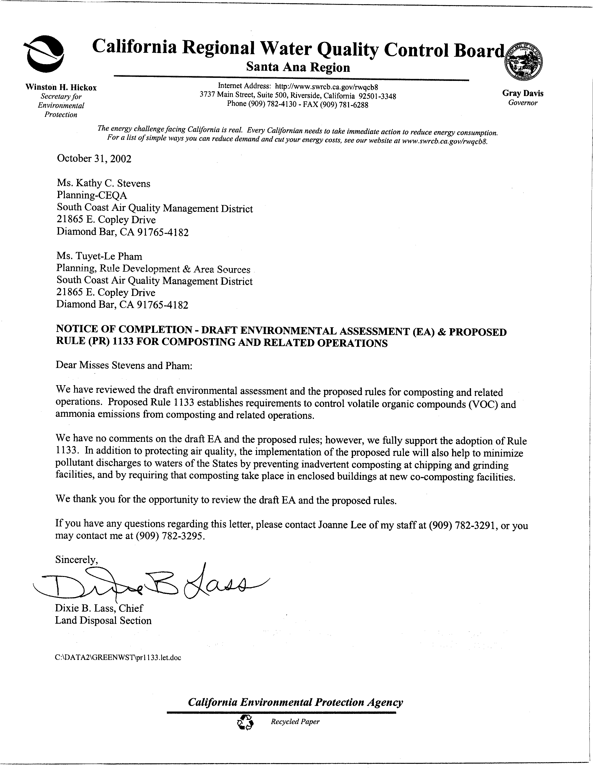
6-1
Response to Comments from California Regional Water Quality Control Board

6-1 The SCAQMD appreciates receiving this comment letter from the California Regional Water Quality Control Board – Santa Ana Region, which expresses support for the proposed project. The SCAQMD understands that the commentator has no comments on the Draft EA for the proposed project. This comment letter will be included in the administrative record for PR 1133, PR 1133.1 and PR 1133.2.

The Lewis-Presley Air Quality Management Act (Health & Safety Code §40400-40540).
Health & Safety Code §40460(a).
Health & Safety Code §40440(a).

