south coast air quality management district

Final Environmental Assessment for:
Proposed Amended Rule 1122- Solvent Degreasers

November 7, 2002
SCAQMD No. 020822MK

Executive Officer
Barry R. Wallerstein, D.Env.
Deputy Executive Officer
Planning, Rule Development and Area Sources
Elaine Chang, DrPH
Assistant Deputy Executive Officer
Planning, Rule Development and Area Sources
Laki Tisopulos, Ph.D.
Planning and Rules Manager
CEQA and Socioeconomic Analysis
Susan Nakamura

Author: Michael Krause Air Quality Specialist

Technical Rizaldy Calungcagin Air Quality Engineer II
Assistance:

Reviewed By: Steve Smith, Ph.D. Program Supervisor
William Wong Senior Deputy District Counsel
Louis Yuhas Air Quality Analysis and Compliance Supervisor
South coast air quality management district
governing board

Chairman: NORMA J. GLOVER
Councilmember, City of Newport Beach
Cities Representative, Orange County

Vice Chairman: WILLIAM A. BURKE, Ed.D.
Speaker of the Assembly Appointee

MEMBERS:

MICHAEL D. ANTONOVICH
Supervisor, Fifth District
Los Angeles County Representative

HAL BERNSON
Councilmember, City of Los Angeles
Cities Representative, Los Angeles County, Western Region

JANE W. CARNEY
Senate Rules Committee Appointee

BEATRICE J.S. LAPISTO-KIRTLEY
Councilwoman, Fifth District, City of Bradbury
Cities Representative, Los Angeles County, Eastern Region

Ronald O. Loveridge
Mayor, City of Riverside
Cities Representative, Riverside County

JON D. MIKELS
Supervisor, Second District
San Bernardino County Representative

LEONARD PAULITZ
Mayor Pro Tem, City of Montclair
Cities Representative, San Bernardino County

JAMES SILVA
Supervisor, Second District
Orange County Representative

CYNTHIA VERDUGO-PERALTA
Governor's Appointee

S. ROY WILSON, Ed.D.
Supervisor, Fourth District
Riverside County Representative

EXECUTIVE OFFICER:

BARRY R. WALLERSTEIN, D.Env.
Table of contents

CHAPTER 1 - PROJECT DESCRIPTION

Introduction 1-1
Legislative Authority 1-2
California Environmental Quality Act 1-2
Project Location 1-3
Project Background 1-4
Project Objective 1-8
Project Description 1-8
Emission Inventory 1-9

CHAPTER 2 - ENVIRONMENTAL CHECKLIST

Introduction 2-1
General Information 2-1
Environmental Factors Potentially Affected 2-2
Determination 2-2
Environmental Checklist and Discussion 2-4

APPENDIX A - Proposed Amended Rule 1122
APPENDIX B – Comment Letters on the Draft EA and Responses to the Comment Letters

List of Figures

Figure 1-1: South Coast Air Quality Management District 1-4

List of Tables

Table 1-1: Facilities Using the Rule 1122 Exemption, Primary Operations
and Solvents Used 1-6
Table 1-2: Emissions Inventory of Small Batch-Loaded Cold
Cleaners and Vapor Degreasers 1-9
Preface

This document constitutes the Final Environmental Assessment (EA) for the amendments to Rule 1122 – Solvent Degreasers. The Draft EA was released for a 45-day public review and comment period starting August 22, 2002 and the close of comments was extended to October 15, 2002. No comment letters were received from the public. Minor modifications have been made to the Draft such that it is now a Final EA. Deletions and additions to the text of the EA are denoted using strikethrough and italics, respectively.

C H A P T E R 1 - P R O J E C T D E S C R I P T I O N

Introduction
Legislative Authority
California Environmental Quality Act
Project Location
Project Background
Project Objectives
Project Description
Emission Inventory

Introduction
Volatile organic compound (VOC) emissions are major contributors to the formation of ozone (key ingredient of smog) in the South Coast Air Basin (Basin). The formation of ozone occurs as VOCs react with oxides of nitrogen (NOx) in the atmosphere. Ozone, a criteria pollutant, has been shown to adversely affect human health. It also contributes to the formation of another criteria pollutant, particulate matter with a diameter less than 10 microns (PM10).
South Coast Air Quality Management District (SCAQMD) Rule 1122 – Solvent Degreasers, was adopted on March 2, 1979, to control VOC emissions from solvent degreasing operations. The rule establishes both equipment and operating requirements for any type of solvent degreasing operation. Industries subject to the provisions of Rule 1122 include any facility that operates degreasing equipment that removes contaminants as part of its production process. Solvent degreasing involves the use of solvents, in either liquid or vapor phase, to remove contaminants such as dirt, oil, soil, and grease from parts, products, tools, machinery, and equipment.
The 1997 amendments to Rule 1122 required that cleaning materials used in cold cleaning operations contain no more than 50 grams per liter of VOC. The 1997 amendments also included a limited exemption that allowed the continued use of high VOC solvents until January 1, 2003 for small batch-loaded cold cleaners and vapor degreasers for specific types of cleaning applications. These cleaning applications included electrical, high precision optics or electronics applications; or aerospace and military applications for cleaning solar cells, laser hardware, space vehicle components and fluid systems. The solvent used in this equipment is limited to less than five gallons per calendar month. Subsequent 2001 amendments to Rule 1122 further reduced the VOC content limit to 25 grams per liter by January 1, 2003.
The SCAQMD performed a Technology Assessment this year to determine whether it is necessary to continue the exemption of small¹ batch-loaded cold cleaners and vapor degreasers from the requirements of Rule 1122. The assessment involved numerous site visits to facilities affected by the exemption and a study of any advancement in cleaning technology since the 1997 rule amendment. The assessment concluded that while most affected facilities have made efforts to find alternatives to their solvent cleaning application, most have not successfully converted yet. Thus, the proposed amendments will extend the sunset date of January 1, 20056, for the existing exemption of small¹ batch-loaded cold cleaners and vapor degreasers from the requirements of Rule 1122. In addition, the proposed amendments include adding the definition of “high precision optics” to clarify that it has the same meaning as that in Rule 1171. Further, the rule requires a Technology Assessment by year 20045 to determine whether to retain the exemption of small batch-loaded cold cleaners and vapor degreasers from the requirements of Rule 1122.
Pursuant to the California Environmental Quality Act (CEQA) (California Public Resources Code § 21000 et seq.), this Environmental Assessment includes an analysis of the potential adverse environmental impacts of implementing proposed amended Rule (PAR) 1122. The environmental analysis determined that a potential adverse impact to air quality would result from foregone VOC emission reductions due to delaying the exemption, but concluded that the impact would not exceed the SCAQMD's significance thresholds and therefore is considered not significant. No other environmental topic areas were identified that could be significantly adversely affected by the proposed amended rule.

LEGISLATIVE AUTHORITY
The California Legislature created the SCAQMD in 1977 (Lewis-Presley Air Quality Management Act, California Health and Safety Code §§ 40400 et seq.) as the agency responsible for developing and enforcing air pollution control rules and regulations in the South Coast Air Basin (SCAB) and portions of the Salton Sea Air Basin and Mojave Desert Air Basin. By statute, SCAQMD is required to adopt an air quality management plan (AQMP) demonstrating compliance with all state and federal ambient air quality standards for the District [California Health and Safety Code § 40460(a)]. Furthermore, SCAQMD must adopt rules and regulations that carry out the AQMP [California Health and Safety Code, § 40440(a)]. The 1997 AQMP concluded that major reductions in emissions of VOCs and NOx are necessary to attain the air quality standards for ozone and PM10. Rule 1122 was originally adopted and subsequently amended to carry out these mandates.

CALIFORNIA ENVIRONMENTAL QUALITY ACT
The proposed amendments to Rule 1122 are a "project" as defined by CEQA (California Public Resources Code §21080.5). SCAQMD is the lead agency for the proposed project and has prepared appropriate environmental analysis pursuant to its certified regulatory program (SCAQMD Rule 110). California Public Resources Code §21080.5 allows public agencies with regulatory programs to prepare a plan or other written document in lieu of an environmental impact report (EIR) once the Secretary of the Resources Agency has certified the regulatory program. The SCAQMD’s regulatory program was certified by the Secretary of the Resources Agency on March 1, 1989, and is codified as SCAQMD Rule 110.
CEQA requires that the potential adverse environmental impacts of proposed projects be evaluated and that feasible methods to reduce or avoid significant adverse environmental impacts of these projects be identified. To fulfill the purpose and intent of CEQA, the SCAQMD has prepared this environmental assessment (EA) to address the potential adverse environmental impacts associated with the proposed amendments to Rule 1122. This Draft EA is intended to: (a) provide the lead agency, responsible agencies, decision makers and the general public with detailed information on the environmental effects of the proposed project; and, (b) to be used as a tool by decision makers to facilitate decision making on the proposed project.
All comments received during the public comment period on the analysis presented in the Draft EA will be responded to and included in the Final EA. Prior to making a decision on the proposed amendments, the SCAQMD Governing Board must review and certify the EA as providing adequate information on the potential adverse environmental impacts of the proposed amended rule.
SCAQMD’s review of the proposed project shows that the project would not have significant adverse effects on the environment. Therefore, pursuant to CEQA Guidelines §15252, no alternatives or mitigation measures are included in this Draft EA. The analysis in Chapter 2 supports the conclusion of no significant adverse environmental impacts.

project location
PAR 1122 would apply to the SCAQMD’s entire jurisdiction. The SCAQMD has jurisdiction over an area of 10,473 square miles (referred to hereafter as the district), consisting of the four-county South Coast Air Basin (Basin) and the Riverside County portions of the Salton Sea Air Basin (SSAB) and the Mojave Desert Air Basin (MDAB). The Basin, which is a subarea of the SCAQMD’s jurisdiction, is bounded by the Pacific Ocean to the west and the San Gabriel, San Bernardino, and San Jacinto Mountains to the north and east. The 6,745 square-mile Basin includes all of Orange County and the nondesert portions of Los Angeles, Riverside, and San Bernardino counties. The Riverside County portion of the SSAB and MDAB is bounded by the San Jacinto Mountains in the west and spans eastward up to the Palo Verde Valley. The federal nonattainment area (known as the Coachella Valley Planning Area) is a subregion of both Riverside County and the SSAB and is bounded by the San Jacinto Mountains to the west and the eastern boundary of the Coachella Valley to the east (Figure 1-1).
Figure 1-1
South Coast Air Quality Management District

PROJECT BACKGROUND

Solvent Degreasing Process
Solvent degreasing can be conducted as either a batch or conveyorized operation. With each of these methods, the solvent can be used in either the liquid or vapor state. When solvent is used as a liquid (cold cleaning), the part to be cleaned is lowered into and raised from the bath, and allowed to drain and dry. The cleaning process can be facilitated by the use of agitation or solvent spray.
When the solvent is used as a vapor (vapor degreasing), the hot vapors condense on the cold article, transferring the dirt and grease to the solvent. When the article reaches the temperature of the vapor, no further condensation occurs. The clean article dries and is removed from the degreaser. This vapor cleaning process has been used for many extensive and difficult cleaning operations.
Many industrial facilities use various solvents for cleaning and degreasing. Facilities that use VOC-containing solvents fall under the provisions of Rule 1122. They vary from small users to major manufacturing operations that may have very sophisticated cleaning and degreasing facilities. Among the small users are machine shops, which use batch-loaded cold cleaners for their degreasing operations. A batch-loaded cold cleaner is a degreaser that is designed to contain liquid solvent and is always operated at a temperature below the solvent’s boiling point.
Facilities affected by the rule exemption typically perform an immersion cleaning method for their cleaning operations. Immersion cleaning refers to dipping or soaking of the parts in a liquid bath (usually organic solvent) at room temperature with no agitation. The cleaning effectiveness of an organic solvent relies on three fundamental solvent properties: chemical solvency, polarity of the solvent and surface tension. Chemical solvency indicates the dissolving power of the solvent, the polarity is the effectiveness of the cleaning solvent to remove a particular type of soil or contaminant and surface tension of the solvent determines the penetration of the solvent which is important when small gaps are part of the geometry of the part being cleaned. The cold cleaning activities subject to the exemption are referred to as precision cleaning activities because of the specified level of particle contamination after cleaning. Different specifications are written for different manufactured parts. Although commercial components may have different cleanliness specifications, it is generally the military and National Aeronautics Space Administration (NASA) specifications that result in more demanding levels of cleanliness.
The current cleaning practices of the affected facilities are relatively unchanged since the 1997 rule amendment. However, some aerospace companies use water and waterborne chemistries to clean a variety of metal housing and circuit boards. Typical of bench top cleaning, parts are soaked in beakers and Pyrex© casserole trays filled with solvent. Such cleaning apparatus or containers are situated in a clean room and under a hood for adequate ventilation of the vapors.

Affected Facilities
There are few industries that utilize the limited exemption of small batch-loaded cold cleaners and vapor degreasers from the requirements of Rule 1122. The types of industries using small batch-loaded cold cleaners and vapor degreasers include aerospace, military, electronics and communications manufacturing of parts for aerospace and military applications. Parts being cleaned by these industries include high tech satellite circuit boards, microelectronics, hybrid circuit boards, and high precision optics. Table 1-1 provides a list of the known facilities that use small² batch-loaded cold cleaners and vapor degreasers, including the types of parts being cleaned, types of contaminants being removed and the cleaning solvents used.
Table 1-1
Facilities Using the Rule 1122 Exemption, Primary Operations and Solvents Used
Affected Facilities | Primary Operation | Types of Contaminants Removed | VOC Solvents Used Under the Exemption
Boeing Satellite Systems | Satellite circuit boards; microelectronics | Rosin flux; plating residues; flux activators; particulates; oils | Isopropyl Alcohol (IPA)
Raytheon | Military microcircuit boards; high precision optics | Rosin flux; plating residues; flux activators; particulates; oils | IPA; Ethanol; Hexane
TRW Spacecraft Technology Division | Space research and development; solar cells; electronics, housing for electronic chips | Rosin flux; plating residues; flux activators; particulates; oils | IPA; IPA/Methylene Chloride; Methanol
Teledyne Electronic Technologies | Microelectronics; custom hybrid circuit boards; fiber optics | Rosin flux; plating residues; flux activators | IPA; IPA/Cyclohexane; n-Propyl Acetate; n-Methyl Pyrrolidone
Union Technology Corp. | Capacitors and electronic connectors | Rosin flux; plating residues; flux activators | Ultrasonic IPA rinse
Newport Optics | Prisms; lenses; mirrors; windows | Polishing and lapping compounds; pitch | IPA
Rand Precision Optics | Prisms; lenses; mirrors; windows | Polishing and lapping compounds; pitch | IPA
Precision Optical | Prisms; lenses; mirrors; windows | Polishing and lapping compounds; pitch | Methyl Alcohol
Optical Components | Prisms; lenses; mirrors; windows | Polishing and lapping compounds; pitch | IPA
J.L. Wood Optical Systems | Prisms; lenses; mirrors; windows | Polishing and lapping compounds; pitch | Methyl Alcohol; Dichloroethane for debonding
Harold Johnson Optical Labs | Prisms; lenses; mirrors; windows | Polishing and lapping compounds; pitch | IPA

Organic Solvents
The organic solvents commonly used under the small batch-loaded cold cleaner exemption are alcohols (IPA, ethanol, methanol, etc.) and blends of IPA with cyclohexane. Cleaning with organic solvents is often faster than with water, and is perceived to be a more reliable mechanism for precision cleaning. Alcohols are often used to keep parts dry after water-based cleaning due to its affinity with water molecules, and as cleaners in precision applications. They are commonly used in the removal of ionic particles such as electroplating salts and rosin activators used during the manufacture of military and aerospace circuit boards. Alcohols are also good rinsing agents for other hardware. Furthermore, alcohols remove oils and fingerprints. Cyclohexanes or other non-polar solvents are often added to IPA to boost its cleaning effectiveness.
Mirrors, prisms, windows and lenses used in the high precision optics industry undergo certain lapping and polishing procedures to obtain the desired shapes and improve optical characteristics. In order to hold the parts in place during the process, mounting blocks, wax and pitch are used. N-methyl pyrrolidone and n-propyl bromide are used to remove the blocking compounds, wax and pitch off the mirrors, prisms, windows and lenses.

Aqueous Systems
Water or aqueous systems (washing, rinsing, and drying) are employed in a wide variety of precision cleaning operations. These aqueous systems replace beakers, buckets and trays of solvents. The choice of aqueous solutions and additives depends on the type of metal to be cleaned and the type of soil to be removed. Alkaline aqueous cleaners are the most commonly used because the high pH allows the removal of a variety of soils and oils. Alkaline cleaners contain additives such as surfactants/detergents, inhibitors, sequestering agents, emulsifiers, and/or saponifiers to aid in cleaning. Drying of the component is also necessary to aid in the prevention of water spots, corrosion, and other residues. Pure water can also be used to remove surface contamination typically through spray mechanisms or steam cleaning.

Future Cleaning Solvents
A study was conducted and reported to the SCAQMD in September 1999 (Institute for Research and Technical Assistance (IRTA)) regarding the companies that have switched from the use of the halogenated solvent degreasing and into a variety of low and non-VOC technologies. IRTA assisted a number of companies with their conversion to low or non-VOC technologies, but concluded the choice of low-VOC materials, such as water-based cleaning, and alternative cleaning techniques should undergo a case-by-case study when evaluating potential conversion for a particular cleaning application. There are a limited number of exempt compounds being used for cleaning because the chemicals tend to be either toxic, global warming compounds or ozone depleting compounds. For more detailed information regarding the latest low-VOC, water-based, or alternative cleaning technologies, please refer to the Technology Assessment for Exempt Cleaning under Rule 1122 – Solvent Degreasers (SCAQMD, September 13, 2002 May 31, 2002), which is available by calling the SCAQMD’s Public Information Center at (909) 396-2039.

Optics
High precision optics refers to electro-optical devices that include laser optics and infrared sensors or detectors used primarily in military and aerospace applications and fiber optics. The removal of wax and pitch presents the biggest challenge to aqueous cleaning of optics. Anti-reflective coatings are applied after cleaning the glass components, thus, the level of cleanliness is very important with regard to the quality of the applied coating. So far, only one optics facility in the district has been able to convert to aqueous cleaning solvents.

Project Objectives
The objectives of PAR 1122 are to:
- implement the recommendations made in the Technology Assessment for Exempt Cleaning under Rule 1122 – Solvent Degreasers (September 13, 2002 May 31, 2002); and
- modify Rule 1122 to implement the recommendations.

PROJECT DESCRIPTION
The following bullet points summarize the main components of PAR 1122. For a complete description of PAR 1122, the reader is referred to Appendix A.

- Extend the sunset date to January 1, 20056 for the existing exemption of small batch-loaded cold cleaners and vapor degreasers from the requirements of Rule 1122; and
- Add the definition of “high precision optics” to clarify that it has the same meaning as that in Rule 1171; and
- Require a Technology Assessment by year 20045 to determine whether to retain the exemption of small batch-loaded cold cleaners and vapor degreasers from the requirements of Rule 1122.
- Add clarifying language to exclude NEHSAPs halogenated solvents after January 1, 2003.

Emission INventory
The VOC emissions associated with small³ batch-loaded cold cleaners and vapor degreasers are low because spent solvents are recycled and because the current work practice is to cover the containers during and after soaking the part. The companies that utilize the exemption for small batch-loaded cold cleaners and vapor degreasers are listed in Table 1-2, along with their most current actual daily VOC emissions.
Table 1-2
Emissions Inventory of Small Batch-Loaded Cold Cleaners and Vapor Degreasers
Affected Facilities | Actual Daily VOC Emissions (pounds per day)
Boeing Satellite Systems | 5
Raytheon | 3
TRW Spacecraft Technology Division | 1
Teledyne Electronic Technologies | 2
Union Technology Corp. | 6
Newport Optics | 2
Rand Precision Optics | 3
Precision Optical | 3
Optical Components | 2
J.L. Wood Optical Systems | 2
Harold Johnson Optical Labs | 2
TOTAL DAILY VOC EMISSIONS  from Small Batch-Loaded Cold Cleaners  and Vapor Degreasers | 31 pounds VOC per day

C H A P T E R 2 - E N V I R O N M E N T A L C H E C K L I S T

Introduction
General Information

Environmental Factors Potentially Affected
Determination
Environmental Checklist and Discussion

INTRODUCTION
The environmental checklist provides a standard evaluation tool to identify a project's adverse environmental impacts. This checklist identifies and evaluates potential adverse environmental impacts that may be created by the PAR 1122 – Solvent Degreasers.

GENERAL INFORMATION
Project Title: | Proposed Amended Rule 1122 – Solvent Degreasers
Lead Agency Name: | South Coast Air Quality Management District
Lead Agency Address: | 21865 E. Copley Drive  Diamond Bar, CA 91765
CEQA Contact Person: | Michael A. Krause (909) 396-2706
Rule Contact Person: | Rizaldy Calungcagin (909) 396-2315
Project Sponsor's Name: | South Coast Air Quality Management District
Project Sponsor's Address: | 21865 E. Copley Drive  Diamond Bar, CA 91765
General Plan Designation: | Not applicable
Zoning: | Not applicable
Description of Project: | The SCAQMD is proposing to extend the sunset date to January 1, 20056, for the exemption of small batch-loaded cold cleaners and vapor degreasers from the requirements of Rule 1122. In addition, the proposed amendments include adding the definition of “high precision optics” to clarify that it has the same meaning as that in Rule 1171. Further, the rule requires a Technology Assessment by year 20045 to determine whether to retain the exemption of small batch-loaded cold cleaners and vapor degreasers from the requirements of Rule 1122.
Surrounding Land Uses and Setting: | Not applicable
Other Public Agencies Whose Approval is Required: | Not applicable

environmental factors POTENTIALLY Affected
The following environmental impact areas have been assessed to determine their potential to be affected by the proposed project. None of the environmental topics are expected to be adversely affected by the proposed project. An explanation relative to the determination of impacts can be found following the checklist for each area.
◻ | Aesthetics | ◻ | Geology and Soils | ◻ | Population/  Housing
◻ | Agricultural Resources | ◻ | Hazards and Hazardous Materials | ◻ | Public Services
☑ | Air Quality | ◻ | Hydrology and Water Resources | ◻ | Recreation
◻ | Biological Resources | ◻ | Land Use and Planning | ◻ | Solid/Hazardous Waste
◻ | Cultural Resources | ◻ | Mineral Resources | ◻ | Transportation/Circulation.
◻ | Energy | ◻ | Noise | ◻ | Mandatory Findings

DETERMINATION
On the basis of this initial evaluation:
☑ | I find the proposed project, in accordance with those findings made pursuant to CEQA Guideline §15252, COULD NOT have a significant effect on the environment, and that an ENVIRONMENTAL ASSESSMENT with no significant impacts will be prepared.
◻ | I find that although the proposed project could have a significant effect on the environment, there will NOT be significant effects in this case because revisions in the project have been made by or agreed to by the project proponent. An ENVIRONMENTAL ASSESSMENT with no significant impacts will be prepared.
◻ | I find that the proposed project MAY have a significant effect(s) on the environment, and an ENVIRONMENTAL ASSESSMENT will be prepared.
◻ | I find that the proposed project MAY have a "potentially significant impact" on the environment, but at least one effect 1) has been adequately analyzed in an earlier document pursuant to applicable legal standards, and 2) has been addressed by mitigation measures based on the earlier analysis as described on attached sheets. An ENVIRONMENTAL ASSESSMENT is required, but it must analyze only the effects that remain to be addressed.
◻ | I find that although the proposed project could have a significant effect on the environment, because all potentially significant effects (a) have been analyzed adequately in an earlier ENVIRONMENTAL ASSESSMENT pursuant to applicable standards, and (b) have been avoided or mitigated pursuant to that earlier ENVIRONMENTAL ASSESSMENT, including revisions or mitigation measures that are imposed upon the proposed project, nothing further is required.

Date August 22, 2002 Signature:
Steve Smith, Ph.D.
Program Supervisor
Planning, Rule Development & Area Sources

ENVIRONMENTAL CHECKLIST AND DISCUSSION

 | Potentially Significant Impact | Less Than Significant Impact | No Impact
I. AESTHETICS. Would the project:

- Have a substantial adverse effect on a scenic vista? | ◻ | ◻ | ☑
- Substantially damage scenic resources, including, but not limited to, trees, rock outcroppings, and historic buildings within a state scenic highway? | ◻ | ◻ | ☑
- Substantially degrade the existing visual character or quality of the site and its surroundings? | ◻ | ◻ | ☑
- Create a new source of substantial light or glare which would adversely affect day or nighttime views in the area? | ◻ | ◻ | ☑

- a), b): The continuation of using high VOC solvents in small batch-loaded cold cleaning and vapor degreasers will occur at existing aerospace and optics facilities located in industrial, institutional, or commercial areas. No construction activities are associated with the proposed amendments and, so construction equipment and material will not be needed and stockpiling of construction materials will not result from the proposed project.
I. c). No new construction of buildings or other structures are anticipated so scenic resources will not be obstructed and the existing visual character of any site in the vicinity of affected facilities will not be degraded.
- d). There are no components in PAR 1122 that would require construction activities at night. Further, degreasing activities typically occur inside industrial or commercial buildings. Therefore, PAR 1122 is not expected to create a new source of substantial light or glare that would adversely affect day or nighttime views in the area. Therefore, the proposed project is not expected to create significant adverse +aesthetic impacts.
Based on the above consideration, significant adverse impacts to aesthetics are not expected from PAR 1122. Since there are no significant adverse impacts, no mitigation measures are required.

 | Potentially Significant Impact | Less Than Significant Impact | No Impact
II. AGRICULTURE RESOURCES. Would the project:

a) Convert Prime Farmland, Unique Farmland, or Farmland of Statewide Importance (Farmland), as shown on the maps prepared pursuant to the Farmland mapping and Monitoring Program of the California Resources Agency, to non- agricultural use? | ◻ | ◻ | ☑
b) Conflict with existing zoning for agricultural use, or a Williamson Act contract? | ◻ | ◻ | ☑
c) Involve other changes in the existing environment which, due to their location or nature, could result in conversion of Farmland, to non-agricultural use? | ◻ | ◻ | ☑

- a) - c): As previously discussed, no construction is associated with extending the exemption for small batch-loaded cold cleaning and vapor degreasers. Further, degreasing activities activity would occur at existing aerospace and optics facilities located in industrial, institutional, or commercial areas. Therefore, the proposed project would not result in any construction of new buildings or other structures that would convert farmland to non-agricultural use or conflict with zoning for agricultural use or a Williamson Act contract. Since the proposed project would allow existing small batch-loaded cold cleaning and vapor degreasing operations to continue using high VOC solvents, there are no provisions in the proposed amended rule that would affect land use plans, policies, or regulations. Land use and other planning considerations are determined by local governments and no land use or planning requirements will be altered by the proposed project.
Based on the above consideration, significant adverse impacts to agriculture resources are not expected from PAR 1122. Since there are no significant adverse impacts, no mitigation measures are required.

 | Potentially Significant Impact | Less Than Significant Impact | No Impact
III. AIR QUALITY. Would the project:

a) Conflict with or obstruct implementation of the applicable air quality plan? | ◻ | ◻ | ☑
b) Violate any air quality standard or contribute to an existing or projected air quality violation? | ◻ | ◻ | ☑
c) Result in a cumulatively considerable net increase of any criteria pollutant for which the project region is non-attainment under an applicable federal or state ambient air quality standard (including releasing emissions that exceed quantitative thresholds for ozone precursors)? | ◻ | ◻ | ☑
d) Expose sensitive receptors to substantial pollutant concentrations? | ◻ | ◻ | ☑
e) Create objectionable odors affecting a substantial number of people? | ◻ | ◻ | ☑
f) Diminish an existing air quality rule or future compliance requirement resulting in a significant increase in air pollutant(s)? | ◻ | ☑ | ◻

III. a): PAR 1122 would not conflict with or obstruct, air quality plan implementation. The primary purpose of the SCAQMD’s AQMP is to control emissions to attain and maintain all federal and state ambient air quality standards for the district. The 1997 AQMP concluded that major reductions in emissions of VOC and NO_{x} are necessary to attain the air quality standards for ozone and PM10. While VOC emission reductions will be foregone, the emissions are not significant and affected facilities are expected to comply by January 1, 20056, five four years before anticipated ozone attainment in 2010. In addition, the 1997 amendments reduced VOC emissions by 40.2 tons per day by full implementation in 2010, so foregone emissions of 31 pounds of VOC per day (0.016 tons per day) will not the SCAQMD’s progress in attaining the ambient air quality standards for ozone.
III. b), d), e): The proposed project would not increase VOC emissions, but simply maintain current emission levels from affected equipment. Air quality standards are not currently being violated because these affected facilities are exempt from the requirements of Rule 1122. The proposed project will not induce any violation of air quality standards because affected facilities will simply continue being exempt from the requirements of Rule 1122 for small batch-loaded cold cleaners and vapor degreasers. The same holds true in the exposure of sensitive receptors to VOC emissions from the exempt activity and creation of objectionable odors. The operation of existing small batch-loaded cold cleaning and vapor degreasers is not expected to change at the affected facilities. In fact, the conditions will improve over time as more facilities switch to low-VOC materials, such as water-based solvents, as the compliance deadline approaches in 20056. In addition, local governments typically have ordinances that are intended to protect the public from adverse odors. SCAQMD Rule 402 – Nuisance, also protects the public from adverse odor impacts.
III. c): The potential adverse air quality impact related to implementation of PAR 1122 is a result of the foregone VOC emission reductions from extending for three years. The exemption from the requirement of Rule 1122 for small batch-loaded cold cleaners and vapor degreasers. The daily VOC emission reductions are less than the SCAQMD’s significance threshold and, therefore, not significant. Since PAR 1122 will not result in project-specific significant air quality impact, it is not expected to cause cumulative impacts in conjunction with other projects that may occur concurrently with or subsequent to the proposed project (CEQA Guidelines §15130(a)). The proposed project’s contribution to a potentially significant cumulative impact is rendered less than cumulatively considerable and thus, is not significant (CEQA Guidelines §15064(i)(2)).
III. f): The proposed project will diminish a future compliance requirement to end an exemption for small batch-loaded cold cleaning and vapor degreasers from the requirements of Rule 1122 by January 1, 2003. As described in Chapter 1, affected facilities are generally not able to operate small batch-loaded cold cleaning and vapor degreasers in compliance with the requirements of Rule 1122. Therefore, the proposed project would extend the future compliance date for small batch-loaded cold cleaning and vapor degreasers to comply with the requirements of Rule 1122 to January 1, 20056. As presented in Table 1-2, the total average daily VOC emissions from the operation of small batch-loaded cold cleaning and vapor degreasers in the district that are currently exempt from the requirements of Rule 1122 are 31 pounds of VOC per day. By delaying the sunset date for the exemption, 31 pounds of VOC emissions per day are not reduced or eliminated as was originally anticipated for the rule. The VOC emission reductions foregone would continue for an additional three years. The foregone emission reduction, however, is less than the SCAQMD significance threshold for VOC, which is 55 pounds per day. So, while there is an adverse air quality impact as a result of the proposed amendments, the impact is not significant.
Based on the above consideration, significant adverse impacts to air quality are not expected from PAR 1122. Since there are no significant adverse impacts, no mitigation measures are required.

 | Potentially Significant Impact | Less Than Significant Impact | No Impact
IV. BIOLOGICAL RESOURCES. Would the project:

a) Have a substantial adverse effect, either directly or through habitat modifications, on any species identified as a candidate, sensitive, or special status species in local or regional plans, policies, or regulations, or by the California Department of Fish and Game or U.S. Fish and Wildlife Service? | ◻ | ◻ | ☑
b) Have a substantial adverse effect on any riparian habitat or other sensitive natural community identified in local or regional plans, policies, or regulations, or by the California Department of Fish and Game or U.S. Fish and Wildlife Service? | ◻ | ◻ | ☑
c) Have a substantial adverse effect on federally protected wetlands as defined by §404 of the Clean Water Act (including, but not limited to, marsh, vernal pool, coastal, etc.) through direct removal, filling, hydrological interruption, or other means? | ◻ | ◻ | ☑
d) Interfere substantially with the movement of any native resident or migratory fish or wildlife species or with established native resident or migratory wildlife corridors, or impede the use of native wildlife nursery sites? | ◻ | ◻ | ☑
e) Conflicting with any local policies or ordinances protecting biological resources, such as a tree preservation policy or ordinance? | ◻ | ◻ | ☑
f) Conflict with the provisions of an adopted Habitat Conservation plan, Natural Community Conservation Plan, or other approved local, regional, or state habitat conservation plan? | ◻ | ◻ | ☑

IV. a), b), d): The proposed amendments would not increase VOC emissions from affected equipment, simply maintain existing emissions until January 1, 20056. Therefore, the proposed amendments to Rule 1122 will have no direct or indirect impacts that could adversely affect plant or animal species or the habitats on which they rely in the SCAQMD’s jurisdiction. The exempt activity takes place at existing facilities and, eventually, the net effect of implementing the proposed amended rule will be improved air quality resulting from reduced VOC emissions, which is expected to be beneficial for both plant and animal life. Modifications at existing affected facilities to switch to low-VOC materials, such as water-based, or alternative solvent degreasing activities would not require acquisition of additional land or further conversions of riparian habitats or sensitive natural communities where endangered or sensitive species may be found.
IV. c): Acquisition of protected wetlands is not expected to be necessary to continue the exemption or to eventually switch to low-VOC materials, such as water-based, or alternative solvent degreasing activities. Affected facilities would be allowed to continue existing operating practices so the proposed amended rule will not directly remove, fill or interrupt any hydrological system or have an adverse effect on federally protected wetlands.
- e), f):There are no provisions in the proposed amended rule that would adversely affect land use plans, local policies or ordinances, or regulations. Land use and other planning considerations are determined by local governments and no land use or planning requirements will be altered by the proposed project. The proposed amended Rule 1122 would not affect in any way habitat conservation or natural community conservation plans, agricultural resources or operations, and would not create divisions in any existing communities.
Based on the above consideration, significant adverse impacts to biological resources are not expected from PAR 1122. Since there are no significant adverse impacts, no mitigation measures are required.

 | Potentially Significant Impact | Less Than Significant Impact | No Impact
V. CULTURAL RESOURCES. Would the project:

- Cause a substantial adverse change in the significance of a historical resource as defined in §15064.5? | ◻ | ◻ | ☑
- Cause a substantial adverse change in the significance of an archaeological resource as defined in §15064.5? | ◻ | ◻ | ☑
- Directly or indirectly destroy a unique paleontological resource or site or unique geologic feature? | ◻ | ◻ | ☑
d) Disturb any human remains, including those interred outside a formal cemeteries? | ◻ | ◻ | ☑

V. a) - d): There are existing laws in place that are designed to protect and mitigate potential impacts to cultural resources. Degreasing operations currently exempt from Rule 1122 takes place at existing aerospace and optics facilities and won’t require construction activities such as grading, trenching, etc. Therefore, cultural resources would not be disturbed. As a result, the proposed project has no potential to cause a substantial adverse change to a historical or archaeological resource, directly or indirectly destroy a unique paleontological resource or site or unique geologic feature, or disturb any human remains, including those interred outside a formal cemeteries.
Based on the above consideration, significant adverse impacts to cultural resources are not expected from PAR 1122. Since there are no significant adverse impacts, no mitigation measures are required.

 | Potentially Significant Impact | Less Than Significant Impact | No Impact
VI. ENERGY. Would the project:

a) Conflict with adopted energy conservation plans? | ◻ | ◻ | ☑
b) Result in the need for new or substantially altered power or natural gas utility systems? | ◻ | ◻ | ☑
c) Create any significant effects on local or regional energy supplies and on requirements for additional energy? | ◻ | ◻ | ☑
d) Create any significant effects on peak and base period demands for electricity and other forms of energy? | ◻ | ◻ | ☑
e) Comply with existing energy standards? | ◻ | ◻ | ☑

VI. a), e): Delaying a future compliance requirement at affected facilities will not conflict with adopted energy conservation plans or be out of compliance with existing energy standards because affected equipment would be allowed to continue existing operations. PAR 1122 will not increase the demand for electricity at affected facilities, and would not be expected to interfere with existing or future energy conservation plans because these are typically targeted to residential consumers, etc.
VI. b), c), d): The operation of existing small batch-loaded cold cleaning and vapor degreasers is not expected to change at the affected facilities. Thus, no additional demand for electricity or the need for new or substantially altered power or natural gas utility systems will result from the proposed project. The proposed project will have a no effect on the electricity capacity and, therefore, no impact on peak or base demands for electricity.
Based on the above consideration, significant adverse impacts to energy are not expected from PAR 1122. Since there are no significant adverse impacts, no mitigation measures are required.

 | Potentially Significant Impact | Less Than Significant Impact | No Impact
VII. GEOLOGY AND SOILS. Would the project:

a) Expose people or structures to potential substantial adverse effects, including the risk of loss, injury, or death involving: | ◻ | ◻ | ☑
- Rupture of a known earthquake fault, as delineated on the most recent Alquist-Priolo Earthquake Fault Zoning Map issued by the State Geologist for the area or based on other substantial evidence of a known fault? | ◻ | ◻ | ☑
- Strong seismic ground shaking? | ◻ | ◻ | ☑
- Seismic–related ground failure, including liquefaction? | ◻ | ◻ | ☑
- Landslides? | ◻ | ◻ | ☑
b) Result in substantial soil erosion or the loss of topsoil? | ◻ | ◻ | ☑
c) Be located on a geologic unit or soil that is unstable or that would become unstable as a result of the project, and potentially result in on- or off-site landslide, lateral spreading, subsidence, liquefaction or collapse? | ◻ | ◻ | ☑
d) Be located on expansive soil, as defined in Table 18-1-B of the Uniform Building Code (1994), creating substantial risks to life or property? | ◻ | ◻ | ☑
e) Have soils incapable of adequately supporting the use of septic tanks or alternative waste water disposal systems where sewers are not available for the disposal of waste water? | ◻ | ◻ | ☑

VII. a): The exempt degreasing activity takes place at existing affected facilities so the proposed amendments to Rule 1122 will not expose people to potential substantial geological effects greater than what they are exposed to already. Delaying a future compliance requirement for existing small batch-loaded cold cleaners and vapor degreasers at aerospace and optics facilities will not expose people or structures to risks of loss, injury, or death involving: rupture of an earthquake fault, seismic ground shaking, ground failure or landslides.
VII. b): The proposed project will not require construction activities (e.g., grading, trenching, refilling and repaving), so there is no potential impacts to existing geophysical conditions. Because the exempt degreasing activity takes place at existing facilities on established foundations, no soil is expected to be disrupted. Therefore, no substantial soil erosion or loss of topsoil is expected from the existing affected facilities as a result of delaying the future compliance requirement for small batch-loaded cold cleaners and vapor degreasers.
VII. c), d): The exempt activity is expected to take place at existing affected facilities and, therefore, will not involve locating any structures on soil that is unstable or expansive. However, as already noted, no soil disturbance is anticipated from delaying the compliance requirement, therefore, no further destabilization of unstable soils would be expected that could cause on- or off-site landslides, lateral spreading, subsidence, liquefaction or collapse.
VII. e): The proposed project does not involve the installation of septic tanks or alternative waste water disposal systems. Therefore, this type of soil impact will not occur.
Based on the above consideration, significant adverse impacts to geology and soils are not expected from PAR 1122. Since there are no significant adverse impacts, no mitigation measures are required.

 | Potentially Significant Impact | Less Than Significant Impact | No Impact
VIII. HAZARDS AND HAZARDOUS MATERIALS. Would the project:

a) Create a significant hazard to the public or the environment through the routine transport, use, and disposal of hazardous materials? | ◻ | ◻ | ☑
- Create a significant hazard to the public or the environment through reasonably foreseeable upset and accident conditions involving the release of hazardous materials into the environment? | ◻ | ◻ | ☑
- Emit hazardous emissions, or handle hazardous or acutely hazardous materials, substances, or waste within one-quarter mile of an existing or proposed school? | ◻ | ◻ | ☑
- Be located on a site which is included on a list of hazardous materials sites compiled pursuant to Government Code §65962.5 and, as a result, would create a significant hazard to the public or the environment? | ◻ | ◻ | ☑
- For a project located within an airport land use plan or, where such a plan has not been adopted, within two miles of a public airport or public use airport, would the project result in a safety hazard for people residing or working in the project area? | ◻ | ◻ | ☑
- For a project within the vicinity of a private airstrip, would the project result in a safety hazard for people residing or working in the project area? | ◻ | ◻ | ☑
- Impair implementation of or physically interfere with an adopted emergency response plan or emergency evacuation plan? | ◻ | ◻ | ☑
- Expose people or structures to a significant risk of loss, injury or death involving wildland fires, including where wildlands are adjacent to urbanized areas or where residences are intermixed with wildlands? | ◻ | ◻ | ☑
- Significantly increased fire hazard in areas with flammable materials? | ◻ | ◻ | ☑

VIII. a), b), c): The operation of existing small batch-loaded cold cleaning and vapor degreasers is not expected to change at the affected facilities and, thus, amount of solvents used in the exempt activity is not expected to change. While the proposed amended rule allows the continued use of high VOC solvents for small batch-loaded cold cleaners and vapor degreasers, no additional transport of the solvents is expected and, thus, no new hazards to the public will be created through transport, use or disposal of hazardous materials. Consequently, the proposed amendments to Rule 1122 will not create a significant new hazard to the public or create a reasonably foreseeable upset involving the release of hazardous materials. Similarly, emissions from affected facilities will not increase.
VIII. d): Government code §65962.5 refers to hazardous waste handling practices at facilities subject to the Resources Conservation and Recovery Act (RCRA). Since the proposed project would allow a continuation of existing degreasing operations from small batch-loaded cold cleaners and vapor degreasers, hazardous waste handling practices, if any, at regulated facilities would not be affected.
VIII. e), f): Even for facilities that may be located near airports or private airstrips, the proposed project will not create new safety hazards because the operation of the small batch-loaded cold cleaners and vapor degreasers is not expected to change.
VIII. g): The exempt degreasing activity has no effect on a facility’s ability to comply, and not interfere, with all applicable rules and regulations, including any government codes, airport land use plans, adopted emergency response plans and emergency evacuation plans.
VIII. h,) i): Affected facilities currently use alcohols, such as IPA, in their solvent degreasing process. The proposed project will not alter existing solvent usage. IPA is flammable but fire suppression systems to control any potential fire hazards are already in place. Eventually, affected facilities are required to comply with lower VOC content limit requirements, which is likely to happen through reformulation of the solvent or conversion to alternative technologies. It is anticipated that the reformulation will entail the use of water-based components or low-VOC materials less hazardous or flammable than currently being used. Potential hazard impacts from low and non-VOC technologies expected to be used to comply with the 25 grams per liter VOC content limit when the exemption expires was analyzed in the 1997 Final Subsequent EA for Proposed Amended Rule 1122 when the exemption was originally proposed.
The Uniform Fire Code and Uniform Building Code set standards intended to minimize risks from flammable or otherwise hazardous materials. Local jurisdictions are required to adopt the uniform codes or comparable regulations. Local fire agencies require permits for the use or storage of hazardous materials and permit modifications for proposed increases in their use. Permit conditions depend on the type and quantity of the hazardous materials at the facility. Permit conditions may include, but are not limited to, specifications for sprinkler systems, electrical systems, ventilation, and containment. The fire departments make annual business inspections to ensure compliance with permit conditions and other appropriate regulations. Consequently, local fire departments ensure that adequate permit conditions are in place to protect against potential risk of upset from the use of hazardous materials. However, any use of hazardous materials at affected facilities is not expected to change as a result of implementing the proposed project.
Based on the above consideration, significant adverse impacts to hazards and hazardous materials are not expected from PAR 1122. Since there are no significant adverse impacts, no mitigation measures are required.

 | Potentially Significant Impact | Less Than Significant Impact | No Impact
IX. HYDROLOGY AND WATER QUALITY. Would the project:

a) Violate any water quality standards or waste discharge requirements? | ◻ | ◻ | ☑
- Substantially deplete groundwater supplies or interfere substantially with groundwater recharge such that there would be a net deficit in aquifer volume or a lowering of the local groundwater table level (e.g. the production rate of pre-existing nearby wells would drop to a level which would not support existing land uses or planned uses for which permits have been granted)? | ◻ | ◻ | ☑
c) Substantially alter the existing drainage pattern of the site or area, including through alteration of the course of a stream or river, in a manner that would result in substantial erosion or siltation on- or off-site? | ◻ | ◻ | ☑
d) Substantially alter the existing drainage pattern of the site or area, including through alteration of the course of a stream or river, or substantially increase the rate or amount of surface runoff in a manner that would result in flooding on- or off-site? | ◻ | ◻ | ☑
e) Create or contribute runoff water which would exceed the capacity of existing or planned stormwater drainage systems or provide substantial additional sources of polluted runoff? | ◻ | ◻ | ☑
f) Otherwise substantially degrade water quality? | ◻ | ◻ | ☑
g) Place housing within a 100-year flood hazard area as mapped on a federal Flood Hazard Boundary or Flood Insurance Rate Map or other flood hazard delineation map? | ◻ | ◻ | ☑
h) Place within a 100-year flood hazard area structures which would impede or redirect flood flaws? | ◻ | ◻ | ☑
i) Expose people or structures to a significant risk of loss, injury or death involving flooding, including flooding as a result of the failure of a levee or dam? | ◻ | ◻ | ☑
j) Inundation by seiche, tsunami, or mudflow? | ◻ | ◻ | ☑
k) Exceed wastewater treatment requirements of the applicable Regional Water Quality Control Board? | ◻ | ◻ | ☑
l) Require or result in the construction of new water or wastewater treatment facilities or expansion of existing facilities, the construction of which could cause significant environmental effects? | ◻ | ◻ | ☑
m) Require or result in the construction of new storm water drainage facilities or expansion of existing facilities, the construction of which could cause significant environmental effects? | ◻ | ◻ | ☑
n) Have sufficient water supplies available to serve the project from existing entitlements and resources, or are new or expanded entitlements needed? | ◻ | ◻ | ☑
o) Require in a determination by the wastewater treatment provider which serves or may serve the project that it has adequate capacity to serve the project's projected demand in addition to the provider's existing commitments? | ◻ | ◻ | ☑

IX. a), b), f), n), o): Delaying a future compliance requirement at affected facilities will have no direct or indirect impact on hydrology and water quality because the solvent degreasers used in affected facilities do not typically require the use of water in any way. Therefore, PAR 1122 will not adversely affect water resources, water quality standards, groundwater supplies, water quality degradation, existing water supplies or wastewater treatment facilities.
IX. g), h): PAR 1122 will not place housing in a 100-year flood hazard areas. Exempt degreasing activities take place at existing aerospace and optics facilities so any flood hazards would be part of the existing setting.
IX. c), d), e): The proposed project would allow continued operation of small batch-loaded cold cleaning and vapor degreasers at existing facilities. Consequently, no construction activities will be necessary to comply with PAR 1122, so the proposed project will not alter any existing drainage patterns, increase the rate or amount of surface runoff water that would exceed the capacity of existing or planned stormwater drainage systems.
IX. l), m): Because no water or waste results from the exempt activity, the proposed project would not generate additional volumes of waterwater that could exceed the capacity of existing stormwater drainage systems or require the construction of new wastewater or stormwater drainage facilities.
IX. k): Since the proposed project will not change degreasing operations at affected facilities, no changes to existing wastewater treatment permits would be necessary so they would still be expected to comply with existing wastewater treatment requirements of the applicable Regional Water Quality Control Board.
IX. i), j): Since PAR 1122 affects existing facilities and does not require construction of new facilities, it will not alter existing flood risks or risks from seiches, tsunami’s or mudflow conditions.
Based on the above consideration, significant adverse impacts to hydrology and water quality are not expected from PAR 1122. Since there are no significant adverse impacts, no mitigation measures are required.

 | Potentially Significant Impact | Less Than Significant Impact | No Impact
X. LAND USE AND PLANNING. Would the project:

a) Physically divide an established community? | ◻ | ◻ | ☑
b) Conflict with any applicable land use plan, policy, or regulation of an agency with jurisdiction over the project (including, but not limited to the general plan, specific plan, local coastal program or zoning ordinance) adopted for the purpose of avoiding or mitigating an environmental effect? | ◻ | ◻ | ☑
c) Conflict with any applicable habitat conservation or natural community conservation plan? | ◻ | ◻ | ☑

X. a.): Delaying a future compliance requirement at affected facilities will not create divisions in any existing communities because this provision applies generally to operations at existing facilities.
X. b), c): Operations at aerospace and optics facilities would still be expected to comply, and not interfere, with any applicable land use plans, zoning ordinances, habitat conservation or natural community conservation plans. There are no provisions of the proposed project that would directly affect these plans, policies, or regulations. Land use and other planning considerations are determined by local governments and no present or planned land uses in the region or planning requirements will be altered by the proposed project.
Based on the above consideration, significant adverse impacts to land use and planning are not expected from PAR 1122. Since there are no significant adverse impacts, no mitigation measures are required.

 | Potentially Significant Impact | Less Than Significant Impact | No Impact
XI. MINERAL RESOURCES. Would the project:

a) Result in the loss of availability of a known mineral resource that would be of value to the region and the residents of the state? | ◻ | ◻ | ☑
b) Result in the loss of availability of a locally-important mineral resource recovery site delineated on a local general plan, specific plan or other land use plan? | ◻ | ◻ | ☑

XI. a), b): There are no provisions of the proposed amended rule that would directly result in the loss of availability of a known mineral resource, such as aggregate, coal, shale, etc. of value to the region and the residents of the state, or of a locally-important mineral resource recovery site delineated on a local general plan, specific plan or other land use plan. The proposed project would simply continue an exemption for small batch-loaded cold cleaners and vapor degreasers at existing facilities.
Based on the above consideration, significant adverse impacts to mineral resources are not expected from PAR 1122. Since there are no significant adverse impacts, no mitigation measures are required.

 | Potentially Significant Impact | Less Than Significant Impact | No Impact
XII. NOISE. Would the project result in:

a) Exposure of persons to or generation of noise levels in excess of standards established in the local general plan or noise ordinance, or applicable standards of other agencies? | ◻ | ◻ | ☑
b) Exposure of persons to or generation of excessive groundborne vibration or groundborne noise levels? | ◻ | ◻ | ☑
c) A substantial permanent increase in ambient noise levels in the project vicinity above levels existing without the project? | ◻ | ◻ | ☑
d) A substantial temporary or periodic increase in ambient noise levels in the project vicinity above levels existing without the project? | ◻ | ◻ | ☑
e) For a project located within an airport land use plan or, where such a plan has not been adopted, within two miles of a public airport or public use airport, would the project expose people residing or working in the project area to excessive noise levels? | ◻ | ◻ | ☑
f) For a project within the vicinity of a private airship, would the project expose people residing or working in the project area to excessive noise levels? | ◻ | ◻ | ☑

XII. a), b), c), d): There is no generation of noise, excessive groundborne vibration, or substantial increase in ambient noise levels from the operation of small batch-loaded cold cleaners and vapor degreasers. Thus, delaying a future compliance requirement regarding the VOC content of solvents used by small batch-loaded cold cleaners and vapor degreasers at affected facilities would have no additional noise impacts.
XII. e), f): Noise levels will either not change or will decline as a result of the proposed project and, therefore, will not have an adverse noise impact even if a facility is located near an airport or private airstrip.
Based on the above consideration, significant adverse impacts to noise are not expected from PAR 1122. Since there are no significant adverse impacts, no mitigation measures are required.

 | Potentially Significant Impact | Less Than Significant Impact | No Impact
XIII. POPULATION AND HOUSING. Would the project:

a) Induce substantial growth in an area either directly (for example, by proposing new homes and businesses) or indirectly (e.g. through extension of roads or other infrastructure)? | ◻ | ◻ | ☑
b) Displace substantial numbers of existing housing, necessitating the construction of replacement housing elsewhere? | ◻ | ◻ | ☑
c) Displace substantial numbers of people, necessitating the construction of replacement housing elsewhere? | ◻ | ◻ | ☑

XIII. a), b), c): Human population in the SCAQMD’s jurisdiction is anticipated to grow regardless of implementing the proposed project. The proposal would continue the exemption of small batch-loaded cold cleaners and vapor degreasers from the requirements of Rule 1122, which will not require additional employees since the proposed project would allow existing operations to continue. The population will not grow directly as a result of the proposed amended rule and the exempt activity will not indirectly induce growth in the area of the aerospace or optic facilities. The construction of single- or multiple-family housing units would not be required as a result of implementing the proposed project. Therefore, existing housing or populations in the district are not anticipated to be displaced necessitating the construction of replacement housing elsewhere.
Based on the above consideration, significant adverse impacts to population and housing are not expected from PAR 1122. Since there are no significant adverse impacts, no mitigation measures are required.

 | Potentially Significant Impact | Less Than Significant Impact | No Impact
XIV. PUBLIC SERVICES. Would the proposal result in substantial adverse physical impacts associated with the provision of new or physically altered governmental facilities, need for new or physically altered government facilities, the construction of which could cause significant environmental impacts, in order to maintain acceptable service ratios, response times or other performance objectives for any of the following public services:

a) Fire protection? | ◻ | ◻ | ☑
b) Police protection? | ◻ | ◻ | ☑
c) Schools? | ◻ | ◻ | ☑
d) Parks? | ◻ | ◻ | ☑
e) Other public facilities? | ◻ | ◻ | ☑

XIV. a), b): Because the operation of the small batch-loaded cold cleaners and vapor degreasers is not expected to change, no new fire hazards or increased use of hazardous materials would be introduced at existing affected facilities. Thus, no new demands for fire or police protection are expected from the continual exemption of small batch-loaded cold cleaners and vapor degreasers from the requirements of Rule 1122 at existing affected facilities.
XIV. c), d): Because the operation of the small batch-loaded cold cleaners and vapor degreasers is not expected to change, affected facilities are not expected to require new employees. Consequently, no new impacts to schools, parks or other recreational facilities are foreseen as a result of implementing the proposed amendments to Rule 1122.
XIV. e): The proposal would not result in the need for new or physically altered government facilities in order to maintain acceptable service ratios, response times or other performance objectives.
Based on the above consideration, significant adverse impacts to public services are not expected from PAR 1122. Since there are no significant adverse impacts, no mitigation measures are required.

 | Potentially Significant Impact | Less Than Significant Impact | No Impact
XV. RECREATION.

a) Would the project increase the use of existing neighborhood and regional parks or other recreational facilities such that substantial physical deterioration of the facility would occur or be accelerated.? | ◻ | ◻ | ☑
b) Does the project include recreational facilities or require the construction or expansion of recreational facilities that might have an adverse physical effect on the environment? | ◻ | ◻ | ☑

XV. a), b): As discussed under “Land Use and Planning” above, there are no provisions in the proposed project that would affect land use plans, policies or ordinances, or regulations. Land use and other planning considerations are determined by local governments; no land use or planning requirements will be altered by the proposal. As already noted in item XII, Population and Housing, the proposed project is not expected to increase population growth in the district because no additional employees would be required at affected facilities so no additional demand for parks is anticipated. Further, the proposed amendments would not increase the use of existing neighborhood and regional parks or other recreational facilities or include recreational facilities or require the construction or expansion of recreational facilities that might have an adverse physical effect on the environment.
Based on the above consideration, significant adverse impacts to recreation are not expected from PAR 1122. Since there are no significant adverse impacts, no mitigation measures are required.

 | Potentially Significant Impact |  | Less Than Significant Impact | No Impact
XVI. SOLID/HAZARDOUS WASTE. Would the project:

a) Be served by a landfill with sufficient permitted capacity to accommodate the project’s solid waste disposal needs? | ◻ | ◻ |  | ☑
b) Comply with federal, state, and local statutes and regulations related to solid and hazardous waste? | ◻ |  | ◻ | ☑

XVI. a), b): The operation of the small batch-loaded cold cleaners and vapor degreasers is not expected to change and, therefore, no new solid or hazardous waste will be generated as a result of delaying the exemption of the small batch-loaded cold cleaners and vapor degreasers from the requirements of Rule 1122. Affected facilities would continue to complying with federal, state, and local statutes and regulations related to solid and hazardous waste handling and disposal. Therefore, potential solid waste impacts are considered not significant.
Based on the above consideration, significant adverse impacts to solid/hazardous waste are not expected from PAR 1122. Since there are no significant adverse impacts, no mitigation measures are required.

 | Potentially Significant Impact | Less Than Significant Impact | No Impact
XVII. TRANSPORTATION/CIRCULATION Would the project:

a) Cause an increase in traffic which is substantial in relation to the existing traffic load and capacity of the street system (i.e., result in a substantial increase in either the number of vehicle trips, the volume to capacity ratio on roads, or congestion at intersections)? | ◻ | ◻ | ☑
- Exceed, either individually or cumulatively, a level of service standard established by the county congestion management agency for designated roads or highways? | ◻ | ◻ | ☑
- Result in a change in air traffic patterns, including either an increase in traffic levels or a change in location that results in substantial safety risks? | ◻ | ◻ | ☑
- Substantially increase hazards due to a design feature (e.g. sharp curves or dangerous intersections) or incompatible uses (e.g. farm equipment)? | ◻ | ◻ | ☑
e) Result in inadequate emergency access? | ◻ | ◻ | ☑
f) Result in inadequate parking capacity? | ◻ | ◻ | ☑
g) Conflict with adopted policies, plans, or programs supporting alternative transportation (e.g. bus turnouts, bicycle racks)? | ◻ | ◻ | ☑

XVII. a), b), f): The operation of the small batch-loaded cold cleaners and vapor degreasers is not expected to change and therefore, no additional transportation/circulation impacts will directly or indirectly result from delaying the exemption of the small batch-loaded cold cleaners and vapor degreasers from the requirements of Rule 1122. No new employees are needed to continue the operation of the exempt activity and therefore no new worker trips that could increase traffic or affect in any way the level of service designation for any roadways will result from the proposed amendments. Similarly, additional parking would not be required from implementing PAR 1122. Because the operation of the small batch-loaded cold cleaners and vapor degreasers is not expected to change, no new or additional raw materials will be needed and, therefore, no transport trips that could affect the level of service for roadways will be generated from the continued operation of the exempt activity.
XVII. c): Air traffic patterns are not expected to be directly or indirectly affected by the proposed amended rule because the exempt activity will not require any air transportation nor will it interfere with air traffic. All applicable local, state and federal requirements would continue to be complied with so no increase in any safety risks is expected.
XVII. d), e): The proposed amendments to Rule 1122 does not have direct or indirect impact on specific construction design because the proposed project does not require or induce the construction of roadway design features. PAR 1122 simply delays an exemption for affected equipment, so it is expected that the operation of the small batch-loaded cold cleaners and vapor degreasers would not change.
XVII. g): Affected facilities would still be expected to comply with, and not interfere with adopted policies, plans, or programs supporting alternative transportation. Delay of the exemption of small batch-loaded cold cleaners and vapor degreasers from the requirements of Rule 1122 will not hinder compliance with any applicable alternative transportation plans or policies.
Based on the above consideration, significant adverse impacts to transportation/circulation are not expected from PAR 1122. Since there are no significant adverse impacts, no mitigation measures are required.

 | Potentially Significant Impact | Less Than Significant Impact | No Impact
XVIII. MANDATORY FINDINGS OF SIGNIFICANCE.

a) Does the project have the potential to degrade the quality of the environment, substantially reduce the habitat of a fish or wildlife species, cause a fish or wildlife population to drop below self-sustaining levels, threaten to eliminate a plant or animal community, reduce the number or restrict the range of a rare or endangered plant or animal or eliminate important examples of the major periods of California history or prehistory? | ◻ | ◻ | ☑
- Does the project have impacts that are individually limited, but cumulatively considerable? ("Cumulatively considerable" means that the incremental effects of a project are considerable when viewed in connection with the effects of past projects, the effects of other current projects, and the effects of probable future projects) | ◻ | ◻ | ☑
c) Does the project have environmental effects that will cause substantial adverse effects on human beings, either directly or indirectly? | ◻ | ◻ | ☑

XVIII. a): As discussed in items I through XVII above, the proposed amended rule has no potential to cause significant adverse environmental effects because it would allow continued operation of small batch-loaded cold cleaners and vapor degreasers at existing facilities. Therefore, the proposed project is not expected to degrade the quality of the environment, substantially reduce the habitat of a fish or wildlife species, cause a fish or wildlife population to drop below self sustaining levels, threaten to eliminate a plant or animal community, reduce the number or restrict the range of a rare or endangered plant or animal. Similarly, PAR 1122 would not eliminate important examples of the major periods of California history or prehistory or otherwise degrade cultural resources.
XVIII.b) Based on the foregoing analyses, since PAR 1122 will not result in project-specific significant environmental impacts, PAR 1122 is not expected to cause cumulative impacts in conjunction with other projects that may occur concurrently with or subsequent to the proposed project. Furthermore, PAR 1122 impacts will not be "cumulatively considerable" because the incremental impacts are not considerable when viewed in connection with the effects of past, current, or probable future projects.
XVIII.c) Based on the foregoing analyses, PAR 1122 is not expected to cause significant adverse effects on human beings, either directly, or indirectly.

A P P E N D I X A

P R O P O S E D A M E N D E D R U L E 1 1 2 2

In order to save space and avoid repetition, please refer to the latest version of the proposed amended rule located elsewhere in the rule package. The proposed amended rule was circulated with the Draft Environmental Assessment that was released on August 22, 2002 for a 30-day public review and comment period ending September 20, 2002. That version of the rule has not substantially changed from the current proposed rule, which can be found after the Resolution in this Governing Board package. If online, the latest version of the rule can be found, along with the complete Governing Board package, under the Board Meeting at which this rule amendment was decided upon.

Original hard copies of the Draft Environmental Assessment, which include the originally proposed rule, can be obtained through the SCAQMD Public Information Center at the Diamond Bar headquarters or by calling (909) 396-2039.

A P P E N D I X B

C O M M E N T L E T T E R S O N T H E D R A F T E A A N D
R E S P O N S E S T O T H E C O M M E N T L E T T E R S

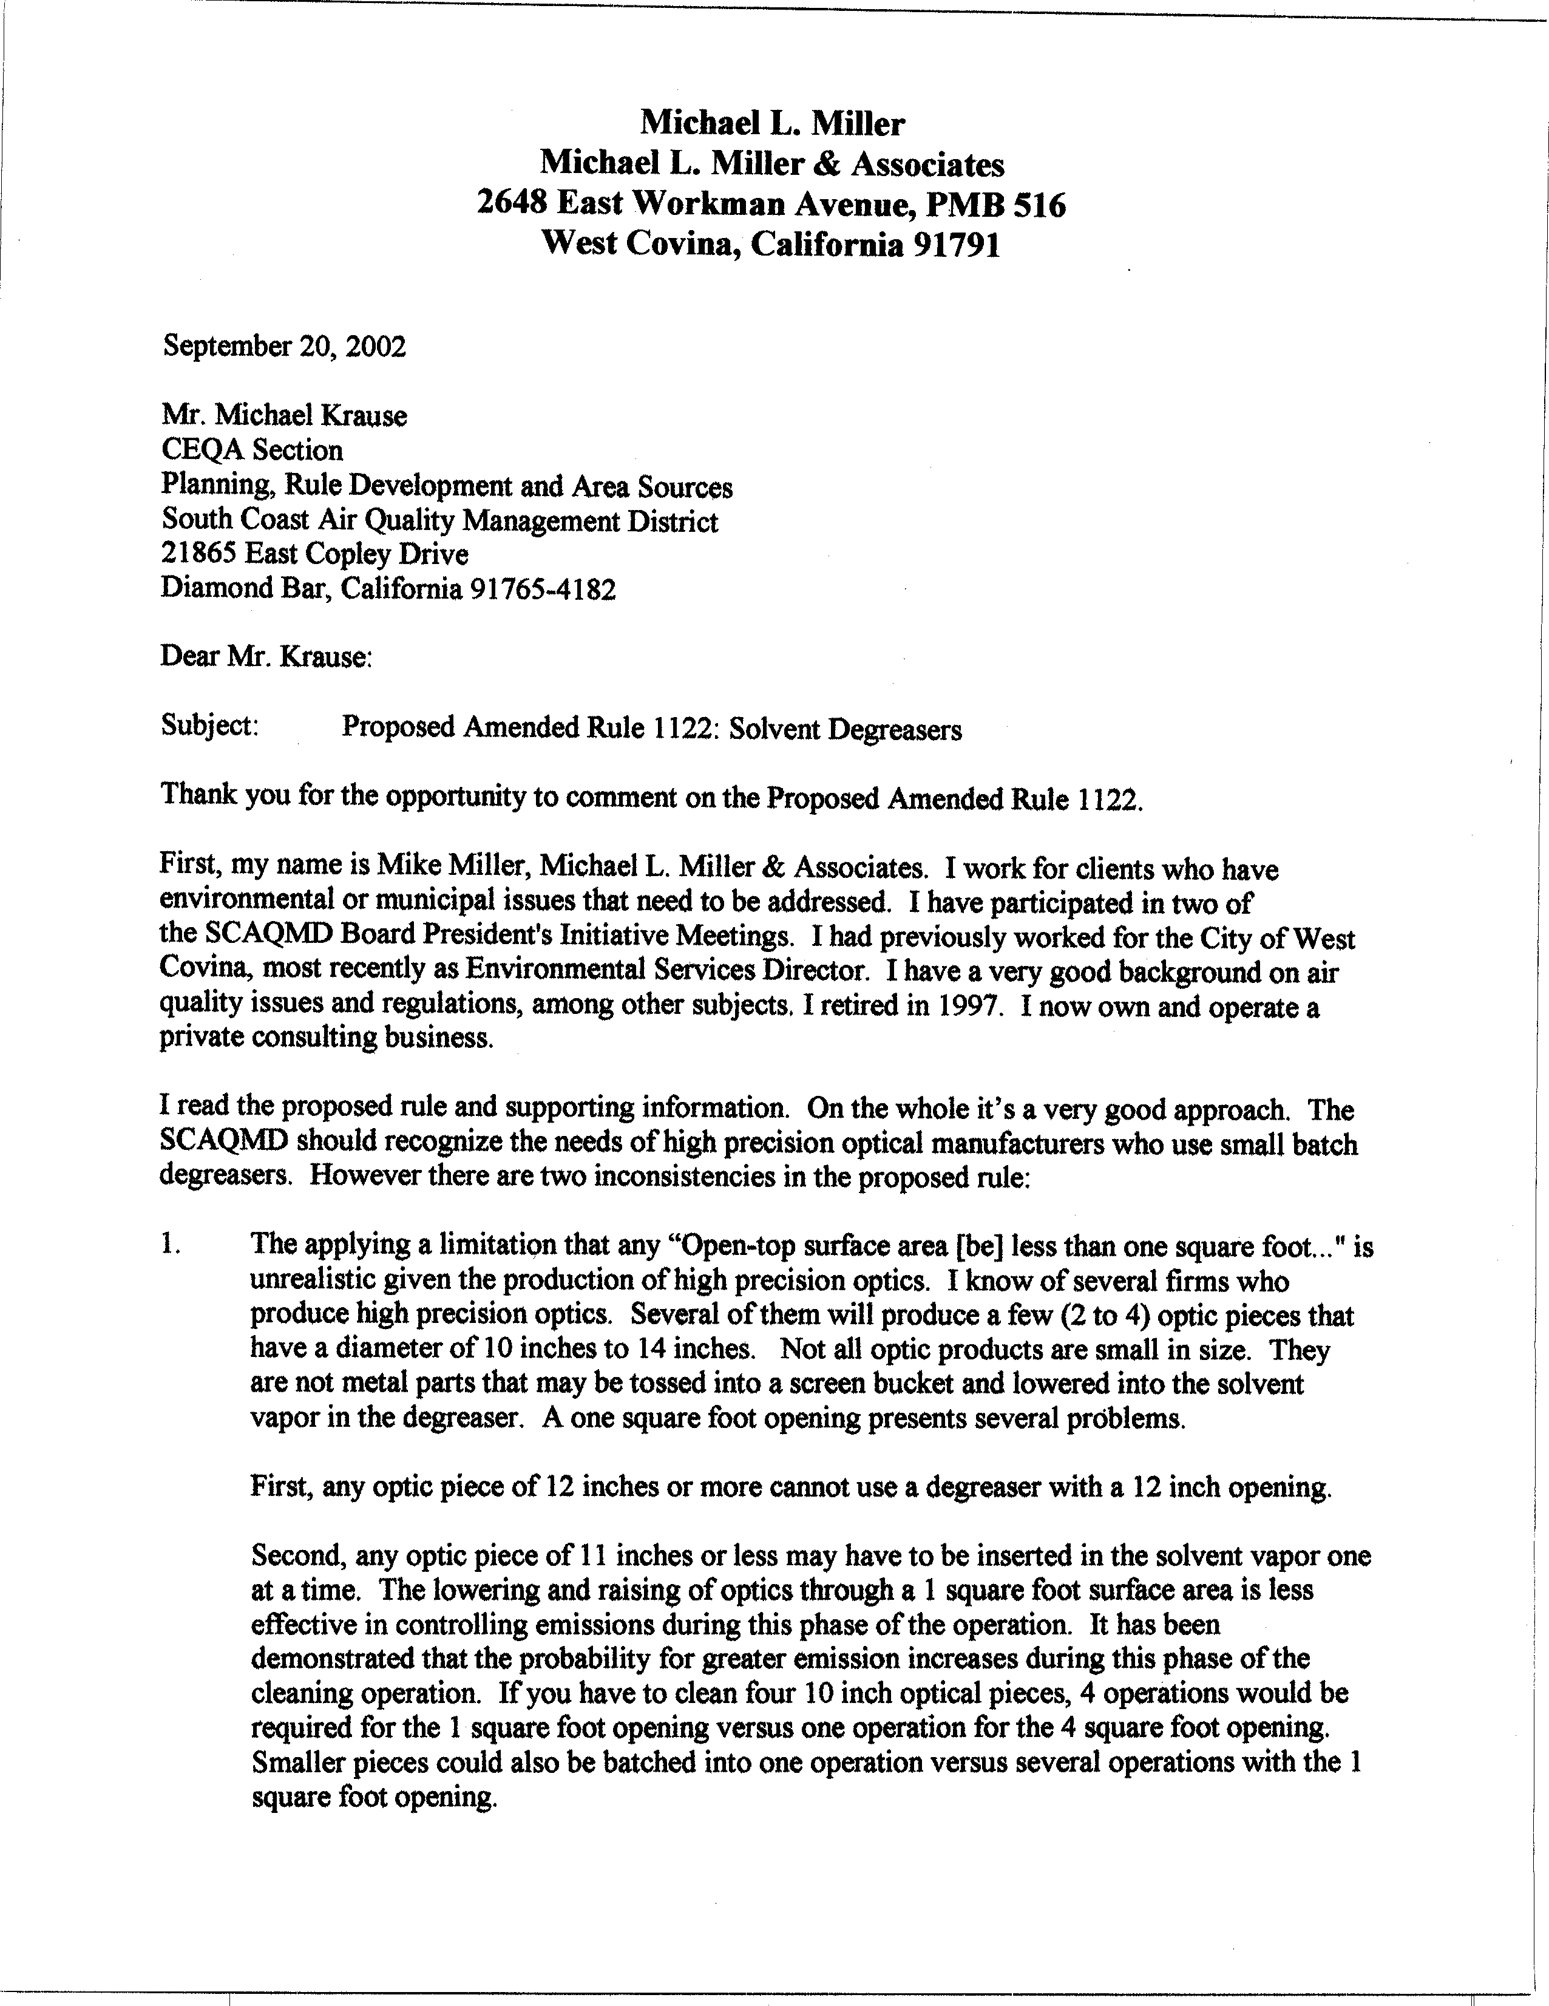
1-1
1-2

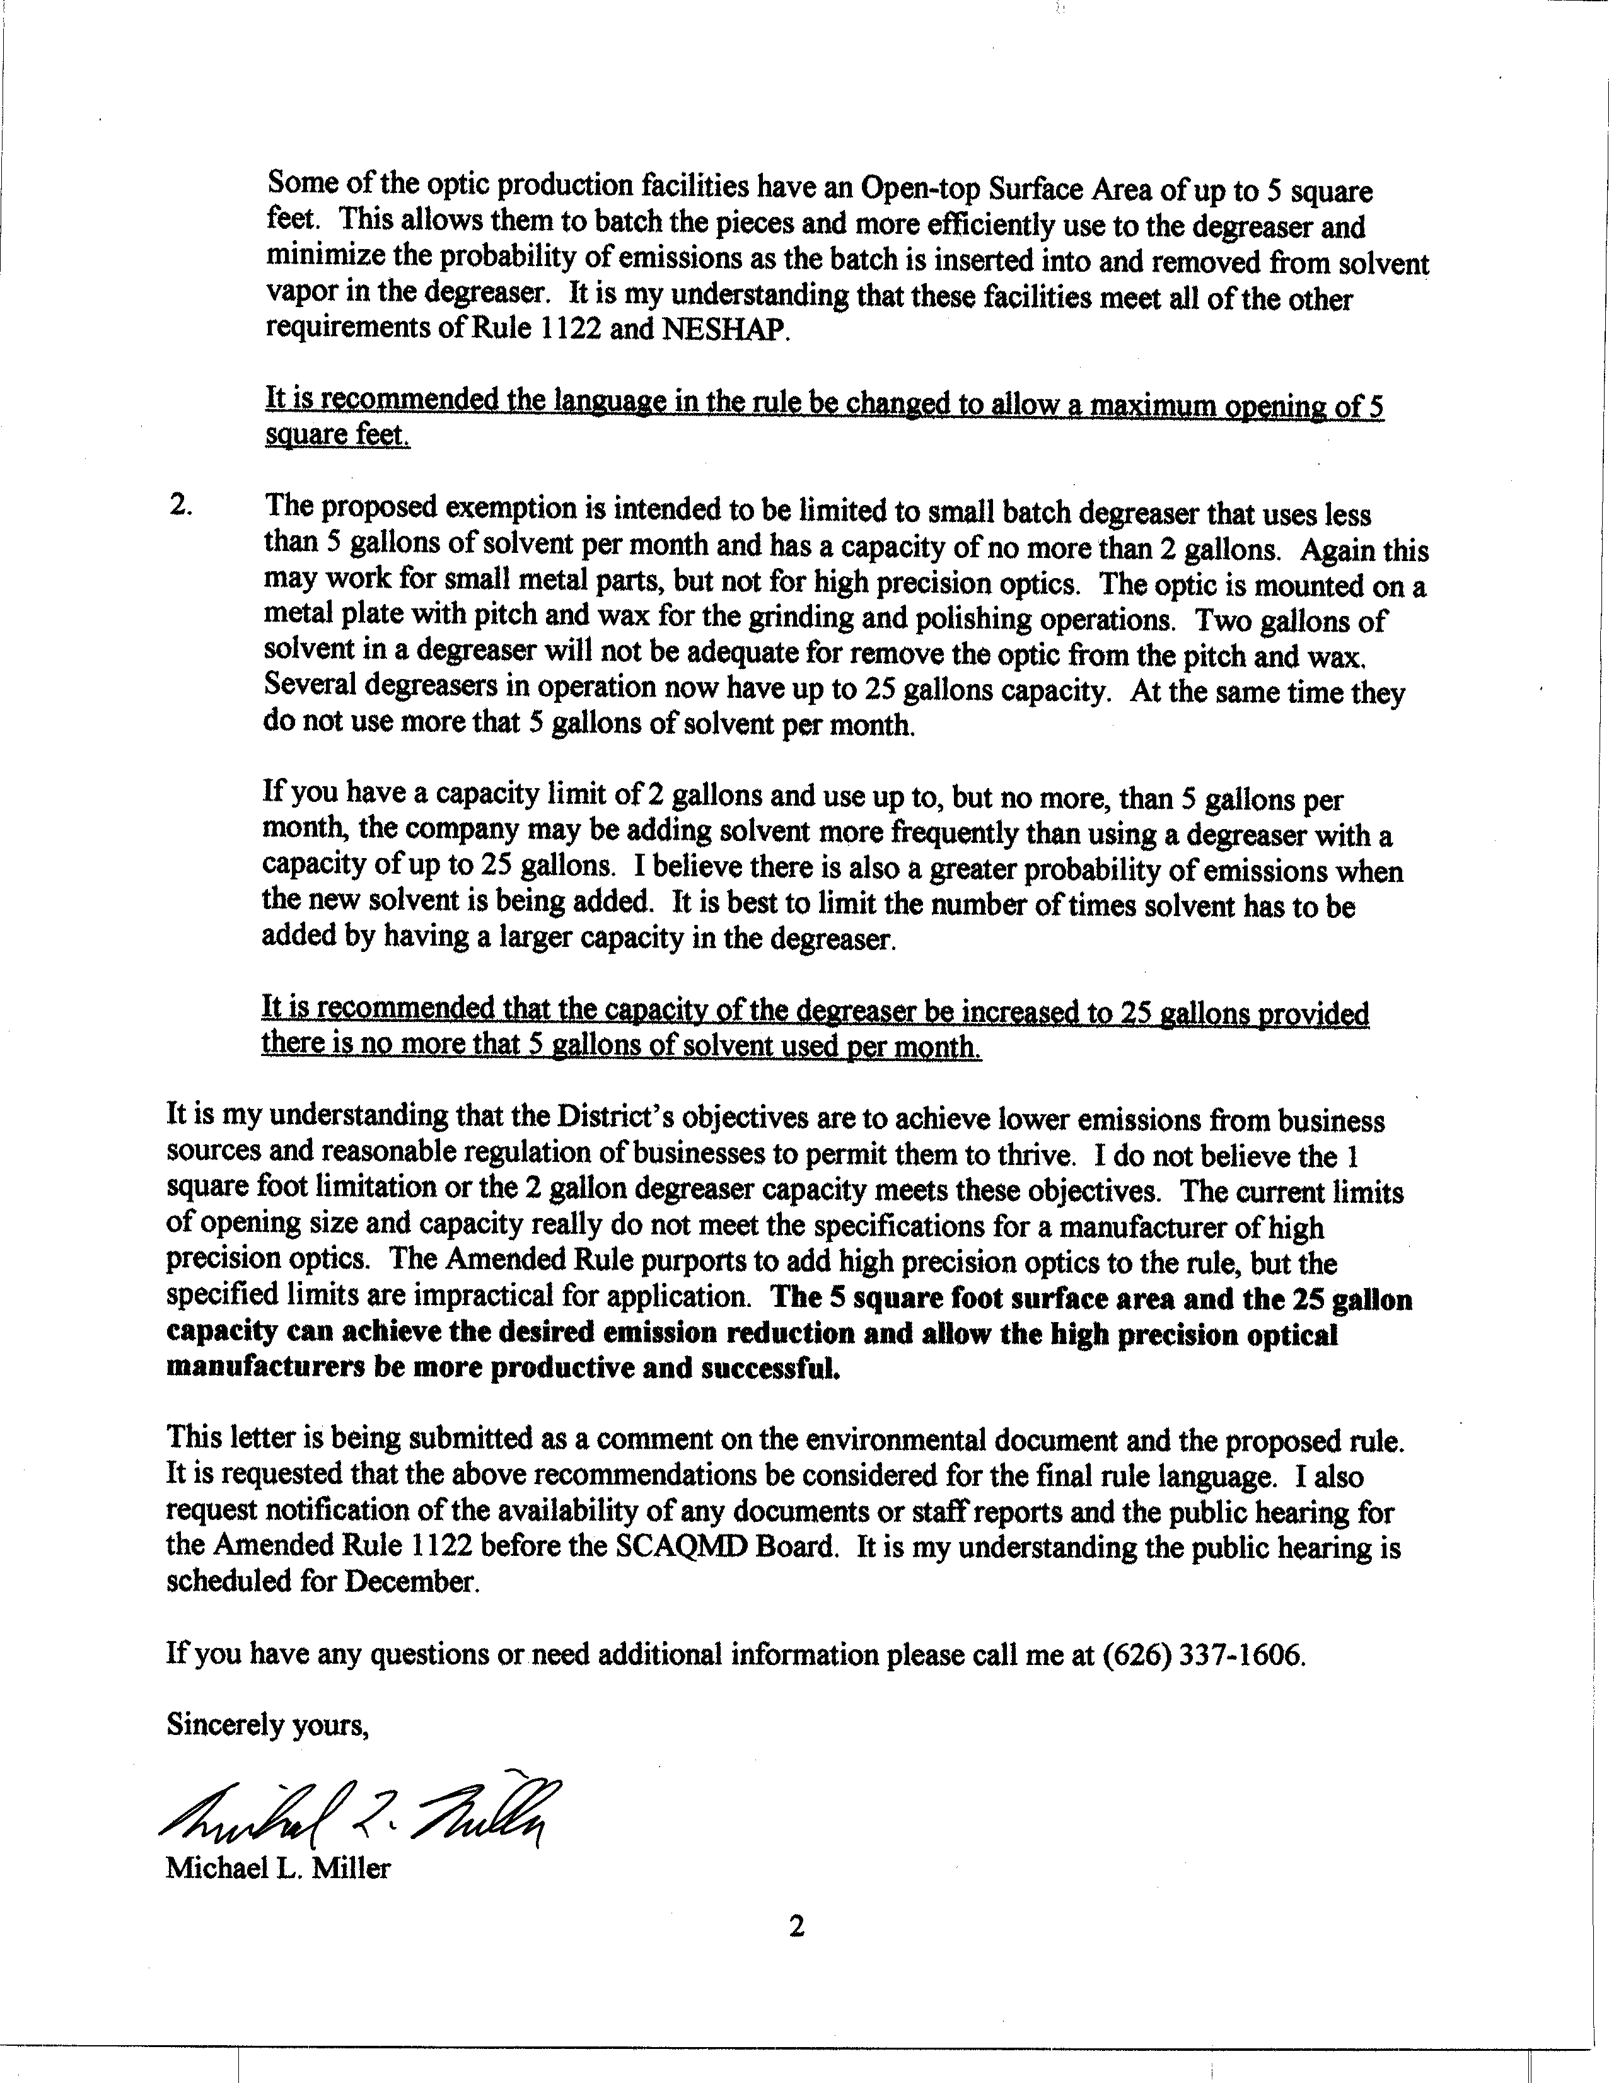
1-2
cont.
1-3
1-4
1-5

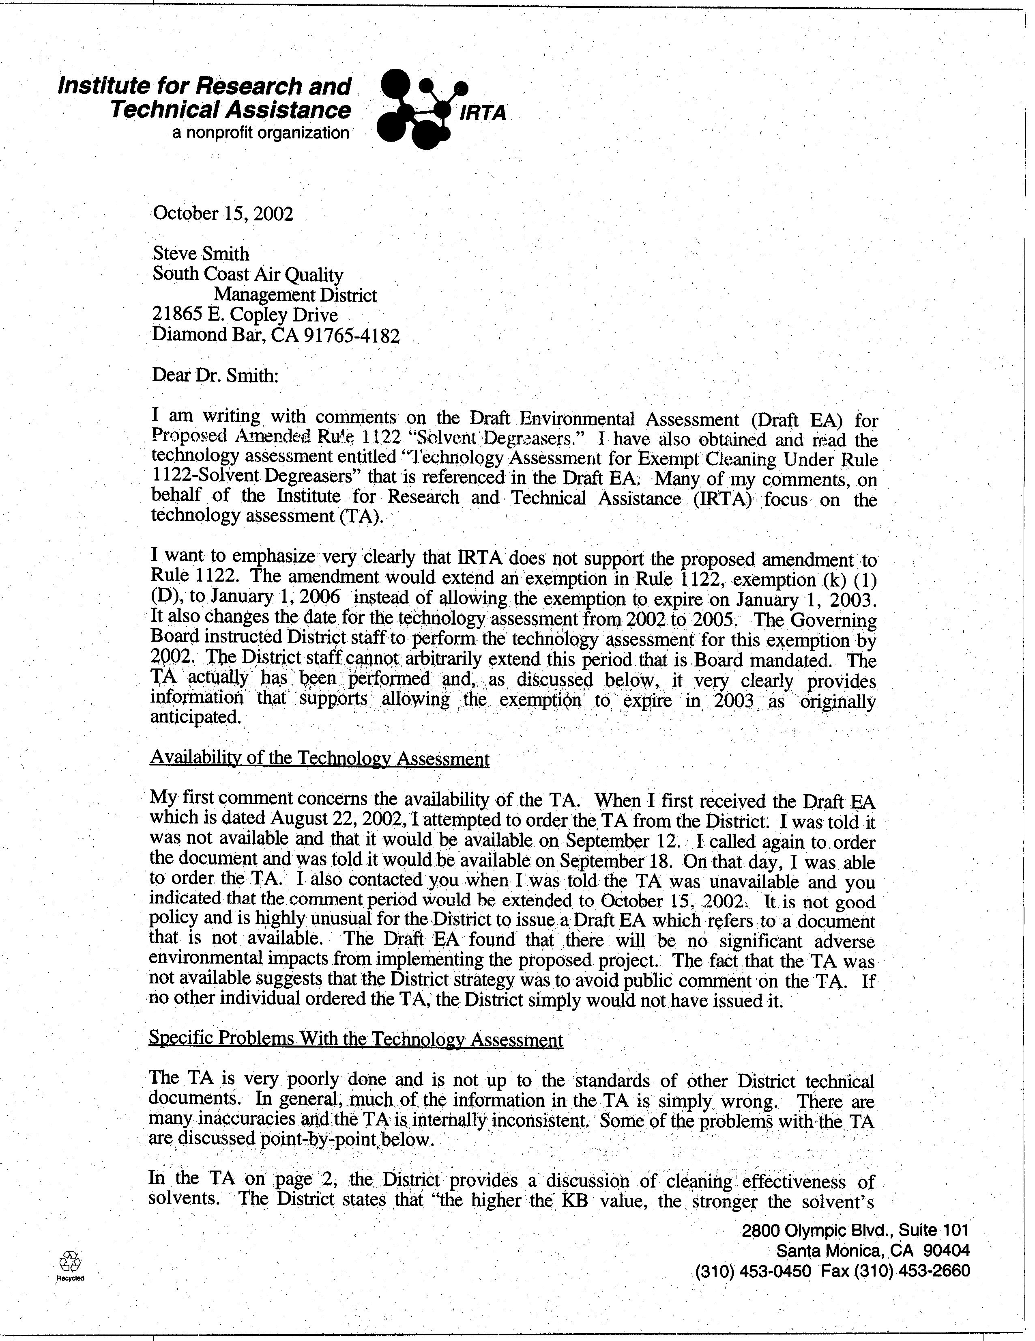
2-1
2-2
2-3

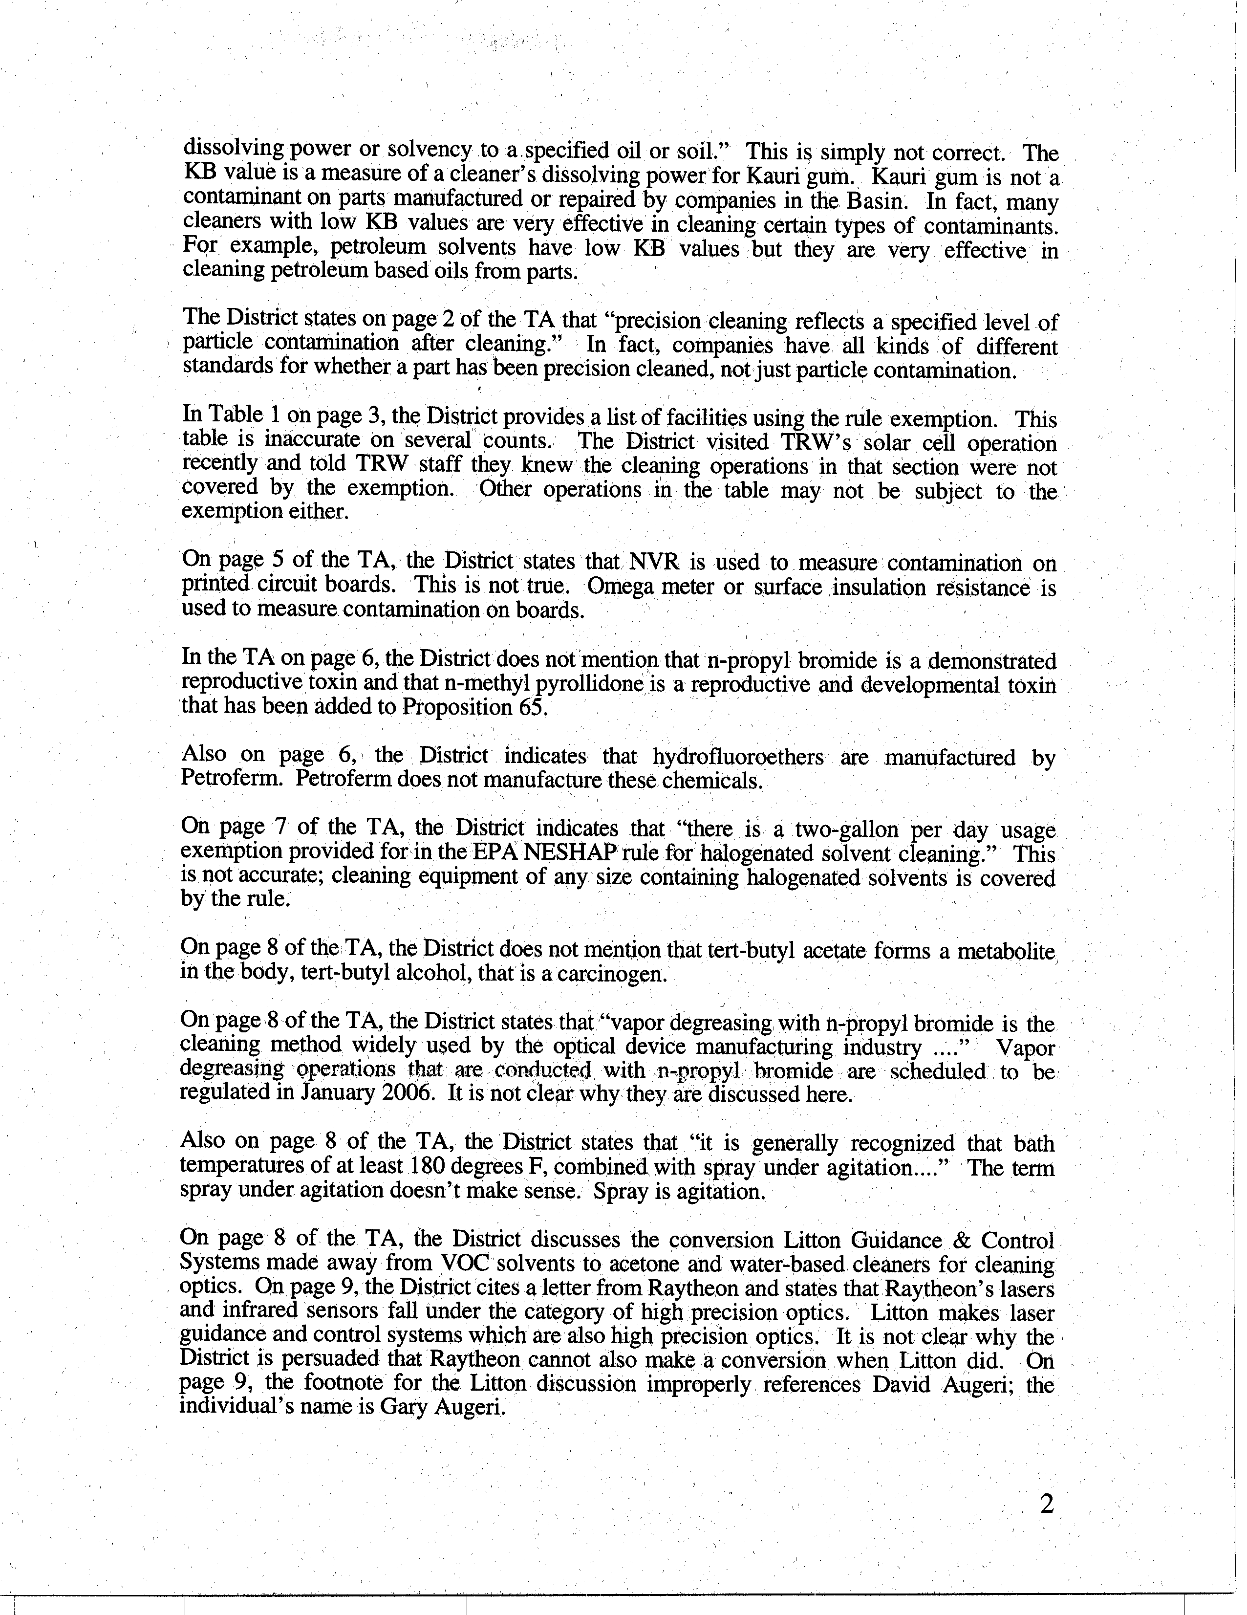
2-3
cont.
2-4
2-5
2-6
2-7
2-8
2-9
2-10
2-11
2-12
2-13

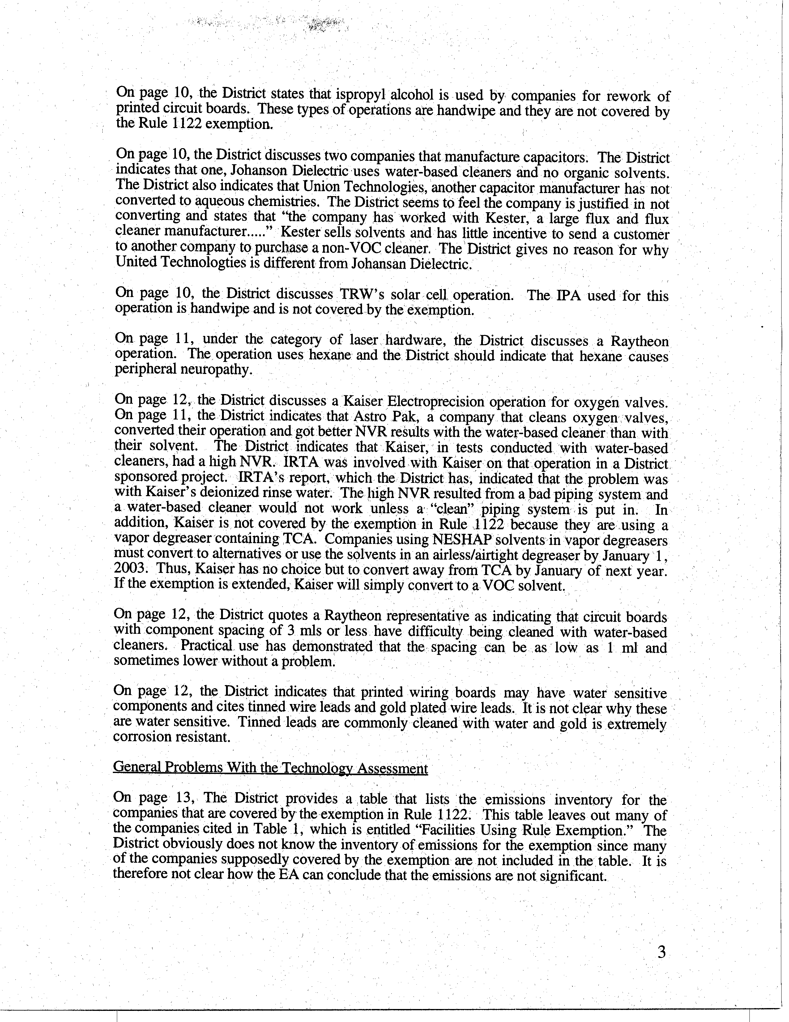
2-14
2-15
2-16
2-17
2-18
2-19
2-20
2-21

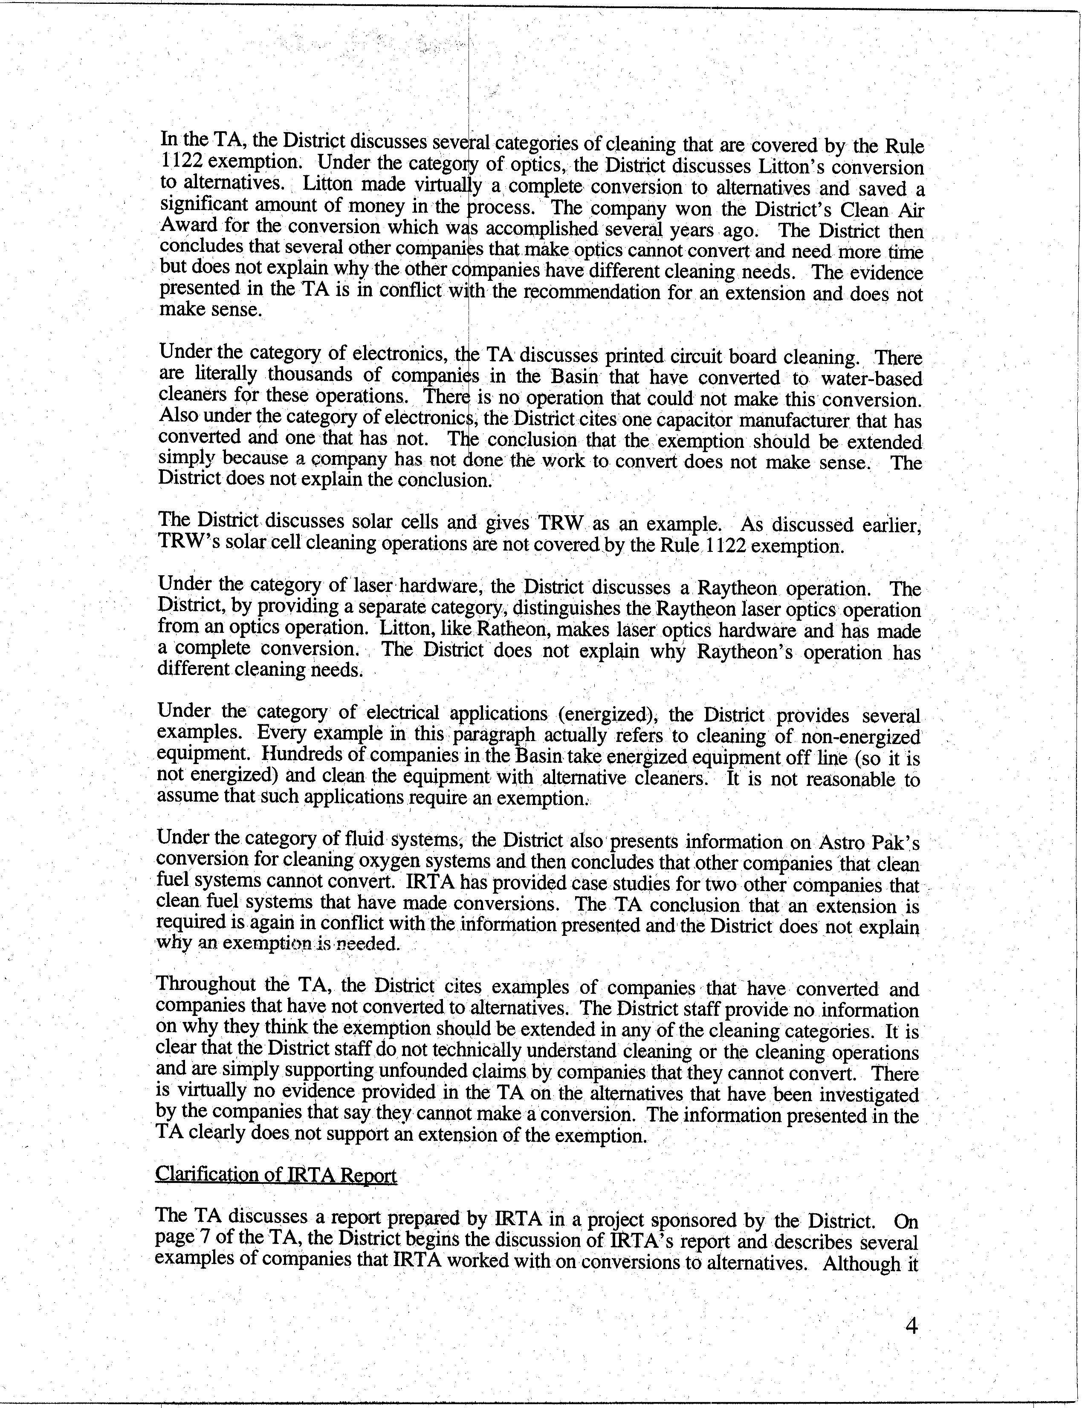
2-22
2-23
2-24
2-25
2-26
2-27
2-28
2-29

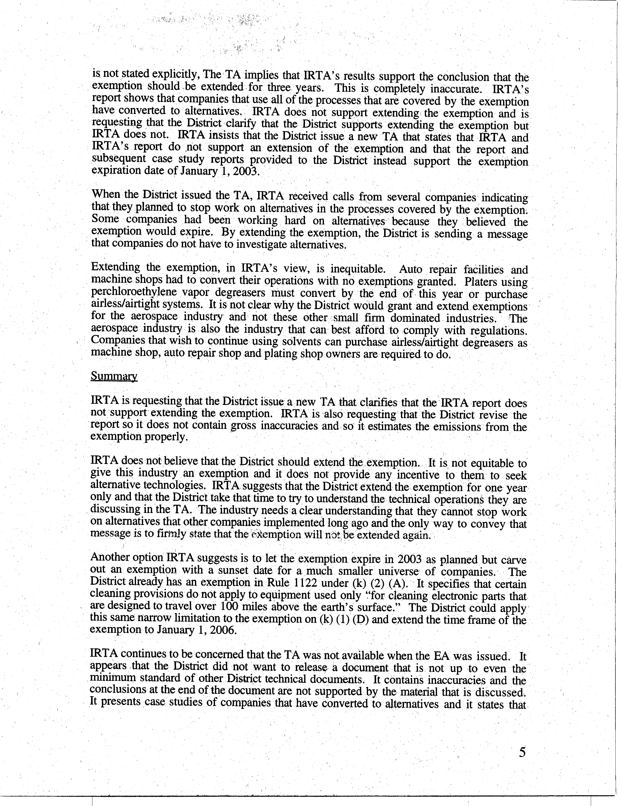
2-29
cont.
2-30
2-31
2-32
2-33
2-34
2-35

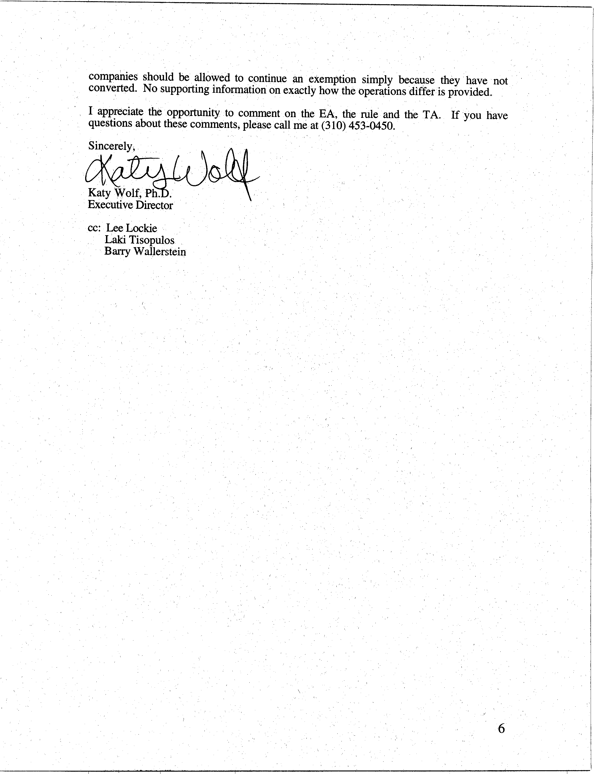
2-35
cont.

COMMENT LETTER #1 FROM
michael l. miller & associates
(September 20, 2002)

Response to Comment 1-1
Thank you for your participation and your comments.

Response to Comment 1-2
Staff disagrees. The limited exemption in (k)(1)(D) was added to the rule during the 1997 amendment to address very specific types of precision cleaning, including optics, for aerospace and military applications. At that time, District staff determined that degreasers with open-top surface area of 1 square foot or with capacity less than 2 gallons was the most acceptable equipment size for this exemption based on the very small aggregate emissions from such equipment. In addition, AQMD Rule 219 exempts small degreasers of this size from permits. Facilities whose cleaning operations cannot utilize the small degreaser exemption (due to part size) need to use larger-sized degreasing equipment that complies with the design and operating requirements of Rule 1122. These types of degreasers are more efficient in controlling emissions during degreasing operations. Furthermore, this has been the current practice within various industries when performing degreasing operations.

Response to Comment 1-3
See response to comment 1-2.

Response to Comment 1-4
See response to comment 1-2.

Response to Comment 1-5
The Governing Board Meeting to decide on this project is scheduled for December 6, 2002. The proposed rule, staff report, Final CEQA document and any other supporting documentation will be made available before the meeting.

COMMENT LETTER #2 FROM
institute for research and technical assistance (IRTA)
(October 15, 2002)

Response to Comment 2-1
Staff has completed a technology assessment (TA), pursuant to the requirements of subdivision (l) of Rule 1122, in order to determine whether it is necessary to continue the small degreaser exemption beyond 2003. Staff visited the affected facilities to evaluate existing cleaning methods as well as advancements in cleaning technology. Staff found a cooperative industry where conversions to alternative cleaning methods were being handled on a case-by-case basis with these specialized applications requiring long time periods to identify options, conduct tests and evaluate the results. The study identified some cleaning applications where aqueous systems may have limitations. Based on the findings and recommendations in the technology assessment, staff proposes to extend the exemption for two additional years. In addition, staff proposes to conduct another technology assessment by the year 2004 to evaluate the exemption in (k)(1)(D). As stated in the technology assessment report, “…with the exception of parts for space vehicle components, staff believes that many of the obstacles to conversion can be overcome with additional research and testing.”

Response to Comment 2-2
Staff disagrees. It has always been the intent of the District to issue the technology assessment report to the public. Documents that are made available to the public undergo review at various levels of the organization. This review process may sometimes cause delays in the issuance of a document. The technology assessment report was made available to the public after the review process was completed, and the comment period was adjusted accordingly.

Response to Comment 2-3
Staff's general statement about KB value is correct. Staff used technical materials to reference the definition of KB value. Staff agrees that even solvents with low KB values can be very effective in cleaning certain types of contaminants. There is no mention in the technology assessment that a solvent with high KB value is the preferred solvent to use when removing any particular contaminant. As discussed in the TA, the KB value of a solvent is only one factor in determining the cleaning effectiveness of a solvent.

Response to Comment 2-4
Staff agrees that the level of contamination is not limited to particles remaining on the part being cleaned. Therefore, the word "particle" will be removed from the statement.

Response to Comment 2-5
The TA presents the best available data obtained at the time the study was made. The District recently contacted TRW and they have indicated that in certain situations solar cell components are required to be cleaned in batch-loaded cold cleaners.

Response to Comment 2-6
Staff agrees. NVR is not the term used to refer to the level of contamination on circuit boards. Staff has modified language in the report to clarify this point.

Response to Comment 2-7
The scope of the study was limited to evaluating the actual cleaning operations pursuant to the requirements of the technology assessment provision in Rule 1122. The technology assessment was not intended to assess the health effects of the different types of cleaning solvents used.

Response to Comment 2-8
Staff agrees. Petroferm is a distributor of hydrofluoroether and the report has been changed to reflect this fact.

Response to Comment 2-9
Staff agrees that there is not a usage exemption. However, there is a two-gallon equipment size exemption in the EPA NESHAP. [Reference: "National Emission Standards for Hazardous Air Pollutants (NESHAP): Halogenated Solvent Cleaning" (Federal Register, June 5, 1995)].

Response to Comment 2-10
See response to comment 2-7.

Response to Comment 2-11
Staff was merely stating the facts for informational purposes only.

Response to Comment 2-12
Staff's intent was to state that "spraying and other forms of agitation" can be used. Language will be revised to clarify intent.

Response to Comment 2-13
From data obtained during the technology assessment, staff concluded that aqueous is not a "one-size-fits-all" system. Conversion to aqueous systems is determined on a case-by-case basis and may require unique process changes. Raytheon has evaluated Litton's conversion and has concluded that the same aqueous cleaning process would not work for them. However, the company has indicated that it is continuing to work to identify conversion opportunities.

Response to Comment 2-14
It is true that IPA is used in handwipe cleaning of printed circuit boards. However, many printed circuit boards are soaked in an IPA bath before any further handwipe cleaning is done. Thus, Rule 1122 applies to the soak cleaning process.

Response to Comment 2-15
Kester manufactures both aqueous saponifiers and solvent-based flux cleaners. Union Technologies manufactures stacked capacitors and their test results show that the company has found difficulty with complete ionic contamination removal using aqueous cleaners.

Response to Comment 2-16
Staff disagrees. As previously stated, the District recently contacted TRW and they have indicated that in certain situations solar cell components are required to be cleaned in batch-loaded cold cleaners.

Response to Comment 2-17
See response to comment 2-7.

Response to Comment 2-18
IRTA's report on Kaiser's test did not conclusively pinpoint the cause of the high NVR results. The report stated that "the problem was likely in the quality of the deionized water. The DI water is transported in pipes….and may not be as pure as necessary." Furthermore, the report did not mention bad piping as cause of the problem nor did it mention that a "clean" piping system would solve the problem". In addition, staff is not aware of how Kaiser plans to comply with the future NESHAP requirements in Rule 1122, and cannot concur with IRTA's conclusion that Kaiser will simply convert to a VOC solvent. However, staff intends to ask Kaiser to conduct further tests over the next 2 years.

Response to Comment 2-19
Staff has information from Raytheon indicating that circuit boards with standoffs of 1 mil and cleaned with aqueous cleaners showed unacceptable levels of ionic contamination from flux residues which lead to shorts. Dendritic growth is also cited as a problem with incomplete removal of some fluxes. In the subsequent technology assessment, staff will ask Raytheon and other companies to provide test data to support this claim.

Response to Comment 2-20
The TA report did not state that water-based cleaners cause corrosion on gold and tinned wire lead. Information obtained during the technology assessment indicated that aqueous cleaners leave ionic contaminants on wire leads, which affects the electrical continuity of the circuit.

Response to Comment 2-21
The emissions inventory for all known facilities using the rule exemption is outlined in Table 2 found on pages 13-14 of the technology assessment report. Emissions data reported in the TA are from usage records provided by the affected facilities, and reflect the best information available at this time. Staff welcomes any data from IRTA relative to basin-wide emissions inventory.

Response to Comment 2-22
The TA report recognizes successful conversions, but again, aqueous cleaning is not a "one-size-fits-all" solution to finding alternative cleaning methods. Successful conversion to aqueous systems may require process changes and should be evaluated on a case-by-case basis; thus, requiring longer times to evaluate the results.

Response to Comment 2-23
Staff's evaluation indicates that water-based cleaners may not work on some circuit board cleaning applications. These applications are discussed in the electronics cleaning section of the technology assessment report. Staff urges the commenter to provide names of companies that use aqueous cleaners for the specific applications discussed in the electronics cleaning section of the report. Staff will provide this information to affected facilities for evaluation and study.

Response to Comment 2-24
See response to comment 2-16.

Response to Comment 2-25
See responses to comments 2-13 and 2-22.

Response to Comment 2-26
Staff has identified problems associated with aqueous cleaners when used on electrical components, which are discussed in the technology assessment. On the use of the word "energized" in the technology assessment, staff agrees with the comment and will remove certain references to the word (energized) as appropriate.

Response to Comment 2-27
See response to comment 2-18.

Response to Comment 2-28
Staff disagrees. The TA presents information on different cleaning categories and offers explanation on why some companies have not successfully converted to aqueous precision cleaning.

Response to Comment 2-29
Staff disagrees. Staff drew the following conclusions regarding their report. First, IRTA's report presents test results and other information relevant to specific conversions.. These clearly demonstrate that successful conversions are possible in each cleaning category and that these can often reduce costs and increase efficiency of an operation. However, IRTA’s report also presented difficulties that some companies experience in converting to alternative cleaning methods. That is, 100 percent success was not achieved in all circumstances for a variety of reasons. Staff concluded from the IRTA report and from test reports from other facilities who were working to find compliant materials that additional time and research could produce broader results, and that the exemption should not be made permanent. Staff could not draw the conclusion, however, that every process could use the new formulations and process changes and simply apply them across-the-board to their individual operations.

Response to Comment 2-30
Staff is not aware of any company that has stopped or plan to stop working on alternatives as a result of the TA's recommendation to extend the exemption. On the contrary, companies that were involved in the technology assessment have informed the District that research to find acceptable alternative precision cleaning chemistries will continue. Staff intends to track this testing closely.

Response to Comment 2-31
The District granted the exemption in (k)(1)(D) to address cleaning problems associated with very precise cleaning applications, and not because of a particular industry. The technology assessment has concluded that, in spite of the success of aqueous cleaners in many cleaning applications, not all of the cleaning issues related to the specified applications in (k)(1)(D) have been adequately addressed by existing alternative cleaning methods; thus, staff recommended to extend the exemption for two additional years. Furthermore, aerospace-related companies have invested in cleaning equipment, such as airless/air-tight systems, to comply with District regulations. The District is not aware of any machine shops, auto repairs or plating operators that had to purchase airless/air-tight systems to comply.

Response to Comment 2-32
See responses to comments 2-21 and 2-29.

Response to Comment 2-33
Staff agrees that an extension of the exemption is needed. The findings in the technology assessment indicated that conversion to alternative precision cleaning methods is done on a case-by-case basis. Staff believes that the affected facilities need more time to find acceptable alternative cleaning methods and that a two-year extension is a more realistic timeframe to complete their research.

Response to Comment 2-34
See response to comment 2-33.

Response to Comment 2-35
The District has acknowledged that there was a delay in the issuance of the technology assessment due to a longer-than-expected review process. As a result, the District extended the public comment period on the Draft EA. In addition, staff remains confident that the conclusions and recommendations discussed in the technology assessment are supported by the facts presented in the technology assessment document.

Open-top surface area less than one square foot or a capacity of less than two gallons.
Open-top surface area less than one square foot or a capacity of less than two gallons.
Open-top surface area less than one square foot or a capacity of less than two gallons.
Open-top surface area less than one square foot or a capacity of less than two gallons.

