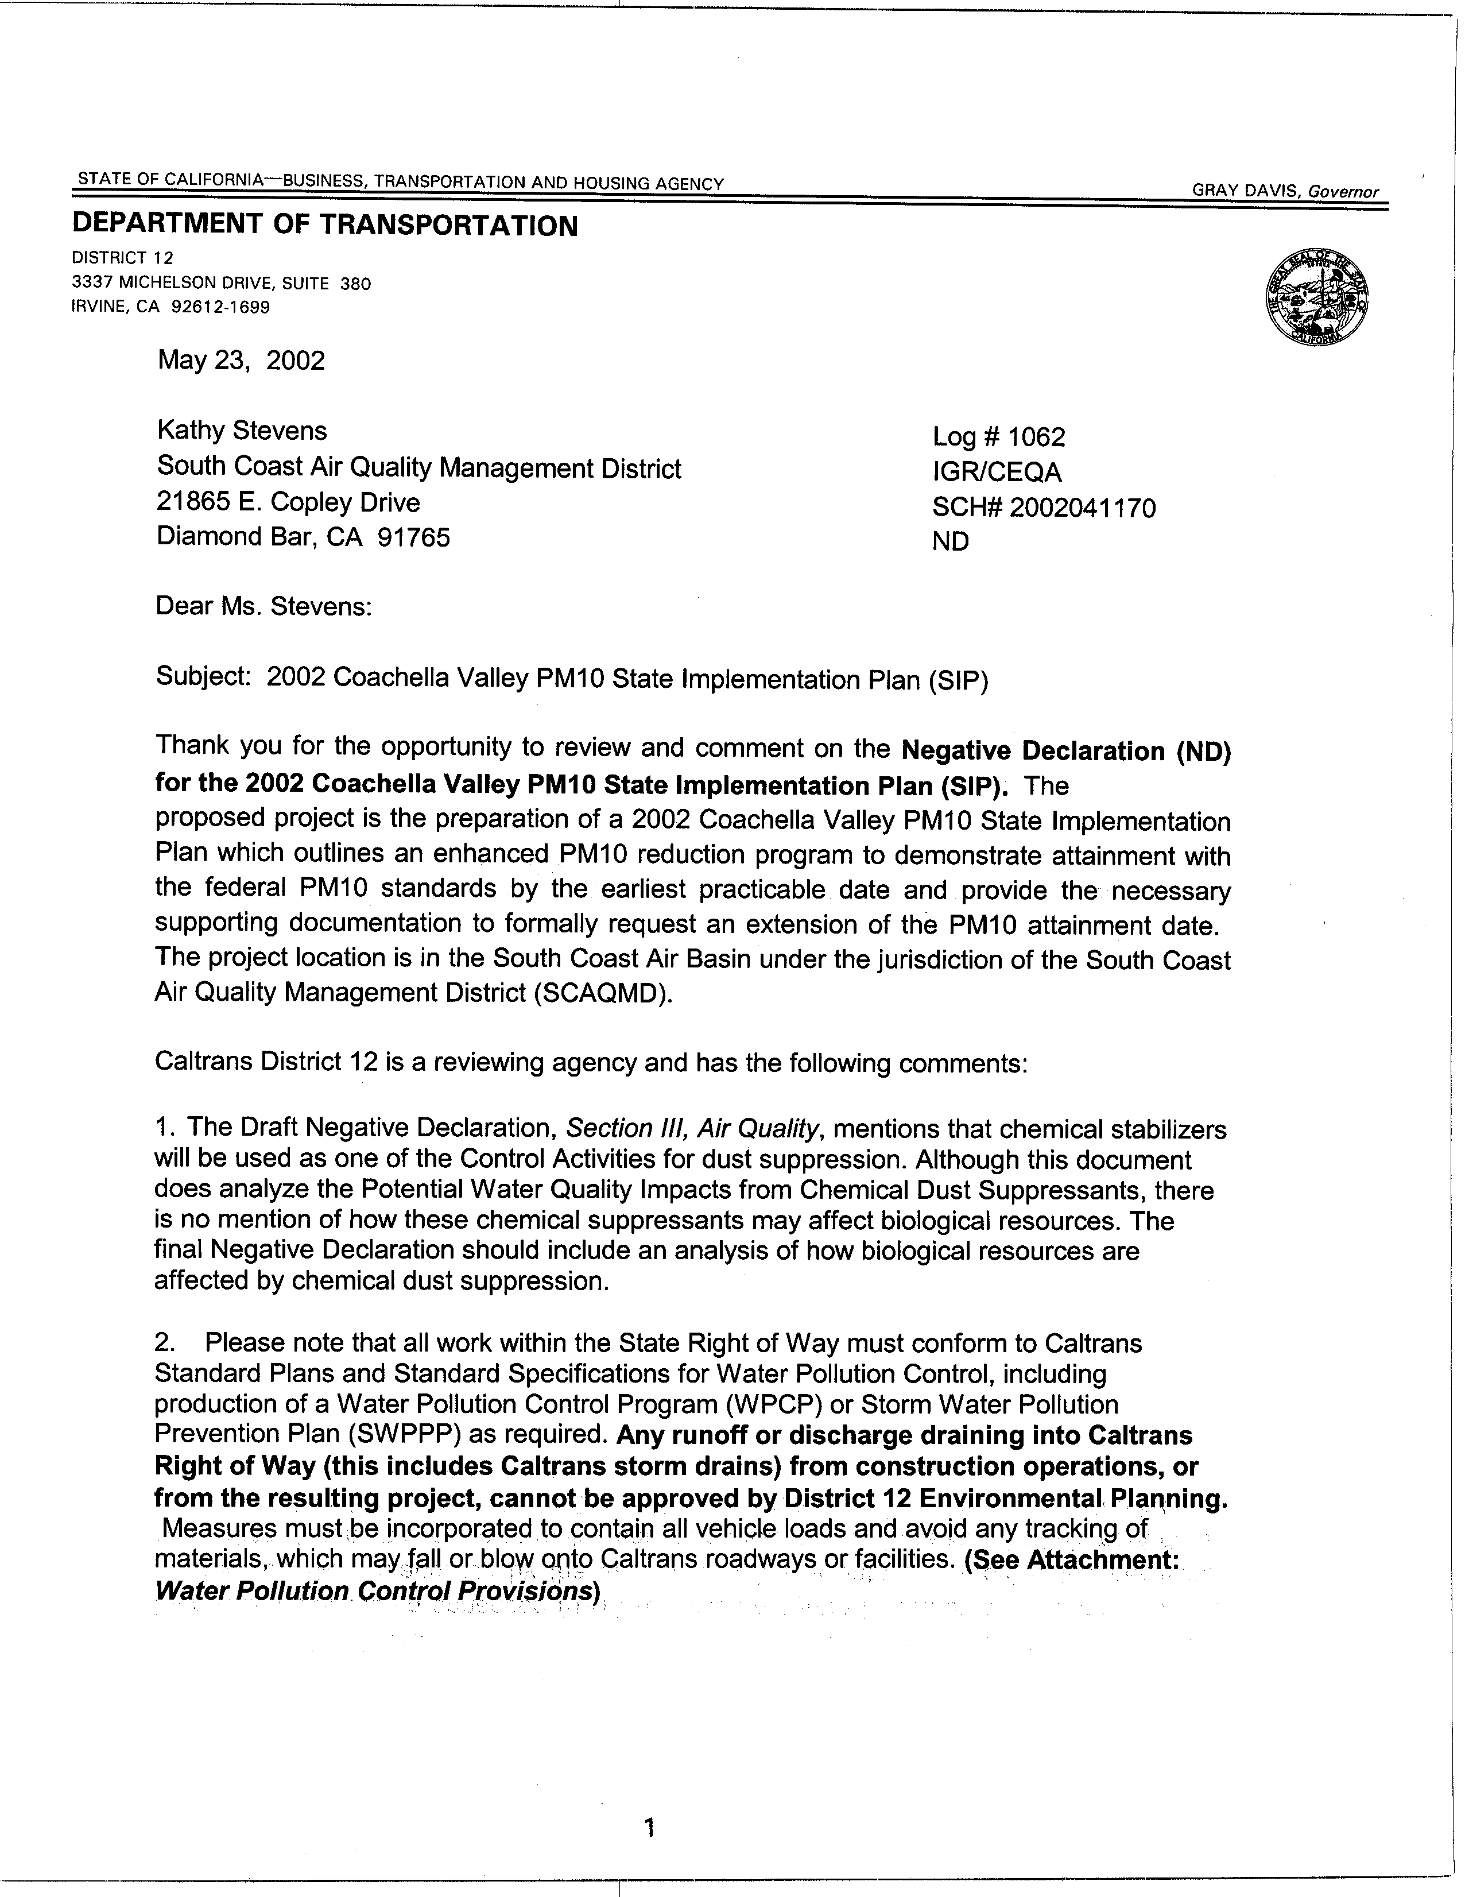
1-1
1-2
1-3
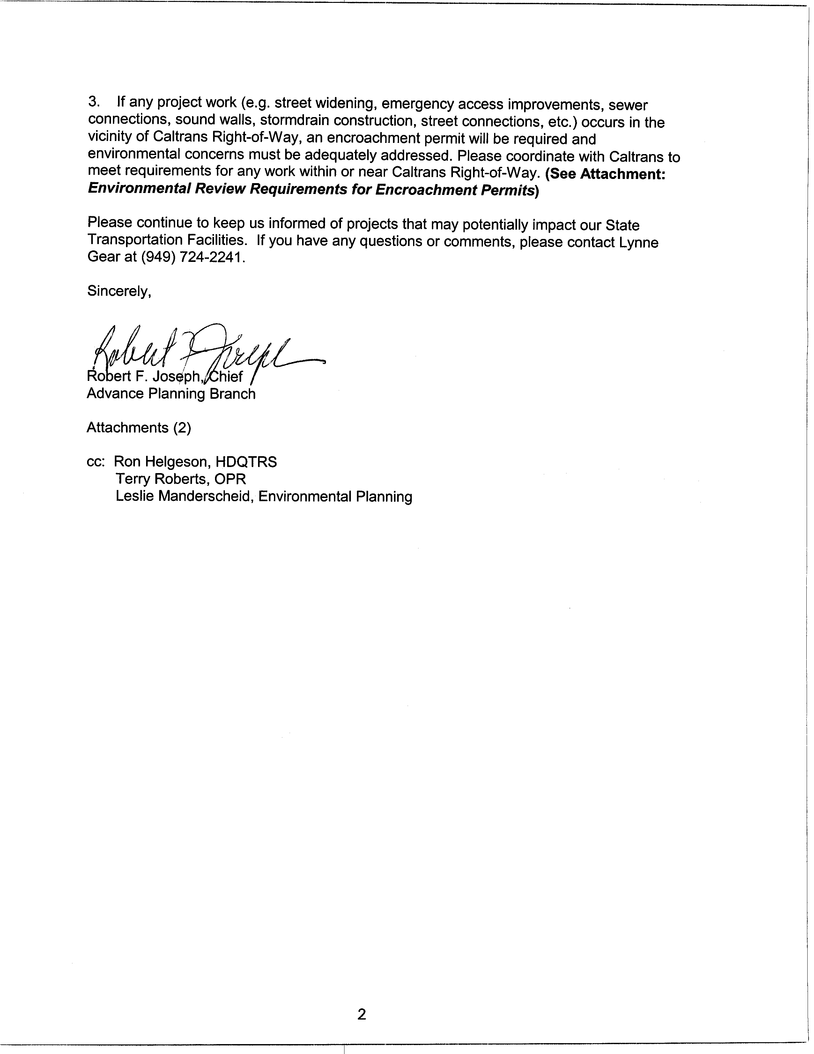
1-4
1-5
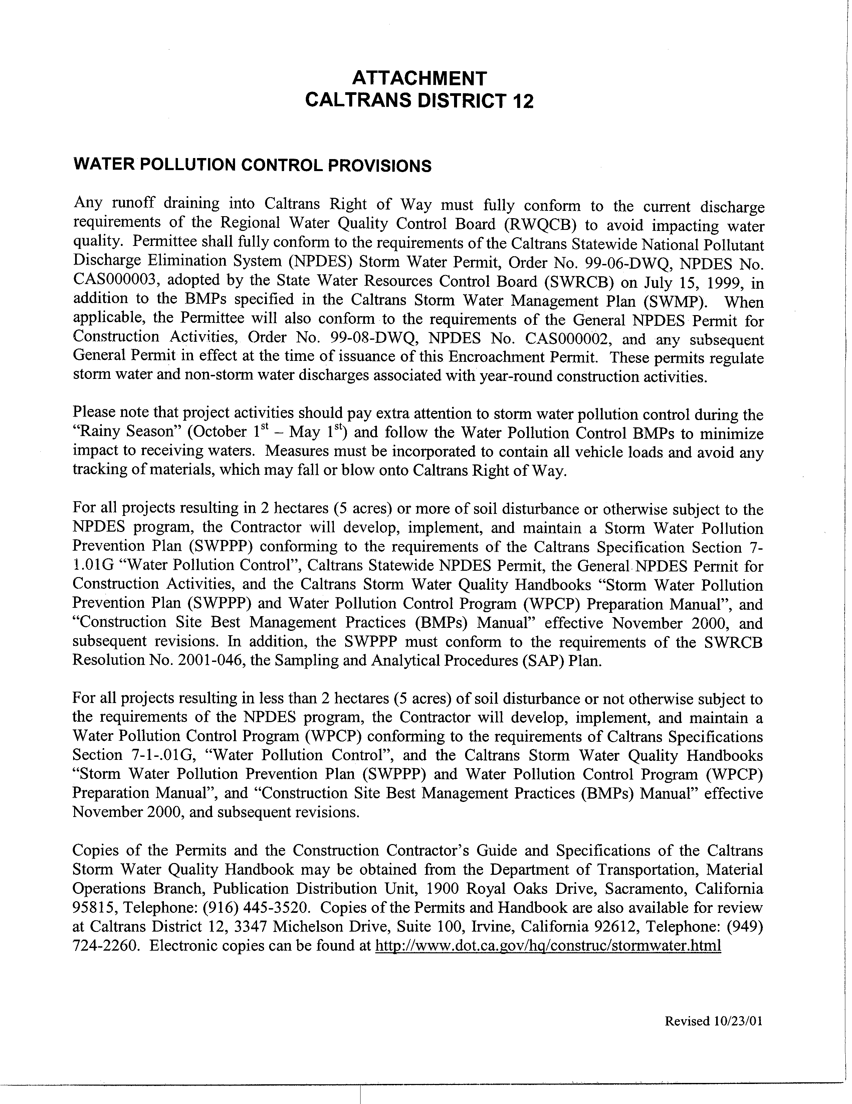
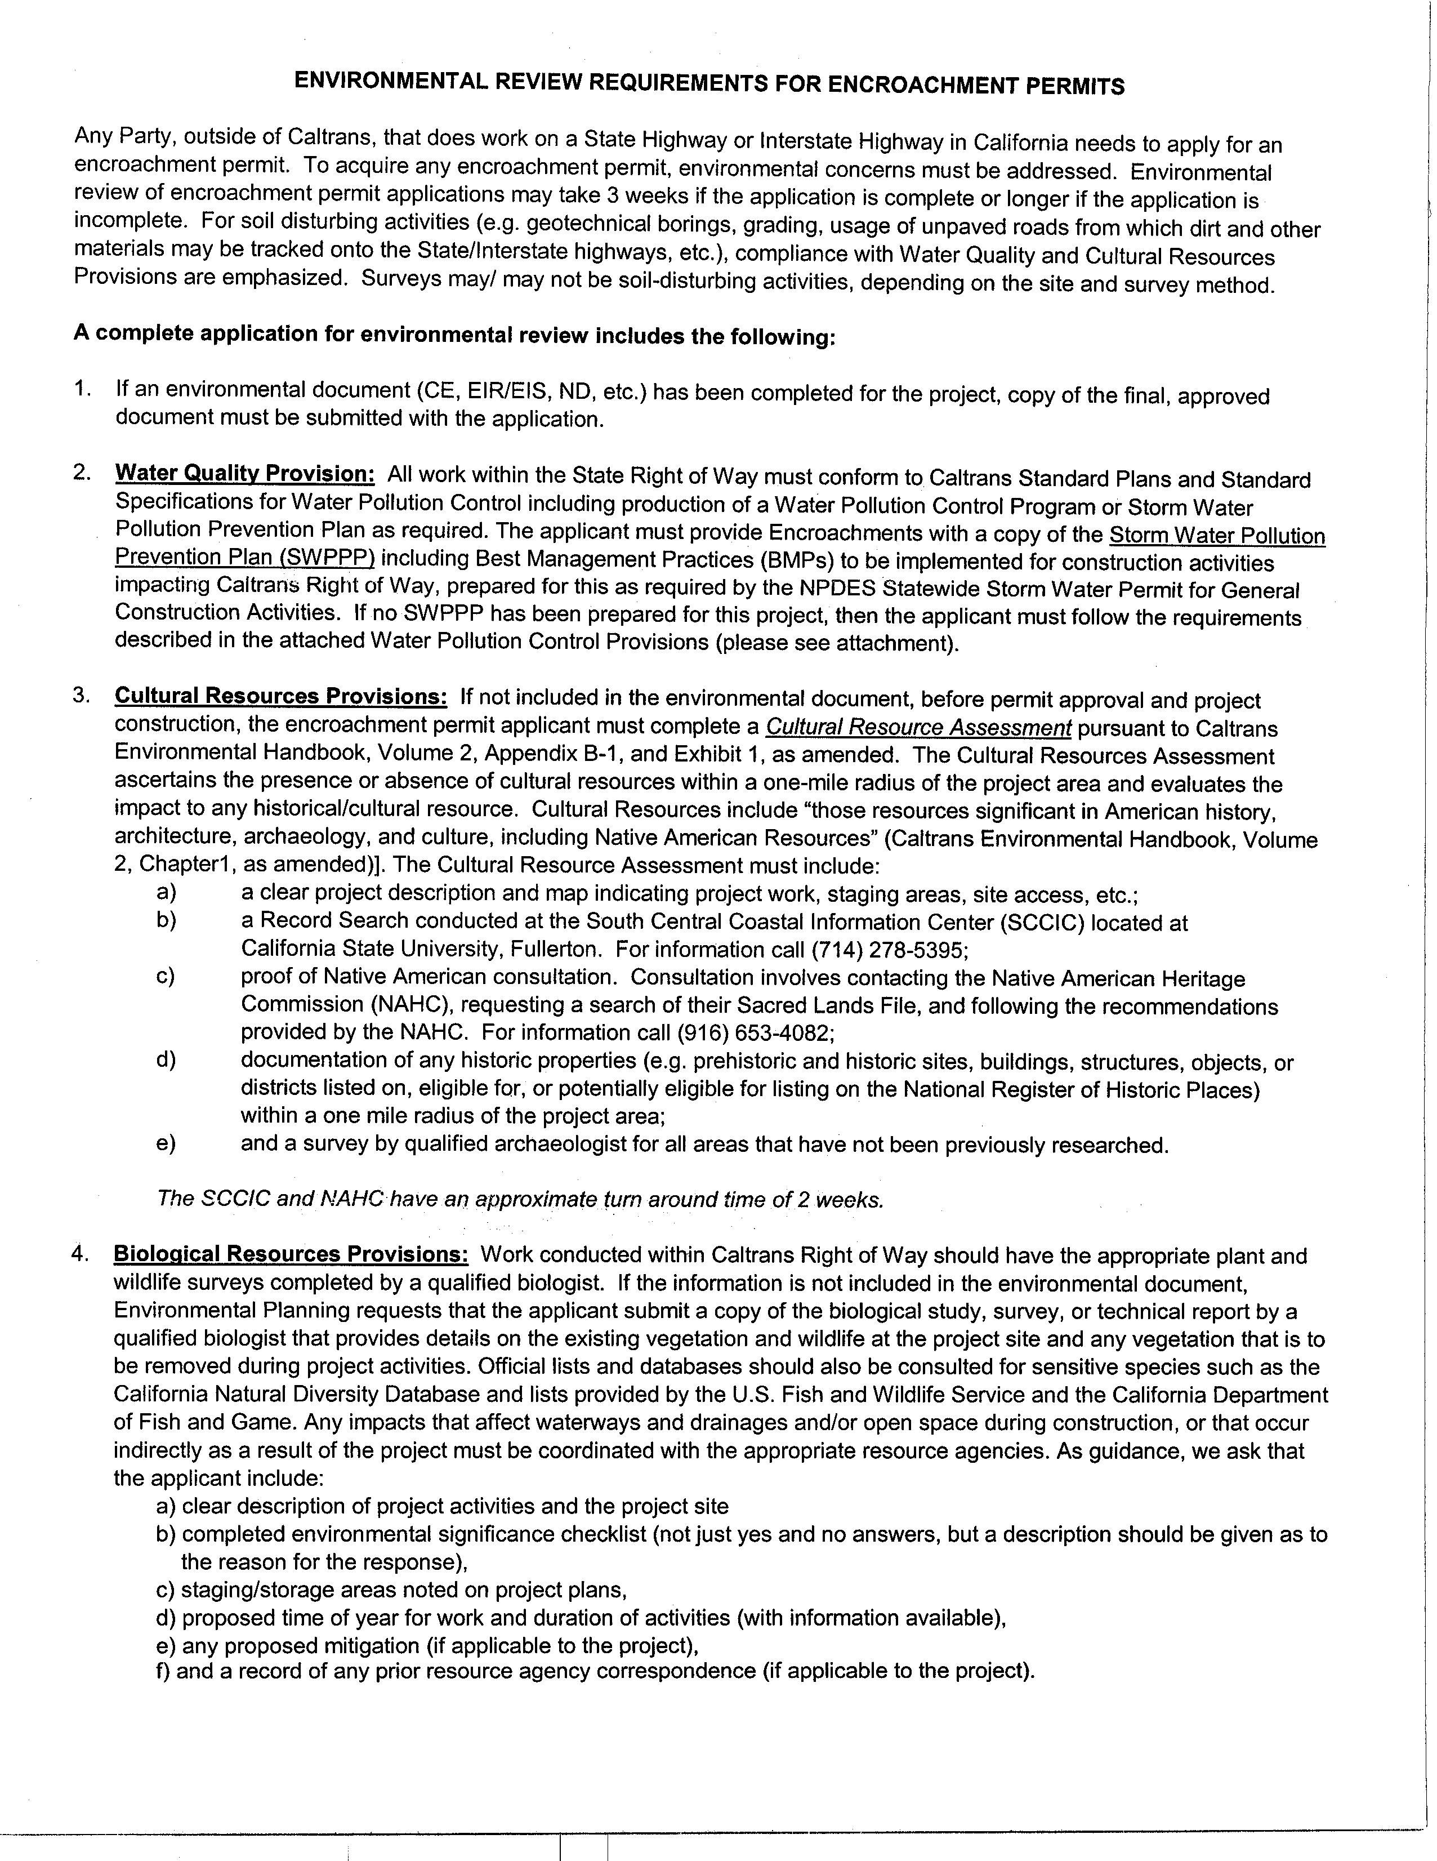

RESPONSE TO COMMENT LETTER 1: DEPARTMENT OF TRANSPORTATION

1-1: This comment is a summary of the proposed project description; however, the proposed project location is in the central portion of Riverside County, within the Salton Sea Air Basin (formerly Southeast Desert Air Basin). The SCAQMD is the agency responsible for air quality assessment and improvement in the Coachella Valley.

1-2: The SCAQMD recognizes that endangered and threatened plants and wildlife are found in the Coachella Valley and agrees that implementation of any PM10 control measures should consider potential effects on biological resources. In addition:

- Current existing SCAQMD rules include the use of chemical dust suppressants;
- Previous analyses prepared by the SCAQMD did not identify significant adverse biological resources impacts for several reasons. These same reasons apply to the currently proposed project:

- Rule 403 defines chemical dust suppressants as non-toxic, which must not be used if prohibited for use by the Regional Water Quality Control Boards; the California Air Resources Board; the U.S. EPA; any applicable law, rule or regulation; and should meet any specifications, criteria or test required by the federal, state or local water agency.
- It is the responsibility of the user to ensure that any chemical dust suppressant they use is not prohibited for use by the Regional Water Quality Control Boards; the California Air Resources Board; the U.S. EPA; any applicable law, rule or regulation; and should meet any specifications, criteria or test required by the federal, state or local water agency.
- Rule 403.1, which applies specifically to the Coachella Valley, currently prohibits fugitive dust mitigation actions that are in conflict with the Endangered Species Act (ESA).
- The incremental increase in the use of chemical dust suppressants would only occur in the urbanized areas of the Coachella Valley.

1-3: The proposed project does not require work to be performed within Caltrans right-of-ways. The proposed project requires the implementation of enhanced measures to control fugitive dust generating activities resulting from public or private projects. Further, it is not anticipated that the use of water as a soil stabilizer will result in increased runoff or discharge because the amount of water used is only enough to form a surface crust. Based on typical information from construction operations, 4,000 gallons of water per acre is sufficient to create an appropriate surface crust. This volume of water is unlikely to create surface runoff.

1-4: The proposed project does not require work (e.g. street widening, emergency access improvements, sewer connections, sound walls, stormdrain construction, street connections, etc.) to be performed within Caltrans right-of-ways. The proposed project requires the implementation of enhanced measures to control fugitive dust generating activities resulting from public or private projects such as those listed above. The public or private entity is responsible for coordinating closely with Caltrans, obtaining any and all permits, and meeting all requirements for performing work within or near Caltrans right-of-ways.

1-5: The SCAQMD will continue to notify the Department of Transportation of any projects that may potentially impact state transportation facilities.

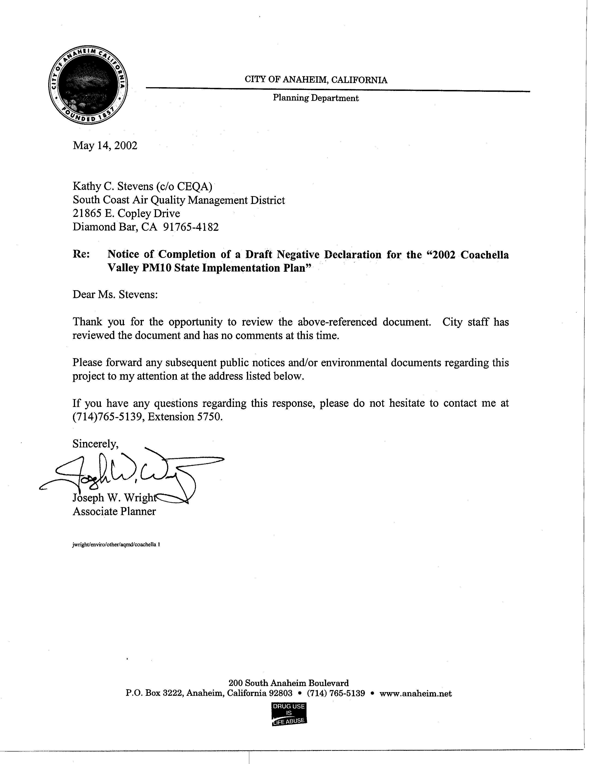
2-1

RESPONSE TO COMMENT LETTER 2: CITY OF ANAHEIM

2-1: The SCAQMD recognizes that the City of Anaheim has reviewed the document and has no comments at this time. Any subsequent public notices and/or environmental documents regarding this proposed project will be sent to the City of Anaheim, attention Joseph W. Wright, for review.

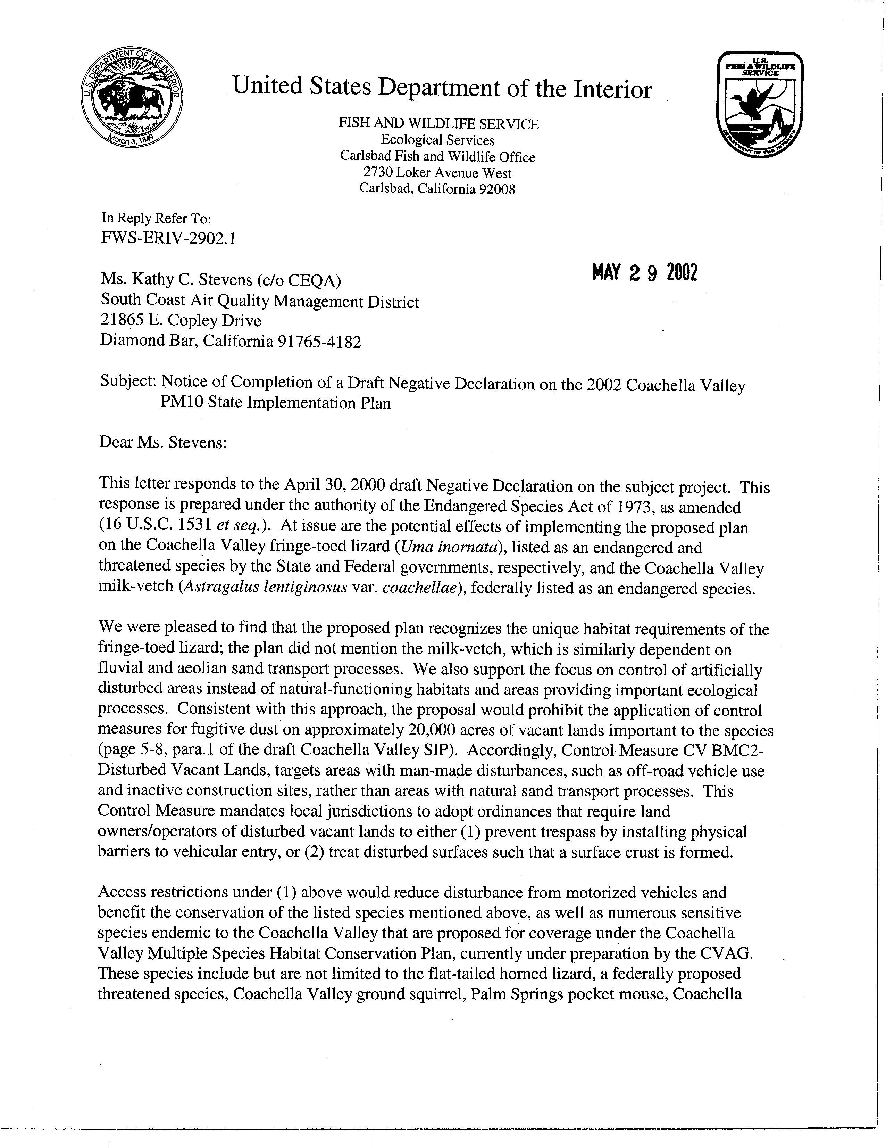
3-1
3-2
3-3
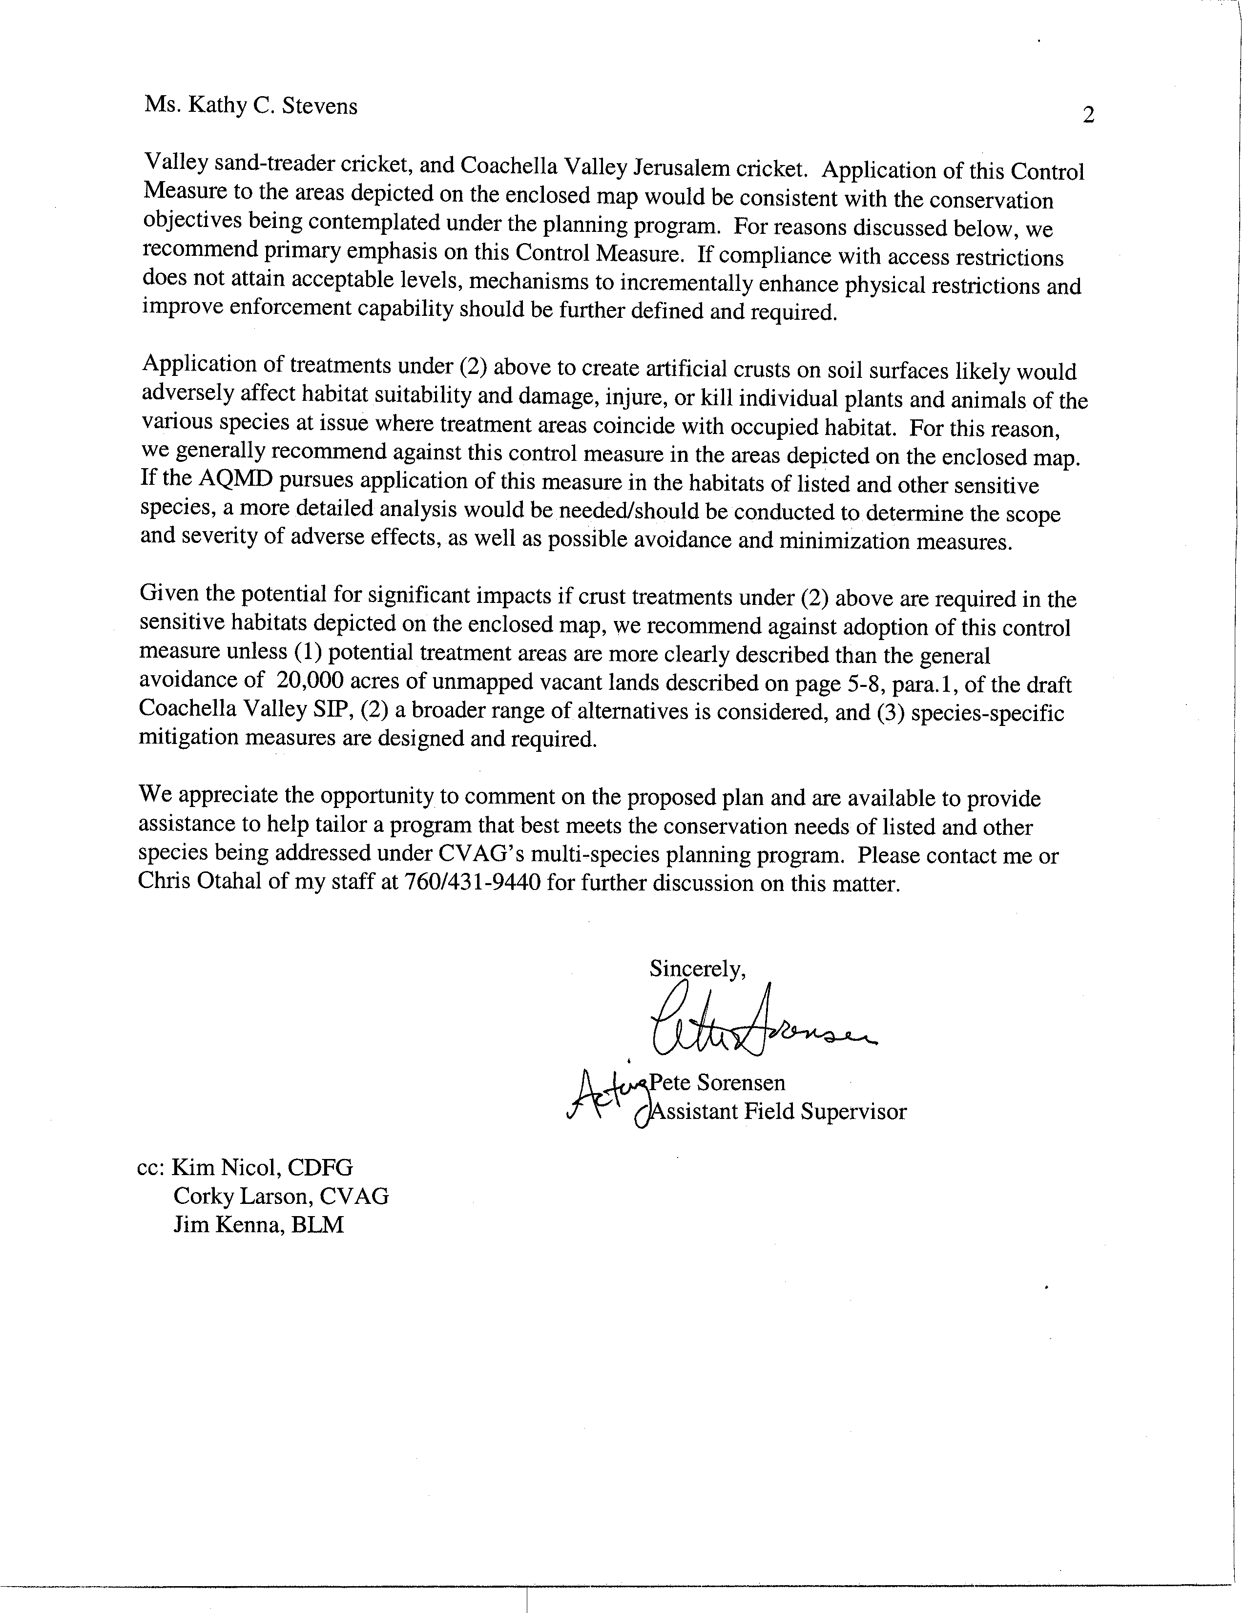
3-3
cont.
3-4
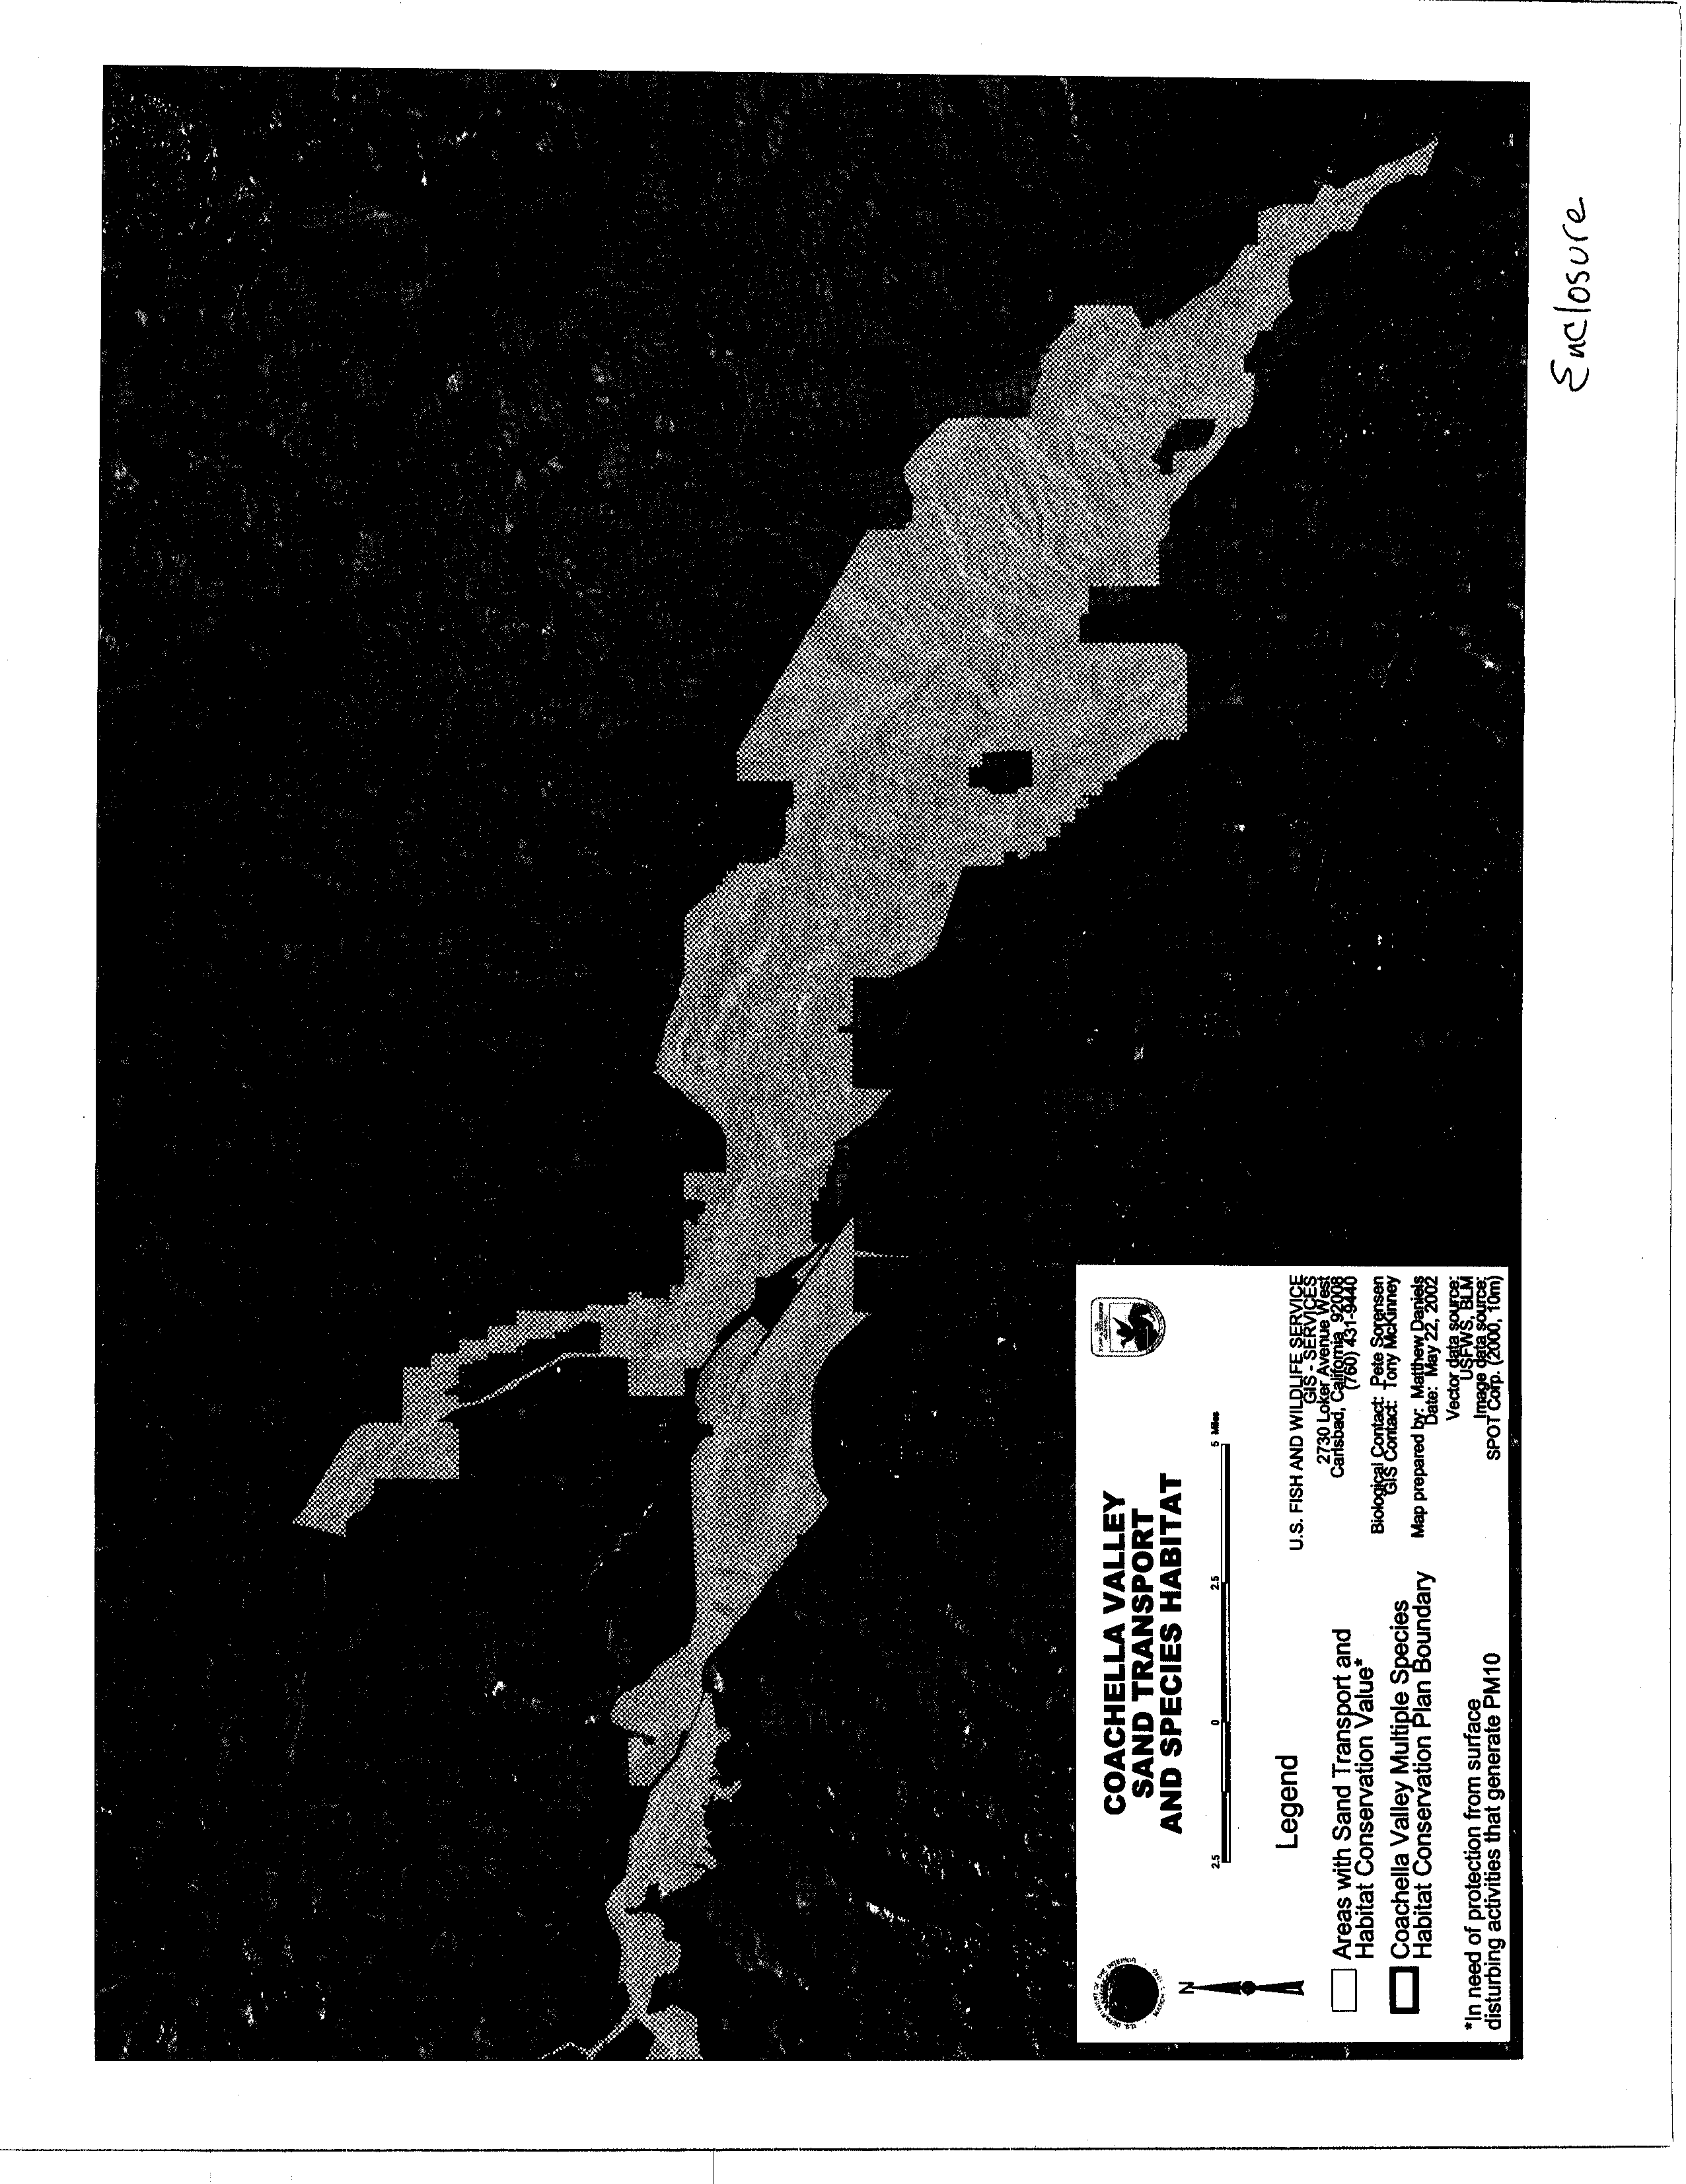
RESPONSE TO COMMENT LETTER 3: UNITED STATES DEPARTMENT OF THE INTERIOR, FISH AND WILDLIFE SERVICE

3-1: The SCAQMD recognizes that endangered and threatened plants and wildlife are found in the Coachella Valley and agrees that implementation of any PM10 control measures should consider potential effects on biological resources. The proposed project, the 2002 Coachella Valley State Implementation Plan (2002 CVSIP), generally enhances fugitive dust control measures that are currently in effect in the Coachella Valley. A previous analyses was conducted by the SCAQMD on the fugitive dust control measures currently in effect, and that analyses did not identify significant adverse biological resources impacts.

SCAQMD Rule 403.1, which applies specifically to the Coachella Valley, currently prohibits fugitive dust mitigation actions that are in conflict with the Endangered Species Act (ESA). Measures to control fugitive dust would only occur in the urbanized areas of the Coachella Valley. As a result, potential adverse impacts to the fringe-toed lizard, milk-vetch, or any other endangered or threatened species are not expected from implementing the proposed 2002 CVSIP.

The 2002 CVSIP includes a State Implementation Plan (SIP) commitment for the SCAQMD to work with the Bureau of Land Management (BLM) and large Coachella Valley landowners to reduce PM10 emissions and maintain habitat for sand-dependent species. Preliminary control strategies included in the draft California Desert Conservation Area Plan Amendment for the Coachella Valley include, reduction in the number of unpaved routes upwind of sensitive receptors, increased enforcement of existing closed areas, installation of sand fencing where permitted, and dust control plans for permitted uses on BLM lands. As already noted, these dust control activities would only occur in urbanized areas in response to human dust generating activities.

Further, it is the responsibility of the project proponent to ensure that any and all applicable regulatory requirements are met, and approvals are obtained. For example, if chemical dust suppressants are used pursuant to SCAQMD Rule 403, it is the responsibility of the user to ensure that they are not prohibited for use by any local, state or federal agency.

  - The 2002 CVSIP recognizes that a variety of endangered and/or threatened plant and animal species (including the milk-vetch) may be found in the Coachella Valley which are dependent on sand transport processes. For the same reasons provided in response to comment 3-1, the proposed project is not expected to adversely affect the milk vetch. Further, the SCAQMD is working closely with CVAG and other agencies to ensure that implementation of the 2002 CVSIP does not conflict with the Coachella Valley Multiple Species Habitat Conservation Plan, currently under preparation by the Coachella Valley Association of Governments.

In addition, the commentator's assertion that the proposed project focuses on dust control activities on artificially disturbed areas, not undisturbed natural areas, is correct. Further, Best Control Measure - 2 (BCM-2) enhances existing requirements for local jurisdictions to adopt new ordinances, or revise existing ordinances, to regulate and enforce dust control activities.

  - The primary purpose of access restrictions to vacant lands is to reduce disturbances, thus reducing PM fugitive dust emissions. Any benefits of this measure resulting in the conservation of several listed species proposed for coverage in the Coachella Valley Multiple Species Habitat Conservation Plan is an unanticipated secondary benefit of implementing the 2002 CVSIP. The SCAQMD is working closely with CVAG and other local jurisdictions to enforce this control measure (BCM-2). The local jurisdiction will evaluate each proposed project and determine the applicability of a BCM and its appropriate control methods based on parameters such as the location of the dust generation activity, the size (acreage) of the project, and the type of project. Also, see response to comment 3-2. Finally, please refer to response to comment 3-1 regarding the conclusion that the proposed project is not expected to adversely affect biological resources, including those identified by the commentator.

  - For the reasons given in response to comment 3-1, it is not anticipated that the proposed project will adversely affect biological resources. Further, as noted in response to comment 3-3, the SCAQMD does not direct or require the use of any particular BCM methods. Instead, the decision to use a particular BCM method is based on a number of factors and the responsibility of the user. The appropriate BCM method is implemented by the user (the entity generating the fugitive dust) in coordination with local jurisdictions.

