PROPOSED 2002 CVSIP APPENDIX E
(An Addendum to the Final 2002 CVSIP dated June 25, 2002)

2003 MILESTONE YEAR TARGET AND EMISSION BUDGETS

NOTE: After the adoption of the 2002 CVSIP on June 21, 2002, U.S. EPA requested additional information for an intermediate milestone year in order for them to complete action on the 2002 CVSIP submittal. The new Appendix E of the 2002 CVSIP provides the emission reductions, the interim milestone year emission target, and emission budgets (for transportation conformity) at the end of the interim milestone year of 2003. It is an addendum to the 2002 CVSIP (dated June 25, 2002). This addendum is scheduled for consideration by the AQMD Governing Board at a public hearing at its September 13, 2002 meeting.

INTRODUCTION
This Appendix discusses the following:
- U.S. EPA request for intermediate milestone information after 2002 CVSIP adoption;
- Interim milestone year reductions by control measures;
- Milestone target at the end of the intermediate milestone year;
- Emission budgets for transportation conformity at the end of the intermediate milestone year; and
- The 2003 CVSIP.

U.S. EPA Request for intermediate milestone information
The 2002 CVSIP was approved by the AQMD Governing Board on June 21, 2002. On June 26, 2002, U.S. EPA staff indicated that additional information about an intermediate milestone would be necessary for them to complete action on the 2002 CVSIP submittal (see Exhibit E-1). Although AQMD staff believes that information in the 2002 CVSIP, including the adoption and implementation schedule in Chapter 5, is sufficient to ensure progress toward attaining the PM10 standards, this addendum to the 2002 CVSIP has been prepared in response to U.S. EPA staff’s request. Per the U.S. EPA staff request letter, the year 2003 is selected as an interim milestone year and emissions are reported as those achieved at the end of 2003, based on the adoption/implementation schedule in the 2002 CVSIP (dated June 25, 2002). The addendum does not alter the substance of the 2002 CVSIP, including the emissions inventories, control measure descriptions, or adoption / implementation dates and commitments. The milestone information for the attainment year 2006 remains unchanged and as presented in the Chapters 3 and 5 of the 2002 CVSIP.

interim milestone year reductions by control measures
The 2003 baseline inventory is shown in Chapter 3, Table 3-5. The full implementation of CV BCM-1 “Construction and Earth-Movement Activities” would results in 1.92 tons/day of emissions reductions. [Additional on-site construction dust control will reduce emissions in the construction category (0.78 tons/day) and enhanced track-out controls will reduce entrained paved road dust (1.14 tons/day).] However, since the adoption date of the local ordinances can be as late as October 2003, and the control measure adoption by the AQMD may not occur until the end of the year, only 50% combined ordinance/rule penetration is assumed by the end of 2003 for this reasonable further progress interim milestone assessment. As noted in Chapter 3 of the 2002 CVSIP, no annual average emission reductions can be assumed for 2003, but for the purposes of a reasonable further progress determination in the interim milestone year, 0.96 tons/day of reductions are anticipated at the end of 2003 as the result of implementation of CV BCM –1 with a 50% combined ordinance/rule penetration by that time. As discussed in Chapter 3, other control measures will have incremental emission reductions beginning in 2004 with full implementation expected by 2006. Table E-1 represents an overview of the 2002 CVSIP control measures and the corresponding emission reduction commitments at the end of 2003.

Table E–1
2002 CVSIP Control Measure Commitments at the End of 2003

Measure | Adoption Date | Implementation Start Date | End of 2003 Emission Reductions (tpd)
CV BCM 1  (Construction Activities) | No later than October 2003 (local), January 2004 (AQMD) | 2003 | 0.961
CV BCM 2  (Disturbed Vacant Lands) | No later than October 2003 | 2003 | 0
CV BCM 3  (Unpaved roads and lots) | Begin no later than October 2003, phased implementation | 2003 | 0
CV BCM 4  (Paved roads) | No later than October 2003 (local), January 2004 (AQMD) | 2003 | 0
CV BCM 5  (Agriculture) | No later than January 2004 | 2004 | 0
CV CTY 1  (Overseeding) | Contingency measure to be adopted in the event of RFP failure or non-attainment by December 31, 2006 | N/A | TBD (partially implemented voluntarily)
Totals |  |  | 0.96

Interim milestone target
The interim milestone year emission target for the Coachella Valley is based on expected emission reductions by the end of 2003. The 2002 CVSIP interim milestone year target is shown in Table E-2. Emissions at the end of 2003 are less than the 2000 baseline emissions and demonstrate progress toward the attainment levels in 2006.
Table E–2
PM10 Interim Milestone Year Target
(Average Day – Tons per Day)

Pollutant | 2000(Baseline) | End of 2003*
PM10 | 54.44 | 54.08*
* Represents remaining emissions at the end of the year 2003 with implementation of CV BCM-1 and 50% combined ordinance/rule penetration by that time.

Transportation Conformity Emission Budgets for the Interim Milestone Year
40 CFR Part 93 requires that emission budgets for criteria air pollutants be specified in the SIP for milestone years. Table E-3 provides the emission budgets after implementation of the 2002 CVSIP controls at the end of the interim milestone year (2003), consistent with the applicable requirements for reasonable further progress and attainment [40 CFR 93.118(e)(4)(iv)], and the U.S. EPA letter in Exhibit E-1. Table E-3 compliments Table 3-8 of the 2002 CVSIP, which reports annual average emissions that take no emission reduction credit in 2003.

TABLE E-3
Coachella Valley Emission Budgets for Transportation Conformity at the End of the 2003 Interim Milestone Year (tons/day)

 | 2003* PM10
Motor Vehicles | 1.04
Reentrained paved road dust | 7.04
Reentrained unpaved road dust | 5.44
Road construction | 0.06
Total | 13.58*
* Represents remaining emissions at the end of the year 2003 with implementation of CV BCM-1 and 50% combined ordinance/rule penetration by that time.

2003 CVSIP
As noted above, the AQMD made a SIP commitment in the 2002 CVSIP Board Resolution to revise the 2002 CVSIP in 2003 to reflect, at a minimum, the latest approved version of EMFAC and the latest approved planning assumptions. The 2003 CVSIP will include revised interim milestone emissions and emission budgets for transportation conformity. In addition, a different interim milestone year may be selected, due to the change in the planning cycle. Upon approval of the 2003 CVSIP by the AQMD Governing Board, it will be submitted to CARB and the U.S. EPA for approval and inclusion as a SIP revision, replacing the milestone year information and emission budgets of this 2002 CVSIP.

EXHIBIT E-1

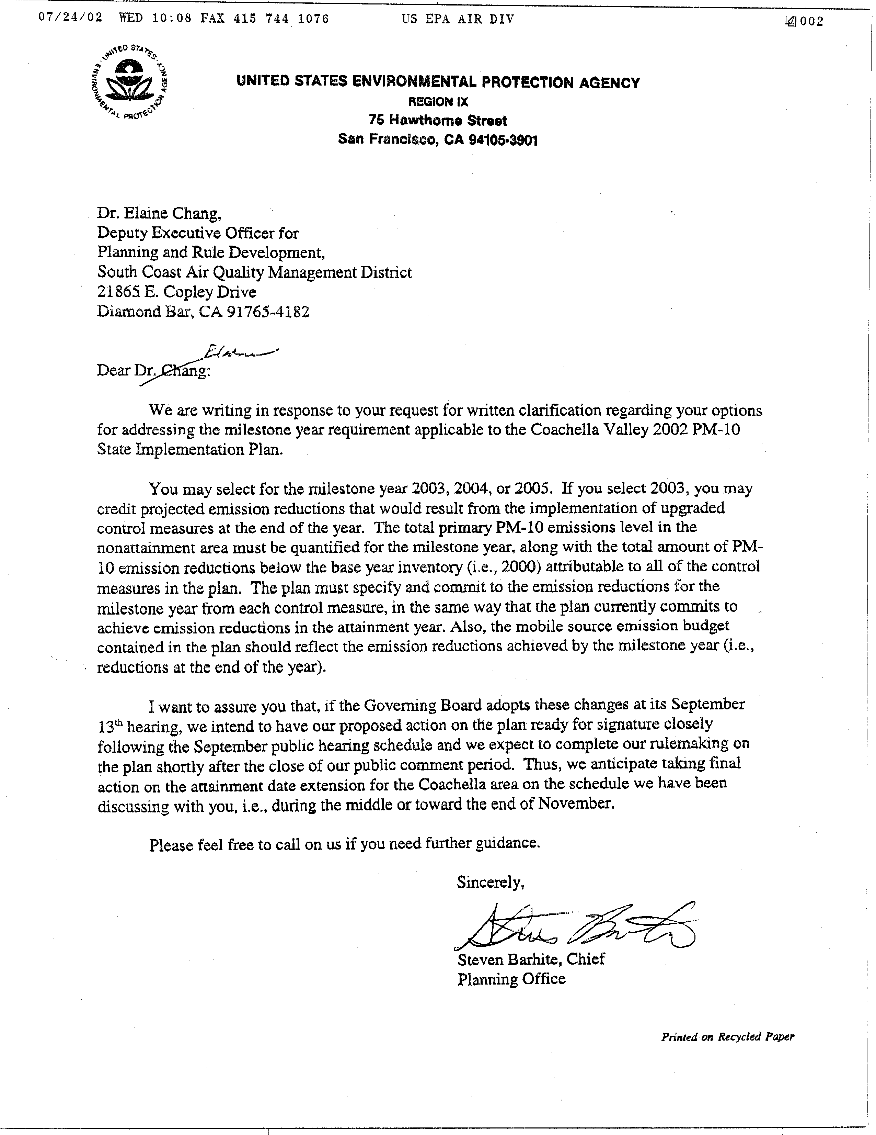

1 Reflects the emission reductions achieved at the end of the year 2003 through the implementation of CV BCM-1, assuming 50% rule penetration by that time. Includes on-site emission reductions (construction) and track-out emission reductions (entrained paved road dust). Per U.S. EPA staff request, CV BCM 4 includes a duplicate discussion of the track-out provisions in CV BCM 1. As noted in Chapter 5, emission reductions from these provisions have been assigned to CV BCM 1.

