south coast air quality management district

Final Environmental Assessment:
Proposed Amended Rules 1302 – Definitions, 1303 – Requirements, 1306 – Emissions Calculations, 2000 – General; and BACT Guidelines

SCAQMD No. 33100JDN
August 23, 2000
Executive Officer
Barry R. Wallerstein, D. Env.
Deputy Executive Officer
Planning, Rules, and Area Sources
Jack P. Broadbent
Assistant Deputy Executive Officer
Planning, Rules, and Area Sources
Elaine Chang, DrPH
Manager
Planning, Rules, and Area Sources
Alene Taber, AICP

Author: Jonathan D. Nadler - Air Quality Specialist

Technical Robert Pease – Air Quality Analysis and Compliance Supervisor
Assistance: Shams Hasan – Air Quality Engineer II

Reviewed By: Anuopm Ganguli, PhD. – Planning and Rules Manager
Fred Lettice, P.E. – Senior Manager – Engineering and Compliance
David E. Schwein - Senior Manager – Engineering and Compliance
Steve Smith, Ph.D. - Program Supervisor
William Wong - Senior Deputy District Counsel
South coast air quality management district
governing board

CHAIRMAN: WILLIAM A. BURKE, Ed.D.
Speaker of the Assembly Appointee

VICE CHAIRMAN: NORMA J. GLOVER
Councilmember, City of Newport Beach
Cities Representative, Orange County
MEMBERS:

MICHAEL D. ANTONOVICH
Supervisor, Fifth District
Los Angeles County Representative

HAL BERNSON
Councilmember, City of Los Angeles
Cities Representative, Los Angeles County, Western Region

JANE W. CARNEY
Senate Rules Committee Appointee

CYNTHIA P. COAD, Ed.D.
Supervisor, Fourth District
Orange County Representative

BEATRICE J.S. LAPISTO-KIRTLEY
Councilmember, City of Bradbury
Cities Representative, Los Angeles County, Eastern Region

Ronald O. Loveridge
Mayor, City of Riverside
Cities Representative, Riverside County

JON D. MIKELS
Supervisor, Second District
San Bernardino County Representative

LEONARD PAULITZ
Councilmember, City of Montclair
Cities Representative, San Bernardino County

CYNTHIA VERDUGO-PERALTA
Governor's Appointee

S. ROY WILSON, Ed.D.
Supervisor, Fourth District
Riverside County Representative

EXECUTIVE OFFICER:

BARRY R. WALLERSTEIN, D.Env.

PREFACE

This document constitutes the Final Environmental Assessment (EA) for the proposed amendments to Rules 1302 – Definitions, 1303 – Requirements, 1306 – Emissions Calculations, and 2000 – General, and BACT Guidelines. Comments received during the 30-day review period for the Draft EA are included in Appendix C. No comments were received which change any of the conclusions reached in the Draft document.
To ease in identification, modifications to the document are included in italics, and text removed from the document is indicated by strikethrough. None of the modifications alter any conclusions reached in the Draft EA, nor provide new information of substantial importance relative to the Draft document.

Table of contents

CHAPTER 1 - PROJECT DESCRIPTION

Introduction 1-1
California Environmental Quality Act 1-1
Project Location 1-1
Project Background and Objective 1-2
Project Description 1-4

CHAPTER 2 - ENVIRONMENTAL CHECKLIST

Introduction 2-1
General Information 2-1
Potentially Significant Impact Areas 2-1
Determination 2-2
Environmental Checklist and Discussion 2-3

APPENDIX A

Proposed Amended Rules 1302, 1303, 1306, and 2000

APPENDIX B

BACT Guidelines Part C: Policy and Procedures for Non-Major Polluting Facilities

BACT Guidelines Part D: BACT for Minor Polluting Facilities

APPENDIX C

Response to Comments on the Draft EA

C H A P T E R 1 - P R O J E C T D E S C R I P T I O N

Introduction
California Environmental Quality Act
Project Location
Project Background and Objective
Project Description

introduction
The California Legislature created the South Coast Air Quality Management District (SCAQMD) in 1977 as the agency responsible for developing and enforcing air pollution control rules and regulations in the South Coast Air Basin (Basin) and portions of the Salton Sea Air Basin and Mojave Desert Air Basin. By statute, the SCAQMD is required to adopt an air quality management plan (AQMP) demonstrating compliance with all federal and state ambient air quality standards for the district. Furthermore, the SCAQMD must adopt rules and regulations that carry out the AQMP. The 1997 AQMP concluded that major reductions in emissions of volatile organic compounds (VOCs) and oxides of nitrogen (NO_{x}) are necessary to attain the air quality standards for ozone and particulate matter (PM10).
As part of the strategy to achieve ambient air quality standards, federal and state laws require the development and implementation of air quality permitting programs, commonly known as New Source Review (NSR) programs. Local NSR programs must, at a minimum, comply with the requirements established pursuant to federal and state law. The general requirements of NSR programs include: (1) pre-construction review; (2) the installation of air pollution control equipment; and, (3) the mitigation of emission increases by providing emission offsets.
To satisfy requirement (2) listed above, the SCAQMD requires Best Available Control Technology (BACT) for any emissions increase from a new, modified, or relocated source within the district. As discussed below, the proposed project would modify the methods by which the SCAQMD determines BACT for non-major polluting facilities. Additionally, the proposal would allow relocations of non-major polluting facilities that meet certain conditions, including no emissions increase, to maintain the existing control level from the prior location instead of installing new BACT controls. The proposed project would specifically amend three rules contained in Regulation XIII – New Source Review (i.e., Rule 1302 – Definitions, Rule 1303 – Requirements, and Rule 1306 – Emissions Calculations) and one rule in Regulation XX – Regional Clean Air Incentives Market (RECLAIM) (i.e., Rule 2000 – General), and establish BACT Guidelines for minor sources.

california environmental quality act
The proposed amendments to Rules 1302, 1303, 1306, and 2000 are a “project’ as defined by the California Environmental Quality Act (CEQA). SCAQMD is the lead agency for the project and has prepared this EA pursuant to its Certified Regulatory Program. California Public Resources Code Section 21080.5 allows public agencies with regulatory programs to prepare a plan or other written document in lieu of an environmental impact report once the Secretary of the Resources Agency has certified the regulatory program. SCAQMD's regulatory program was certified by the Secretary of the Resources Agency on March 1, 1989, and is codified as SCAQMD Rule 110. Pursuant to Rule 110, SCAQMD is preparing this Draft Environmental Assessment (EA).
CEQA and SCAQMD Rule 110 require that the potential environmental impacts of proposed projects be evaluated and that feasible methods to reduce or avoid significant adverse environmental impacts of these projects be identified. To fulfill the purpose and intent of CEQA, the SCAQMD has prepared this Environmental Assessment (EA) to address the potential environmental impacts associated with the proposed project. The EA is intended to: (a) provide the lead agency, responsible agencies, decision makers and the general public with information on the environmental effects of the proposed project; and, (b) be used as a tool by decision makers to facilitate decision making on the proposed project.
Written comments on the Draft EA have been responded to and included in this Final EA. Prior to making a decision on the proposed amendments, the SCAQMD Governing Board must review and certify the Final EA as providing adequate information on the potential adverse environmental impacts of the proposed rule.
SCAQMD’s review of the proposed project shows that the project would not have a significant effect on the environment. Therefore, pursuant to CEQA Guidelines §15252, no alternatives or mitigation measures are included in this EA. The analysis in Chapter 2 supports the conclusion of no significant adverse environmental impacts.

project location
Existing Rules 1302, 1303, 1306, and 2000 apply to SCAQMD’s entire jurisdiction. The SCAQMD has jurisdiction over an area of 10,473 square miles (referred to hereafter as the district), consisting of the four-county South Coast Air Basin (Basin) and the Riverside County portions of the Salton Sea Air Basin (SSAB) and the Mojave Desert Air Basin (MDAB). The Basin, which is a subarea of the district, is bounded by the Pacific Ocean to the west and the San Gabriel, San Bernardino, and San Jacinto Mountains to the north and east. The 6,745 square-mile Basin includes all of Orange County and the nondesert portions of Los Angeles, Riverside, and San Bernardino counties. The Riverside County portion of the SSAB and MDAB is bounded by the San Jacinto Mountains in the west and spans eastward up to the Palo Verde Valley. The federal nonattainment area (known as the Coachella Valley Planning Area) is a subregion of both Riverside County and the SSAB and is bounded by the San Jacinto Mountains to the west and the eastern boundary of the Coachella Valley to the east (Figure 1-1).

PROJECT background AND OBJECTIVE
Federal and state laws require the development and implementation of NSR programs to ensure that the operation of new, modified, or relocated stationary emission sources in nonattainment areas does not interfere with the attainment and maintenance of National Ambient Air Quality Standards (NAAQS). Local NSR programs must, at a minimum, comply with the requirements established pursuant to federal and state law. The general requirements of NSR programs include: (1) pre-construction review; (2) the installation of air pollution control equipment; and, (3) the mitigation of emission increases by providing emission offsets.

Figure 1-1
South Coast Air Quality Management District

To satisfy requirement (2) listed above, the SCAQMD requires BACT for any emissions increase greater than one pound per day from a new, modified, or relocated source within the district. BACT has historically been defined in SCAQMD NSR rules as the most stringent emission limit or control technology which has been achieved in practice for that category or class of source; or contained in a SIP; or other limit that is technologically feasible and cost-effective. SCAQMD rules require BACT for all sources to be at least as stringent as the lowest achievable emission rate (LAER) as defined in the federal Clean Air Act (CAA).
LAER is a requirement for major polluting facilities. Since U.S. Environmental Protection Agency (EPA) policy generally precludes cost considerations for LAER, regulated sources have raised concerns with the cost of control equipment for non-major emission sources. As part of the discussions pertaining to the proposed amendments, the U.S. EPA has expressed willingness to exclude facilities that are not major sources from LAER applicability.
Another issue regarding LAER for non-major polluting facilities is associated with relocations. Some sources that relocate without an emission increase are considered new sources under EPA’s LAER policy and are thus subject to LAER. Regulated sources have also raised concerns with requiring LAER for a non-major polluting facility that relocates without an emission increase.
The proposed amendments are intended to address the issues outlined above. The objective of the proposed project, therefore, is to 1) adopt an NSR process that considers cost of the controls in the determination of BACT emission levels and source categories for non-major polluting facilities, and 2) to modify the BACT applicability determination for relocating non-major polluting facilities.

project description
The following is a brief summary of the proposed amendments. Proposed amended Rules 1302, 1303, 1306, and 2000 are included in this document as Appendix A. The proposed BACT Guidelines Part C: Policy and Procedures for Non-Major Polluting Facilities, are included in this document as Appendix B.
The proposed amendments would bifurcate NSR control technology requirements into LAER for federal major polluting facilities and Minor Source BACT (MSBACT) for all others. All major polluting facilities, as defined in the federal CAA, would be required to employ LAER for any new or relocated sources, and for any emission increase from modified sources. All other facilities would be required to employ MSBACT. This modification would apply to both RECLAIM and non-RECLAIM facilities. The result of the proposed amendments is that cost would be taken into consideration when determining emissions levels and source categories for MSBACT for non-major polluting facilities. Currently, cost is usually not considered in SCAQMD BACT determinations since BACT is defined as being equivalent to LAER.
As part of the proposed project, the SCAQMD would revise its current BACT Guideline to address MSBACT for non-major polluting facilities. Appendix B of this Draft EA contains the draft BACT Guidelines Part C. Part C includes explanations of how to determine whether a facility is non-major or major, when MSBACT is required, and what MSBACT is and how it is determined.
MSBACT is listed in Part D: BACT Guidelines for Non-Major Polluting Facilities. The proposed MSBACT for non-major polluting facilities is based on existing control requirements (i.e., existing BACT which is equivalent to LAER). That is, the initial listing of MSBACT does not represent new requirements, but rather memorializes current BACT determinations and emission levels. It is possible, however, that MSBACT for non-major polluting facilities may be less stringent than future LAER if the stringency of LAER increases, since costs would be considered when determining emissions levels and source categories for MSBACT.
As part of the proposed amendments, relocations of non-major polluting facilities (under certain conditions) may no longer trigger a BACT determination. This would apply at the facilities option if there is no emissions increase upon relocation nor within two years after the relocation and only if the facility owner can demonstrate same ownership and operation for two years prior to relocation. The facility owner may not relocate part of the facility under this option. The relocated facility would still be subject to the offset requirements set forth in Regulation XIII, which would require the facility to take either a BACT adjusted limit or otherwise offset emissions to zero. In the event a relocated facility using this option increases its emission within two years of relocation, the entire facility will be subject to new BACT. This amendment would not affect major polluting facilities that would continue to be subject to EPA’s LAER policy, which requires relocated facilities to be treated as new facilities.
Existing provisions in Regulation XIII that exempt relocating facilities from providing offsets created an incentive for some spray booth operators/owners to engage in activities aimed at circumventing the offset requirement. The proposed modified relocation provision’s requirement to provide offsets and two-year restriction on emissions increases would likely deter facilities from engaging in activities to circumvent BACT or offset requirements. Also, since discovery of the circumvention activities, the SCAQMD has been vigilant in combating such abuses. The SCAQMD has increased its enforcement presence at affected facilities. In addition to an increased number of inspectors, enforcement personnel specifically investigate locations with pending relocation applications to detect such activities. Additionally, if the current proposal is adopted, the permit engineer who processes an application for a spray booth would check on the last two years of permit activity at the facility prior to issuing a permit. This practice would ensure that only applicable sources could utilize the proposed provision relative to BACT for relocations. Based on the above, it is anticipated that the proposed relocation provision would not further aggravate the existing situation.
Subsequent to the release of the Draft EA, an additional change to Rule 1303 has been proposed. Rule 1303 would prohibit the use of ERCs issued for compounds that are no longer identified as a VOC under Rule 102 – Definition of Terms. This proposal recognizes that in the past few years several compounds have been de-listed as VOCs by the U.S. EPA (and ultimately the California Air Resources Board (ARB) and the AQMD). ERCs issued for compounds that are no longer considered VOCs could no longer be considered real emission reductions, and therefore should not be used to offset actual increases in actual VOC emissions.

C H A P T E R 2 - E N V I R O N M E N T A L C H E C K L I S T

Introduction
General Information
Potentially Significant Impact Areas
Determination
Environmental Checklist and Discussion

INTRODUCTION
The environmental checklist provides a standard evaluation tool to identify a project's adverse environmental impacts. This checklist identifies and evaluates potential adverse environmental impacts that may be created by the proposed amendments to SCAQMD Rules 1302 – Definitions, 1303 – Requirements, 1306 – Emissions Calculations, and 2000 New Source Review for RECLAIM.

GENERAL INFORMATION
Name of Proponent: | South Coast Air Quality Management District
Address of Proponent: | 21865 E. Copley Drive  Diamond Bar, CA 91765
Lead Agency: | South Coast Air Quality Management District
CEQA Contact Person: | Jonathan D. Nadler (909) 396-3071
Rule Contact Person: | Shams Hasan (909) 396-2338
Name of Project: | Proposed Amended Rules 1302 – Definitions, 1303 – Requirements, 1306 – Emissions Calculations, and 2000 - General

POTENTIALLY SIGNIFICANT IMPACT AREAS
The following environmental impact areas have been assessed to determine their potential to be affected by the proposed project. As indicated by the checklist on the following pages, environmental topics marked with an "✓" may be adversely affected by the proposed project. An explanation relative to the determination of impacts can be found following the checklist for each area.
◻ | Land Use and Planning | ◻ | Transp./Circ. | ◻ | Public Services
◻ | Pop./Housing | ◻ | Biological Resources | ◻ | Solid/Hazardous Waste
◻ | Geophysical | ◻ | Energy/Mineral Resources | ◻ | Aesthetics
◻ | Water | ◻ | Hazards | ◻ | Cultural Resources
◻ | Air Quality | ◻ | Noise | ◻ | Recreation
 |  |  |  | ◻ | Mandatory Findings
DETERMINATION
On the basis of this initial evaluation:
☑ | I find the proposed project, in accordance with those findings made pursuant to CEQA Guideline §15252, could NOT have a significant effect on the environment, and that an ENVIRONMENTAL ASSESSMENT with no significant impacts will be prepared.
◻ | I find that although the proposed project could have a significant effect on the environment, there will NOT be significant effects in this case because the mitigation measures described on an attached sheet have been added to the project. an ENVIRONMENTAL ASSESSMENT with no significant impacts will be prepared.
◻ | I find that the project MAY have a significant effect(s) on the environment, and an ENVIRONMENTAL ASSESSMENT will be prepared.

Date July 6, 2000 Signature:
Steve Smith, Ph.D.
Program Supervisor

ENVIRONMENTAL CHECKLIST AND DISCUSSION
As discussed in Chapter 1, the proposed project modifies the method by which BACT determinations are made for sources located at non-major polluting facilities. The proposed amendments would bifurcate NSR control technology requirements into LAER for major polluting facilities and MSBACT for all others. All major polluting facilities, as defined in the federal CAA, would be required to employ LAER for any emission increase subject to NSR. All non-major polluting facilities would be required to employ MSBACT for any emission increase subject to NSR. This modification would apply to both RECLAIM and non-RECLAIM sources. The result of the bifurcation is that cost would be considered when determining MSBACT emission levels and source categories for non-major polluting facilities. Additionally, the proposal would allow relocations of non-major polluting facilities that meet certain conditions, including no emissions increase, to maintain the existing control level from the prior location instead of installing new BACT controls. Facilities choosing this option would still be subject to the offset requirements set forth in Regulation XIII.

 | Potentially Significant Impact | Less Than Significant Impact | No Impact
I. LAND USE AND PLANNING. Would the proposal:

a) Conflict with any applicable land use plan, policy, or regulation of an agency with jurisdiction over the project adopted for the purpose of avoiding or mitigating an environmental effect? | ◻ | ◻ | ☑
b) Conflict with any applicable habitat conservation or natural community conservation plan? | ◻ | ◻ | ☑
c) Affect agricultural resources or operations (e.g. impacts to soils or farmlands, or impacts from incompatible land uses)? | ◻ | ◻ | ☑
d) Physically divide an established community (including a low-income or minority community)? | ◻ | ◻ | ☑

There are no provisions in the proposed amendments that would affect land use plans, policies, or regulations, physically divide an established community, or affect agricultural resources or operaitons. Land use and other planning considerations are determined by local governments and no land use or planning requirements will be altered by bifurcating MSBACT and LAER requirements. Therefore, present or planned land uses in the region will not be affected as a result of the proposed amendments.

 | Potentially Significant Impact | Less Than Significant Impact | No Impact
II. POPULATION AND HOUSING. Would the proposal:

a) Induce substantial growth in an area either  directly or indirectly (e.g. through projects in  an undeveloped area or extension of major  infrastructure)? | ◻ | ◻ | ☑
b) Displace substantial numbers of existing housing or people, necessitating the construction of replacement housing elsewhere? | ◻ | ◻ | ☑

There are no provisions in the proposed amendments that would result in the creation of any industry that would affect population growth, or directly or indirectly induce the construction of single- or multiple-family units. No population relocation or growth inducement is expected from the implementation of the proposed amendments.

 | Potentially Significant Impact | Less Than Significant Impact | No Impact
III. GEOPHYSICAL. Would the proposal:

a) Expose people or structures to potential substantial adverse effects, including the risk of loss, injury, or death involving rupture of a known earthquake fault, strong seismic ground shaking, seismic–related ground failure, or landslides? | ◻ | ◻ | ☑
b) Result in substantial soil erosion or the loss of topsoil? | ◻ | ◻ | ☑
c) Be located on a geologic unit or soil that is unstable or that would become unstable as a result of the project, and potentially result in on- or off-site landslide, lateral spreading, subsidence, liquefaction or collapse? | ◻ | ◻ | ☑

The proposed project has no provisions that call for the disruption or overcovering of soil, changes in topography or surface relief features, the erosion of beach sand, or a change in existing siltation rates. In addition, the proposed project would not expose people or property to geological hazards such as earthquakes, landslides, mudslides, ground failure, or other natural hazards.

 | Potentially Significant Impact | Less Than Significant Impact | No Impact
IV. WATER. Would the proposal:

a) Violate any water quality standards or waste discharge requirements? | ◻ | ◻ | ☑
b) Exceed wastewater treatment requirements of the applicable Regional Water Quality Control Board? | ◻ | ◻ | ☑
c) Substantially deplete groundwater supplies or interfere substantially with groundwater recharge such that there would be a net deficit in aquifer volume or a lowering of the local groundwater table level? | ◻ | ◻ | ☑
d) Substantially alter the existing drainage pattern of the site or area, including through alteration of the course of a stream or river, or substantially increase the rate or amount of surface runoff in a manner that would result in erosion or flooding on- or off-site? | ◻ | ◻ | ☑
e) Create or contribute runoff water which would exceed the capacity of existing or planned stormwater drainage systems or provide substantial additional sources of polluted runoff? | ◻ | ◻ | ☑
f) Otherwise substantially degrade water quality? | ◻ | ◻ | ☑
g) Require or result in the construction of new water, wastewater treatment facilities, stormwater drainage facilities, or expansion of existing facilities, the construction of which could cause significant environmental effects? | ◻ | ◻ | ☑
h) Have sufficient water supplies available to serve the project from existing entitlements and resources, or are new or expanded entitlements needed? | ◻ | ◻ | ☑
i) Result in a determination by the wastewater treatment provider that serves or may serve the project’s projected demand in addition to the provider’s existing commitments? | ◻ | ◻ | ☑

Bifurcating NSR control technology requirements into LAER for major polluting facilities and MSBACT for all others is not expected to create a significant adverse water resource impact. The proposed project has no provision that would require the construction of additional water resource facilities, the need for new or expanded water entitlements, or an alteration of drainage patterns.

As proposed, the initial MSBACT for non-major polluting facilities is equivalent to current BACT requirements; no change from existing conditions is anticipated. Further, control equipment at such facilities tends to be more environmentally benign than the equipment used to control major emission sources. It is expected that potential water resource impacts from air pollution control equipment would not be altered, or would possibly be reduced, if MSBACT were to be less stringent than currently required LAER.

 | Potentially Significant Impact | Less Than Significant Impact | No Impact
V. AIR QUALITY. Would the proposal:

a) Conflict with or obstruct implementation of the applicable air quality plan? | ◻ | ☑ | ◻
b) Violate any air quality standard or contribute to an existing or projected air quality violation? | ◻ | ◻ | ☑
c) Expose sensitive receptors to substantial pollutant concentrations? | ◻ | ◻ | ☑
d) Expose off-site receptors to significant concentrations of hazardous air pollutants? | ◻ | ◻ | ☑
e) Result in a cumulatively considerable net increase of any criteria pollutant for which the project region is non-attainment under an applicable federal or state ambient air quality standard (including releasing emissions that exceed quantitative thresholds for ozone precursors)? | ◻ | ☑ | ◻
- Diminish an existing air quality rule or future compliance requirement resulting in a significant increase in air pollutant(s). | ◻ | ☑ | ◻
g) Create objectionable odors affecting a substantial number of people? | ◻ | ◻ | ☑

The proposed project would bifurcate NSR control technology requirements into LAER for major polluting facilities and MSBACT for all others. The result of the bifurcation is that cost would be considered when establishing new BACT requirements for classes or categories of sources. The proposal would also allow relocations of non-major polluting facilities that meet certain conditions, including no increase in emissions, to maintain the existing control level from the prior location instead of achieving a new BACT level. Facilities choosing this option would still be subject to the offset requirements set forth in Regulation XIII.
This document analyzes the potential adverse air quality impacts associated with the proposed amendments. The analysis is divided into three main sections. The first section discusses the proposed bifurcation of MSBACT and LAER. The second section analyzes the proposed relocation provision. The last section analyzes how the proposed amendments relate to the emission accounts created for the 1997 AQMP to track emissions associated with the SCAQMD’s NSR program.
MSBACT/LAER
The proposed project would bifurcate NSR control technology requirements into LAER for major polluting facilities and MSBACT for all others. As discussed in Chapter 1, the proposal updates the current BACT Guidelines to include MSBACT requirements for non-major polluting facilities that is equivalent to current LAER. It is possible that as technology progresses, however, MSBACT for minor sources may lag behind major source LAER for certain source categories since costs would be considered when making MSBACT determinations. MSBACT would be expected to ultimately catch up to LAER since the cost of control technology tends to decrease over time and the LAER technology would qualify as “achieved in practice”.
An example of a potential MSBACT/LAER split is the potential future MSBACT and LAER for small boilers. Currently, LAER for small boilers is 12 parts per million (ppm) of oxides of nitrogen (NOx). It is conceivable that future LAER for this source category would be as low as two ppm of NOx, while MSBACT could remain at 12 ppm until cost and performance data are well established. Another possible future MSBACT/LAER split may occur for non-automotive spray booths. It is possible that future MSBACT-adjusted emissions for spray booths could remain at 39 pounds per day, while LAER-adjusted emissions may be 30 pounds per day. No other MSBACT/LAER splits are foreseen in the near future, and any projections beyond these would be too speculative to analyze.
Emission Reductions Forgone
Due to the requirements inherent in Regulation XIII, there would be no increase in emissions if a split between LAER and MSBACT for boilers, spray booths, or any other equipment category were to occur. Any future difference in emission reductions between the control technology requirements of MSBACT and LAER for new sources would be met by emission offsets. That is, Regulation XIII requires emission offsets for any emission increase from new sources [Rule 1303(b)(2)]. Therefore, if a new non-major source were subject to MSBACT rather than LAER, and MSBACT was less stringent than LAER, the emission reductions achieved under MSBACT could be less than those that would have occurred under LAER. Due to the offset requirements in Regulation XIII, however, any “excess” emissions would need to be offset by either the applicant or the SCAQMD.
Likewise, a split between MSBACT and LAER would not increase emissions for a modification to an existing source. If an existing source were modified such that its PTE decreased (which is typically the case), neither MSBACT nor LAER would apply because there would be no increase in emissions. Conversely, if an existing source were modified such that the PTE increased, MSBACT or LAER would apply depending on the PTE of the source. Thus, if future MSBACT were less stringent than LAER, the emission reductions achieved under MSBACT would be less than those under LAER. Therefore, while a split between MSBACT and LAER would not result in an increase in emissions from a modified source, it may result in future emission reductions forgone.
The actual amount of emission reductions forgone cannot be definitively known. The quantity would depend on the difference between MSBACT and LAER. It is not known at this time in which equipment categories MSBACT and LAER will diverge, if any. Potential emission reductions forgone would also depend on the number of modified sources subject to MSBACT in those equipment categories where MSBACT and LAER have diverged.
With regard to spray booths, the provisions of NSR have created a system where existing sources are highly unlikely to modify their operations such that VOC emissions increase above 22 pounds per day (four tons per year) since a source above this limit would be responsible for providing offsets. Therefore, a split between MSBACT and LAER for spray booths such that the add-on control equipment trigger for MSBACT is 39 pounds VOC per day and LAER is 30 pounds per day would not be expected to result in emission reductions forgone.
For the purposes of analyzing the potential impact of forgone NOx emission reductions associated with the bifurcation of MSBACT and LAER for small boilers, the following assumptions have been made.
- small boiler MSBACT = 12 ppm NOx; future LAER = 2 ppm NOx
- boiler size = 15 million British thermal units per hour (MMBtu/hr)
- ppm-to-pound conversion factor = 1 lb NOx/825 ppm NOx/MMBtu/hr
- hours of operation = 24 hours/day
- capacity factor = 0.25
- number of modified boilers subject to MSBACT per year = 5
These assumptions are extremely conservative. The size of the boiler, while not the highest rated of the small boiler category (i.e., up to 20 MMBtu/hr), is greater than the average size boiler that has historically been permitted. Additionally, boilers generally do not operate 24 hours per day; many boilers are used for heating at night or on a seasonal basis. Most importantly, this analysis assumes that all proposed modifications to existing boilers would increase emissions such that BACT is required. In fact, the SCAQMD rarely receives permit applications for modifications to boilers where there is an increase in emissions. Applications to modify boilers are usually for compliance with Rule 1146 - Emissions of Oxides of Nitrogen from Industrial, Institutional and Commercial Boilers, Steam Generators, and Process Heaters, or Rule 1146.1 - Emissions of Oxides of Nitrogen from Small Industrial, Institutional, and Commercial Boilers, Steam Generators, and Process Heaters. In either case, there are no emission increases from such modifications and BACT does not apply. Finally, based on recent experience of boilers with ultra-low-NOx burners, it is possible that MSBACT for this source category may be reduced from 12 ppm to nine ppm within a year or two, following applicable procedures as set forth in the BACT Guidelines.

Based on the extremely conservative assumptions listed above, the amount of forgone emission reductions are estimated as follows:
(12 – 2 ppm NOx) x (15 MM Btu/hr) x (1 lb NOx/825 ppm NOx/MM Btu/hr) x (24 hr/day) x (0.25) = 1.09 pounds NOx/day/boiler
Assuming five boilers modifications subject to MSBACT per year, the amount of emission reductions forgone at the end of one year equals 5.45 pounds of NOx per day. Since it is unknown when and if LAER for small boilers would be reduced to two ppm and how long MSBACT would remain at 12 ppm, it cannot be determined to what extent the emission reductions forgone may accumulate. Based on the assumptions used in this analysis, it would take over ten years to accumulate forgone emission reductions to exceed the SCAQMD’s daily NOx emission significance threshold of 55 pounds per day. Considering the extremely conservative assumptions used in this analysis coupled with the long time frame before the SCAQMD daily NOx emission threshold may be exceeded, the potential air quality effects associated with forgone emission reductions are deemed not significant.
Increased Demand for Emission Offsets for Which the SCAQMD is Responsible
The bifurcation of MSBACT and LAER would not alter the NSR requirements for major sources, and the proposed amendments would have no effect on Regulation XIII’s effectiveness in achieving federal NSR requirements. Nonetheless, since staff was questioned at a public workshop for the proposed project whether bifurcating MSBACT and LAER would require the SCAQMD to require a 1.5-to-1.0 emissions offset ratio as opposed to a 1.2-to-1.0 ratio, the following briefly discusses the federal NSR offset requirements and how the SCAQMD complies with those requirements.
The federal CAA requires a 1.5-to-1 or a 1.2-to-1 external offset ratio and a 1.3-to-1 internal offset ratio for major VOC or NOx sources. An extreme ozone nonattainment area may qualify for the 1.2-to-1 offset ratio if it requires all existing major sources to use federally defined BACT [CAA § 182(e)(1)] (the South Coast Air Basin is the only extreme ozone nonattainment area in the nation). The CAA states that "for purposes of satisfying the offset requirements pursuant to this part, the ratio of total emission reductions of VOCs to all increased emissions of such air pollutant shall be at least 1.5-to-1.0 ... " [§182(e)]. Because the statute uses the term "total emission reductions" the offset ratio requirements of §182(e)(1) can be met on an aggregate basis, provided the information is substantiated by an emissions tracking system. The SCAQMD’s NSR program meets the federal offset requirements in an aggregate form. For information purposes, sources of creditable emission reductions for compliance with federal NSR requirements are discussed below.
Sources of creditable emission reductions for compliance with federal NSR requirements include orphan shutdowns, BACT discount of ERCs, and the discounting of negative NSR balances. Orphan shutdowns are emission decreases from stationary sources that go out of business, permanently cease emitting activities, and do not apply for ERCs. These emission decreases are retained by the SCAQMD to fund the NSR program.
Emission reductions from shutdowns for which ERCs are issued are discounted to BACT levels. The amount discounted is credited to the NSR account as a creditable emission reduction, since they are in excess of the federal NSR requirements.
Negative NSR balances represented a facility’s emission reduction credit balance. Negative NSR balances were generated by emission reductions (which were the result of equipment or facility modifications or shutdowns) that were credited to a facility’s NSR account and not issued as a certificate. As part of the 1990 amendments to Regulation XIII, the SCAQMD reduced these credit balances by 80 percent to generate emission reductions to fund the Community Bank, Priority Reserve and Rule 1304 exemptions.
While the bifurcation of MSBACT and LAER would not alter the NSR requirements for major sources (and thus not increase demand for offsets from these sources) or impair Regulation XIII’s effectiveness in achieving federal NSR requirements, it has the potential to increase the demand for emission offsets for which the SCAQMD is responsible pursuant to state NSR requirements.
State law requires “no net emissions increase” of non-attainment pollutants or their precursors. As discussed above, new emission sources are required to offset any emissions increases after application of BACT. Thus the “no net emissions increase” requirement is met by a combination of emission control equipment and emission offsets. If MSBACT were to lag behind LAER, a new emission source may reduce a smaller percentage of their emissions by control equipment and a greater percentage by applying emissions offsets. The SCAQMD is responsible under Regulation XIII for providing offsets for sources whose PTE is less than four tons per year for VOC, NOx, SOx, or PM10, or 29 tons per year for CO, and for other specified sources. Thus, an increased demand for emission offsets from a MSBACT/LAER bifurcation could increase the demand for offsets that are the responsibility of SCAQMD.
Unlike new emission sources, modified existing sources are typically not required to provide offsets since their post-modification emissions are usually less than their baseline emissions. In the event that post-modification emissions would be greater than baseline emissions, MSBACT would be required and its application would likely reduce emissions below the baseline. In this case, no offsets would be necessary. For these reasons, the bifurcation of MSBACT and LAER would not be expected to result in an increased demand for offsets from modified existing sources.
In the case of new spray booths, the potential future bifurcation of MSBACT and LAER emission thresholds for add-on control equipment to 39 and 30 pounds per day of VOC, respectively, would not result in an additional offset burden on the SCAQMD. The SCAQMD is responsible for offsets for sources less than four tons per year, which equals 22 pounds per day. Therefore, the proposed bifurcation of MSBACT and LAER would not increase the demand for offsets that are the responsibility of SCAQMD.
The proposed bifurcation of MSBACT and LAER may, however, result in an additional demand for offsets from new small boilers. As with the case for potential emission reductions forgone, the increased demand for emission offsets for which the SCAQMD is responsible cannot be definitively known. The quantity would depend on the difference between future LAER and MSBACT, if any, and the number of new sources in those equipment categories where LAER and MSBACT have diverged. For the purpose of analyzing the potential increased demand for offsets that are the responsibility of SCAQMD, it is assumed that all new sources have emissions less than four tons per year. Thus all the offsets required of these sources would be the responsibility of the SCAQMD.
Based on the calculations for boilers made above and assuming 50 new small boilers are permitted per year, the estimated amount of NOx offsets for which the SCAQMD would be responsible due to a potential split in MSBACT and LAER for small boilers is 54.5 pounds per day after one year. Since it is unknown when and if LAER for small boilers would be reduced to two ppm and how long MSBACT would remain at 12 ppm, it cannot be determined to what extent the offsets may accumulate. While it is unknown how many years MSBACT may lag behind LAER for small boilers, the potential increase in demand for offsets that are the responsibility of SCAQMD is negligible as compared to the existing supply and demand for such offsets (see Tables 2-1 and 2-2).

Effectiveness of Regulation XIII
Rule 1310 - Analysis and Reporting, requires a submittal of an annual report to the SCAQMD Governing Board on the effectiveness of Regulation XIII in meeting state and federal NSR requirements. BACT and offsetting emission increases are the primary requirements of federal and state NSR requirements. SCAQMD's BACT standards are equivalent to LAER and BACT as defined by federal and state laws, respectively. Therefore, the principal measure to determine equivalency with federal and state NSR laws is the requirement to offset emission increases. The following is an analysis of Regulation XIII’s effectiveness in achieving state NSR requirements and why the proposed amendments are not expected to adversely affect the determination. Since the bifurcation of MSBACT and LAER would not alter the NSR requirements for major sources, the proposed amendments would have no effect on Regulation XIII’s effectiveness in achieving federal NSR requirements.
The last annual report on the effectiveness of Regulation XIII was submitted to the SCAQMD Governing Board on April 9, 1999, and covered the period from August 1997 to July 1998 for both state and federal compliance with applicable NSR requirements.
State law requires "no net increase in emissions" from certain permitted new or modified sources based on their PTE and the nonattainment classification of the area in which they are located. The analysis presented here is based on the fact that the "no net emission increase" requirement for extreme nonattainment pollutants is applicable only to VOC and NOx. The "no net emission increase" requirements for serious non-attainment pollutants are applicable to PM10, SOx and CO.
The SCAQMD uses "actual" emission levels to represent emission increases subject to state NSR requirements. Since creditable emission reductions are based on actual emission decreases, ARB staff has previously agreed with SCAQMD staff that reporting emission increases with the use of "actual" emissions is an acceptable methodology for demonstrating compliance with the "no net emission increase" requirement of state law. Emission increases using "permitted" emissions were extracted from the NSR Tracking System and reduced by 20 percent to represent "actual" emissions. Based on extensive permitting, inspection, and emission fee billing experience, SCAQMD believes that estimating "actual" emissions as 80 percent of "permitted" emission yields a conservative estimate.
Table 2-1 presents the cumulative creditable emission reductions available for compliance with the state’s "no net emission increase" requirement for the period from August 1, 1998, to July 31, 1999. Table 2-2 presents the cumulative amount of emission increases subject to the state’s "no net emission increase" requirements for the same period for sources for which the SCAQMD was responsible to meet the state’s offset requirement. As presented in Table 2-2, the SCAQMD’s NSR program meets the offset requirements of state law for the period of August 1998 to July 1999.
TABLE 2-1
Creditable Emission Reductions for State NSR Compliance
(August 1998 to July 1999)
(tons/day)
Source | VOC | NOx | SOx | CO | PM10
Orphan Shutdowns | 4.06 | 1.70 | 0.06 | 1.05 | 1.17
BACT Discount of ERCs | 0.63 | 0.0 | 0.0 | 0.0 | 2.75
Balance | 53.50 | 4.90 | 18.9 | 29.10 | 42.00
Total | 58.19 | 6.6 | 18.96 | 30.15 | 45.92

TABLE 2-2
Emission Increases for Which SCAQMD is Accountable Compared with
Creditable Emission Reductions for State NSR Compliance
(August 1998to July 1999)
(tons/day)

Source Amount | VOC | NOx | SOx | CO | PM10
Community Bank | 0.48 | 0.09 | 0.0 | 0.15 | 0.0
Priority Reserve | 0.09 | 0.13 | 0.09 | 0.23 | 0.01
Exempt Emissions(Rule 1304) | 9.24 | 2.10 | 0.09 | 3.50 | 0.33
Total Permitted Emission Increases | 9.81 | 2.32 | 0.18 | 3.88 | 0.34
Actual Increase (80% of permitted) | 7.85 | 1.86 | 0.15 | 3.10 | 0.27
Creditable Emission Reductions (from Table 2-1) | 58.19 | 6.60 | 18.96 | 30.15 | 45.92
Balance | 50.34 | 4.74 | 18.81 | 27.05 | 45.65

As shown above, the potential increase in demand for offsets that are the responsibility of SCAQMD as a result of the bifurcation of MSBACT and LAER is negligible as compared to the existing supply (i.e., 4.74 tons per day) and demand (i.e., 1.86 tons per day) for such offsets. A potential increase in demand of 54.5 pounds per day (0.027 tons per day) of NOx is not expected to diminish the SCAQMD’s ability to meet state NSR offset requirements.
Relocations
Under the proposed amendments, relocated non-major sources may elect for a calculation procedure that will not trigger BACT if there is no emission increase. Sources may elect to utilize this provision to avoid installing new control equipment. The source would, however, be subject to the offset requirements as if it were a new source. As shown below, the net effect of a facility choosing to avoid triggering BACT would be a net decrease in emissions as a result of the requirement to provide offsets. The example is based on the relocation of spray booth facilities since permit activity data reveals that these facilities make up the vast majority of relocations.
NSR consists of two main requirements for relocated sources: BACT and offsets. Current BACT for spray booths is add-on controls for facilities with emissions greater than 39 pounds per day. BACT is required for a relocated source as if it were a new source. Relocated sources are exempt from offsets provided the new emissions are "BACT-adjusted". Therefore, in the case of spray booths, an existing source with emissions greater than 39 pounds per day can relocate with a permit condition limiting it to emissions of no more than 39 pounds per day without providing offsets or add-on controls. Similarly, an existing source with emissions less than 39 pounds per day can relocate at the existing emission level without providing BACT or offsets.
It should be note that, in existing practice, relocated facilities that take an emissions cap to avoid add-on control or offsets often employ some super low-VOC coatings to maintain production levels at the new location. Super low-VOC coatings (less than five percent by weight VOC) allow facilities to coat more product per pound of VOC used than conventional low-VOC coatings. If used exclusively, super low-VOC coatings can be considered equivalent to add-on controls.
Under the proposed amendments, the emissions calculation procedure for a relocated source would be changed such that BACT is triggered only if an emissions increase results. The offset requirement would not change. This means that although a minor source can relocate with emissions above 39 pounds per day without triggering BACT, it would be required to offset (at a 1.2-to-1.0 ratio) the entire relocated emissions because it would be above the BACT-adjusted level.
Based on estimates by SCAQMD permitting teams, there are about six non-automotive spray booth facility relocations per month. Of these, around five involve minor sources with PTE of less than 55 pounds VOC per day. One is usually a major source with a typical PTE in excess of 55 pounds VOC per day. Staff performed an analysis for BACT and offsets for six facility relocations under the current rule and the proposed amendments. For the purposes of the analysis, the following hypothetical facilities were chosen: one at 300 pounds VOC per day, three at 30 pounds VOC per day and two at 55 pounds VOC per day.
Staff examined the impact of the relocation of a hypothetical existing major source with a daily PTE of 300 pounds per day. Having been permitted some time ago, this facility does not have add-on controls. Under the current rule, such a facility could take a 39 pounds per day emissions cap at the new location to avoid offsets and BACT. Under the proposed amendments, this same source could relocate with an emissions cap of 55 pounds per day (to become a minor source). However, since the emissions are above 39 pounds per day, the facility no longer qualifies for the BACT-adjusted offset exemption [Rule 1304 (c)(1)] and must offset the entire amount at the new location. According to the proposal, the emissions offset in this case would be 66 pounds per day (55 pounds per day x 1.2) in addition to the 245 pounds per day reduction in PTE.
For a source relocating with existing emissions of 30 pounds per day, there would be no difference between the current rule and the proposed amendments. In both cases, the facility would relocate and take an emissions limit of 30 pounds per day at the new location.
Under the current rule, a source with an existing PTE of 55 pounds per day could relocate and take a cap of 39 pounds per day to avoid add-on control equipment and offsets at the new location. Under the proposed amendments, the relocated source could take a cap of 39 pounds per day or alternatively move all 55 pounds per day. Under the first scenario, the source takes a cap of 39 pounds per day. For this case, there is no difference between the current rule and the proposed amendments. For the second scenario, the source relocates with a cap of 55 pounds per day. Although BACT would not be triggered, this source would be required to offset all 55 pounds per day at a 1.2-to-1.0 ratio (66 pounds per day).
Based on six spray booth relocations per month as analyzed herein, the facilities potential to emit would be 239 pounds per day compared to 207 pounds per day under the current rule. Required emission reduction credits (ERC), however, would increase from zero pounds to 132 pounds per day. These offsets would be beyond the facilities’ reduced PTE. Table 2-3 summarizes the analysis.
To comprehensively analyze the potential effects of the proposed amendments, another scenario has been evaluated. In the event that the proposed emissions calculation provision for relocations is adopted by the SCAQMD Governing Board but the proposed MSBACT/LAER split is not (i.e., BACT remains equivalent to LAER), and LAER for spray booths is eventually lowered to 30 pounds of VOC per day, then relocating sources seeking to avoid add-on controls would be subject to an emission cap of 30 pounds VOC per day. In this scenario, the aggregate relocated emissions associated with the six spray booth facilities in the example would be 230 pounds per day as opposed to 239. Thus, the net emissions after accounting for the aggregate offsets provided would be 98 pounds per day as opposed to 107.
TABLE 2-3
Non-automotive Spray Booth Relocations
Emissions and Offsets Pre-and Post- Proposed Amendments
(pounds per day)

Relocation Scenario – Source Type | Existing Emissions (PTE) | Relocated Emissions (PTE) | Add-on Control | Offsets Provided | Frequency (#/month) | Aggregate Relocated Emissions | Aggregate Offsets Provided
CURRENT RULE  Major  Minor Ex. 1  Minor Ex. 2 | 300  30  55 | 39  30  39 | NO  NO  NO | 0  0  0 | 1  3  2 | 39  90  78  207 | 0  0  0  0
PROPOSED RULE  Major  Minor Ex. 1  Minor Ex. 2A*  Minor Ex. 2B** | 300  30  55  55 | 55  30  39  55 | NO  NO  NO  NO | 66  0  0  66 | 1  3  1  1 | 55  90  39  55  239 | 66  0  0  66  132
* In the event that the proposed relocation provision is adopted but the proposed MSBACT/LAER split is not (i.e., BACT remains equivalent to LAER), and LAER for spray booths is eventually lowered to 30 pounds of VOC per day, then relocating sources seeking to avoid add-on controls would be subject to an emission cap of 30 pounds VOC per day. In this case, the aggregate relocated emissions would be 230 pounds per day as opposed to 239. Thus, the net emissions after accounting for the aggregate offsets provided would be 98 pounds per day as opposed to 107.
** Minor example 2B is not presented as a “current rule relocation scenario” because it has not previously nor is ever expected to occur under the current rule. Based on the current rule, a source under this scenario would be required to install add-on control equipment and fully offset the emissions. However, sources of this size have historically chosen to take a 39 pound per day emission cap rather than install add-on control equipment and provide ERCs. Consequently, staff does not anticipate this scenario would occur.

It should be noted that the amended relocation provision would not alter the quantity of offsets that are the responsibility of the SCAQMD. As shown in Table 2-3, the offsets required for relocated sources “Minor Ex. 1” and “Minor Ex. 2A” are not changed by the proposed amendment. The two other sources in the table (i.e., “Major” and “Minor Ex. 2B”) would be required to provide offsets since they exceed the four ton per year offset exemption threshold.
It should be further noted that the proposed relocation provision is not expected to result in adverse localized impacts. VOCs are mainly a regional pollutant. There are no state or federal ambient air quality standards for VOCs because they are not classified as criteria pollutants. VOCs are regulated because in the presence of sunlight they undergo photochemical reactions with NO₂ molecules to form photochemical oxidants, most notably ozone. They are also transformed into organic aerosols in the atmosphere, contributing to higher PM10 and lower visibility levels. The consideration for adverse localized effects from VOC emissions is that some VOCs have toxic constituents. The proposed relocation provision would not, however, expose off-site receptors to significant concentrations of hazardous air pollutants. SCAQMD Rule1401 - New Source Review of Toxic Air Contaminants, would ensure the proposed amendment for relocated facilities would not result in significant adverse toxic air contaminant (TAC) impacts. Relocated facilities whose emissions could cause a significant adverse TAC impact would be denied an operating permit unless they altered their operations to reduce the impact below significance.
AQMP Attainment Demonstration
Growth projection is a critical component of the AQMP inventory forecast which in turn dictates the amount of emission reductions needed to meet reasonable further progress (RFP) and attainment requirements. There are several SCAQMD regulatory programs that have specific impacts on future emissions through certain “set-aside” or exemption provisions. As a result, special emission accounts were created for the 1997 AQMP to track these emissions. NSR plays a unique role in the AQMP emission forecast because it affects future emission growth in permitted sources.
In December 1995, the Governing Board amended the NSR regulations to exempt small sources (facility-wide PTE less than four tons per year of VOC, NOx, SOx,, or PM10, or 29 tons per year CO) from providing offsets. In this case, SCAQMD is responsible for providing the offsets. Sources not exempt from the offset requirement have to purchase offsets from the NSR ERC market. In either case, these emissions can potentially be added to the air and their impacts need to be accounted for in the AQMP. The ERC demand assumed in the 1997 AQMP is based on historical data (i.e., the average 1993 and 1994 reflecting actual demand in 1991 and 1992) and projected to the future according to the SCAG overall industry growth.
The AQMP emissions budgeted for ERCs and NSR offset exemption are summarized in Table 2-4.
Table 2-4
Summary of Emissions Budgeted in the 1997 AQMP for NSR and ERCs*
(Planning Inventory - tons/day)
Pollutant | Type of Offset | 2000 | 2006 | 2010 | 2020
VOC | NSR | 11.06 | 24.33 | 33.18 | 33.18
 | ERC | 4.47 | 10.44 | 14.80 | 14.80
NO_{x} | NSR | 5.18 | 11.40 | 15.55 | 15.55
 | ERC | 1.53 | 2.19 | 2.19 | 2.19
CO | NSR | 1.20 | 2.64 | 3.60 | 3.60
 | ERC | 1.97 | 4.59 | 4.59 | 4.59
SO_{x} | NSR | 0.00 | 0.00 | 0.00 | 0.00
 | ERC | 0.06 | 0.15 | 0.21 | 0.21
PM₁₀ | NSR | 0.00 | 0.00 | 0.00 | 0.00
 | ERC | 0.66 | 1.53 | 2.01 | 2.01
* NSR represents those emission offsets provided by the SCAQMD for sources exempt from the NSR offset requirements; ERC represents those emission offsets purchased by facilities on the NSR ERC market.
As discussed above, the proposed amendments may result in emission reductions forgone from new sources subject to BACT and may increase the demand for ERCs by existing sources that relocate. The amount of emission reductions forgone is estimated to be 5.45 pounds per day of NOx after one year. The potential increased demand for ERCs by the relocation of existing facilities is estimated to be 132 pounds per day of VOC each month, which equals 1,584 pounds at the end of one year. As can be seen in Table 2-4, the emissions budget in the 1997 AQMP for Regulation XIII is sufficient to account for the proposed amendments. Furthermore, since the AQMP must be updated on a regular basis, the emission budget for Regulation XIII in future AQMP updates would account for any changes associated with the proposed amendments, if necessary.
The proposal to invalidate ERCs of compounds that are no longer considered VOCs would void ERCs that have been created but not yet used. The two compounds that would represent the bulk of voided ERCs are perchloroethylene and acetone. The amount of unused perchloroethylene ERCs is estimated to be approximately 1,800 pounds per day. The amount of unused acetone ERCs is not specifically known at this time, but is anticipated to be less than that of unused perchloroethylene ERCs since use of perchloroethylene has historically been more widespread than acetone. The invalidation of unused ERCs created from compounds that are no longer considered VOC would not result in an adverse environmental impact.
Based on the analysis presented herein, implementation of the proposed project is not expected to result in significant adverse air quality impacts.

 | Potentially Significant Impact | Less Than Significant Impact | No Impact
VI. TRANSPORTATION/CIRCULATION. Would the proposal:

a) Cause an increase in traffic which is substantial in relation to the existing traffic load and capacity of the street system (i.e., result in a substantial increase in either the number of vehicle trips, the volume to capacity ratio on roads, or congestion at intersections)? | ◻ | ◻ | ☑
- Exceed, either individually or cumulatively, a level of service standard established by the county congestion management agency for designated roads or highways? | ◻ | ◻ | ☑
- Substantially increase hazards due to a design feature (e.g. sharp curves or dangerous intersections) or incompatible uses (e.g. farm equipment)? | ◻ | ◻ | ☑
d) Result in inadequate emergency access or? | ◻ | ◻ | ☑
e) Result in inadequate parking capacity? | ◻ | ◻ | ☑
f) Hazards or barriers for pedestrians or bicyclists? | ◻ | ◻ | ☑
g) Conflict with adopted policies, plans, or programs supporting alternative transportation (e.g. bus turnouts, bicycle racks)? | ◻ | ◻ | ☑

There are no provisions in the proposed amendments that would increase vehicle trips, impact parking, or conflict with adopted policies associated with alternative transportation. There is no potential for significant additional trip generation or traffic congestion.

 | Potentially Significant Impact | Less Than Significant Impact | No Impact
VII. BIOLOGICAL RESOURCES. Would the proposal:

a) Have a substantial adverse effect, either directly or through habitat modifications, on any species identified as a candidate, sensitive, or special status species in local or regional plans, policies, or regulations, or by the California Department of Fish and Game or U.S. Fish and Wildlife Service? | ◻ | ◻ | ☑
b) Have a substantial adverse effect on any riparian habitat or other sensitive natural community identified in local or regional plans, policies, or regulations, or by the California Department of Fish and Game or U.S. Fish and Wildlife Service? | ◻ | ◻ | ☑
c) Have a substantial adverse effect on federally protected wetlands as defined by § 404 of the Clean Water Act through direct removal, filling, hydrological interruption, or other means? | ◻ | ◻ | ☑
d) Interfere substantially with the movement of any native resident or migratory fish or wildlife species or with established native resident or migratory wildlife corridors, or impede the use of native wildlife nursery sites? | ◻ | ◻ | ☑
e) Conflicting with any local policies or ordinances protecting biological resources, such as a tree preservation policy or ordinance? | ◻ | ◻ | ☑
f) Conflict with the provisions of an adopted Habitat Conservation plan, Natural Community Conservation Plan, or other approved local, regional, or state habitat conservation plan.? | ◻ | ◻ | ☑

No direct or indirect impacts from the proposed project were identified that could adversely affect plant or animal species in the jurisdiction of the SCAQMD. A conclusion of the 1997 AQMP EIR was that population growth in the region would have greater effects on plant species and wildlife dispersal or migration corridors than any air quality control measures. The current and expected future land use development to accommodate population growth is primarily due to economic considerations or local government planning decisions. The proposed project would not affect population growth or land use development. Therefore, the proposed project would not create significant adverse direct or indirect impacts on biological resources.
 | Potentially Significant Impact | Less Than Significant Impact | No Impact
VIII. ENERGY AND MINERAL RESOURCES. Would the proposal:

a) Conflict with adopted energy conservation plans? | ◻ | ◻ | ☑
b) Use non-renewable resources in a wasteful and inefficient manner? | ◻ | ◻ | ☑
c) Result in the loss of availability of a known mineral resource that would be of future value to the region and the residents of the State? | ◻ | ◻ | ☑
d) Result in the need for new or substantially altered power or natural gas utility systems? | ◻ | ◻ | ☑

The proposed project has no provisions that would conflict with energy conservation plans, use non-renewable resources in a wasteful manner, or result in the need for new or substantially altered power or natural gas systems.

 | Potentially Significant Impact | Less Than Significant Impact | No Impact
IX. HAZARDS. Would the proposal:

a) Create a significant hazard to the public or the environment through the routine transport, use, disposal, or other handling of hazardous materials? | ◻ | ◻ | ☑
b) Handle hazardous materials, substances, or waste within one-quarter mile of an existing or proposed school? | ◻ | ◻ | ☑
c) Create a significant hazard to the public or the environment through reasonably foreseeable upset and accident conditions involving the release of hazardous materials into the environment? | ◻ | ◻ | ☑
d) Be located on a site which is included on a list of hazardous materials sites compiled pursuant to Government Code §65962.5 and, as a result, would create a significant hazard to the public or the environment? | ◻ | ◻ | ☑
e) Impair implementation of or physically interfere with an adopted emergency response plan or emergency evacuation plan? | ◻ | ◻ | ☑
f) Significantly increased fire hazard in areas with flammable materials? | ◻ | ◻ | ☑

Bifurcating NSR control technology requirements into LAER for major polluting facilities and MSBACT for others is not expected to create a significant hazard to the public or the environment. As proposed, the initial MSBACT for non-major polluting facilities is equivalent to current BACT requirements; no change from existing conditions is anticipated. Further, control equipment at such facilities tends to be more environmentally benign than the equipment used to control major emission sources. It is expected that potential hazard impacts from air pollution control equipment would not be altered, or would possibly be reduced, if MSBACT were to be less stringent than currently required LAER.

 | Potentially Significant Impact | Less Than Significant Impact | No Impact
X. NOISE. Would the proposal result in:

- Exposure of persons to or generation of noise levels in excess of standards established in the local general plan or noise ordinance, or applicable standards of other agencies? | ◻ | ◻ | ☑
- Exposure of persons to or generation of excessive groundborne vibration or groundborne noise levels? | ◻ | ◻ | ☑
- A substantial permanent increase in ambient noise levels in the project vicinity above levels existing without the project? | ◻ | ◻ | ☑
- A substantial temporary or periodic increase in ambient noise levels in the project vicinity above levels existing without the project? | ◻ | ◻ | ☑

The proposed project has no provisions that alter requirements for noise-producing equipment or otherwise generate noise. Further, the affected operations typically occur in industrial settings where any noise that may be associated with these operations would be negligible relative to ambient conditions. In addition, facilities must comply with local noise ordinances. Finally, OSHA regulations would protect against excessive noise at the affected facilities.

 | Potentially Significant Impact | Less Than Significant Impact | No Impact
XI. PUBLIC SERVICES. Would the proposal result in substantial adverse physical impacts associated with the provision of new or physically altered governmental facilities, need for new or physically altered government facilities, the construction of which could cause significant environmental impacts, in order to maintain acceptable service ratios, response times or other performance objectives for any of the following public services:

a) Fire protection? | ◻ | ◻ | ☑
b) Police protection? | ◻ | ◻ | ☑
c) Schools? | ◻ | ◻ | ☑
d) Parks? | ◻ | ◻ | ☑
e) Other public facilities? | ◻ | ◻ | ☑

The proposed project does not have any requirements that would directly or indirectly result in adverse effects to public services. The proposal would not result in the need for new or physically altered government facilities in order to maintain acceptable service ratios, response times or other performance objectives.

 | Potentially Significant Impact | Less Than Significant Impact | No Impact
XII. SOLID/HAZARDOUS WASTE. Would the proposal:

a) Be served by a landfill with sufficient permitted capacity to accommodate the project’s solid and/or hazardous waste disposal needs? | ◻ | ◻ | ☑
b) Comply with federal, state, and local statutes and regulations related to solid and hazardous waste? | ◻ | ◻ | ☑

There is no indication that the proposed project would alter the generation of solid waste relative to MSBACT/LAER requirements. As proposed, the initial MSBACT for non-major polluting facilities is equivalent to current BACT requirements; no change from existing conditions is anticipated. Further, control equipment at such facilities tends to be more environmentally benign than the equipment used to control major emission sources. It is expected that potential solid/hazardous waste impacts from air pollution control equipment would not be altered, or would possibly be reduced, if MSBACT were to be less stringent than currently required LAER.

 | Potentially Significant Impact | Less Than Significant Impact | No Impact
XIII. AESTHETICS. Would the proposal:

a) Substantially damage scenic resources, including, but not limited to, trees, rock outcroppings, and historic buildings within a state scenic highway? | ◻ | ◻ | ☑
b) Substantially degrade the existing visual character or quality of the site and its surroundings? | ◻ | ◻ | ☑
c) Create a new source of light or glare which would adversely affect day or nighttime views in the area? | ◻ | ◻ | ☑

The proposed project would not result in any new construction of buildings or other structures that would obstruct scenic resources or degrade the existing visual character of a site. Likewise, additional light or glare would not be created which would adversely affect day or nighttime views in the area since no additional light generating equipment would be required to comply with proposed amendments.

 | Potentially Significant Impact | Less Than Significant Impact | No Impact
XIV. CULTURAL RESOURCES. Would the proposal:

a) Cause a substantial adverse change in the significance of a historical or archaeological resource as defined in CCR § 15064.5? | ◻ | ◻ | ☑
b) Directly or indirectly destroy a unique paleontological resource or site or unique `geologic feature? | ◻ | ◻ | ☑
c) Disturb any human remains, including those interred outside a formal cemeteries.? | ◻ | ◻ | ☑

The proposed project has no potential to affect cultural resources because the amendments have no provisions that physically change the environment that may disturb paleontological or archaeological resources. The proposed project regulates the type of air pollution control equipment at mainly industrial facilities that are either devoid of significant cultural resources or whose cultural resources have been previously disturbed.

 | Potentially Significant Impact | Less Than Significant Impact | No Impact
XV. RECREATION.

a) Would the project increase the use of existing neighborhood and regional parks or other recreational facilities such that substantial physical deterioration of the facility would occur or be accelerated.? | ◻ | ◻ | ☑
b) Does the project include recreational facilities or require the construction or expansion of recreational facilities that might have an adverse physical effect on the environment? | ◻ | ◻ | ☑

No significant adverse impacts to recreational facilities are expected, for the same reasons outlined in item I - Land Use, XIII - Aesthetics, and XIV - Cultural Resources.

 | Potentially Significant Impact | Less Than Significant Impact | No Impact
XVI. MANDATORY FINDINGS OF SIGNIFICANCE.

a) Does the project have the potential to degrade the quality of the environment, substantially reduce the habitat of a fish or wildlife species, cause a fish or wildlife population to drop below self-sustaining levels, threaten to eliminate a plant or animal community, reduce the number or restrict the range of a rare or endangered plant or animal or eliminate important examples of the major periods of California history or prehistory? | ◻ | ◻ | ☑
b) Does the project have impacts that are individually limited, but cumulatively considerable? ("Cumulatively considerable" means that the incremental effects of a project are considerable when viewed in connection with the effects of past projects, the effects of other current projects, and the effects of probable future projects) | ◻ | ◻ | ☑
c) Does the project have environmental effects that will cause substantial adverse effects on human beings, either directly or indirectly? | ◻ | ◻ | ☑

As discussed in items I through XV above, the proposed project is not expected to result in significant adverse environmental impacts.

XVII. EARLIER ANALYSES
Earlier analyses may be used where, pursuant to provisions of CEQA (e.g., tiering, program EIR, etc.), one or more effects have been adequately analyzed in an earlier EIR or negative declaration. Section 15063(c)(3)(D). In this case a discussion should identify: a) the earlier analyses used, b) the impacts which were adequately addressed, and c) mitigation measures.
Previous environmental analyses for modifications to Regulation XIII did not analyze the potential environmental impacts specific to the proposed amendments.

A P PE N D I X A

P R O P O S E D A M E N D E D R U L E S 1 3 0 2, 1 3 0 3, 1 3 0 6, A N D 2 0 0 0

To avoid repetition, the proposed amended rules are not included here. They can be found elsewhere in this Board package.

A P PE N D I X B

B A C T G U I D E L I N E S P A R T C - P O L I C Y A N D P R O C E D U R E S F O R N O N - M A J O R P O L L U T I N G F A C I L I T I E S

B A C T G U I D E L I N E S P A R T D - B A C T F O R M I N O R
P O L L U T I N G F A C I L I T I E S

To avoid repetition, the proposed BACT Guidelines Parts C and D are not included here. They can be found elsewhere in this Board package.

A P PE N D I X C

R E S P O N S E T O C O M M E N T S O N D R A F T E A

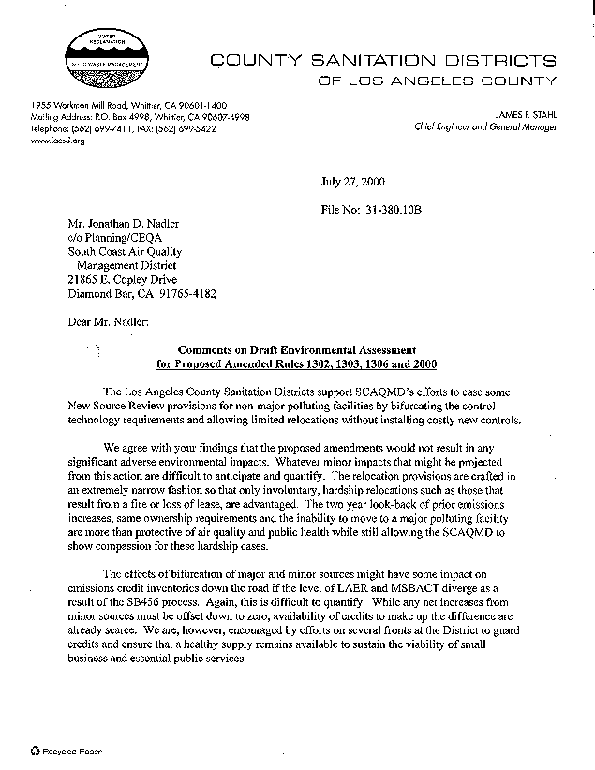
1-1
1-2

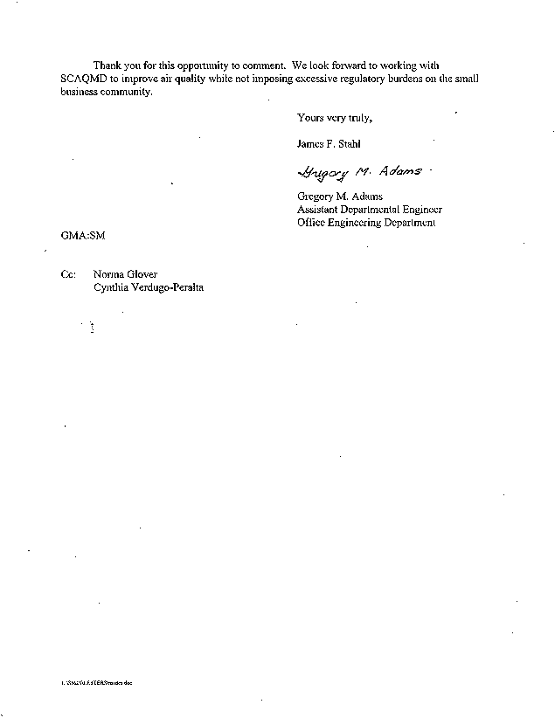

Sanitation Districts of County of Los Angeles
August 1, 2000

1-1 Comment noted. The commentator’s conclusion is consistent with the analysis in Chapter 2 of the Draft EA. Chapter 2 provides a comprehensive analysis of the proposed relocation provision and concludes that it would not result in significant adverse environmental impacts.
1-2 Comment noted. The commentator’s conclusion is consistent with the analysis in Chapter 2 of the Draft EA. Chapter 2 provides a comprehensive analysis of the proposed bifurcation of BACT for major and minor sources and concludes that it would not result in significant adverse environmental impacts.
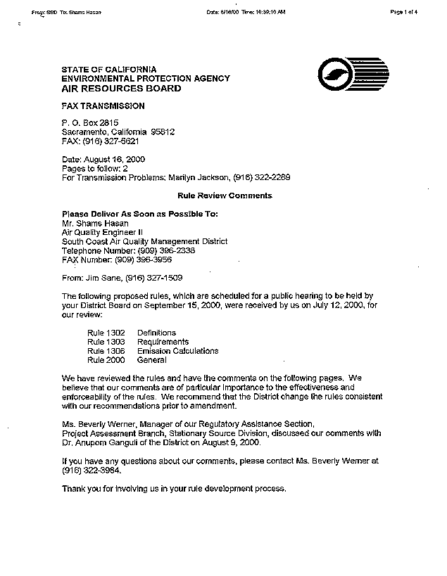
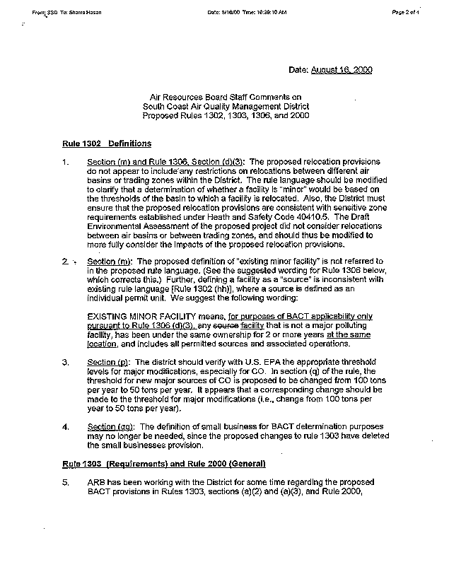
2-1
2-2
2-3
2-4
2-5
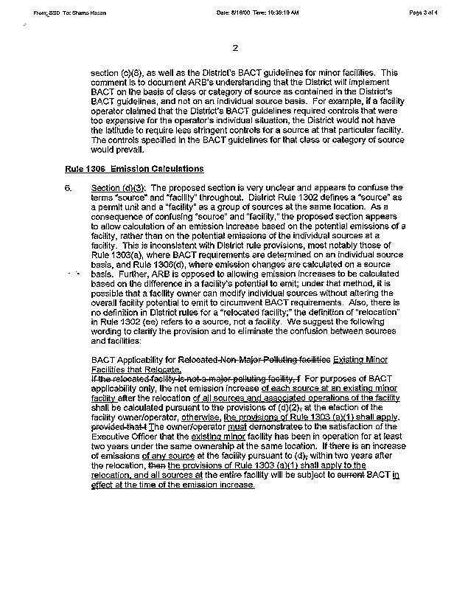
2-5
cont.
2-6
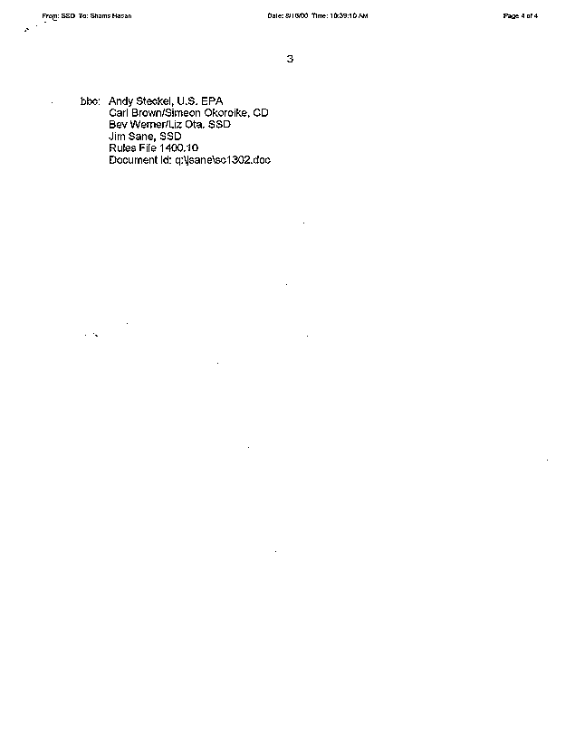

California Air Resources Board (CARB)
August 16, 2000

  - The proposed amendments do not affect current limitations on relocations between different air basins within the district. Under the current New Source Review (NSR) regulation, a minor source can relocate from one air basin to another, including a downwind air basin to an upwind air basin. The difference between the current regulation and the proposed amendments is that, under the amended relocation provision, relocated minor sources may elect to be subject to a calculation procedure that will not trigger BACT if there is no emission increase. The source would, however, be subject to the offset requirements as if it were a new source. As described in detail in Chapter 2, the net effect of a facility choosing to avoid triggering BACT would be a net decrease in regional emissions as a result of the requirement to provide offsets at a ratio of 1.2 to 1.0. There would thus be no adverse impact relative to the potential relocation of minor sources between air basins.
Likewise, the existing NSR regulation already includes the sensitive zone requirements established under Health and Safety Code section 40410.5. The proposed amendments do not alter the sensitive zone requirements, and no adverse environmental impact relative to these requirements has been identified.
2-2 This comment is not related to the environmental analysis. A response to this comment is included in the Final Staff Report for the proposed project.
2-3 This comment is not related to the environmental analysis. A response to this comment is included in the Final Staff Report for the proposed project.
2-4 This comment is not related to the environmental analysis. A response to this comment is included in the Final Staff Report for the proposed project.
2-5 This comment is not related to the environmental analysis. A response to this comment is included in the Final Staff Report for the proposed project.
2-6 This comment is not related to the environmental analysis. A response to this comment is included in the Final Staff Report for the proposed project.

The Lewis-Presley Air Quality Management Act, 1976 Cal. Stats., ch 324 (codified at Health & Safety Code, §§40400-40540).
Health & Safety Code, §40460 (a).
Health & Safety Code, §40440 (a).
The SCAQMD prepared a Notice of Preparation / Initial Study for the proposed project that was released for a 30-day public review period. No comments were received on the Initial Study. Analysis performed subsequent to the Initial Study showed that implementation of the proposed project would not result in any significant adverse environmental impacts. Therefore, this Draft EA with no significant impacts has been prepared and supersedes the Initial Study.
Major polluting facilities are defined relative to their emissions or potential to emit. The definition also accounts for the attainment designation of the air basin within which the source is located. See PAR 1302, subdivision (q).
As part of the SCAQMD’s program to achieve the state requirement of “no net increase” in emissions of criteria pollutants, Regulation XIII requires emissions offsets for emissions greater than one pound per day from new, modified, or relocated sources. The offsets are provided by either the applicant or the SCAQMD depending on the annual emissions from the facility. The SCAQMD provides offsets for smaller sources (i.e., less than four tons per year of VOC, NOx, SOx, or PM10, or 29 tons per year of CO).
“Achieved in practice” is one of three criteria by which an emission limit or control technique may be considered BACT [Rule 1302(f)]. See BACT Guidelines Part C, Chapter 4, for a complete discussion of how a control technology or emission limit would be considered “achieved in practice.”
SCAQMD NSR regulations exempt small sources (facility-wide PTE less than four tons per year VOC, NOx, SOx, or PM10, or 29 tons per year of CO) from providing offsets. For these sources, SCAQMD is responsible for providing the offsets. Sources not exempt from the offset requirement have to purchase offsets from the NSR emission reduction credit (ERC) market.
SCAQMD Permit Processing Handbook, Table 12-5
The average size of 24 recently permitted small boilers is 8.3 MMBtu.
The “Report on the Effectiveness of Regulation XIII” submitted to the SCAQMD Governing Board on March 13, 1998, used a calculation methodology where “actual” emission levels represent the emission increases subject to state NSR requirements. Prior to that report, the SCAQMD had utilized “permitted” emissions to report emissions subject to the “no net increase” requirement of state law.
Chrome plating is the other equipment category that shows a history of relocations. The emissions associated with chrome plating equipment, however, are below BACT and offsetting thresholds and the proposed amendments would not affect this source category. The concern associated with this activity is the emissions of toxic air contaminants. A relocated chrome plating facility would still be subject to Rule 1401 – New Source Review of Toxic Air Contaminants, which would likely lead to a reduction in toxic air emissions from that source.

